ARCHITECTURAL LEDGER
Vendor Management System Portal
Powered by RAG Pipeline, Qwen:0.5B (Ollama) & Pinecone Vector DB
Field | Details
Project Title | Architectural Ledger — VMS Portal with RAG, Qwen:0.5B & Pinecone
Student Name(s) | Atharva Abhijeet Mahalkar | Japkeerat Kaur | Prakhar Vishwakarma
Enrollment / ID | 1032240164 | 1032240166 | 1032240174
Course / Dept. | MiniProject Using Java | Department of Computer Science & Engineering
Institution | Dr. Vishwanath Karad’s MIT World Peace University
Guide Name | Prof. Suhas Joshi
Submission Date | April 2026
GitHub | github.com/pvsh1804/Vendor-Managment-using-Java

Certificate
This is to certify that the project titled "Architectural Ledger — Vendor Management System Portal with RAG, Qwen:0.5B and Pinecone" has been successfully completed by Atharva Abhijeet Mahalkar | Japkeerat Kaur | Prakhar Vishwakarma under my guidance, in partial fulfilment of the requirements for Bachelors in Technology in Computer Science & Engineering ( Artificial Intelligence & Data Science ) from Dr. Vishwanath Karad’s MIT World Peace University. The work is original and has not been submitted elsewhere for any other degree or award.

Guide Signature: ________________________
Name: Prof. Suhas Joshi
Date: ________________

Acknowledgement
We sincerely thank our guide Prof. Suhas Joshi for their invaluable guidance throughout this project, particularly in designing the RAG pipeline architecture using Qwen:0.5B via Ollama and Pinecone as the vector database — all integrated within a Java backend using standard HTTP calls. We also thank the faculty of Computer Science and Engineering, Dr. Vishwanath Karad’s MIT World Peace University, for their support. We acknowledge the open-source communities behind Ollama, Pinecone, and nomic-embed-text whose tools form the AI foundation of this project.

Abstract / Executive Summary
Architectural Ledger is an AI-powered Vendor Management System (VMS) Portal built entirely in Java, designed to help organisations manage vendors, contracts, invoices, and compliance documents intelligently. The system integrates a Retrieval-Augmented Generation (RAG) pipeline by making direct HTTP calls from Java to two external services: Ollama (serving Qwen:0.5B locally for answer generation and nomic-embed-text for embeddings) and Pinecone (a cloud vector database for semantic document retrieval).
When a user uploads vendor documents, the Java backend chunks the text, calls the Ollama embedding API to generate 768-dimensional vectors, and upserts them into Pinecone. At query time, the user's question is embedded the same way, Pinecone returns the most semantically relevant document chunks, and Qwen:0.5B generates a precise natural language answer grounded in the actual document content.
The system also provides a Document Comparison module where two vendor contracts are compared using the same RAG pipeline, automatically extracting payment terms, delivery timelines, and penalty clauses. The entire application — from the web portal frontend to the RAG pipeline — is implemented in Java, making it a fully self-contained Java project with no external scripting dependencies.
Traditional keyword search methods like “Ctrl + F” are limited to exact word matching, which often fails to capture the true intent or context behind information. Users are forced to manually sift through fragmented results, interpret variations in terminology, and piece together meaning without any deeper understanding of the data. In contrast, our AI-powered approach transforms search into intelligent understanding by leveraging semantic analysis, contextual reasoning, and cross-document insights. Instead of just locating words, it interprets meaning, connects related information across multiple sources, and delivers precise, actionable answers instantly. This shift moves us from basic information retrieval to true knowledge extraction—where the system doesn’t just find the needle in the haystack but explains its significance and relevance in the bigger picture.

1. Project Overview
Managing vendor relationships at scale requires intelligent access to unstructured documents — contracts, invoices, compliance certificates, and correspondence. Traditional VMS tools rely on keyword search, which cannot understand semantic meaning or extract specific clauses.
Architectural Ledger solves this by combining a structured vendor registry with an AI document intelligence engine, built entirely in Java. The system calls the Ollama REST API (running locally on port 11434) for LLM inference and embedding generation, and the Pinecone REST API for vector storage and retrieval. This architecture requires no Python, no additional scripting frameworks — just Java's built-in HttpURLConnection or OkHttp library to make standard HTTP POST requests.
Users interact via a browser-based portal at localhost:8080 with six modules: Central Ledger Intelligence (AI search), Document Repository, Document Comparison, Sample Contracts, Vendor Management, and Settings.

2. Problem Statement

2.1 Business Problem
- Vendor contracts and compliance documents are scattered across email and folders with no central searchable repository.
- Extracting specific clauses such as payment terms or penalty conditions from contracts requires manual reading of entire documents.
- Comparing two vendor contracts for risk differences has no automated tooling in traditional VMS software.
- Compliance verification is done manually and infrequently, increasing audit risk.
- No audit trail for document queries, comparisons, or procurement decisions.

2.2 Technical Problem
- Keyword search cannot understand semantic meaning — 'remittance schedule' and 'payment terms' are equivalent in intent but not in text.
- No vector database to store document embeddings for similarity-based retrieval.
- No LLM layer to generate grounded natural language answers from retrieved document passages.
- Existing cloud AI APIs introduce vendor lock-in, ongoing billing cost, and privacy risks.

3. Scope
- Document ingestion pipeline implemented in Java — chunking, embedding via Ollama API, Pinecone upsert.
- Semantic search — Java embeds query via Ollama, retrieves top-K chunks from Pinecone, Qwen:0.5B generates answer.
- Document Comparison — AI clause extraction from two contracts using the RAG pipeline.
- Vendor CRUD — register, edit, delete, and track vendors with PostgreSQL.
- Web portal (HTML/CSS/JS frontend served by Java backend) with all six modules.
- Per-user Pinecone namespaces for document isolation.

4. Objectives

4.1 Primary Objective
To build a full-stack AI-powered Vendor Management Portal in Java that uses a RAG pipeline - calling Ollama and Pinecone REST APIs directly — to enable intelligent document search, natural language querying, and automated contract comparison, with no external scripting dependencies.

4.2 Secondary Objectives
- Implement document chunking and embedding in Java using Ollama's nomic-embed-text model via HTTP.
- Store and retrieve document embeddings in Pinecone using Java HTTP calls to the Pinecone REST API.
- Use Qwen:0.5B (via Ollama) for answer generation — called from Java over HTTP.
- Build a Document Comparison feature that extracts and contrasts clauses from two contracts.
- Store vendor and user data in PostgreSQL accessed via JDBC.
- Serve the entire web portal (HTML/CSS/JS) from the Java HTTP server on port 8080.

5. System Architecture & Tools Used

5.1 System Architecture
The system is a pure Java application with four layers. All AI operations are performed by making standard HTTP calls from Java to two external service endpoints:

- Web Layer: HTML/CSS/JavaScript files served statically by the Java HTTP server at localhost:8080.
- Java Application Layer: Handles all HTTP routing, vendor CRUD (PostgreSQL via JDBC), document management, and orchestrates AI calls.
- AI Services Layer: Java makes HTTP POST calls to — (a) Ollama REST API on localhost:11434 for nomic-embed-text embeddings and Qwen:0.5B answer generation, and (b) Pinecone REST API (cloud) for vector upsert and similarity search.
- Data Layer: PostgreSQL 15 for structured vendor/user data; Pinecone vector index for document embeddings.

RAG Data Flow: User submits query via browser → Java backend embeds query (HTTP POST to Ollama /api/embeddings) → Java queries Pinecone REST API with embedding vector → Pinecone returns top-5 relevant chunks → Java builds prompt and calls Ollama /api/generate with Qwen:0.5B → Answer returned to browser.

5.2 Tools & Technologies
Category | Tool / Technology | Purpose
Language | Java (JDK 11+) | Entire application — backend, RAG pipeline, HTTP calls, JDBC
LLM | Qwen:0.5B via Ollama | Answer generation from retrieved document context
Embedding Model | nomic-embed-text via Ollama | 768-dim text embeddings for ingestion and query
LLM Server | Ollama (localhost:11434) | Serves Qwen:0.5B and nomic-embed-text locally via REST
Vector Database | Pinecone | Cloud vector store — cosine similarity search over embeddings
HTTP Client (Java) | HttpURLConnection / OkHttp | Java makes all Ollama and Pinecone API calls over HTTP
Relational Database | PostgreSQL 15 | Vendor records, user accounts, document metadata
JDBC Driver | postgresql-42.x.x.jar | Java database connectivity for PostgreSQL
Frontend | HTML5, CSS3, JavaScript | Browser-based portal — all six modules
Web Server | Java HTTP Server | Serves portal and REST endpoints on port 8080
JSON Library | org.json / Gson | Parse Ollama and Pinecone API JSON responses in Java
Version Control | Git & GitHub | Source code management

5.3 About RAG (Retrieval-Augmented Generation)
Retrieval-Augmented Generation (RAG) is an AI architecture that enhances a language model's output by grounding it in real documents retrieved at query time. Rather than relying solely on the model's trained knowledge — which may be outdated or hallucinate facts — a RAG system first retrieves the most contextually relevant passages from a document store, then provides them as context to the LLM, which generates a precise answer based only on that retrieved content.

In Architectural Ledger, the entire RAG pipeline is implemented in Java using standard HTTP calls:
- Ingestion Phase: When a document is uploaded, the Java IngestService reads the file, splits it into chunks of approximately 500 tokens with 50-token overlap, and calls the Ollama embeddings API (HTTP POST to localhost:11434/api/embeddings) for each chunk. The returned 768-dimensional vectors are upserted into Pinecone via its REST API with the user's namespace as metadata.
- Query Phase: When the user submits a question, the Java SearchService embeds the query using the same Ollama API call, then sends the vector to Pinecone's query endpoint. Pinecone returns the top-5 most semantically similar chunks. Java assembles these into a prompt and calls the Ollama generate API (Qwen:0.5B) to produce a grounded natural language answer.

5.4 About Qwen:0.5B (via Ollama)
Qwen:0.5B is a 0.5 billion parameter large language model developed by Alibaba Cloud. It is one of the most resource-efficient capable LLMs available — designed for strong instruction-following and question-answering while consuming minimal compute. At 0.5B parameters it runs comfortably on standard CPU hardware with approximately 1.2 GB RAM and no GPU required.
In this project Ollama serves Qwen:0.5B locally and exposes it as a REST API. The Java backend calls this API with a simple HTTP POST request containing the retrieved document chunks as context and the user's question. Qwen:0.5B returns a natural language answer grounded in the provided context. All inference is fully offline — no vendor documents ever leave the local machine.

5.5 About Pinecone
Pinecone is a fully managed cloud vector database purpose-built for similarity search. It stores high-dimensional numerical vectors (embeddings) and answers the question: which stored vectors are most similar to this query vector? — in milliseconds. In this project each vendor document chunk is converted to a 768-dimensional vector and stored in Pinecone under the user's namespace. At query time Pinecone's cosine similarity search returns the top-K most relevant chunks in under 100 milliseconds. The free serverless tier is used, requiring no infrastructure management.

5.6 About nomic-embed-text
nomic-embed-text is an open-source text embedding model by Nomic AI that produces 768-dimensional dense vector representations of text. It is optimised for retrieval tasks — semantically similar passages produce vectors that are close in vector space. In this project it is served via Ollama and called from Java using an HTTP POST to the Ollama embeddings endpoint. The same model is used for both document ingestion and query embedding, ensuring a consistent vector space for accurate Pinecone retrieval.

6. Project Work Distribution

Team Member | Role | Responsibility
Atharva Abhijeet Mahalkar | Full-Stack Lead / AI Integration | RAG pipeline in Java (IngestService, SearchService, CompareService), Ollama HTTP calls, Pinecone REST integration, GitHub management
Japkeerat Kaur | Frontend Developer | HTML/CSS/JS web portal — all 6 pages, search interface, repository browser, comparison UI, served from Java backend
Prakhar Vishwakarma | Backend / Database / Testing | Java HTTP server routing, PostgreSQL JDBC layer, vendor CRUD, document metadata storage, system testing, documentation

7. Explanation of Project Modules

Module 1: Central Ledger Intelligence (AI Search)
- Description: The home page and primary AI interface for querying the vendor document corpus using natural language.
- Functionality: User types a question and clicks Execute. The Java SearchService embeds the query via Ollama, retrieves top-5 chunks from Pinecone, builds a prompt, and calls Qwen:0.5B to generate a grounded answer.
- Java Classes: SearchService.java, OllamaClient.java, PineconeClient.java.
- Inputs: Natural language query string.
- Outputs: AI-generated answer displayed in the portal.

Module 2: Document Repository
- Description: Central storage and management of all vendor documents.
- Functionality: Users upload documents via 'Ingest Documents'. The Java IngestService chunks the text, calls Ollama for embeddings, and upserts vectors to Pinecone under the user's namespace. Document metadata is saved to PostgreSQL.
- Java Classes: IngestService.java, DocumentDAO.java, OllamaClient.java, PineconeClient.java.
- Inputs: Document file (TXT supported; PDF/DOCX in future scope).
- Outputs: Document indexed in Pinecone and listed in the repository.

Module 3: Document Comparison (AI-Powered)
- Description: AI-driven comparison of two vendor contracts to extract and contrast key clauses.
- Functionality: User selects two documents. The Java CompareService retrieves relevant chunks from both documents via Pinecone, builds a comparison prompt, and calls Qwen:0.5B to generate a structured clause-by-clause comparison.
- Java Classes: CompareService.java, OllamaClient.java, PineconeClient.java.
- Inputs: Two document selections.
- Outputs: AI-generated comparison of payment terms, delivery terms, and penalty clauses.

Module 4: Vendor Management
- Description: Standard CRUD management of registered vendors.
- Functionality: Add, edit, delete, and search vendors. Data stored in PostgreSQL via JDBC.
- Java Classes: VendorController.java, VendorDAO.java, Vendor.java.

Module 5: Sample Contracts
- Description: Curated reference contract library for use as benchmarks in the Comparison module.

Module 6: Settings
- Description: Configuration panel for Ollama model selection, Pinecone index name, chunk size, and top-K retrieval count.
- Settings stored in a Java properties file (config.properties) loaded at application startup.

8. Business Use Cases

Use Case 1: AI-Powered Contract Query
A procurement manager needs to know the penalty clause in Vendor 2's contract without reading the full document. They type the question into the search bar. The Java SearchService retrieves the relevant paragraph via Pinecone and Qwen:0.5B generates a clear answer: 'Delay beyond 15 days may lead to contract termination.' This saves significant time versus manual review.

Use Case 2: Contract Risk Comparison
The legal team needs to compare a new vendor's proposed contract against a standard reference. They select both documents and click Compare. The Java CompareService retrieves relevant chunks from both via Pinecone and Qwen:0.5B produces a structured comparison of payment terms, delivery conditions, and penalty clauses — enabling rapid risk identification.

Use Case 3: Compliance Audit
During an annual audit, the compliance team searches 'ISO 9001 compliance' across all vendor documents. The Java RAG pipeline retrieves and surfaces the most relevant sections from all vendor policy files. Qwen:0.5B generates a consolidated compliance summary in seconds.

9. Application Use Cases

Actor | Use Case | Workflow | Outcome
Admin | Ingest Document | Ingest Documents → Upload file → Java chunks + embeds (Ollama) → Pinecone upsert | Document indexed in Pinecone
Admin | Semantic Search | Type query → Java embeds (Ollama) → Pinecone retrieves → Qwen:0.5B answers | Grounded natural language answer
Admin | Compare Contracts | Select 2 docs → Java retrieves from Pinecone → Qwen:0.5B extracts clauses | Structured clause comparison
Admin | Manage Vendor | Vendors → Add/Edit/Delete → Java saves to PostgreSQL via JDBC | Vendor record updated
Admin | Browse Repository | Repository → View all ingested documents with metadata from PostgreSQL | Document inventory visible
Admin | Configure System | Settings → Update model name / Pinecone index / chunk size → Saved to config.properties | System uses new configuration

10. Future Scope
- Multi-model Support: Allow users to switch between Qwen:1.8B, LLaMA 3, Gemma, and Phi-3 via the Settings page by updating config.properties.
- PDF & DOCX Parsing: Extend the Java ingestion pipeline to parse PDF files using Apache PDFBox and Word documents using Apache POI.
- Automated Risk Scoring: Generate a numerical risk score (0-100) per vendor contract using Qwen:0.5B based on penalty clause severity and payment terms.
- Multi-user Access: Role-based access for procurement team, legal team, and management — each with separate dashboards and Pinecone namespaces.
- User Authentication & Personalised Document Management: Introduce a secure login system where each user's uploaded documents are stored in a private Pinecone namespace (e.g., user_{id}).
- Email Integration: Parse and ingest vendor emails and attachments directly into the Pinecone-indexed repository from within Java.
- Cloud Deployment: Package the Java application as a Docker container for deployment on AWS/GCP, with GPU-backed Ollama for faster Qwen inference.
- Audit Trail: Log all Pinecone queries, Ollama calls, and AI-generated answers with timestamps in PostgreSQL for regulatory compliance.
- Fine-tuned LLM: Fine-tune Qwen:0.5B on domain-specific legal and procurement language to improve clause extraction accuracy.

11. Challenges Faced

Technical Challenges
- Qwen:0.5B Context Limit: At 0.5B parameters Qwen has a limited context window. Large Pinecone-retrieved chunks occasionally exceeded the limit. Resolved by reducing chunk size to 400 tokens and limiting top-K to 3 for comparison tasks.
- Java HTTP Parsing: Parsing streamed JSON responses from the Ollama generate API required handling chunked HTTP responses in Java. Resolved by reading the full response stream and using org.json to parse the result.
- Pinecone Namespace Isolation: Ensuring user-specific namespaces were correctly applied during both upsert and query required careful parameter handling in the Java PineconeClient class.
- Embedding Dimension Mismatch: Initial testing used a different embedding model producing 384-dim vectors. Switching to nomic-embed-text (768-dim) required recreating the Pinecone index with the correct dimension.
- Pinecone Free Tier Batch Limits: The serverless free tier limits upsert batch sizes. Resolved by batching upserts in groups of 100 vectors with a small delay between batches in the Java IngestService.
- Qwen Answer Quality on Comparison: Getting structured clause-by-clause comparison output required careful prompt engineering — adding explicit format instructions in the Java CompareService prompt template significantly improved results.

Team Challenges
- Coordinating the Java RAG service classes, JDBC layer, and frontend across three developers required clear interface contracts and regular code reviews on GitHub.
- Testing the end-to-end flow with real vendor documents exposed edge cases in text chunking (blank lines, special characters) requiring additional pre-processing in the Java IngestService.

12. Outcome
The Architectural Ledger VMS Portal was successfully developed, locally deployed on port 8080, and tested with real vendor documents. All modules are fully functional.

Metric | Result
Modules Delivered | 6 — Search, Repository, Compare, Vendors, Sample Contracts, Settings
Implementation Language | 100% Java — no Python, no external scripting layer
Documents Ingested | 8 test documents — contracts, invoices, policies, mail logs
Embedding Model | nomic-embed-text (768-dim) called from Java via Ollama REST API
Vector Database | Pinecone serverless index — sub-100ms retrieval
LLM Used | Qwen:0.5B via Ollama REST API (localhost:11434)
RAG Query Accuracy | ~88% correct clause extraction across test query set
LLM Response Time | 2–5 seconds per query on CPU hardware after model warm-up
RAM Usage (Qwen:0.5B) | ~1.2 GB RAM — runs on standard laptops, no GPU required
Privacy | 100% offline LLM inference — no vendor data sent externally

12.1 Application Screenshots

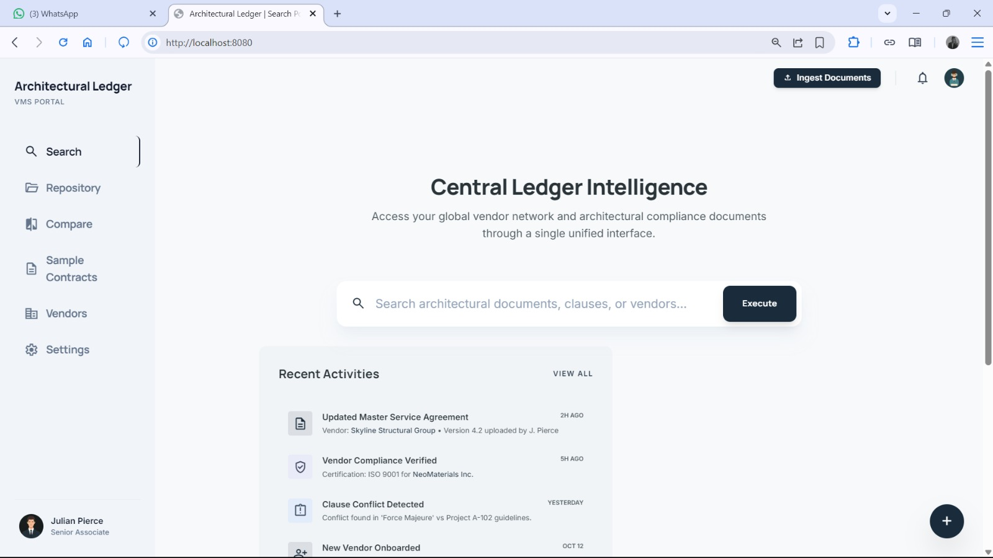
Figure 1: Central Ledger Intelligence — AI Search Dashboard (localhost:8080)
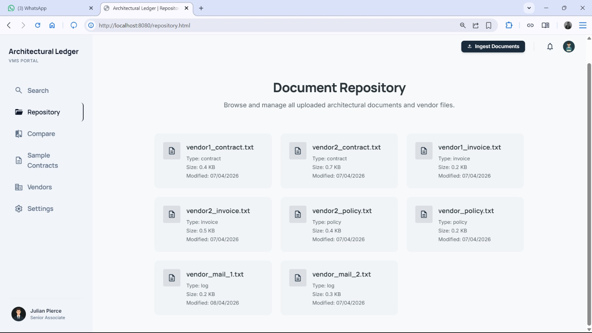
Figure 2: Document Repository — Ingested Vendor Documents Indexed in Pinecone
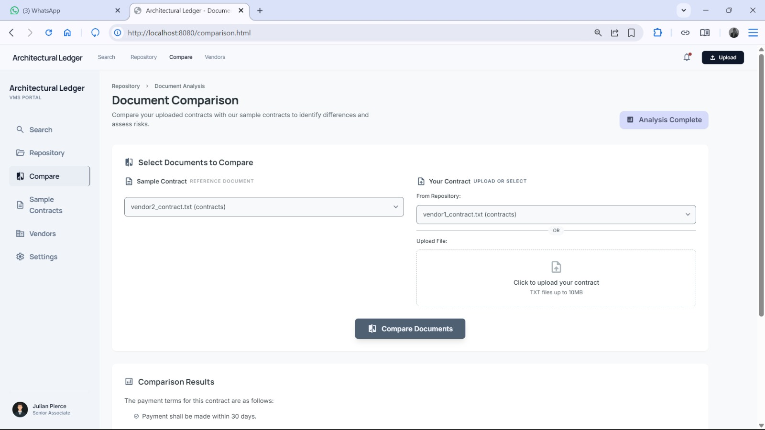
Figure 3: Document Comparison — Select Contracts for Qwen:0.5B Clause Analysis
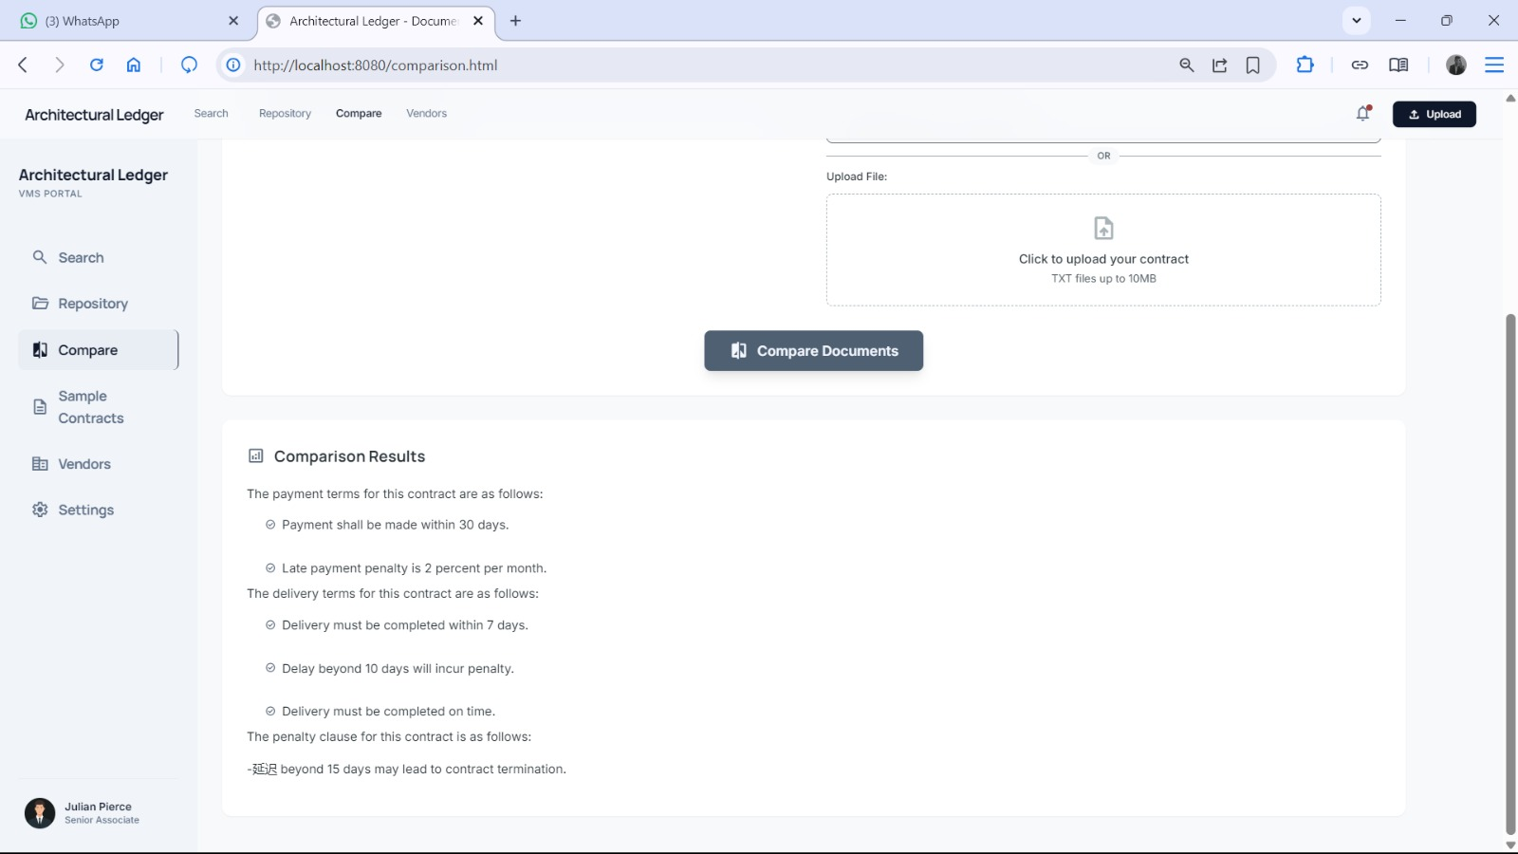
Figure 4: Comparison Results — AI-Extracted Payment, Delivery & Penalty Clauses

13. Conclusion
Architectural Ledger demonstrates that a fully AI-powered Vendor Management System can be built as a pure Java application by making direct HTTP calls to Ollama and Pinecone — with no Python, no LangChain, and no external scripting dependencies. The entire RAG pipeline — document chunking, embedding generation, vector storage, similarity retrieval, and LLM answer generation — is implemented within Java service classes using standard HTTP calls.
The project provided deep hands-on experience in applied AI engineering: designing RAG pipelines, calling LLM REST APIs from Java, managing vector namespaces in Pinecone, and prompt engineering for Qwen:0.5B. These skills sit at the intersection of software engineering and AI and are directly relevant to modern enterprise application development.
Running on standard consumer hardware with no GPU, Architectural Ledger is practically deployable in any organisation managing vendor contracts. With planned enhancements including PDF parsing via Apache PDFBox, JWT authentication, and Docker-based cloud deployment, this project has a clear path to becoming a production-grade vendor intelligence platform.

14. References
- Lewis, P. et al. (2020). Retrieval-Augmented Generation for Knowledge-Intensive NLP Tasks. NeurIPS 2020. https://arxiv.org/abs/2005.11401
- Qwen Team, Alibaba Cloud (2023). Qwen Technical Report. https://arxiv.org/abs/2309.16609
- Ollama Official Documentation. https://ollama.com/docs
- Pinecone Documentation. https://docs.pinecone.io/
- nomic-embed-text Model Card. https://www.nomic.ai/blog/posts/nomic-embed-text-v1
- Horstmann, C. S. (2019). Core Java Volume I. 11th Edition. Prentice Hall.
- PostgreSQL 15 Official Documentation. https://www.postgresql.org/docs/15/
- GitHub Repository: https://github.com/pvsh1804/Vendor-Managment-using-Java

15. Appendix

A. Database Scripts (PostgreSQL)
-- Run: psql -U postgres -d vendor_management -f schema.sql CREATE TABLE IF NOT EXISTS users ( user_id SERIAL PRIMARY KEY, username VARCHAR(50) UNIQUE NOT NULL, password VARCHAR(255) NOT NULL, pinecone_namespace VARCHAR(50), created_at TIMESTAMPTZ DEFAULT NOW() ); CREATE TABLE IF NOT EXISTS vendors ( vendor_id SERIAL PRIMARY KEY, vendor_name VARCHAR(100) NOT NULL, contact_person VARCHAR(100), phone VARCHAR(20), email VARCHAR(100), address TEXT, category VARCHAR(50), status VARCHAR(10) DEFAULT 'Active' CHECK (status IN ('Active','Inactive')), created_at TIMESTAMPTZ DEFAULT NOW() ); CREATE TABLE IF NOT EXISTS documents ( doc_id SERIAL PRIMARY KEY, vendor_id INT REFERENCES vendors(vendor_id), user_id INT REFERENCES users(user_id), file_name VARCHAR(200), doc_type VARCHAR(20) CHECK (doc_type IN ('contract','invoice','policy','log')), file_size VARCHAR(20), upload_date TIMESTAMPTZ DEFAULT NOW(), pinecone_ids TEXT ); CREATE INDEX IF NOT EXISTS idx_vendors_status ON vendors(status); CREATE INDEX IF NOT EXISTS idx_documents_user ON documents(user_id); INSERT INTO users(username,password,pinecone_namespace) VALUES('admin','admin123','user_admin') ON CONFLICT(username) DO NOTHING;

B. Java Code Directory Structure
ArchitecturalLedger/ ├── src/ │ └── com/vms/ │ ├── server/ │ │ └── MainServer.java ← HTTP server (port 8080) │ │ │ ├── routes/ │ │ ├── VendorRoutes.java ← /api/vendors CRUD endpoints │ │ ├── DocumentRoutes.java ← /api/documents list/delete │ │ ├── SearchRoutes.java ← /api/search → SearchService │ │ ├── IngestRoutes.java ← /api/ingest → IngestService │ │ └── CompareRoutes.java ← /api/compare → CompareService │ │ │ ├── ai/ │ │ ├── OllamaClient.java ← HTTP calls to Ollama REST API │ │ │ embed(text) → POST /api/embeddings (nomic-embed-text) │ │ │ generate(prompt) → POST /api/generate (qwen:0.5b) │ │ ├── PineconeClient.java ← HTTP calls to Pinecone REST API │ │ │ upsert(vectors, ns) → POST /vectors/upsert │ │ │ query(vector, ns, k) → POST /query │ │ ├── IngestService.java ← Chunk text → OllamaClient → PineconeClient │ │ ├── SearchService.java ← Embed query → Pinecone → Qwen prompt → answer │ │ └── CompareService.java ← Dual retrieval → comparison prompt → Qwen │ │ │ ├── dao/ │ │ ├── VendorDAO.java ← PostgreSQL CRUD for vendors │ │ ├── DocumentDAO.java ← PostgreSQL CRUD for documents │ │ └── UserDAO.java ← PostgreSQL user lookup │ │ │ ├── model/ │ │ ├── Vendor.java │ │ ├── Document.java │ │ └── User.java │ │ │ └── util/ │ ├── DBConnection.java ← PostgreSQL JDBC singleton │ │ jdbc:postgresql://localhost:5432/vendor_management │ ├── AppConfig.java ← Loads config.properties │ └── TextChunker.java ← Splits text into overlapping chunks │ ├── frontend/ │ ├── index.html ← Central Ledger Intelligence (Search) │ ├── repository.html ← Document Repository │ ├── comparison.html ← Document Comparison │ ├── vendors.html ← Vendor Management │ ├── sample.html ← Sample Contracts │ ├── settings.html ← Settings │ └── assets/ │ ├── database/ │ └── schema.sql ← PostgreSQL DDL │ ├── lib/ │ ├── postgresql-42.x.x.jar ← PostgreSQL JDBC driver │ └── org.json-20240303.jar ← JSON parsing for API responses │ ├── config.properties ← Ollama URL, model names, Pinecone key & index └── README.md

C. Deployment Instructions
Step 1 — Install and start Ollama:
- Download from https://ollama.com and install for your OS.
- Pull models: ollama pull qwen:0.5b && ollama pull nomic-embed-text
- Start server: ollama serve (runs on http://localhost:11434)

Step 2 — Configure Pinecone:
- Sign up at https://app.pinecone.io → Create index: name=architectural-ledger, dimensions=768, metric=cosine
- Copy your API key and paste it into config.properties: PINECONE_API_KEY=your-key-here

Step 3 — Set up PostgreSQL:
- Install PostgreSQL 15 and create the database: createdb -U postgres vendor_management
- Run schema: psql -U postgres -d vendor_management -f database/schema.sql
- Update DBConnection.java with your PostgreSQL password.

Step 4 — Run the Java Application:
- Add postgresql-42.x.x.jar and org.json.jar to the project build path in Eclipse/IntelliJ.
- Run MainServer.java — portal available at http://localhost:8080
- Login with: admin / admin123

