[1]

Book Management with email notifier

Abha Marathe, Atharva Meshram (63)

Department of Engineering, Sciences and Humanities (DESH)

*Abstract* — *Traditional Library Management where manual records are maintained of the books available in the library, and about the books issued and the number of books returned. Such library management processes are prone to some or the other kind of human error. These manual records are also prone to damage. With the computerization in the modern world, library management should also become modernized. An application which can benefit the library management system by not only securing such data but also providing additional features to boost and make this library management efficient.*

***Keywords*** *— Library book management, PyQt5, Python, SQLite Database, Gmail API*

# INTRODUCTION

With the modernization around us, old traditional methodology of maintaining records of the library management becomes inefficient. In today’s world, where data is preserved and secured in cloud data servers. Library management should also become updated and online.

The project here tries to simplify this process of library management with the help of an application. When data is stored in the digital format, it can be easily recovered anytime anywhere and can also be duplicated to multiple systems very easily. My objective with this project is to not only make the process of maintaining records on a computer system, but also provide some additional helpful features which will help the user in different ways.

The data of the books and the members registered to a library can be stored in databases with the help of my application. This will enable the user check and verify book availability status and member issued book status with click of a button. This becomes a more efficient to handle and manage books in library.

# Literature Review

**I) Koha**

Koha is an open-source Integrated Library System, used world-wide by public, school libraries. The name comes from a Māori term for a gift or donation. It was first released over 20 years ago, that is, in January 2000 and has been updated ever since. It was written in Perl, JavaScript, HTML. Koha is a web-based ILS, with a SQL database (MariaDB or MySQL preferred) back end with cataloguing data stored in MARC and accessible via Z39.50 or SRU. The user interface is very configurable and adaptable and has been translated into many languages.

**II) Evergreen ILS**

Evergreen is an open-source Integrated Library System (ILS), initially developed by the Georgia Public Library Service for Public Information Network for Electronic Services (PINES), a statewide resource-sharing consortium with over 270 member libraries. Beyond PINES, the Evergreen ILS is deployed worldwide in approximately 1,800 libraries, and is used to power a number of statewide consortia catalogs.

**III) BibiloteQ**

BiblioteQ strives to be a professional archiving, cataloging, and library management suite, utilizing a Qt interface and providing connectivity to PostgreSQL and SQLite. The Open Library, SRU, and Z39.50 protocols are used for retrieving data for books, journals, and magazines. One of the professional software which provides extensive features and functionalities.

**IV) OpenBiblio**

OpenBiblio is an open-source Integrated Library System. The software is popular with small and rural libraries worldwide due to its simplicity, extensive language support, and good documentation. OpenBiblio was created in 2002 by Dave Stevens, who was interested in creating an easy-to-use, well-documented, easy-to-install library system.

**V) InvenioILS**

InvenioILS is another open-source Integrated Library System. It provides various features such as Cataloging, Circulation, Acquisition with a Modern UI and Rest API. It relies on the Invenio Framework with additional frameworks such as Elasticsearch, PostgreSQL/MySQL with Python/Flask and React at its core.

**VI) PMB**

PMB is a fully featured open-source integrated library system. It is continuously developed and maintained by the French company PMB Services. It provides an integrated portal of news and management of Web 2.0 content and is the only ILS that doesn't use a third-party CMS for the management of the portal. PMB is written using PHP language and also requires Apache web server, MySQL database and a web browser.

# Methodology/Experimental

## Technology

PYTHON - Python is an interpreted, high-level and general-purpose programming language. Created by Guido van Rossum and first released in 1991, Python's design philosophy emphasizes code readability with its notable use of significant whitespace. Its language constructs and object-oriented approach aim to help programmers write clear, logical code for small and large-scale projects.

PyQt - PyQt is a Python binding of the cross-platform GUI toolkit Qt, implemented as a Python plug-in. PyQt is free software developed by the British firm Riverbank Computing. It is a simple python-based GUI creating toolkit. It comes with a built-in PyQt Designer which helps the user to create applications, with desired outlook. It gives the user the raw data of the GUI, which the user then can use to add the backend code to the GUI.

SQL – SQL is a domain-specific language used in programming and designed for managing data held in a relational database management system (RDBMS), or for stream processing in a relational data stream management system (RDSMS). It is particularly useful in handling structured data, i.e. data incorporating relations among entities and variables. SQLite has been for the database handling in the application.

Gmail API – The Gmail API is configured so as to add the email sending functionalities of the application. The Gmail API is easy to use and once configured, works efficiently.

## Synthesis/Algorithm/Design/Method

General features which provide the user to add data of books as well as about the members of the library is provided by linking the SQLite database to the python module which is configured with the GUI of PyQt. All data entered is store in the database in proper formats. Additional features such as Email notifications have been configured with Gmail API and added to the python module. More functionalities such as showing data of books and members is achieved by the same python module which links this GUI and the SQLite database.

## Testing

The formal testing was conducted with additional dummy database with dummy Member data and Books data, and the program has been working without errors and while also implementing proposed features such as the email support.

# Results and Discussions

The program had some runtime errors, which were then fixed. The program can now issue and return books and such records are maintained in the database.

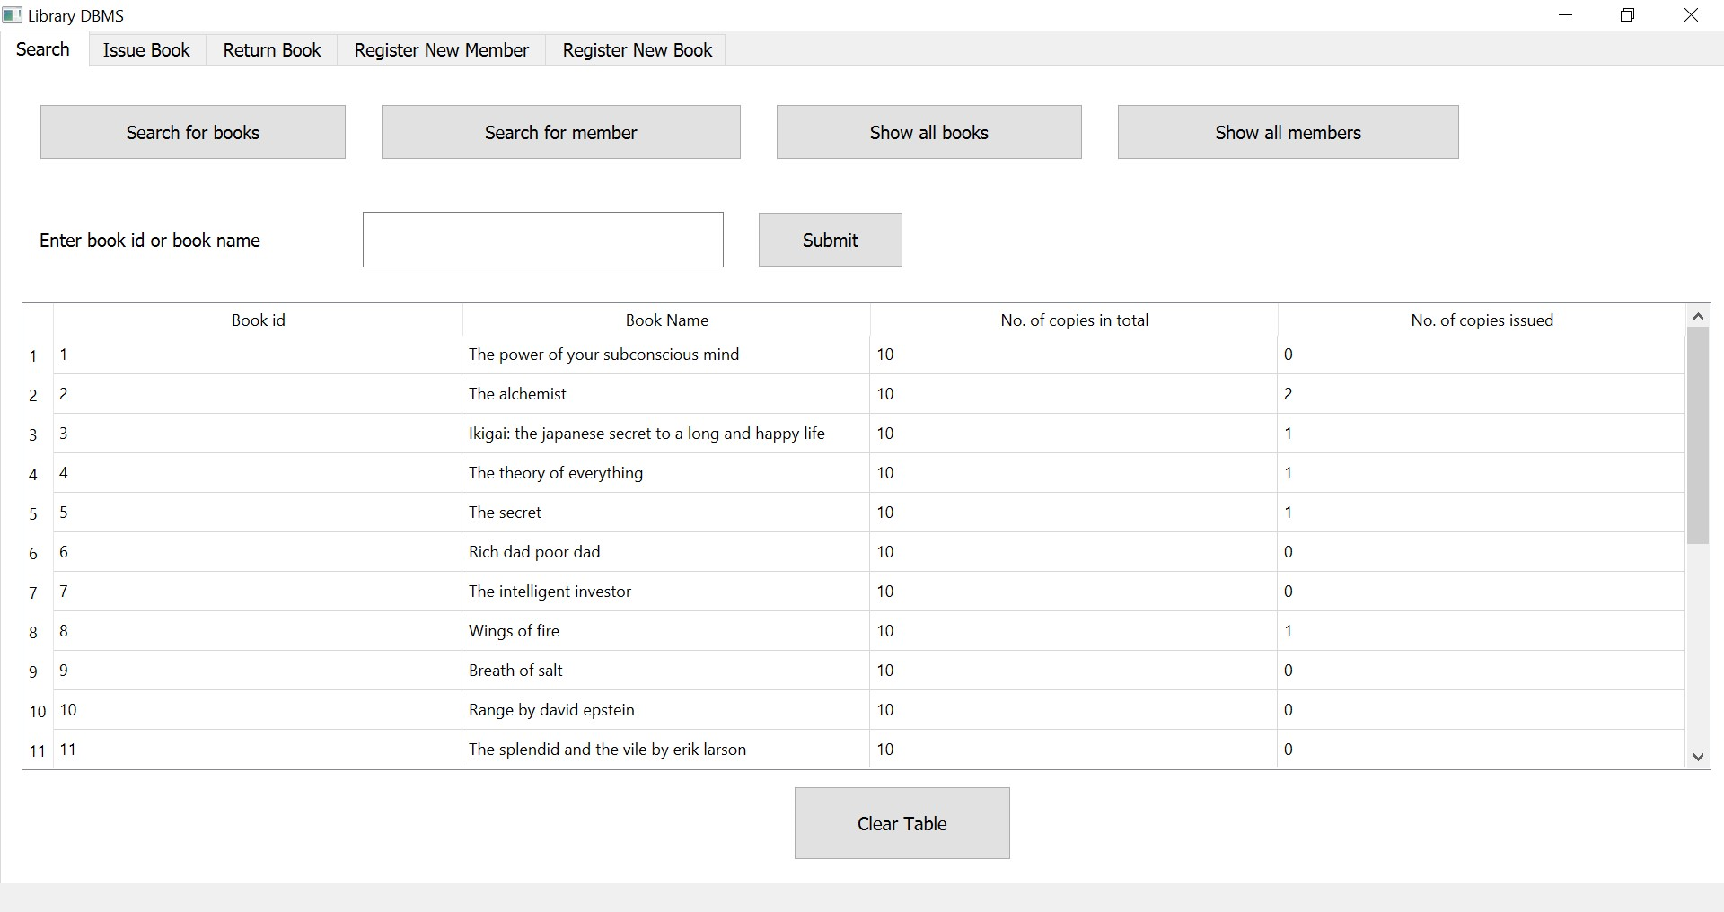

Above is the screenshot of the program running. Various tabs and functions work perfectly, while integrating database.

Below is the screenshot of the database created for the program.

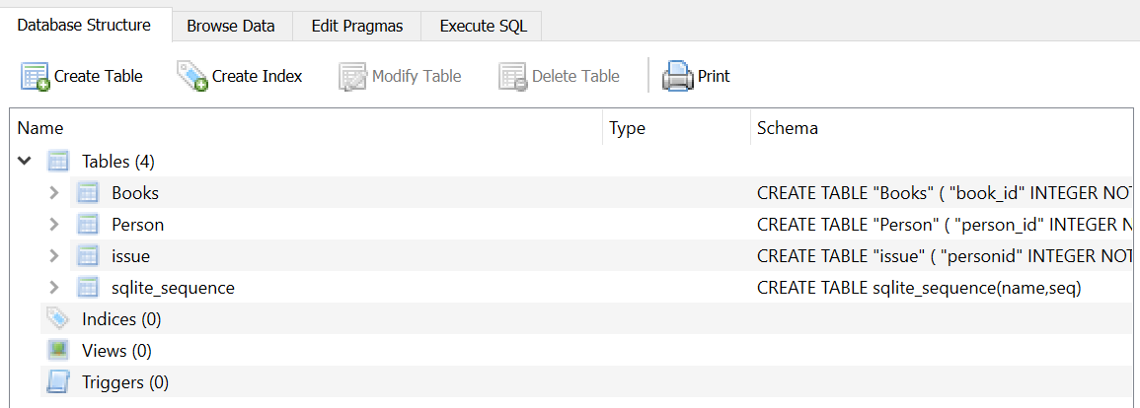

# Future Scope

Project can be added with more helpful features. Not only library management of one library but also management of multiple libraries can be done if project is made web-based, with data servers to tend to user queries and database.

# Conclusion

Implementation of the project was successful. Such simple basic library system, can be made simply with PyQt, Python and SQLite Database at its core. The added features were based on Python and SQLite Database integration which can also be done easily.

Acknowledgment

The existing professional software are a guiding path towards the design of the application and also provide help in determining the absolute necessary features and functions. It also provides additional ideas which will definitely prove helpful for the project. The guidance provided by Prof. Abha Marathe ma’am has also been helpful in overcoming errors and unnecessary addons of the application.

References

1. Fredrick Lundh, “An Introduction to Tkinter”
2. Vivian Siahaan, Rismon Hasiholan Sianipar, “Learning PyQt5: A Step-by-Step Tutorial to Develop MySQL-Based Applications”
3. Vivian Siahaan, Rismon Hasiholan Sianipar, “SQLite For Beginners: Learn Fundamentals of Queries and Implement PyQt-Based Projects Easily”
4. Official website of Koha: www.koha-community.org
5. Official website of Evergreen ILS: www.evergreen-ils.org
6. Official website of BiblioteQ: www.biblioteq.sourceforge.io
7. Wikipedia page of OpenBiblio www.en.wikipedia.org/wiki/OpenBiblio
8. InvenioILS by Invenio Software: www.invenio-software.org/products/ils/
9. Wikipedia page of PMB: https://en.wikipedia.org/wiki/PMB_(software)
10. PyQt5 tutorial playlist on YouTube by Tech with Tim: https://www.youtube.com/watch?v=Vde5SH8e1OQ&list=PLzMcBGfZo4-lB8MZfHPLTEHO9zJDDLpYj
11. PyQt5 tutorials by Learn PyQt5 website: www.learnpyqt5.com
12. Official documentation of Gmail API: https://developers.google.com/gmail/api
13. Official documentation of PyQt5: https://doc.qt.io/qtforpython/

1.