BeagleBone Black

What is BeagleBone Black?
BeagleBone Black is a low-cost, community-supported development platform for developers and hobbyists. Boot Linux in under 10 seconds and get started on development in less than 5 minutes with just a single USB cable.

BeagleBone Black Picture
Here is a picture of the Rev A5A board.
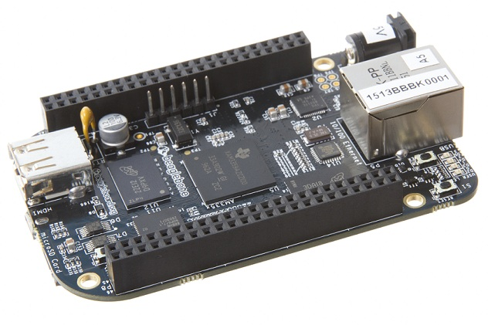

Processor: AM335x 1GHz ARM® Cortex-A8
- 512MB DDR3 RAM
- 4GB 8-bit eMMC on-board flash storage
- 3D graphics accelerator
- NEON floating-point accelerator
- 2x PRU 32-bit microcontrollers

Connectivity
- USB client for power & communications
- USB host
- Ethernet
- HDMI
- 2x 46 pin headers

Software Compatibility
- Debian
- Android
- Ubuntu
- Cloud9 IDE on Node.js w/ BoneScript library

BeagleBone Black Features
The following table lists the key features of the BeagleBone Black.
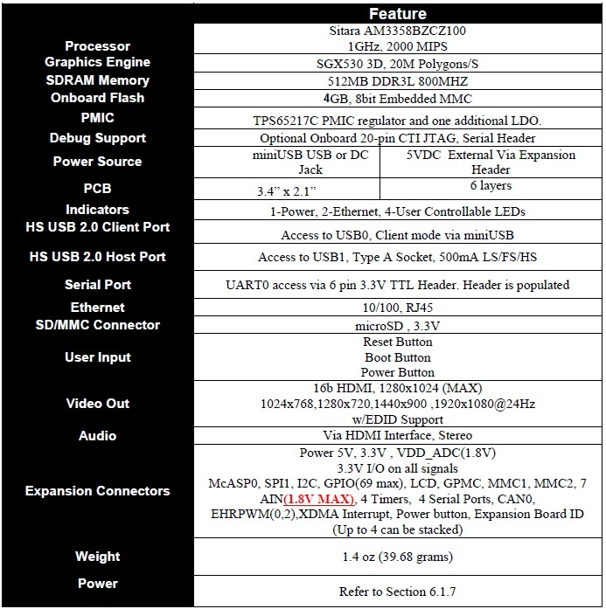

BeagleBone Black Key Component Locations
Here are the locations of the key components on the Rev A5A.
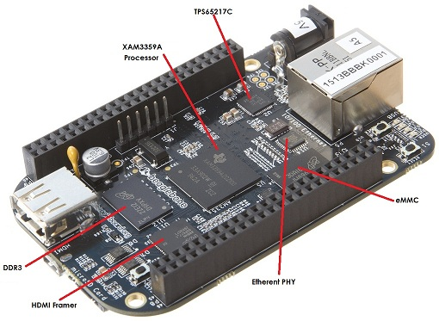

BeagleBone Black Connector and Switch Locations
Below is the location of the connectors and switches on the Rev A5A board.
The Power Button and Battery Connections are new additions to the Rev A5A.
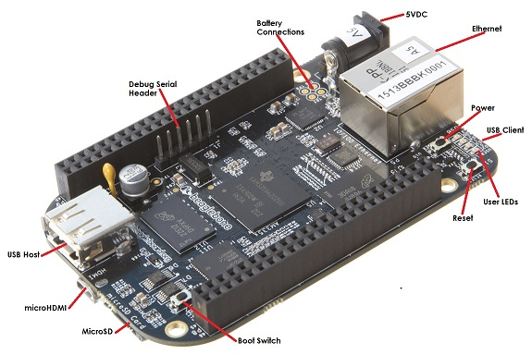

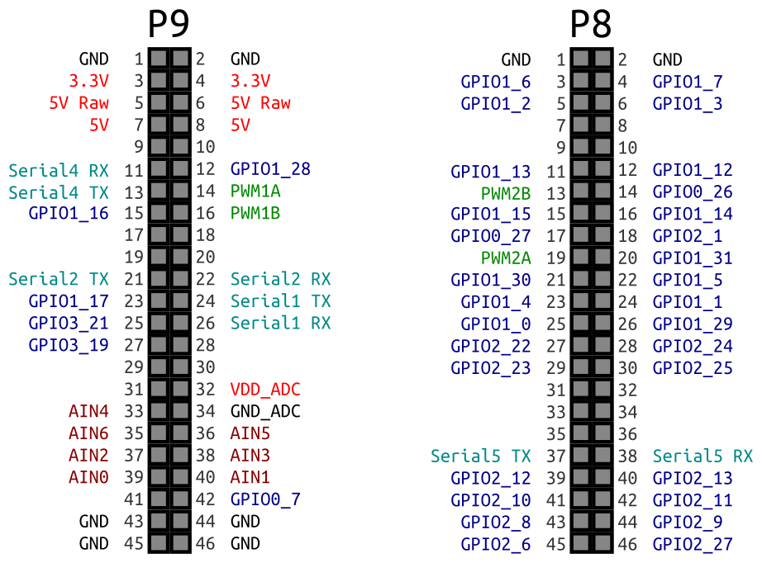
BeagleBone Black Pinout Diagram

Accessing BeagleBone Black via PC

Windows
If you use Windows, you need to download and install a free application called PuTTY. Here’s how to install it:
- Open your web browser.
- Go to the free PuTTY download.
- Click the putty.exe file to download it.
- Run the putty.exe file to install the software.
Before you power up your board, you need to make a few connections:
- Connect the USB side of the TTL cable to your computer.
- Connect the wires to the J1 headers on your BeagleBone Black as shown:
  - Black wire to Pin 1
  - Green wire to Pin 4
  - White wire to Pin 5
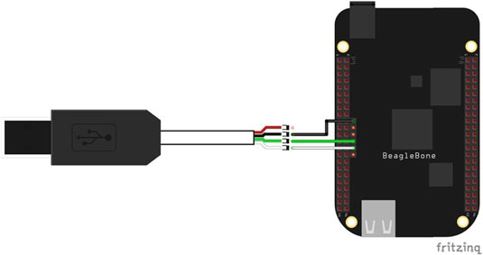
With PuTTY installed, you can establish a serial communication with your BeagleBone Black. Follow these steps:
- Open PuTTY.
- In the PuTTY Configuration dialog box, select Serial.
- Type the name of your BeagleBone Black’s serial port.
Open Device Manager to see the serial port’s name. Press Windows+R, type devmgmt.msc, and press Enter. The name of your BeagleBone’s serial port is listed below Ports.
- Type 115200 in the Speed field.
- Click Open.
- Power on your BeagleBone Black with a Mini USB cable.
You see all sorts of information about the booting process.
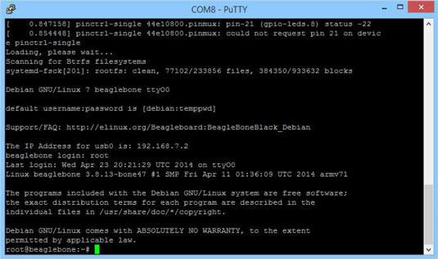
- When you’re asked to log in, type root and press Enter.
- When you’re asked to type a password, press Enter.
By default, no password is set.

Mac OS X and Linux
- Open a new window, as follows:
  - On a Mac, navigate to /Applications/Utilities and double-click Terminal to open a new Terminal window.
  - In Linux, press Ctrl+Alt+T to open a new terminal window.
- Type ls /dev/tty*.
- Connect the USB side of the TTL cable to your computer.
- Connect the wires to J1 headers on your BeagleBone Black:
  - Black wire to Pin 1
  - Green wire to Pin 4
  - White wire to Pin 5
- Type ls /dev/tty*.
Now you can see a new device connected to your computer — in the figure, ttyUSB0.
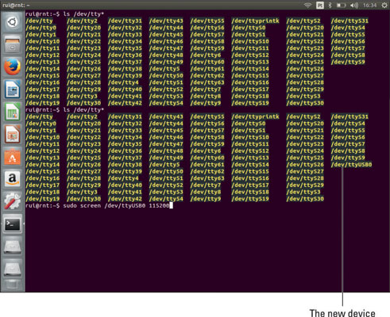
To establish the serial communication, follow these steps:
- Type sudo screen /dev/ttyUSB0 115200.
- Power on your BeagleBone Black with a Mini USB cable.
You see all sorts of information about the booting process.
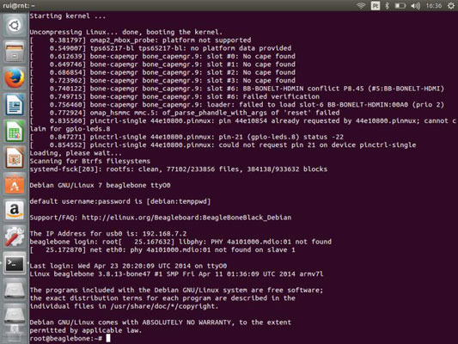
- Enter your computer password, and press Enter or Return.
- When you’re asked to log in, type root and press Enter or Return.
- When you’re asked to type a password, press Enter or Return.
By default, no password is set.

Accessing your BeagleBone with your web browser
With your BeagleBone connected to your computer and with the drivers installed, open this URL in your web browser: http://192.68.7.2. If everything is working, you should see a new web page with a green box at the top that says Your board is connected! That web page is being hosted by your BeagleBone.
Now you can have some fun exploring the menus, which contain a lot of information about and examples of BoneScript.

