Raspberry Pi 3

What is Raspberry Pi 3 ?

It is a Single-board computer with wireless LAN and Bluetooth connectivity.

Operating Systems Supported:
- Android Things
- Arch Linux ARM
- CentOS
- Debian
- Fedora
- FreeBSD
- Gentoo Linux
- Kali Linux
- Kano
- NetBSD
- Plan 9
- Raspbian
- RISC-OS
- Slackware
- SUSE
- Ubuntu Core
- Ubuntu MATE
- Windows 10 IOT Core

Other Features:
System-on-chip used | Broadcom BCM2837
CPU | 1.2 GHz 64/32-bit quad-core ARM Cortex-A53
Memory | 1 GB LPDDR2 RAM at 900 MHz[2]
Storage | MicroSDHC slot
Graphics | Broadcom VideoCore IV 300 MHz/400 MHz
Power | 1.5 W (average when idle) to 6.7 W (maximum under stress)[3]

Accessories Supported:

- Camera
- GertBoard
- IR Camera
- Official Display
- HAT(Hardware Attached on Top) Expansion Boards.

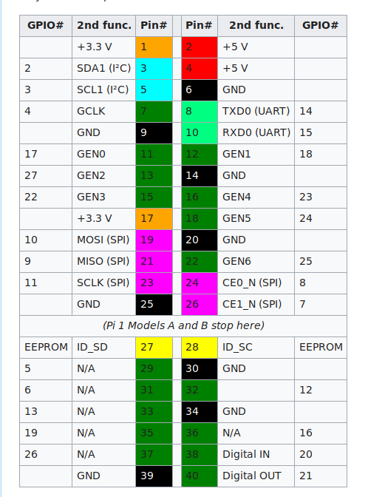
GPIO Pin Diagram of Raspberry PI

Installation

Installing NOOBS on Raspberry Pi

Besides your Raspberry Pi and essential peripherals, here’s all you’ll need:
- A computer with an SD card slot
- An SD or microSD card of at least 8 GB

Step 1: Download NOOBS and extract it

You’re going to use your computer to put NOOBS on an SD card – so step one is to get NOOBS onto your computer!
Click here to head to the NOOBS download page.
The NOOBS download page will let you choose between NOOBS and “NOOBS Lite.” NOOBS includes a full version of Raspbian, so you can install that particular operating system without using the internet at all. With NOOBS Lite, on the other hand, you’ll need a network connection to install any of the operating systems NOOBS makes available – even Raspbian.
Go ahead and choose whichever version you would like. NOOBS will download as a .zip file, so before you do anything else, go ahead and extract it.

Step 2: Format an SD card
Now you’re going to want to go ahead and stick your SD card into the corresponding slot on your computer. You’re going to want to format it as FAT. There are a few ways to do this:
On Mac or Windows, use the SD Association’s Formatting Tool (Mac users can also just use the disk utility). Make sure the “Format size adjustment” option is set to “on.” Then erase it in FAT (or MS-DOS) format.
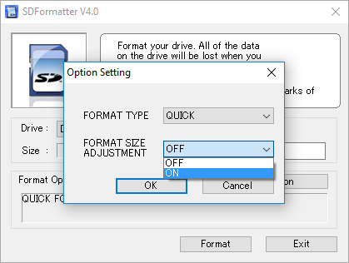

Step 3: Put the NOOBS files on the SD card
Now, just drag and drop the NOOBS files into your newly formatted SD card. You want the files only, so if your .zip extracted to a folder, open that folder up and select only the stuff inside of it.

Step 4: Put your SD card into your Raspberry Pi and boot it up
Once you have NOOBS on your SD card, using it is incredibly easy. Just put the SD card into your Raspberry Pi and start that sucker up. As we said before, while this guide is called “How to install NOOBS on the Raspberry Pi,” the endgame here is actually to install an operating system like Raspbian, LibreELEC, OSMC, or any of the others NOOBS gives you access to.
This is the step in which that happens. After booting to NOOBS, you’ll be greeted with a menu that will let you choose which operating system you’d like to install on your Pi. Your menu may look a little bit different than the one in the screenshot above, because NOOBS ingeniously adapts to your generation and model of Raspberry Pi.
Which OS should you choose? Well, that’s up to you. Raspbian is probably the most frequently used, and you’ll find plenty of projects here on our site that utilize it. OSMC acts as a media center, and LibreELEC boots directly to the popular media center app Kodi. Ultimately, it’s all a matter of personal preference!
Once you’ve decided, just hit “Install” and sit back. From now on, your Pi will boot directly to that operating system.

