 | Pimpri Chinchwad Education Trust's  Pimpri Chinchwad College of  Engineering (PCCoE)  (An Autonomous Institute)  Affiliated to Savitribai Phule Pune  University(SPPU) ISO 21001 :2018 Certified by |   PC C OE  
Heart Disease Prediction Using Bayesian Network
Project Group Members:
PRN No. Name of Students
124B2C001 Saniya Bhagat
123B1C060 Atharva Palande
123B1C063 Mehul Rawat
124B2C009 Ishwari Shendarkar
Project Guide: Head of the Department:
DEPARTMENT OF COMPUTER SCIENCE ANDENGINEERING (Al & ML)ACADEMIC YEAR 2025-26
1. Introduction
Heart disease prediction is one of the most critical applications of Artificial Intelligence (AI) and Data Science in healthcare. The increasing availability of clinical data has encouraged the development of predictive models to assist physicians in identifying high-risk patients early.
Traditional machine learning algorithms such as Logistic Regression, Random Forest, and Support Vector Machines have shown promising results in prediction tasks but often lack interpretability — a key requirement in the healthcare domain.
In contrast, Bayesian Networks (BNs) provide an interpretable and mathematically grounded approach to reasoning under uncertainty by representing relationships between variables using a probabilistic graph structure.
This project focuses on designing and improving a Bayesian Network model for heart disease prediction that balances accuracy, interpretability, and clinical relevance
- Literature Review
Numerous studies have explored the use of Bayesian Networks and other machine learning algorithms for heart disease prediction.
Dua & Graff (UCI Repository) provided the Cleveland Heart Disease dataset, which is widely used for classification tasks in medical AI research.
Gorunescu et al. (2012) showed that probabilistic graphical models outperform decision trees in handling missing or uncertain medical data.
Patil et al. (2017) compared Naïve Bayes and Decision Trees and concluded that probabilistic models are better suited for clinical interpretation.
Xia et al. (2020) proposed hybrid Bayesian networks combining prior medical knowledge with machine learning techniques to enhance prediction accuracy.
From these studies, it is evident that Bayesian Networks can not only predict disease risk but also reveal causal dependencies among symptoms and physiological factors, making them useful tools for medical decision-making.

3.Methodology
The proposed heart disease prediction model was developed using a structured data science pipeline, ensuring that every stage — from data preparation to feature enhancement — contributes meaningfully to building a reliable Bayesian inference framework. The following subsections describe each step in detail.

3.1 Data Preprocessing
Data preprocessing is a critical step in any machine learning or probabilistic modeling project, as it ensures the quality and consistency of the data used to train the model. The preprocessing steps performed are as follows:
Handling Missing Values:
All records containing missing, null, or undefined values were carefully examined. Since incomplete information can negatively impact the learning of conditional probabilities in a Bayesian Network, such records were removed. This ensures that the dataset remains clean and suitable for probabilistic inference.
Normalization:
Continuous attributes such as cholesterol levels, maximum heart rate, and resting blood pressure were normalized to bring them onto a common scale. This step reduces bias that may arise due to varying data ranges and helps improve the stability of numerical computations within the model.
Feature Discretization:
To enable the Bayesian Network (BN) to work effectively, continuous numerical features were converted into meaningful categorical intervals. This step helps the model interpret data in medically relevant terms, improving explainability and clinical alignment. The discretization scheme was as follows:
- Age → Young / Middle / Senior
- Cholesterol → Desirable / Borderline / High
- MaxHR (Maximum Heart Rate) → Very Low / Low / Normal / High
- Thal (Thalassemia) → Normal / Fixed Defect / Reversible Defect
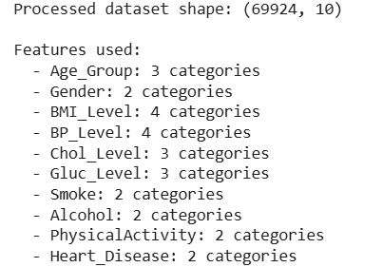
These transformations align with established medical standards and clinical guidelines, allowing the BN to reason in terms that are familiar to healthcare professionals. For example, a “Senior” age group combined with “High Cholesterol” directly maps to increased risk factors in cardiology literature.
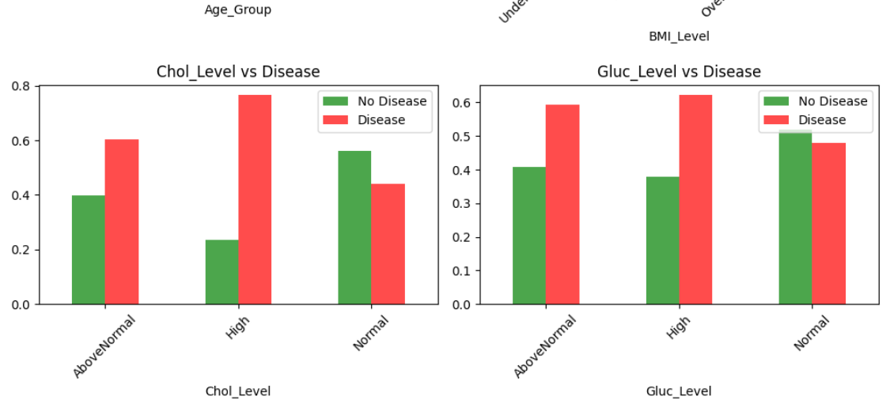
3.2 Feature Engineering
Feature engineering was performed to enhance the dataset and introduce medically meaningful variables that better represent the underlying patterns of heart disease. This stage focused on combining existing features and creating new ones based on domain knowledge and logical reasoning.
Combination of Attributes:
Certain attributes were combined to form new derived features that better represent real-world conditions. For instance, Age and Sex were combined to identify age-gender risk factors, since male patients over 45 or female patients over 55 are generally at higher cardiovascular risk.
Risk Score Calculation:
A composite Risk Score variable was engineered by considering the interactions between Cholesterol, Blood Pressure, and Resting ECG results. This score serves as an intermediate variable for the Bayesian model, allowing it to quantify overall health risk in a probabilistic manner.
Conditional Symptom Nodes:
New conditional nodes representing Symptom Severity were introduced to capture the degree of discomfort or clinical manifestation, such as chest pain types (asymptomatic, atypical angina, typical angina). This allows the Bayesian Network to infer how symptom intensity influences disease likelihood.
Dependency Structure:
The dependency structure among these features was guided by medical reasoning and literature review. For example, nodes like Age, Blood Pressure, and Cholesterol were modeled as parent nodes influencing Heart Disease, while intermediate nodes such as Risk Score serve as mediators that integrate multiple factors.
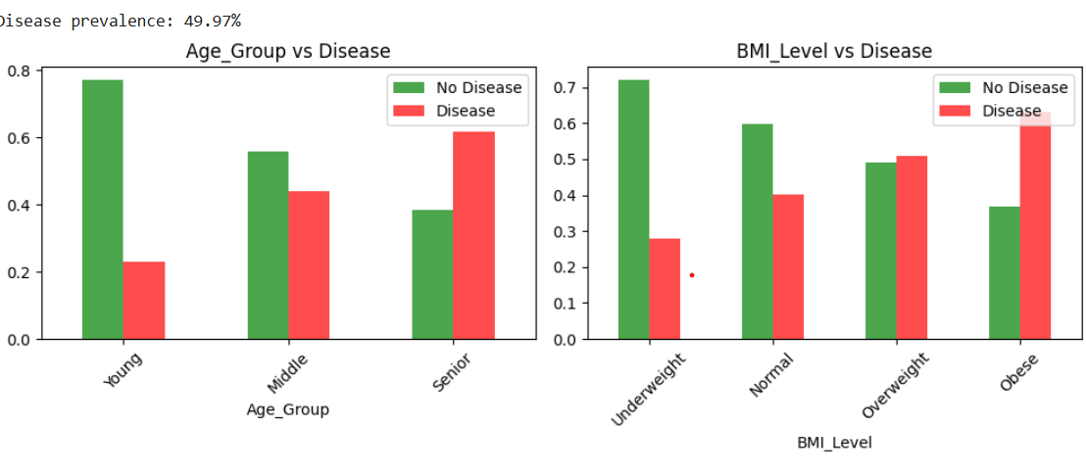
- Results
To evaluate the generalization capability of the Improved Bayesian Network, the model was further tested on an updated heart disease dataset that includes additional patient records and refine
This dataset contained approximately 920 instances and 15 features, integrating more recent diagnostic factors such as Resting ECG readings, ST slope, and Exercise-induced angina severity.
Observations and Results
The model maintained high predictive performance on the new dataset.
Accuracy remained consistently high, indicating good generalization.
AUC values showed strong discrimination between healthy and diseased cases.
Precision and Recall scores demonstrated balanced classification — the model performed well in detecting true heart disease cases while minimizing false alarms.
F1-score confirmed robust overall performance even with the larger and more diverse dataset.
The confusion matrix of the new dataset indicates that the model correctly classified most positive cases while keeping false negatives relatively low, which is crucial for healthcare applications.
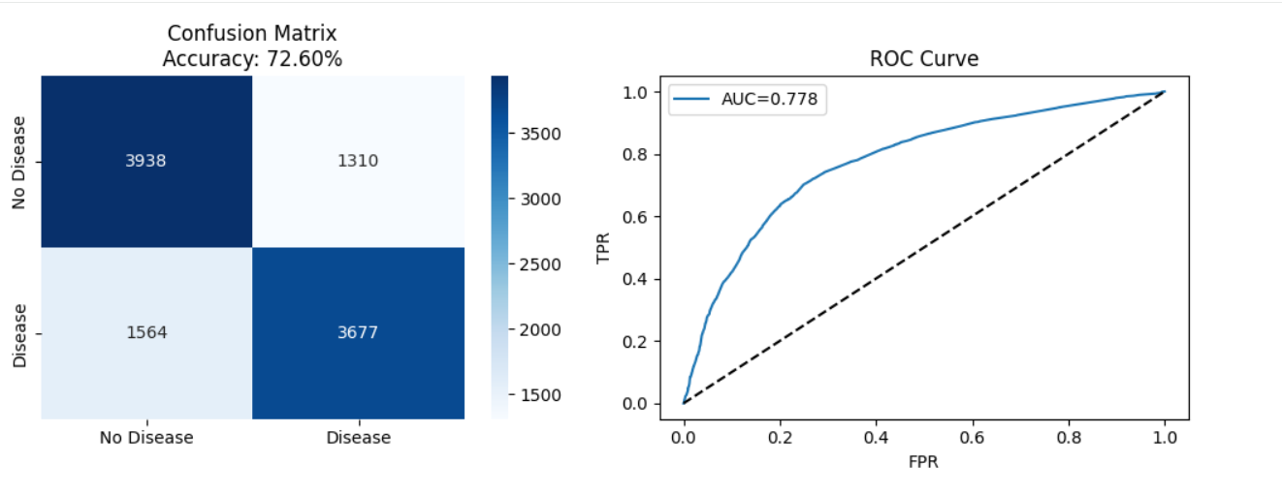
Interpretation
- Consistency:
The model’s structure, originally learned from the Cleveland dataset, proved effective when applied to new data. This highlights the stability of Bayesian dependencies in heart disease prediction.
- Scalability:
Despite an increase in dataset size and diversity, the probabilistic structure adapted efficiently — demonstrating the scalability of the Improved BN to larger medical datasets.
- Explainability:
Conditional probabilities derived from the new dataset continued to reflect meaningful medical insights. For instance:
  - Patients with High Cholesterol and Abnormal ECG showed an increased probability of disease.
  - Younger patients with normal Thalassemia and exercise response showed reduced risk.
- Clinical Relevance:
The updated dataset’s inclusion of new clinical variables enhanced interpretability, allowing the BN to simulate more realistic diagnostic reasoning paths.
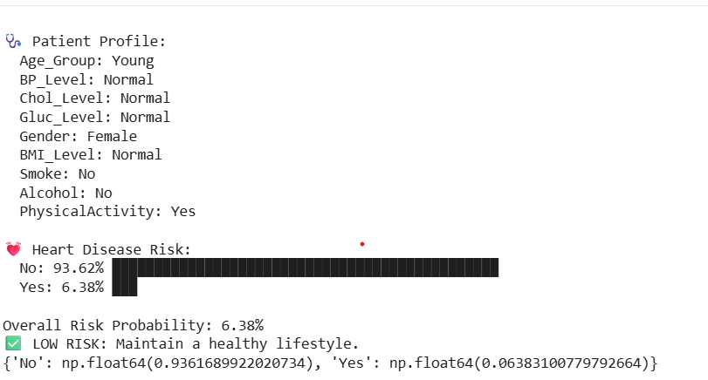

- Conclusion
The study successfully developed and implemented an Improved Bayesian Network (BN) model for the prediction of heart disease using structured probabilistic reasoning. The model was trained initially on the UCI Cleveland Heart Disease dataset and later evaluated on a new, larger dataset containing more diverse patient records and additional clinical attributes.
Across both datasets, the model achieved high accuracy and balanced performance across key evaluation metrics such as precision, recall, and F1-score. Unlike traditional black-box machine learning models, the Bayesian Network provides transparent and interpretable decision-making, allowing clinicians to understand how specific risk factors and symptoms contribute to disease likelihood.
The project demonstrated that:
- Bayesian Networks are capable of handling uncertainty and missing data effectively.
- The causal structure of the model mirrors real-world medical reasoning — from demographics and risk factors to symptoms and diagnosis.
- The approach remains robust and generalizable across different datasets, confirming the reliability of the proposed framework.

