DevOps Practical Questions

- Create AWS instance and connect it to putty
ANS.

🌐 Step 1: Log in to AWS Console
- Go to https://aws.amazon.com/console.
- Sign in with your AWS account.

☁️ Step 2: Launch an EC2 Instance
- In the search bar, type “EC2” and open it.
- Click “Launch Instance.”
- Fill in the details:
  - Name: MyEC2Instance
  - AMI: Choose Ubuntu Server 22.04 LTS (Free tier eligible)
  - Instance type: t2.micro (Free tier eligible)
  - Key pair:
    - Click “Create new key pair.”
    - Name it something like mykeypair.
    - Select “.ppk” as the format (important for PuTTY).
    - Download and save it safely (you’ll need it soon).
  - Network settings:
    - Allow SSH (port 22).
    - Optionally allow HTTP (port 80) if you plan to host a web app later.
  - Storage: Default 8GB is fine.
- Click Launch Instance.

🔍 Step 3: Find Your Instance’s Public IP
- Go to EC2 → Instances → Running Instances.
- Wait until the status shows “running.”
- Copy the Public IPv4 address (you’ll use it in PuTTY).

💻 Step 4: Connect via PuTTY
You’ll use PuTTY (SSH client) to access your instance.
- Open PuTTY.
- In the Host Name box, enter:
- ubuntu@<your_public_ip>
Example:
ubuntu@13.234.12.45
- Go to Connection → SSH → Auth → Credentials.
- Click Browse and select your .ppk key you downloaded earlier.
- Click Open → when prompted “Are you sure?” click Yes.
If all is correct, you’ll see:
Welcome to Ubuntu 22.04 LTS (GNU/Linux ...)
ubuntu@ip-172-31-xx-xx:~$
🎉 You’re connected to your AWS instance!

🧠 Quick Commands to Try
Once inside the terminal:
sudo apt update
sudo apt install nginx -y
Then open your browser → http://<your_public_ip> → you’ll see the Nginx welcome page, confirming your instance is live.

- Install Docker on AWS instance and show the version of it.
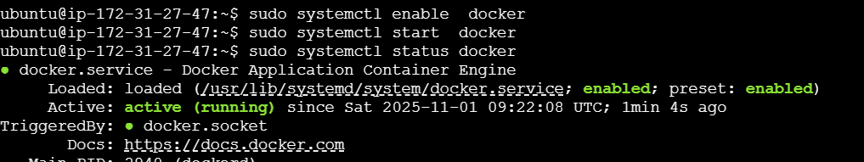
- Install git on AWS instance and show the version of it.
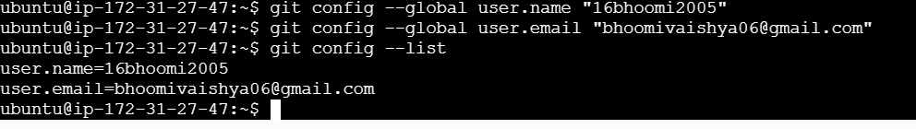

- Compile project in Jenkins using Maven
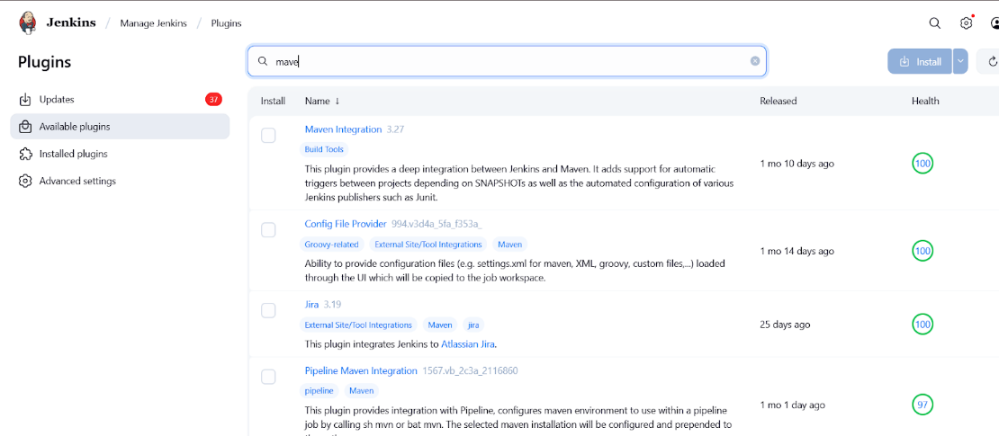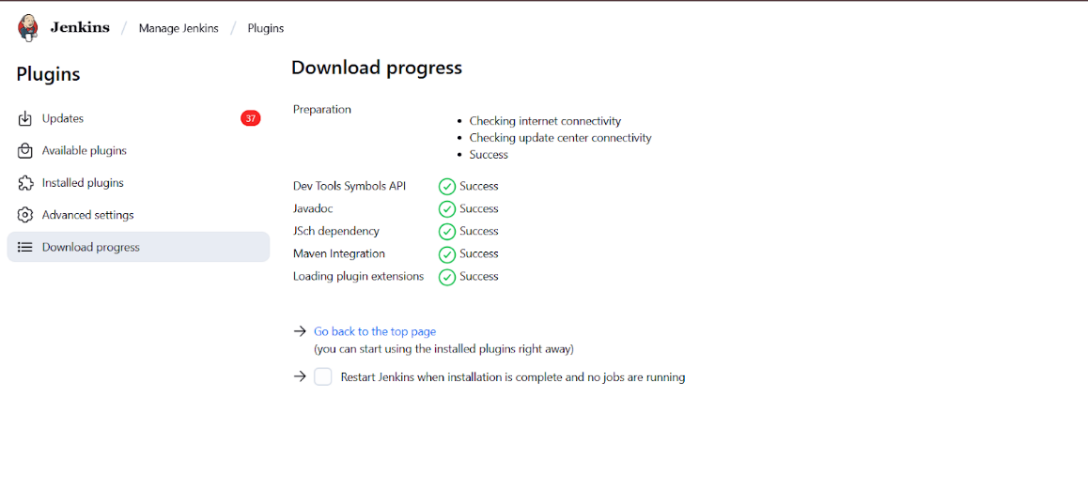
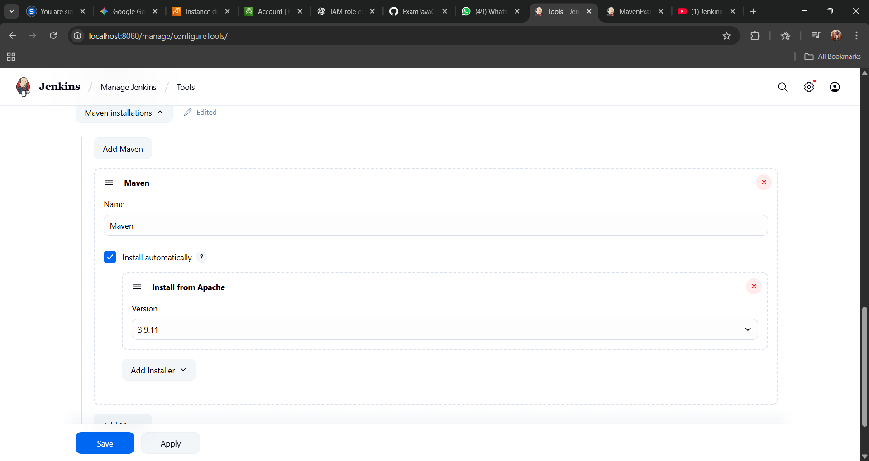
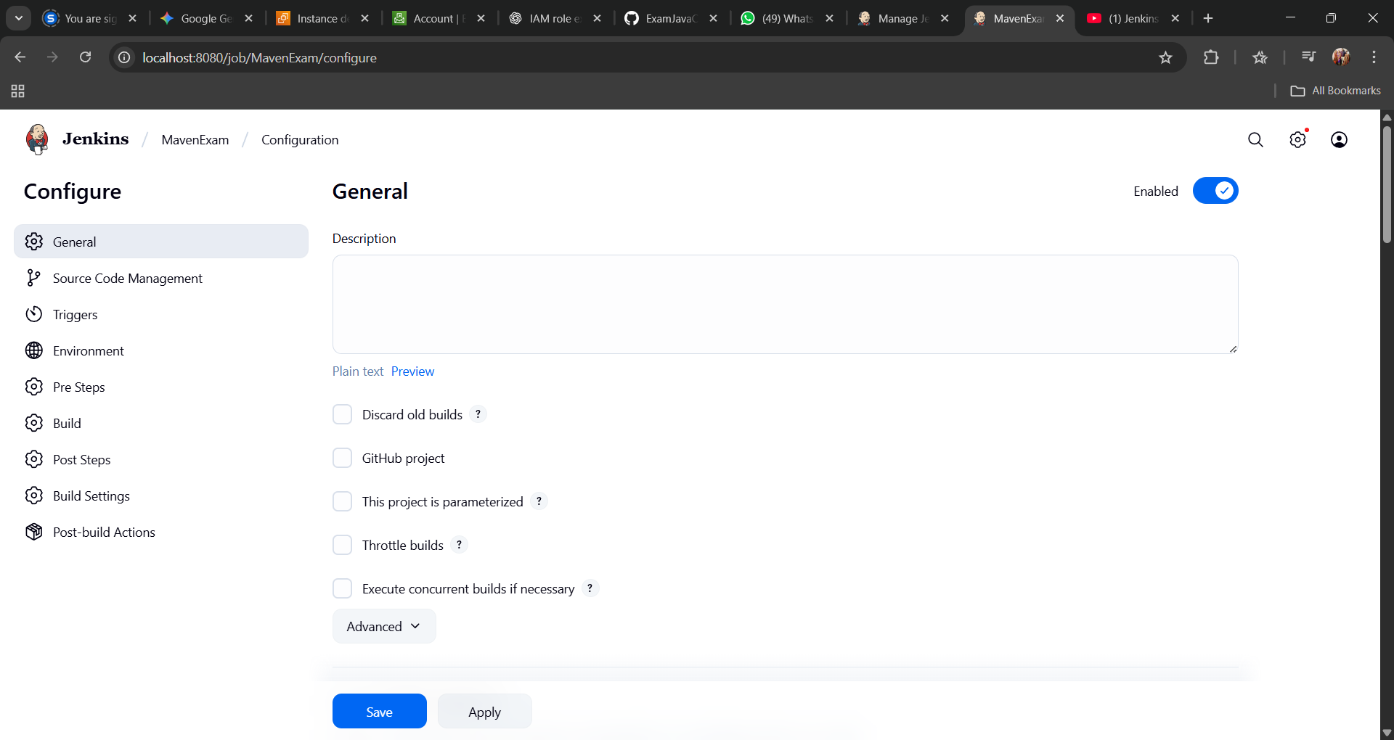
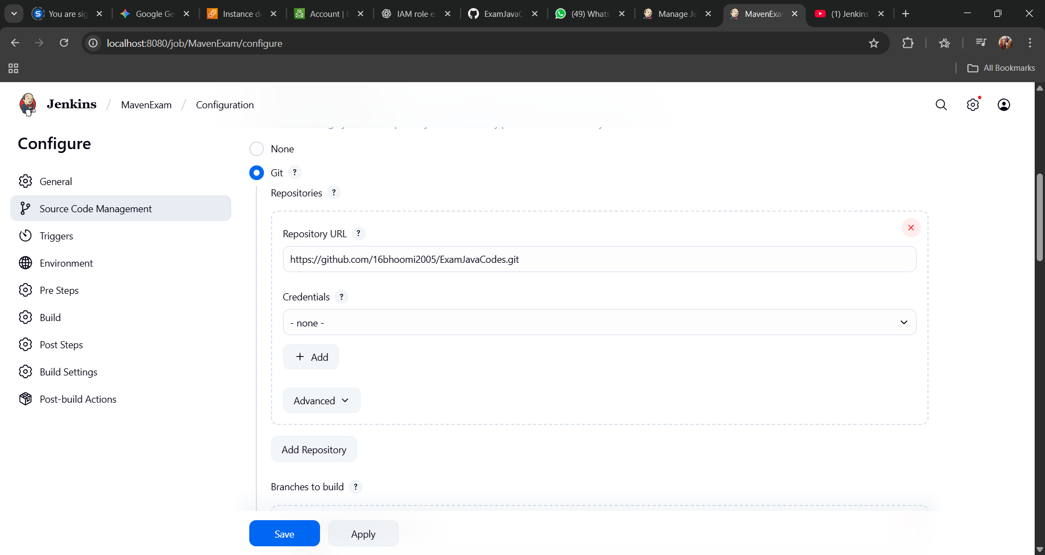
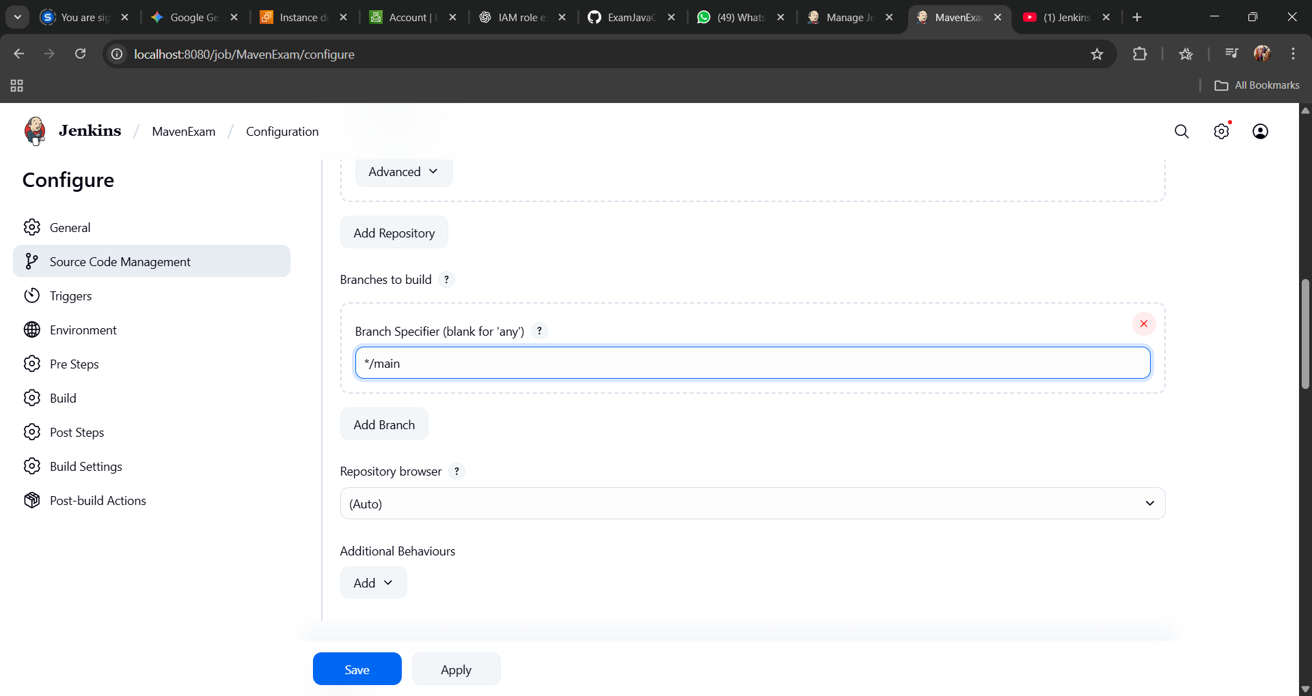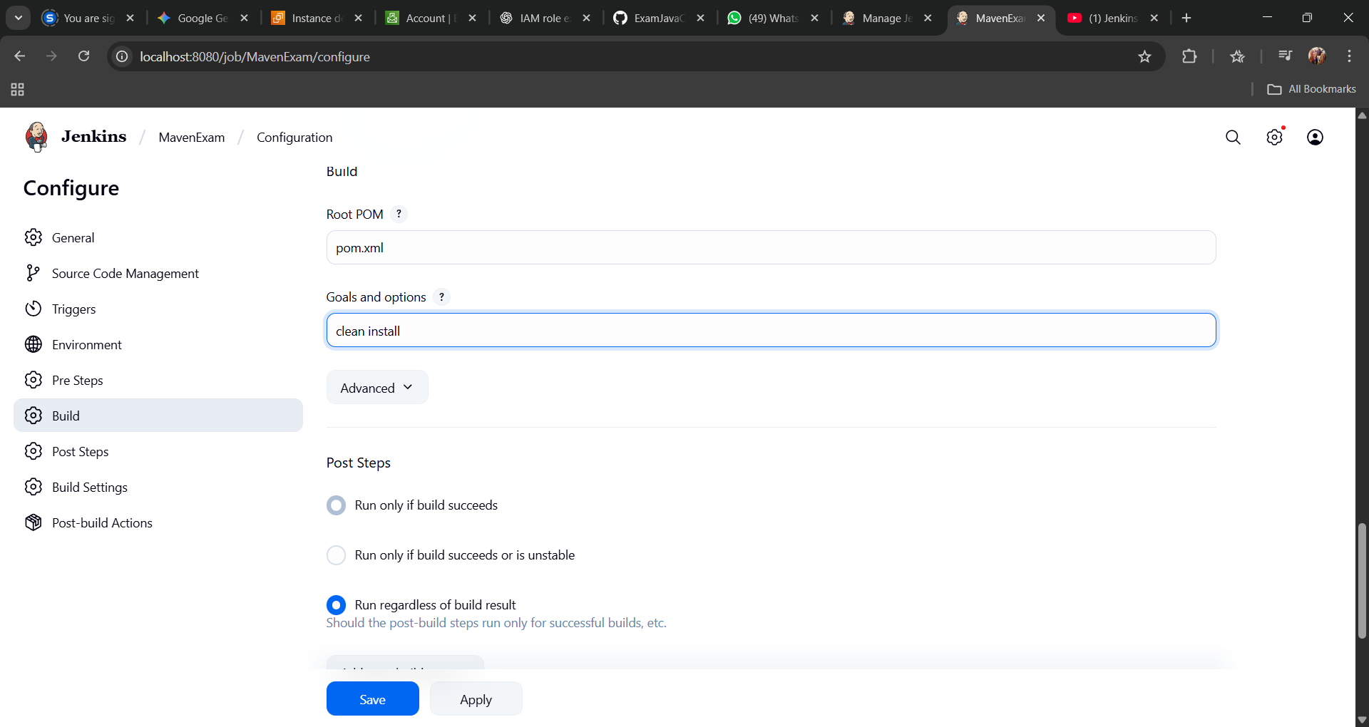
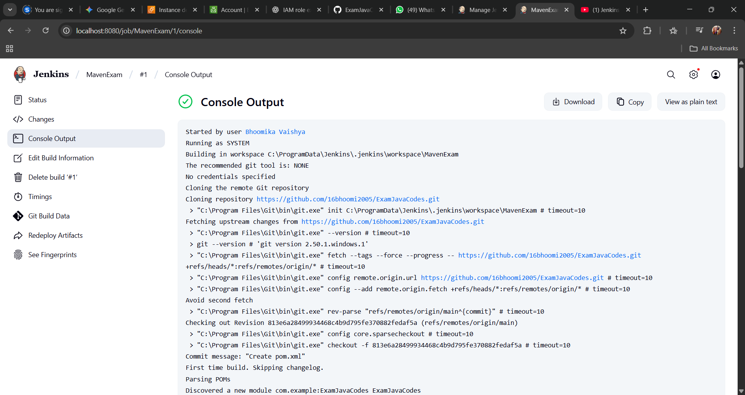
- Create slave node in Jenkins
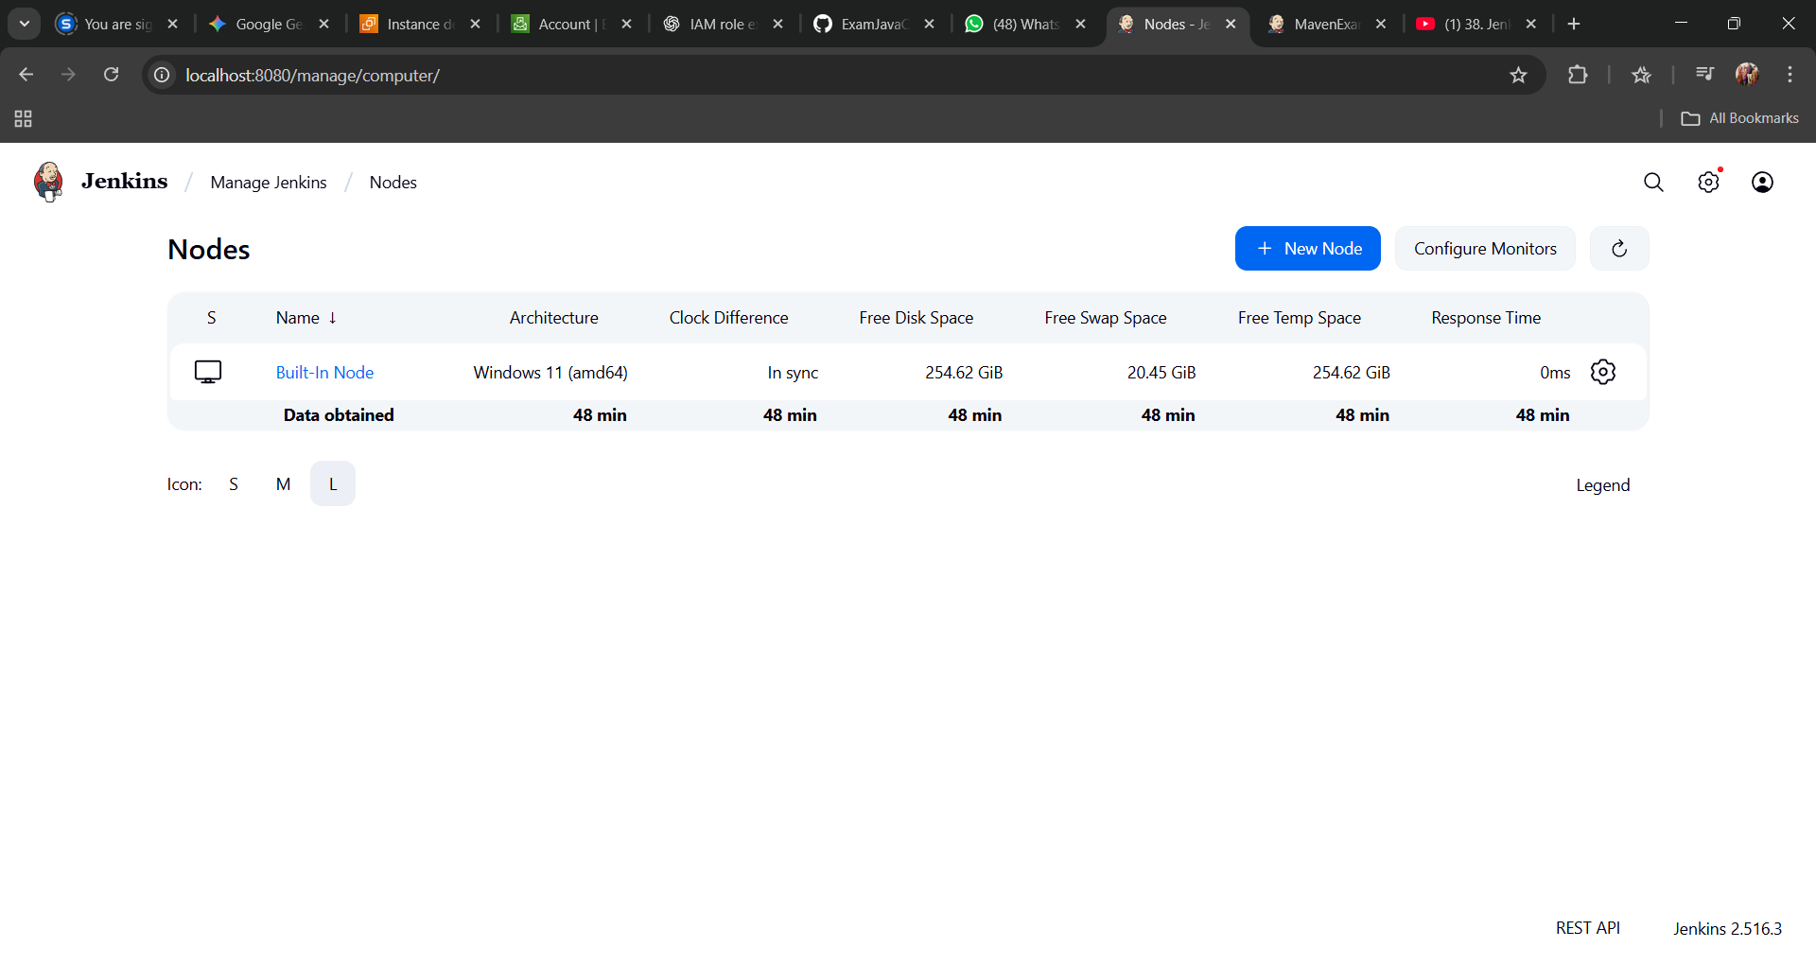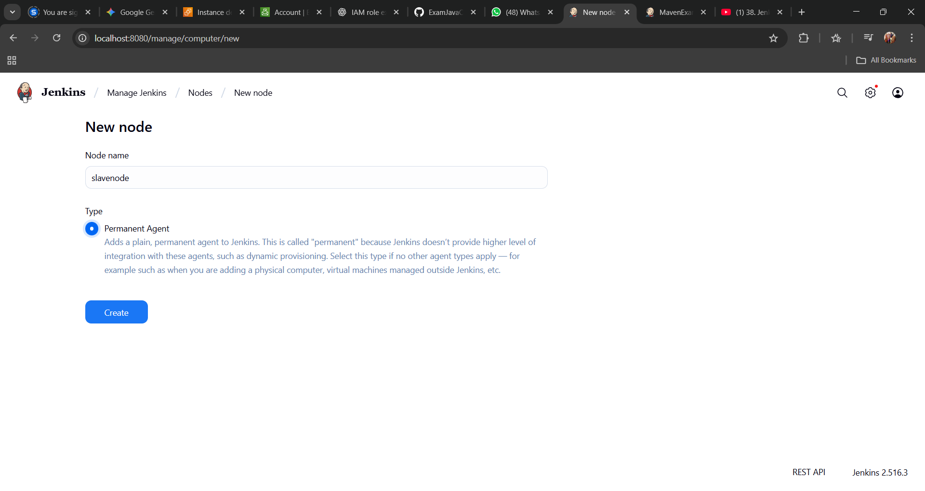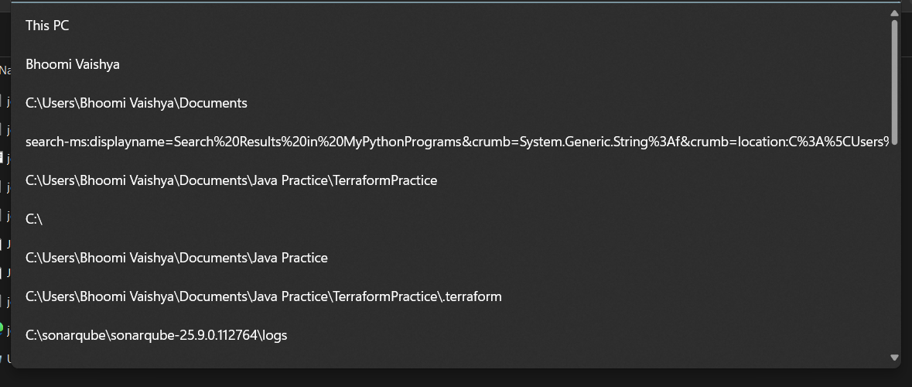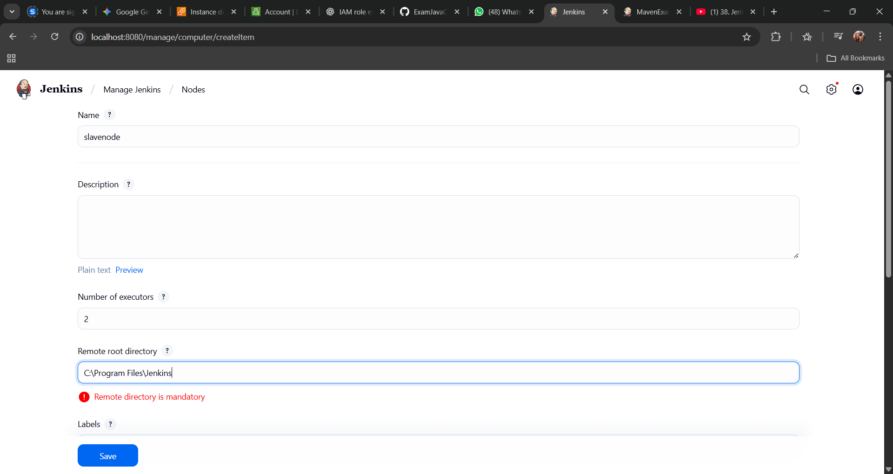
Click Save
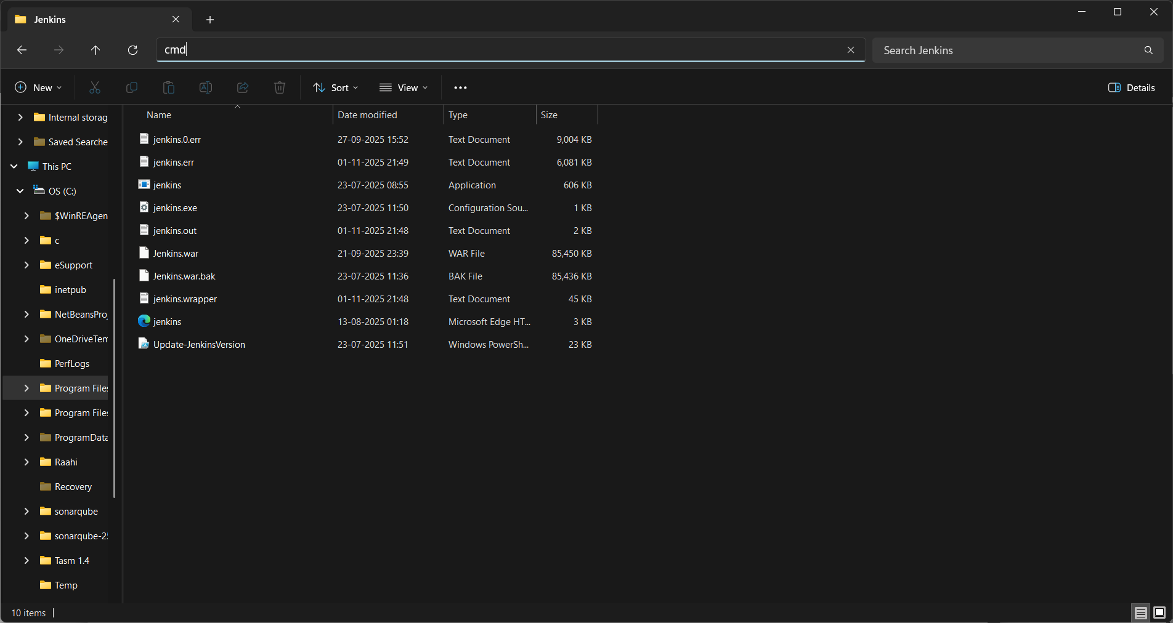
curl.exe -sO http://localhost:8080/jnlpJars/agent.jar & java -jar agent.jar -url http://localhost:8080/ -secret 551df76ad88dd17e549deea51559eebe1c9323e58103b93388ed81ece81c9553 -name slave -webSocket -workDir "C:\Program Files\Jenkins"

Now you wpuld see that node running

- Assign project to slave node and build project
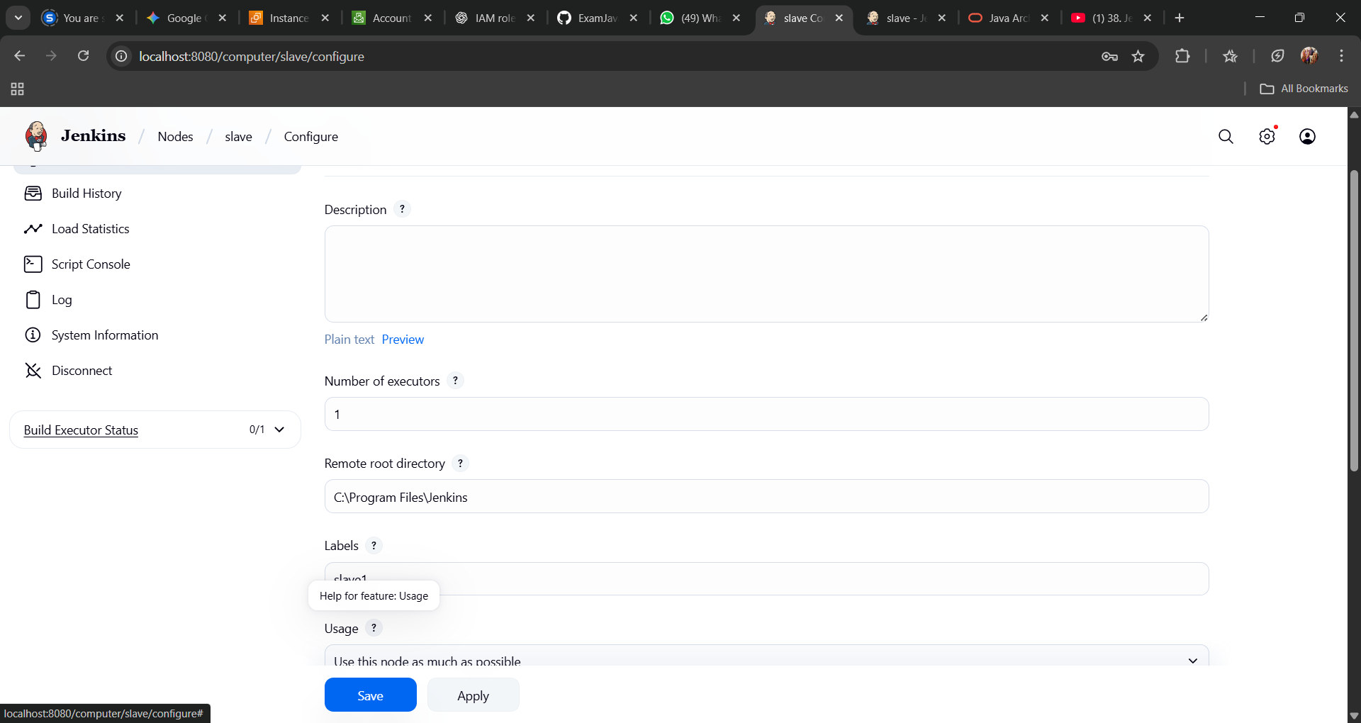
⚙️ Phase 1: Check Your Agent's Label (Prerequisite)
Before you can assign a job to an agent, the agent needs a "name tag" or label that the job can find.
- On your Jenkins dashboard, go to Manage Jenkins > Nodes.
- You will see a list of your agents. Click the gear icon (Configure) next to the agent you want to use.
- Find the "Labels" field.
- Type a simple, descriptive, one-word label here. For example: windows-builder or linux-agent. Make sure there are no spaces. (You can add multiple labels separated by a space, e.g., windows x64 build).
- Click Save.
For this guide, let's assume you used the label build-agent.

🚀 Phase 2: Assign Your Maven Project to the Label
Now you will tell your Maven project, "You are only allowed to run on an agent with the build-agent label."
I will show you two ways: the Freestyle method (which you have been using) and the Pipeline method (the modern standard).
Method 1: For a Freestyle Project
- Go to your Maven project's dashboard and click Configure on the left menu.
- You will be on the configuration page. At the very top, in the General section, find the checkbox: "Restrict where this project can be run"
- Check this box.
- A new text box will appear labeled "Label Expression".
- Type the exact label you created in Phase 1. Example: build-agent
- Click Save at the bottom of the page.
Method 2: For a Pipeline Project (using a Jenkinsfile)
If you are using a Pipeline, this is much simpler. You just need to change the agent line at the top of your Jenkinsfile from agent any to:
agent { label 'build-agent' }
Here is a full example:
Groovy
pipeline {
// This line "assigns" the entire build to an agent
// with the label 'build-agent'.
agent { label 'build-agent' }

stages {
stage('Checkout Code') {
steps {
git branch: 'main', url: 'https-url-to-your-repo.git'
}
}
stage('Build with Maven') {
steps {
// 'bat' is for Windows, 'sh' is for Linux
bat 'mvn clean install'
}
}
}
}

▶️ Phase 3: Run the Build and Verify
Now, just run your project.
- On your project's page, click Build Now.
- Click on the new build number that appears in the "Build History."
- You will immediately see where it is running. The build status will say: "Building on agent [your-agent-name]"
- You can also click Console Output. The very first line will confirm which machine it is on, for example: Running on my-windows-agent in C:\Jenkins\workspace\my-java-app-build

⚠️ A Very Common "Gotcha" (Read This!)
Your build will almost certainly fail the first time you do this.
Why? Because your Maven and JDK are not installed on the agent machine.
The tool settings you configured on the master do not apply to the agent. The agent is a separate machine and needs its own copies of all build tools.
How to Fix: You have two options:
- Install the Tools on the Agent: Log in to the agent machine and install the JDK and Maven, just as you did on the master.
- Use Jenkins Tool Installers (Better): Go to your agent's configuration page (Manage Jenkins > Nodes > Configure Agent). Under the "Node Properties" section, check "Tool Locations". Here you can add paths to the agent's JAVA_HOME and MAVEN_HOME, just like you did in the "Global Tool Configuration" for the master.

- Run Selenium Tests in Jenkins Using Maven
- Build pipeline project in Jenkins

- To Perform various GIT operations on local and Remote repositories
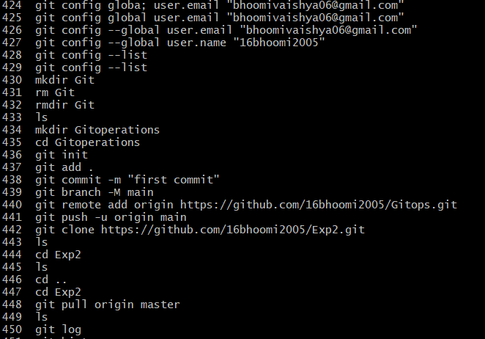

- Pull Ubuntu image in Docker and execute bash
ANS.

🧭 Step 1: Verify Docker is Installed
First, confirm Docker is working correctly on your EC2 instance:
docker --version
If it shows something like:
Docker version 27.0.1, build 1234567
—you’re good to go.
If not, install Docker using:
sudo apt update -y
sudo apt install docker-ce -y
sudo systemctl start docker
sudo systemctl enable docker

🐋 Step 2: Pull the Ubuntu Image
Use the official image from Docker Hub:
sudo docker pull ubuntu
You’ll see output like:
Using default tag: latest
latest: Pulling from library/ubuntu
Digest: sha256:...
Status: Downloaded newer image for ubuntu:latest

🔍 Step 3: Verify Image Download
Check all images available on your system:
sudo docker images
You should see something like:
REPOSITORY TAG IMAGE ID CREATED SIZE
ubuntu latest 1d622ef86b13 2 weeks ago 77.8MB

💻 Step 4: Run a Container and Open Bash
Now, run the Ubuntu container and start an interactive bash session:
sudo docker run -it ubuntu bash
Explanation:
- -i → interactive mode (keeps STDIN open)
- -t → allocates a pseudo-TTY (for a terminal interface)
- bash → starts the bash shell inside the container

✅ Step 5: Confirm You’re Inside Ubuntu Container
Once inside, your prompt will change to something like:
root@c1f4c3f2e3a7:/#
Now you can run Linux commands directly inside this isolated environment, for example:
ls
cat /etc/os-release
You’ll see:
NAME="Ubuntu"
VERSION="22.04 LTS (Jammy Jellyfish)"

🚪 Step 6: Exit the Container
To leave the container’s bash shell:
exit
This will stop the container unless you use --rm or -d options.

🧰 Step 7: List Running and Stopped Containers
Check currently active containers:
sudo docker ps
To see all containers (including stopped ones):
sudo docker ps -a

✅ Summary:
Task | Command
Pull Ubuntu image | sudo docker pull ubuntu
Run with bash | sudo docker run -it ubuntu bash
Exit container | exit
List images | sudo docker images
List containers | sudo docker ps -a

Would you like me to show how to save changes made inside your Ubuntu container as a new custom Docker image (for example, “ubuntu-with-tools”)? That’s the next logical step in container management.

- Pull files from GitHub using git, make changes and push file to GitHub using git
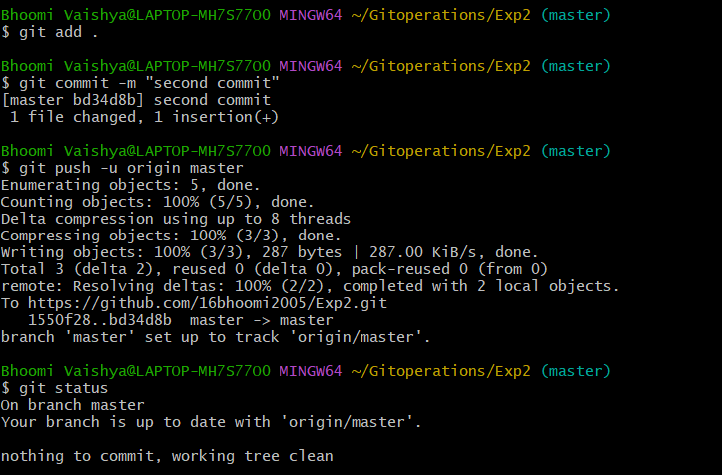
- Pull Docker images, list the Docker images currently stored on your machine, remove an image that you no longer need
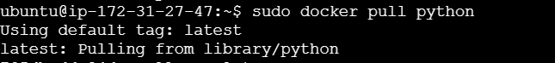
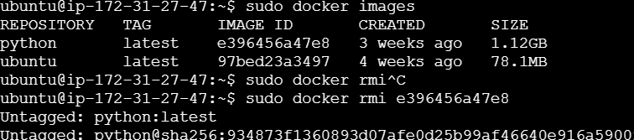
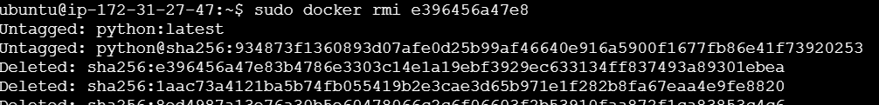
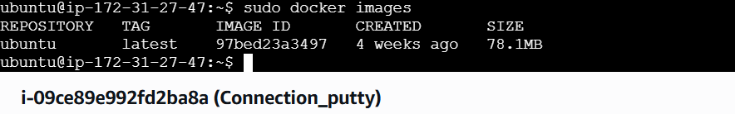
- Execute basic commands in Docker
ANS. Perfect — this is where you really start feeling at home with Docker! Let’s walk through the most important and commonly used Docker commands so you can confidently manage containers and images on your system.
We’ll go hands-on with explanations and examples. 🚀

🧭 Step 1: Verify Docker Installation
Check if Docker is installed and running:
docker --version
Example output:
Docker version 27.0.1, build 1234567

🧱 Step 2: Pull an Image
Download an image from Docker Hub:
sudo docker pull ubuntu

🧩 Step 3: List Images
View all images currently stored on your machine:
sudo docker images

💻 Step 4: Run a Container
Start a new container interactively:
sudo docker run -it ubuntu bash
- -i → interactive mode
- -t → terminal
- bash → open bash shell
When inside, try:
ls
pwd
cat /etc/os-release
Then exit:
exit

🧰 Step 5: List Running Containers
Check which containers are active:
sudo docker ps
Check all containers (including stopped ones):
sudo docker ps -a

🛑 Step 6: Stop and Start Containers
Stop a running container:
sudo docker stop <container_id>
Start it again:
sudo docker start <container_id>
Restart:
sudo docker restart <container_id>

🧼 Step 7: Remove Containers
Delete a stopped container:
sudo docker rm <container_id>
Remove all stopped containers:
sudo docker container prune

🧹 Step 8: Remove Images
Delete an image you don’t need:
sudo docker rmi <image_name_or_id>

📦 Step 9: View Logs and Details
View container logs:
sudo docker logs <container_id>
Inspect detailed container information:
sudo docker inspect <container_id>

🧮 Step 10: Check Disk Usage
See how much space Docker is using:
sudo docker system df

🧾 Quick Summary Table
Task | Command | Description
Pull image | docker pull ubuntu | Download image from Docker Hub
List images | docker images | Show local images
Run container | docker run -it ubuntu bash | Start container interactively
List containers | docker ps -a | Show all containers
Stop container | docker stop <id> | Stop a container
Remove container | docker rm <id> | Delete container
Remove image | docker rmi <id> | Delete image
View logs | docker logs <id> | Show container output
Inspect container | docker inspect <id> | View details
Prune unused data | docker system prune -a | Clean up everything

Would you like me to take this a step further and show basic Docker networking commands next — like linking containers, checking IPs, and connecting to each other inside Docker? It’s super useful for real-world projects.

- Execute basic commands in git
- Create a Git repository, add a new file to the repository, Commit the changes with a meaningful message, Push the changes to a remote repository.
- Set up a basic CI pipeline using a CI/CD tool (e.g., Jenkins), Configure the pipeline to build a simple project (e.g., a "Hello World" application).
- Build a Docker image from the Docker file, run a Docker container using the built image.

