Executive Sales Dashboard and Decision Report
Analysis of the Olist Brazilian E-Commerce Dataset
Project Report
Submitted by: Atharva Shangarwar
Programme: [AICTE | IBM SkillsBuild Data Analytics with AI]
Date: [24/09/2026]

1. Abstract
This project builds an executive decision dashboard for an online marketplace using the public Olist Brazilian E-Commerce dataset. Instead of showing many charts, the work follows the flow Data → Information → Insight → Decision → Action. Six executive KPIs are defined, sales are analysed by product category and region, and two risks are examined: late deliveries and high-value customers who stop ordering. The findings are written as Fact → Insight → Opportunity → Action statements so that a CEO can act on them.
Main result: revenue grew by 141.1% between Jan–Aug 2017 (R$ 2.99 million) and Jan–Aug 2018 (R$ 7.22 million), late deliveries lowered the average review score from 4.29 to 2.27, and 10,912 high-value customers have not ordered for more than 180 days.

2. Introduction
Business Intelligence (BI) is the discipline of turning raw data into decisions. A good dashboard compresses noise into something a leader can act on within seconds. A poor dashboard is a data dump: too many charts, too many filters and no clear message.
This project applies that idea to e-commerce data. The audience is a CEO who needs to know whether the business is healthy, what could go wrong, and what to do next.

2.1 Problem statement
Management of an online marketplace has transaction data but no single view of business health. The task is to analyse the data and present clear KPIs, drivers, risks and recommended actions.

2.2 Objectives
- Clean and combine multiple related tables into one analysis-ready dataset.
- Define and calculate executive KPIs that each have a clear business purpose.
- Identify the main drivers of sales by category and region.
- Identify risks related to delivery performance and customer retention.
- Design a 3-page decision dashboard and write actionable recommendations.

3. Dataset Description
Source: Brazilian E-Commerce Public Dataset by Olist, available on Kaggle (https://www.kaggle.com/datasets/olistbr/brazilian-ecommerce). It contains about 100,000 orders placed between 2016 and 2018 across several linked tables.

File | Content | Key columns
olist_orders_dataset | Order status and dates | order_id, customer_id, order_status, purchase and delivery dates
olist_order_items_dataset | Items in each order | order_id, product_id, price, freight_value
olist_customers_dataset | Customer location | customer_id, customer_unique_id, customer_state
olist_products_dataset | Product details | product_id, product_category_name
product_category_name_translation | English category names | product_category_name, product_category_name_english
olist_order_reviews_dataset | Customer reviews | order_id, review_score

Size after loading: orders 99,441 rows, order items 112,650, customers 99,441, products 32,951 and reviews 99,224.
Limitation: the dataset has no Profit or cost column. Revenue is therefore defined as the item price, excluding freight.

4. Tools and Technologies
Tool | Purpose
Python 3 | Main programming language
pandas and NumPy | Data loading, cleaning, merging and calculation
matplotlib | Charts used in the analysis
Jupyter Notebook | Running and documenting the analysis step by step
Power BI / Tableau Public | Building the 3-page interactive dashboard
GitHub | Storing and sharing the project files
AI assistant | Drafting findings from verified metrics (validated manually)

5. Methodology
The project followed these steps:
- Understand the tables. Identify how tables connect: orders link to items and reviews through order_id, to customers through customer_id, and items link to products through product_id.
- Clean the data. Remove duplicates and keep only what is reliable for analysis (Section 6).
- Merge the tables into a line-item table and an order-level table.
- Calculate KPIs (Section 7).
- Exploratory analysis by time, category and state.
- Risk analysis of delivery performance and customer inactivity.
- Insight writing using the Fact → Insight → Opportunity → Action format.
- Dashboard design as three pages, following the dashboard hierarchy (Section 9).
- AI-assisted review with manual validation of every claim (Section 11).

6. Data Cleaning and Preparation
Decision | Reason
Keep delivered orders only | Cancelled or unavailable orders have no real revenue and no delivery date.
Remove duplicate order_id rows | Prevents double counting.
Use Jan 2017 to Aug 2018 | 2016 has very few orders and late 2018 is incomplete, which would distort trends and growth.
Count customers by customer_unique_id | customer_id changes with each order, so it would overcount people.
Average multiple reviews per order | Some orders have more than one review; one score per order avoids duplicates.
Fill missing category names with 'unknown' | Keeps those orders in revenue totals.
Create delay_days and is_late | Delivery date minus estimated date; a positive value means the order was late.

Orders before cleaning: 99,441. Orders after cleaning: 96,203 (delivered orders from Jan 2017 to Aug 2018). The 96,203 orders contain 109,872 line items.

7. Executive KPIs
Every KPI must have a clear business purpose. If it cannot be explained, it does not belong on the dashboard.

KPI | Definition and purpose | Value | Above fold?
Revenue | Sum of item prices. Shows the size of the business. | R$ 13,179,778 | Yes
Growth % | Jan–Aug 2018 revenue vs Jan–Aug 2017. Shows direction. | 141.1% | Yes
Average Order Value | Revenue divided by orders. Shows value per order. | R$ 137.00 | Yes
Orders | Number of delivered orders. Shows volume. | 96,203 | No
Customers | Unique customers. Shows reach. | 93,096 | No
On-time delivery % | Orders delivered on or before the estimate. Shows service quality. | 93.2% | Small tile

7.1 Choice of top 3 KPIs
Revenue, Growth % and Average Order Value were placed above the fold. Together they answer "is the business healthy?" in five seconds: how big it is, which way it is moving, and how valuable each order is. On-time delivery is added as a small fourth tile because delivery is the main operational risk in this dataset. Profit was not possible because the dataset has no cost data.

8. Analysis and Results

8.1 Revenue trend
Monthly revenue peaked in November 2017 at R$ 987,648, the Black Friday month. Revenue rose steadily from R$ 111,798 in January 2017, then levelled off in 2018. Average monthly revenue was R$ 0.90 million in Jan–Aug 2018 compared with R$ 0.37 million in Jan–Aug 2017. The growth is measured against a small early base, so the 141.1% figure should be read with that in mind.
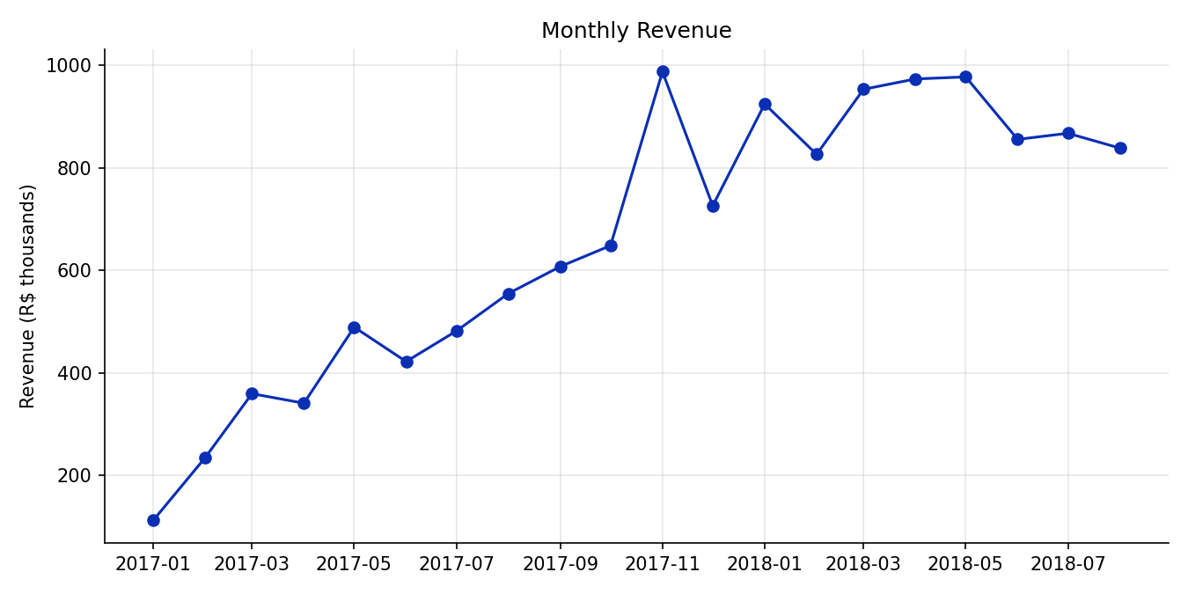
Figure 1: Monthly revenue

8.2 Drivers: category
The top category is health_beauty with 9.3% of revenue, followed by watches_gifts (8.8%) and bed_bath_table (7.8%). The top 3 categories account for 25.9% of revenue and the top 10 for 62.5%. Sales are spread across 72 categories, so no single category dominates.
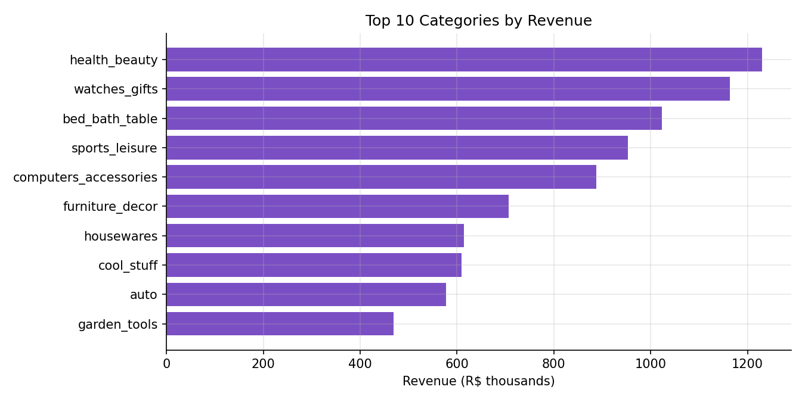
Figure 2: Top 10 categories by revenue

8.3 Drivers: region
The top state is São Paulo (SP) with 38.4% of revenue, followed by Rio de Janeiro (RJ) at 13.3% and Minas Gerais (MG) at 11.7%. These three states together generate 63.4% of revenue.
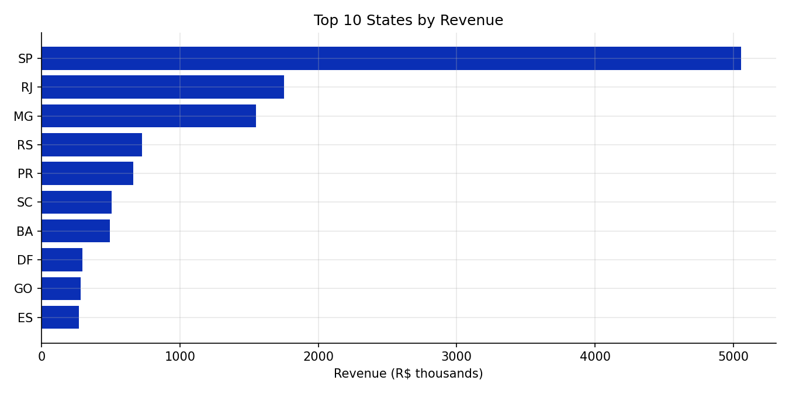
Figure 3: Top 10 states by revenue

8.4 Risk: delivery performance
6.8% of orders (6,531 orders) arrived late. Late orders had an average review score of 2.27 compared with 4.29 for on-time orders. Bad reviews (1–2 stars) were 60.9% for late orders versus 9.2% for on-time orders. Late delivery is the strongest driver of bad reviews found in this analysis.
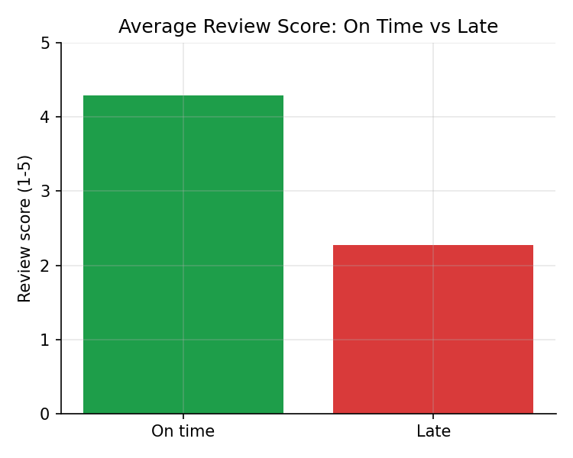
Figure 4: Average review score: on time vs late
Among states with at least 500 orders, Maranhão (MA) has the highest late rate at 17.5%, followed by Ceará (CE) at 13.8% and Bahia (BA) at 12.2%. Rio de Janeiro (RJ), the second-largest state by revenue, also has a 12.1% late rate and an average review of 3.97, compared with 4.5% late and 4.25 for São Paulo. RJ has 1,495 late orders, the second highest count after SP. The peak month, November 2017, had a late rate of 12.4%, about double the overall rate.
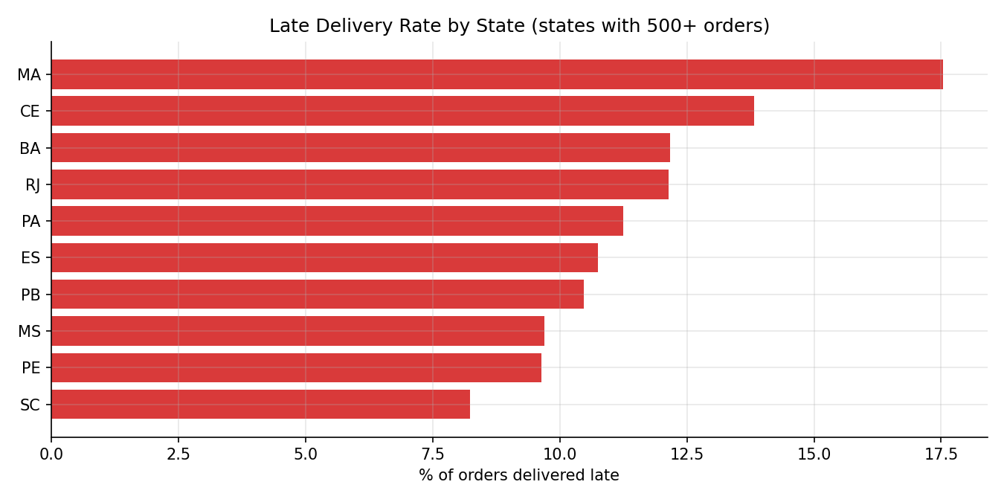
Figure 5: Late delivery rate by state

8.5 Risk: customers
Only 3.0% of customers (2,789 of 93,096) ordered more than once. There are 18,726 high-value customers (top 20% by spend, meaning R$ 179.90 or more in total). Of these, 10,912 (58%) have not ordered for more than 180 days, representing R$ 4,311,606 in past spend. About 93% of this group bought only once, so they are customers who did not return rather than loyal customers who left.
The repeat purchase rate was 3.03% for customers whose first order arrived on time and 2.58% for customers whose first order was late. The difference is small (0.45 percentage points), so late delivery is linked to slightly fewer repeat purchases, but it is not a strong effect in this data.

9. Dashboard Design
The dashboard follows the five-level hierarchy: Level 1 KPIs (what is happening), Level 2 Trends (how is it changing), Level 3 Drivers (why), Level 4 Risk (what could go wrong) and Level 5 Action (what should we do). It is split into three pages so that each audience finds its answer fast.

Page | Focus | Contents
Page 1 | Executive Overview | 4 KPI cards (Revenue, Growth %, AOV, On-time %), monthly revenue trend, one-sentence takeaway
Page 2 | Sales and Product Analysis | Top 10 categories, revenue by state, category share table
Page 3 | Customer and Risk Analysis | Late rate by state, review score on time vs late, repeat rate, at-risk high-value customers

Design rules: at most two or three filters (year and state), one clear message per page, and no chart without a purpose.

10. Insights and Recommendations
Each insight follows the executive communication format: Fact → Insight → Opportunity → Action.

10.1 Growth
Step | Statement
Fact | Revenue grew 141.1% year over year (R$ 2.99 million in Jan–Aug 2017 to R$ 7.22 million in Jan–Aug 2018).
Insight | São Paulo generates 38.4% of revenue, and SP, RJ and MG together generate 63.4%. health_beauty leads categories with 9.3%.
Opportunity | Growth depends on a few regions and categories, so extra investment there can have a large effect.
Action | Keep investing in SP, RJ and MG and in the top categories (health_beauty, watches_gifts, bed_bath_table), and test growth in mid-sized states once their delivery is fixed.

10.2 Delivery risk
Step | Statement
Fact | Late orders average 2.27 stars vs 4.29 for on-time orders; 6.8% of orders are late, and 60.9% of late orders get a 1–2 star review.
Insight | Maranhão has the highest late rate (17.5%). Rio de Janeiro is the biggest concern by impact: 12.1% late, 1,495 late orders, and a lower review score (3.97). November 2017 had a 12.4% late rate.
Opportunity | Improving delivery in the worst states can raise review scores.
Action | Work with carriers in RJ, BA, CE and MA, set more realistic delivery estimates there, and add delivery capacity before peak periods such as Black Friday.

10.3 Customer risk
Step | Statement
Fact | Only 3.0% of customers ordered more than once.
Insight | 10,912 high-value customers have not ordered for 180+ days (R$ 4,311,606 past spend); 93% of them bought only once.
Opportunity | Winning back even a small share of these customers is low-cost growth.
Action | Launch a targeted win-back offer for inactive high-value customers.

11. AI-Assisted Analysis and Validation
An AI assistant was used as an executive analyst. It was given only verified metrics from the notebook and asked for 5 key findings, 3 risks, 3 opportunities and 5 recommended actions.
Every AI-generated statement was checked against the notebook output and the dashboard before use. Statements that could not be matched to a computed number were removed. AI was used to help draft wording, not to produce numbers.

12. Limitations
- No Profit or cost data, so Revenue is used instead of profit.
- Churn is approximated as no order for 180+ days among high-value customers; most customers order only once, so a classic churn model is not suitable.
- The 141.1% growth is measured against a small early base (Jan–Aug 2017), so it overstates the long-term growth rate.
- The at-risk customer count is large because 97% of customers buy only once. It measures customers who did not return, not loyal customers who stopped buying.
- The data covers 2017 to 2018 only, so seasonality across more years cannot be confirmed.
- Findings show association, not proof of cause. For example, late delivery is linked to lower reviews, but other factors may also play a role.

13. Conclusion and Future Work
The analysis shows that revenue grew 141.1% year over year and that sales are concentrated in three states (SP, RJ and MG, 63.4% of revenue). The largest risks are late deliveries, which cut the average review score from 4.29 to 2.27 and are worst in MA, CE, BA and RJ, and 10,912 high-value customers who have not returned in over 180 days. The recommended actions are to improve delivery performance in the worst states and before peak periods, and to run a win-back offer for high-value customers.

Future work
- Add cost or margin data to measure Profit.
- Build a repeat-purchase prediction model.
- Track delivery and review KPIs monthly on a live dashboard.
- Test the recommended actions with a small pilot and measure the result.

14. References
- Olist. Brazilian E-Commerce Public Dataset by Olist. Kaggle. https://www.kaggle.com/datasets/olistbr/brazilian-ecommerce
- Bharat Cares and IBM SkillsBuild. Business Intelligence and Dashboard Design masterclass.
- pandas documentation: https://pandas.pydata.org/docs/
- matplotlib documentation: https://matplotlib.org/stable/

