QWeave Three Week Team Execution Plan
Four-person work division, integration rhythm, and submission gates
Team: Shrivardhini N | Atharva Sheersh Pandey | Diptesh Das | Haridasu Sreedhar
Guide: Prof. Bhuvaneswari M | Planning horizon: 21 days | Version: 1.0

Operating Principle
The team should work in parallel but integrate daily. Each workstream has one directly responsible owner and one reviewer. Proofs are not a separate writing exercise at the end: every formal invariant must be paired with an implementation assertion and test during development. The allocations below are a balanced starting point and may be swapped if skills differ.
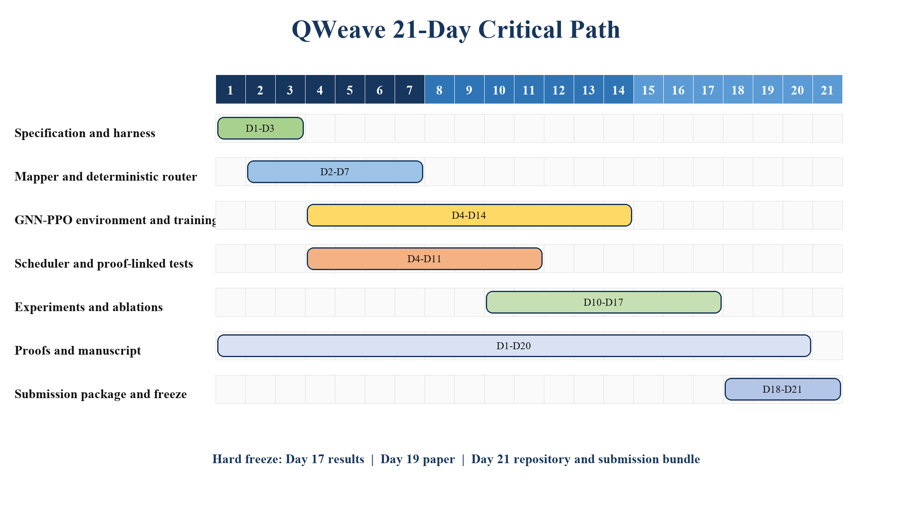
Figure 1. Twenty-one-day critical path. Workstreams overlap, but result and manuscript freezes are fixed.

1 Role Allocation
Person | Primary ownership | Secondary ownership | Final accountable outputs
Atharva Sheersh Pandey | Integration lead; Qiskit IR, target adapter, experiment harness | Repository, CI, final artifact build | End-to-end compiler command; immutable experiment records; release tag
Shrivardhini N | Mathematical lead; formal model, proofs, equivalence strategy | Paper methods and limitations | LaTeX theorem section; proof-to-test matrix; correctness review
Diptesh Das | Deterministic optimisation lead; initial mapping, fallback router, baselines | Small-instance CP-SAT oracle | Mapper and fallback modules; SABRE/oracle comparisons; ablation outputs
Haridasu Sreedhar | Learning lead; Gymnasium environment, GNN, masked PPO | Training diagnostics and topology generalisation | Policy code and checkpoints; training logs; learning ablations

Guide checkpoint. Prof. Bhuvaneswari M should review the frozen research question on Day 2, the proof boundary and preliminary pipeline on Day 8, the result interpretation on Day 17, and the final manuscript on Day 20.

2 Review Pairing and Bus-Factor Control
Workstream | Owner | Reviewer | Required handoff artifact
Compiler integration | Atharva | Diptesh | Interface tests and sample routed circuit
Formal proofs | Shrivardhini | Atharva | Assumption list, theorem source, linked assertions
Mapper/fallback/baselines | Diptesh | Shrivardhini | Objective trace, termination tests, baseline parity
GNN-PPO | Haridasu | Atharva | Environment checker, masked-policy tests, training dashboard
Scheduler | Shrivardhini | Diptesh | Feasibility tests, lower-bound calculations, makespan report
Statistics and figures | Atharva | Haridasu | Frozen analysis script and regenerated figures
Manuscript | Shrivardhini | All authors | Compiled PDF, response checklist, contribution statement

3 Daily Plan
Day | Focus | Parallel assignments | Exit evidence
1 | Kick-off and scope freeze | Atharva: repo/env spike. Shrivardhini: formal objects. Diptesh: baselines and mapper spec. Haridasu: RL state/action draft. | One-page research contract; repository skeleton; initial bibliography.
2 | Interfaces and datasets | Agree dataclasses and target adapter. Select circuits/topologies and create train/validation/test manifest. | Interface document; immutable split manifest; guide review.
3 | Baseline gate | Run Qiskit SABRE and basic routing on smoke circuits. Establish metrics and validation skeleton. | Baseline CSV/JSON; reproducible seed; Gate A passed.
4 | Core implementations | Mapper and scheduler coding; Gymnasium environment scaffold; theorem assumptions and invariants. | Unit tests for graphs, mapping, ready set, resources.
5 | Deterministic routing | Implement fallback shortest-path router and final-layout bookkeeping; policy feature builder. | Legal routed outputs on paths/grids; mapping trace.
6 | End-to-end deterministic path | Integrate mapper, fallback, scheduler, validation; implement GNN actor-critic forward pass. | One command compiles smoke suite; PyG tensors validated.
7 | Core gate | Stress deterministic pipeline and exact oracle on tiny cases; fix interfaces before learning integration. | Gate B passed; no open interface redesign.
8 | Masked policy integration | Connect GNN scores to edge actions and EXECUTE; prove/verify zero probability for illegal actions. | Environment checker passes; action-mask property tests.
9 | PPO rollout | Implement trajectory buffer, GAE, clipped loss, entropy and value losses; start tiny curriculum. | Short training run improves shaped return without invalid actions.
10 | Scheduler feedback | Feed realised or incremental depth signals into routing reward; monitor fallback and cycles. | Reward decomposition logs; scheduler lower-bound report.
11 | Learning gate | Run end-to-end learned routing on validation circuits; profile bottlenecks and memory. | Gate C learning milestone; selected architecture fixed.
12 | Curriculum and tuning | Limited hyperparameter search on validation set only; expand circuit width/topology diversity. | Candidate configs and deterministic comparison notebook/script.
13 | Robustness | Topology holdout evaluation, failure analysis, watchdog tuning, proof assumption audit. | Generalisation table draft; failure taxonomy.
14 | Training freeze | Choose one primary model and one backup. Freeze reward weights, architecture, seeds, and timeouts. | Signed configuration hash; test set still unopened.
15 | Main experiments | Run all baselines and QWeave on test circuits. Validate every output and preserve failures. | Per-circuit raw result bundle, run manifests, logs.
16 | Ablations and statistics | Run required ablations; calculate paired deltas, bootstrap intervals, tests, and effects. | Tables and main plots regenerated from scripts.
17 | Results freeze | No method changes. Review anomalies, timeouts, and negative results; write exact claims. | Gate D passed; result table frozen and checksummed.
18 | Paper assembly | Integrate methods, proofs, experiments, results, threats, data statement, and related work. | Complete first full manuscript; all figures final-size readable.
19 | Manuscript freeze | Internal review for claim/evidence alignment, citations, theorem assumptions, and reproducibility. | Gate E draft; no new experiments unless correcting an error.
20 | Guide and venue review | Apply guide feedback; format target template; anonymise if required; verify quartile/scope and costs. | Submission-ready manuscript, supplement, cover letter draft.
21 | Release and submission bundle | Fresh-clone reproduction test; tag repository; archive release; final author approvals. | Release artifact, final PDFs/source, checklist, submission package.

4 Person-Level Deliverables

Atharva Sheersh Pandey
- Qiskit pass integration and CLI
- Target/circuit adapters and shared dataclasses
- Experiment runner, configuration hashing, CI, release
- Statistical aggregation and regenerable figures
- Final repository and artifact reproducibility test

Shrivardhini N
- Formal problem model and assumption register
- Mapping, legality, equivalence, scheduler, and termination proofs
- Depth-aware scheduler and feasibility checker
- Proof-linked property/equivalence tests
- Methods, theory, limitations, and final manuscript integration

Diptesh Das
- Weighted interaction graph and initial mapping
- Strict-improvement local search and trace
- Deterministic shortest-path fallback
- SABRE/basic baselines and small CP-SAT oracle
- Mapper/fallback/oracle ablations and runtime analysis

Haridasu Sreedhar
- Gymnasium environment and graph observations
- PyG message-passing actor-critic
- Masked edge-action distribution and PPO trainer
- Curriculum, checkpoints, diagnostics, and topology holdout
- No-GNN/no-shaping/no-learning ablations

5 Daily Integration Rhythm
- 09:00-09:15: stand-up. State yesterday's evidence, today's measurable exit, and blockers.
- 13:00: interface checkpoint. Merge contract changes before dependent work continues.
- 18:00: integration window. Owner demonstrates tests/results; reviewer approves or returns specific issues.
- 18:30: automated smoke run and artifact upload. Main must remain green overnight.
- Twice weekly: 30-minute claim audit. Each manuscript sentence labelled proof, measured result, interpretation, or future work.

5.1 Pull Request Rules
- One logical change per pull request; no direct commits to main after Day 3.
- Every algorithm change includes or updates tests and a short complexity/assumption note.
- Every experiment change updates a versioned config; never overwrite raw results.
- Proof-affecting code requires mathematical-lead review. Metric-affecting code requires integration-lead review.
- A reviewer reproduces one representative command before approval.

6 RACI for Critical Decisions
Decision | Responsible | Accountable | Consulted | Informed
Research question and scope | All | Guide + Atharva | All | All
Formal assumptions and theorem wording | Shrivardhini | Shrivardhini | Atharva, Diptesh | Haridasu
Compiler interfaces | Atharva | Atharva | Diptesh, Haridasu | Shrivardhini
Reward and model architecture | Haridasu | Haridasu | Shrivardhini, Atharva | Diptesh
Baseline and oracle settings | Diptesh | Diptesh | Atharva, Shrivardhini | Haridasu
Results freeze and paper claims | All | Guide + Shrivardhini | All | All
Venue and submission | Atharva, Shrivardhini | Guide | All | All

7 Risk and Contingency Plan
Risk trigger | Immediate response | Protected paper contribution
PPO fails to beat heuristic by Day 13 | Stop broad tuning; use learned reranking on a small candidate set or present negative ablation honestly | Proof-backed safe compiler and rigorous evaluation remain
Training too slow | Reduce width/curriculum; parallelise environments; freeze deterministic core | Correctness, mapper, scheduler, oracle comparisons
Equivalence failures | Block experiments; isolate final-layout or direction/decomposition bug | No invalid result enters the paper
Exact solver times out | Restrict oracle to tiny instances and report optimality bounds/timeouts | Oracle remains a sanity reference
Insufficient novelty for Q1/Q2 | Strengthen proof-to-implementation linkage and topology-holdout evidence; do not inflate claims | Submission may move to a better-fit venue after advisor review
One member unavailable | Reviewer assumes owner role using mandatory handoff artifacts | Daily integration prevents single-person knowledge silos

8 Freeze Checklists

8.1 Day 14 Training Freeze
- Primary and backup checkpoints selected
- Config, environment, split, and source commit hashes recorded
- No test data inspected
- Reward components and metric code unit-tested
- Fallback threshold fixed

8.2 Day 17 Results Freeze
- All outputs validated
- All failures/timeouts included
- Ablations complete
- Paired statistics regenerated
- Claims written with exact numbers and uncertainty
- Raw results immutable

8.3 Day 21 Submission Freeze
- Fresh-clone reproduction passes
- Paper source compiles without warnings affecting output
- Author names, affiliations, emails, order, and contributions approved
- Venue scope/quartile/cost rechecked
- Ethics, data, code, conflict, and AI-use statements complete
- Repository release archived and cited

9 Final Team Rule
If a feature does not strengthen the main claim, a proof obligation, a required baseline, or reproducibility, it is out of scope until after submission. Depth minimisation is the headline; safety, correctness, and transparent evidence are what make the headline publishable.

