Chronos: A Content-Addressed Versioned Data Store: A Git-Inspired Approach to Structured Data Versioning Using Merkle Search Trees
[Adhyan Jain]¹, [Atharva Sheersh Pandey]¹
¹Department of Computer Science and Engineering, VIT Vellore
adhyan.jain2024@vitstudent.ac.in, atharva.sheersh2024@vitstudent.ac.in
Guide: Dr. Poornima N, VIT Vellore

Abstract
Versioning structured datasets requires durable history, efficient sparse updates, historical reconstruction, and comparison without copying or scanning every record. Chronos is a Python prototype built around an immutable fixed-depth Merkle hash trie. A commit rewrites only affected leaf buckets and the union of their ancestor paths; unchanged subtrees are reused by content hash. Chronos-H adds addressed changesets and selects between log aggregation and hash-pruned tree differencing using a separately calibrated threshold. We evaluate Snapshot, Log-only, forced-Merkle Chronos-M, Chronos-H, and Dolt 2.3.1 on identical deterministic workloads up to 100,000 rows. The audited paper run contains 333 successful and correct trials. Under the CLI-facing protocol, Chronos-H diff latency was 5.8x to 554.2x lower than Dolt and its incremental commit latency was 2.3x to 37.4x lower, while Chronos-H consumed 1.83x to 6.43x more repository storage. Against forced Merkle, the hybrid log path reduced median sparse or hot diff latency by 6.0x to 10.0x. A five-configuration sensitivity study shows that the current b=8, d=4 trie minimizes storage in the tested set, whereas b=8, d=3 favors latency. The results support a workload-dependent hybrid design, not universal superiority over a production SQL system.

1 Introduction
Version control for structured data is more than archiving files. A useful system must retain exact versions, apply sparse mutations without rebuilding the complete state, reconstruct historical versions, and identify changes efficiently. Git demonstrates the value of immutable content-addressed objects and parent-linked commits [7], but its tree model is file-oriented. Structured records introduce stable keys, diverse mutation densities, and comparisons that may span either a few operations or many commits.
Chronos studies whether a deliberately simple fixed-depth Merkle hash trie can combine incremental structural sharing with an operation index. The primary model, Chronos-H, selects a log path for short or sparse history intervals and a Merkle path for intervals whose accumulated operations exceed a frozen calibration boundary. SQLite supplies an atomic durable object container; it does not define the versioning algorithm.
Dolt is the production comparator because it combines SQL semantics, a Git-style commit graph, and content-addressed Prolly Trees [8], [9]. Chronos is not presented as a feature replacement for Dolt. The comparison instead identifies the performance and storage trade-offs of a smaller instrumentable mechanism under a reproducible CLI-facing protocol.

1.1 Research Questions
- RQ1: What latency and storage trade-offs does Chronos-H exhibit against Snapshot, Log-only, and Dolt across dataset size, mutation density, and locality?
- RQ2: Does adaptive log/Merkle selection improve diff latency relative to a forced-Merkle ablation without changing correctness?
- RQ3: How sensitive are fixed-trie latency, storage, and examined work to branching factor and depth?

1.2 Contributions
- A canonical SHA-256-addressed fixed-depth trie with incremental multi-key path rewriting.
- A hybrid diff policy combining addressed changesets with hash-pruned tree comparison.
- An atomic SQLite repository that persists objects, commits, aliases, metrics, and HEAD and verifies hashes after reopen.
- A five-variant benchmark with shared deterministic workloads, correctness oracles, Dolt integration, raw evidence, and an independently audited summary.
- A controlled branching-factor/depth sensitivity study that prevents treating b=8, d=4 as universally optimal.

2 Literature Review and Related Work

2.1 Content Addressing and Persistent Structures
Merkle's authenticated tree construction established that a compact root digest can commit to a larger collection [13], while persistent-data-structure theory formalized path copying and bounded-overhead access to historical versions [10]. Git applies content-addressed blobs, trees, and commits to software history [7], and IPFS generalizes content-addressed links into a versionable Merkle DAG [4]. Chronos adopts immutable object identity and parent links, but routes structured keys by hash into a persistent trie rather than mirroring a filesystem hierarchy.
Merkle Search Trees combine search-tree ordering with Merkle authentication for efficient state reconciliation [3]. Chronos shares hash-pruned comparison but intentionally uses fixed-depth routing and a centralized commit history rather than a replicated CRDT. Content-defined chunking, established in LBFS for redundancy detection [14], also explains why history-independent boundaries are a credible storage improvement beyond the current fixed buckets.

2.2 Structured Dataset Versioning
Dataset-versioning research exposes a broader storage-retrieval design space. DataHub motivates collaborative dataset history at scale [5]. Decibel integrates branching into a relational storage engine and compares version-first, tuple-first, and hybrid layouts [12]. OrpheusDB bolts versioning onto a conventional DBMS and optimizes partitioning for version retrieval [11]. The dataset-versioning model in [6] formalizes the conflict between storing more materialized state and paying more reconstruction cost. Delta Lake represents the complementary log-and-checkpoint design for ACID tables and time travel [1]. These systems motivate reporting commit, checkout, diff, and storage together rather than selecting a single metric.

2.3 System Design Gap
Noms represents structured data as a Merkle DAG of immutable chunks and supports efficient diff and synchronization [2]. ForkBase combines content addressing, fork semantics, and duplicate-content detection for forkable applications [15]. Dolt stores table indexes as content-addressed Prolly Trees: ordered, B-tree-like structures with history-independent chunk boundaries, structural sharing, and native diff [8], [9]. Chronos differs by using fixed-depth hash routing and by exposing an explicit alternative operation-log path. This simplifies instrumentation, but gives up Dolt's ordered range behavior, SQL surface, mature branching, merging, and production engineering.
Prior work | Core representation | Relationship to Chronos
Persistent DS [10] | Path copying | Formal structural-sharing basis
Git [7] | Object DAG | Identity and commit ancestry; file-oriented
IPFS [4] | Merkle DAG | General content-addressed versioning
MST [3] | Merkle search tree | Authenticated ordered reconciliation
DataHub [5] | Version graph | Collaborative dataset motivation
Decibel [12] | Relational layouts | Native database branching
OrpheusDB [11] | Partitioned versions | Storage/retrieval optimization
Delta Lake [1] | Log/checkpoints | ACID time travel at data-lake scale
Noms [2] | Merkle DAG | Structured content addressing
ForkBase [15] | Forkable CAS | Fork and deduplication semantics
DoltHub [8,9] | Prolly Trees | Production SOTA comparator
Table 1: Literature-review matrix and the gap addressed by Chronos.

2.4 Design Implications and Research Positioning
The literature separates three costs that are sometimes conflated: the bytes retained for history, the work required to create a new version, and the work required to recreate or compare old versions. Complete snapshots minimize reconstruction logic but duplicate unchanged records. Operation logs reduce immediate duplication but move cost into replay, compaction, or checkpoint maintenance. Persistent structures occupy a middle position by reusing unchanged topology while materializing new paths. The dataset-versioning model in [6] formalizes this storage/recreation tension, while path-copying results in [10] provide its structural foundation. Decibel and OrpheusDB further show that no single physical layout dominates scans, version retrieval, and storage across all branching workloads [11], [12]. These findings motivate evaluating import, commit, checkout, diff, and storage together rather than declaring a winner from one operation.
Prior systems also differ in how they discover change. A full-state comparison requires little historical metadata but scales with materialized data. Log replay scales with the operations between endpoints, provided an ancestry path and complete changesets exist. A Merkle comparison instead exploits structural equality: equal subtree hashes terminate the search, while unequal paths are explored recursively. Its effectiveness therefore depends on tree geometry, bucket occupancy, key distribution, and the spatial locality of updates. The ordered MST preserves search order [3], whereas Noms and Dolt use content-defined boundaries to obtain history-independent Prolly Tree structure [2], [9]. ForkBase extends content-addressed reuse across objects, branches, and versions [15]. Chronos intentionally uses fixed hash routing instead: it sacrifices ordered range behavior and adaptive chunk boundaries for deterministic geometry that can be varied and instrumented directly.
The resulting research gap is not the invention of another content-addressed store. It is the lack of a controlled study in which two correct diff mechanisms share the same durable version history and are selected from observable interval properties. Chronos-H retains both an immutable Merkle root and an addressed operation history, allowing the comparison path to change without changing version semantics. This leads to three testable expectations: log aggregation should favor short sparse intervals; Merkle pruning should become competitive as accumulated operations grow; and trie depth or branching factor should alter latency, examined work, and storage. Snapshot, Log-only, Chronos-M, and Chronos-H isolate these effects, while Dolt tests whether the observations remain meaningful beside a mature production system. The comparison is consequently framed as mechanism and system evidence, not as proof that a fixed trie is universally superior to a Prolly Tree.

3 Chronos Design
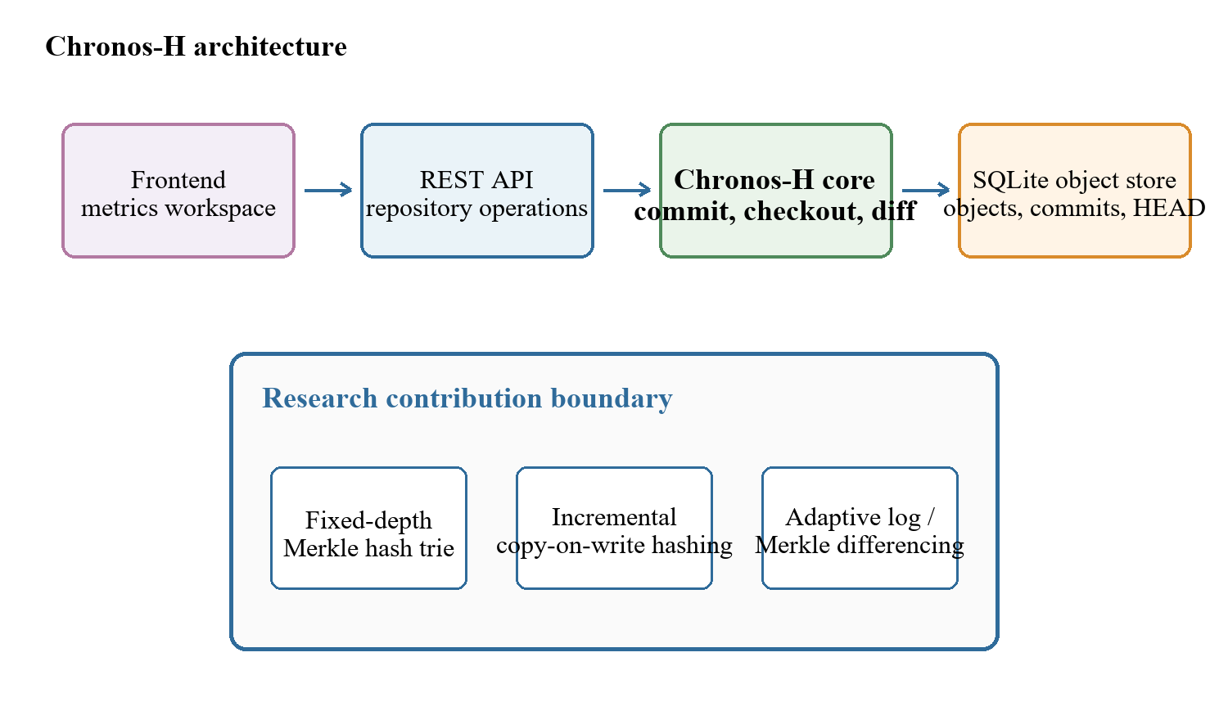
Figure 1: Chronos architecture and research contribution boundary.

3.1 Addressed Object Model
Trie nodes and changesets are identified by SHA-256 over canonical JSON. A commit hash covers the root, parent, changeset, message, and timestamp. Sequential aliases v1, v2, and so on improve usability but are not content identities. HEAD is a named durable reference to the latest commit.

3.2 Fixed-Depth Merkle Hash Trie
The evaluated default has branching factor b=8 and depth d=4. SHA-256(key) contributes three routing bits per level, producing 4,096 possible leaf buckets after twelve bits. Full keys remain in leaves, so routing-prefix collisions do not affect correctness. Expected occupancy under uniform routing is N/b^d, but the sensitivity study treats the geometry as a tunable design choice.

3.3 Incremental Hashing and Commit
A mutation batch is canonicalized, routed, and grouped by shared prefixes. Each affected leaf is rewritten once, and only the union of affected ancestor paths is rebuilt. Unchanged child hashes are copied into new internal nodes, providing structural sharing. One SQLite transaction then inserts new objects, the changeset, commit metadata, version alias, measurements, and updated HEAD. Reopen verifies payload hashes and references.
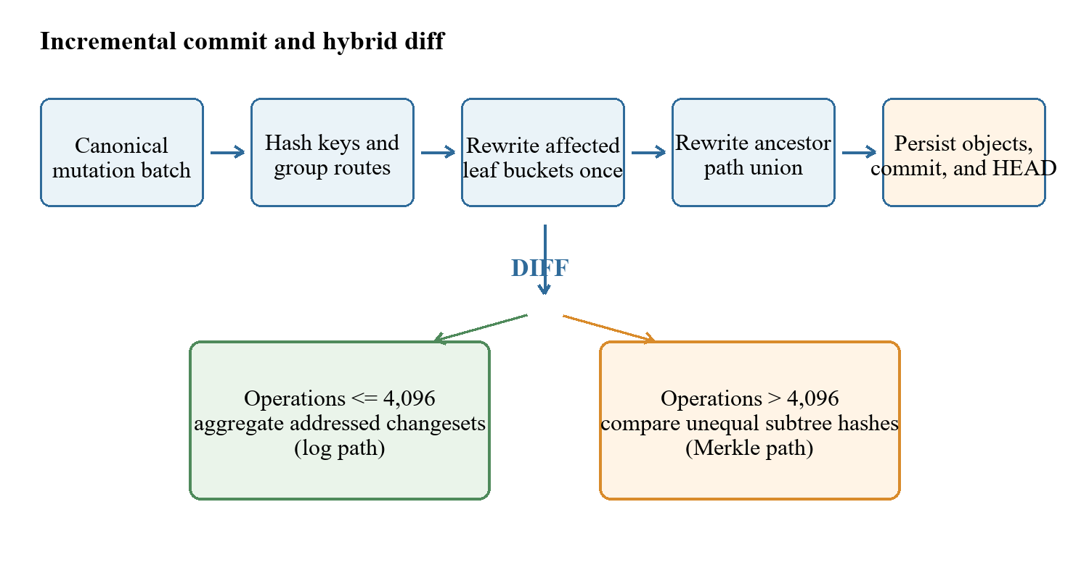
Figure 2: Incremental commit path and adaptive diff decision.

3.4 Hybrid Diff
The log path walks the ancestor chain and aggregates key operations. The Merkle path recursively compares roots, prunes equal subtree hashes, and examines full leaf entries only below unequal paths. Chronos-H counts accumulated ancestor operations and uses the log at or below 4,096 operations; it uses Merkle above that boundary. Chronos-M forces the Merkle path and therefore serves only as an ablation.

4 Experimental Methodology

4.1 Variants and Workloads
Five implementations receive identical logical states and mutation batches: a complete Snapshot per version, an initial state plus operation-log baseline, forced-Merkle Chronos-M, adaptive Chronos-H, and Dolt 2.3.1 using a keyed SQL table and native diff. Chronos-M is not a headline product variant; it isolates the selector.
Scenario | Rows | Comm. | Changes | Locality
Small sparse | 1,000 | 10 | 10 | spread
Medium sparse | 10,000 | 10 | 10 | spread
Medium dense | 10,000 | 10 | 1,000 | spread
Large sparse | 100,000 | 10 | 100 | spread
Large hot | 100,000 | 10 | 100 | hot
Table 2: Final evaluation workload matrix.

4.2 Measurement Contract
Initial import measures creation of the first durable state; incremental commit is the within-trial median across ten durable commits; diff consumes the complete initial-to-final comparison; checkout fully materializes the target version; storage is the sum of regular repository-file bytes. Correctness requires exact initial and final states plus a changed-key oracle. Work examined uses each system's natural unit and is not normalized across keys, operations, and trie-node pairs.

4.3 Repetition, Calibration, and Integrity
The paper run uses two warmups and seven measured trials with base seed 20260822. Every adapter receives a regenerated workload whose SHA-256 must match the manifest. Calibration workloads are disjoint from evaluation. Medians, 25th percentiles, and 75th percentiles exclude warmups. Run 7048cc1674dc4038a8e42c87818b9088 was executed on Windows-11-10.0.26200-SP0 with Python 3.14.3. An independent audit reconstructed the expected trial matrix and every summary statistic.
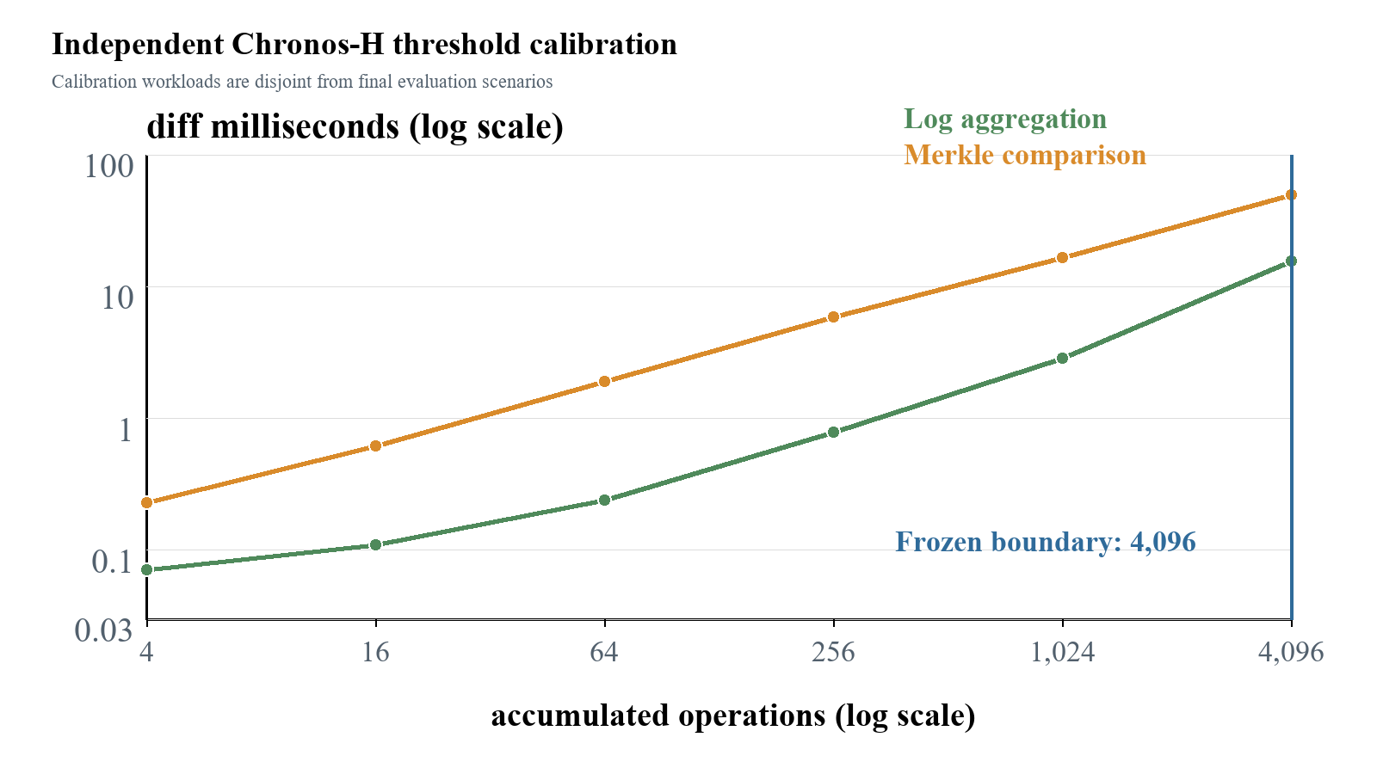
Figure 3: Independent threshold calibration; 4,096 is the largest sampled log-favorable point.
The boundary is a frozen policy for this machine, not proof that the true crossover is exactly 4,096. All 333 paper-profile rows completed with status ok and correctness true. The audit retained all 83 Tukey outlier candidates; no observation was manually deleted.

5 Results

5.1 Final Diff Performance
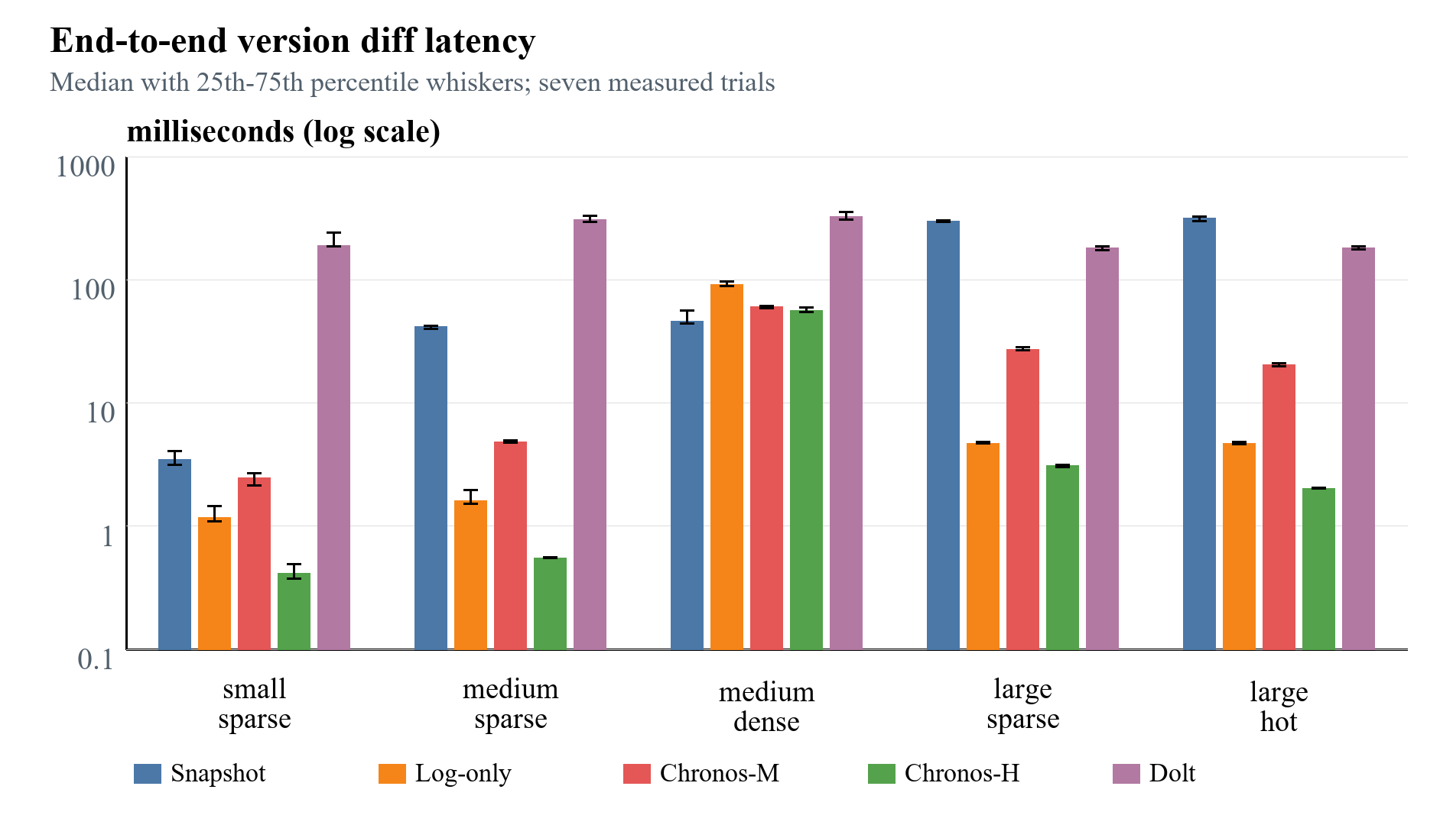
Figure 4: Final diff latency from the audited CSV bundle; lower is better.
Scenario | Path | H ms | Dolt ms | Ratio
Small sparse | log | 0.417 | 188.91 | 453.3x
Medium sparse | log | 0.553 | 306.47 | 554.2x
Medium dense | merkle | 56.496 | 326.01 | 5.8x
Large sparse | log | 3.082 | 180.77 | 58.7x
Large hot | log | 2.031 | 182.41 | 89.8x
Table 3: Chronos-H versus Dolt median diff latency.
Chronos-H selected log for the four sparse or hot workloads and Merkle for the 10,000-operation medium-dense workload. Relative to Dolt, its median diff was 5.8x lower in medium-dense and 58.7x to 554.2x lower in the other workloads. These ratios include repeated Dolt CLI and SQL invocation costs and therefore describe the evaluated system protocol, not isolated Prolly Tree algorithm speed.

5.2 Hybrid Ablation
For log-selected workloads, Chronos-H reduced median diff latency relative to forced-Merkle Chronos-M by 6.0x (small sparse), 8.7x (medium sparse), 8.8x (large sparse), and 10.0x (large hot). In medium-dense, both used Merkle and Chronos-H was within 7.3% of the forced variant. This supports the selector's intended mechanism without claiming that its threshold is hardware-independent.

5.3 Commit, Checkout, and Storage
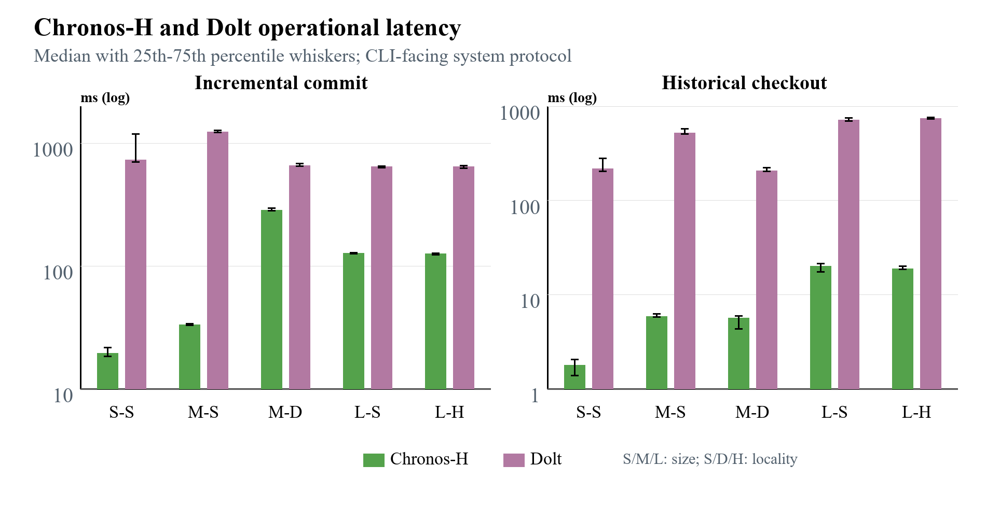
Figure 5: Chronos-H and Dolt operational latency; lower is better.
Chronos-H incremental commit medians were 2.3x to 37.4x lower than Dolt, and checkout medians were 35.8x to 123.4x lower. Initial import was mixed: Chronos-H was 4.9x faster for small sparse and 1.14x faster for medium sparse, approximately tied for medium dense, and 2.73x to 2.79x slower at 100,000 rows. The latency advantage is therefore not uniform.
Chronos-H paid a consistent storage cost. Its median repository footprint was 1.83x, 3.16x, 2.19x, 4.10x, and 6.43x Dolt's for small sparse through large hot, respectively. The 100,000-row Chronos repositories occupied about 34.4 MiB. This reflects inline values, JSON object encoding, and the absence of compact chunk packing and garbage collection.

5.4 Trie-Parameter Sensitivity
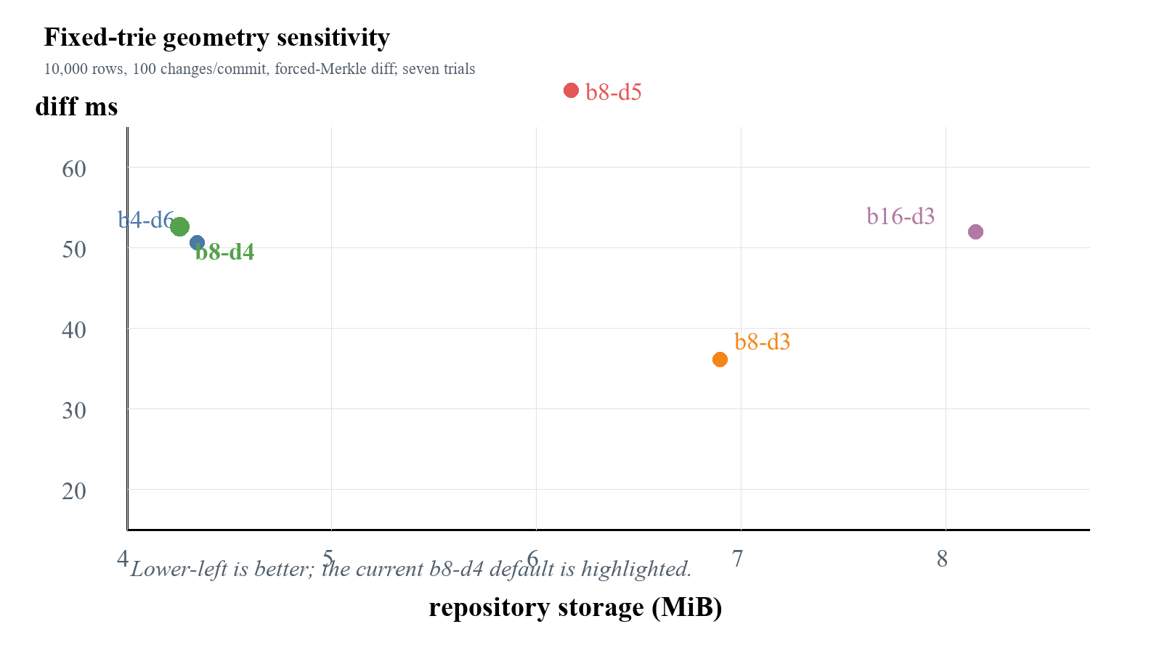
Figure 6: Fixed-trie sensitivity; the preferred point depends on the objective.
All 45 sensitivity trials were correct. The b8-d3 configuration delivered the lowest median diff latency (20.15 ms versus 44.43 ms for b8-d4) and compared 84.3% fewer node pairs, but consumed 61.2% more storage and examined three times as many leaf entries. The current b8-d4 default used the least storage (4.27 MiB). The over-deep b8-d5 design was slower for every timed operation and used 44.8% more storage. Thus b8-d4 is a storage-conscious balanced default, not a universal optimum.

6 Discussion
The results answer RQ1 with a trade-off rather than a single winner. Chronos-H offered low diff, commit, and checkout latency under the benchmark interface, but its import advantage disappeared at 100,000 rows and its repository was always larger than Dolt's. Snapshot and Log-only also remained important: their simpler representations were often cheaper to import or store, while Snapshot diff scaled with materialized key count.
RQ2 is supported more directly. Because Chronos-H and Chronos-M share the same durable trie, their sparse-workload diff gap isolates adaptive selection more cleanly than an absolute comparison with Dolt. The log path avoided thousands of trie comparisons when only 100 or 1,000 operations separated the endpoints; the dense case switched to Merkle.
RQ3 rejects a universal geometry. Shallow routing lowers internal traversal but creates larger leaf buckets and higher storage; deeper routing lowers occupancy but increases internal-node work. The appropriate point therefore depends on whether latency, storage, or worst-case bucket scanning dominates the target workload.
The Dolt comparison must remain scoped. Dolt performs SQL parsing, schema management, version-control operations, and production durability work that Chronos does not. Its Prolly Trees additionally support ordered access, branches, merges, and remotes. The reported system-level ratios demonstrate the behavior of these implementations through their declared interfaces; they do not establish that fixed tries are intrinsically faster than Prolly Trees.

7 Limitations and Threats to Validity
- Runtime and interface asymmetry: Chronos is Python and in-process, while Dolt is a mature Go executable repeatedly invoked through CLI/SQL boundaries.
- Feature asymmetry: Chronos has linear history and one writer; it does not implement SQL, branches, merges, remotes, schema evolution, or production concurrency.
- Synthetic scope: deterministic key/value workloads reach 100,000 rows but do not represent all real schemas, skew, payload sizes, or long histories.
- Single environment: results come from one Windows 11 machine; cache, scheduling, filesystem, and antivirus behavior may affect short operations.
- Calibration boundary: 4,096 is the largest sampled log-favorable point, not a measured universal crossover.
- Memory comparability: Python tracemalloc values and Dolt process memory are not equivalent, so the paper does not present a cross-system memory graph.
- Work-unit mismatch: keys, operations, trie-node pairs, and Dolt-internal work cannot be interpreted as one normalized counter.
- Outlier policy: all 83 Tukey candidates were retained. Medians and interquartile ranges reduce their influence, but seven trials do not establish distributional normality.

8 Future Work
The immediate improvement is workload-aware structure selection. A repository could estimate key count, prefix skew, mutation density, and leaf occupancy and then choose among tested trie geometries instead of fixing b and d globally. The hybrid selector should likewise learn a crossover from periodic calibration and include history distance, changed-prefix density, and observed I/O cost rather than only operation count.
Storage efficiency can be improved through compact binary node encoding, value chunking, pack files, compression, object reachability analysis, and garbage collection. An ordered Merkle index or content-defined chunk boundaries would add range scans and history-independent layout while retaining the current fixed trie as a controlled baseline.
System scope should expand to named branches, merge commits, conflict reporting, schema-aware records, concurrent readers and writers, and remote synchronization. Evaluation should add public structured datasets, one-million-row and longer-history workloads, Linux replication, and unified external process telemetry for time, CPU, I/O, and peak resident memory.

9 Conclusion
Chronos demonstrates a complete content-addressed versioning path for structured key/value data: canonical immutable objects, incremental copy-on-write Merkle trie updates, atomic SQLite persistence, historical checkout, and adaptive differencing. The audited 333-trial comparison shows that Chronos-H can substantially reduce CLI-facing diff, commit, and checkout latency relative to Dolt 2.3.1, but it also exposes slower large imports, higher storage consumption, a narrower feature set, and runtime/interface asymmetry. The ablation supports hybrid log/Merkle selection, while the sensitivity experiment shows that trie geometry must be chosen by workload objective. The defensible contribution is therefore an instrumentable hybrid design and reproducible evidence of its trade-offs, not a claim of universal replacement for a production version-controlled SQL database.

Acknowledgment
The authors acknowledge the open-source Dolt project and the researchers whose dataset-versioning systems informed the experimental design.

References
[1] Michael Armbrust et al. 2020. Delta Lake: High-Performance ACID Table Storage over Cloud Object Stores. Proceedings of the VLDB Endowment, 13(12):3411-3424. doi:10.14778/3415478.3415560.
[2] Attic Labs. n.d. Noms technical overview. GitHub. https://github.com/attic-labs/noms/blob/master/doc/intro.md.
[3] Alex Auvolat and Francois Taiani. 2019. Merkle Search Trees: Efficient State-Based CRDTs in Open Networks. 38th IEEE International Symposium on Reliable Distributed Systems, pages 1-10. doi:10.1109/SRDS47363.2019.00032.
[4] Juan Benet. 2014. IPFS - Content Addressed, Versioned, P2P File System. arXiv:1407.3561.
[5] Anant Bhardwaj, Souvik Bhattacherjee, Amit Chavan, Amol Deshpande, Aaron J. Elmore, Samuel Madden, and Aditya G. Parameswaran. 2015. DataHub: Collaborative Data Science and Dataset Version Management at Scale. 7th Biennial Conference on Innovative Data Systems Research.
[6] Souvik Bhattacherjee, Amit Chavan, Silu Huang, Amol Deshpande, and Aditya Parameswaran. 2015. Principles of Dataset Versioning: Exploring the Recreation/Storage Tradeoff. Proceedings of the VLDB Endowment, 8(12):1346-1357. doi:10.14778/2824032.2824035.
[7] Scott Chacon and Ben Straub. 2014. Git Internals - Git Objects. In Pro Git, 2nd edition. https://git-scm.com/book/en/v2/Git-Internals-Git-Objects.
[8] DoltHub. 2024a. Dolt Storage Engine: Block Store. Dolt Documentation. https://www.dolthub.com/docs/architecture/storage-engine/block-store/.
[9] DoltHub. 2024b. Dolt's Storage Engine: Prolly Trees and Commit Graph. https://www.dolthub.com/blog/2024-02-29-storage-engine/.
[10] James R. Driscoll, Neil Sarnak, Daniel D. Sleator, and Robert E. Tarjan. 1989. Making Data Structures Persistent. Journal of Computer and System Sciences, 38(1):86-124. doi:10.1016/0022-0000(89)90034-2.
[11] Silu Huang, Liqi Xu, Jialin Liu, Aaron J. Elmore, and Aditya G. Parameswaran. 2017. OrpheusDB: Bolt-on Versioning for Relational Databases. Proceedings of the VLDB Endowment, 10(10):1130-1141. doi:10.14778/3115404.3115417.
[12] Michael A. Maddox et al. 2016. Decibel: The Relational Dataset Branching System. Proceedings of the VLDB Endowment, 9(9):624-635. doi:10.14778/2947618.2947619.
[13] Ralph C. Merkle. 1988. A Digital Signature Based on a Conventional Encryption Function. In Advances in Cryptology - CRYPTO '87, LNCS 293, pages 369-378. doi:10.1007/3-540-48184-2_32.
[14] Athicha Muthitacharoen, Benjie Chen, and David Mazieres. 2001. A Low-Bandwidth Network File System. Proceedings of the 18th ACM Symposium on Operating Systems Principles, pages 174-187. doi:10.1145/502059.502052.
[15] Sheng Wang et al. 2018. ForkBase: An Efficient Storage Engine for Blockchain and Forkable Applications. Proceedings of the VLDB Endowment, 11(10):1137-1150. doi:10.14778/3231751.3231762.

Appendix A Reproducibility and Data Availability
The repository contains the benchmark harness, evidence audit, trie-sensitivity harness, and paper generator. The final evidence bundle is output/benchmarks/paper-final-20260824; the sensitivity bundle is output/benchmarks/trie-sensitivity-20260824. Results in this paper are generated programmatically from their summary CSV files and verified against raw results and manifests; no table or graph uses an earlier validation export.

