**ATHARVA SHUKLA**

**BATCH A**

**GIT ASSIGNMENT**

**1.1.1 Create a directory ‘project_dir’ & cd to ‘project_dir’.**

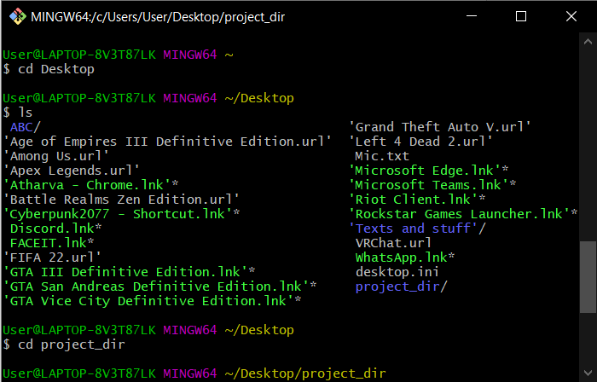

**1.1.2 Initialize git version database. (git init)** 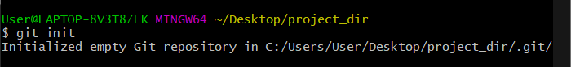

**1.1.3 Create a new file index.html.**

**1.1.4 Check the git status. You should find index.html as untracked file.**

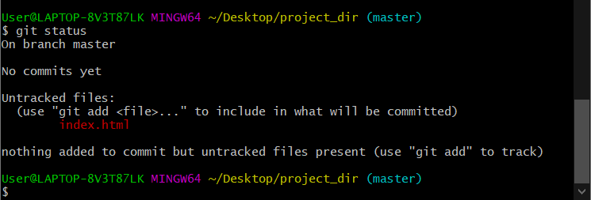

**1.1.5 Stage the index.html file.**

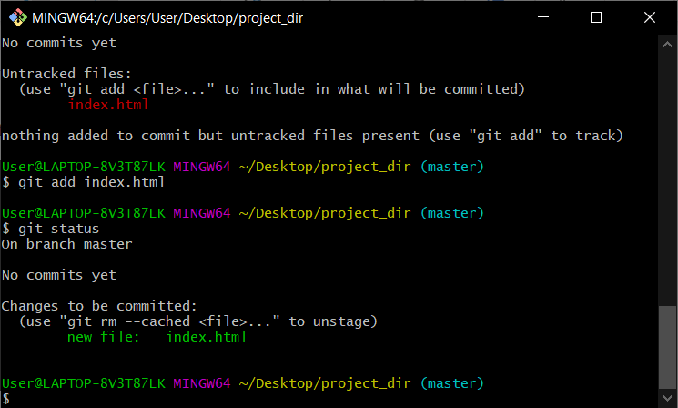

**1.1.6 Commit index.html**

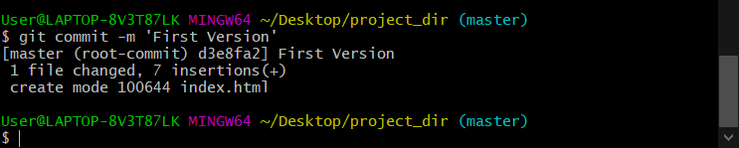

**1.1.7 Make few changes in index.html & create a new file info.txt file.**

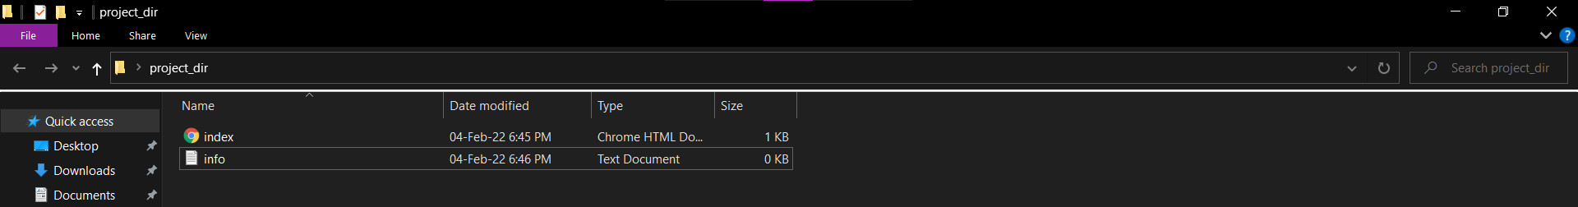

**1.1.8 Check git status. You should find index.html & info.txt as untracked files.**

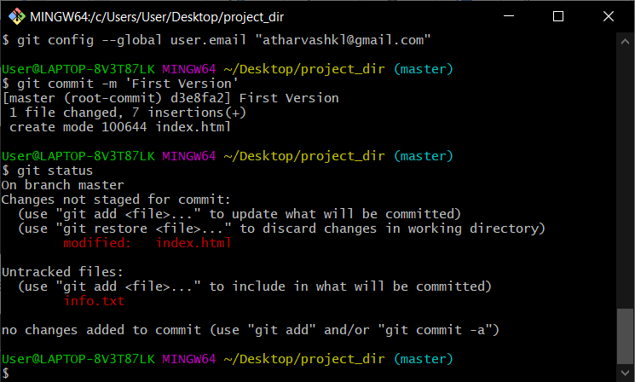

**1.1.9 Configure GIT to ignore all txt files.**

**1.1.10 Again check the git status. You should find only index.html as untracked file.**

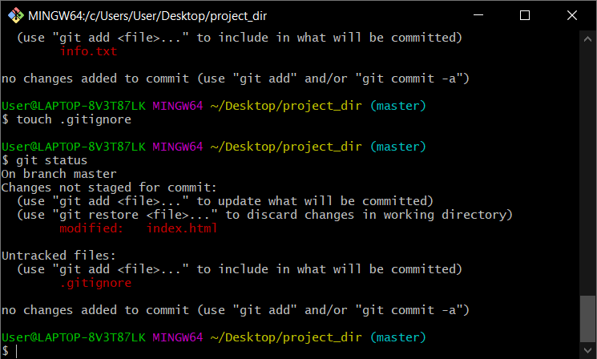

**1.1.11 State & commit index.html**

**1.1.12 Log all your comments so far.**

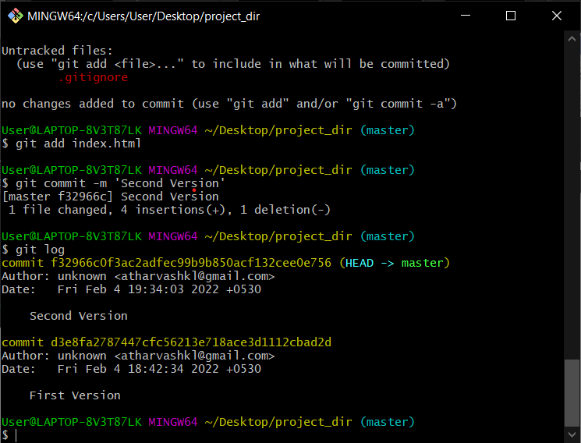

**1.1.13. Make some changes in index.html.**

**1.1.14. Revert the change made in the previous step using git command.**

**1.1.15. Again change index.html.**

**1.1.16. Stage index.html**

**1.1.17. Revert back the last stage.**

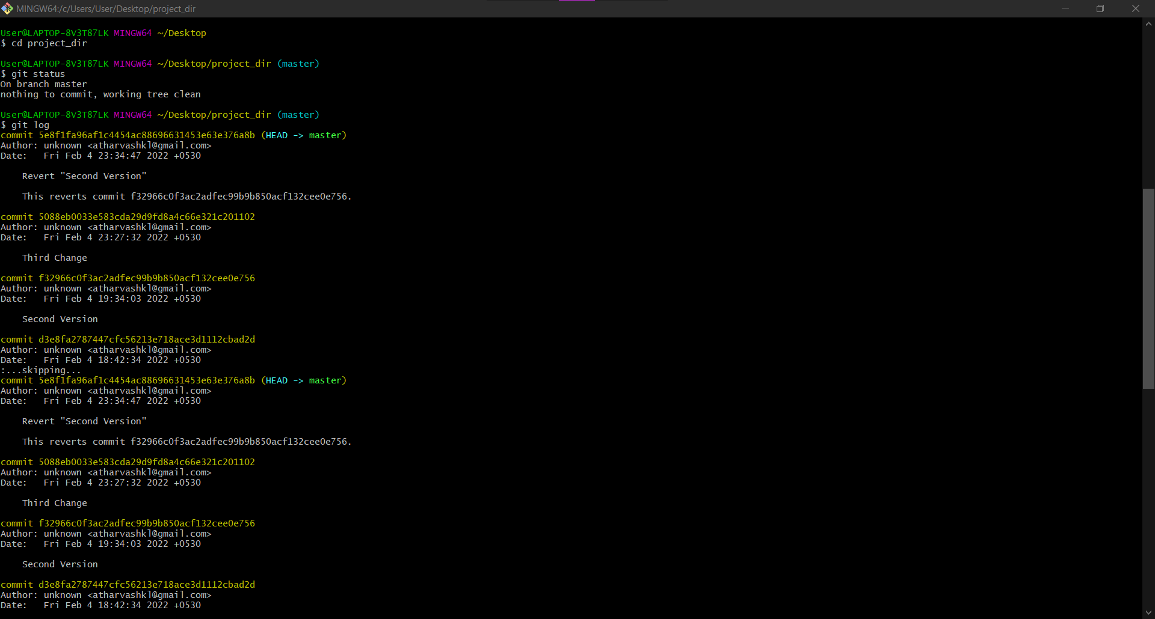

**1.1.18. Rename ‘add’ command to ‘my-add’.**

**1.1.19. Using my_add command Stage index.html again & commit the changes.**

**1.1.20. Revert the last commit.**

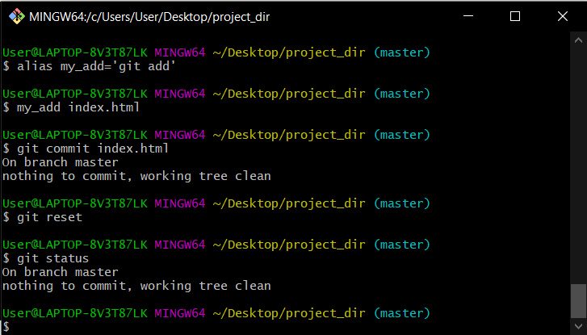

**GIT BRANCHING**

**Objective: Commit HTML, CSS & JavaScript assignments into GIT.**

**SECTION A : HTML**

**1.2.1. First take a backup of your assignments & projects. This is required because due to incorrect GIT operation you may lose your files.**

**1.2.2. Create an empty directory ‘Assignments’ & cd to ‘Assignments’**

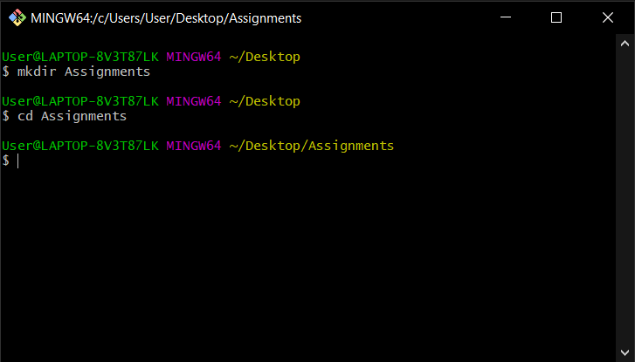

**1.2.3. Create a file README.txt inside ‘Assignments’ & write few lines about the contents of ‘Assignments’ folder.**

**1.2.4. Commit README.txt file.**

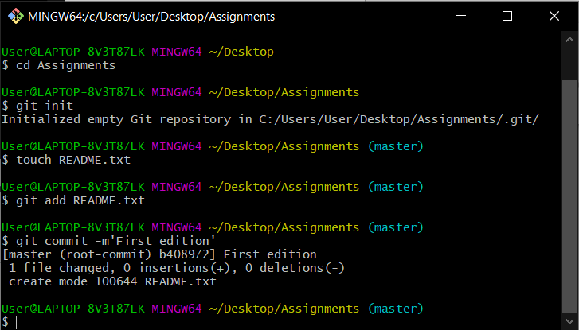

**1.2.5. Now create a new branch ‘html-assignments’.**

**1.2.6. Switch to ‘html-assignments’ branch.**

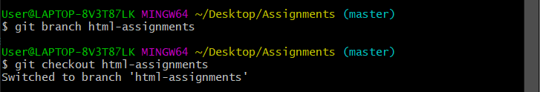

**1.2.7. Copy all HTML assignments inside ‘Assignments’ folder.**

**1.2.8. Commit HTML assignments into ‘html-assignments’ branch.**

**1.2.9. Make minor changes into few files belonging to ‘html-assignments’ branch.**

**1.2.10. Commit those changed files.**

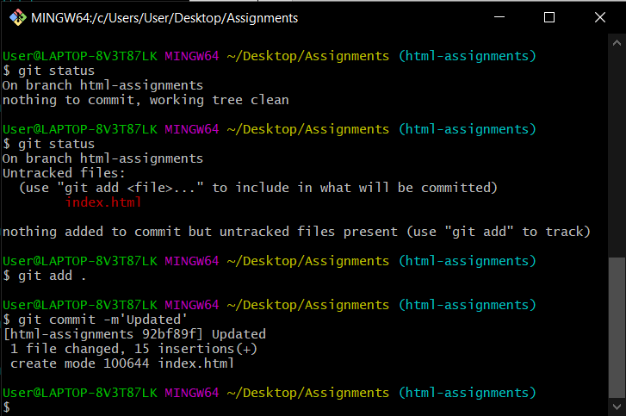

**1.2.11. Switch to master branch.**

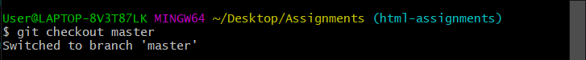

**1.2.12. Make minor changes into README.txt file & commit those changes into master.**

**1.2.13. Again switch to ‘html-assignments’ branch**

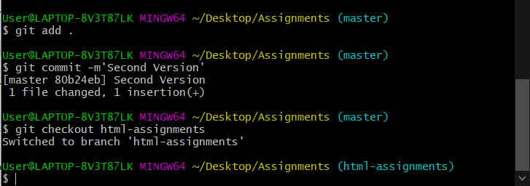

**1.2.14. Make minor changes into few files belonging to ‘html-assignments’ branch.**

**1.2.15. Commit those changes.**

**1.2.16. Switch to master.**

**1.2.17. Merge ‘html-assignments’ branch into master. Confirm all html assignments are shown in master.**

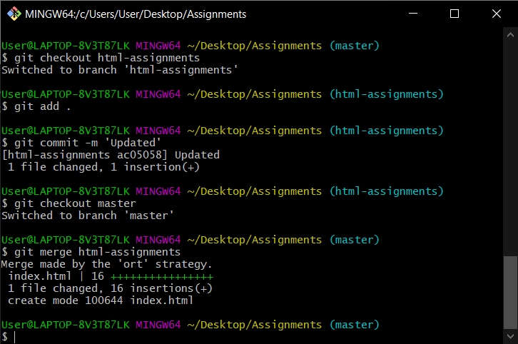

**1.2.18 Finally delete the ‘html-assignments’ branch.**

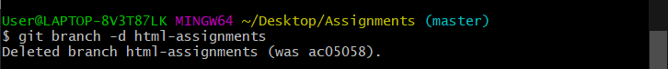

**SECTION B: CSS**

**1.3.1 Create a new branch ‘css-assignments’**

**1.3.2. Switch to ‘css-assignments’ branch.**

**1.3.3. Copy all CSS assignments inside ‘Assignments’ folder.**

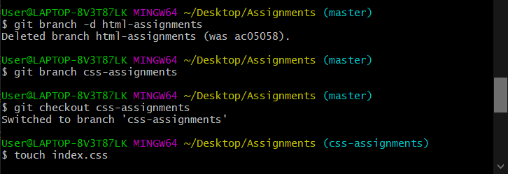

**1.3.4. Commit CSS assignments into ‘css-assignments’ branch.**

**1.3.5. Make minor changes into README.txt file on line 1 belonging to ‘css-assignments’ branch.**

**1.3.6. Commit those changed files.**

**1.3.7. Switch to master branch.**

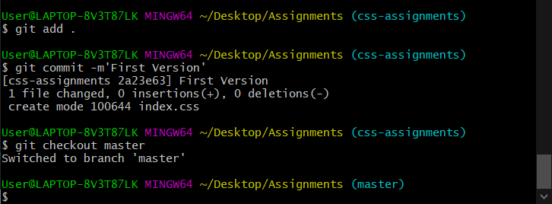

**1.3.8. Make minor changes into README.txt file on line 3 & commit those changes into master.**

**1.3.9. Again switch to ‘css-assignments’ branch.**

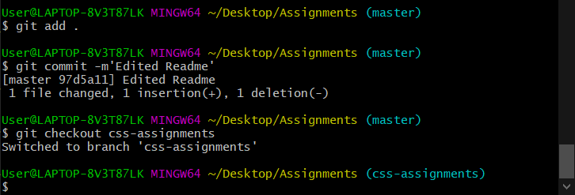

**1.3.10. Make minor changes into few files belonging to ‘css-assignments’ branch.**

**1.3.11. Commit those changes.**

**1.3.12. Switch to master.**

**1.3.13. Merge ‘css-assignments’ branch into master. Confirm all css assignments are shown in master.**

**1.3.14. Finally delete the ‘css-assignments’ branch**

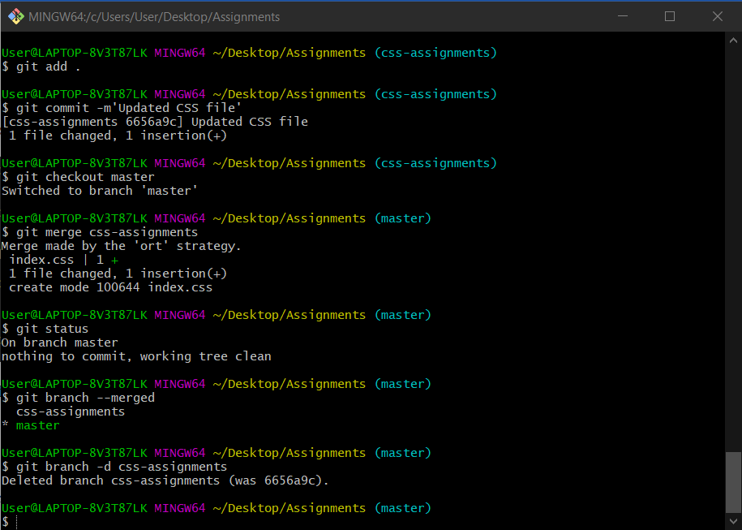

**SECTION C**

**JavaScript**

**1.4.1. Create a new branch ‘js-assignments’.**

**1.4.2. Switch to ‘js-assignments’ branch.**

**1.4.3. Copy all JavaScript assignments inside ‘Assignments’ folder.**

**1.4.4. Commit JavaScript assignments into ‘js-assignments’ branch.**

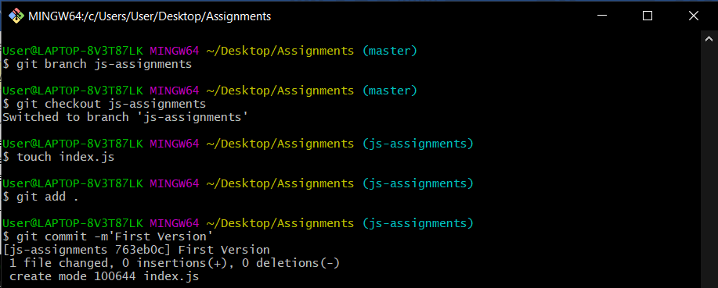

**1.4.5. Make minor changes into README.txt file on line 1 belonging to ‘js-assignments’ branch.**

**1.4.6. Commit those changed files.**

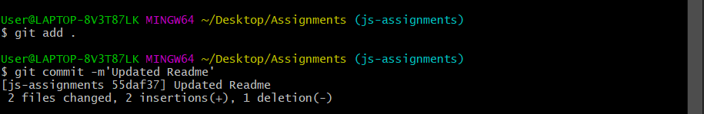

**1.4.7. Switch to master branch.**

**1.4.8. Make minor changes into README.txt file on line 1 & commit those changes into master.**

**1.4.9. Again switch to ‘js-assignments’ branch.**

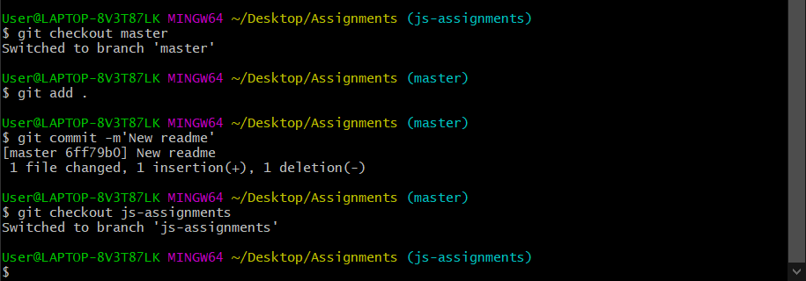

**1.4.9. Again switch to ‘js-assignments’ branch.**

**1.4.10. Make minor changes into few files belonging to ‘js-assignments’ branch.**

**1.4.11. Commit those changes.**

**1.4.12. Switch to master.**

**1.4.13. Merge ‘js-assignments’ branch into master. Confirm all JavaScript assignments are shown in master.**

**1.4.14. Finally delete the ‘js-assignments’ branch.**

