**Mongo DB Exercises - With the Restaurants Data Set**

**1. Download the restaurants.zip file**

**2. Unzip the file, you will see restaurants.json file**

**3. Run the mongod server**

**4. Run the following command to import the json file provided. It will load the json file into the mongodb with database name - restaurants, collections name - addresses**

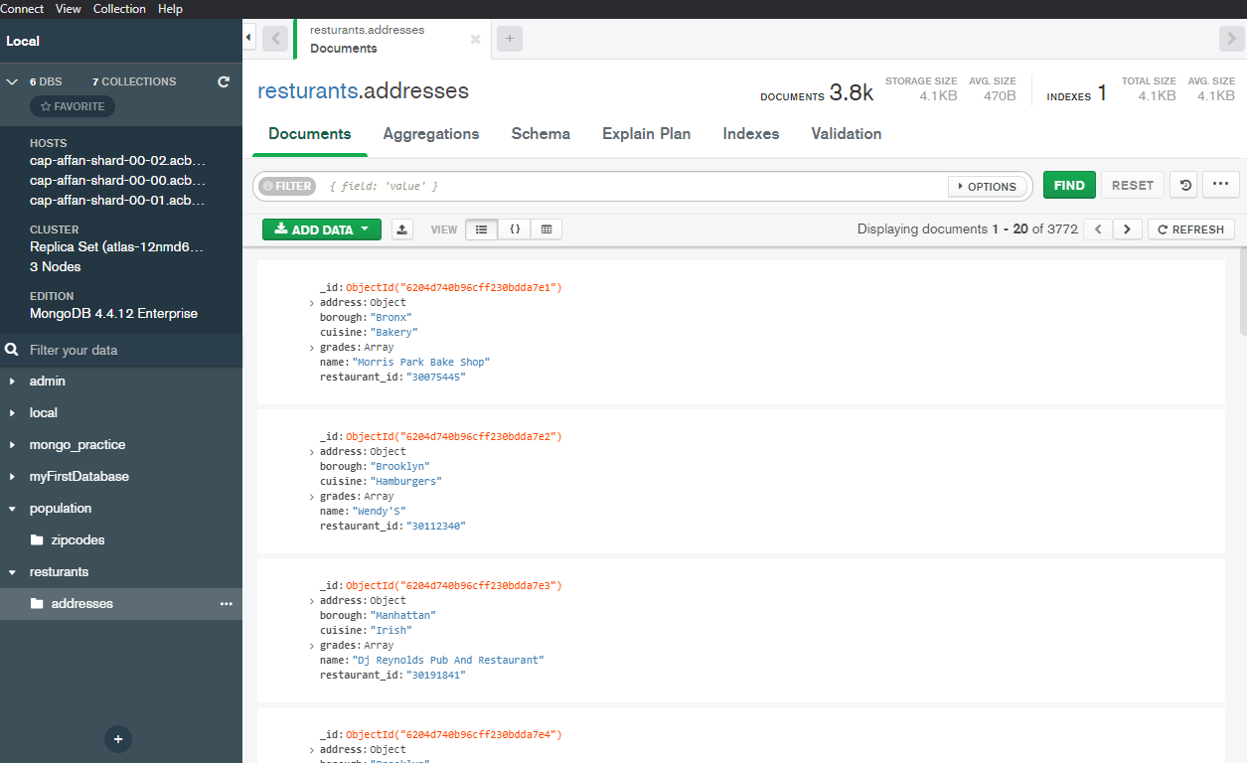

**5. Run mongo shell command**

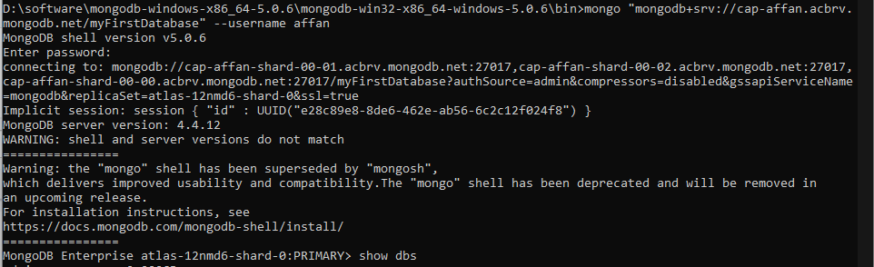

**6. show databases**

**7. use restaurants**

**8. db.addresses.find() should print entire json data**

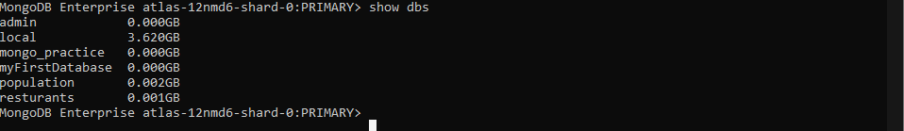



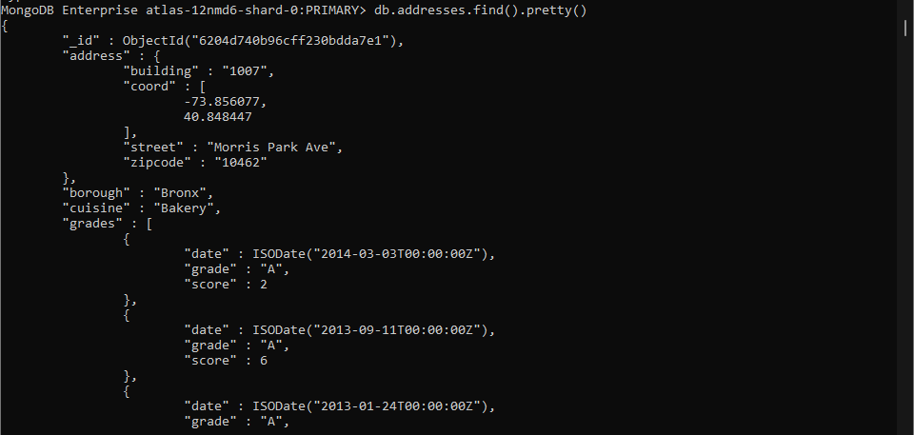

**Exercise Questions**

1. **Write a MongoDB query to display all the documents in the collection restaurants.**



1. **Write a MongoDB query to display the fields restaurant_id, name, borough and cuisine for all the documents in the collection restaurant.**

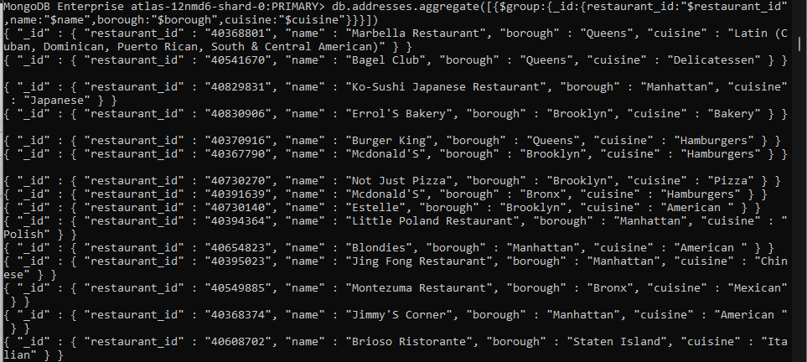

1. **Write a MongoDB query to display the fields restaurant_id, name, borough and cuisine, but exclude the field _id for all the documents in the collection restaurant.**



1. **Write a MongoDB query to display the fields restaurant_id, name, borough and zip code, but exclude the field _id for all the documents in the collection restaurant.**

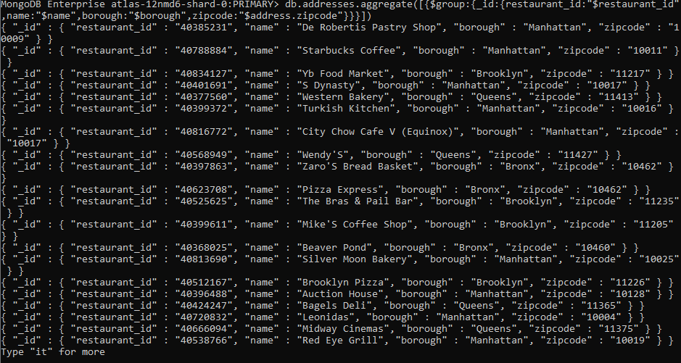

1. **Write a MongoDB query to display the first 5 restaurant which is in the borough Bronx.**

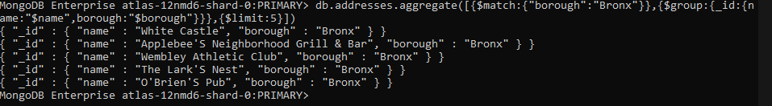

1. **Write a MongoDB query to display all the restaurant which is in the borough Bronx.**

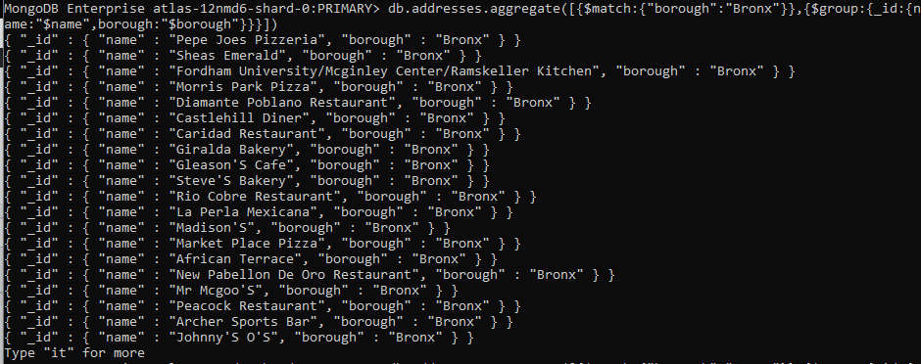

1. **Write a MongoDB query to display the next 5 restaurants after skipping first 5 which are in the borough Bronx.**

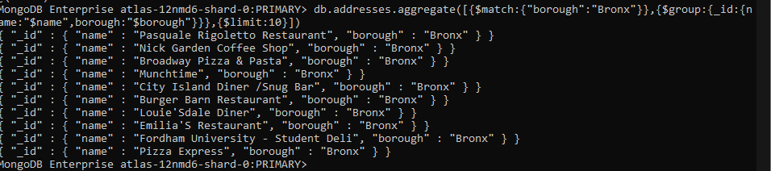

1. **Write a MongoDB query to find the restaurants who achieved a score more than 90.**

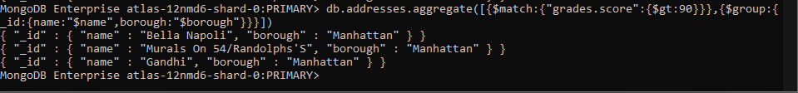

1. **Write a MongoDB query to find the restaurants that achieved a score, more than 80 but less than 100.**

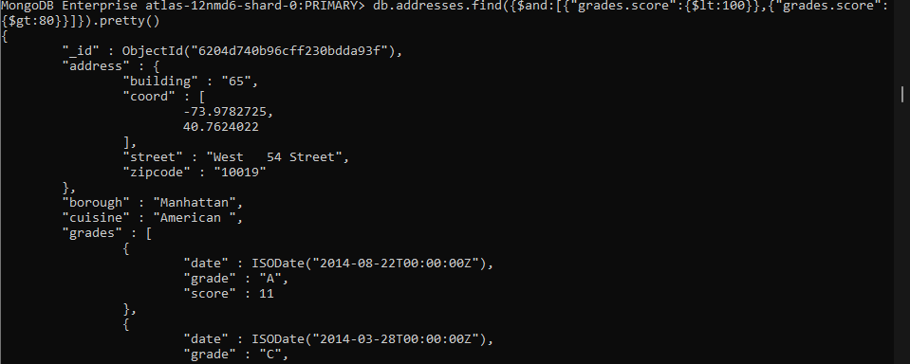

**10. Write a MongoDB query to find the restaurants which locate in latitude value less than -95.754168.**

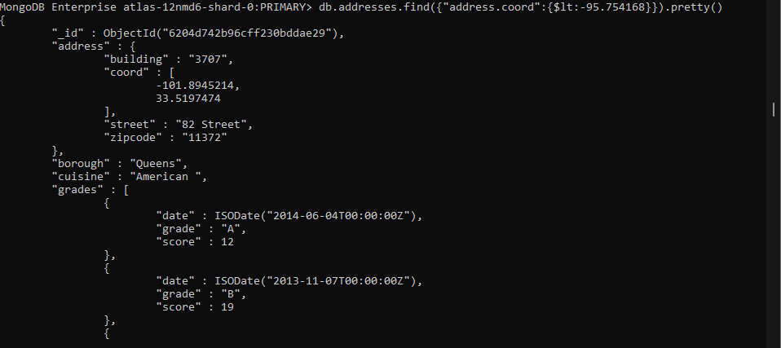

1. **Write a MongoDB query to find the restaurants that do not prepare any cuisine of 'American' and their grade score more than 70 and latitude less than -65.754168.**

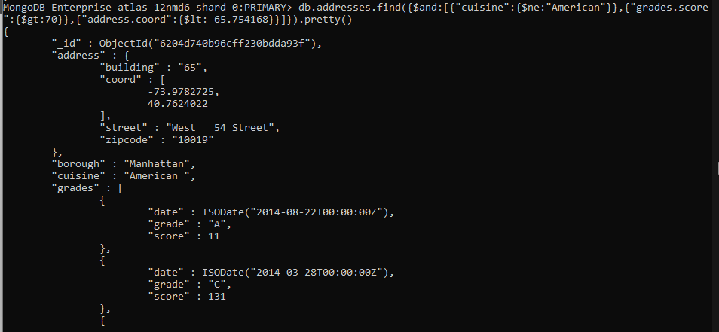

**12. Write a MongoDB query to find the restaurants which do not prepare any cuisine of 'American' and achieved a score more than 70 and located in the longitude less than -65.754168.**

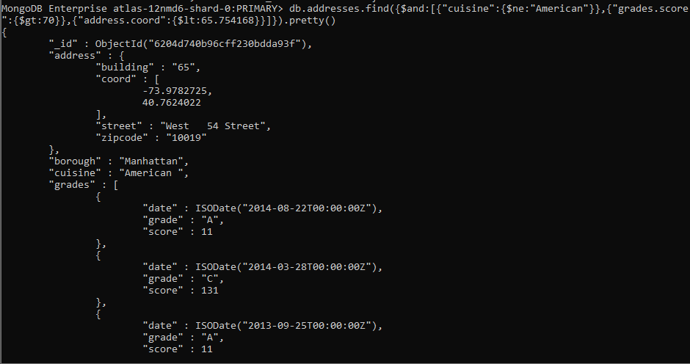

**13. Write a MongoDB query to find the restaurants which do not prepare any cuisine of 'American ' and achieved a grade point 'A' not belongs to the borough Brooklyn. The document must be displayed according to the cuisine in descending order.**

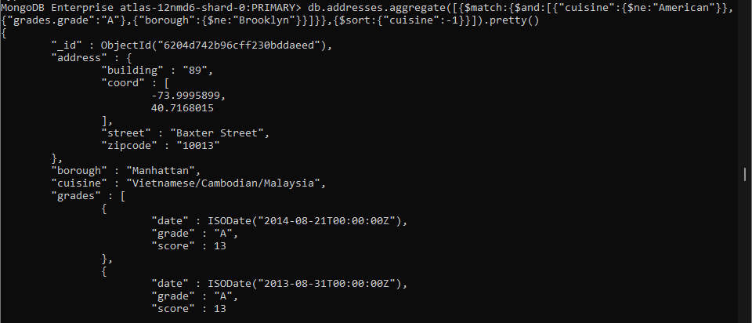

**14. Write a MongoDB query to find the restaurant Id, name, borough and cuisine for those restaurants which contain 'Wil' as first three letters for its name.**



**15. Write a MongoDB query to find the restaurant Id, name, borough and cuisine for those restaurants which contain 'ces' as last three letters for its name.**

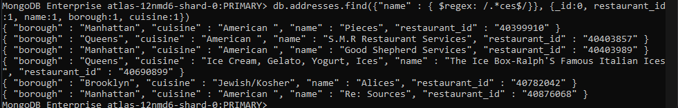

**16. Write a MongoDB query to find the restaurant Id, name, borough and cuisine for those restaurants which contain 'Reg' as three letters somewhere in its name.**

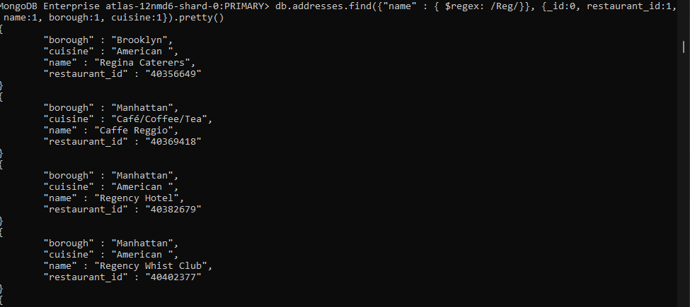

**17. Write a MongoDB query to find the restaurants which belong to the borough Bronx and prepared either American or Chinese dish.**

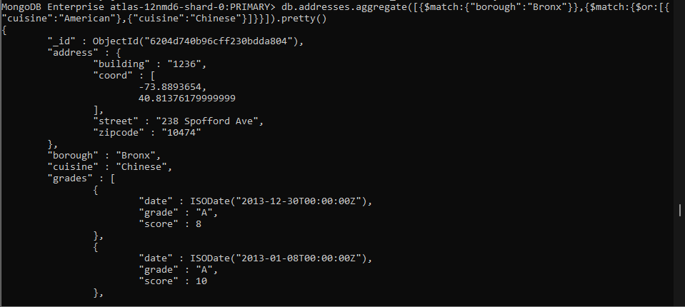

**18. Write a MongoDB query to find the restaurant Id, name, borough and cuisine for those restaurants which belong to the borough Staten Island or Queens or Bronx or Brooklyn.**

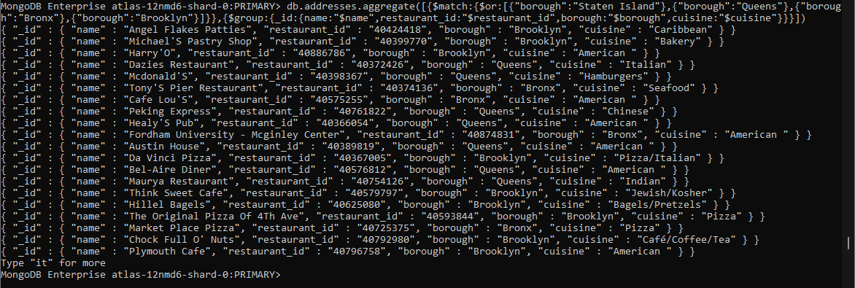

**19. Write a MongoDB query to find the restaurant Id, name, borough and cuisine for those restaurants which are not belonging to the borough Staten Island or Queens or Bronxor Brooklyn.**

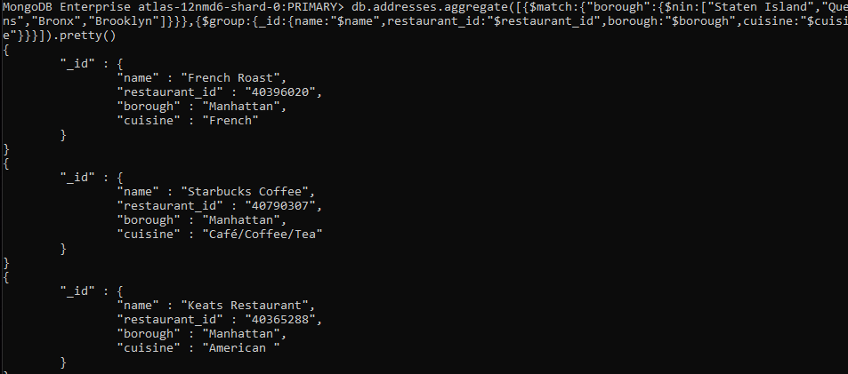

**20. Write a MongoDB query to find the restaurant Id, name, borough and cuisine for those restaurants which achieved a score which is not more than 10.**

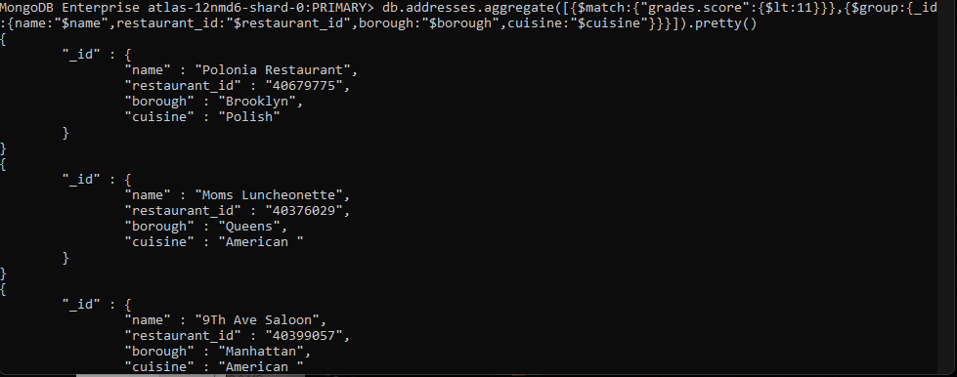

**21. Write a MongoDB query to find the restaurant Id, name, borough and cuisine for those restaurants which prepared dish except 'American' and 'Chinees' or restaurant's name begins with letter 'Wil'.**

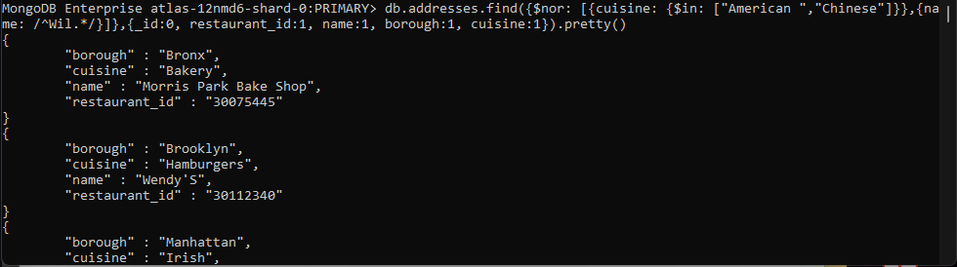

**22. Write a MongoDB query to find the restaurant Id, name, and grades for those restaurants which achieved a grade of "A" and scored 11 on an ISODate "2014-08-11T00:00:00Z" among many of survey dates..**

**{"grades.date":{"$gte" :ISODate("2014-08-11T00:00:00Z")}}**

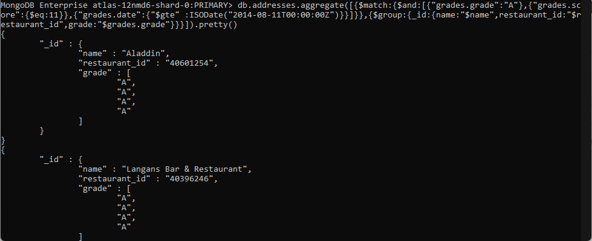

**23. Write a MongoDB query to find the restaurant Id, name and grades for those restaurants where the 2nd element of grades array contains a grade of "A" and score 9 on an ISODate "2014-08-11T00:00:00Z"**

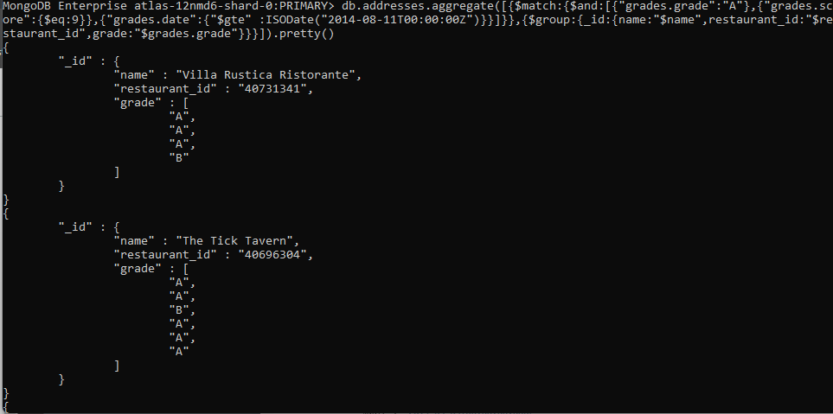

**24. Write a MongoDB query to find the restaurant Id, name, address and geographical location for those restaurants where 2nd element of coord array contains a value which is more than 42 and upto 52..**

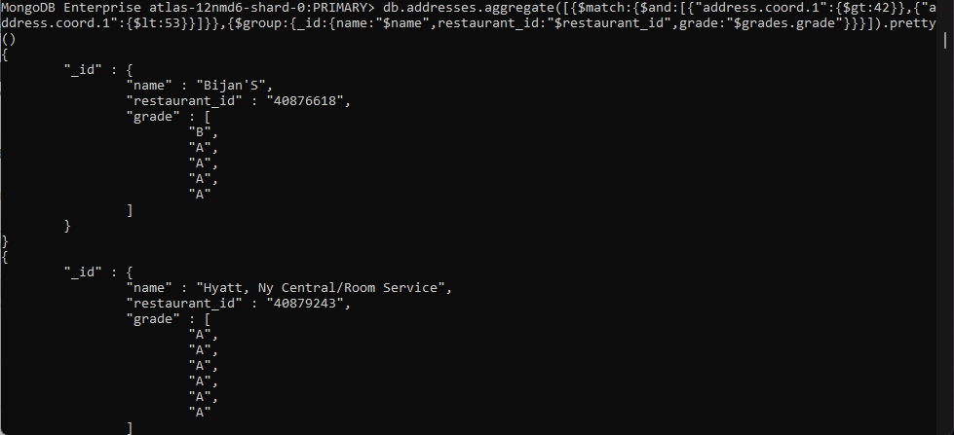

**25. Write a MongoDB query to arrange the name of the restaurants in ascending order along with all the columns.**

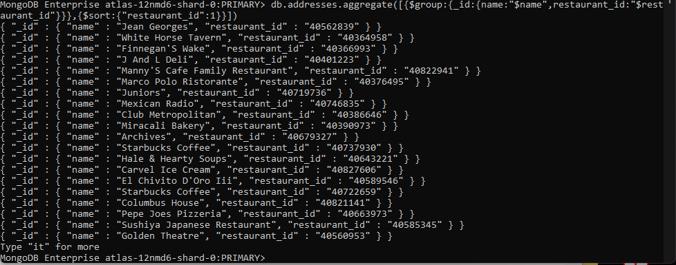

**26. Write a MongoDB query to arrange the name of the restaurants in descending along with all the columns.**

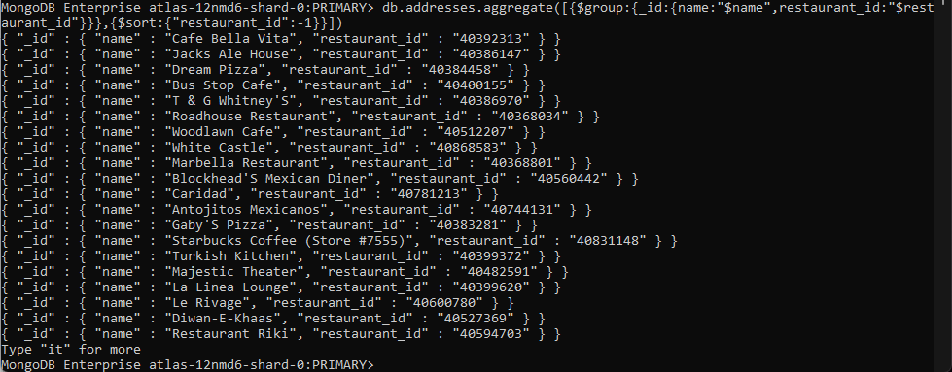

**27. Write a MongoDB query to arranged the name of the cuisine in ascending order and for that same cuisine borough should be in descending order.**

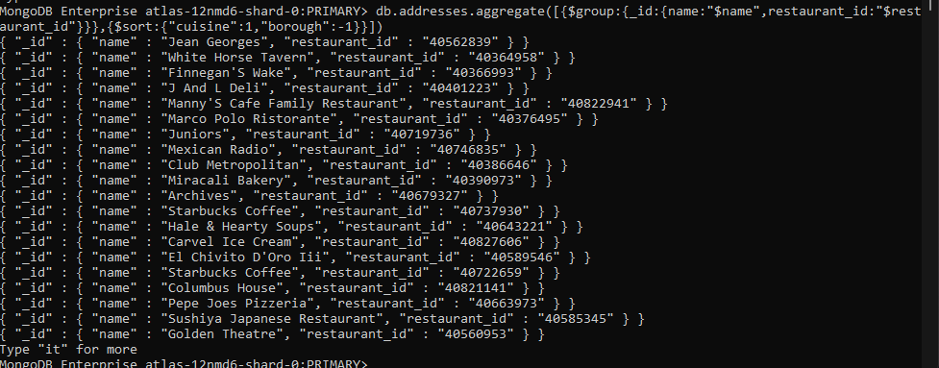

**28. Write a MongoDB query to know whether all the addresses contains the street or not.**

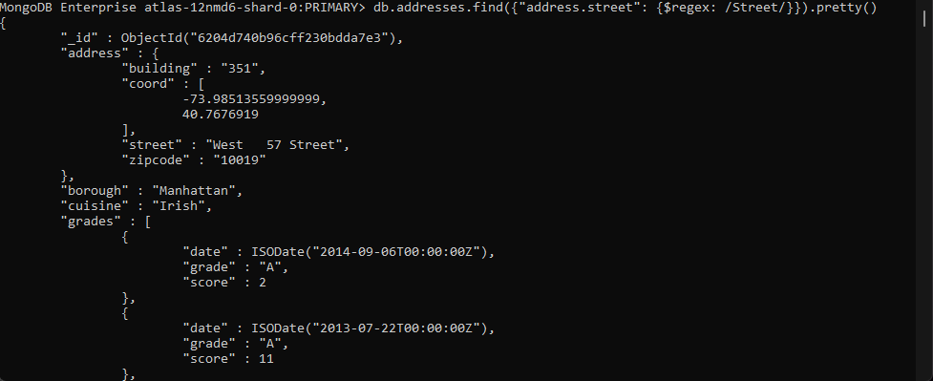

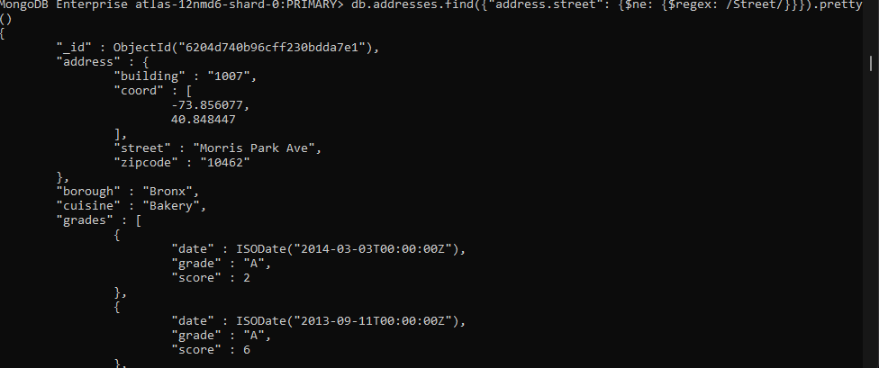

**29. Write a MongoDB query which will select all documents in the restaurants collection where the coord field value is Double.**

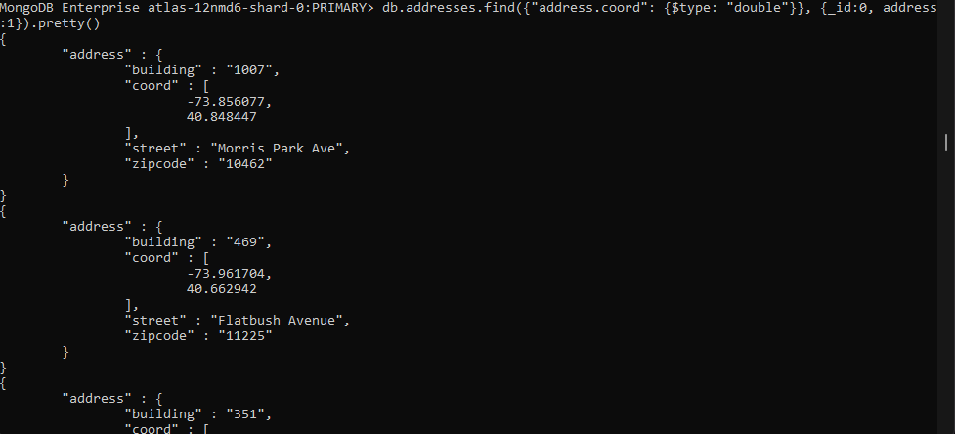

**30. Write a MongoDB query which will select the restaurant Id, name and grades for those restaurants which returns 0 as a remainder after dividing the score by 7.**

