**IE-2 REPORT ON**

**E-waste Management**

**SUBMITTED TOWARDS THE FULFILMENT OF THE REQUIREMENTS OF**

**BACHELOR OF ENGINEERING (B. Tech.)**

**Academic Year: 2023-24**

**Group members**

|  |  |  |
| --- | --- | --- |
| **Name** | **Roll Number** | **Remark** |
| Atharva Swami | BTCOD294 |  |
| Ayush Sarode | BTCOD291 |  |
| Devendra Sangle | BTCOD290 |  |
| Siddhesh Choudhari | BTCOD307 |  |

**Under The Guidance of**

**Prof. Anushree Chandragade**

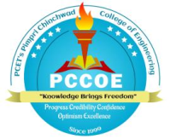

**PIMPRI CHINCHWAD COLLEGE OF ENGINEERING**

**SECTOR 26, NIGDI, PRADHIKARAN**

1. **Web Application for collection, segregation, and recycling.**

https://erecycler.vercel.app



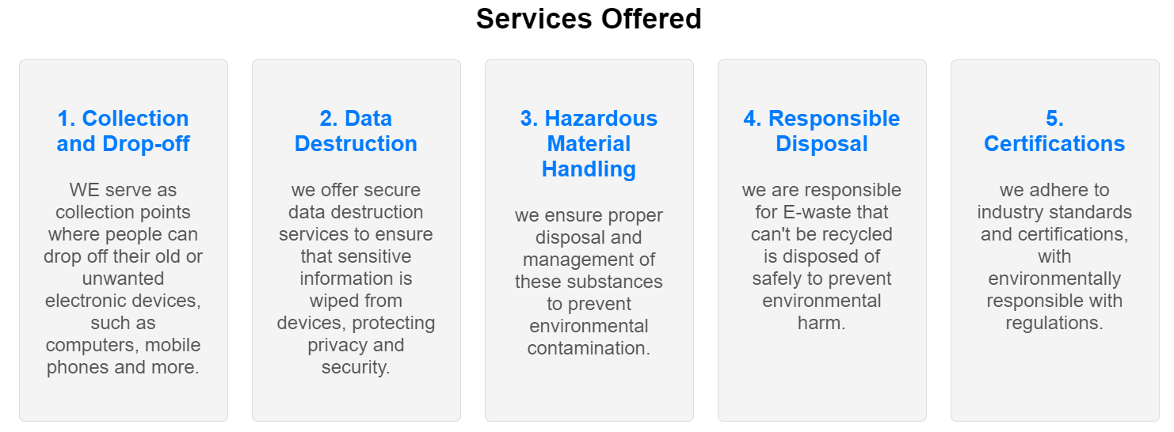

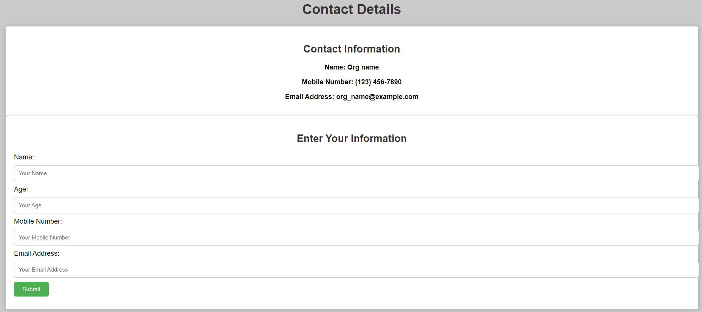

1. **Participation in E-waste Collection Drive:**

**Following are approaches to be followed in E-waste drive:**

* **Education**: Advocate for secure data handling and certified recycling centers.
* **Classification**: Categorize collected items for refurbishment, recycling, or disposal.
* **Sustainability Promotion**: Emphasize the environmental benefits of e-waste recycling.
* **Continuous Learning**: Stay updated on e-waste regulations and best practices.
* **Networking**: Establish connections with professionals in recycling and environmental sectors for potential collaborations.

**One should follow following aspects during collection of e-waste:**

1. **Community Engagement**: E-waste collection drives promote community involvement, raising awareness about recycling and the need for responsible electronics disposal.
2. **Recycling Complexity**: E-waste sorting and recycling processes are intricate, underlining the potential for innovation in efficient and eco-friendly recycling solutions.
3. **Material Recovery**: Valuable materials, such as metals, can be extracted from e-waste, showcasing the potential for resource conservation.
4. **Data Security**: E-waste often contains data-bearing devices, emphasizing the importance of secure data erasure or destruction.
5. **Technological Progression**: The presence of obsolete devices highlights the rapid technological evolution, emphasizing the importance of sustainable electronics design.

**3. Basel Action Network (BAN) Report 2020:**

The Basel Action Network (BAN) is dedicated to global environmental concerns, particularly electronic and hazardous waste. The BAN Report 2020 likely addresses issues in international electronic waste trade and recycling.

It cover topics like improper disposal, illegal e-waste exports, and the environmental and health risks involved. As of my last update in January 2022.

1. Raising Awareness:

- The BAN report helps in creating awareness about the illegal trade of e-waste and its environmental impact in India.

- Use data analytics to identify regions with high e-waste generation based on the report's findings.

2. Regulatory Compliance:

- It can be used to develop algorithms for monitoring and enforcing compliance with e-waste regulations.

- Implement a system using machine learning to track the movement of e-waste and ensure it is disposed of properly.

3. E-Waste Tracking:

- Develop a blockchain-based system for tracking e-waste from its source to disposal, which can be based on the recommendations in the BAN report.

- Advantages include increased transparency, reduced illegal trade, and better traceability.

4. Recycling Solutions:

- Analyze the report's data to design efficient recycling processes for different types of e-waste.

- Implement robotics and automation to improve the dismantling and recycling of electronic components.

**Following are some of advantages of Utilizing the BAN Report:**

Data-Driven Decision-Making: The report provides valuable data that can drive data-driven policies and decisions for e-waste management.

Reduced Environmental Impact: Implementing the report's recommendations can lead to better e-waste management practices, reducing environmental pollution.

Regulatory Compliance: Following the report's guidance helps in adhering to regulations and reducing illegal e-waste trade.