**Design Document for Library Management System**

This library management system is made by using python GUI library Tkinter. The application is hooked onto a MySQL database using XAAMP. When run the application looks like the below:

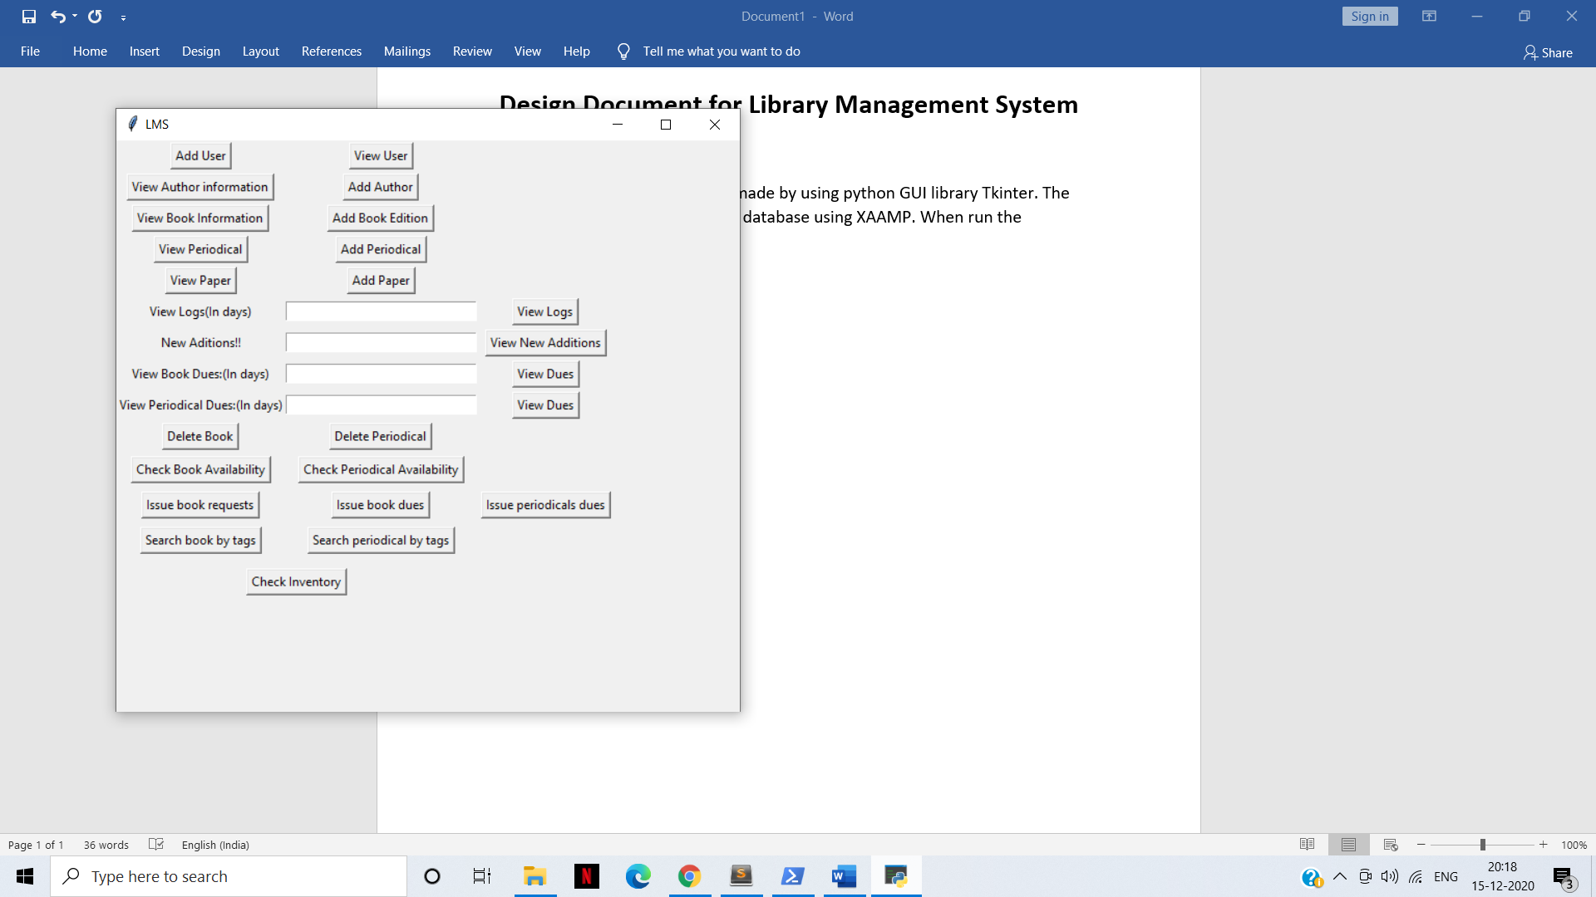

Let us look at the functionality one by one:

1. **Inventory:** Tells us the numbers of users, books, periodicals and authors.

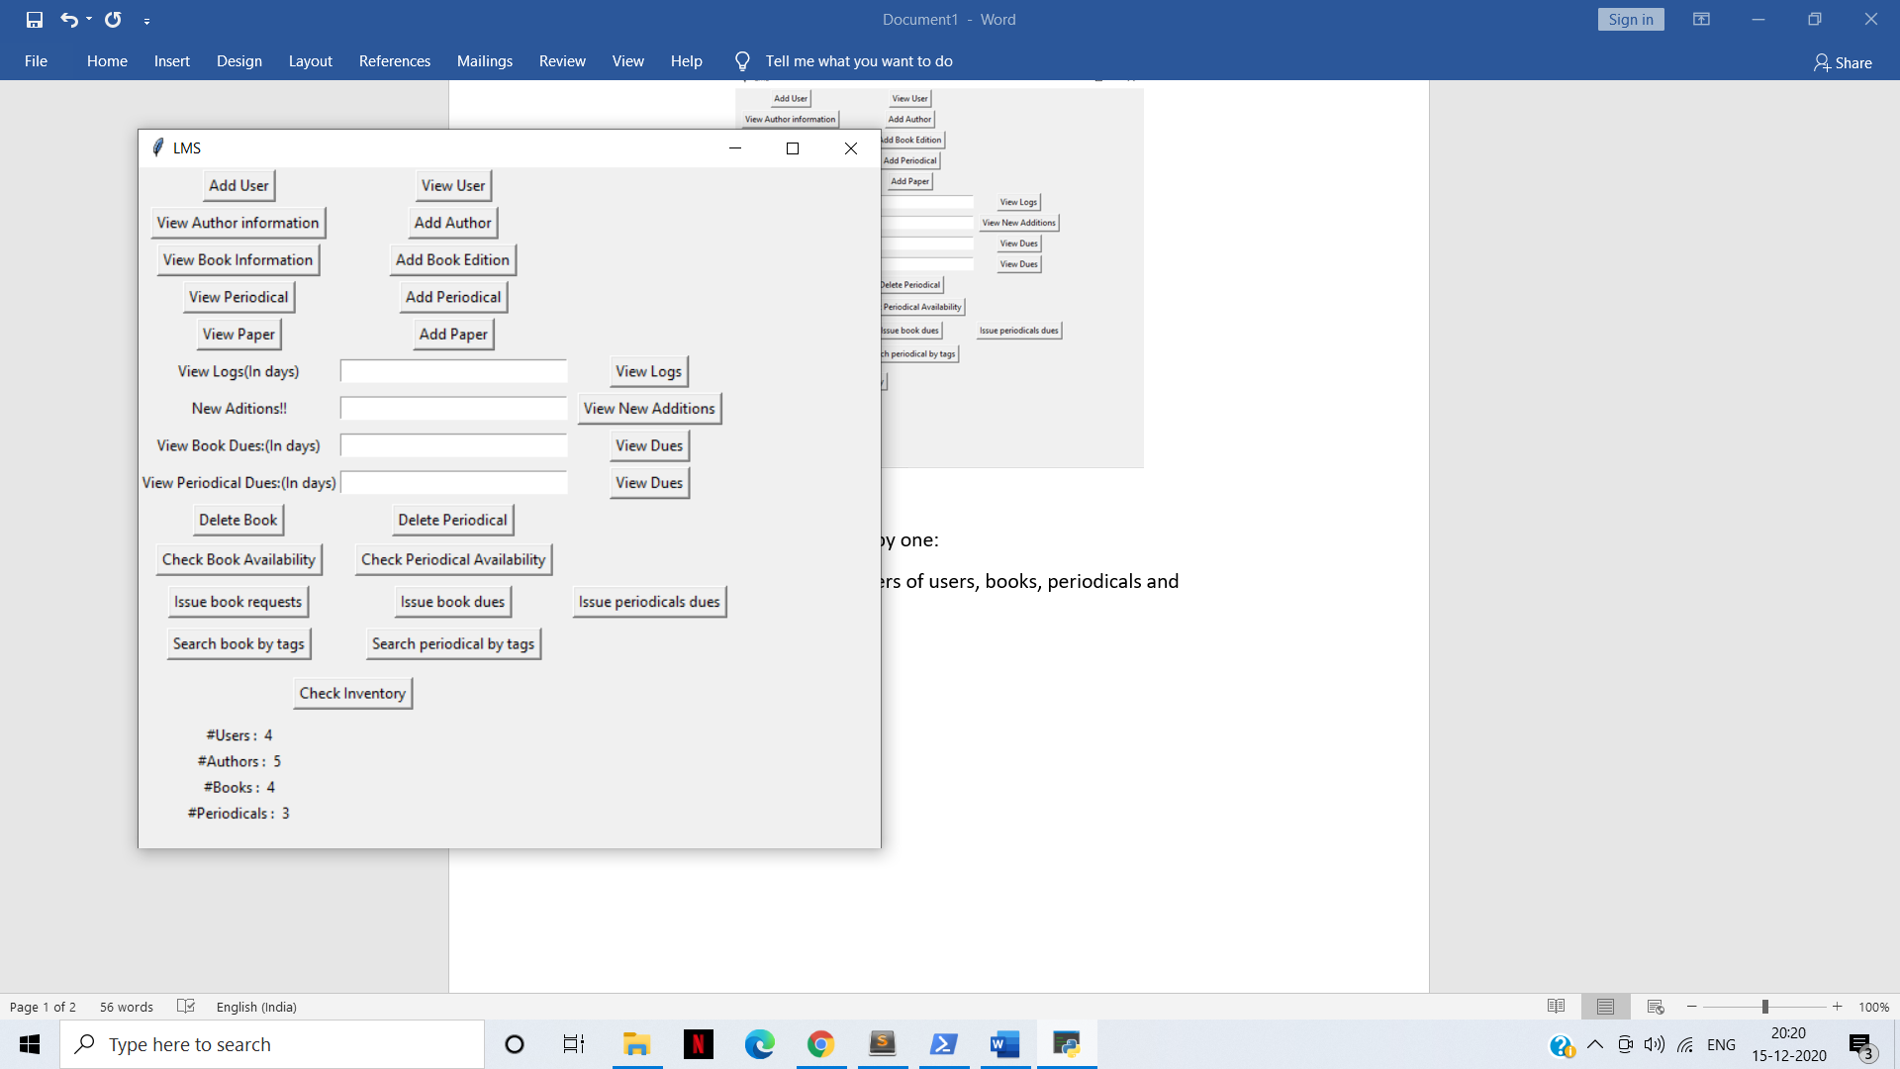

1. **Add User:** Adds a new user with category Student, Faculty, Staff, Guest.

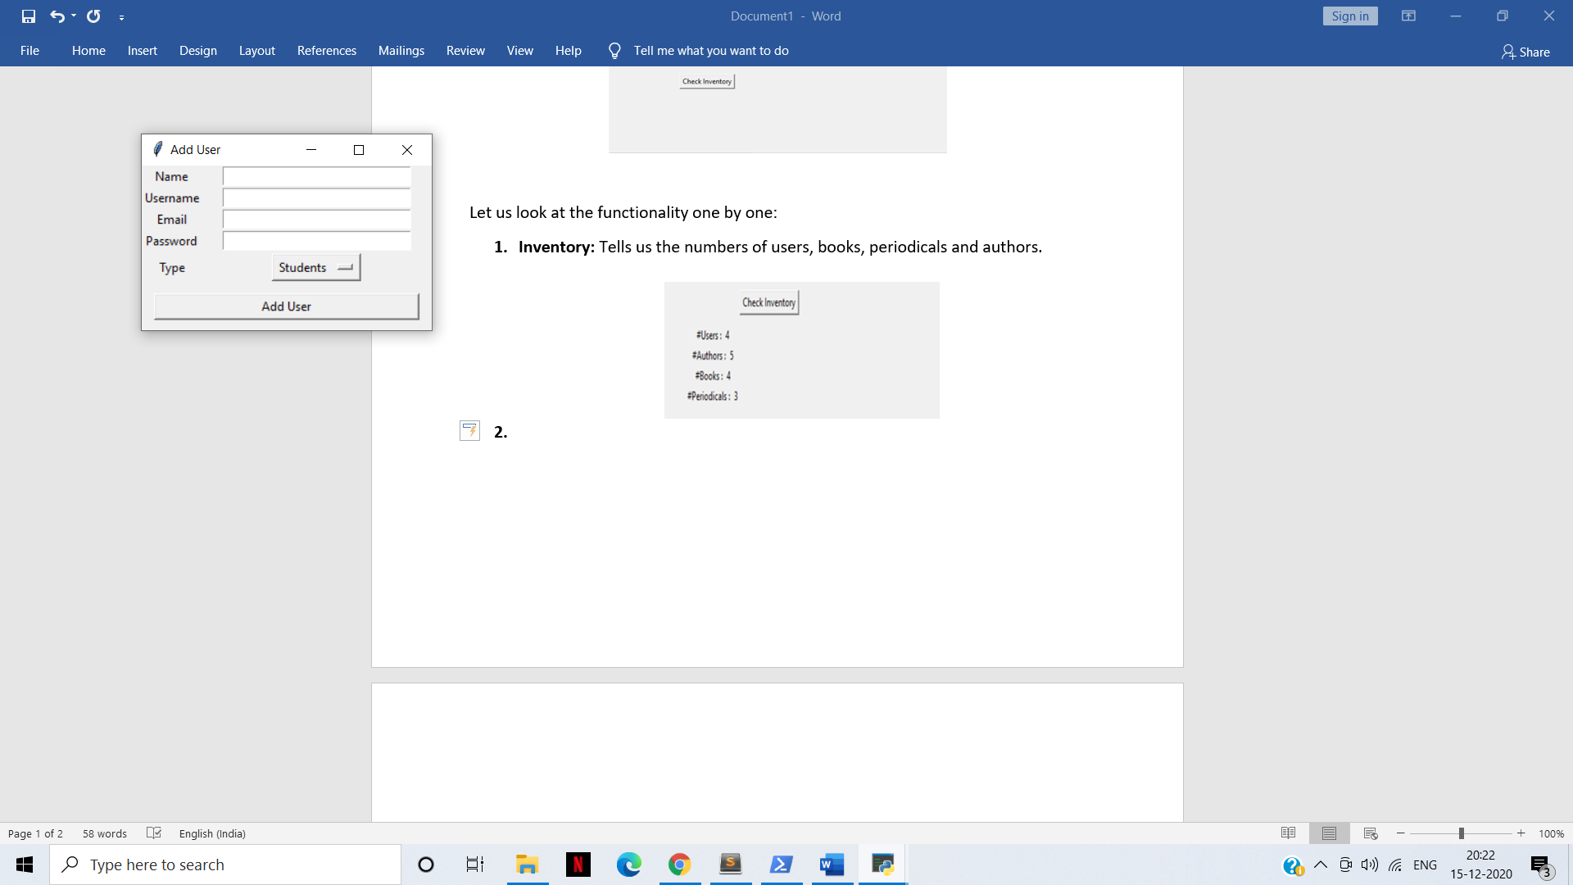

1. **View User:** View your details by entering your username. You can borrow a book/periodical based on your limit, return a book/periodical and pay pending fines.

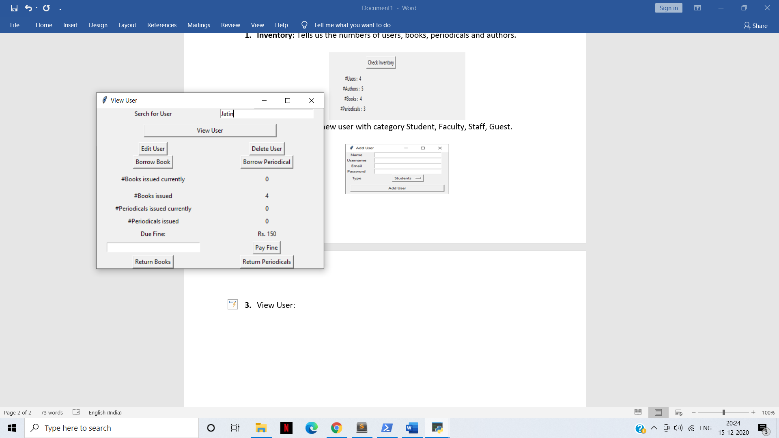

1. **View Book:** View details of a particular book by isbn. You can also add a copy of this book. Similarly you can view papers and periodicals.

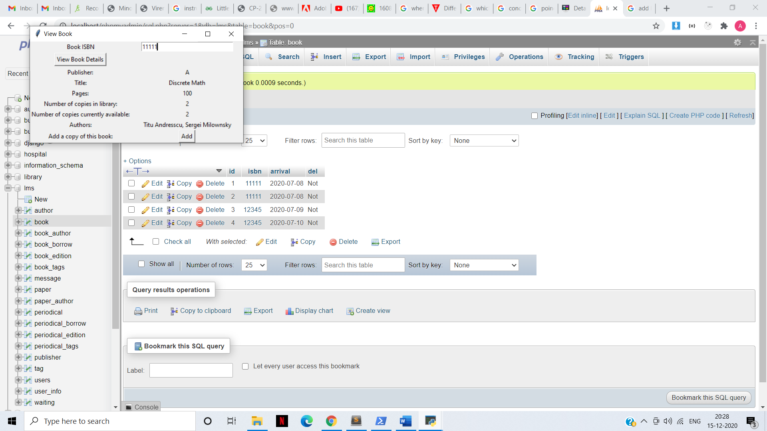

1. **Add book by isbn:** You can add a book edition (determined by isbn). Choose it’s publisher, authors, discipline.

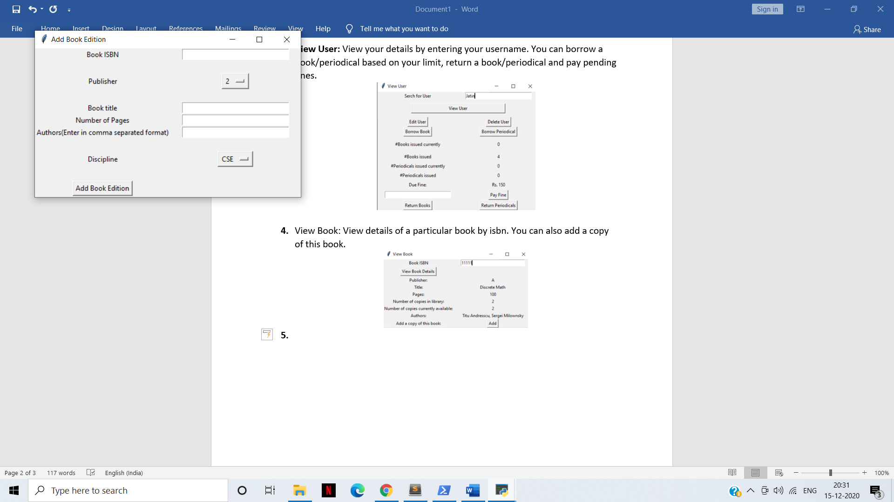

1. **View Logs/Dues:** You can view logs of issued books and periodicals any for the past couple of days. You can also view which books are/were due for past couple of days.
2. **View Book/Periodical availability:** You can view which copies of a particular book isbn are currently available. If not available, you could reserve a copy.

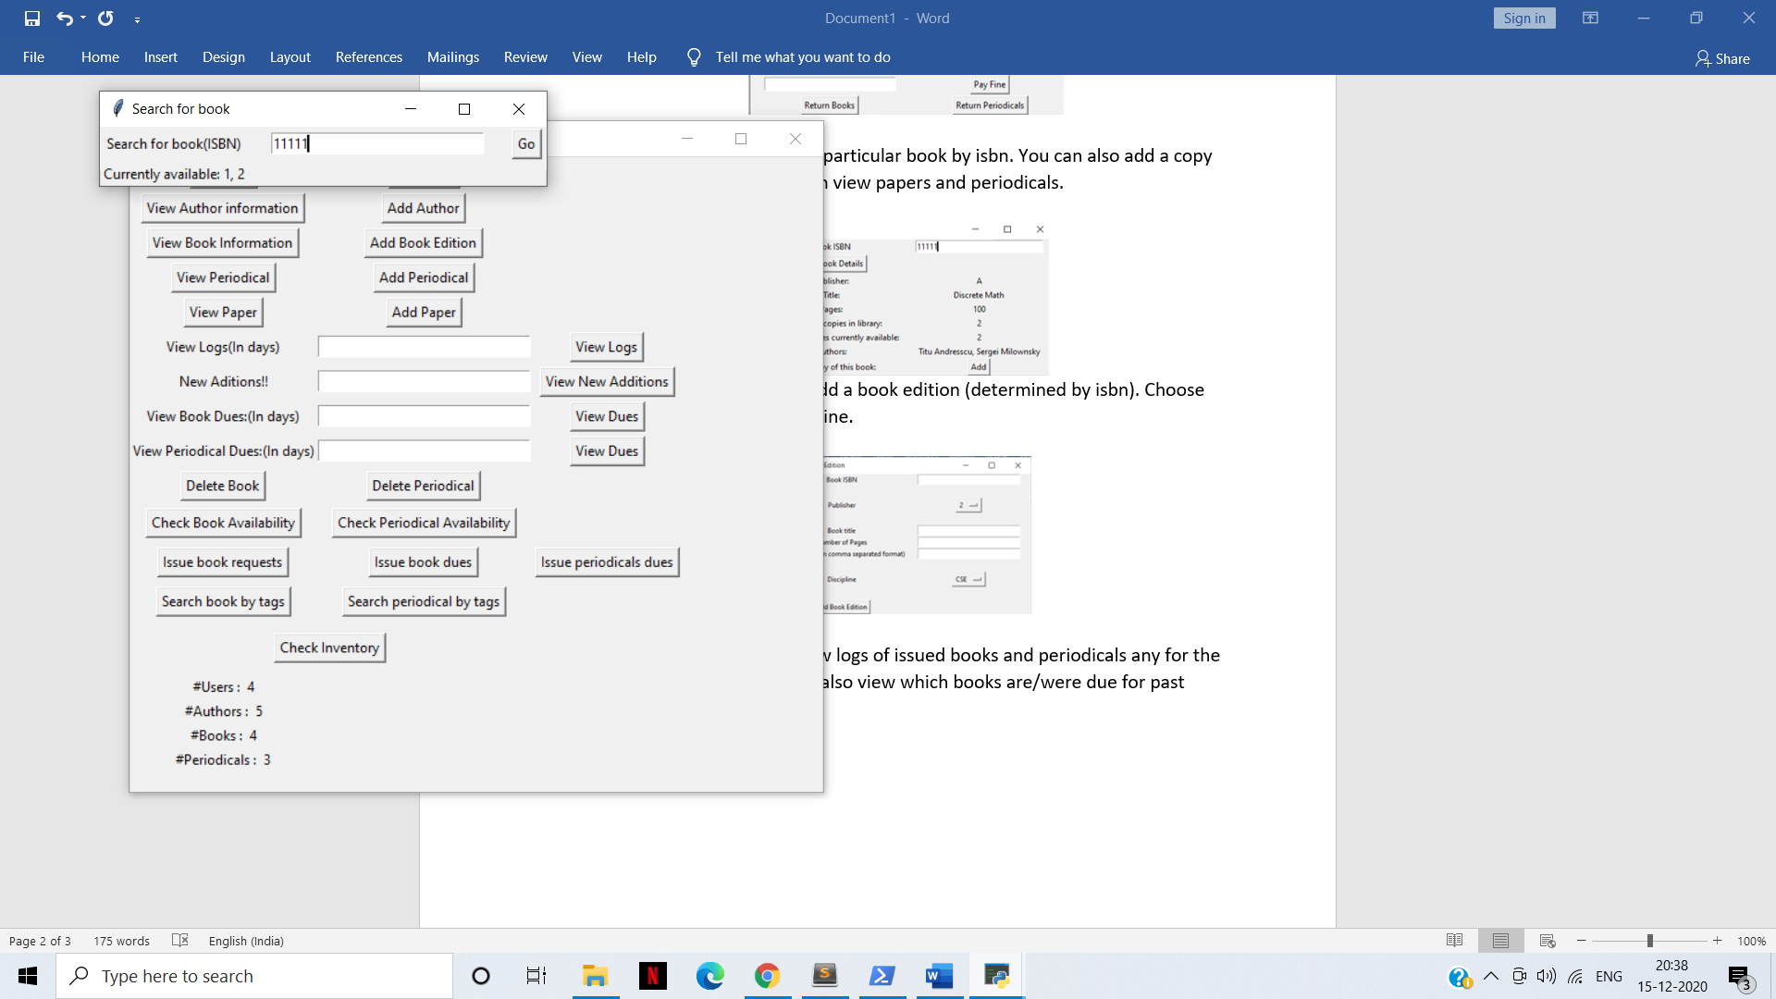

1. **Issue Book Dues:** Sends notifications via mail to all users with books overdue.
2. **Issue book Requests**: This takes into account all requests for reserving books and issues books on first reserve basis when available.
3. **Search books by tags:** Searches books by selected tags and shows the results.

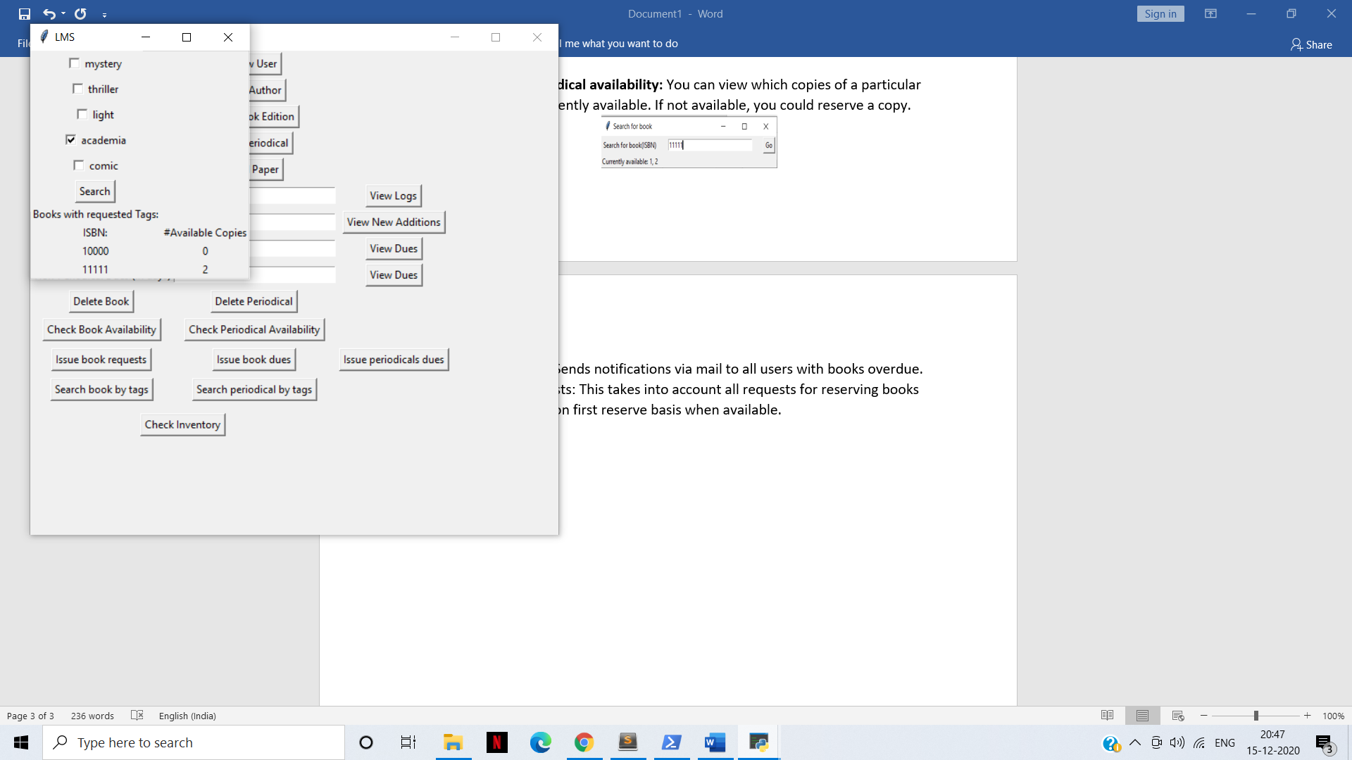

Apart from this, we have added functionalities like searching for particular author showing books he/she has written. Deleting users, books or periodicals is also possible.