**Steps for wordcount program execution**

**Map Function –**It takes a set of data and converts it into another set of data, where individual elements are broken down into tuples (Key-Value pair).

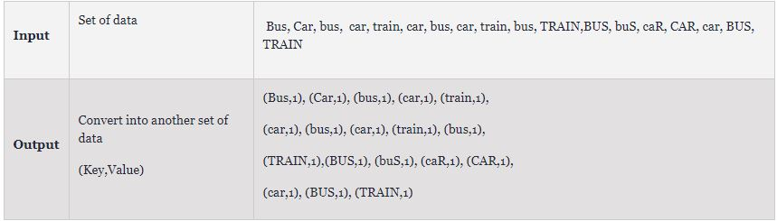

**Reduce Function –**Takes the output from Map as an input and combines those data tuples into a smaller set of tuples.

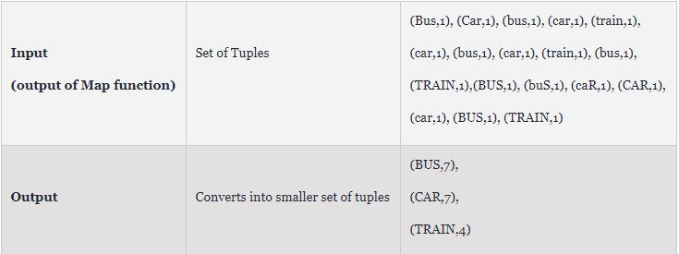

### Work Flow of Program

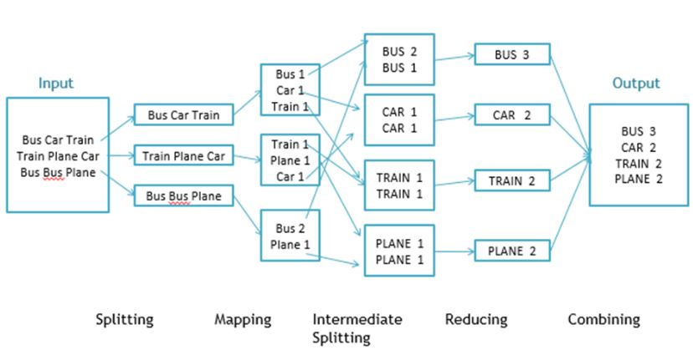

**Execution Steps:**

Step 1.  Open Eclipse> File > New > Java Project >( Name it – MRProgramsDemo) > Finish

Step 2.  Right Click > New > Package ( Name it - PackageDemo) > Finish

Step 3. Right Click on Package > New > Class (Name it - WordCount)

Step 4. Add Following Reference Libraries –

Right Click on Project > Build Path> Add External Archivals

* */usr/lib/hadoop-0.20/***hadoop-core.jar**
* *Usr/lib/hadoop-0.20/lib/***Commons-cli-1.2.jar**

Step 5. Type following Program :

package PackageDemo;

import java.io.IOException;

import org.apache.hadoop.conf.Configuration;

import org.apache.hadoop.fs.Path;

import org.apache.hadoop.io.IntWritable;

import org.apache.hadoop.io.LongWritable;

import org.apache.hadoop.io.Text;

import org.apache.hadoop.mapreduce.Job;

import org.apache.hadoop.mapreduce.Mapper;

import org.apache.hadoop.mapreduce.Reducer;

import org.apache.hadoop.mapreduce.lib.input.FileInputFormat;

import org.apache.hadoop.mapreduce.lib.output.FileOutputFormat;

import org.apache.hadoop.util.GenericOptionsParser;

public class WordCount {

public static void main(String [] args) throws Exception

{

Configuration c=new Configuration();

String[] files=new GenericOptionsParser(c,args).getRemainingArgs();

Path input=new Path(files[0]);

Path output=new Path(files[1]);

Job j=new Job(c,"wordcount");

j.setJarByClass(WordCount.class);

j.setMapperClass(MapForWordCount.class);

j.setReducerClass(ReduceForWordCount.class);

j.setOutputKeyClass(Text.class);

j.setOutputValueClass(IntWritable.class);

FileInputFormat.addInputPath(j, input);

FileOutputFormat.setOutputPath(j, output);

System.exit(j.waitForCompletion(true)?0:1);

}

public static class MapForWordCount extends Mapper<LongWritable, Text, Text, IntWritable>{

public void map(LongWritable key, Text value, Context con) throws IOException, InterruptedException

{

String line = value.toString();

String[] words=line.split(",");

for(String word: words )

{

Text outputKey = new Text(word.toUpperCase().trim());

IntWritable outputValue = new IntWritable(1);

con.write(outputKey, outputValue);

}

}

}

public static class ReduceForWordCount extends Reducer<Text, IntWritable, Text, IntWritable>

{

public void reduce(Text word, Iterable<IntWritable> values, Context con) throws IOException, InterruptedException

{

int sum = 0;

for(IntWritable value : values)

{

sum += value.get();

}

con.write(word, new IntWritable(sum));

}

}

}

Step 6. Make Jar File

Right Click on Project> Export> Select export destination as **Jar File** > next> Finish

Step 7. Take a text file and move it in HDFS

*(Hadoop fs –put <textfilename> <output dir in hdfs>)*

Step 8 . Run Jar file

*(hadoop jar jarfilename.jar packageName.ClassName  PathToInputTextFile PathToOutputDirectry)*

Step 9 . open Result file

(Hadoop fs –cat outputDirectry/part-r-0000)