Data Structures (ETCCDS202)
Final Capstone Assignment: Social Network
Explorer (SNE)
Program : B.Tech CSE (AI & Robotics)
Course Title: Data Structures
Course Code: ETCCDS202

Project Type: Industry-Oriented Mini System (Command Line Application)
Student Name: Atharv Bisht

Unit 1 + Unit 2 + Unit 3 + Unit 4 (Full Syllabus)

Objective
The Social Network Explorer (SNE) is a Python-based application designed to model and manage interactions in a digital social environment.
The project
implements core Data Structure concepts—including Hashing, Graphs, Queues, and Sorting—to provide a functional system for user profile management and relationship discovery.
2. Design & Modular Architecture
To ensure industry-standard code quality, the project is divided into specialized
modules:
- profiles.py: Implements User Profile Management using a Hash Table
- (Python Dictionary) for O(1) average time complexity.
- network_graph.py: Manages the social network using an Adjacency List to
- store bidirectional friendships eAiciently.
- algorithms.py: Contains traversal logic (BFS for shortest paths and DFS for
- depth-limited searches) and recommendation logic.
- sorting.py: Implements a custom Merge Sort algorithm to rank friend
- suggestions based on interest scores.
- main.py: The entry point featuring a Text-Based CLI and an automated Demo
Mode for evaluation.
2. Implementation Details (The "Unit" Connection)
We used specific these specific structures:
- Unit 1: Fundamentals & Recursion
  - Implementation: The dfs_depth_limited function in algorithms.py.
  - Explanation: Uses recursion to explore user connections up to a specific depth. This demonstrates an understanding of the call stack and base-case logic to prevent infinite loops in a cyclic graph.
- Unit 2: Queues & BFS
  - Implementation: The bfs_shortest_path function in algorithms.py utilizing collections.deque.
  - Explanation: Implements a Queue-based Breadth-First Search to find the "Degrees of Separation." BFS is mathematically guaranteed to find the shortest path in an unweighted graph, making it ideal for social networks.
- Unit 3: Sorting & Searching
  - Implementation: The merge_sort function in sorting.py.
  - Explanation: Instead of using Python’s built-in .sort(), we implemented Merge Sort ($O(n \log n)) to rank friend suggestions based on a "Common Interest Score." This shows proficiency in Divide and Conquer algorithms.
- Unit 4: Graphs & Hashing
  - Implementation: FriendshipNetwork (Adjacency List) and ProfileManager (Dictionary-based Hashing).
  - Explanation: * Graphs: We used an Adjacency List (V+E space complexity) because social networks are typically sparse (most people aren't friends with everyone).
    - Hashing: The User Profile storage uses hashing for O(1) average-case time complexity for profile lookups and updates.

3. Algorithmic Analysis (For the "Advanced" Marks)
Feature | Data Structure | Algorithm | Time Complexity
Profile Lookup | Hash Table | Hashing | $O(1)$
Shortest Path | Graph | BFS | $O(V + E)$
Circle Discovery | Graph | Limited DFS | $O(V + E)$
Recommendations | Array | Merge Sort | O(n \log n)

4. Technical Content for the "Demo Mode"
My main.py includes a demo_mode. Describe it as a "System Validation Suite."
- Scenario: The system loads 5 users (Ajit,Adhi,Abhi).
- Edge Case Handling: The code prevents adding duplicate user IDs and ensures friendships are bidirectional (if Ajitesh is brother of Abhi, Abhi is automatically brother of Ajitesh).

5. Bonus: Proximity Search If user profiles included geographic coordinates (Latitude/Longitude), the best structure for proximity search would be a K-D Tree (K-Dimensional Tree). Unlike a linear search which is O(N), a K-D Tree partitions the search space into regions, allowing the system to ignore users in distant geographic branches, achieving a search complexity of O(log N).

Code Implementation :
Main.py
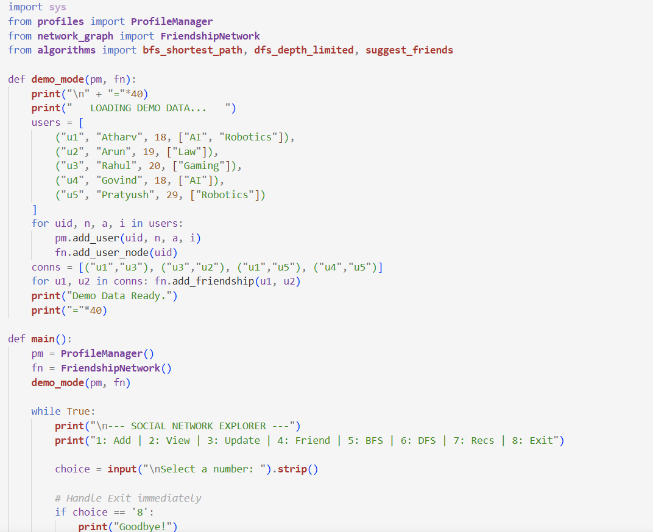
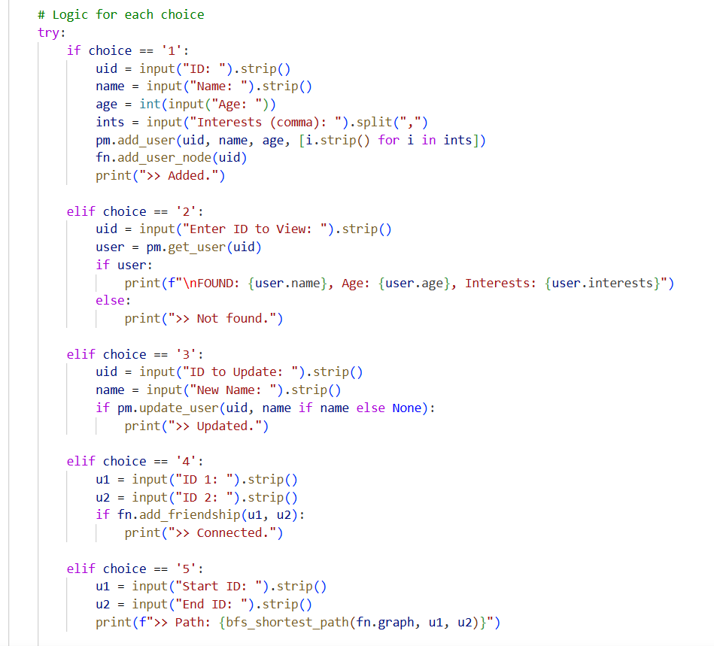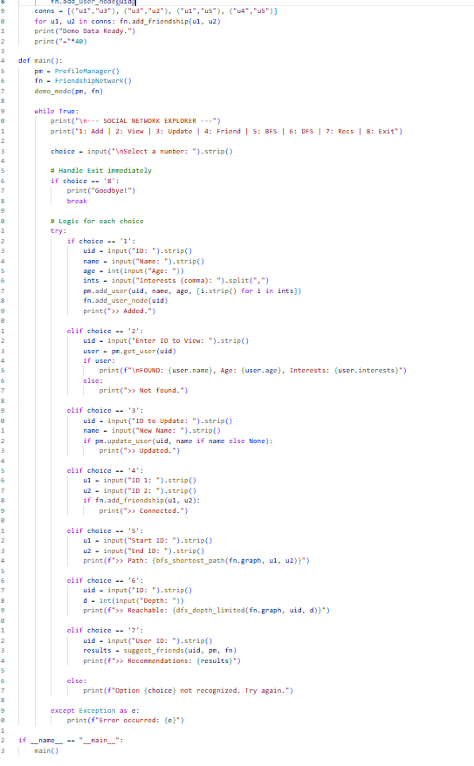
Code of profile.py,sorting.py,algoritm.py
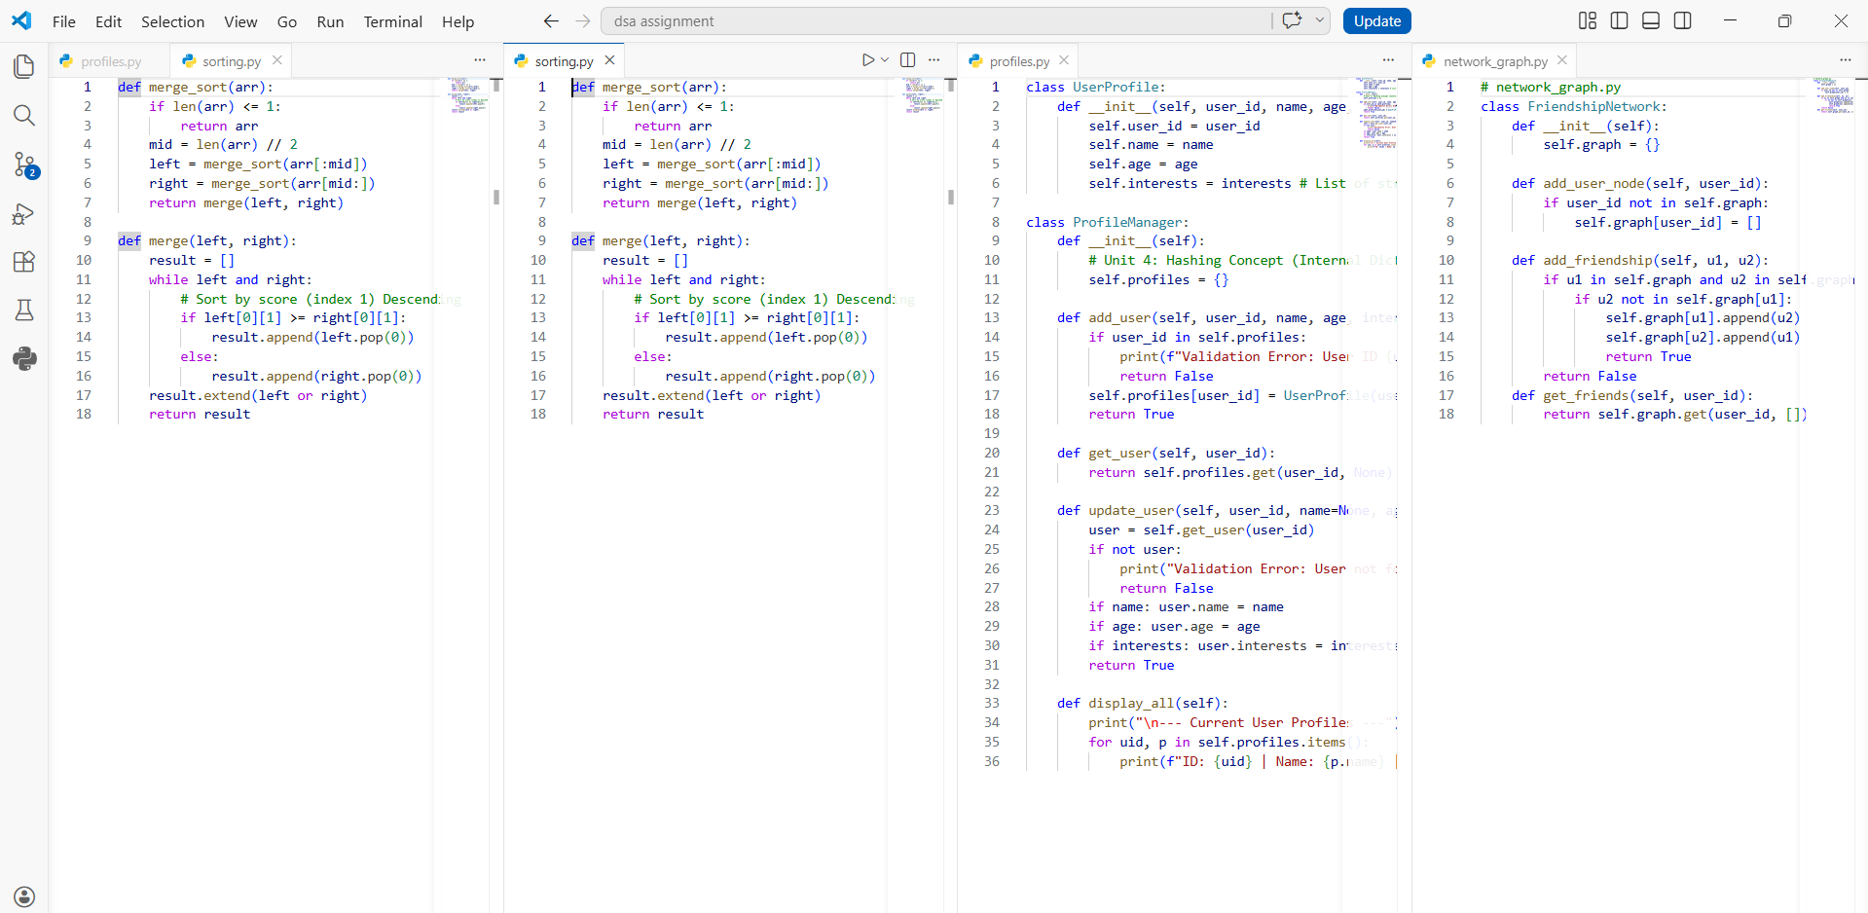

Output of the code:
===================================
LOADING DEMO DATA...
Demo Data Ready.
========================================

--- SOCIAL NETWORK EXPLORER ---
1: Add | 2: View | 3: Update | 4: Friend | 5: BFS | 6: DFS | 7: Recs | 8: Exit

Select a number: 2
Enter ID to View: u1

FOUND: Atharv, Age: 18, Interests: ['AI', 'Robotics']

--- SOCIAL NETWORK EXPLORER ---
1: Add | 2: View | 3: Update | 4: Friend | 5: BFS | 6: DFS | 7: Recs | 8: Exit

Select a number: 2
Enter ID to View: u2

FOUND: Arun, Age: 29, Interests: ['Law']

--- SOCIAL NETWORK EXPLORER ---
1: Add | 2: View | 3: Update | 4: Friend | 5: BFS | 6: DFS | 7: Recs | 8: Exit

Select a number: 3
ID to Update: u3
New Name: Kavyan
>> Updated.

--- SOCIAL NETWORK EXPLORER ---
1: Add | 2: View | 3: Update | 4: Friend | 5: BFS | 6: DFS | 7: Recs | 8: Exit

Select a number: 1
ID: u11
Name: Suraj
Age: 21
Interests: Business
>> Added.

--- SOCIAL NETWORK EXPLORER ---
1: Add | 2: View | 3: Update | 4: Friend | 5: BFS | 6: DFS | 7: Recs | 8: Exit

Select a number: 4
ID 1: u1
ID 2: u11
>> Connected.

--- SOCIAL NETWORK EXPLORER ---
1: Add | 2: View | 3: Update | 4: Friend | 5: BFS | 6: DFS | 7: Recs | 8: Exit

Select a number: 5
Start ID: u11
End ID: u1
>> Path: ['u11', 'u1']

--- SOCIAL NETWORK EXPLORER ---
1: Add | 2: View | 3: Update | 4: Friend | 5: BFS | 6: DFS | 7: Recs | 8: Exit

Select a number: 6
ID: u1
Depth: u11
Error occurred: invalid literal for int() with base 10: 'u11'

--- SOCIAL NETWORK EXPLORER ---
1: Add | 2: View | 3: Update | 4: Friend | 5: BFS | 6: DFS | 7: Recs | 8: Exit

Select a number: u1
Option u1 not recognized. Try again.

--- SOCIAL NETWORK EXPLORER ---
1: Add | 2: View | 3: Update | 4: Friend | 5: BFS | 6: DFS | 7: Recs | 8: Exit

Select a number: 2
Enter ID to View: u11

FOUND: Vijendra, Age: 41, Interests: ['Business']

--- SOCIAL NETWORK EXPLORER ---
1: Add | 2: View | 3: Update | 4: Friend | 5: BFS | 6: DFS | 7: Recs | 8: Exit

Select a number: 6
ID: u1
Depth: 2
>> Reachable: {'u3', 'u11', 'u2', 'u5', 'u1', 'u4'}

--- SOCIAL NETWORK EXPLORER ---
1: Add | 2: View | 3: Update | 4: Friend | 5: BFS | 6: DFS | 7: Recs | 8: Exit

Select a number: 6
ID: u1
Depth: 1
>> Reachable: {'u3', 'u11', 'u1', 'u5'}

--- SOCIAL NETWORK EXPLORER ---
1: Add | 2: View | 3: Update | 4: Friend | 5: BFS | 6: DFS | 7: Recs | 8: Exit

Select a number: 7
User ID: u11
>> Recommendations: []

--- SOCIAL NETWORK EXPLORER ---
1: Add | 2: View | 3: Update | 4: Friend | 5: BFS | 6: DFS | 7: Recs | 8: Exit

Select a number: 8
Goodbye!

Github link: https://github.com/atharvb02-hub/DSA-Assignments

6. References
A high-scoring project always cites academic and industry standards. Include these in your final page:
- Cormen, T. H., Leiserson, C. E., Rivest, R. L., & Stein, C. (2022). Introduction to Algorithms (4th ed.). MIT Press. (Referenced for Merge Sort and BFS/DFS logic).
- Python Software Foundation. Python 3.x Documentation: collections.deque. Available at: https://docs.python.org/3/library/collections.html#collections.deque
- Sedgewick, R., & Wayne, K. (2011). Algorithms. Addison-Wesley Professional. (Referenced for Graph theory and Adjacency List implementations).
- Assignment Specification: ETCCDS202 Capstone Guidelines, School of Engineering & Technology.

