**PRACTICAL NO. 01**

Roll No.: TSA 20.

AIM: - Program to demonstrate features of Dart language.

STEPS :-

1] Install VS Code

2] Add extension Flutter and Dart

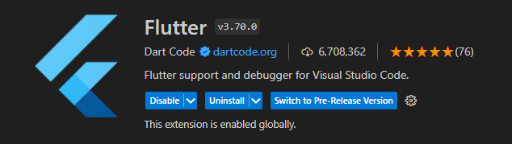

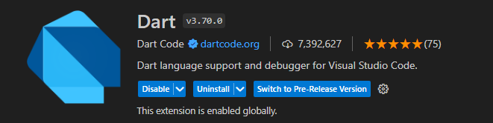

3] Download Flutter SDK

4] Copy path from C:\Users\testuser\Downloads\flutter\bin

5] Control Panel – Edit the system environment variable – Paste the path

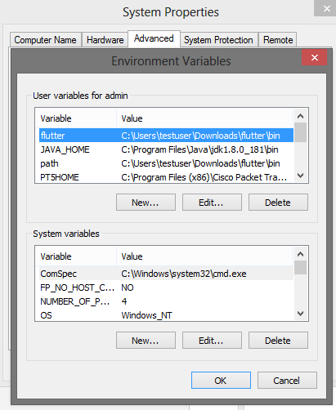

6] Open command prompt and type ‘flutter’ command

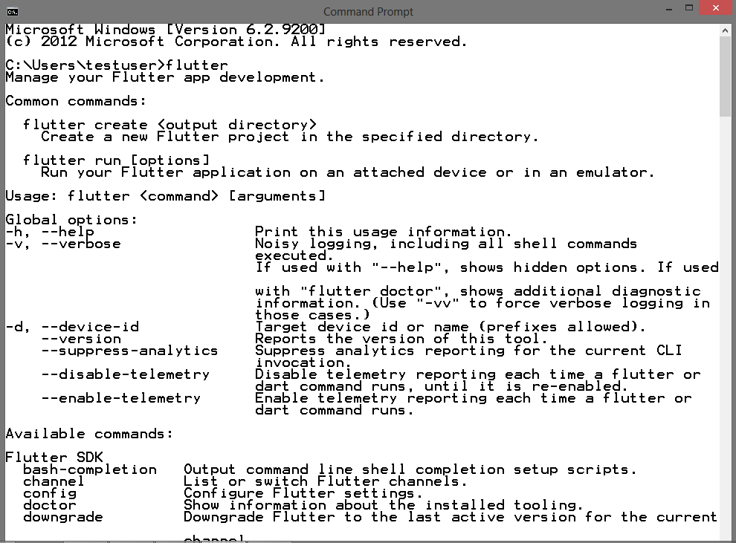

CODE :-

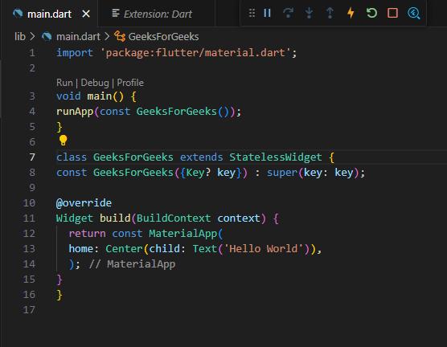

**OUTPUT:-**

