Lab 1 Part 2 Writeup

Answers to Lab Questions :

1. What voltage is present at the regulator input?

* 7.63V is the Input voltage to the regulator.

1. What voltage is present at the regulator output?

* 5.04V is the voltage regulator’s output.

1. What peak to peak noise is present across the processor VCC and GND?
2. Measured value at processor package pins on top side of board:

* 575 mV is the measured value as also seen in the oscilloscope screenshot below.

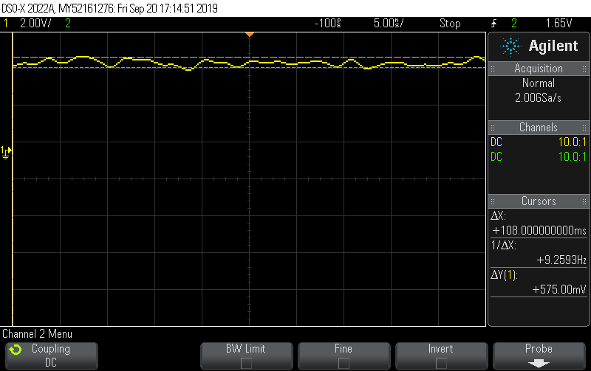

1. Measured value at wire wrap socket pins on bottom side of board:

* 525 mV is the measured value as also seen in the oscilloscope screenshot below.

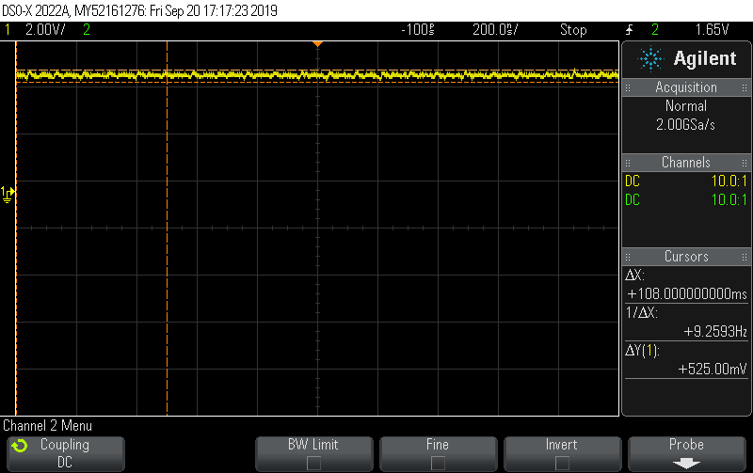

1. How long is the processor held in reset after the run-time reset pushbutton is released? Use an oscilloscope and try to measure the time between the release of the pushbutton and the time when noise from ALE is observed on the RST signal.

* As seen in the screenshot below, the total time taken was 106 mS between the release of the pushbutton and the time when noise from ALE was observed on the reset signal.

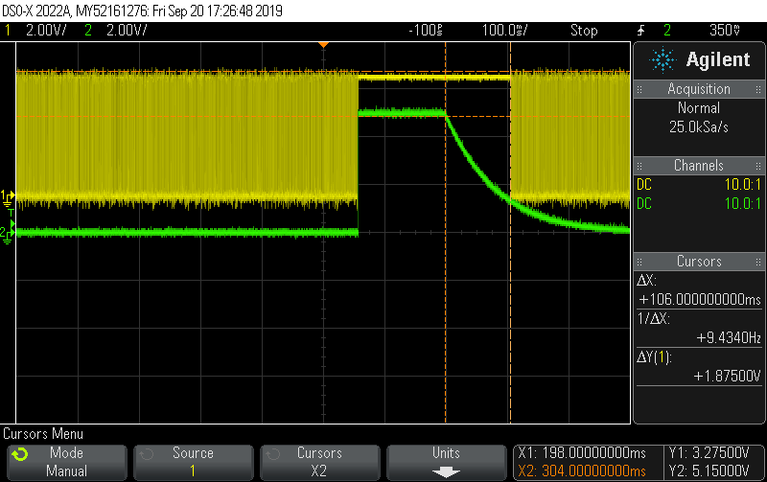

1. What frequency is present at the ALE pin?

* As calculated in the screenshot below, the frequency at the ALE pin is 1.838 MHz.

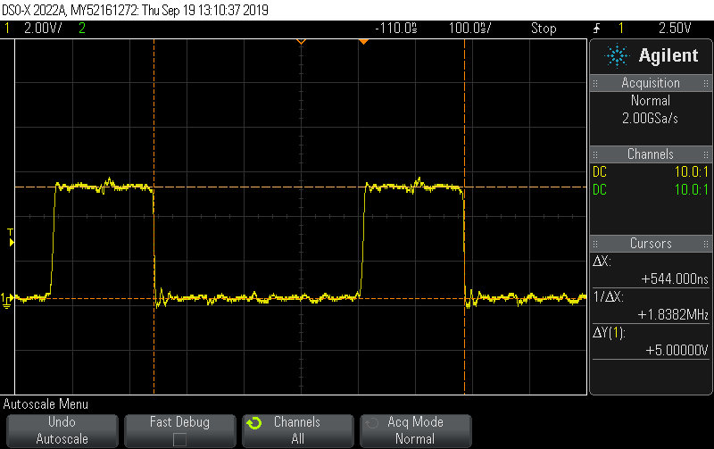

* The significance of this frequency is that the ALE frequency is 1/6 th the total XTAL Oscillator Frequency. As observed in the screenshot below, the oscillator frequency is 11.05 MHz
* The reason behind this is that, the Oscillator frequency (11.0592 MHz) consists of 12 machine cycles while the ALE signal takes 2 machine cycles. Therefore, this relation between the ALE signal frequency and the oscillator frequency can be observed.

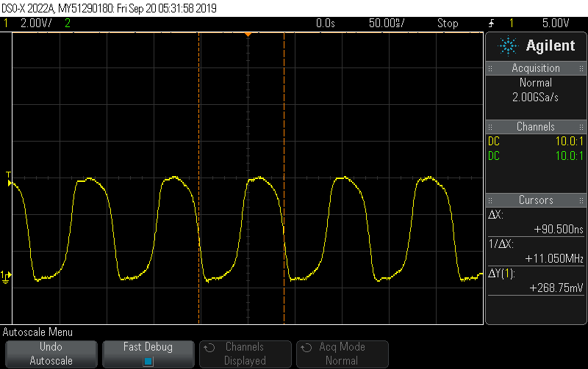

1. Reset Circuit Settling time (Extra)
2. Attached below is the screenshot of the reset circuit response when the push betton is pressed and released. The time taken here is calculated as 178 mS for Reset Output Voltage to fall from 0.9Vcc to 0.1Vcc (range suggested by TA considering the time required for the peripherals) where Vcc here is 5V from the regulator.

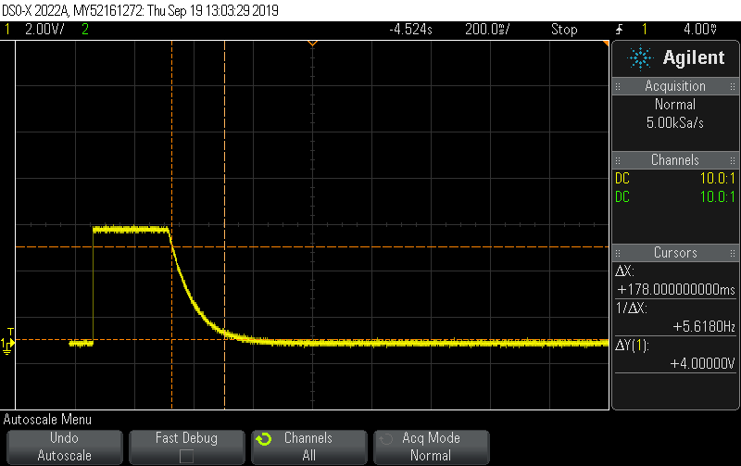

1. Attached below is the screenshot of the reset circuit response when the push betton is pressed and released. The time taken here is calculated as 178 mS for Reset Output Voltage to fall from Vcc to 0.6Vcc (this range is taken as per the datasheet of the microcontroller) where Vcc here is 5V from the regulator.

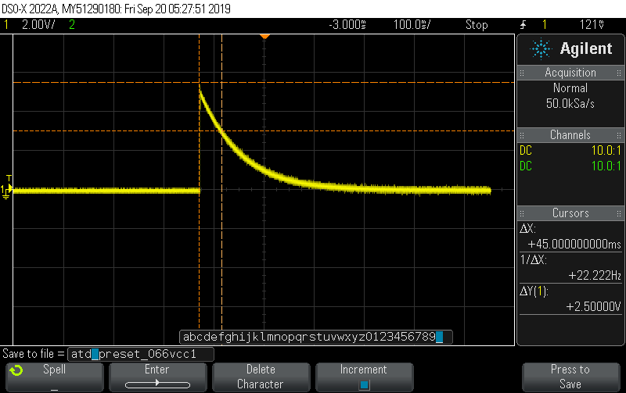

1. XTAL Oscillator Settling Time (Extra)

* The screenshot below demonstrates the time taken for XTAL Oscillator circuit to settle and provide constant frequency to the microcontroller from the Power turned ON.
* The time taken is 996uS as observed in the screenshot.

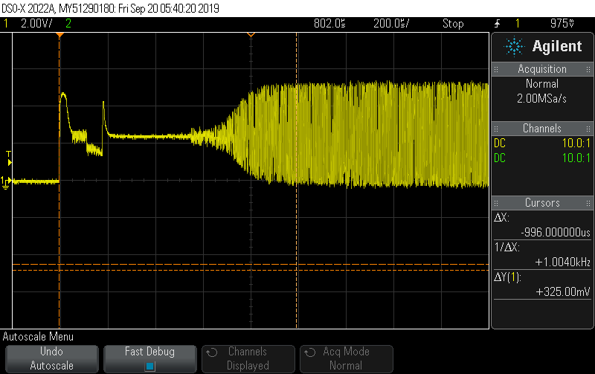

1. SPLD Output Read pin Response

* Shown below is the SPLD Output Read pin response. The logic for the Read pin is Read= RD & PSEN.

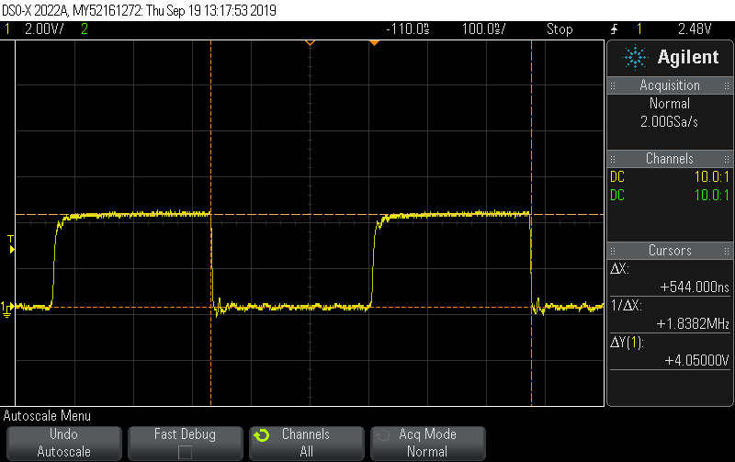

1. SPLD Output CSPERIPH pin response

* Shown below is the CSPERIPH pin response for the logic

CSPERIPH = !(A15 & A14 & A13 & A12)

* The duty cycle for this signal is 93.7 %. The reason is because for 15 of the 16 input combinations, CSPERIPH pin will be high.

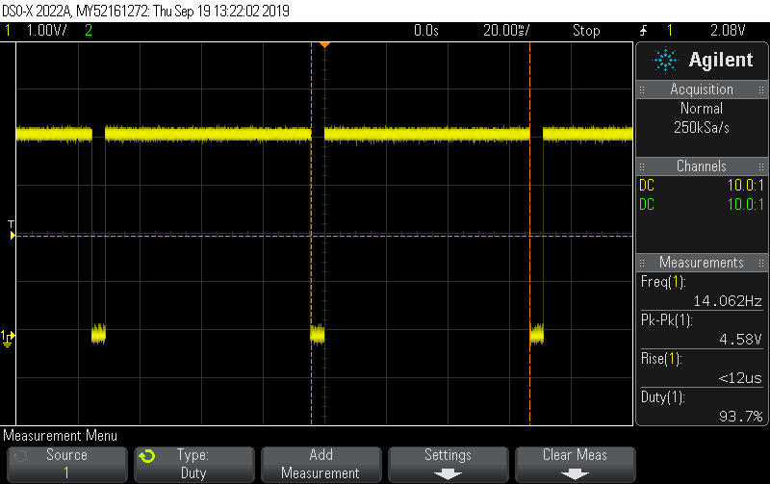

1. Power Settle Time

* Shown below is the total time taken by the power source to turn and settle at at constant high voltage.
* The time taken is 367 uSec.

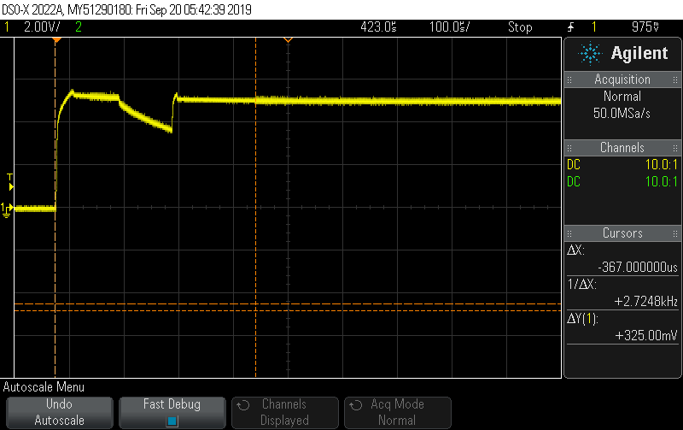

1. Vcc and GND noise

* The Vcc noise observed is 450mV

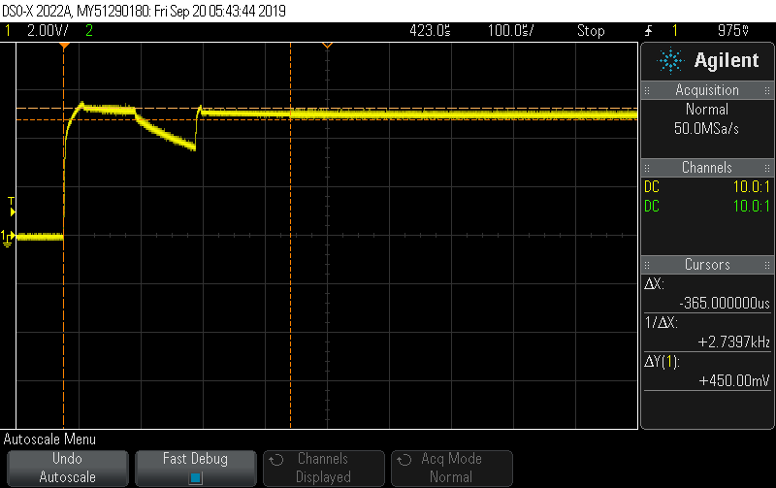

* The GND observed is 375mV

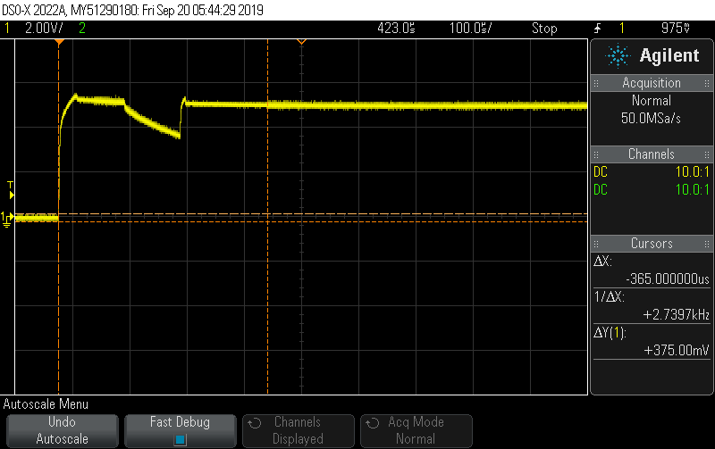

Gained Outcomes from Lab 1 Part 2 :

Schematic Design : This lab helped me to develop skills required for schematic design. Using Kicad Software, I was able to design the schematic layout and also to create the new components like C501 microcontroller and the SPLD and adding them to the Kicad library.

Mounting Components, Soldering and Wire Wrapping: While designing the board based on the schematic,I got acquainted with the Soldering and Wire Wrapping and I got a chance to improve these skills.

Use of Oscilloscope: After mounting all the components on the board, I got an opportunity to cognize the features of the Agilent Oscilloscope. Verification of the working of reset circuitry, oscillator circuitry and interfacing of C501 with its peripherals.