**Assignments**

**|- - Git**

**A1 part**

**Q1. Create a directory ‘project_dir’ & cd to ‘project_dir’.**

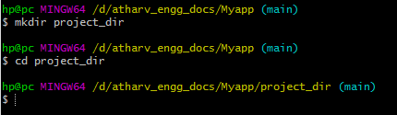

**Q2. Initialize git version database**



Q 3. Create a new file index.html.



Q4. Check the git status. You should find index.html as untracked file.

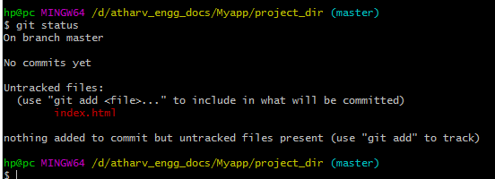

Q5. Stage the index.html file.

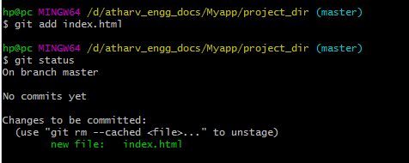

Q6. Commit index.html.

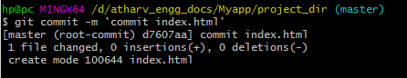

Q7.Make few changes in index.html & create a new file info.txt file.



Q8. Check git status. You should find index.html & info.txt as untracked files.

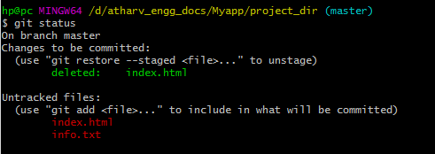

Q9. Configure GIT to ignore all txt files.

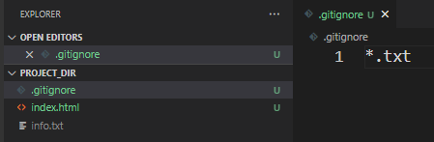

Q10. Again check the git status. You should find only index.html as untracked file.

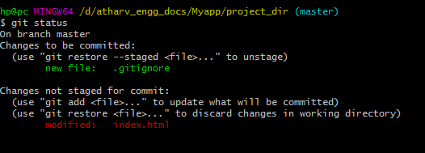

Q11. State & commit index.html.

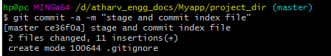

Q12. Log all your comments so far.

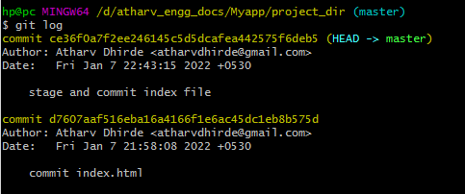

Q13. Make some changes in index.html.

Old file

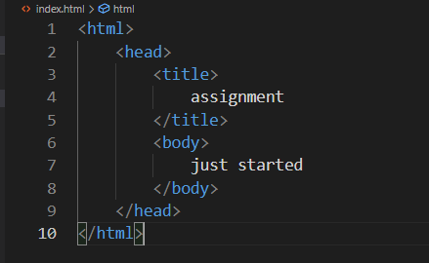

New file

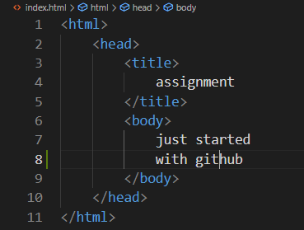 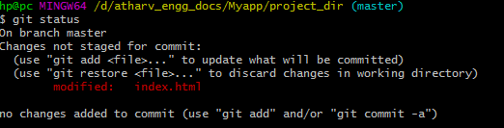

Q14. Revert the change made in the previous step using git command.

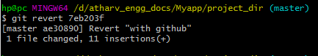 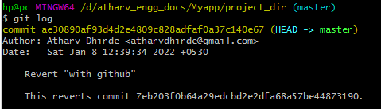

After reverting op

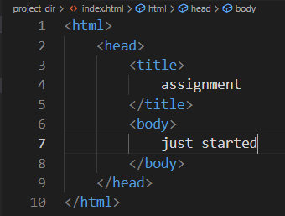

Q15. Again change index.html.

Old file new file

 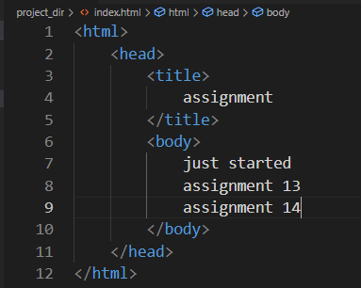

Q16. Stage index.html



Q17. Revert back the last stage

Old file

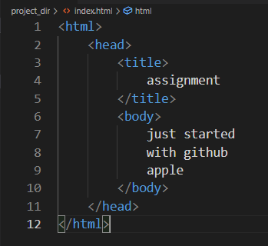

After reverting new file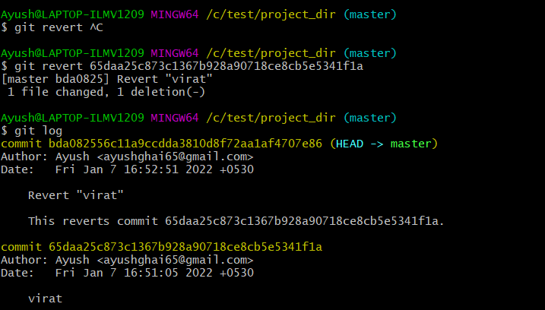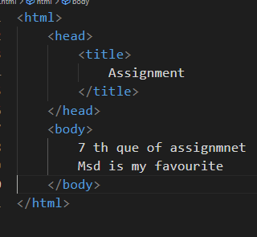

Again reverting without commiting



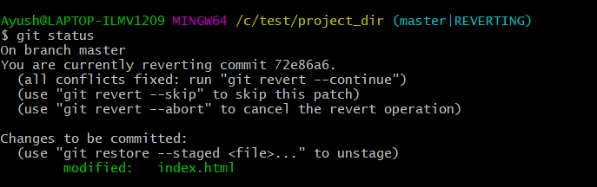

Q18 Rename ‘add’ command to ‘my-add’



Q19 Using my_add command Stage index.html again & commit the changes.

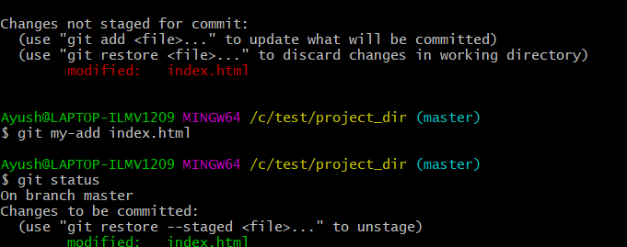

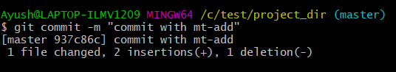

Q20 Revert the last commit.

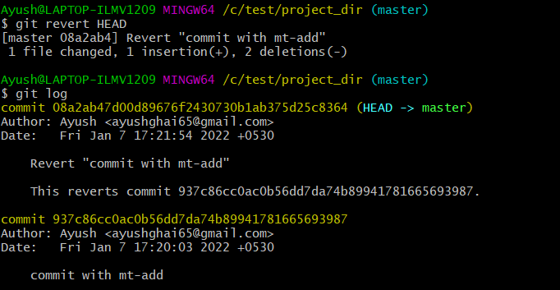

**GIT Branching(A2part)**

Q21. First take a backup of your assignments & projects. This is required because due to incorrect GIT operation you may lose your files

Q22. Create an empty directory ‘Assignments’ & cd to ‘Assignments’.

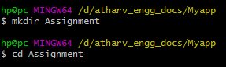

Q23. Create a file README.txt inside ‘Assignments’ & write few lines about the contents of ‘Assignments’ folder

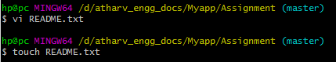

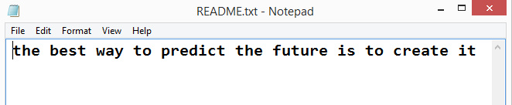

Q24 Commit README.txt file

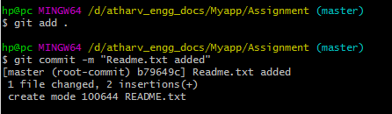

Q25 Now create a new branch ‘html-assignments’.



Q26 witch to ‘html-assignments’ branch.

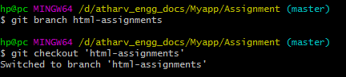

Q27 Copy all HTML assignments inside ‘Assignments’ folder.

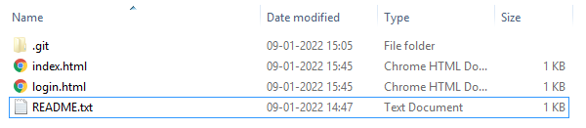

Q28 Commit HTML assignments into ‘html-assignments’ branch.

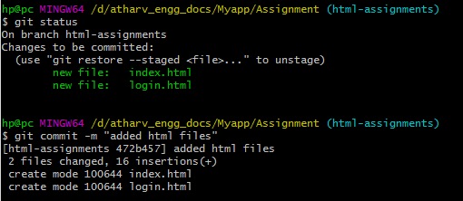

Q29 . Make minor changes into few files belonging to ‘html-assignments’ branch'

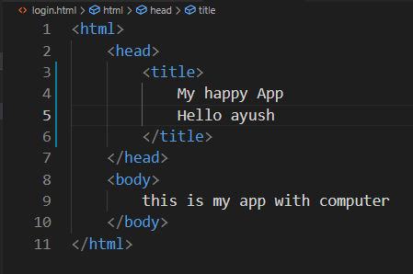

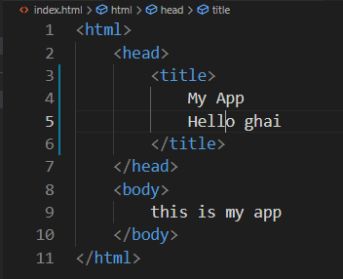

Q30 Commit those changed files.

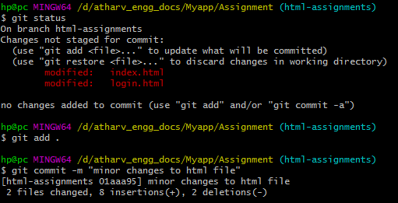

Q31 Switch to master branch



Q32 Make minor changes into README.txt file & commit those changes into master.

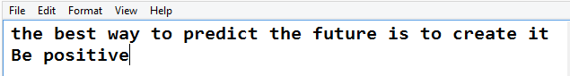

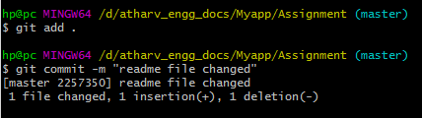

Q33 . Again switch to ‘html-assignments’ branch



Q34 Make minor changes into few files belonging to ‘html-assignments’ branch.

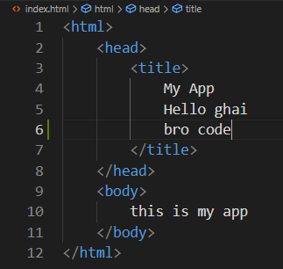 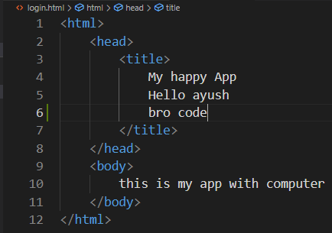

Q35 Commit those changes

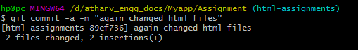

Q36 Switch to master.



Q 37 Merge ‘html-assignments’ branch into master. Confirm all html assignments are shown in master

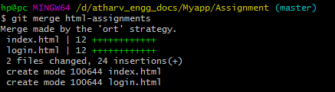

Q38 Finally delete the ‘html-assignments’ branch



**SECTION-2 - (CSS assignments) Steps to follow:**

Q1 Create a new branch ‘css-assignments’.



Q2 Switch to ‘css-assignments’ branch.



Q3 Copy all CSS assignments inside ‘Assignments’ folder.

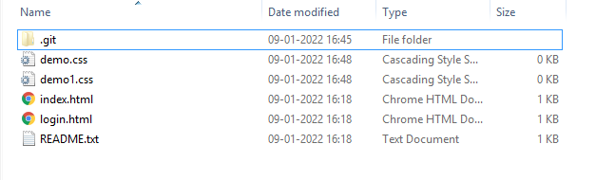

Q4 Commit CSS assignments into ‘css-assignments’ branch.

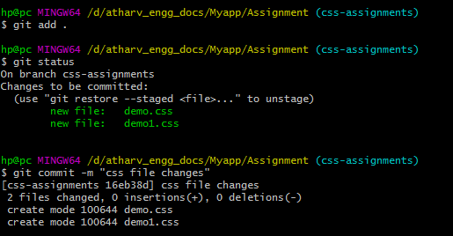

Q5 Make minor changes into README.txt file on line 1 belonging to ‘css-assignments’ branch.

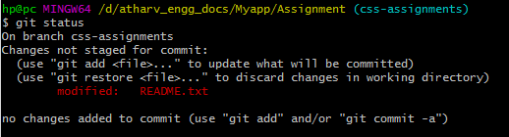

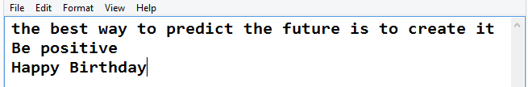

Q6 Commit those changed files.

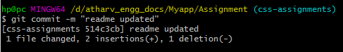

Q7 Switch to master branch.



Q8 Make minor changes into README.txt file on line 3 & commit those changes into master.

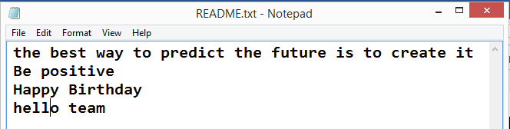

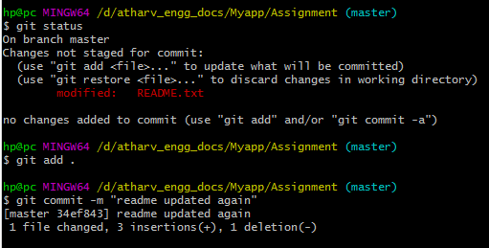

Q9 Again switch to ‘css-assignments’ branch.



Q10 Make minor changes into few files belonging to ‘css-assignments’ branch

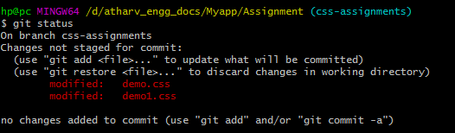

Q11 Commit those changes.

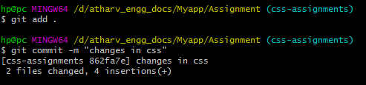

Q12 . Switch to master



Q13. Merge ‘css-assignments’ branch into master. Confirm all css assignments are shown in master



Q14. Finally delete the ‘css-assignments’ branch.



**SECTION-3 - (JavaScript assignments) Steps to follow**

Q1. Create a new branch ‘js-assignments’.



Q2. Switch to ‘js-assignments’ branch.



Q3. Copy all JavaScript assignments inside ‘Assignments’ folder.

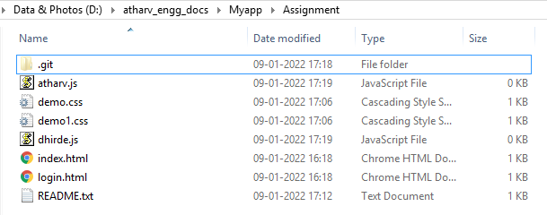

Q4. Commit JavaScript assignments into ‘js-assignments’ branch

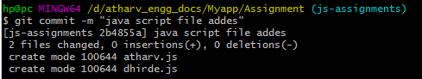

Q5. Make minor changes into README.txt file on line 1 belonging to ‘js-assignments’ branch.

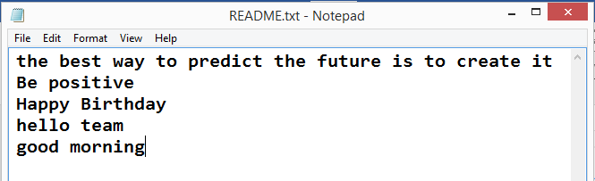

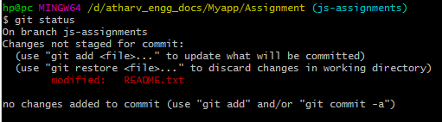

Q6. Commit those changed files.

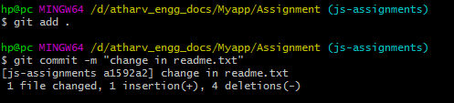

Q7. Switch to master branch



Q8. Make minor changes into README.txt file on line 1 & commit those changes into master.

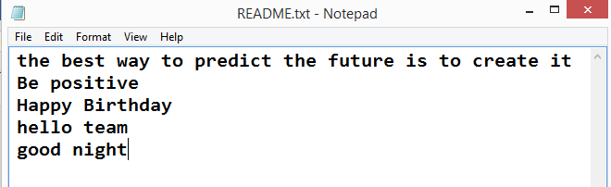

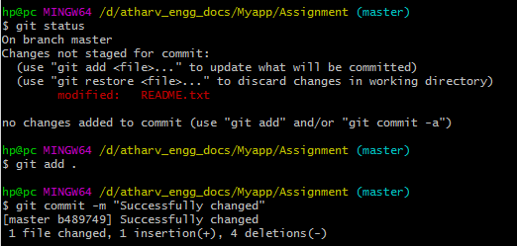

Q9 Again switch to ‘js-assignments’ branch



Q10 . Make minor changes into few files belonging to ‘js-assignments’ branch

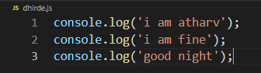

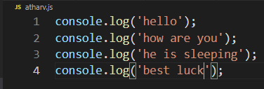

Q 11. Commit those changes.

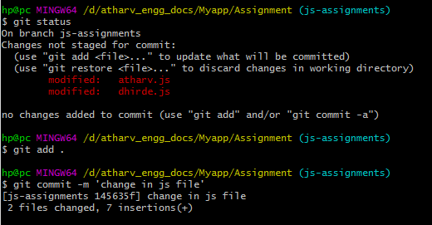

Q12. Switch to master



Q13. Merge ‘js-assignments’ branch into master. Confirm all JavaScript assignments are shown in master.

Before merging

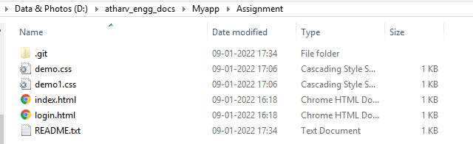

After merging

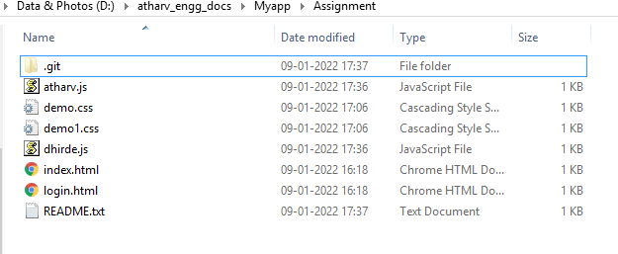

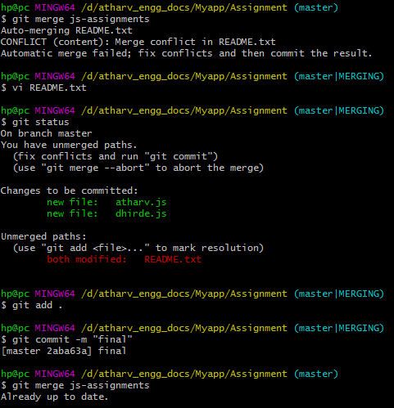

Q14 .Finally delete the ‘js-assignments’ branch.



**GIT Remoting**

Q39 Create a github account if you do not have already.

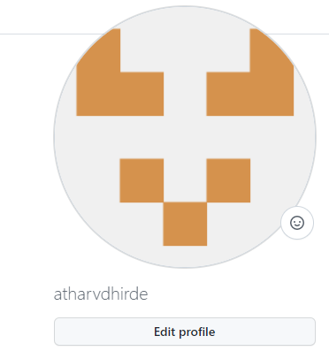

Q40. Login on into github account.

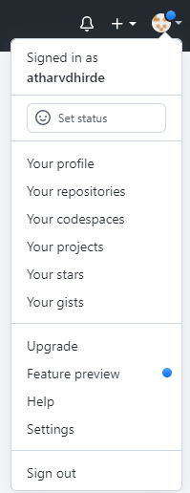

Q41. Create new public repository ‘freshersbatch-oct16’

