**Assignments**

**|- - MongoDB**

**A1 part**

**MongoDB Exercise in mongo shell**

Connect to a running mongo instance, use a database named **mongo_practice**.

Document all your queries in a javascript file to use as a reference.

**Insert Documents**

Insert the following documents into a **movies** collection.

title : Fight Club

writer : Chuck Palahniuko

year : 1999

actors : [

Brad Pitt

Edward Norton

]

title : Pulp Fiction

writer : Quentin Tarantino

year : 1994

actors : [

John Travolta

Uma Thurman

]

title : Inglorious Basterds

writer : Quentin Tarantino

year : 2009

actors : [

Brad Pitt

Diane Kruger

Eli Roth

]

title : The Hobbit: An Unexpected Journey

writer : J.R.R. Tolkein

year : 2012

franchise : The Hobbit

title : The Hobbit: The Desolation of Smaug

writer : J.R.R. Tolkein

year : 2013

franchise : The Hobbit

title : The Hobbit: The Battle of the Five Armies

writer : J.R.R. Tolkein

year : 2012

franchise : The Hobbit

synopsis : Bilbo and Company are forced to engage in a war against an array of combatants and keep the Lonely Mountain from falling into the hands of a rising darkness.

title : Pee Wee Herman's Big Adventure

title : Avatar

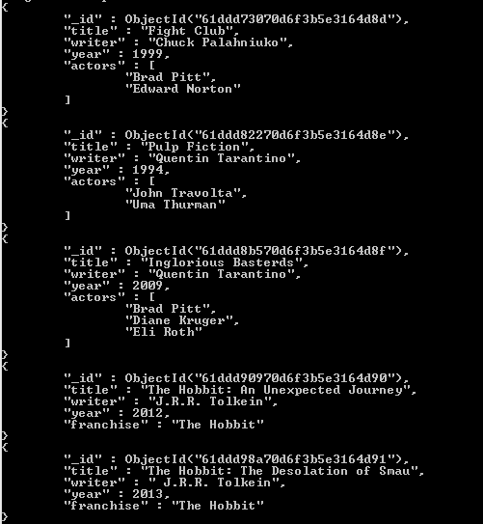

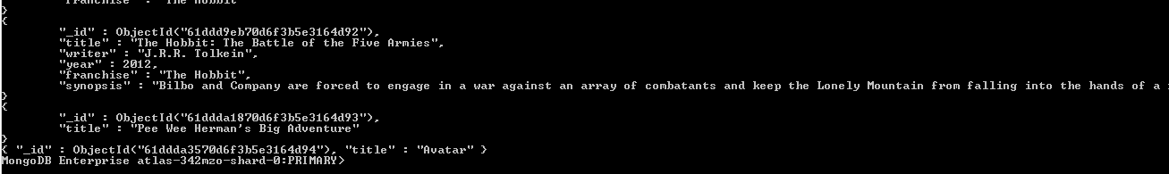

**Query / Find Documents**

query the **movies** collection to

1. get all documents

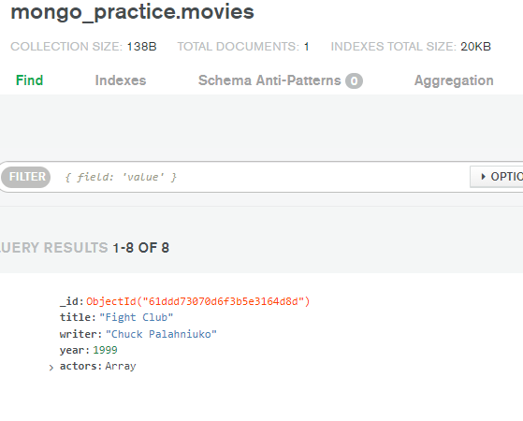

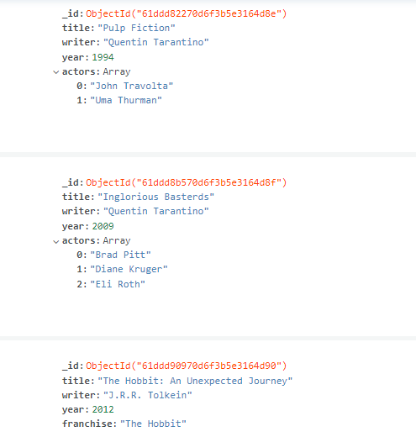

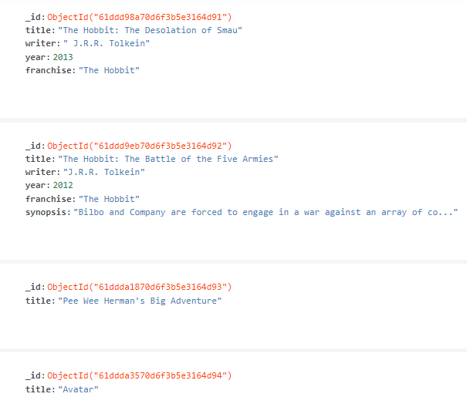

2. get all documents with writer set to "Quentin Tarantino"

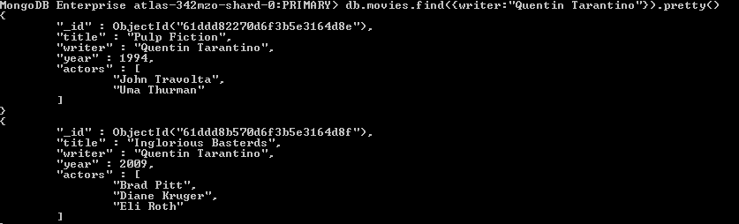

3. get all documents where actors include "Brad Pitt"

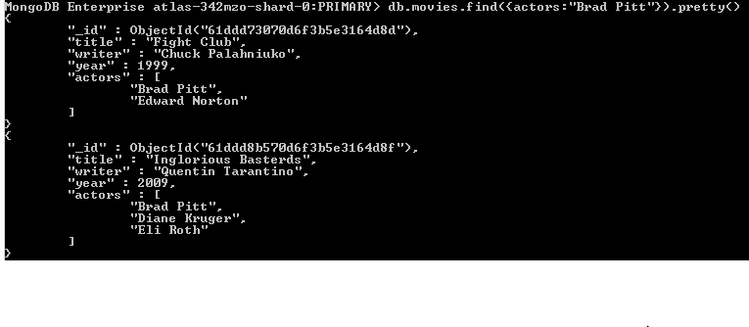

4. get all documents with franchise set to "The Hobbit"

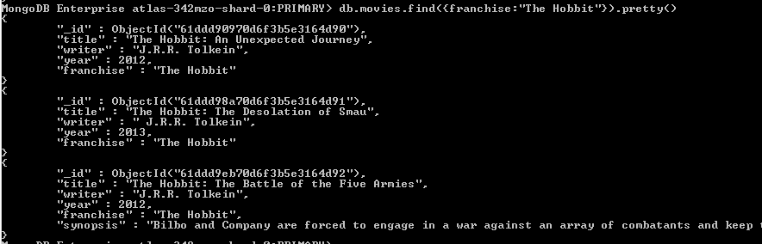

5. get all movies released in the 90s

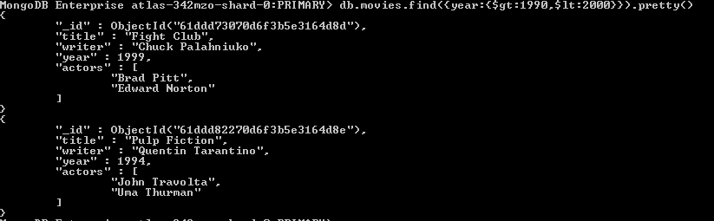

6. get all movies released before the year 2000 or after 2010

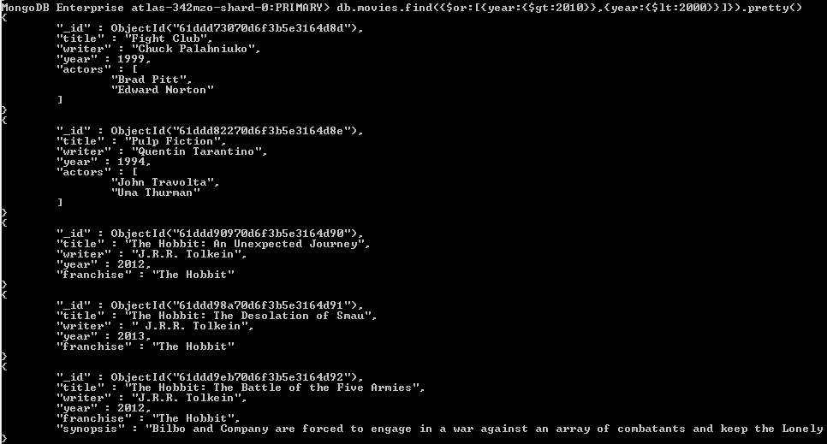

**Update Documents**

1. add a synopsis to "The Hobbit: An Unexpected Journey" : "A reluctant hobbit, Bilbo Baggins, sets out to the Lonely Mountain with a spirited group of dwarves to reclaim their mountain home - and the gold within it - from the dragon Smaug."



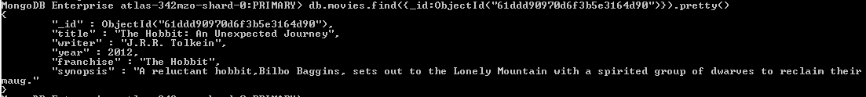

2. add a synopsis to "The Hobbit: The Desolation of Smaug" : "The dwarves, along with Bilbo Baggins and Gandalf the Grey, continue their quest to reclaim Erebor, their homeland, from Smaug. Bilbo Baggins is in possession of a mysterious and magical ring."



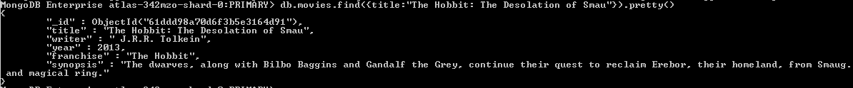

3. add an actor named "Samuel L. Jackson" to the movie "Pulp Fiction"

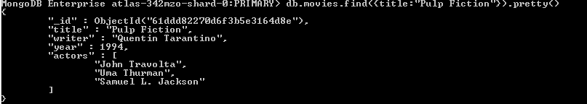

**Relationships**

1)Insert the following documents into a users collection

username : GoodGuyGreg

first_name :Good Guy"

last_name : "Greg"

username : ScumbagSteve

full_name:

first : "Scumbag"

last : "Steve





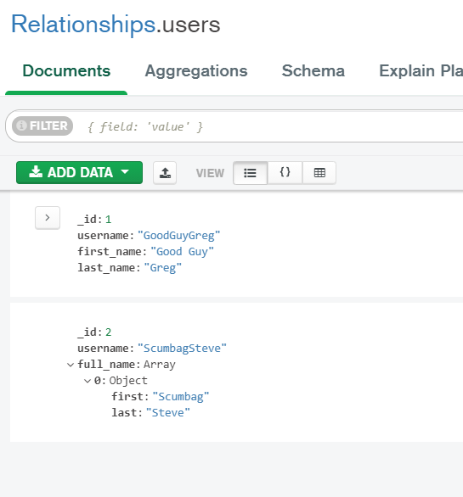

2) Insert the following documents into a posts collection

username : GoodGuyGreg

title : Passes out at party

body : Wakes up early and cleans house

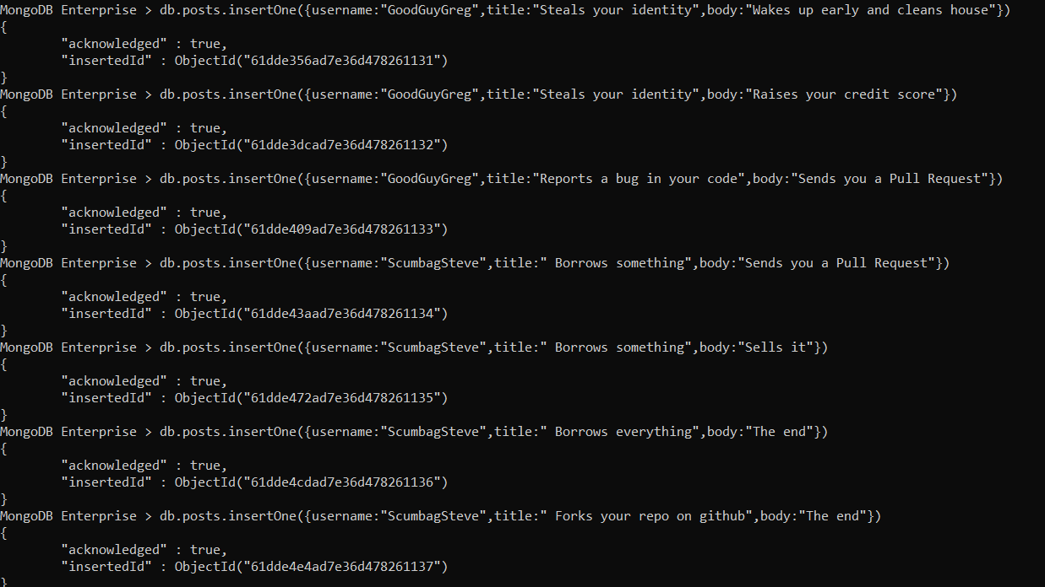

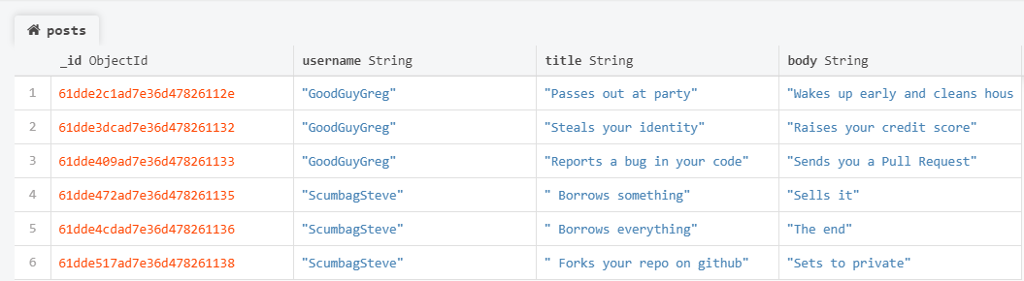

**Delete Documents**

1. delete the movie "Pee Wee Herman's Big Adventure"



2. delete the movie "Avatar"

