Education Economics: Insights into Debt, Earnings, and Career Sustainability

Introduction

The financial impact of higher education has become a growing concern for students, families, and policymakers, especially in an era of rising tuition fees and increasing student debt. As the cost of education continues to climb, the burden of student loans has left many graduates facing financial challenges long after earning their degrees. With the added complexity of varying salary outcomes based on institutions, regions, and academic majors, understanding these economic factors has never been more important.

This project seeks to dive deeper into the financial dynamics of higher education by exploring patterns in debt accumulation and post-graduation salary trends. By analyzing these elements across different educational institutions, geographical regions, and fields of study, the project aims to provide valuable insights into how students can make more informed decisions about their educational investments. Additionally, the findings can inform policymakers on how to structure financial aid, loan repayment options, and other initiatives to better support students in achieving a positive financial outcome after graduation.

Research Questions:

This project explores the following key research questions:
1. How does student debt vary by institution type, major, and region?
2. To what extent do Pell Grants reduce student debt across different types of institutions?
3. What are the trends in starting and mid-career salary growth across different majors and regions?
4. Are certain majors financially sustainable in the long term, considering both debt levels and salary outcomes?

Methodology

Data Sources

Data for this analysis was obtained from a variety of educational datasets, which provide insights into debt levels, regional salary outcomes, and salary potential across majors. The following data sources were utilized:

- Institutional Debt Data: This dataset provides insights into the average debt carried by graduates from different institutions and examines the role of Pell Grants in influencing debt levels. It helps assess whether financial aid reduces the financial burden on students and highlights trends across institutions and regions.
Link(Institutional Debt Data): https://collegescorecard.ed.gov/data/

- Salary Based Data:
- Regional Salary Data: This dataset includes data on starting and mid-career salaries by geographic region, allowing for an analysis of how location influences earning potential across different areas.

- Major-specific Salary Data: This dataset offers a detailed breakdown of starting and mid-career salaries for various majors, allowing for a comparison of financial outcomes across different fields of study. It helps identify which majors lead to higher earning potential and how salary growth varies over time by discipline.

- Institutional Type Salary Data: This dataset provides insights into starting and mid-career salaries based on institutional types, such as Ivy League, public, and state institutions. It allows for comparisons of how the type of institution impacts earning potential both early in one's career and over time.

Link(Regional Salary Data, Major-specific Salary Data, Institutional Type Salary Data): https://www.kaggle.com/datasets/wsj/college-salaries?

Data Preparation:

I processed the data in Python to make it suitable for analysis in Tableau. This included cleaning and structuring the dataset, handling any inconsistencies, and filling missing values with averages for consistency across visualizations. Once the data was ready, I created a single excel file with different sheets for all datasets in it and imported it into Tableau, where I applied various calculated fields, filters, and animations to create visualizations that effectively address the research questions.

Analysis

Research Question 1:
How does average student debt vary by institution type, major, and region?

Chart 1: School Type vs. Average Debt

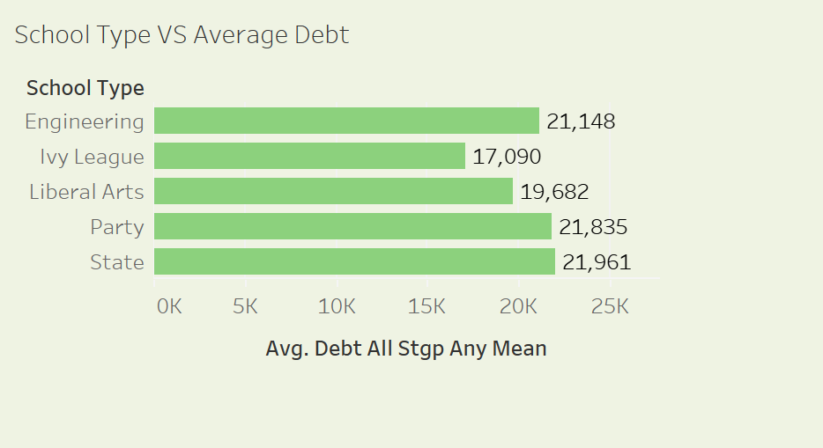

Visualization Overview:
The bar chart shows the average debt for different types of institutions (Engineering, Ivy League, Liberal Arts, Party, and State).

Insights:
Ivy League schools have the lowest average debt at $17,090, while state schools have the highest at $21,961.
This visualization highlights that Ivy League institutions report the lowest average debt, likely due to large endowments that allow for substantial financial aid. State schools, on the other hand, show higher average debt levels, potentially due to limited financial aid resources compared to private institutions. This trend suggests that while public schools are more affordable in tuition costs, students may still face significant debt burdens in the absence of robust financial aid.

Implications:
This information is particularly useful for prospective students considering their school options. Those concerned about debt may consider Ivy League institutions if financial aid is available.

Chart 2: Average Debt vs. Starting Median Salaries for Each Region

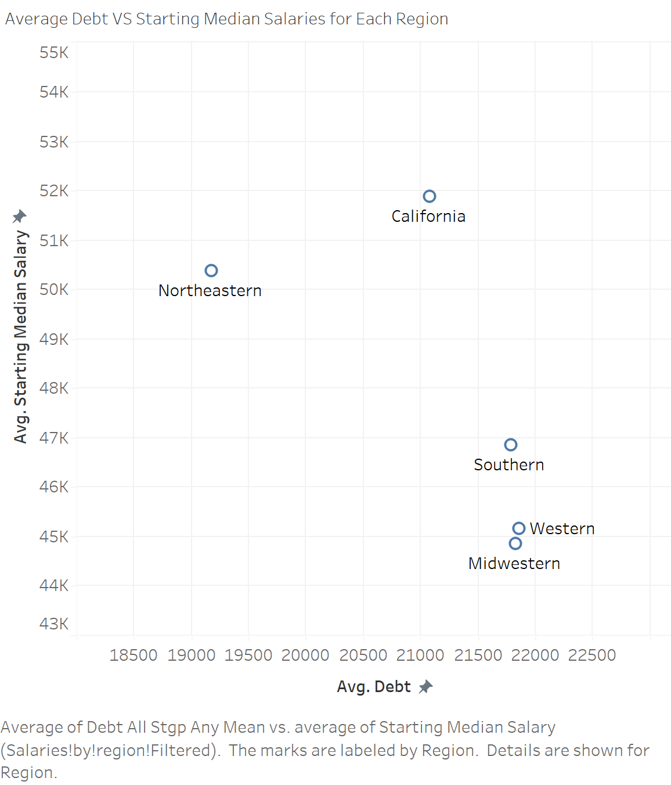

Visualization Overview:
This scatter plot compares the average debt and starting median salaries across regions in the United States.

Insights:
The California region stands out, with a high starting median salary and relatively lower debt. This suggests that graduates in California may have higher earning potential despite lower average debt levels, potentially due to stronger job markets in that area.
The Western region has one of the highest debt levels but also shows lower starting median salaries, indicating a potential mismatch between educational costs and earning potential.
This comparison highlights regional disparities in the cost-benefit of education. Students in high-debt, low-salary regions may face more financial challenges in paying off their loans.

Implications:
This insight can guide students in understanding the regional variation in debt vs. salary, helping them make informed decisions about where to study and work.

Chart 3: Trend of Average Debt across different Universities

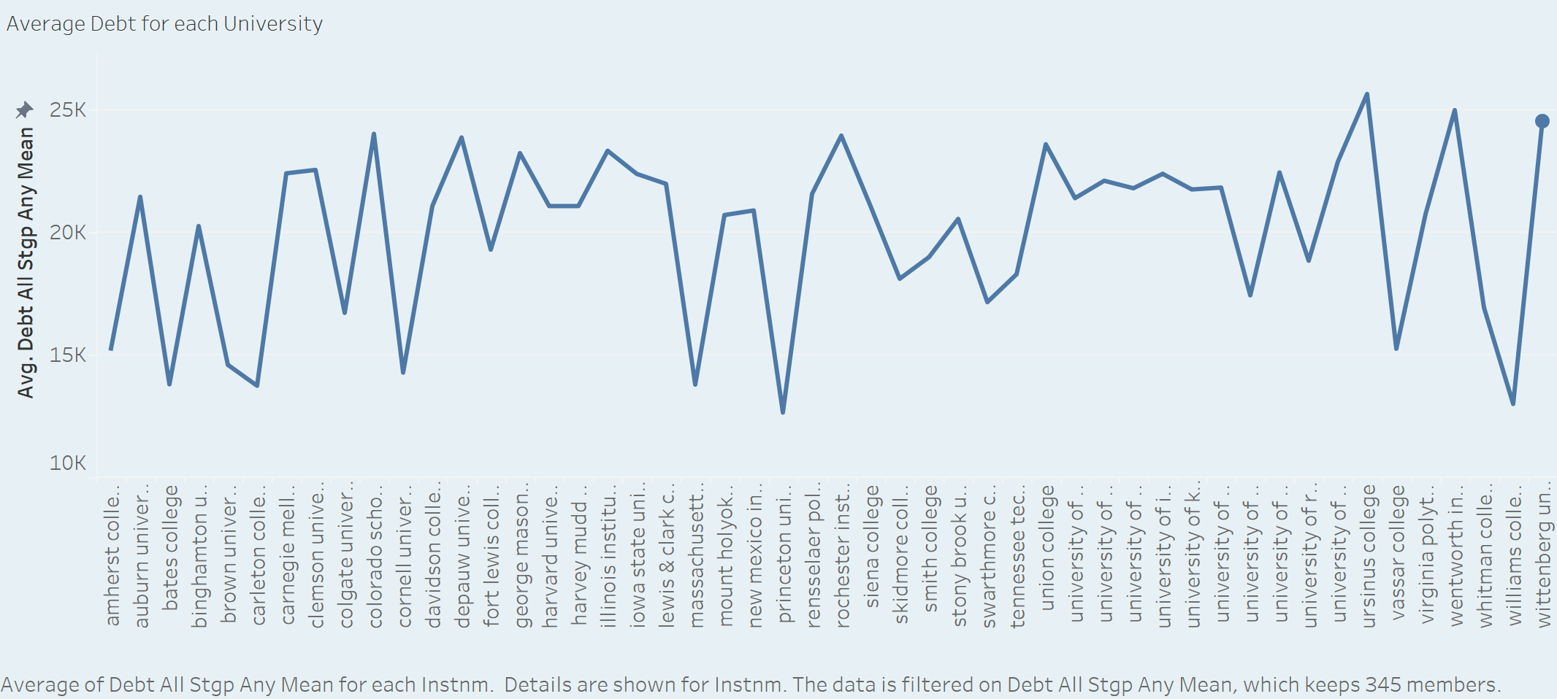

Visualization Overview:
This line chart shows the average debt for each university. The x-axis represents different universities, and the y-axis indicates the average debt level.

Insights:
Debt Variation Across Universities: There is significant variation in average debt across different universities. Some universities have significantly higher average debt compared to others.
Outliers: There are a few universities with exceptionally high debt levels. These outliers could be investigated further to understand the reasons behind the high debt.
Clustering: Some universities seem to have similar debt levels, suggesting potential clustering based on factors like institutional type, location, or program offerings.

Implications:
Students and Parents: This visualization can help students and parents make informed decisions about college choices by considering the potential financial impact.
Policymakers: Understanding the debt distribution across different universities can inform policy decisions related to financial aid, tuition costs, and program design.
Institutions: Institutions can use this data to identify areas where they can improve affordability and reduce student debt.

Research Question 2:
To what extent do Pell Grants reduce debt across institutions?

Chart 1: Pell Grant Debt for Institution Name

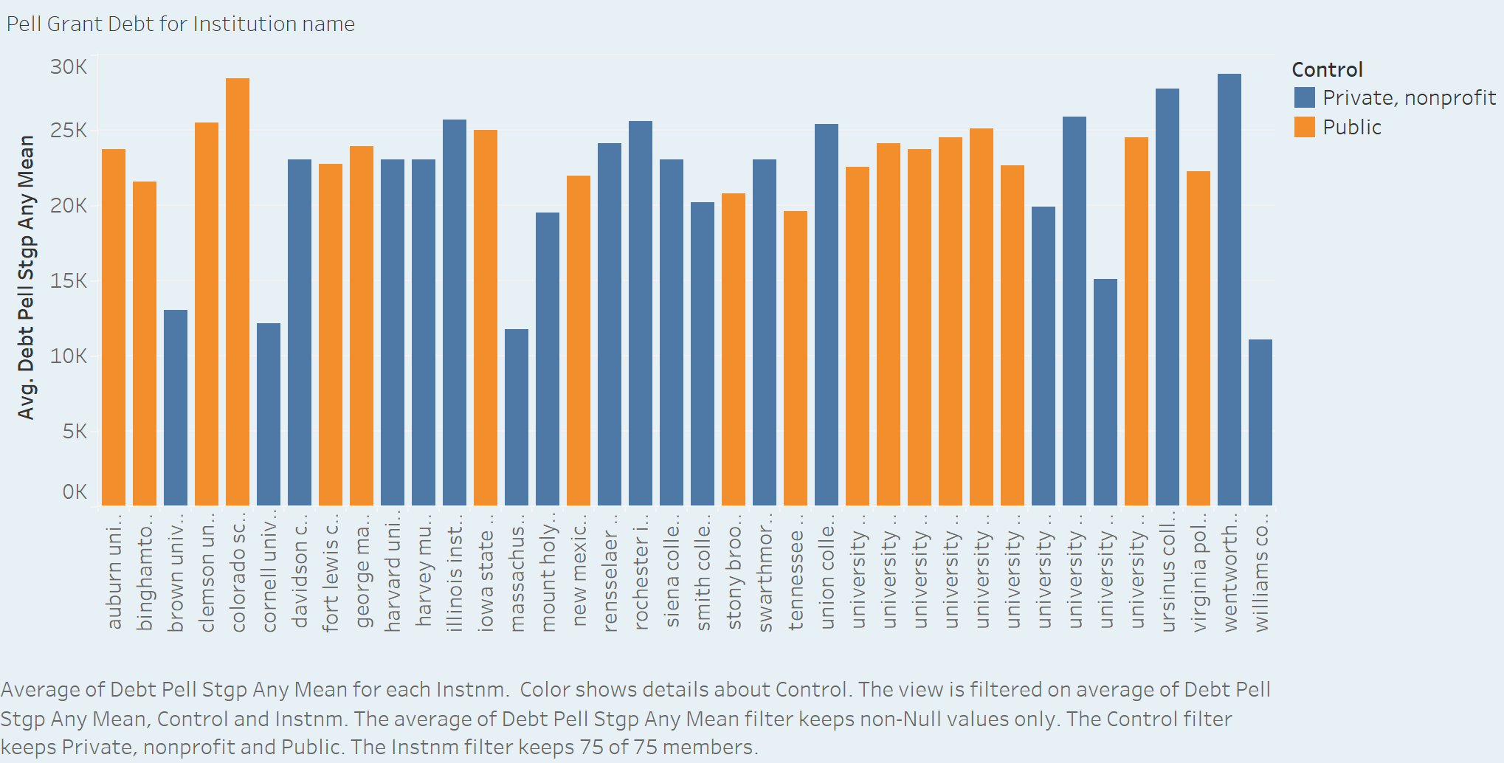

Visualization Overview:
This bar chart compares the average Pell Grant debt across public, private nonprofit, and control groups of institutions.

Insights:
Public vs. Private Nonprofit: Public institutions, on average, have significantly lower Pell Grant debt compared to private nonprofit institutions. This suggests that public institutions may offer more affordable options for low-income students.
Variation Within Groups: While there's a clear trend between public and private institutions, it's important to note that there's significant variation within each group. Some public institutions have higher debt than some private institutions, indicating that other factors beyond control type influence debt levels.

Implications:
Policymakers:
This data can inform decisions about financial aid distribution and regulations for higher education institutions.
Targeted support may be needed for public institutions with higher-than-average debt to ensure affordability.
Students and Parents:
When considering college choices, students and parents can use this information to identify institutions with lower average debt.
It's important to consider other factors like program quality, location, and specific financial aid packages beyond the average debt.

Chart 2: Difference Between Normal Debt and Debt After Pell Grant for Different Institutions

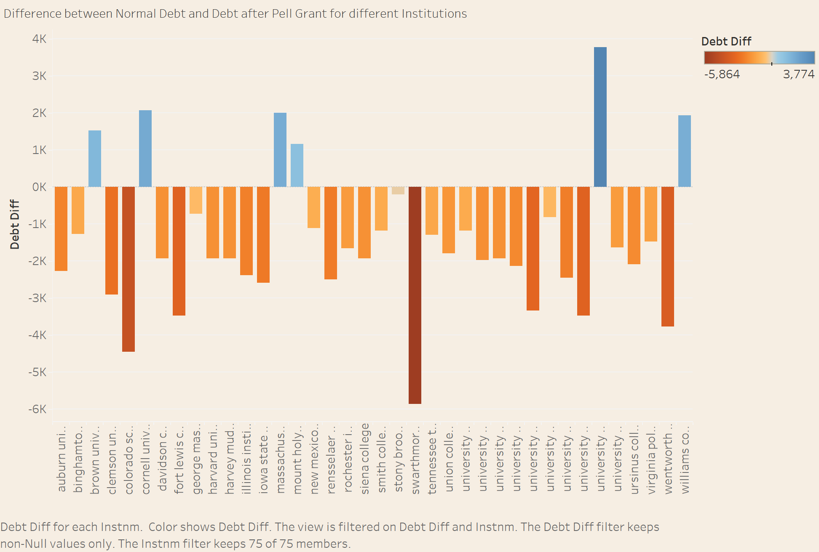

Visualization Overview:
This bar chart compares the difference in debt between students who received Pell Grants and those who didn't for various institutions. The difference is calculated by subtracting the average debt of non-Pell Grant recipients from the average debt of Pell Grant recipients.

Insights:
Impact of Pell Grants: For most institutions, receiving a Pell Grant seems to have a positive impact on reducing debt. This is evident from the majority of bars being above the zero line, indicating lower debt for Pell Grant recipients.
Variation Across Institutions: The magnitude of the debt reduction varies significantly across institutions. Some institutions show a substantial decrease in debt due to Pell Grants, while others have a smaller impact.

Implications:
Policymakers: This visualization highlights the effectiveness of Pell Grants in reducing student debt. Policymakers can use this information to advocate for continued funding and potential expansion of the program.
Students and Parents: Understanding the impact of Pell Grants can help students and parents make informed decisions about college affordability. It's crucial to consider the institution's average debt and the potential impact of Pell Grants on reducing that debt.

Research Question 3:
What are the trends in starting and mid-career salary growth across different majors and regions?

Chart 1: Average Starting Salary and Mid-career Salary vs. Majors

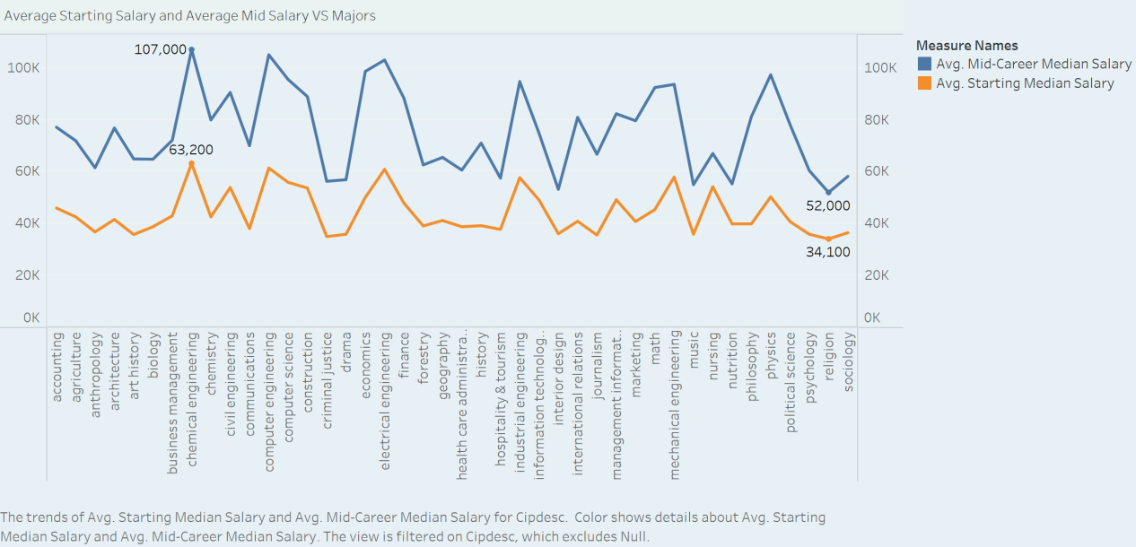

Visualization Overview:
This line chart compares the average starting and mid-career median salaries across different majors. Each line represents the trend of salaries for a specific major over time.

Insights:
Salary Disparity: There's a significant difference between starting and mid-career salaries for most majors. Mid-career salaries are generally much higher than starting salaries.
Top-Paying Majors: Some majors consistently have higher salaries at both starting and mid-career stages. These include fields like Computer Science, Engineering, and Finance.
Variability Across Majors: There's considerable variation in salary trends across different majors. Some majors have a steeper salary growth curve, while others have a more gradual increase.
Impact of Experience: The increasing trend in salaries over time highlights the importance of experience and career progression in determining earning potential.

Implications:
Students and Parents: This visualization can help students and parents make informed decisions about college majors by considering the potential earning potential of different fields.
Policymakers: Understanding the salary trends across different majors can inform policy decisions about investments in education and workforce development.
Employers: This data can be useful for employers to benchmark salaries and understand the market value of different skills and expertise.

Chart 2: 10th and 90th Percentile Salary for Each Region

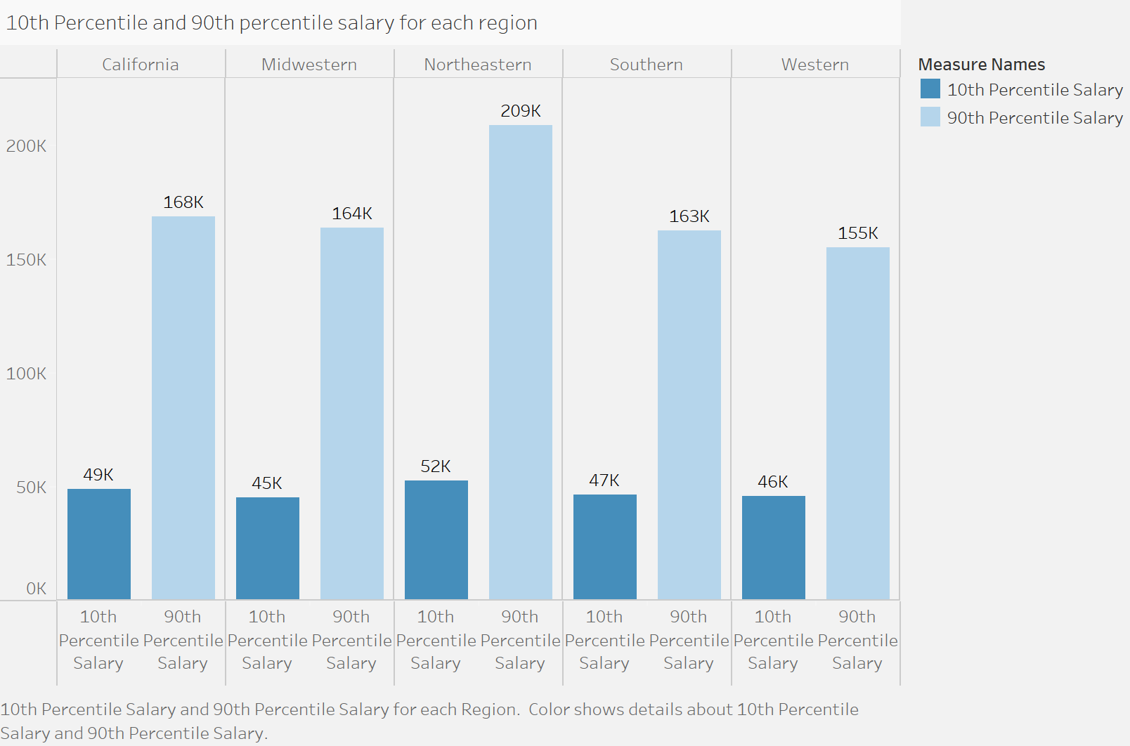

Visualization Overview:
This bar chart compares the 10th and 90th percentile salaries across five different regions: California, Midwestern, Northeastern, Southern, and Western. This visualization provides insights into salary distribution and income inequality within each region.

Insights:
Regional Disparities: There are significant regional disparities in both the 10th and 90th percentile salaries. Northeastern region has the highest 90th percentile salary, indicating a higher potential for top earners in that region.
Income Inequality: The difference between the 10th and 90th percentile salaries within each region highlights income inequality. Regions with a larger gap between these two percentiles have higher income inequality.
Regional Opportunities: The data suggests that certain regions may offer better opportunities for high-earning individuals. Northeastern region, for instance, seems to have a higher concentration of high-paying jobs.
Implications:
Policymakers: Understanding regional disparities in income can inform policy decisions related to economic development, tax policies, and social programs.
Individuals: This information can help individuals make informed decisions about where to live and work based on their career goals and desired income level.
Businesses: Businesses can use this data to understand regional labor market conditions and make decisions about recruitment, compensation, and location strategies.

Research Question 4:
Are certain majors financially sustainable in the long term, considering both debt levels and salary outcomes?

Chart 1: Average Debt vs. Majors

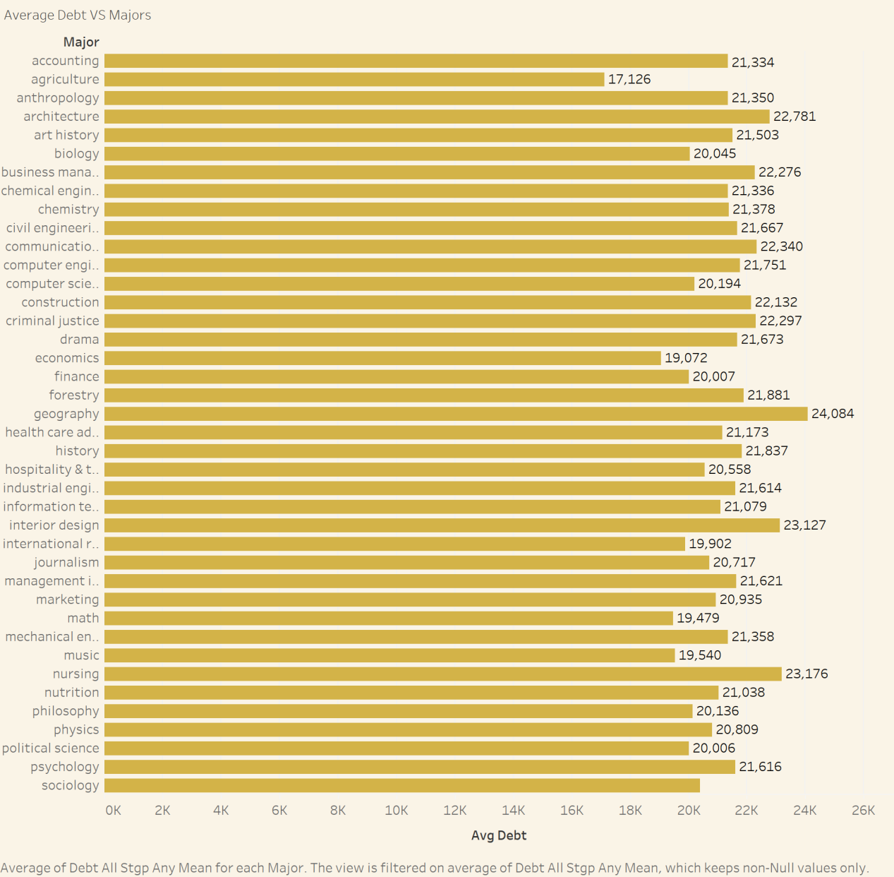

Visualization Overview:
This bar chart displays the average debt for students majoring in various fields. Each bar represents a different major, and the length of the bar indicates the average debt for that major.

Insights:
Debt Variation Across Majors: There is a significant variation in average debt across different majors. Some majors have much higher average debt compared to others.
Top Debt Majors: Some majors consistently rank high in terms of average debt. These include fields like Architecture, Computer Science, and Nursing.
Factors Influencing Debt: The variation in debt across majors could be influenced by factors such as program length, tuition costs, and financial aid packages.
Financial Planning: Students considering these majors should be aware of the potential financial burden and plan accordingly.

Implications:
Students and Parents: This visualization can help students and parents make informed decisions about college majors by considering the potential financial impact.
Policymakers: Understanding the debt burden across different majors can inform policy decisions related to financial aid, tuition costs, and program design.
Institutions: Institutions can use this data to identify programs with high debt loads and implement strategies to reduce student debt.

Chart 2: Average Percent Change of Salary by Majors
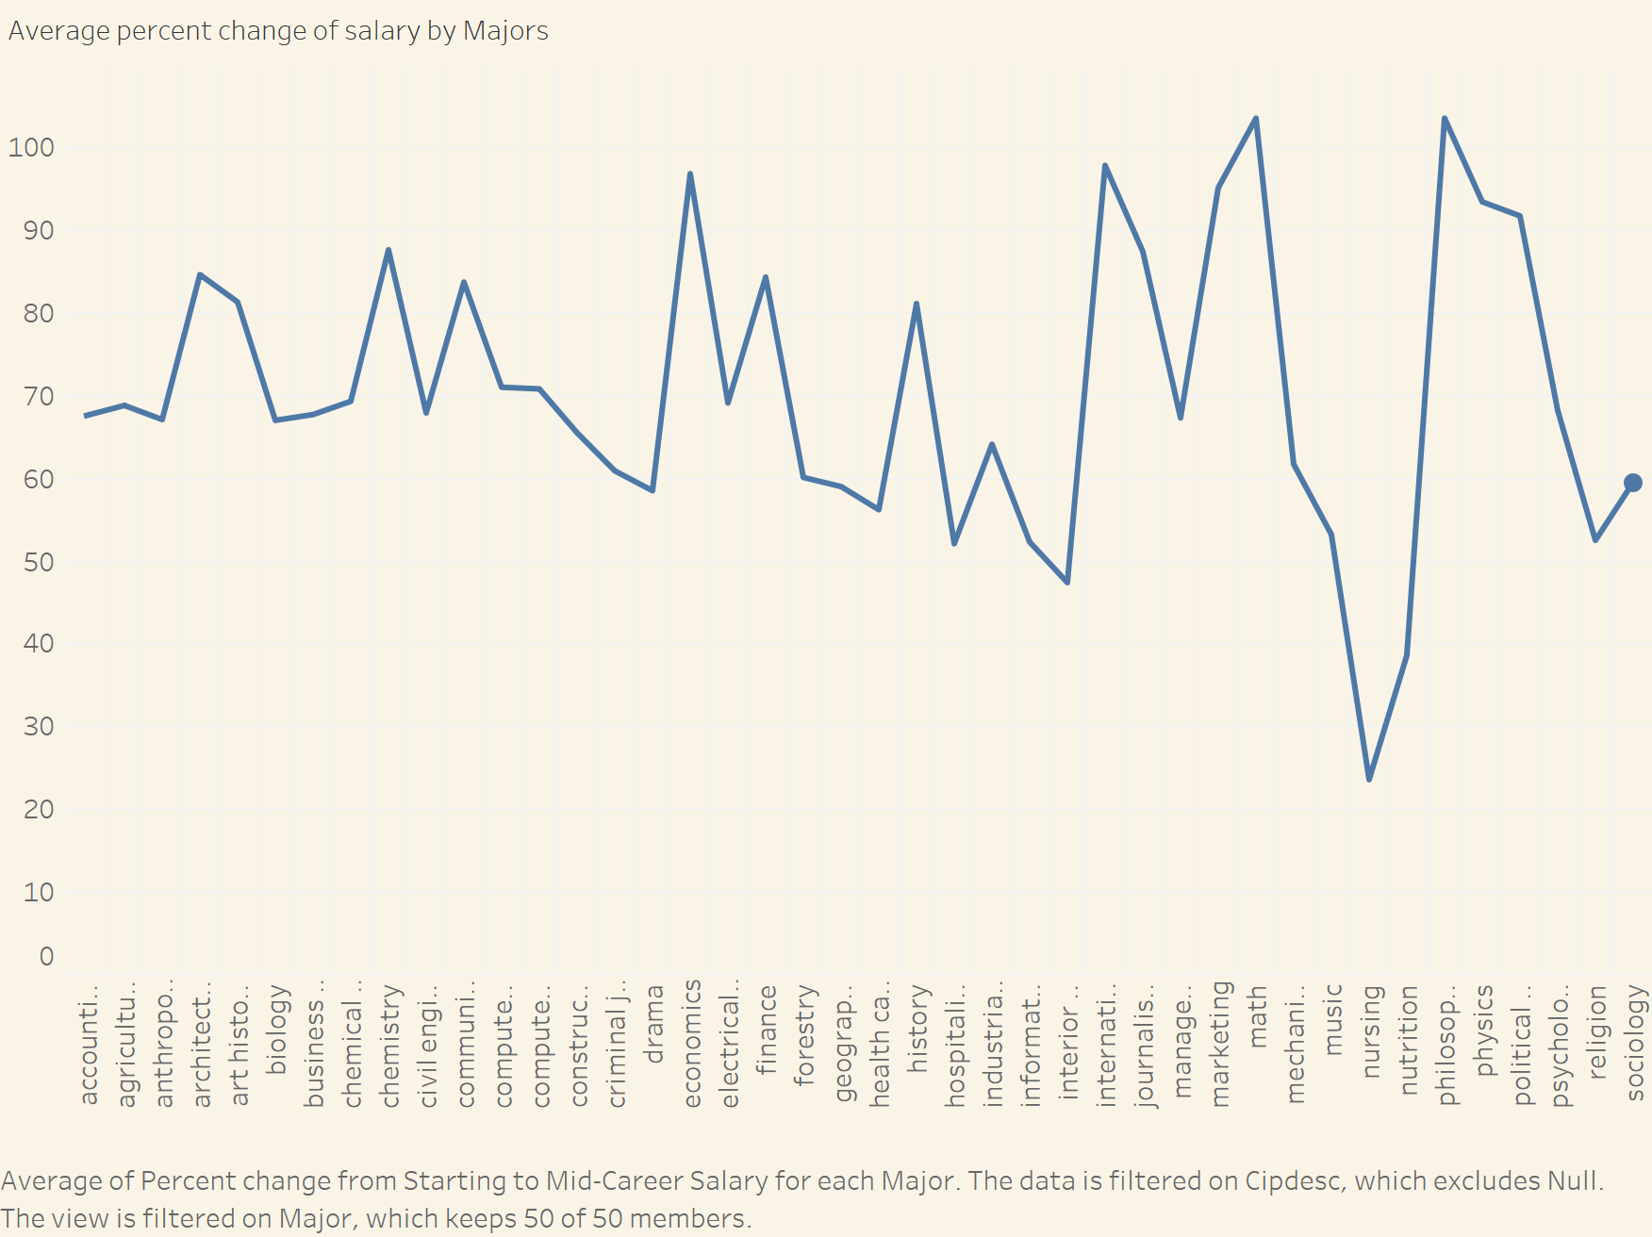

Visualization Overview:
This line chart shows the average percentage change in salary from starting to mid-career for various majors. Each point on the line represents a different major, and the vertical axis indicates the percentage change in salary.

Insights:
Salary Growth Variation: There is a significant variation in salary growth across different majors. Some majors experience substantial salary increases from starting to mid-career, while others have more modest growth.
Top Salary Growth Majors: Certain majors consistently rank high in terms of salary growth. These include fields like Computer Science, Engineering, and Finance.
Factors Influencing Salary Growth: The variation in salary growth across majors could be influenced by factors such as demand for specific skills, industry trends, and educational attainment.
Career Planning: Students considering these majors should be aware of the potential for salary growth and plan their career paths accordingly.
Implications:
Students and Parents: This visualization can help students and parents make informed decisions about college majors by considering the potential for future earnings.
Policymakers: Understanding the salary growth trends across different majors can inform policy decisions related to education and workforce development.
Employers: This data can be useful for employers to benchmark salaries and understand the market value of different skills and expertise.

Dashboard Summaries:

Salary Dashboard:
This dashboard focuses on salary outcomes, including average starting and mid-career salaries, salary percentiles by region, and salary growth by major. It offers insights into which fields and regions provide the most promising financial outcomes.

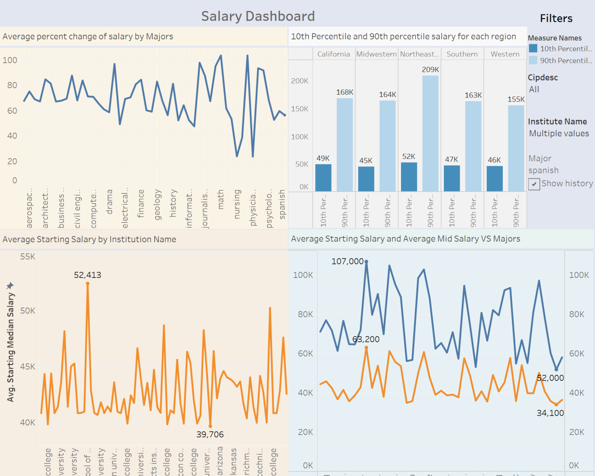

Debt Dashboard: This dashboard compiles visualizations related to debt, including School Type vs. Average Debt, Pell Grant Debt, and Debt Differences with Pell Grants. It provides a comprehensive view of how debt levels vary across institution types and the impact of financial aid.

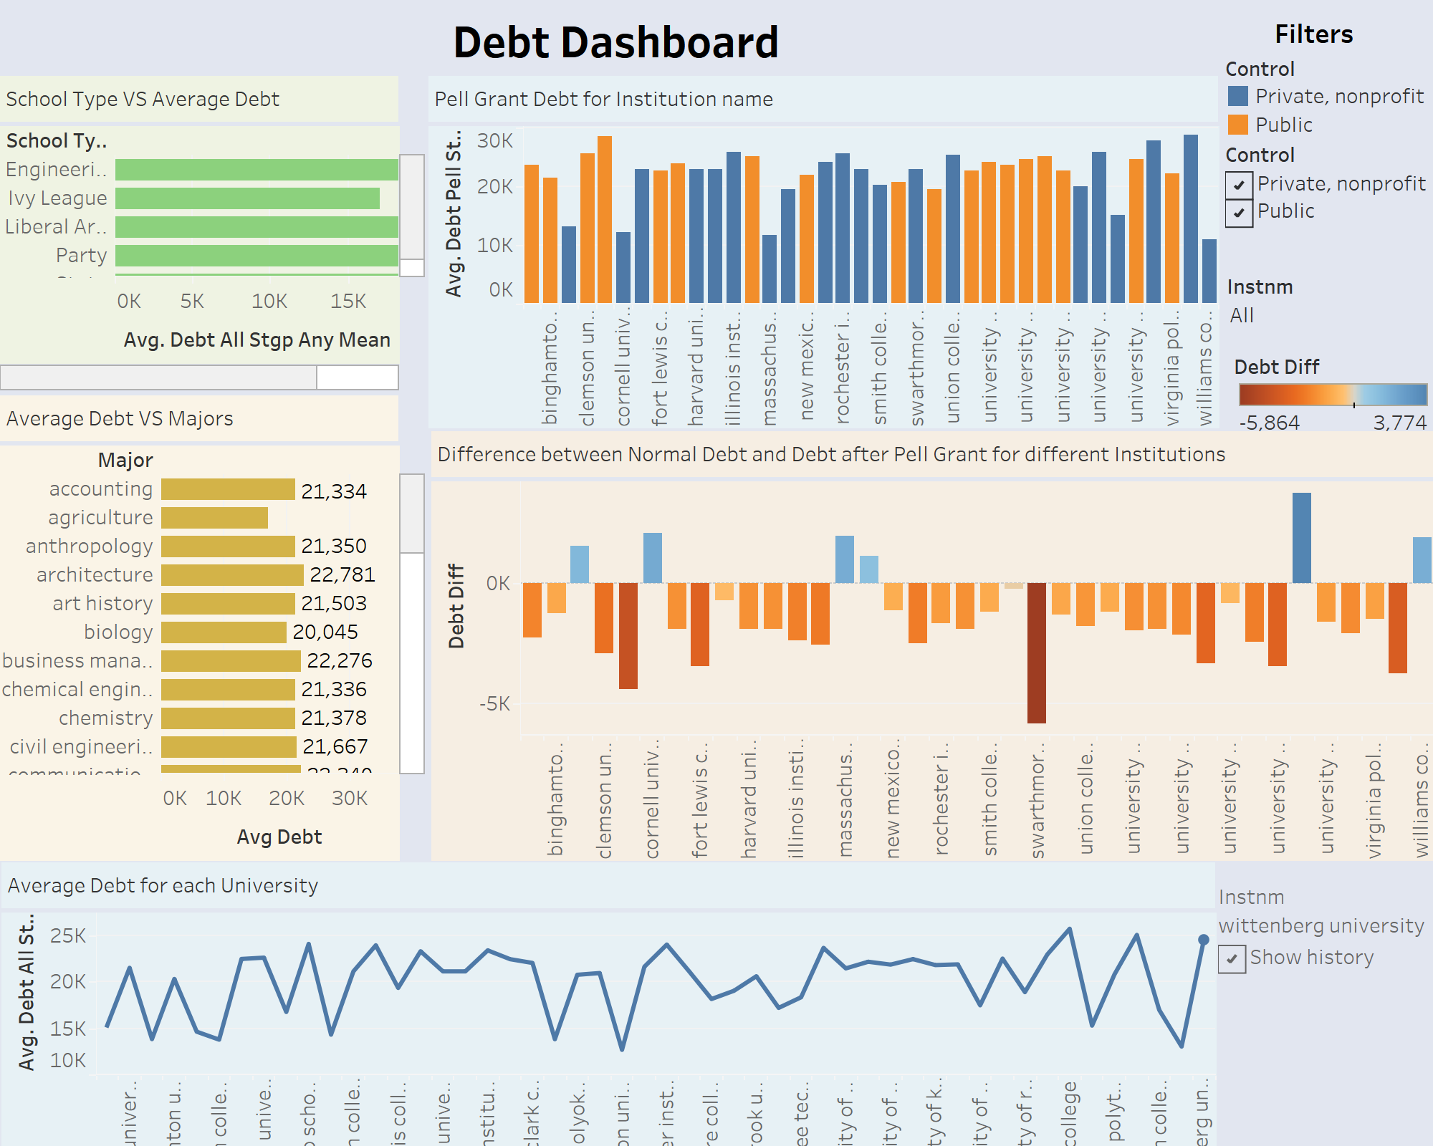

Conclusion

The analysis provides several insights into debt and salary trends in higher education:
Debt Disparities by Institution Type: Public institutions show higher average debt levels than selective Ivy League schools, likely due to the latter’s substantial financial aid endowments, which significantly reduce the net cost for students. This underscores the influence of institutional wealth and aid capacity on student debt outcomes.
Impact of Pell Grants: The inconsistent impact of Pell Grants across institutions reflects how varying financial aid policies can either amplify or reduce debt burdens. For example, private or wealthier institutions might supplement Pell Grants more robustly than public ones, affecting debt reduction differently based on institutional policies.
Regional Differences in Salary and Debt: Regions like California stand out, where graduates often face lower debt and access higher starting salaries, creating a more financially stable post-graduation environment. This suggests that geographic industry concentrations and local cost-of-living adjustments play key roles in shaping salary potential and debt repayment ease.
Salary Growth and Financial Sustainability Across Majors: Majors like Chemical Engineering and Mathematics show strong financial sustainability through robust starting salaries and continued salary growth, supporting long-term debt repayment. In contrast, graduates in lower-paying fields with limited salary growth, such as the humanities, may find it challenging to manage and repay student debt over time.

Further Research Questions

- What factors contribute to the variability of Pell Grant impact across institutions?
- How does debt load correlate with job satisfaction and career trajectory in lower-paying fields?
- Can regional industry concentrations explain salary variations across geographic areas?
- What role do institutional resources (e.g., financial aid, career services) play in shaping student debt outcomes?
- How does the availability of work-study programs impact student debt accumulation across different institution types?
- In what ways do demographic factors (e.g., race, socioeconomic status) influence debt burden and post-graduation success?
- How do employment rates and job availability within certain fields affect salary growth and career stability over time?
- What is the relationship between graduate school enrollment and long-term student debt levels across different academic disciplines?
- Do certain majors experience higher levels of underemployment, and how does this influence debt repayment patterns?
- What impact does a strong alumni network have on the long-term salary growth and career trajectories of graduates?
- How do regional differences in cost of living influence debt repayment strategies and financial stability?
- What impact does the availability of high-paying internships or co-op programs have on student debt and future salary outcomes?

The findings underscore the importance of financial considerations in higher education choices, with implications for students, families, and policymakers in fostering equitable and sustainable financial outcomes in higher education.

