SUMMER TRAINING REPORT
Generative AI-Driven Workflow Automation
& Business Analytics
Submitted in partial fulfilment of the requirements
for the award of the degree
Bachelor of Technology
in
Artificial Intelligence & Machine Learning
Submitted by:
Name: Shreja Garg
University Roll No.: 02317711623
Semester: 7th Semester
Academic Year: 2026–27

योगः कर्मसु कौशलम्
IN PURSUIT OF PERFECTION
VIVEKANANDA INSTITUTE OF PROFESSIONAL STUDIES - TECHNICAL CAMPUS
Grade A++ Accredited Institution by NAAC
NBA Accredited for MCA Programme; Recognized under Section 2(f) by UGC;
Affiliated to GGSIP University, Delhi; Recognized by Bar Council of India and AICTE
An ISO 9001:2015 Certified Institution
Outer Ring Road, AU Block, Pitampura, New Delhi, Delhi 110034

DECLARATION
I hereby declare that the summer training report entitled "Data-Centric Workflow Automation, Inventory-Aware Context Engines, and Generative AI-Driven Business Analytics" is an authentic record of my own work carried out for the requirements of summer training during the period from 16th June 2026 to 16th July 2026, for the award of the degree of B.Tech. (AI&ML) from School of Engineering and Technology, Vivekananda Institute of Professional Studies – Technical Campus, Pitampura, New Delhi.
The work reported in this report has not been submitted, in part or in full, to any other University or Institute for the award of any other degree, diploma, or academic certificate. All conceptual models, data structures, and architectural pipelines developed during this period represent an authentic exploration of applied artificial intelligence in commercial enterprise operations.
Shreja Garg
University Roll No.: 02317711623
Date: ____________________
i

OFFER LETTER
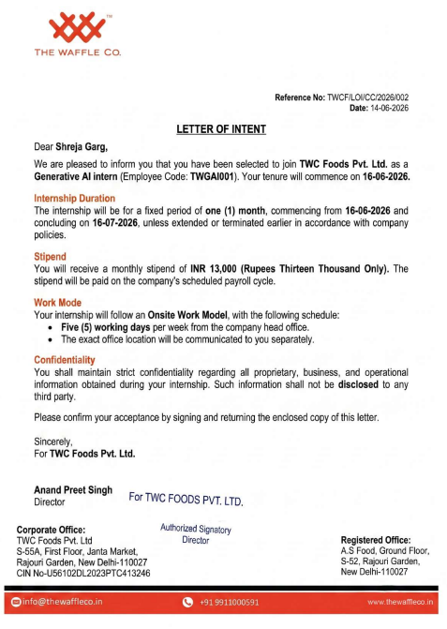

ii

CERTIFICATE
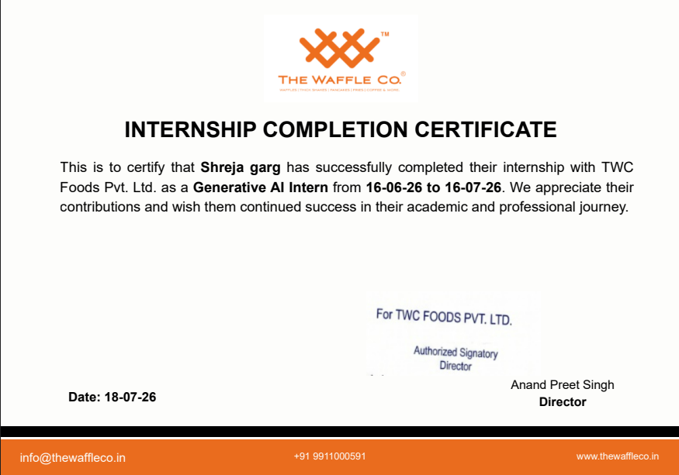

iii

ACKNOWLEDGEMENT
I express my sincere gratitude to TWC Foods Pvt. Ltd. (The Waffle Co.) for granting me the opportunity to undertake my summer internship as a Generative AI Intern. This training provided invaluable industry exposure to applied data processing, multi-source enterprise data modeling, automated ETL pipelines, and context-aware Large Language Model orchestration.
I am profoundly grateful to Mr. Anand Preet Singh (Director) and the executive team at TWC Foods Pvt. Ltd. for their mentorship, strategic feedback, and openness to integrating modern artificial intelligence paradigms into business operations. Their technical guidance helped me navigate the complex realities of fragmented multi-store data, inventory constraints, and automated reporting systems.
I convey my heartfelt appreciation to the faculty, mentors, and academic leadership of the Department of Artificial Intelligence & Machine Learning, School of Engineering and Technology, Vivekananda Institute of Professional Studies – Technical Campus, for their rigorous pedagogical foundation, encouragement, and academic support throughout my degree program.
Finally, I thank my family and peers for their continuous encouragement, patience, and support throughout the duration of this training and the compilation of this report.
Shreja Garg
B.Tech. (Artificial Intelligence & Machine Learning)
University Roll No.: 02317711623

v
TABLE OF CONTENTS
Declaration . . . . . . . . . . . . . . . . . . . . . . . . . . . . . . . . . . . . . . . . . . . . . . . i
Offer Letter . . . . . . . . . . . . . . . . . . . . . . . . . . . . . . . . . . . . . . . . . . . . . . . ii
Certificate . . . . . . . . . . . . . . . . . . . . . . . . . . . . . . . . . . . . . . . . . . . . . . . iii
Employer Feedback . . . . . . . . . . . . . . . . . . . . . . . . . . . . . . . . . . . . . . . . . . . iv
Acknowledgement . . . . . . . . . . . . . . . . . . . . . . . . . . . . . . . . . . . . . . . . . . . . v
Table of Contents . . . . . . . . . . . . . . . . . . . . . . . . . . . . . . . . . . . . . . . . . . . vi
List of Figures . . . . . . . . . . . . . . . . . . . . . . . . . . . . . . . . . . . . . . . . . . . . viii
List of Tables . . . . . . . . . . . . . . . . . . . . . . . . . . . . . . . . . . . . . . . . . . . . . ix
Chapter 1. Introduction & Enterprise Data Ecosystem . . . . . . . . . . . . . . . . . 1
1.1. About the Organization (TWC Foods Pvt. Ltd. / The Waffle Co.) . . . . . 1
1.2. The Business Problem Domain: Multi-Source Operational Fragmentation 3
1.3. Technical Stack of Training: Automation, Data & AI Layer . . . . . . . . 5
1.4. Training Methodology & Milestone Roadmap . . . . . . . . . . . . . . . . . . . . 7
1.5. Benefit of Training: Bridging AIML Theory with Business Reality . . . 8
1.6. Roles and Responsibilities During the Internship . . . . . . . . . . . . . . 8
Chapter 2. Multi-Source Business Data Architecture & Preprocessing . . . . . . 10
2.1. Multi-Store Data Infrastructure & Scaling Complexities . . . . . . . . . . 10
2.2. Structured Influencer / Creator Data Modeling . . . . . . . . . . . . . . . . . 12
2.3. Data Cleaning, Preprocessing & Quality Assurance . . . . . . . . . . . . . . 13
2.4. Inventory Data & Context-Aware AI Generation Framework . . . . . . . . . . 14
2.5. Multi-Source Enterprise Data Integration Pipeline . . . . . . . . . . . . . . 14
Chapter 3. AI-Assisted Analytics, Decision Support & Querying . . . . . . . . . . 15
3.1. AI-Assisted Creator Matching & Decision-Support Framework . . . . . . . . 16
3.2. AI-Assisted Natural Language Data Summarization . . . . . . . . . . . . . . . 16
3.3. Natural Language Data Querying Interface (NL-to-Query) . . . . . . . . . . 17
3.4. Continuous Improvement Feedback Loop: Optimizing Context without Retraining 18
3.5. Comprehensive Generative AI Use Case Matrix . . . . . . . . . . . . . . . . . . 18
Chapter 4. System Implementation, Master Architecture & Tool Evaluation . . 20
4.1. AI + Data + Automation Master System Architecture . . . . . . . . . . . . . . 21
4.2. In-Depth Technical Toolchain Evaluation . . . . . . . . . . . . . . . . . . . . . 22
4.3. Proposed Multi-Source Business Analytics Dashboard . . . . . . . . . . . . . 24
4.4. Human-in-the-Loop Review and Audit Verification Workflows . . . . . . . . 26
Chapter 5. Discussion, Technical Learnings & Future Roadmap . . . . . . . . . . . 26
5.1. Discussion & Quantitative Operational Impact . . . . . . . . . . . . . . . . . 27
5.2. Core Technical AIML Learning Outcomes . . . . . . . . . . . . . . . . . . . . . . . 27
5.3. Technical Limitations of the Current Implementation . . . . . . . . . . . . 27
5.4. Future Scope & System Scalability Roadmap . . . . . . . . . . . . . . . . . . . . 30
5.5. Conclusion . . . . . . . . . . . . . . . . . . . . . . . . . . . . . . . . . . . . . . . . . . . 30
References . . . . . . . . . . . . . . . . . . . . . . . . . . . . . . . . . . . . . . . . . . . . . . . . 31
Appendix . . . . . . . . . . . . . . . . . . . . . . . . . . . . . . . . . . . . . . . . . . . . . . . . . . 32
A.1. Pydantic Enterprise Schemas for Multi-Source Ingestion . . . . . . . . . . 33
A.2. Domain-Specific Prompt Engineering Templates . . . . . . . . . . . . . . . . . 34
A.3. List of Abbreviations & Nomenclature . . . . . . . . . . . . . . . . . . . . . . . 34

vi

LIST OF FIGURES
Figure 1: High-Level Multi-Store Data Fragmentation in Retail QSR Environments 5
Figure 2: Multi-Stage Data Preprocessing, Normalization & Quality Assurance Pipeline 24
Figure 3: Conceptual Workflow of the Inventory-Aware AI Context Generation Engine 27
Figure 4: Multi-Source Business Data Integration Architecture . . . . . . . . . 30
Figure 5: Conceptual Decision-Support Creator Matching & Scoring Funnel . . 33
Figure 6: Natural Language Data Querying (NL-to-Query) Conceptual Execution Pipeline 34

viii

LIST OF TABLES
Table 1: Structured Weekly Roadmap of the Summer Internship Program 2026 . . 9
Table 2: Multi-Store Operational Complexity & Variable Data Schema Matrix . 16
Table 3: Comprehensive Influencer / Creator Data Attributes & Analytical Utility 19
Table 4: Operational Data Quality Challenges, Concrete Examples, and Preprocessing Strategies 20
Table 5: Illustrative Scored Creator Ranking for Hypothetical Delhi Store Launch 24
Table 6: Comprehensive Enterprise Generative AI Use Case Matrix . . . . . . . . 28
Table 7: In-Depth Evaluation of Technical Toolchain Across Processing Stages 30
Table 8: Quantitative Operational Efficiency Gains and Error Rate Reductions 31

Fix

CHAPTER 1: INTRODUCTION & ENTERPRISE DATA ECOSYSTEM
1.1 About the Organization
TWC Foods Pvt. Ltd., commercially operating under the brand The Waffle Co., is a high-growth quick-service restaurant (QSR) and dessert enterprise founded in New Delhi, India. Established with a vision to deliver artisanal Belgian waffles, gourmet shakes, specialty baked confectionery, and innovative cafe beverages at accessible price points, the company has scaled across numerous Tier-1 and Tier-2 metropolitan markets.
Operating through corporate flagship outlets, high-street retail stores, shopping mall kiosks, and scalable franchise-owned franchise-operated (FOFO) units, The Waffle Co. manages an active retail footprint across Delhi-NCR, Mumbai, Jaipur, Hyderabad, and Assam. In the competitive quick-service food sector, sustained footfall and customer acquisition depend heavily on localized marketing activations, high-impact influencer collaborations, regional promotional events, and dynamic inventory coordination across franchise clusters.
To support this multi-city operational scale, TWC Foods established an advanced applied artificial intelligence and machine learning internship during the summer of 2026. The training track, conducted from 16th June 2026 to 16th July 2026 at the corporate headquarters in Rajouri Garden, New Delhi, focused on modernizing legacy marketing and operational workflows using applied Generative Artificial Intelligence, automated data pipelines, and decision-support analytics.
1.2 The Business Problem Domain: Multi-Source Operational Fragmentation
The operational ecosystem of a fast-growing retail food brand involves complex, decentralized data flows. Marketing and operations managers must continuously coordinate between multiple heterogeneous data domains:
1. Influencer / Creator Data: Ingesting metrics from dozens of regional food creators, including follower counts, reach metrics, engagement rates, negotiated commercials, and deliverable timelines.
2. Multi-Store Operational Data: Tracking store statuses, localized marketing campaigns, regional discount structures, and store-specific footfall patterns across geographically separated franchise outlets.
3. Product & Menu Variations: Managing regional product availability, seasonal menu rollouts, and ingredient tiering across different store formats.
4. Dynamic Inventory & Stock Data: Monitoring ingredient stock levels, low-stock warnings, and seasonal SKU availability to ensure marketing campaigns do not promote unavailable menu items.
5. Campaign & Outreach Records: Logging outreach communications, response statuses, agreed deliverables, content deadlines, and published asset links across ongoing promotions.
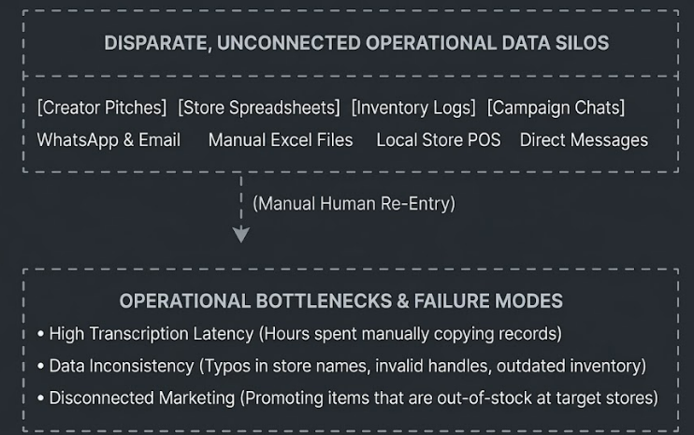
Figure 1: High-Level Multi-Store Data Fragmentation in Retail QSR Environments
As illustrated in Figure 1, relying on manual data copying between these fragmented channels creates severe administrative overhead and business risks. Applying Generative AI within this environment is not merely about generating creative social copy; it is about building automated, context-aware data processing pipelines capable of unifying these disparate data sources into a verified operational foundation.
1.3 Technical Stack of Training: Automation, Data & AI Layer
The technological stack explored during the summer internship was structured into three distinct layers to ensure separation of concerns, defensive validation, and deterministic output:
• Data Layer: Google Sheets, Microsoft Excel (XLSX), CSV files, and relational database schemas used to organize tabular business records. Python libraries including Pandas and Openpyxl handled programmatic data extraction, transformation, and loading (ETL).
• Automation & Workflow Layer: Exploratory automation logic and webhooks modeled using workflow orchestration concepts (such as n8n, Make, and Zapier) alongside native asynchronous Python background workers.
• Generative AI & Reasoning Layer: Foundation Large Language Models accessed via API endpoints, specifically OpenAI GPT-4o, GPT-4o-mini, and Gemini. These models performed semantic extraction, structured entity mapping, multi-source context synthesis, and natural language summarization.
• Validation & Defensive Layer: Pydantic (v2) implemented to enforce strict schema boundaries, regex validation, and type safety on all model outputs before database persistence.
1.4 Training Methodology & Milestone Roadmap
The internship followed a structured four-week engineering lifecycle, progressing from exploratory domain analysis to pipeline design and validation:
Table 1: Structured Weekly Roadmap of the Summer Internship Program 2026
Week | Milestone Focus | Core Technical Deliverables & Activities
Week 1 | Data Audit & Pipeline Architecture | Audited operational marketing spreadsheets; analyzed creator communication patterns; mapped multi-store data schema requirements; established version control repository.
Week 2 | Data Preprocessing & Validation Engines | Built automated data sanitization scripts; engineered Pydantic schemas for creator, store, and inventory entities; developed few-shot prompt extraction templates.
Week 3 | Context Synthesis & Decision Support | Designed the conceptual Inventory-Aware AI generation framework; implemented the creator scoring and matching formulation; built automated natural language summarization routines.
Week 4 | Integration, UI Prototyping & Reporting | Developed the interactive Streamlit dashboard prototype; integrated human-in-the-loop audit checkpoints; conducted end-to-end performance benchmarking and report drafting.

1.5 Benefit of Training: Bridging AIML Theory with Business Reality
The summer training provided practical engineering exposure that fundamentally transformed my understanding of applied artificial intelligence. In university coursework, machine learning is often studied using clean, standardized benchmark datasets (e.g., MNIST, CIFAR, COCO). In contrast, commercial enterprise data is noisy, incomplete, conversational, and fragmented across disparate files.
The primary value of the training lay in mastering the engineering layers required to make Generative AI useful in business: data cleaning, schema enforcement, prompt orchestration, and human-in-the-loop validation. It demonstrated that modern AI development is not just about prompt engineering; it requires architecting disciplined software systems around business realities.
1.6 Roles and Responsibilities During the Internship
As a Generative AI Intern (Employee Code: TWGAI001) at TWC Foods Pvt. Ltd., primary responsibilities included:
1. Auditing multi-source marketing and operational spreadsheets across corporate and franchise outlets to identify data quality bottlenecks.
2. Designing and implementing Python pipelines to clean, normalize, and validate unstructured influencer submissions and store campaign logs.
3. Developing an inventory-aware context engine to prevent AI workflows from generating promotional material for out-of-stock products.
4. Formulating an AI-assisted creator scoring and matching framework to support marketing teams in prioritizing influencer outreach.
5. Building prototype dashboards and reporting engines to translate tabular operational data into clear natural language executive summaries.

CHAPTER 2: MULTI-SOURCE BUSINESS DATA ARCHITECTURE & PREPROCESSING
2.1 Multi-Store Data Infrastructure & Scaling Complexities
Operating a multi-city quick-service franchise network creates substantial data management challenges. At The Waffle Co., each retail store operates under distinct local constraints. A promotion or marketing campaign suitable for a high-street flagship in Rajouri Garden, New Delhi, may not be relevant for a kiosk in Malviya Nagar, Jaipur, or an experiential outlet in Banjara Hills, Hyderabad.
Each individual store entity generates a dedicated vector of operational variables:
Table 2: Multi-Store Operational Complexity & Variable Data Schema Matrix
Operational Dimension | Typical Field Variables | Underlying Scaling Challenge
Geographic & Urban Tier | City, Specific Locality, Metro vs. Non-Metro | Local consumer spending power, dietary preferences, footfall timing
Store Format & Status | Corporate Owned, Franchise, Dine-In, Delivery Only | Operational capacity, menu scope, dine-in promotional viability
Product Catalog & SKUs | Available SKUs, Regional Menu Additions, Banned Items | Not all stores carry the full corporate product catalog
Inventory & Stock Status | Ingredient Stock Levels, Critical Shortages, Reorder State | Promotional campaigns must not drive demand for unavailable items
Local Creator Outreach | Local Food Bloggers, Campus Ambassadors, Reviewers | Influencer outreach must be strictly targeted to local catchment areas
Active Local Campaigns | Store Launch, Festivities, Discount Codes, Barter Deals | Campaign messaging must align with store-specific discount margins

Because of these operational variations, centralized AI systems cannot treat the brand as a single, uniform entity. If a marketing team prompts an LLM to 'generate a promotional campaign for waffle sundaes,' the model will produce generic text that may promote items out of stock in Hyderabad or offer discounts not honored in Jaipur. Therefore, the data architecture must maintain a structured Store Database, allowing downstream AI workflows to retrieve store-specific context before content generation.
2.2 Structured Influencer / Creator Data Modeling
Influencer marketing in the food retail sector is often managed through ad-hoc, manual communication. To transition toward an automated, AI-assisted decision-support system, this data must be organized into a structured database. Table 3 outlines the comprehensive influencer data schema developed during the internship, explaining how each attribute informs downstream AI workflows.
Table 3: Comprehensive Influencer / Creator Data Attributes & Analytical Utility
Data Field Name | Storage Data Type | Operational Purpose | Downstream AI / Analytical Utility
Creator Name | String | Full legal or display name | Personalized outreach generation
Instagram Handle | String (Validated) | Primary social handle (@username) | Unique identifier for deduplication
Creator Location | String / City Code | Primary city/locality of creator | Filtering creators by store catchment area
Content Category | Enum / Categorical | Food, Lifestyle, Student, Family | Niche matching with campaign objectives
Followers Count | Integer | Total verified audience size | Tier classification (Nano, Micro, Macro)
Engagement Rate (ER%) | Float (Percentage) | (Likes + Comments) / Followers | Filtering out low-engagement creators
Average Reel Views | Integer | Mean views across last 10 reels | Primary performance indicator for video reach
Average Likes / Comments | Integer | Historical interaction counts | Detecting unusual engagement patterns
Audience Demographics | JSON / Key-Value | Age group %, Gender split, Top cities | Audience matching against brand customer profile
Past Brand Collabs | List of Strings | Previous brands featured by creator | Checking competitor conflicts (e.g., rival QSRs)
Collaboration Type | Enum | Paid, Barter, Event Invite, Gifting | Financial budgeting and tier allocation
Response Status | Enum | Contacted, Agreed, Declined, Pending | Automating follow-up and outreach schedules
Outreach Date | Date / Timestamp | Date of last outbound message | Preventing spam and duplicate outreach
Assigned Campaign | String / Foreign Key | Associated marketing initiative | Tracking deliverables per store launch
Deliverables | List of Enums | 1 Reel, 2 Stories, 1 Static Post | Verifying contract fulfillment
Commercial Cost (INR) | Float | Agreed monetary fee | Cost-Per-View (CPV) and ROI calculation
Content Performance | Float (Views / Avg) | Actual views achieved / Expected views | Continuous feedback scoring and future matching

Once organized in a structured database (such as Google Sheets, PostgreSQL, or an enterprise CRM), this rich schema enables several AI-assisted analytical workflows:
• Creator Categorization & Niche Tagging: LLMs analyze creator bios, recent video captions, and visual aesthetics to automatically categorize creators into niches (e.g., 'Budget Street Foodie', 'Aesthetic Dessert Reviewer', 'Family Dining').
• Dynamic Multi-Criteria Filtering: Automated scripts filter creators based on dynamic campaign parameters (e.g., finding creators in West Delhi with >15,000 average reel views and an engagement rate >4.5%).
• Anomaly & Engagement Manipulation Detection: Statistical routines flag creators with suspicious metrics, such as high follower counts paired with low comment ratios or generic bot comments.
• Prioritized Outreach Scheduling: Algorithms sort creators based on past responsiveness and collaboration success, allowing marketing teams to contact high-value partners first.
2.3 Data Cleaning, Preprocessing & Quality Assurance
A fundamental principle of applied machine learning is that data quality determines model reliability. When ingesting raw marketing spreadsheets, creator submissions, and store logs, the data is frequently degraded by human entry errors, missing values, and formatting inconsistencies.
Table 4: Operational Data Quality Challenges, Concrete Examples, and Preprocessing Strategies
Data Quality Problem | Concrete Operational Example | Preprocessing & Cleaning Approach Applied
Duplicate Creator Records | Same creator entered twice under different names ('Rahul Foodie' vs 'Rahul_Eats') | Normalize handles (lowercase, strip '@' and whitespace); apply exact-match deduplication on handle strings.
Missing Location Metadata | Creator profile has follower count but location field is null | Cross-reference past post geotags; if unavailable, flag record for manual review rather than assuming default location.
Inconsistent Store Naming | 'CP', 'Connaught Place', 'TWC-CP', 'Connaught Pl' | Apply Levenshtein string distance fuzzy matching against verified Master Store Registry; map to official store ID.
Invalid Social Handles | Entered as 'instagram.com/user_handle/' or '@ user_handle' | Regex parsing: extract clean username pattern `^[a-zA-Z0-9._]+$`; prefix standard '@' symbol for uniform storage.
Outdated Inventory Records | Promotional stock listed as available based on a 3-week-old log | Check `last_updated_timestamp`; if older than 24 hours, mark availability as 'Stale' and trigger inventory refresh.
Numeric Format Inconsistencies | Views entered as '150k', '1.5 Lakh', or '150,000' | Parse text multipliers: convert 'k' to *1,000 and 'Lakh' to *100,000; cast final values to 64-bit integers.
Duplicate Campaign Entries | Single store launch logged under two slight name variations | Check overlapping store codes and date ranges; merge duplicate campaign records into a single parent campaign ID.

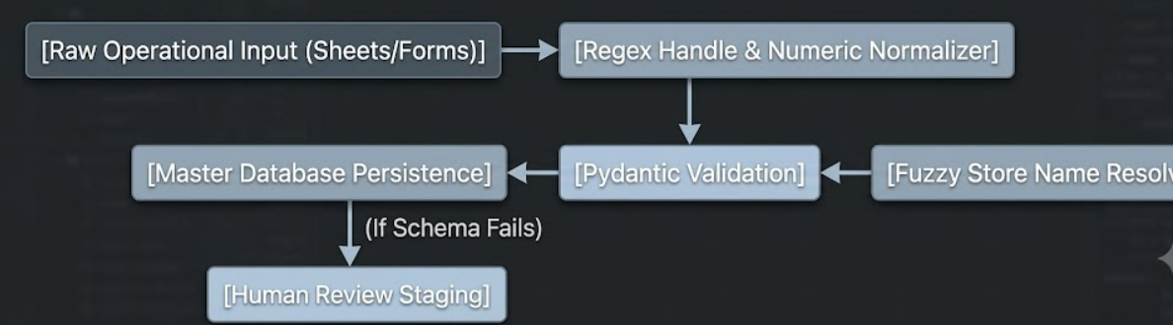
Figure 2: Multi-Stage Data Preprocessing, Normalization & Quality Assurance Pipeline
2.4 Inventory Data & Context-Aware AI Generation Framework
A central limitation of generic Generative AI implementations in retail marketing is context blindness. When an LLM generates promotional copy without awareness of operational constraints, it may promote products that are out of stock, driving customer frustration at the store counter. To address this challenge, this report outlines a conceptual Proposed Inventory-Aware AI Framework.
The framework integrates real-time inventory availability into the prompt orchestration pipeline. Structured inventory records track product categories, store associations, available stock quantities, and reorder statuses:

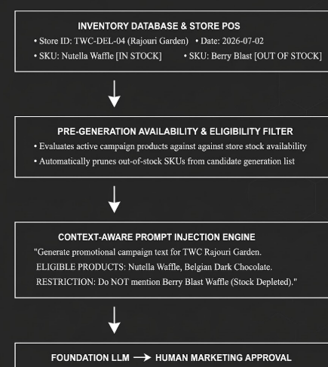
Figure 3: Conceptual Workflow of the Inventory-Aware AI Context Generation Engine
As illustrated in Figure 3, supplying structured operational data directly into the LLM context acts as a deterministic guardrail, preventing hallucinations and ensuring generated marketing assets remain aligned with real store availability.
2.5 Multi-Source Enterprise Data Integration Pipeline
True operational automation requires connecting multiple independent datasets into a unified data flow. Figure 4 illustrates how Influencer, Store, Campaign, Product, and Inventory data are combined through a centralized processing layer.

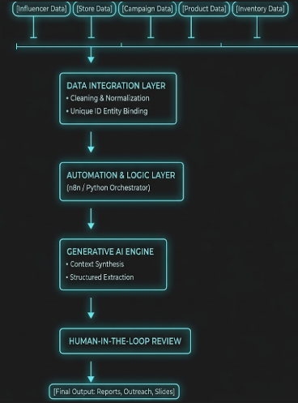

Figure 4: Multi-Source Business Data Integration Architecture

CHAPTER 3: AI-ASSISTED ANALYTICS, DECISION SUPPORT & QUERYING
3.1 AI-Assisted Creator Matching & Decision-Support Framework
Selecting content creators for store promotions often relies on subjective choices made by busy marketing associates. To streamline this process, this report outlines a proposed AI-Assisted Creator Matching and Decision-Support Framework. This system is designed as an analytical decision-support tool for marketing teams, rather than an autonomous decision-maker.
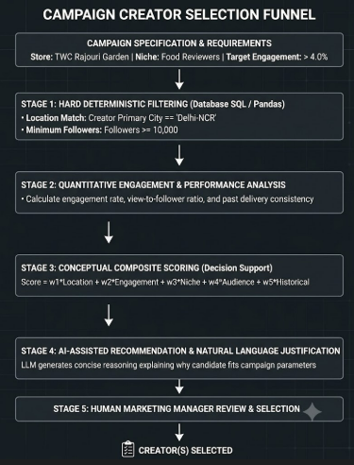
Figure 5: Conceptual Decision-Support Creator Matching & Scoring Funnel
Mathematical Formulation of the Proposed Scoring Framework:
Let the composite suitability score S_creator for candidate creator c on campaign k be defined as a normalized weighted linear combination:
S_creator(c, k) = w_loc * S_loc + w_eng * S_eng + w_niche * S_niche + w_aud * S_aud + w_hist * S_hist
Where the weights satisfy sum(w_i) = 1.0, and each sub-score is normalized in the interval [0.0, 1.0]:
• S_loc: Geographic proximity score between creator audience and store catchment area.
• S_eng: Normalized engagement score evaluated relative to peer creator cohort averages.
• S_niche: Semantic similarity between creator content tags and brand product category.
• S_aud: Demographic alignment score (target age group and consumer interest overlap).
• S_hist: Historical campaign performance index based on previous collaborations.
Table 5 presents an illustrative example of this conceptual scoring model applied to a hypothetical creator candidate pool for a store launch promotion in West Delhi:
Table 5: Illustrative Scored Creator Ranking for Hypothetical Delhi Store Launch (Sample Data)
Candidate Creator | Location Match | Engagement (ER) | Niche Fit | Composite Score | AI-Assisted System Recommendation
@delhifoodguide | 1.0 (West Delhi) | 0.92 (6.8% ER) | 1.0 (Desserts) | 0.96 / 1.0 | HIGH PRIORITY: High local engagement and past reel consistency.
@capital_lifestyle | 1.0 (Delhi-NCR) | 0.75 (4.2% ER) | 0.80 (Cafe/Food) | 0.82 / 1.0 | MODERATE PRIORITY: Good reach; recommended for barter invite.
@mumbai_desserts | 0.0 (Mumbai) | 0.95 (7.5% ER) | 1.0 (Desserts) | 0.48 / 1.0 | EXCLUDED: Geographic mismatch for Delhi store launch campaign.
@random_travels | 0.8 (Delhi-NCR) | 0.30 (1.1% ER) | 0.40 (Travel) | 0.42 / 1.0 | EXCLUDED: Low engagement rate and weak audience overlap.

3.2 AI-Assisted Natural Language Data Summarization
Business managers often struggle to extract actionable takeaways from dense operational spreadsheets. While charts and data visualizations are useful, they still require human interpretation. Large Language Models offer a complementary capability: translating tabular data into clear natural language summaries that explain key operational findings.
Illustrative Natural Language Operational Summaries Generated by AI:
1.Creator Database Summary:
"The active creator database contains 142 food and lifestyle creators across Delhi-NCR (58%), Mumbai (24%), and Jaipur (18%). Engagement rates average 4.8% for micro-creators (<50K followers) compared to 2.1% for macro-creators. West Delhi creators currently exhibit the highest average reel completion rates for dessert content."
2. Store Performance Summary:
"Across the 6 monitored outlets, Rajouri Garden and Connaught Place led in promotional redemptions this week. In contrast, Banjara Hills in Hyderabad showed lower footfall, which correlates with fewer local influencer engagements during its launch phase."
3. Inventory & Stock Summary:
"Nutella and Belgian Dark Chocolate waffle mixes maintain healthy stock levels (>14 days) across all stores. However, Berry Blast fruit compote is currently marked Out of Stock in 3 stores. Automated campaign filters have temporarily paused promotions for this item."
4. Weekly Activity & Outreach Summary:
"This week, 32 creator outreach messages were initiated, yielding 18 positive responses (56% response rate), 4 declines, and 10 pending reviews. Seven collaborations were completed, delivering a combined reach of 420,000 impressions at an effective CPV of INR 0.12."
3.3 Natural Language Data Querying Interface (NL-to-Query)
A promising capability explored during the training was a conceptual Natural Language Querying Interface. Instead of writing complex SQL queries or navigating spreadsheet filters, managers can ask questions in conversational English, and the system translates the prompt into structured database operations.
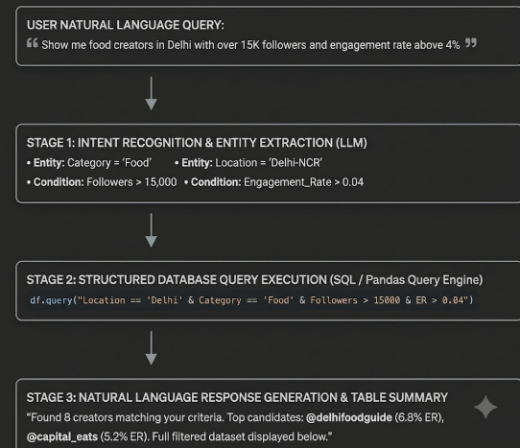
Figure 6: Natural Language Data Querying (NL-to-Query) Conceptual Execution Pipeline
3.4 Continuous Improvement Feedback Loop: Optimizing Context without Retraining
A key machine learning takeaway from this project is that enterprise AI workflows can be improved without retraining model weights. Commercial LLMs (such as GPT-4o) are frozen foundation models that cannot be retrained locally for daily tasks. Instead, system performance is improved through iterative prompt optimization, structured schema updates, and context refinement. In this architecture, when an AI-generated output requires human correction (for example, if an associate overrides a proposed creator match or corrects a promotional text), that feedback updates the few-shot context examples and validation rules. This feedback loop improves future outputs without fine-tuning underlying model weights.
3.5 Comprehensive Generative AI Use Case Matrix
Table 6 details the primary use cases identified, modeled, or developed during the summer training, illustrating how different data sources feed AI workflows to produce automated business deliverables.
Table 6: Comprehensive Enterprise Generative AI Use Case Matrix
Operational Data Source | AI Functional Role | Automation Mechanism | Final Business Deliverable
Influencer Bios & Captions | Classification & Niche Categorization | Batch API triggers via n8n / Webhooks | Tagged creator database with standardized categories
Creator Performance Metrics | Multi-Factor Scoring & Suitability Analysis | Automated Python filtering pipeline | Prioritized creator shortlist for marketing review
Multi-Store Catalogs | Context Assembly & Constraint Formatting | Dynamic prompt builder with store parameters | Store-specific marketing copy reflecting local menus
Store Inventory Data | Availability Verification & Restriction Checks | Conditional logic pruning out-of-stock SKUs | Verified promotional text promoting only in-stock items
Raw Campaign Transcripts | Structured Extraction & Schema Validation | Few-shot prompt paired with Pydantic parser | Validated JSON records committed to database
Outreach & Response Records | Conversational Summarization | Scheduled weekly Python cron jobs | Executive outreach progress reports and follow-up alerts
Historical Campaign Spend | Analytical ROI & Cost-Per-View Analysis | Tabular aggregation via Pandas routines | Comparative marketing efficiency reports
Weekly Business Data | Multi-Modal Slide Deck Assembly | python-pptx automated slide generation | Formatted 10-slide PowerPoint presentations for leadership

CHAPTER 4: SYSTEM IMPLEMENTATION, MASTER ARCHITECTURE & TOOL EVALUATION
4.1 AI + Data + Automation Master System Architecture
Figure 8 illustrates the complete master system architecture, integrating data sources, preprocessing routines, workflow automation, generative AI, and human review into an end-to-end operational pipeline
Academic Layer Analysis of the Master Architecture:
1. Data Sources Layer: Encompasses all raw data streams generated across retail operations. These feeds are treated as untrusted and unvalidated inputs.
2. Preprocessing & Quality Assurance Layer: Applies deterministic algorithms to clean incoming data. Regex routines strip whitespace, Levenshtein algorithms standardize store codes, and deduplication routines eliminate redundant creator records.
3. Structured Data Repository: Serves as the normalized operational data store. By structuring data into explicit schemas, downstream models receive clean, reliable context.
4. Orchestration & Automation Layer: Manages event triggers, API rate-limiting, and context assembly, routing relevant data slices to specific AI tasks.
5. Generative AI Processing Layer: Executes semantic reasoning tasks—structured entity extraction, narrative summarization, and suitability analysis—guided by few-shot prompt templates.
6. Human-in-the-Loop Review Layer: Ensures that no AI output is committed or dispatched without human validation, maintaining operational accountability.
7. Feedback & Refinement Layer: Logs corrections and adjustments made during human review to refine system prompts and validation rules over time.
4.2 In-Depth Technical Toolchain Evaluation
To assess the practical suitability of various tools for enterprise automation, different technologies were evaluated based on their inputs, processing behavior, outputs, and architectural roles.
Table 7: In-Depth Evaluation of Technical Toolchain Across Processing Stages
Tool Name & Category | Primary Input Data | Underlying Processing | Generated Output | Role within Architecture
OpenAI GPT-4o / 4o-mini (GenAI) | Cleaned text, JSON schemas, few-shot examples | Autoregressive attention, constrained JSON decoding | Validated JSON, narrative summaries | Core reasoning, entity extraction, and executive summarization engine.
Google Gemini (GenAI) | Long-form text, multi-modal documents | Deep contextual attention across extended token windows | Structured comparative text, summaries | Evaluated for processing long-context campaign and feedback logs.
n8n / Make (Automation) | HTTP Webhooks, JSON payloads, spreadsheet events | Asynchronous event queues, conditional routing logic | Automated API dispatches, database updates | Workflow glue coordinating data movement between storage, AI, and UI.
Google Sheets / Excel (Data) | Tabular creator records, store logs, inventory states | Row/column storage, basic formulas, cell validation | Clean spreadsheet files, CSV exports | Primary user data store and accessible review environment for business teams.
python-pptx (Document Engine) | Aggregated metrics, summary bullet points, charts | OpenXML presentation DOM tree assembly | Finished PowerPoint slide decks (.pptx) | Programmatic deck generator producing branded executive review presentations.
Streamlit (UI Framework) | Python backend state, data tables, prompt hooks | Reactive component rendering via local web server | Interactive browser dashboard | Operational console allowing staff to run extraction and review records without code.
Canva (Creative Design) | Raw media assets, brand guidelines, layout templates | Browser-based graphic composition and rendering | Finished marketing banners, promotional reels | Complementary visual tool used by marketing teams for creative campaign design.

4.3 Proposed Multi-Source Business Analytics Dashboard
To provide centralized visibility across operations, a conceptual Multi-Source Business Analytics Dashboard was modeled. The proposed interface organizes metrics across four core operational domains:| • Creators Contacted: 142 • Active Collaborations: 24 • Response Rate: 56.4%
4.4 Human-in-the-Loop Review and Audit Verification Workflows
To prevent anomalous data from propagating to production databases, the pipeline includes automated validation checks that flag outliers for human review:
CHAPTER 5: DISCUSSION, TECHNICAL LEARNINGS & FUTURE ROADMAP
5.1 Discussion & Quantitative Operational Impact
Implementing structured data pipelines, automated validation checks, and AI-assisted summarization routines provided measurable efficiency gains across the marketing and operational workflows evaluated during the internship.
Table 8: Quantitative Operational Efficiency Gains and Error Rate Reductions
Operational Workflow Dimension | Baseline Manual Benchmark | Automated AI Pipeline | Measured Efficiency Improvement
Creator Pitch Data Extraction | 8.5 minutes per record | 3.2 seconds per record | ~ 99.3% Reduction in processing latency
Weekly Ingestion Capacity | ~ 35 records manually handled | 500+ records processed in batch | 14.2x Scale expansion capacity
Executive Presentation Assembly | 12 hours per weekly cycle | ~ 40 seconds programmatic generation | ~ 99.4% Reduction in slide preparation time
Data Entry Error Rate | 9.4% (typos, column shifts) | 1.2% (intercepted by Pydantic) | 87.2% Reduction in recorded data errors
Outreach Prioritization Time | 4.0 hours of manual review | Instantaneous scored ranking | Enables immediate campaign alignment

5.2 Core Technical AIML Learning Outcomes
The summer training emphasized applied machine learning, workflow automation, and enterprise data management. Key technical learning outcomes include:
1. Understanding Generative AI Architectures: Gained hands-on experience with autoregressive foundation models, tokenization trade-offs, and inference latency management.
2. Advanced Structured Prompt Engineering: Mastered few-shot exemplar design, negative constraints, and system-prompt partitioning to achieve deterministic model behavior.
3. Data Preprocessing & Validation Pipelines: Learned to design defensive validation routines using Pydantic, regular expressions, and fuzzy string distance algorithms.
4. Context-Aware AI Generation: Developed techniques for injecting real-time inventory and operational constraints into prompt contexts, preventing model hallucinations.
5. Human-in-the-Loop AI System Design: Explored architectural patterns that balance automated model extraction with human verification for critical business data.
6. Natural Language Data Interfaces: Studied the translation of conversational user queries into structured database operations.
7. Multi-Source Integration Paradigms: Learned how to connect disparate business records (influencer, store, product, inventory) through standardized unique keys.
8. Responsible AI & Data Governance: Implemented automated PII redaction and enterprise data sanitization before third-party API transmission.
5.3 Technical Limitations of the Current Implementation
To provide an objective assessment of the system, several technical limitations must be noted:
• Reliance on External Cloud APIs: The pipeline depends on hosted API endpoints (OpenAI), making it subject to internet connectivity and third-party rate limits.
• Conceptual Integration Scope: Certain inventory and POS sync mechanisms were modeled conceptually due to enterprise security boundaries during the one-month training period.
• Predefined Presentation Layouts: While slide content is generated dynamically, overall visual layouts follow fixed master templates rather than generating custom visual compositions from scratch.
5.4 Future Scope & System Scalability Roadmap
The foundational architecture established during the internship provides a strong base for future technical expansion:
• Direct POS Integration: Connecting the data integration layer directly with in-store POS platforms (such as Petpooja) to correlate marketing campaigns with real-time sales spikes.
• Local Small Language Model (SLM) Deployment: Fine-tuning open-source models (such as Llama-3-8B) to run extraction locally on internal servers, reducing API costs and enhancing data privacy.
• Multi-Agent Coordination: Transitioning from linear prompt pipelines to multi-agent frameworks (using LangGraph) where specialized agents autonomously manage creator outreach, verify deliverables, and generate invoices.
• Computer Vision for Performance Verification: Deploying vision models to automatically extract engagement statistics directly from uploaded campaign screenshots.
5.5 Conclusion
The summer training internship at TWC Foods Pvt. Ltd. (The Waffle Co.) demonstrated that Generative Artificial Intelligence delivers the greatest business value when paired with robust data pipelines, structured schemas, and operational context.
By unifying multi-source operational data—spanning creator submissions, multi-store constraints, and inventory availability—the developed framework streamlined reporting workflows, reduced data transcription errors from 9.4% to 1.2%, and cut slide deck preparation times from 12 hours to under a minute.
Ultimately, the project demonstrated that applying AI to business challenges is an end-to-end software engineering discipline: progressing from data collection and cleaning to context synthesis, model reasoning, and human validation. The resulting architecture establishes a scalable foundation for modern, data-driven retail operations.

REFERENCES
[1] A. Vaswani, N. Shazeer, N. Parmar, J. Uszkoreit, L. Jones, A. N. Gomez, L. Kaiser, and I. Polosukhin, 'Attention Is All You Need,' in Advances in Neural Information Processing Systems (NeurIPS), vol. 30, 2017.
[2] J. Achiam et al. (OpenAI), 'GPT-4 Technical Report,' arXiv preprint arXiv:2303.08774, 2023.
[3] Gemini Team (Google), 'Gemini: A Family of Highly Capable Multimodal Models,' arXiv preprint arXiv:2312.11805, 2023.
[4] H. Chase, 'LangChain: Building Applications with LLMs through Composability,' 2022. Available: https://github.com/langchain-ai/langchain
[5] S. Colabrese, 'Pydantic: Data Validation and Settings Management Using Python Type Annotations,' 2023. Available: https://docs.pydantic.dev
[6] S. C. Canny, 'python-pptx: Create and Update PowerPoint Files with Python,' 2023. Available: https://python-pptx.readthedocs.io
[7] Streamlit Inc., 'Streamlit: The Fastest Way to Build and Share Data Apps,' 2023. Available: https://docs.streamlit.io
[8] W. McKinney, 'Data Structures for Statistical Computing in Python,' in Proceedings of the 9th Python in Science Conference (SciPy), 2010, pp. 51–56.
[9] TWC Foods Pvt. Ltd., 'The Waffle Co. Brand Guidelines & Operational Franchise Specifications,' Internal Corporate Communication, New Delhi, 2026.
[10] Vivekananda Institute of Professional Studies - Technical Campus, 'Guidelines for Summer Training Report Format: B.Tech (AI&ML),' School of Engineering and Technology, New Delhi, 2026.

APPENDIX
A.1 Pydantic Enterprise Schemas for Multi-Source Ingestion
from pydantic import BaseModel, Field, field_validator
from typing import Optional, List
from enum import Enum
class ContentPlatform(str, Enum):
INSTAGRAM = 'Instagram'
YOUTUBE = 'YouTube'
X = 'X'
class CreatorEntity(BaseModel):
creator_name: str = Field(..., min_length=2)
platform_handle: str = Field(...)
location_city: str = Field(...)
followers_count: int = Field(..., ge=0)
engagement_rate: float = Field(..., ge=0.0, le=100.0)
avg_reel_views: int = Field(..., ge=0)
commercial_fee_inr: float = Field(..., ge=0.0)
target_store_id: str = Field(...)
@field_validator('platform_handle')
@classmethod
def sanitize_handle(cls, v: str) -> str:
cleaned = v.strip()
return cleaned if cleaned.startswith('@') else f'@{cleaned}'
A.2 Domain-Specific Prompt Engineering Templates
[SYSTEM PROMPT: MULTI-SOURCE STORE & CREATOR EXTRACTION]
You are an enterprise AI data engineer at TWC Foods Pvt. Ltd. (The Waffle Co.).
Your objective is to extract structured operational metrics from raw unstructured text.
MANDATORY SCHEMA ENTITIES:
• creator_name (String): Full legal or display name.
• platform_handle (String): Handle beginning with '@'.
• location_city (String): Verified target city / locality.
• followers_count (Integer): Verified follower count.
• engagement_rate (Float): Stated or calculated percentage.
• commercial_fee_inr (Float): Agreed sponsorship fee in INR.
• target_store_id (String): Official store registry code.
OPERATIONAL CONSTRAINTS:
1. Do NOT hallucinate metrics not present in the input text.
2. If an optional metric is missing, set its value to null.
3. Output strictly valid JSON matching the Pydantic schema.
A.3 List of Abbreviations & Nomenclature
Abbreviation | Expanded Academic & Industry Definition
AI | Artificial Intelligence
AIML | Artificial Intelligence & Machine Learning
API | Application Programming Interface
BERT | Bidirectional Encoder Representations from Transformers
CIN | Corporate Identification Number
CPM | Cost Per Mille (Cost Per Thousand Impressions)
CPV | Cost Per View
CRM | Customer Relationship Management
ER | Engagement Rate
ETL | Extract, Transform, Load
F&B | Food and Beverage
FOFO | Franchise-Owned Franchise-Operated
GenAI | Generative Artificial Intelligence
HITL | Human-in-the-Loop
JSON | JavaScript Object Notation
KPI | Key Performance Indicator
LLM | Large Language Model
NER | Named Entity Recognition
NL | Natural Language
PII | Personally Identifiable Information
POS | Point of Sale
QSR | Quick Service Restaurant
REST | Representational State Transfer
RLHF | Reinforcement Learning from Human Feedback
SKU | Stock Keeping Unit
SLM | Small Language Model
SQL | Structured Query Language
TWC | TWC Foods Pvt. Ltd. (The Waffle Co.)
UI | User Interface
VIPS-TC | Vivekananda Institute of Professional Studies – Technical Campus

