AI Mental Health Screening Chatbot
System Architecture
Mini-project | B.Tech CSE (Data Science)

1. Overview
The app is a conversational check-in assistant for students. It asks questions adapted from validated screening instruments (PHQ-9 and GAD-7 style), accepts typed or spoken answers, and optionally reads facial expression through the camera. An NLP/LLM engine scores each session for stress, anxiety and risk. Low-risk sessions end with self-help tips; high-risk sessions send a confidential alert to a counselor, who sees an anonymous ID and mood trends on a dashboard.
The system has three input signals (questionnaire answers, text/voice sentiment, and facial emotion) that are combined into one risk score. It is a screening aid, not a diagnostic tool.

2. Architecture diagram
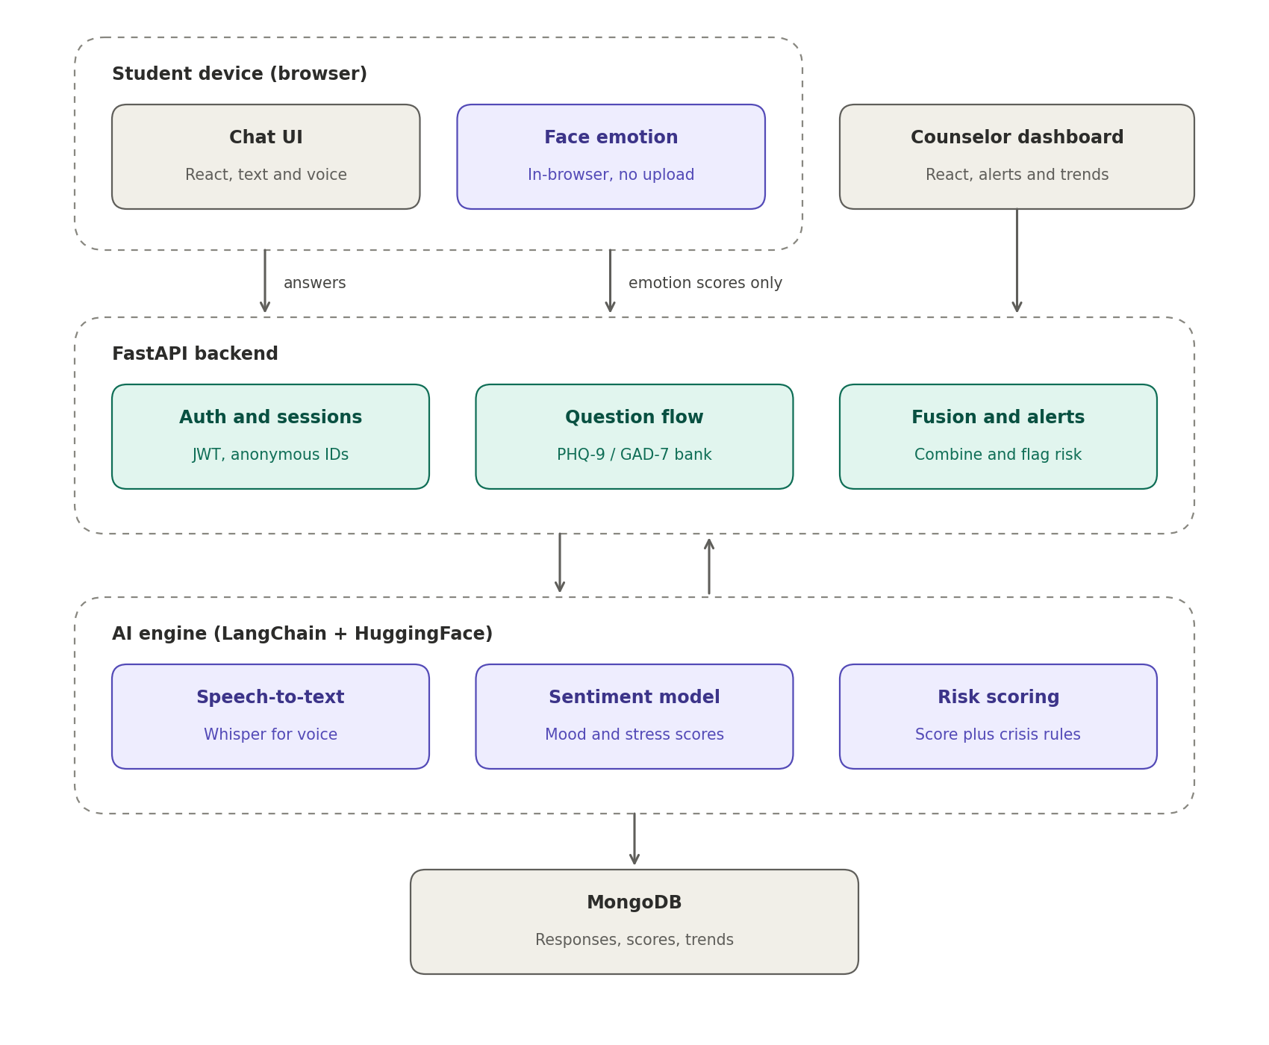
Figure 1. Layered architecture with on-device face emotion recognition

3. Components
Layer | Component | Technology | Responsibility
Student device | Chat UI | React | Check-in conversation with text or voice input; consent screen; tips at the end of a session.
Student device | Face emotion | face-api.js / TensorFlow.js / MediaPipe | Opens the camera after consent, detects the face and classifies emotion in the browser. Sends scores only.
Counselor device | Counselor dashboard | React | Alert list and mood/stress trends per anonymous student ID.
Backend | Auth and sessions | FastAPI, JWT | Login, roles (student / counselor), anonymous IDs, session state.
Backend | Question flow | FastAPI | Serves the PHQ-9 / GAD-7 style question bank and decides the next question.
Backend | Fusion and alerts | FastAPI | Combines questionnaire, text and face scores; creates alerts for high-risk cases.
AI engine | Speech-to-text | Whisper (HuggingFace) | Transcribes spoken answers to text.
AI engine | Sentiment model | LangChain, HuggingFace | Scores mood and stress from free-text answers.
AI engine | Risk scoring | Python, rules + LLM | Produces a risk level and runs the rule-based crisis check.
Data | MongoDB | MongoDB | Stores sessions, responses, scores, alerts and trends.

4. Check-in data flow
- The student opens the app, accepts the consent screen, and turns the camera on if they want to.
- The student answers each question by typing or speaking. The browser sends the answers to the backend.
- In parallel, the face model runs locally in the browser and sends averaged emotion scores for each question.
- The backend passes the text (or transcript) to the AI engine for sentiment and risk scoring.
- The fusion step combines all scores, saves the results in MongoDB and decides whether to raise an alert.
- Low-risk sessions close with self-help tips. High-risk sessions alert the counselor and show a helpline to the student.

5. Face emotion module (on-device)
Facial emotion recognition runs entirely inside the student's browser. The video never leaves the device, and only emotion scores such as {sad: 0.62, neutral: 0.30} are sent to the backend.

How it works
- Camera: navigator.mediaDevices.getUserMedia() after explicit consent; one frame is sampled every 1-2 seconds while the student answers.
- Model: face detection followed by an expression classifier (happy, sad, angry, fearful, neutral, surprised) using face-api.js, TensorFlow.js or MediaPipe Face Landmarker.
- Output: scores averaged over each question and sent with the answer. No images or video are uploaded or stored.
- Evaluation: FER2013, AffectNet or CK+ can be used to measure accuracy for the project report.

Why on-device
- Privacy: facial images of students are never transmitted or stored.
- Lower server load and no video upload bandwidth.
- Easier to justify in a mental health setting, where trust matters.

Limitations
- Facial emotion models are only moderately accurate (about 65-75% on FER2013) and do worse with real webcam footage.
- A face shows expression, not feeling. Someone can look neutral while anxious, so this is a weak signal.
- Models can be biased across skin tones, lighting and glasses. The app must work fully without the camera.
- The camera score alone must never trigger a high-risk alert.

6. Score fusion
The three signals are combined into one risk score. The weights below are a starting point to be tuned and described in the methodology:
final_risk = 0.5 x questionnaire + 0.3 x text sentiment + 0.2 x face emotion
- Questionnaire scores use the standard PHQ-9 / GAD-7 totals, calculated with fixed formulas, not by the LLM.
- The LLM is used for conversational tone and free-text sentiment only.
- The face score has the lowest weight and supports a flag only when text or answers also show concern.

7. Safety and privacy
- Rule-based crisis check: keyword and phrase detection on every message, independent of the LLM. If it fires, the app immediately shows a helpline (India: Tele-MANAS 14416) and alerts the counselor.
- Anonymity: students are stored under an anonymous ID. The ID-to-name mapping sits in a separate collection that only the counselor role can access.
- Consent: a consent screen on first use, with separate opt-in for the camera and a visible 'camera on' indicator that can be turned off at any time.
- Data protection: encryption in transit and at rest; no images or video stored; only scores kept.
- Disclaimer: a clear message that this is a screening aid and not a diagnosis.

8. Data model and API

MongoDB collections
Collection | Main fields
users | anon_id, role, created_at, consent_flags (text, voice, camera)
sessions | session_id, anon_id, started_at, ended_at, final_risk, risk_level
responses | session_id, question_id, answer_text, sentiment, questionnaire_score, face_scores
alerts | alert_id, anon_id, session_id, risk_level, created_at, status, counselor_notes
counselors | counselor_id, name, email, assigned_students (anonymous IDs)

API routes (FastAPI)
Method | Route | Purpose
POST | /sessions | Start a new check-in session.
POST | /sessions/{id}/answer | Submit an answer with face scores; returns the next question.
POST | /sessions/{id}/finish | Close the session, run fusion, return tips or crisis info.
GET | /students/{id}/trends | Mood and stress trend data for the dashboards.
GET | /alerts | List of open alerts for counselors.

9. Future scope
- Multi-language support for regional languages.
- Counselor referral flow that auto-schedules a session when a student is flagged.
- Peer support matching for shared themes.

