Customer Purchases Behaviour

Project Overview
This Project analyse the customer purchase behaviour. The goal is to uncover the insights into spending patterns, customers segments, product preferences. This project demonstrates an end-to-end data analytics workflow using Python for data cleaning, SQL for data analysis, and Power BI for data visualization.

Dataset Summary
- Rows: 1,00,000
- Columns : 12
Key Features: It includes various features such as age, gender(Male, Female), income, education(College, Masters, Bachelors, HighSchool), region(East, West, North, South), loyalty status(Gold, Regular, Silver), purchase frequency(Rare, Frequent, Occasional ), purchase amount, product category, promotion usage(Yes, No), and satisfaction score consisting 1,00,000 customers data.

Step-by-Step Project Methodology
Step1: Data Import and Cleaning Using Python
- The Excel dataset was imported into Python using the Pandas library.
- Initial data inspection was performed using functions like:
      - .head()
      - .info()
      - .describe()
- Data cleaning tasks included:
      - Handling missing values
      - Removing or correcting inconsistent data
      - Ensuring correct data types
Step 2: Create Age Group Column
- A new column called Age Group was created to segment customers.
- Customers were grouped into meaningful age buckets such as:
      - Young Adult
      - Adult
      - Middle-Aged
      - Senior
- This step helped in better customer segmentation and analysis.
Step 3: Export Cleaned Data to SQL Database
- After cleaning and transformation, the dataset was exported from Python to a SQL database.
- The structured data was stored in a table for further analysis.

Step 4: Data Analysis Using SQL Queries
Various SQL queries were written to answer business-related questions.
1. What is the total number of customers in each age group?
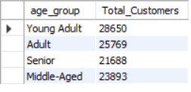
-To understand how customers are distributed across different age categories.

-The analysis shows that the majority of customers fall under the Young Adult age group, followed by Adults. This insight helps in designing targeted marketing strategies for high-value age segments.
2. What is the total purchase done by male and female?
- To compare customer spending behaviour across genders.
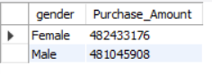
-The results indicate that female customers contribute slightly more to total spending than male customers.
3. What are the top product preferences by gender?
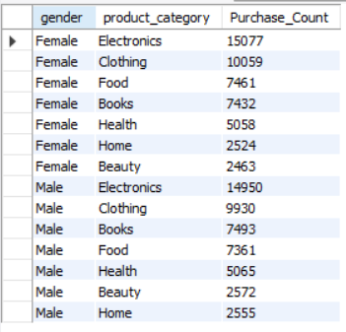
-To compare products buying behaviour across genders.
-The results indicates that both female and male customers spend more on the electronics followed by clothings.
4. What is the average purchase value by age group?
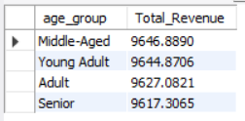
- To identify which age group contributes the highest average purchase value.

-Middle-aged customers show a slightly higher average purchase value, indicating stronger purchasing power compared to other age groups.

5. What are the top product that got highest satisfaction rate?
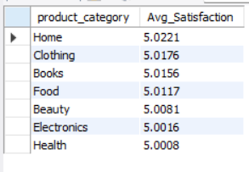
-To identify product category from that customers most satisfied and got Highest average satisfaction rate.
-The result shows that home product category got slightly higher satisfaction rate then any other products.
6. What is the average purchase amount by loyalty_status?
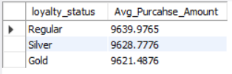
- To analyse how customer loyalty status impacts the average purchase amount and identify which loyalty segment contributes higher value per transaction.
-The analysis reveals that Regular customers have the highest average purchase amount, followed closely by Silver and Gold customers. Although the differences among loyalty tiers are relatively small, the results suggest that purchasing behaviour remains fairly consistent across loyalty statuses. This indicates that while loyalty programs may support customer retention, they may not significantly impact the average purchase value per transaction.
7. Do loyal customer purchase more?
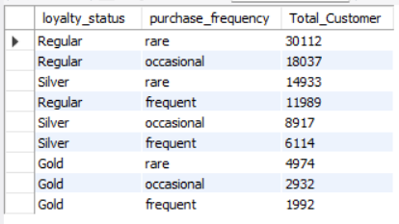
- To analyse the relationship between customer loyalty status and purchase frequency in order to understand whether loyal customers demonstrate higher purchasing behaviour.

-The analysis indicates that regular customers form the largest group across all purchase frequency categories, mainly due to their higher overall population. However, when comparing loyalty tiers, Silver and Gold customers show a relatively higher proportion of frequent purchases compared to Regular customers. This suggests that loyal customers tend to purchase more frequently, validating the effectiveness of loyalty programs in encouraging repeat purchases.
8. What are the top 5 product categories by revenue in each region?
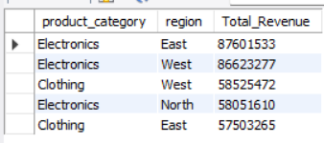
-To identify the highest revenue-generating product categories across different regions for better regional sales strategy.
-Electronics dominates revenue generation across regions, making it the most profitable product category region-wise.
9. Which region should marketing efforts focus on based on average purchase amount and purchase frequency?
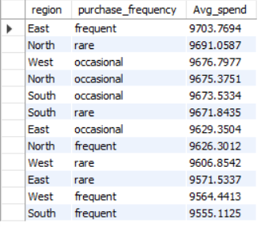
- To identify the region with higher customer value and engagement in order to prioritize marketing campaigns effectively.
-Marketing efforts should primarily focus on the East region, as it demonstrates the highest average purchase amount among frequent customers, indicating stronger potential for revenue growth through targeted campaigns.
10. Are highly educated customers more likely to be brand-loyal?
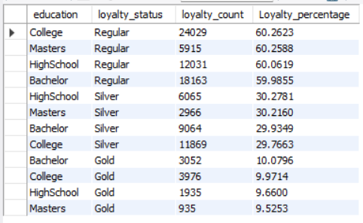
-To analyse the relationship between customer education level and loyalty status in order to understand whether higher education influences brand loyalty.

No, highly educated customers are not significantly more brand-loyal than others, as loyalty levels remain consistent across all education categories.

11. Does customer education level indirectly influence purchase amount through income?
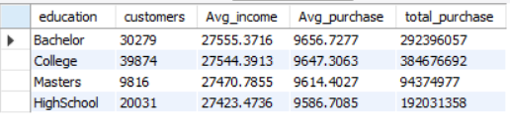
-To analyse whether higher education levels are associated with higher income, which in turn impacts the purchase amount.
The analysis shows that customers with higher education levels (Bachelor and College) have slightly higher average incomes, which corresponds to marginally higher average purchase amounts. Customers with lower education levels (High School) show comparatively lower income and purchase amounts. Although the differences are not very large, a gradual positive trend can be observed, indicating that education indirectly influences purchase amount through income.
12. How does age influence purchase frequency and spending?
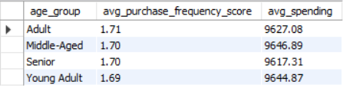
Methodology: Purchase frequency was converted into a numerical score (Frequent = 3, Occasional = 2, Rare = 1) to enable quantitative comparison across age groups.

The analysis shows that senior customers have the highest purchase frequency score and spending, followed by middle-aged and adult customers. Young adults show comparatively lower purchase frequency and spending. This indicates that purchasing behaviour strengthens with age.
13. Are loyal customers more responsive to promotions?
To analyse whether customer loyalty status influences responsiveness to promotional campaigns.
Methodology: Promotion responsiveness was measured by calculating the percentage of customers who used promotions across different loyalty levels.
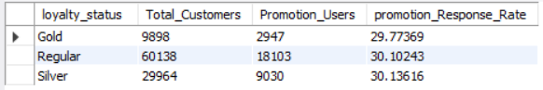
The promotion response rate is nearly identical across all loyalty categories. Regular and Silver customers show a slightly higher response rate compared to Gold customers, but the difference is minimal. This suggests that loyalty status does not have a significant impact on customer responsiveness to promotions.
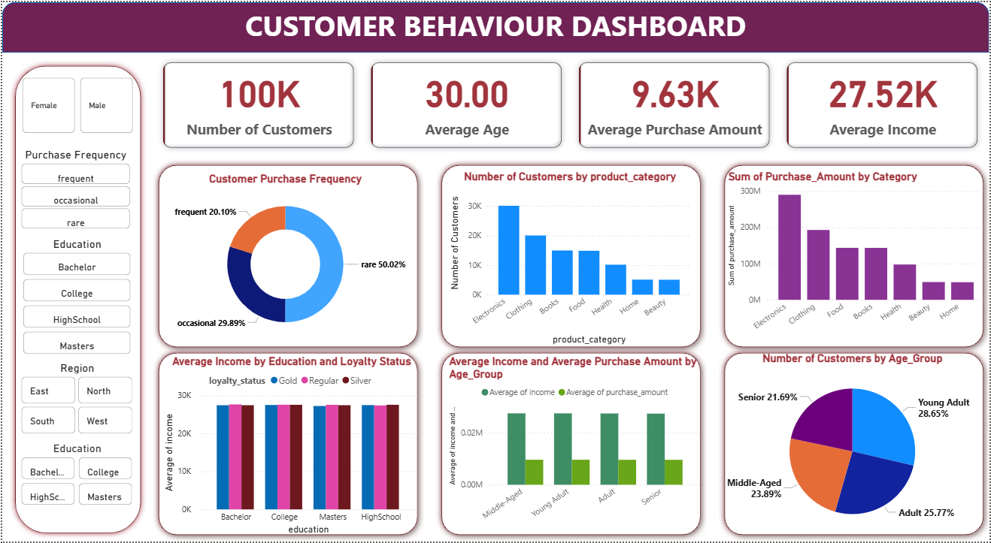
Step 5: Dashboard in PowerBI

Key Findings
- Age Influence: Senior customers show higher purchase frequency and spending compared to younger age groups.
- Loyalty Analysis: Regular customers generate the highest revenue, while promotion response rates are similar across loyalty levels.
- Regional Performance: The East region emerges as a strong focus area for marketing due to higher engagement and spending.
- Product Categories: Electronics consistently generate the highest revenue across multiple regions.
- Education & Income: Higher education levels are associated with slightly higher income, which indirectly leads to higher spending.

Business Recommendations
- Target High-Value Age Groups:
Marketing campaigns should focus on senior and middle-aged customers, as they demonstrate higher purchase frequency and spending.
- Region-Focused Marketing Strategy:
The East region should be prioritized for promotional and sales campaigns due to stronger customer engagement and higher purchase values.
- Optimize Loyalty Programs:
Since promotion response rates are similar across loyalty tiers, loyalty programs should emphasize exclusive benefits and personalized experiences rather than only discounts.
- Category-Based Strategy:
Inventory planning and promotions should prioritize Electronics, especially in high-performing regions such as East and West.
- Income-Based Segmentation:
Marketing strategies should incorporate income segmentation, as income plays a mediating role between education level and purchase behaviour.

Conclusion
This project successfully demonstrated an end-to-end data analytics workflow using Python, SQL, and Power BI to analyse customer behaviour and purchasing patterns. The raw customer data was first cleaned and transformed in Python, enhanced with additional features such as age groups, and then analysed using SQL to answer key business questions. Finally, Power BI was used to visualize insights through an interactive dashboard.

The analysis revealed that customer behaviour varies across age groups, regions, loyalty levels, and education backgrounds, though some patterns remain consistent. Senior and middle-aged customers tend to show higher purchase frequency and spending, while regular customers contribute the highest overall revenue due to volume. Promotion responsiveness remains fairly similar across loyalty segments, indicating that loyalty alone does not strongly influence promotional engagement. Additionally, education indirectly impacts purchase behaviour through income levels rather than directly influencing spending.

Overall, the project highlights how data-driven insights can support strategic marketing and business decisions, reinforcing the importance of combining analytical tools with visualization platforms.

