INTRODUCTION

INTRODUCTION

In this report, we will outline the importance of using a Todo list to manage tasks efficiently and effectively. A Todo list is a simple and powerful tool that helps individuals and teams stay organized, prioritize tasks, and maintain productivity. This report will explore the benefits of using a Todo list and provide practical tips on creating and managing one. A to-do list is a written or digital inventory of tasks, activities, or goals that we need to accomplish within a certain timeframe. It serves as a personal roadmap, providing us with a clear and structured outline of what needs to be done and when. From mundane daily chores to important projects, a to-do list helps us prioritize, manage our time efficiently, and track our progress towards achieving our objectives.

A to-do list is necessary for several reasons, and it serves as a valuable tool for personal and professional productivity. Overall, a to-do list is a simple yet powerful tool that can significantly improve your productivity, reduce stress, and help you achieve your goals effectively. It's important to find a method of list-making that works best for you, whether it's using a pen and paper, a digital app, or any other preferred system.

REQUIREMENTS
ANALYSIS

REQUIREMENTS ANALYSIS

Programming Languages :
This project is based on the concept of Web Technology, so we used following languages :
- HTML
- CSS
- PHP
Database:
- MySQL
Software requirements
- Visual Studio Code / Xampp.
- Wamp Server – For PHP / My SQL database
- Browser –Google Chrome/Edge etc.
Hardware requirements:
- Keyboard, Mouse, Desktop Screen
- Ram – 8 GB Or Higher
- SSD – 256GB Or Higher

IMPLEMENTATION

`

IMPLEMENTATION

HTML:
The Hyper Text Markup Language or HTML is the standard markup language for documents designed to be displayed in a web browser. It can be assisted by technologies such as cascading style sheet (CSS) and Scripting languages such as JavaScript. HTML elements are the building blocks of HTML pages.

CSS :
CSS is the language for describing the presentation of web pages, including colors, layout, and fonts. It allows one to adapt the presentation to different types of devices, such as large screens, small screens, or printers. CSS is independent of HTML and can be used with any XML based markup language.

PHP :
PHP (Hypertext Preprocessor) is known as a general-purpose scripting language that can be used to develop dynamic and interactive websites. It was among the first server-side languages that could be embedded into HTML, making it easier to add Functionality to web pages without needing to call external files for data.
Bootstrap :
Bootstrap is a free and open-source CSS framework directed at responsive, mobile-first front-end web development. It contains HTML, CSS and JavaScript-based design templates for typography, forms, buttons, navigation, and other interface components.

MySQL Database :
MySQL is an open-source relational database management system. Its name is a combination of "My", the name of co-founder Michael Widenius's daughter My, and "SQL", the acronym for Structured Query Language.
A database is a structured collection of data. It may be anything from a simple shopping list to a picture gallery or a place to hold the vast amounts of information in a corporate network. In particular, a relational database is a digital store collecting data and organizing it according to the relational model. In this model, tables consist of rows and columns, and relationships between data elements all follow a strict logical structure. An RDBMS is simply the set of software tools used to actually implement, manage, and query such a database.

CODING
Todo.php
<?php
$errors = "";
$db = mysqli_connect('localhost','root','','todo');
if(isset($_POST['submit']))
{
$date = $_POST['date'];
$task = $_POST['task'];
$time = $_POST['time'];
if(empty($task)){
$errors= "Task Can,t Be Empty";
}else{
mysqli_query($db,"INSERT INTO tasks (task,time,date) VALUES ('$task','$time','$date')");
header('location: todo.php');
}

}
if(isset($_GET['del_task'])){
$id = $_GET['del_task'];
mysqli_query($db, "DELETE FROM tasks WHERE id=$id");
header('location: todo.php');
}
if (isset($_GET['done_task'])) {
$id = $_GET['done_task'];
mysqli_query($db, "UPDATE tasks SET is_done = 1 WHERE id=$id");
header('location: todo.php');
}
$tasks = mysqli_query($db, "SELECT * FROM tasks");
?>
<!DOCTYPE html>
<html>
<head>
<title>To_do List</title>
<link rel="stylesheet" href="todo.css?v=<?php echo time(); ?>">
</head>
<body>
<div class="container">
<div class="info">

<h1>Organize your work <br> and life, finally.</h1>
</div>
<nav>
<ul>
<li><a href="main.php#middle">About</a></li>
<li><a href="main.php#foot">Contact</a></li>
<li><a href="completed.php">Completed Tasks</a></li>
<li><a href="main.php">Log Out</a></li>
</ul>
</nav>
<div class="bdy">
<div class="heading">
<h2>To Do List</h2>
</div>
<form method = "POST" action="todo.php">
<div class="search">
<?php if(isset($errors)){?>
<m><?php echo $errors; ?></m>
<?php } ?>

<div class="dat">
<div class="ti">
<label for="appt" class="ti">Select a time:</label >
<input required type="time" id="appt" name="time" class="da1">
</div>
<div class="da">
<label for="birthday">Date:</label>
<input required type="date" id="date" name="date" class="da2">
</div>
</div>
<input type="text" name="task" class="task_input" required>
<button type ="submit" class="add_btn" name="submit">Add task</button>
</form>
</div>
<table>
<thead class="he">
<tr>
<th >N</th>
<th>date</th>
<th>Time</th>
<th>Task</th>
<th>Action</th>
<th>Status</th>
</tr>
</thead>
<tbody>
<?php $i = 1; while($row = mysqli_fetch_array($tasks)) { ?>
<tr>
<td><?php echo $i; ?></td>
<td class="date"><?php echo $row['date'];?></td>
<td class="time"><?php echo $row['time'];?></td>
<td class="task"><?php echo $row['task'];?></td>
<td class="delete">
<a href="todo.php?del_task=<?php echo $row['id'];?> ">X</a>
</td>
<td class="do">
<a href="todo.php?done_task=<?php echo $row['id']; ?>">Done</a>
</td>
</tr>
<?php $i++ ; } ?>
</tbody>
</table>
</div>
</div>
</body>
</html>

Todo.css

.heading{
width: 50%;
margin: 30px auto;
text-align: center;
color: #6B8E23;
background: #fff8dc;
border: 2px solid #6b8e23;
border-radius: 20px;

}
.h2{
width: 50%;
margin: 30px auto;
text-align: center;
color: #6B8E23;
background: #fff8dc;
border: 2px solid #6b8e23;
border-radius: 20px;
}
body{
background-color: #f1faee ;
}
.container{
margin-top: 70px;
width: 100%;
}
.bdy{
width: 100%;
}
.info{
text-align: center;
font-family: Arial, Helvetica, sans-serif;
}
form{
width: 50%;
margin: 30px auto;
text-align: center;
color: #af7eeb;
background: #fff8dc;
border: 2px solid #6b8e23;
}
form m{
color: red;
margin: 0px;
}
.task_input{
width: 73%;
height: 15px;
padding: 10px;
border: 2px solid #6b8e23;
}
.add_btn{
height: 39px;
background: #fff8dc;
color: black;
border-radius: 5px;
padding: 5px 20px;
}
.add_btn:hover {
color: #ff7a59;
background: #fff;
border: 3px solid black;
}
table{
width: 60%;
margin: 30px auto;
border-collapse:collapse ;
border: 2px solid black;
}
tr{
border-bottom: 1px solid #cbcbcb;

}
th{
font-size: 19px;
color: #6b8e23;
}
th,td{
border: none;
height: 30px;
padding: 2px;
text-align: center
}
tr:hover{
background: #e9e9e9;
}
nav {
background-color: #555;
padding: 0.5rem;
justify-content: space-between;
margin-bottom: 40px;
}
nav ul {
list-style: none;
text-align: center;
}

nav ul li {
display: inline-block;
margin: 0 1rem;

}

nav ul li a {
color: #fff;
text-decoration: none;
}

.task{
text-align: center;
}
td.task {
text-align: center;
max-width: 330px;
}
.time{
text-align: center;
}
.n{
text-align: center;
}
.delete{
text-align: end;
}
td.delete{
text-align: center;

justify-content: flex-end;
}
.delete a{
text-align: end;
color: white;
background: #a52a2a;
padding: 1px 6px;
border-radius: 3px;
text-decoration: none;
}h1{
margin-top: 30px;
}
.ti{
text-align: start;
margin-left: 50px;
color: black !important;
}
.search{
height: 90px;
}
.do{
text-decoration: none;
text-align: center;
font-family: var(--font-family,var(--font-family-body)) !important;
background-color: #d9ed92;
color: black;
border: none;
border-radius: 1px;
width: 30px;
}
.dat{
display: flex;
margin-top:10px ;
margin-bottom: 10px;
}
.da{
margin-left: 130px;
color: black;
}
.da1{
width: 100px;
height: 25px;
}
.da2{
width: 150px;
height: 25px;
}
.back{
margin-left: 720px !important;
width: 70%;
margin: 30px auto;
text-align: center;
color: #6B8E23;
background: #fff8dc;
border: 2px solid #6b8e23;
border-radius: 10px;
padding: 10px;
}

DESIGN / OUTPUT

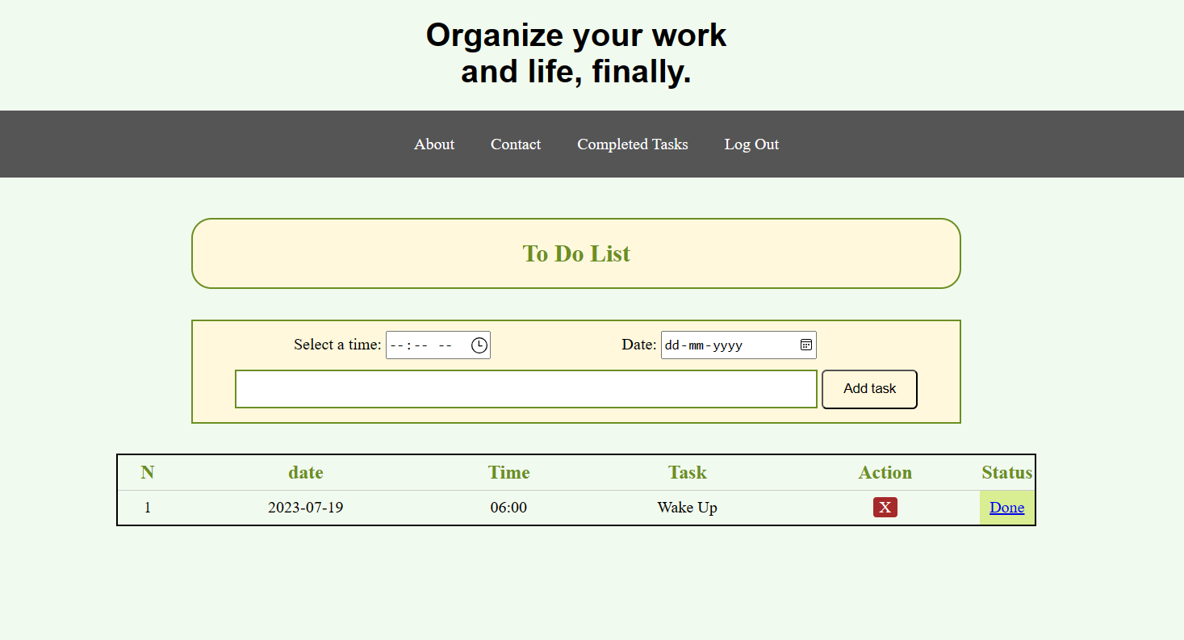

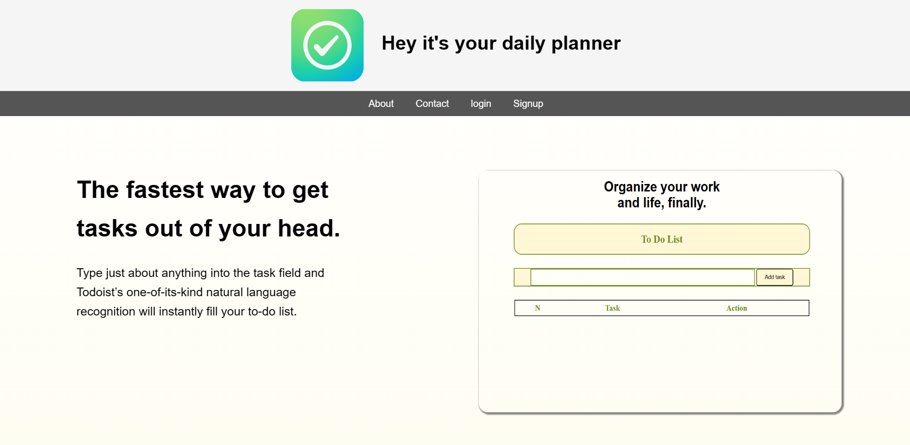
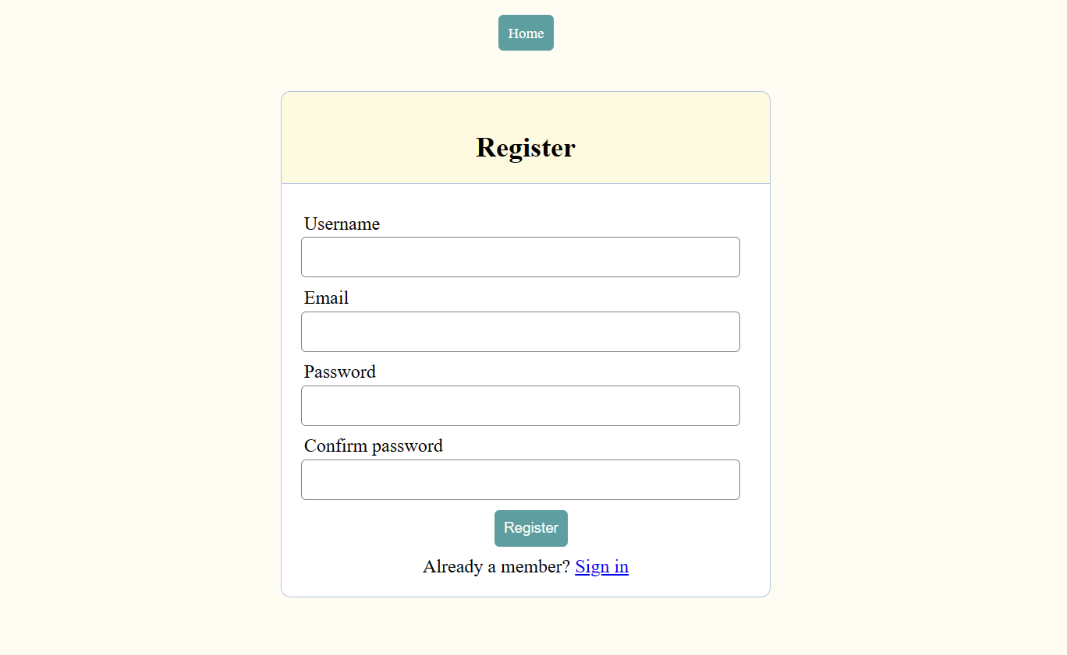
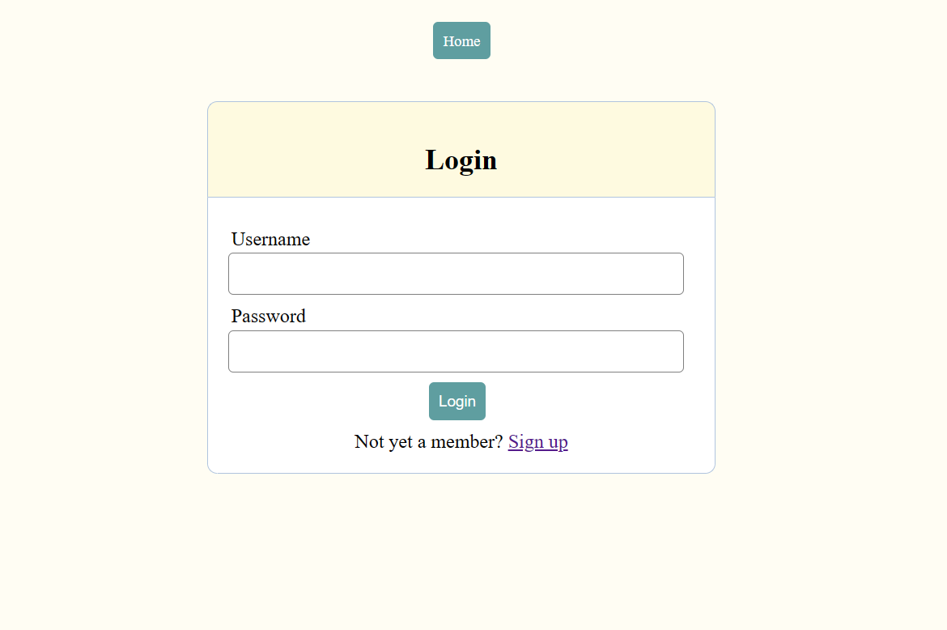
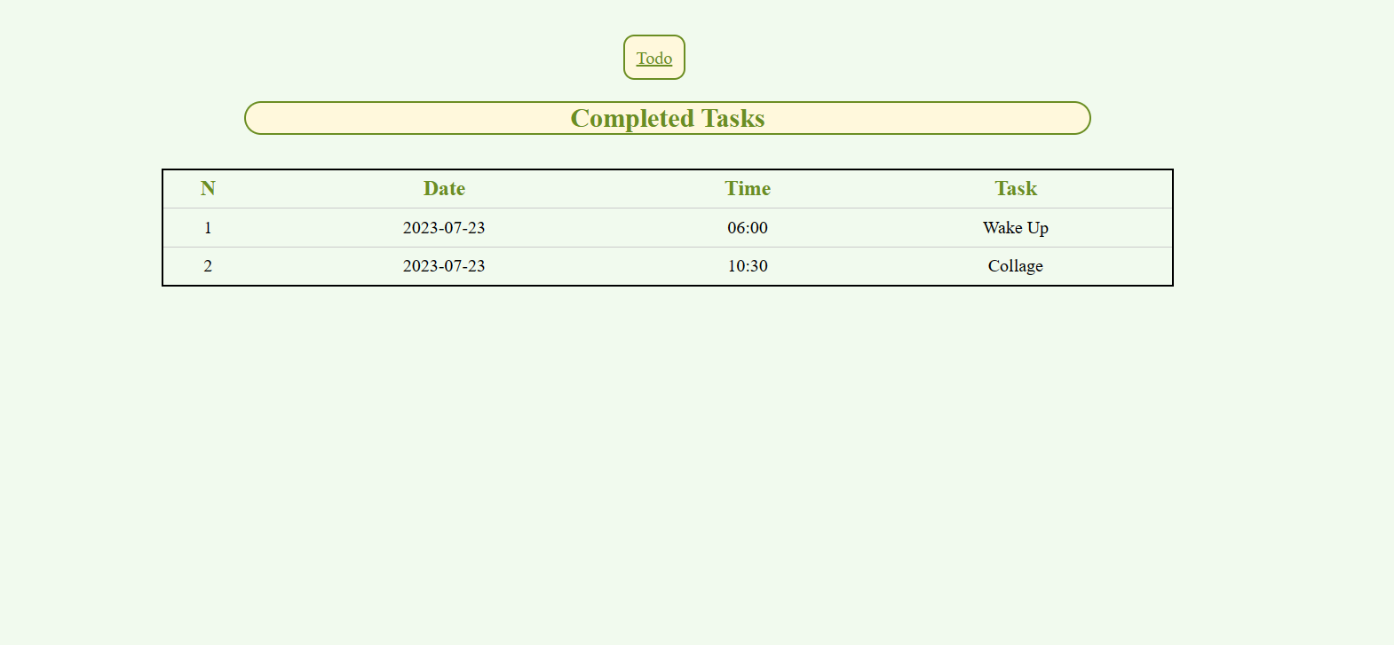

TESTING REPORT

Test Case Id | Description | Input | Expected O/P | Output | Status

ADVANTAGES

Advantages
Increases productivity. ...
Provides motivation. ...
Improves memory. ...
Reduces stress. ...
Allows for more personal time. ...
Reduces anxiety and improves mental health. ...
Provides a sense of accomplishment. ...
Set deadlines for each goal.

