ROLL NO. : OFA-47
CLASS : - FYCS
COURSE NAME : LINUX
Practical no. 12
Date:

aim:-study of networking command
who,whoami,ping,telnet,ftp,ssh,etc.
1)who command :who command is a tool print information about users who are currently logged in.
input:- :- ubantu@ubantu-virtual-machine-~$ who
output:-
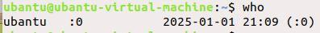
2)whoami command :tool used in UNIX systems to determine the current username of the user logged
input:- ubantu@ubantu-virtual-machine-~$ whoami
output:-
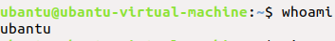
3)ping command:a network utility used to test a host's reachability on an Internet Protocol (IP) network
input:- ubantu@ubantu-virtual-machine ping www.google.com
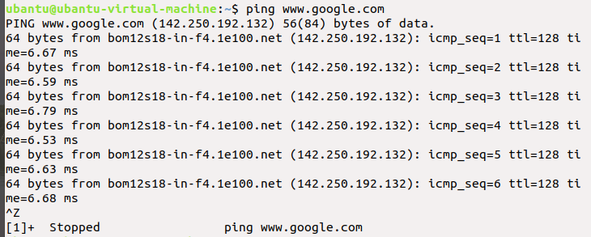
4)telnet command:utilizes the telnet network protocol to connect to remote machines and manage them through a TCP/IP network.
input:- ubantu@ubantu-virtual-machine www.google.com
output:-
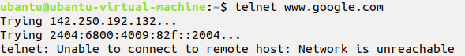
5)ftp command:connects a computer system to a remote server using the FTP protocol.
input:- ubantu@ubantu-virtual-machine ftp
output:-
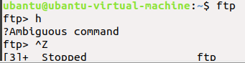
6)ssh command:provides a secure encrypted connection between two hosts over an insecure network
input:- ubantu@ubantu-virtual-machine ssh

output:-
