Tugas JobSheet 6
Athasyah Addin Satriya Abdi
TI – 1C / 05

Studi Kasus 1
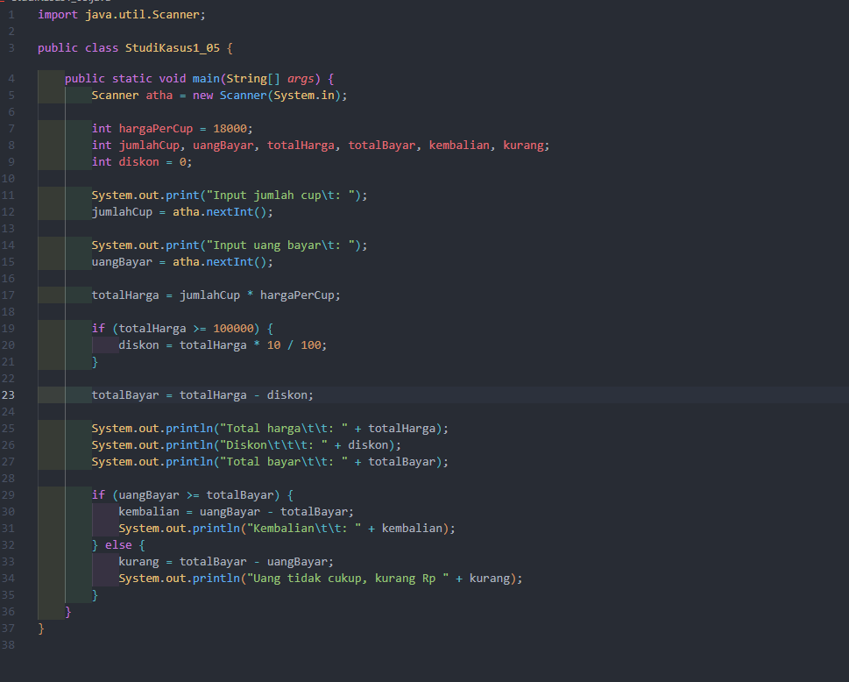
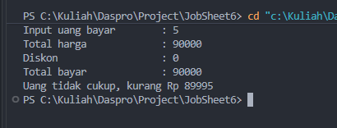
Commit github
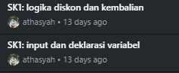

Studi Kasus 2
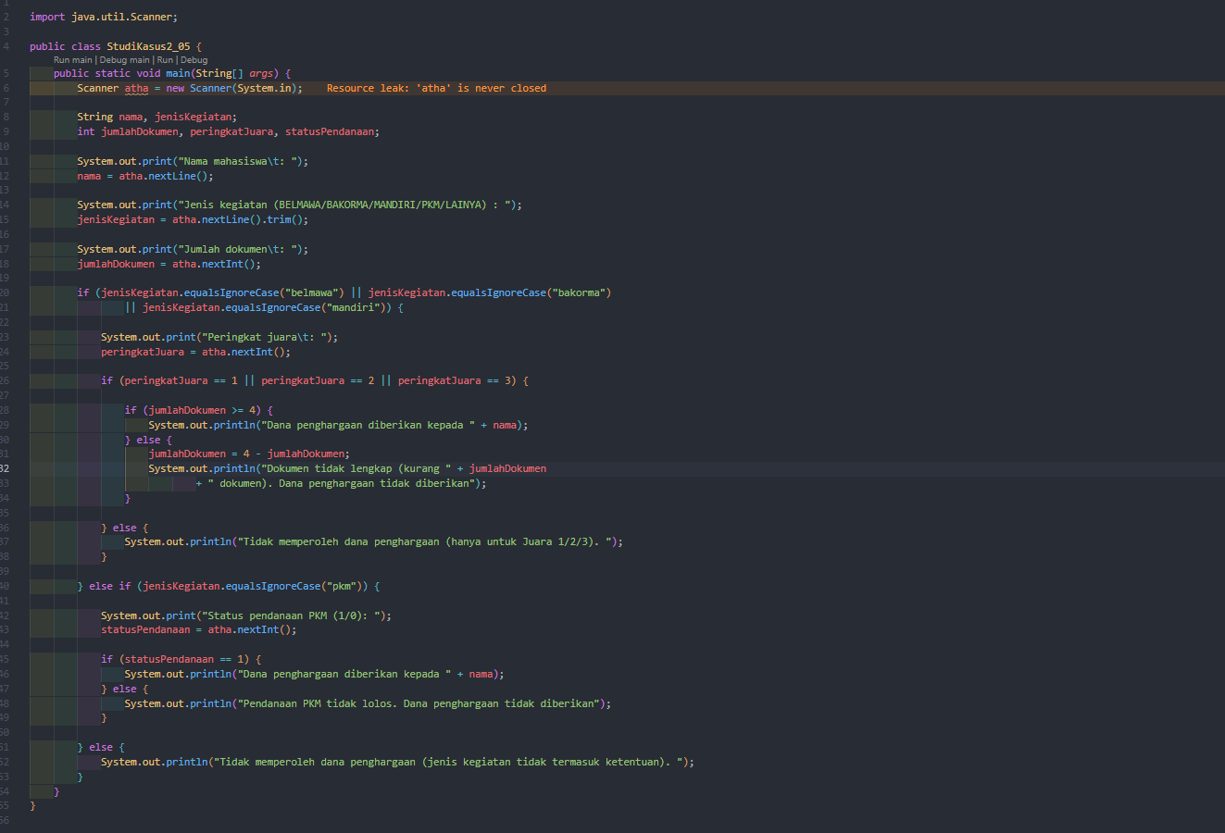
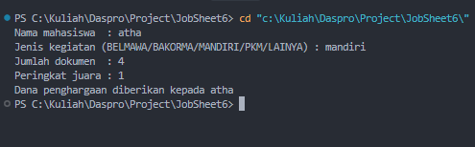
Commit Github


