Gesture Identification

Supervisor: Maria Papadopouli

Student: Evaggelia Athanasaki

Period: winter semester of 2017 and summer semester of 2018. (about 600 hours)

**Introduction**

The objective of this research is to identify four basic hand gestures: up, down, left and right using small wearable devices. These devises are embedded kinematic sensors.

**Hardware**

Shimmer is a small device well suited for wearable applications. Each Shimmer is equipped with tri-axial accelerometer, tri-axial gyroscope and tri-axial magnetometer.

An accelerometer is a device which measures acceleration based on all forces acting on the device. A tri-axial accelerometer is formed of three mutually orthogonal uni-axial accelerometers (i.e. three accelerometer components arranged such that each axis is at a right angle to the other two axes). Each axis measures a certain proportion of both the gravitational acceleration and the inertial acceleration. The proportions measured by a given axis depend on the angles between that axis and the directions of the acceleration components. The total acceleration vector can be written as:

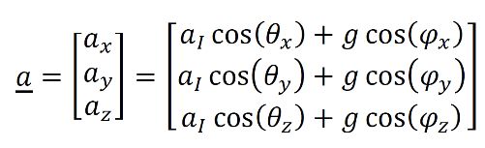

Where

* g is the gravitational acceleration, 1 g ≈ 9.81 m/s2,
* αx,y,z is the inertial acceleration, rate of change of velocity due to forces on body
* θ x,y,z is the angle that the axis αx,y,z makes with the inertial acceleration vector α*I*
* φx,y,z is the angle that the axis αx,y,z makes with the gravity vector g

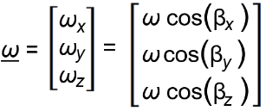A gyroscope can be used to measure angular velocity. The angular velocity of a body can be described as the rate at which the object is rotating, in terms of both the speed of rotation and the axis around which it is rotating. A tri-axial rate gyroscope is formed of three orthogonal uni-axial rate gyroscopes. A 3-dimensional angular velocity vector is obtained from a tri-axial rate gyroscope. The angular velocity vector measured by a tri-axial rate gyroscope is given by:

Where

* ωx,y,z is the magnitude of the angular velocity vector component along the measuring axis of the rate gyroscope
* βx,y,z is the inclination of the measuring axis with respect to the angular velocity vector
* ω is the magnitude of the angular velocity acting on the sensor

A magnetometer is a sensor which is used to measure the direction and/or the strength of the local magnetic field. Α tri-axial magnetometer to measure the local magnetic field in three-dimensions. A tri-axial magnetometer is formed by three orthogonal uni-axial magnetometers. A 3-dimensional magnetic field vector is obtained from a tri-axial magnetometer. The magnetic field vector, m , measured by a tri-axial magnetometer is given by:

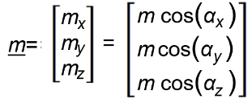

Where

* mx,y,z is the magnitude of the magnetic field vector component along the measuring axis of the magnetometer
* αx,y,z the angle between the magnetometer measuring axis and the magnetic field vector

**Implementation**

The methodology used for the gesture identification was:

1. Dataset Construction
2. Feature Extraction
3. Data Analyzing
4. Results

Dataset Construction

A basic movement was either an up, down, left or a right hand movement. Each experiment was one of the four basic hand movements.

It was asked from three subjects to perform a set of experiments. Subjects were guided from the instructor about the experiments’ elaboration, while following the instructions below:

* To wear the bracelet with the Shimmer device at their right or left hand.
* To perform a set of experiments for all 4 hand gestures (up/down/left/right).
* Each experiment may have different duration, traveled distance and velocity of their hand’s movement.
* To stay stationary for about two seconds at the start and the end of each hand gesture.

Subjects performed many repetitions of each hand movement.

The hand movement explanation was the above:

* *Up*: Vertical movement towards the ceiling
* *Down*: Vertical movement towards the ground
* *Left*: Horizontal movement to the left
* *Right*:Horizontal movement to the right

The final dataset was constructed from four subsets. Each subset was strictly composed from repetitions of the same hand movement, as shown in *figure 1*. The data that each experiment had, was timestamp, measurements from all three sensors in all three dimensions, a good representation of these information is shown in *figure 2*.

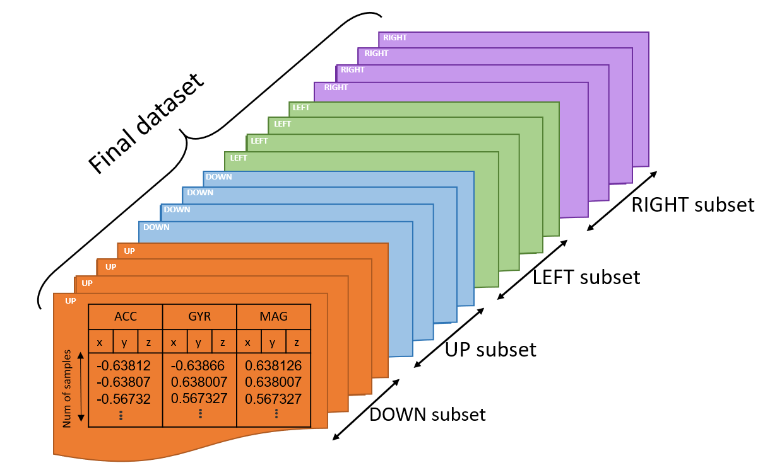

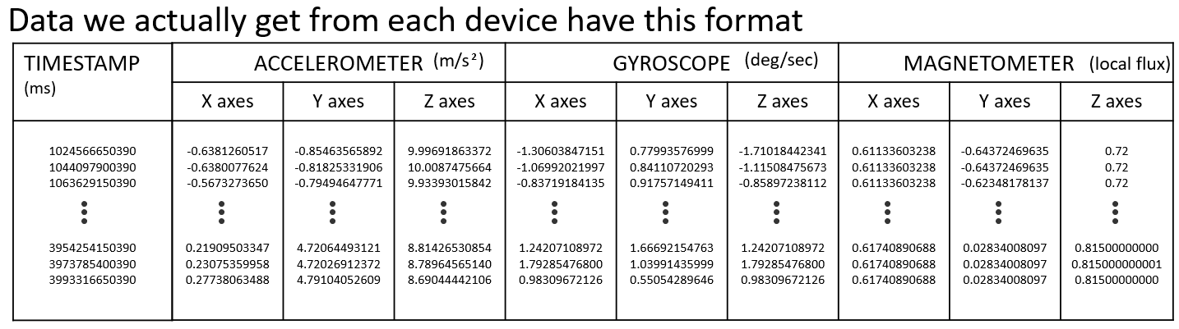Feature Extraction

Figure 1: visual representation of data from each experiment

Figure 2: visual representation of final dataset components

The statistical metrics that used were mean, median, rms and stdev.

* *mean*: average of all numbers
* *median*: the middle number in a set of data
* *rms* (root mean square): the square root of the mean square
* *stdev* (standard deviation): quantifies the amount of variation or dispersion of a set of data values

In order to create the final matrix for data analyzation 36 values were extracted from each experiment, the features. For all three sensors (accelerometers, gyroscope, magnetometer) and for all three dimensions of each were applied the statistical metrics referred above, thus 36 features. The final dataset was a N × 36 matrix, were N was the numbers of all experiments from all subjects (*figure 3*).

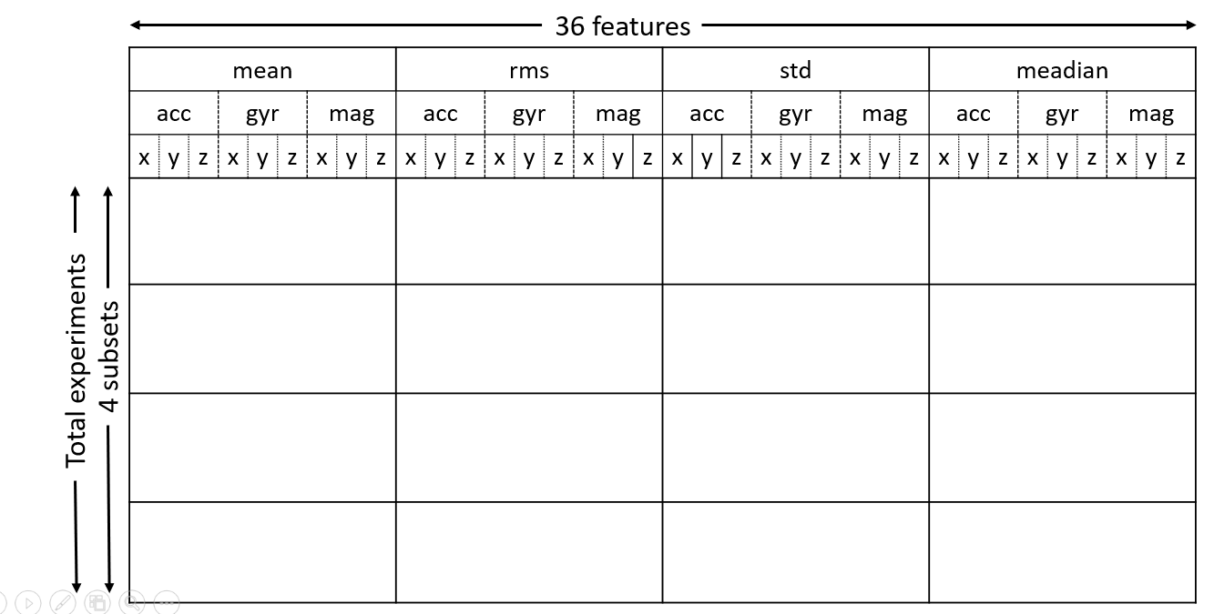

Figure : matrix with features

Data analyzing

The way data analyzed was k-means algorithm, which was separated in two sets, the training set (70%) and the testing set (30%). From both sets, ¼ was data from up hand movement, ¼ from down and so on.

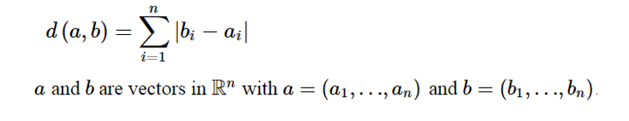K-means was tested for k=4 and for distance metric it was used cityblock. Cityblock is defined in $R^{n}$ by the formula:

The majority of movements in each cluster given from k-means, determined the label of each cluster, so four clusters came up, each labeled as one movement of the basic hand movements. Afterwards each observation from the testing set was compared with all four centroids from the clusters. The smallest distance gave the label after which the observation was labeled, then the comparison of the predicted label and the actual hand movement that was known to the instructor gave the final results. The percentage of the well predicted labels was the result of success for the total prediction.

For the cross-validation of the results the k-fold algorithm was used.

**Flowchart**

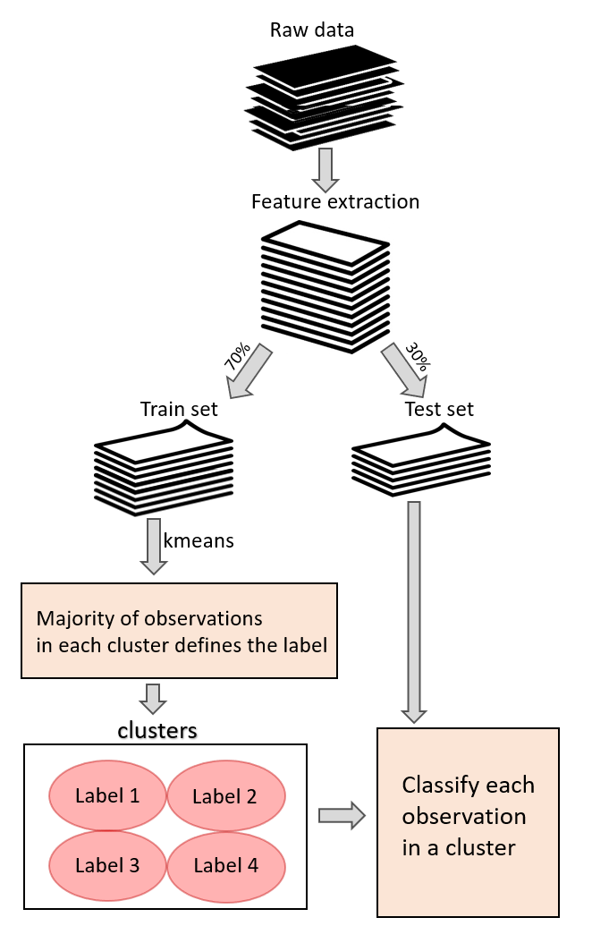

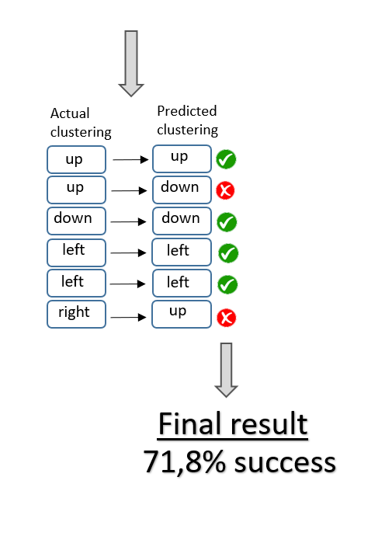

Results

|  |  |  |  |  |  |
| --- | --- | --- | --- | --- | --- |
| Size of dataset  (experiments from each subject) | *Controlled measurements | Left hand involved | Right hand involved | **Fixed hand orientation per gesture | Results |
| 40 |  |  |  |  | 96,87% |
| 72 |  |  |  |  | 89,29% |
| 28 |  |  |  |  | 29,28% |

*Controlled measurements: subject had total awareness about taking measurements

*Fixed hand orientation per gesture: for all gesture repetitions hand had fixed orientation

**Future Work**

Research on gestures identification has been used both in natural science, namely human biology, and in computer science.

In Human Biology, gesture identification is considered useful especially for diseases that involve movement disorders (e.g. Parkinson’s disease, epilepsy etc.). Not only can it be used to improve the quality of life of people who are in need by providing factual help with the daily track of the disease, but in long term it can also help cure the disease they have been suffering from.

For each patient it is easy to keep a log with the disease’s progression. This information is critical for doctors in order to provide them with personalized treatment. In addition, if an application is implemented, which could interpret the different patterns on patients’ movements and at real time inform the patient for some treatment adjustment or an upcoming kinetic crisis, this could improve patients’ daily life with less doctor visits and increased self-confidence for activities that were prohibited until then due to high risk of injury.

Undoubtedly, a big amount of data is useful in long term research for the diseases in order to comprehend their symptoms and patterns and finally find a cure. Thus, keeping an activity record from the patients that wear the bracelets at their daily life gives useful information that can be analyzed from experts and help them reach to a conclusion and possibly a treatment for the disease.

Automations in daily activities is a field of research that computer science tries to bring in the foreground. IoT (Internet of Things) is a technology that allows people to control hardware devices through the internet. A research on gestures can help people control hardware through hand movements. In detail, each hand gesture can be used for a different activity in everyday life like opening lights at home, setting alarms, switching on electronic devices and so on.

**System Improvement**

There are multiple ways to evolve this research; the first is to add more hand movements at the list of the gestures that can be identified. A significantly helpful tool for the instructor of this research would be an implementation of a user interface that could run the total experiment at their own without the instructor’s involution and that for the process of experiments’ elaboration will become more efficient and objective.

Talking about the applications the gesture recognition can have in IoT, the way that this awareness could become approachable to a user, is the implementation of a Graphical User Interface. This GUI will allow the user to interact with devices at home.

**Knowledge gained**

Engaging with IMU (Inertial Measurement Unit) devices was an opportunity to familiarize with basic physical laws and the actual impact they have in everyday life. The hardware of the IMU devices and the knowledge that is gained on Bluetooth protocol – the protocol over which the devices communicate with a server – are also rather useful and interesting.

The research about hand gestures provided the opportunity to work and discover the methods behind the manipulation of a big amount of data. Understanding classification algorithms and learning how they work was also a great asset acquired by this research. A deep understanding of Matlab platform and the tools it comes with is another significant skill that was gained.

While working on this research, the need to approach many problems come up, not only from the computer science point of view but also from the mathematical aspect, as a very good familiarization with the plots for pattern recognition or complex mathematical concepts.

The elaboration of a research like this teaches the steps that should be followed in order to complete tasks and how to go through with a project. The problem solution and dealing with the deadlines are also lifelong learning skills.