**Project Name: IoT Noise Pollution Monitoring Website AND App**

**Table of Contents :**

**website overview**

**website design**

**App design**

**website overview :**

**The IoT Noise Pollution Monitoring Website is a Django-based web application designed for real-time monitoring and visualization of environmental noise levels. This project integrates IoT devices that capture decibel percentage values and transmit them to the website via HTTP POST requests**

**Real-time Data Display: The website provides a dynamic dashboard that displays real-time noise level data in the form of graphical visualizations.**

**IoT Integration: The system is designed to seamlessly receive data from IoT devices using HTTP POST requests, making it a versatile platform for monitoring noise pollution across various environments**

**User-Friendly Interface: The website offers an intuitive and user-friendly interface, ensuring a seamless experience for both novice and experienced users**

**website design :**

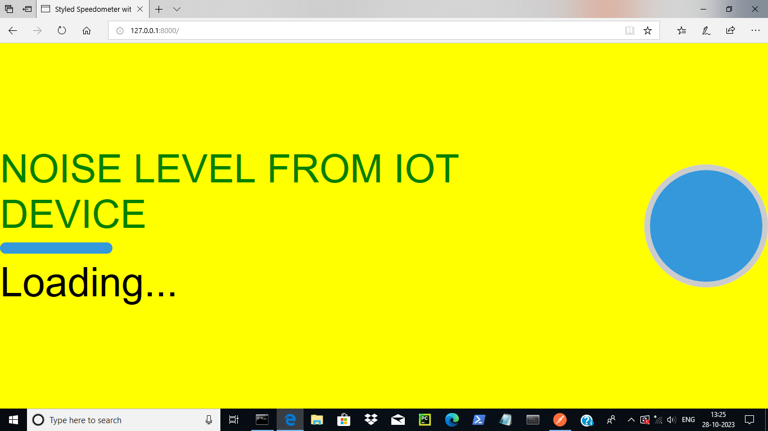

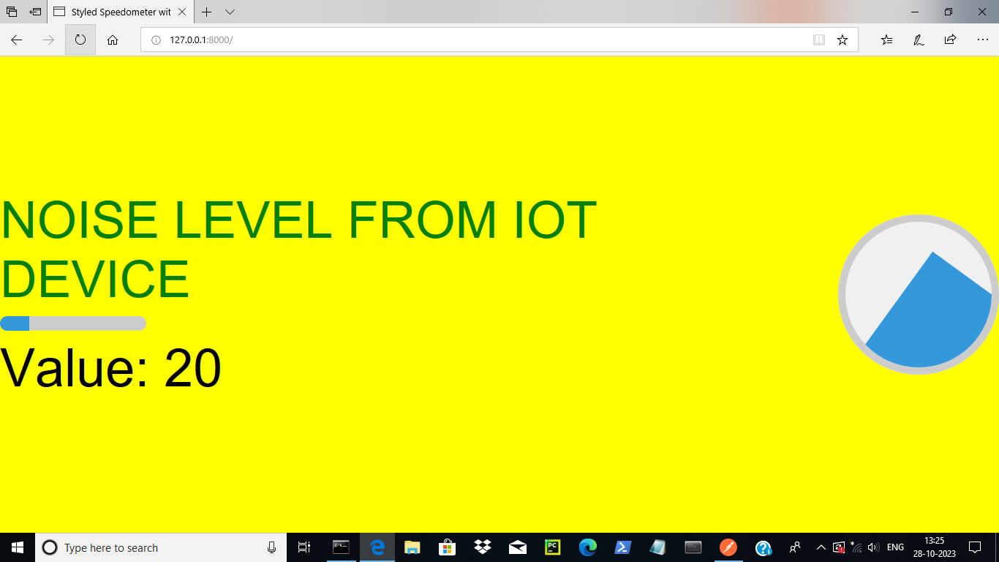

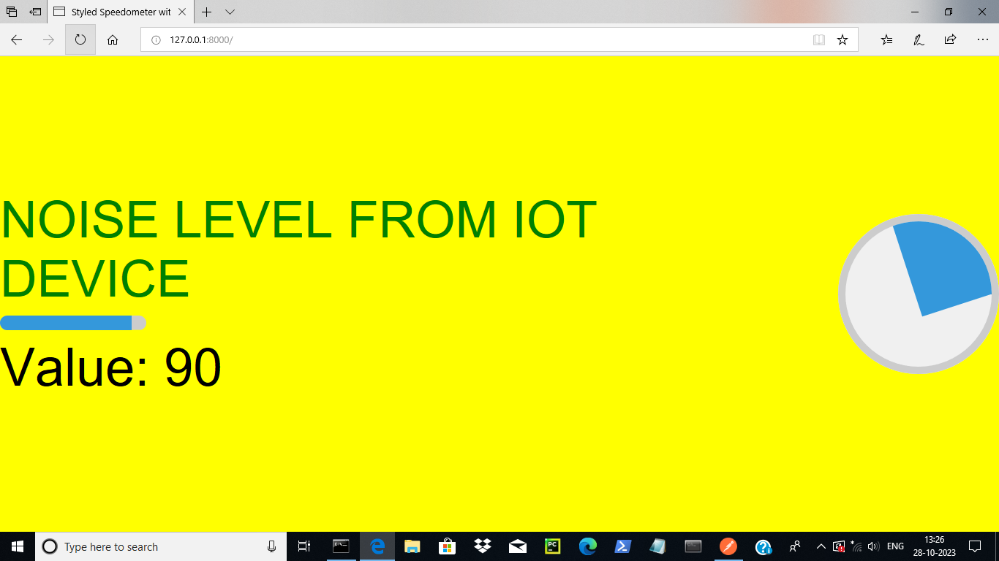

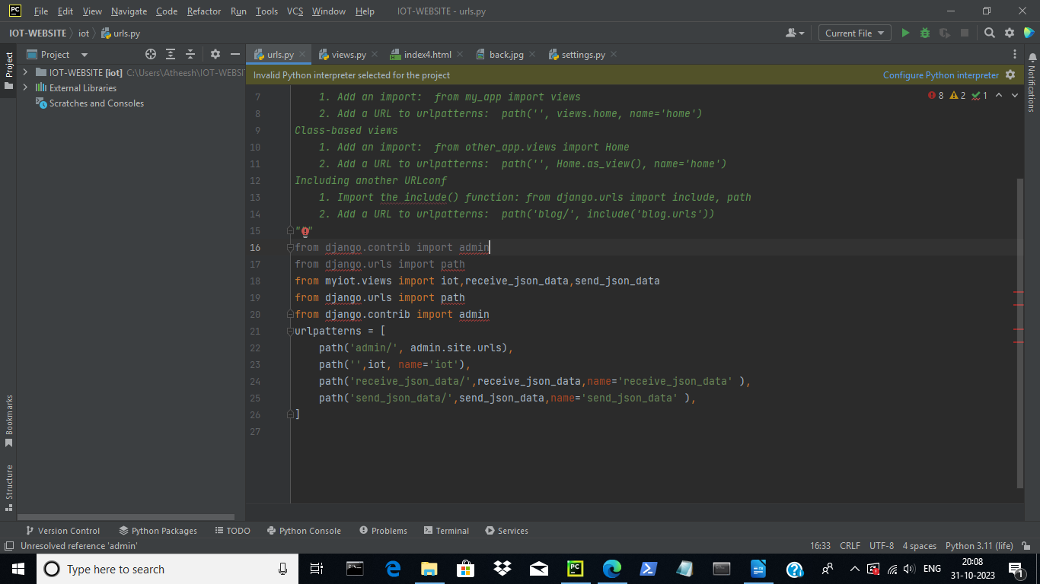

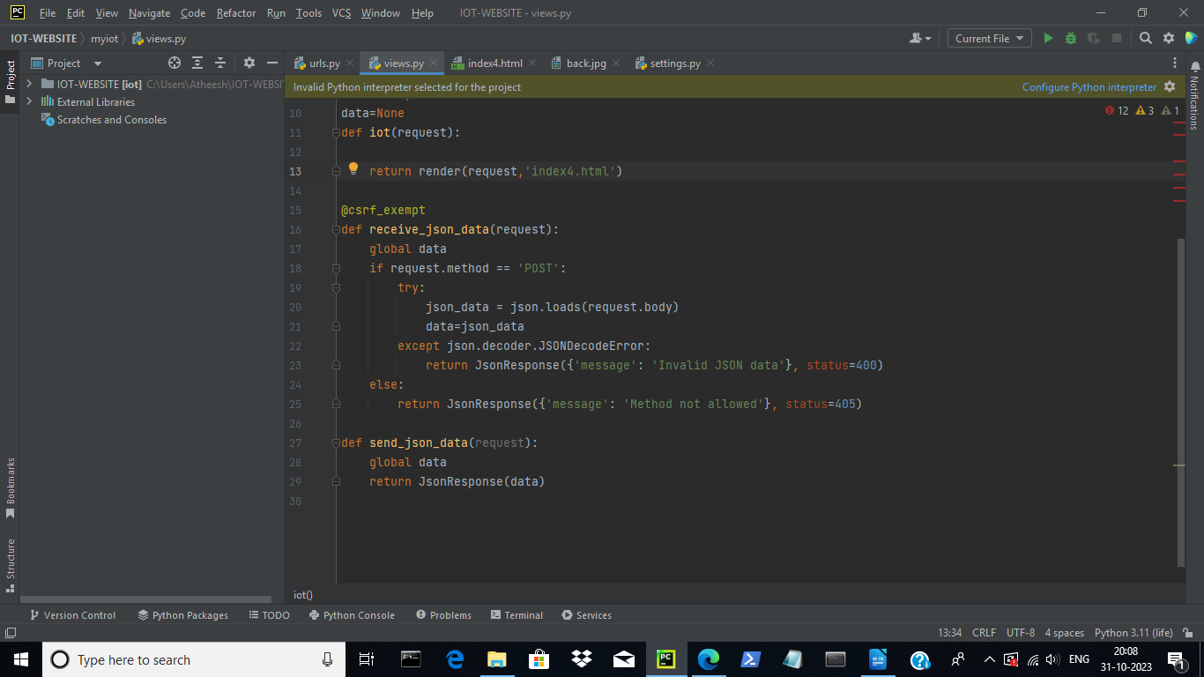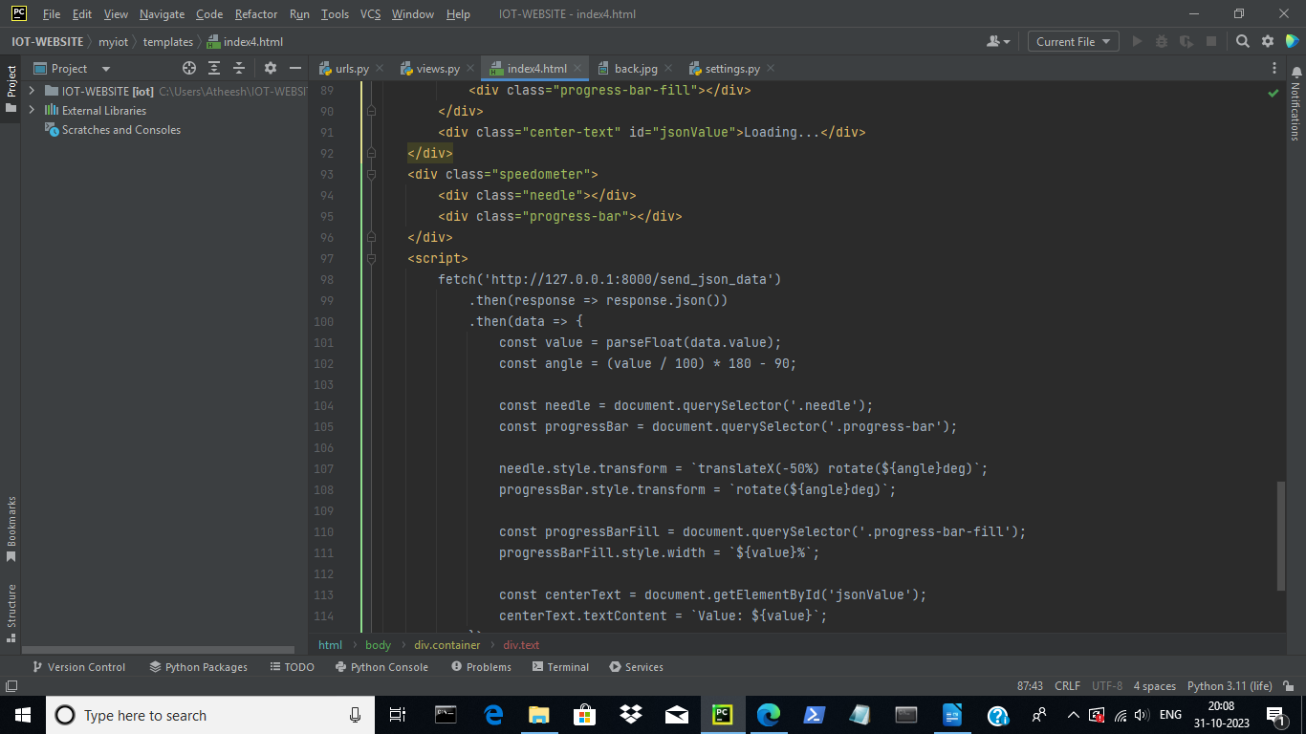

**App design :**

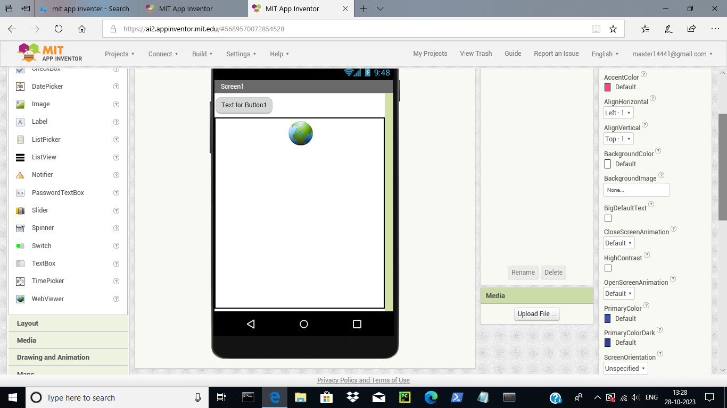

**The IoT Noise Pollution Monitoring Mobile App is a companion application developed using MIT App Inventor. This app serves as a convenient interface for users to access the IoT Noise Pollution Monitoring Website directly from their mobile devices. Here's an overview of its key features**

**Webview Integration: The app utilizes a webview component to seamlessly display the IoT Noise Pollution Monitoring Website within the mobile application. This provides users with a familiar and accessible interface.  
  
Cross-Platform Accessibility: The app is compatible with both Android and iOS platforms, ensuring a wide user base can easily access the monitoring website on their mobile devices.  
  
User-Friendly Navigation: The mobile app is designed with an intuitive navigation system, allowing users to browse the website's features and data with ease.  
  
Real-time Monitoring on-the-go: Users can conveniently monitor noise pollution levels from their mobile devices, enabling them to access critical information even while away from their computer.**