IOT – NOISE POLLUTION MONITORING

AIM :

Iot Noise Monitoring Device

Website Interface

App Interface

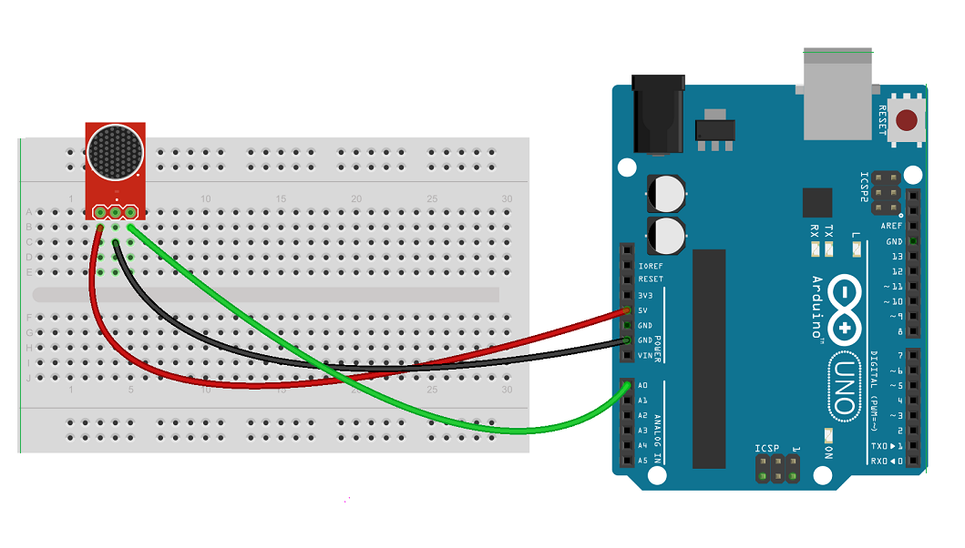Iot Noise Monitoring Device :

1. *Arduino*: This serves as the brain of your project. It processes data from the microphone and sends it to the ESP module.

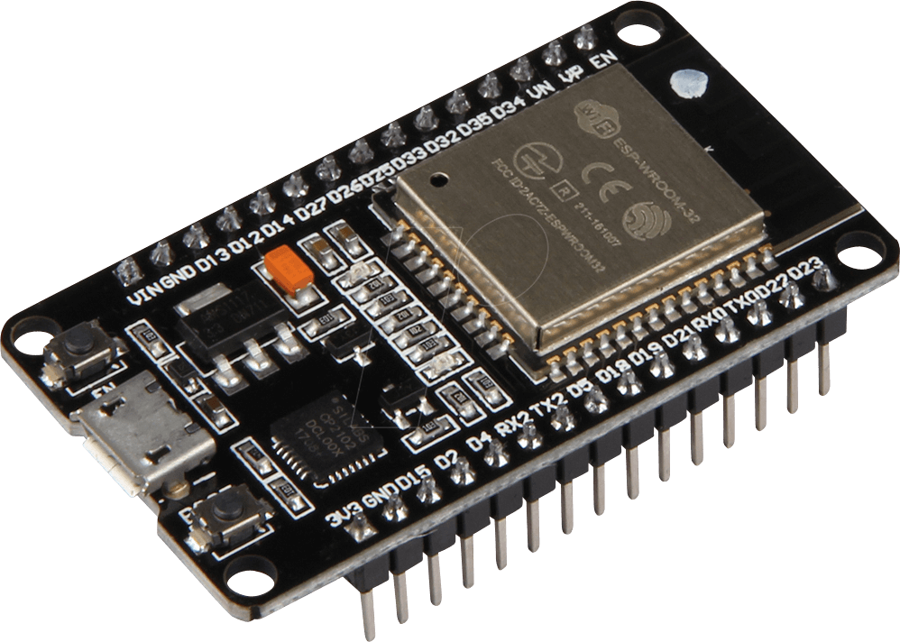2. *ESP Module (e.g., ESP8266 or ESP32)*: This provides the capability to connect to the internet and transmit data wirelessly. It allows your device to be part of an IoT network.  
  
3. *Microphone*: This is the sensor that captures audio data. It converts sound waves into electrical signals which are then processed by the Arduino.  
  
These components work together to monitor noise levels in the environment and send this data to a central server or platform for further analysis or visualization. This information can be used for various applications like noise pollution mapping, identifying high-noise areas, or even for regulatory compliance.

Website Overview:

The Website created using python django servers as the interface for viewing the noise levels. It receives the audio payload send from the arduino ,processes it to obtain decibel values and displays them in a user friendly format

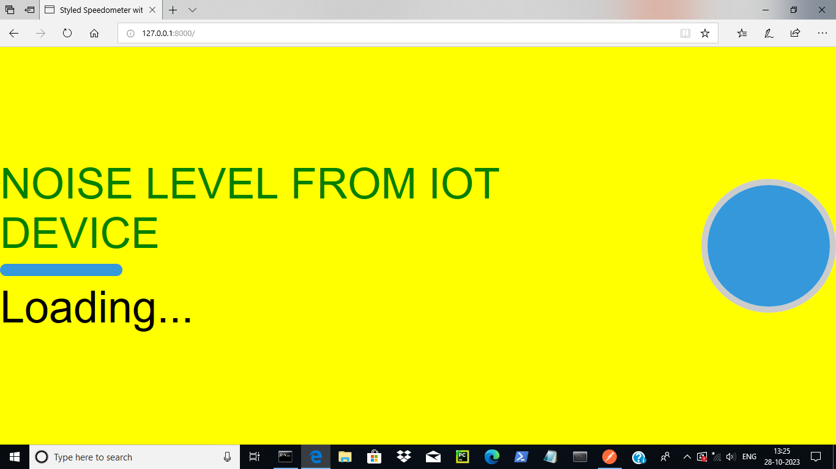

Website Interface

**Real-time Data Display: The website provides a dynamic dashboard that displays real-time noise level data in the form of graphical visualizations.**

**IoT Integration: The system is designed to seamlessly receive data from IoT devices using HTTP POST requests, making it a versatile platform for monitoring noise pollution across various environments**

**User-Friendly Interface: The website offers an intuitive and user-friendly interface, ensuring a seamless experience for both novice and experienced users**

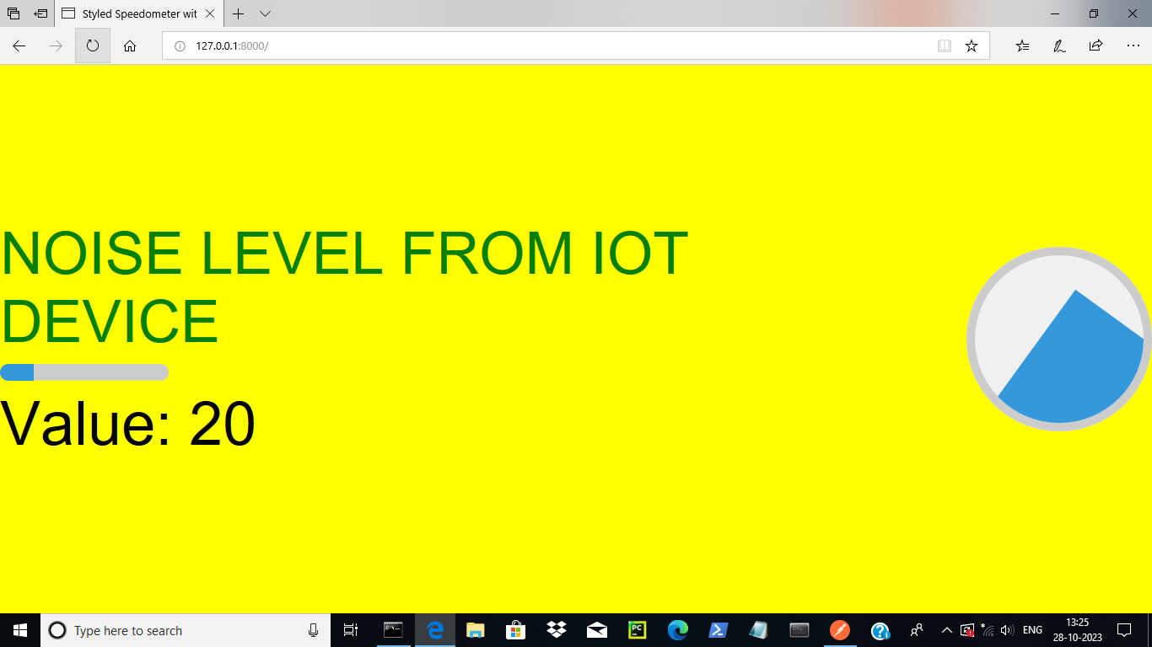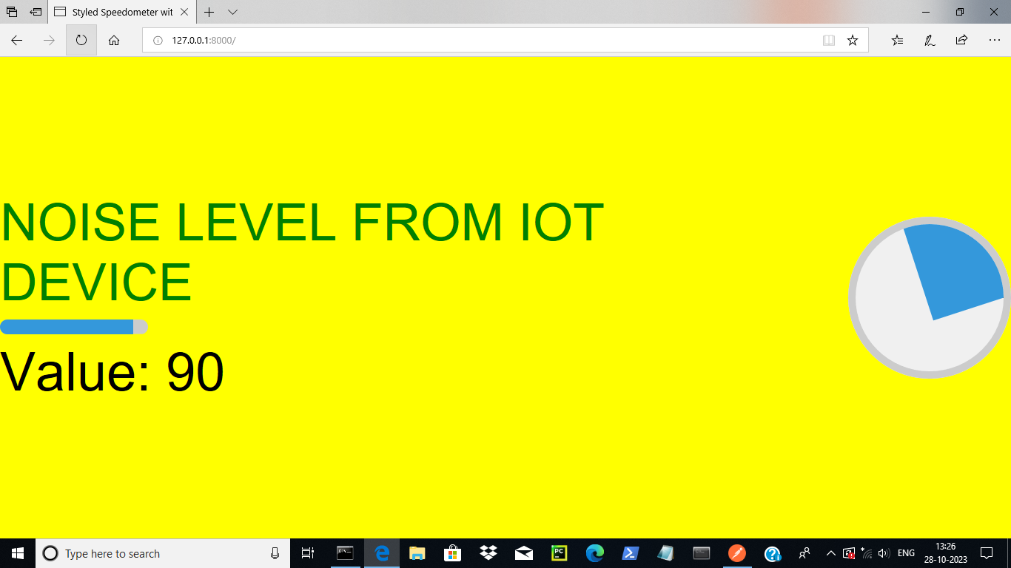

Django implementation

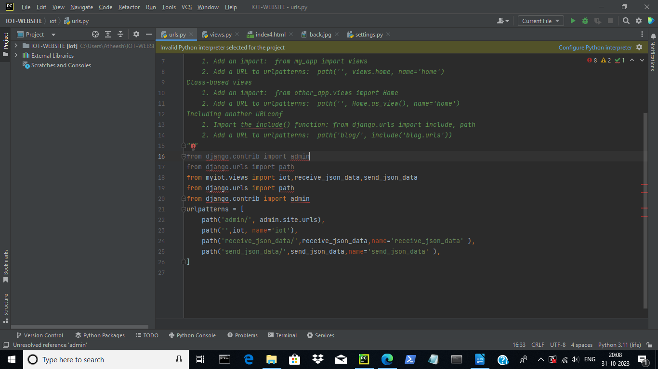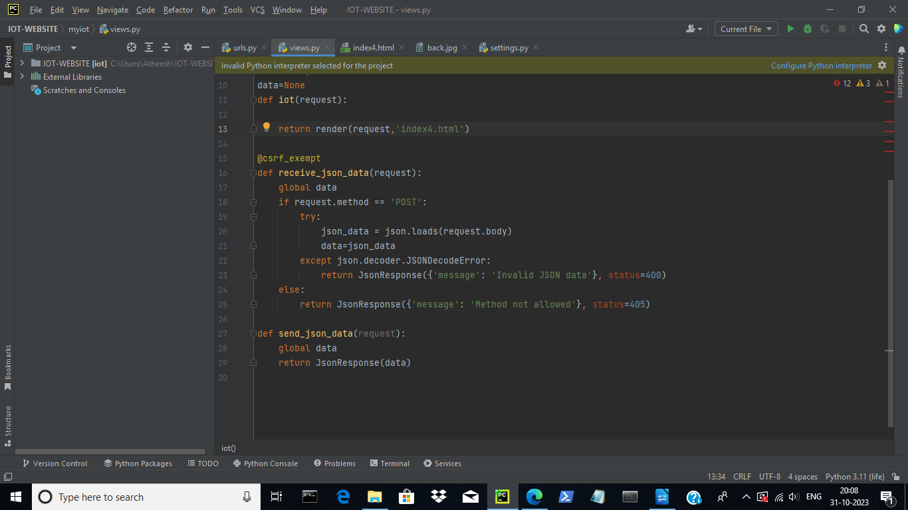

**App design :**

**The IoT Noise Pollution Monitoring Mobile App is a companion application developed using MIT App Inventor. This app serves as a convenient interface for users to access the IoT Noise Pollution Monitoring Website directly from their mobile devices. 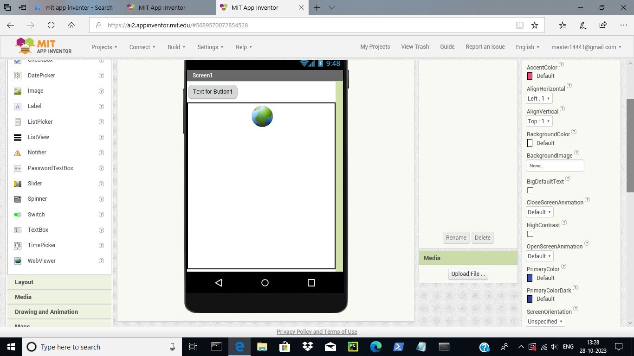Here's an overview of its key features**

**Webview Integration: The app utilizes a webview component to seamlessly display the IoT Noise Pollution Monitoring Website within the mobile application. This provides users with a familiar and accessible interface.**

**Cross-Platform Accessibility: The app is compatible with both Android and iOS platforms, ensuring a wide user base can easily access the monitoring website on their mobile devices.  
  
User-Friendly Navigation: The mobile app is designed with an intuitive navigation system, allowing users to browse the website's features and data with ease.  
  
Real-time Monitoring on-the-go: Users can conveniently monitor noise pollution levels from their mobile devices, enabling them to access critical information even while away from their computer.**