A Gamified Upper Limb Stroke Rehabilitation System with Remote Monitoring and Communication Features

Abstract - Stroke is one of the main causes of long term disability in adults. Most survivors are left with lasting problems in arm and hand movement that make daily tasks harder to perform. Standard rehabilitation depends on repeated, therapist led exercises, which patients often find hard to continue because they lose interest and cannot always reach a trained clinician outside major hospitals. This paper presents the design and current development status of a low cost, gamified upper limb rehabilitation system that combines a single channel forearm electromyography sensor, connected to a low power microcontroller, with camera based hand tracking. The sensor measures how strongly the forearm muscles are activated, while the camera identifies the position of the hand and wrist during therapeutic movements. A machine learning classifier reads the muscle signal to recognize muscle activity, and the detected hand and wrist gestures are used to control interactive rehabilitation games. A companion web based platform allows patients and physiotherapists to communicate through text and voice messages, and lets physiotherapists remotely monitor patient progress. By combining low cost muscle sensing, engaging games, and remote clinical support, the system aims to improve exercise adherence, provide clear progress data, and bring rehabilitation to patients outside the clinic.
Index Terms - Electromyography, gamification, gesture recognition, hand tracking, mediapipe, remote monitoring, serious games, stroke rehabilitation, telerehabilitation

INTRODUCTION
Stroke is one of the most common causes of long term disability in adults worldwide [1]. Most survivors are left with lasting problems in arm and hand movement, which make it harder to do activities of daily living (ADLs) such as eating, dressing, and washing.
Good recovery from stroke needs frequent, repeated, and task specific practice of movements, and this is hard to keep up using regular therapy alone [2]. Using sensors and game based technology for rehabilitation has shown promising results, because it can make therapy more engaging, easier to access, and easier to measure [3].
Because the hand and arm are involved in almost every self care and daily living task, from eating and dressing to writing and using a phone, even a partial loss of arm and hand function can affect a stroke survivor's independence more than difficulty walking alone, which can often be helped with a cane or a walker. This makes upper limb recovery one of the most important, and most difficult, goals of stroke rehabilitation.
In recent years, advances in low cost wearable sensors, embedded microcontrollers, webcam based computer vision, and machine learning have opened new ways to support this recovery outside the clinic. Electromyography (EMG) sensors pick up the electrical activity of a muscle even when visible movement is still very small, which makes them well suited to tracking effort in patients whose movement is limited [4]. Webcam based hand tracking, on the other hand, can show the position of the hand and fingers without any wearable device [5]. At the same time, wider use of telehealth, accelerated by the COVID-19 pandemic, has shown that clinicians can meaningfully support patients from a distance when the right tools are available [6].
Bringing these trends together, low cost muscle sensing, camera based hand tracking, and remote clinical support, motivates the system presented in this paper. Before describing the proposed solution, the specific problems with current rehabilitation approaches are described below.

Problem Description
The current stroke rehabilitation situation has several ongoing problems:
• Low patient motivation: Traditional rehabilitation programs repeat the same exercises again and again, so patients get bored and stop following their exercise plan [2], especially long term stroke patients who need to keep practicing for a long time. Once clinical supervision stops, many patients exercise less and less often.
• Limited access to specialized care: Patients living far from cities often cannot reach rehabilitation centers or trained therapists, which creates a serious gap in their care [7]. Long travel time and cost also stop patients from doing the frequent, short exercise sessions that work best for relearning movement.
• Separate, incomplete technology solutions: Many existing systems only do one thing, for example they track hand gestures or general arm movement, but do not combine game based engagement with clinician monitoring in one easy to use system [8], [9]. Patients and caregivers must then set up several different tools, which makes adoption less likely.
• No clear progress tracking: Regular therapy rarely gives clear, numeric progress data, so it is hard for clinicians to adjust treatment for each patient or track recovery in an organized way. Clinicians must depend on occasional in person checkups or on what the patient remembers to report.
• No combined remote supervision: Tele rehabilitation platforms already exist [7], [6], but few combine a real time game interface, muscle activity sensing, and full clinician monitoring and communication in one system. Patients often have to choose between an engaging home exercise tool and a clinically supervised one.
These problems show the need for one combined, low cost, and easy to set up rehabilitation system. This paper presents such a system, built around a single channel EMG sensor and a standard webcam. The EMG sensor was chosen because it is low cost, easy to wear, and directly measures the muscle activity behind hand and wrist movement. The webcam adds hand and wrist position information without extra wearable sensors, avoiding the setup and calibration that multi sensor motion tracking systems require.

Aim and Objectives
The aim of this project is to build a low cost rehabilitation game platform that recognizes therapeutic hand and wrist gestures from EMG and webcam data, uses them to control interactive games, and lets physiotherapists monitor and guide patients remotely. The specific objectives are:
1. To develop a hardware subsystem with sensors for the synchronous capture of hand kinematics and muscle activity.
2. To design and implement a feature extraction and classification algorithm to identify hand movements from the collected sensor data.
3. To analyze the accuracy of patient movements using Machine Learning algorithms on the classified movement data, and to develop multiple interactive video games for upper limb rehabilitation of stroke patients, with different gaming exercises.
4. To develop a secure web based platform that enables effective communication between physiotherapists and patients, allows them to monitor patient progress remotely, and provides personalized feedback to patients.

Current Status of the Work
To make clear which parts of this work are finished and which are planned, Table 1 summarizes the status of each component, and the Methodology and the Results and Discussion each begin every part with a status line that uses the labels Completed and Future work.
Table 1. Status of the work
Status | Components
Completed | Hardware system with battery powered ±9 V supply (except the enclosure and Wi-Fi data transmission); webcam hand position tracking; per-session EMG calibration; Balloon Pop and Car Control games; web application with messaging and dashboard; initial data collection from healthy volunteers
Future work | Hardware enclosure; Wi-Fi (UDP) wireless data transmission from the ESP32 to the laptop; automatic patient threshold calculation for the three game levels; Shape Placement game; integration of EMG and webcam signals for game control; collection of more volunteer data; data collection from stroke patients after ethics approval; training and comparison of machine learning models

Paper Organization
The rest of this paper is organized as follows. The Literature Review section reviews related work on wearable sensing, serious games, camera based hand tracking, gesture recognition, and tele rehabilitation. The Methodology section describes the system design, hardware, signal processing, classification, games, and web application. The Results and Discussion section presents the results obtained so far and discusses them, including the limitations of the current dataset. The Conclusion summarizes the paper and lists future work.

LITERATURE REVIEW

Wearable Sensing for Rehabilitation
Wearable sensors have greatly improved how movement is measured in rehabilitation. Inertial measurement units (IMUs) give detailed information about large arm movements [10], [7], while surface EMG sensors record the electrical signal from muscles, which can show a patient's movement intention even when voluntary movement is very limited [11]. A systematic review and meta analysis found that EMG based interventions can improve upper limb motor function after stroke, although evidence that they are better than conventional therapy of the same amount is still limited [4]. Low cost EMG systems have also been used at home: Tele-REINVENT used a portable EMG interface with games that reward wrist extension, guided by a therapist through video calls, in chronic stroke survivors [6], [12], and MyoGuide evaluated mobile EMG guided wrist extension training in subacute stroke patients [13]. Combining motion sensors with EMG can improve hand and wrist gesture recognition [11], but it adds cost, makes the device harder to wear, and needs extra calibration between sensors. This work therefore uses a single EMG sensor for muscle activity and a webcam, instead of an IMU, for hand position.

Serious Games for Rehabilitation
Serious games can make rehabilitation more engaging, and a meta analysis of randomized controlled trials found that they improved upper limb function after stroke more than conventional therapy [3]. Game based robotic systems have also combined motor and cognitive training [14]. Good serious games follow known rules of motor learning: practicing the right task, repeating it, giving feedback, and slowly increasing difficulty [15]. More recently, Ibrahim et al. combined Kinect based tracking, rehabilitation games, and EMG monitoring of upper limb muscles, but tested the system only with healthy participants [16].

Camera Based Hand Tracking
Camera based tracking can measure hand and wrist movement without any wearable device. MediaPipe Hands detects 21 hand landmarks in real time from a single RGB camera image [5]. Recent work has used MediaPipe for remote hand rehabilitation, where hand landmarks from a webcam or phone camera are classified with deep learning to give feedback during home exercises [17]. However, a camera alone cannot measure how strongly a muscle is activated, so it cannot tell a relaxed open hand from an actively opened hand, or a weak grip from a strong one. This is the main reason the proposed system combines webcam tracking with EMG.

Gesture and Movement Recognition Algorithms
Pattern recognition methods are important for reading sensor data and identifying movements. Time domain features such as mean absolute value and waveform length, combined with fast classifiers, are widely used for real time EMG control [18]. Linear Discriminant Analysis (LDA) and Support Vector Machines (SVM) are commonly used in real time EMG based systems because they are fast to compute and reliable [18]. Deep learning methods have also been used to classify arm movements from wearable sensors [19], but they usually need more training data and more computing power. A common problem is building a classifier that still works well when the electrode position, arm position, or user changes [18].

Tele Rehabilitation Systems
Tele rehabilitation systems help solve care problems caused by distance and limited clinical access. These systems usually combine a sensor, a way to send data, and a remote monitoring platform [7], [6]. Use of tele rehabilitation grew quickly during the COVID-19 pandemic, which showed both its potential and its current limits. Many existing systems, however, do not combine an interactive game interface, muscle activity sensing, and two way communication with the therapist in one platform. Table 2 compares representative systems with the proposed system.
Table 2. Comparison of related rehabilitation systems
Study | Sensing Modality | Serious Game | Remote Monitoring
Yin & Xu [10] | IMU | Yes | No
Jiang et al. [11] | EMG + IMU | No | No
Heins et al. [14] | Robotic device | Yes | Not reported
Lee et al. [7] | Wearable IMU | No | Yes
Marin-Pardo et al. [6] | EMG | Yes | Yes (video calls)
Ibrahim et al. [16] | Kinect + EMG | Yes | No
Dhuzuki et al. [17] | Camera (MediaPipe) | No | Yes
Proposed system | EMG + webcam (MediaPipe) | Yes | Yes

Research Gap and Positioning
Previous studies have used EMG biofeedback, serious games, camera based movement tracking, and remote supervision for upper limb stroke rehabilitation, but usually in separate systems. Systems that use several wearable sensor types together [10], [11] usually cost more and are harder to set up at home, while many serious game systems [14], [16] are tested without any way for a clinician to monitor progress remotely. There is limited evidence for a low cost system that combines forearm EMG and webcam based hand tracking to control rehabilitation games at progressive muscle activation levels, together with remote physiotherapist monitoring and communication. This work addresses that gap. When the combined system is complete, it will be evaluated by comparing EMG only, webcam only, and combined EMG and webcam control (Section X of the Methodology).

METHODOLOGY
The project is built in four phases that follow the four objectives: (1) hardware for EMG acquisition and webcam hand tracking, (2) signal processing and gesture classification, (3) rehabilitation games and movement analysis, and (4) a web application for communication and remote monitoring. Each subsection below starts with its status, using the labels Completed and Future work.

System Architecture
Completed: EMG acquisition path, webcam detection path, two games, and the web application, each working separately.
Future work: combining (fusing) the EMG and webcam data to control the games.
The system has four layers, shown in Fig. 1: an input layer (the patient performing hand and wrist exercises), a sensing layer (the EMG sensor with the ESP32, and the laptop webcam), a processing layer on the laptop (EMG feature extraction and classification, and MediaPipe hand tracking), and an application layer (the games and the web application used by patients and physiotherapists). In the final design, the EMG path tells the system how strongly the forearm muscles are activated, the webcam path tells it where the hand and wrist are, and a gesture is accepted by a game only when both agree. Parts drawn with dashed lines in Fig. 1 are future work.
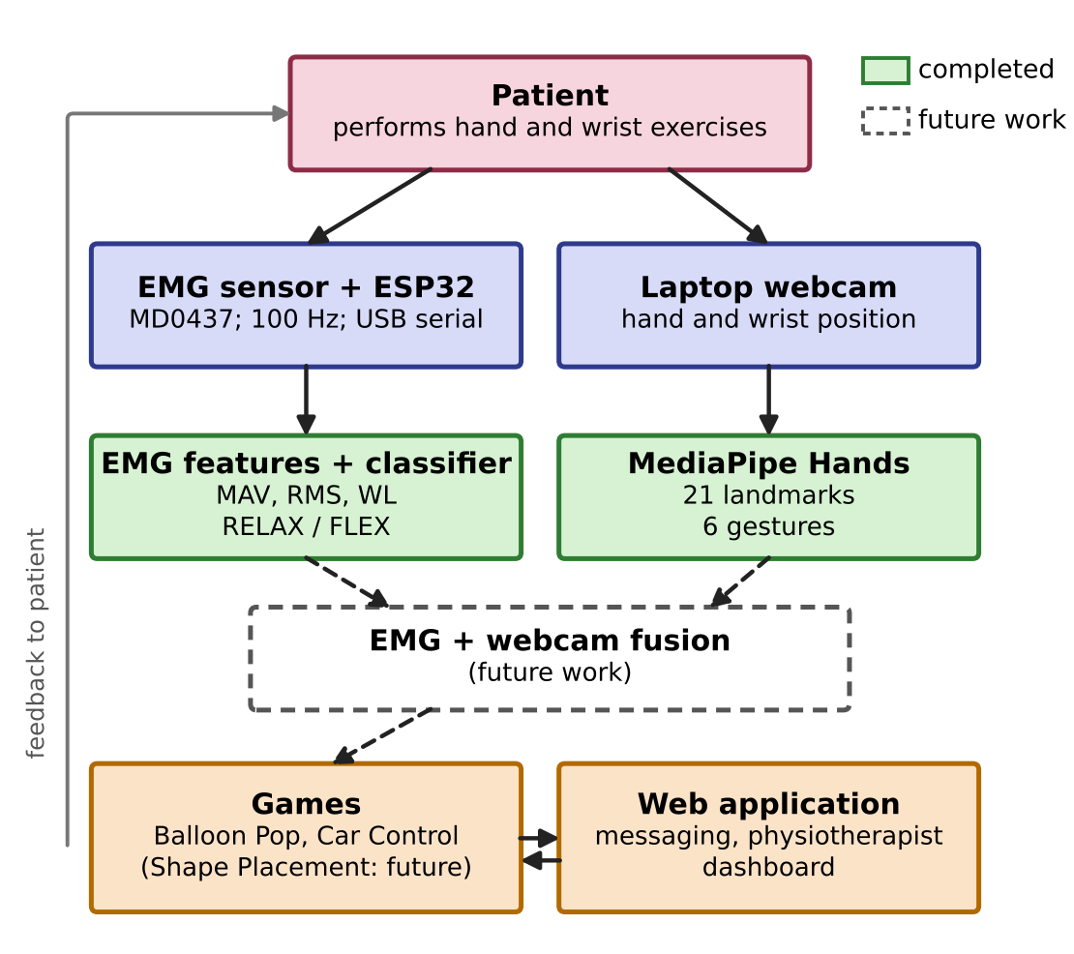
Fig. 1. System architecture (solid: completed; dashed: future work).

Hardware Implementation
Completed: EMG acquisition hardware with a battery powered ±9 V supply, and ESP32 firmware (Fig. 2, Table 3).
Future work: wireless data transmission from the ESP32 to the laptop over Wi-Fi (UDP).
• EMG sensor (MD0437): a single channel surface EMG module powered from a split ±9 V battery supply. The module amplifies the small muscle signal and converts it on board into a smoothed muscle activation envelope, so its output is a slowly changing analog voltage that rises with contraction strength. The module gain is adjustable.
• Electrodes: three disposable surface electrodes. The green (signal +) electrode is placed on the upper forearm over the muscle, the red (signal −) electrode 3–4 cm further along the same muscle towards the wrist, and the yellow (reference) electrode on the bony area near the elbow, where there is little muscle activity.
• ESP32 microcontroller: a 30-pin ESP32 development board with a USB Type-C port. The sensor output (SIG) is connected to GPIO34, an input only pin on ADC1, and the sensor ground is connected to the ESP32 ground. The ADC is set to 12-bit resolution (0–4095) with 11 dB attenuation, which gives the widest input range; the module gain is set so that the envelope stays within this range.
• Firmware: the ESP32 samples the sensor at 100 Hz using a timer based loop with a fixed 10 ms period and sends each sample to the laptop as a text line "timestamp (ms), ADC value" over USB serial at 921600 baud. Once per second, the firmware checks whether the ADC has read zero for more than 100 samples in a row (1 s) and, if so, sends a warning to check the sensor power and wiring.
• Power and communication: the EMG module is powered from its own split ±9 V battery supply. The ESP32 is powered from the laptop and sends the data to it through a USB Type-C cable (USB serial). Sending the data wirelessly over the built in Wi-Fi of the ESP32 using UDP, which would remove the USB data cable, has not yet been implemented and is future work.
Table 3. Hardware connections and settings
Item | Connection / setting
Electrodes | Green (+): upper forearm; red (−): 3–4 cm towards wrist; yellow (reference): near elbow
EMG module power | +Vs to +9 V, −Vs to −9 V, GND to the 0 V midpoint of the split battery supply
EMG module output | SIG to ESP32 GPIO34 (ADC1); module GND to ESP32 GND
ADC | 12-bit (0–4095), 11 dB attenuation, 100 Hz sampling (10 ms period)
ESP32 to laptop | USB Type-C, serial at 921600 baud; one line per sample: timestamp (ms), ADC value

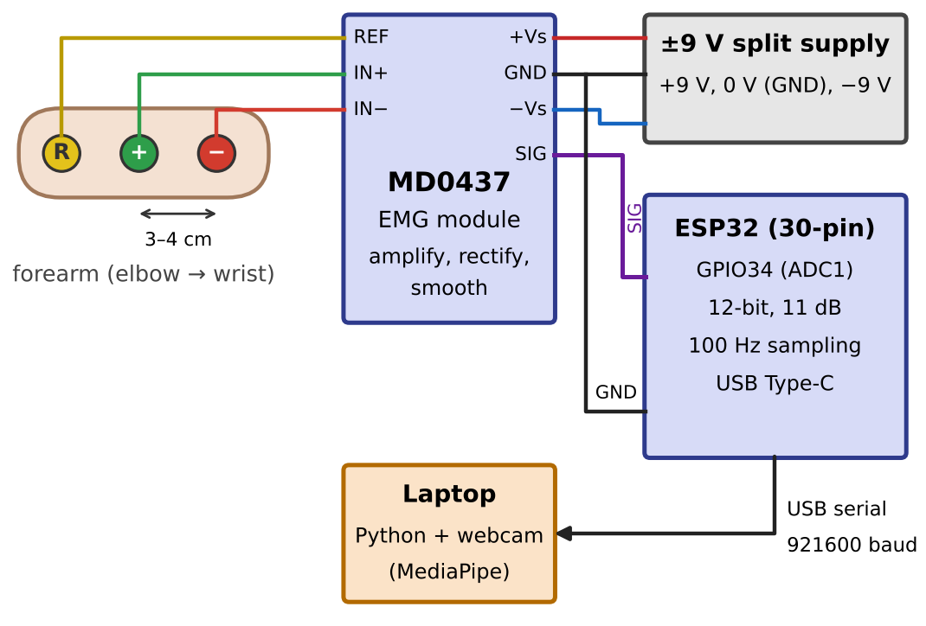
Fig. 2. Wiring diagram of the EMG acquisition hardware.

Visual Hand Detection
Completed: real time webcam detection of six hand and wrist gestures.
Future work: time synchronization and fusion with the EMG data, measurement of detection accuracy, and a learned hand gesture model (Section VI of the Methodology).
The laptop webcam captures the patient's hand, and each frame is processed with MediaPipe Hands, which returns 21 landmarks for the wrist, finger joints, and fingertips [5]. The landmarks are mapped to six gestures: Hand Open, Hand Close, Wrist Left, Wrist Right, Wrist Up, and Wrist Down. The steps are:
1) Capture a frame from the webcam and convert it to RGB.
2) Run MediaPipe Hands to obtain the 21 landmark coordinates. If no hand is found, no gesture is output.
3) Hand Open / Hand Close: for each finger, compare the fingertip position with the finger's middle joint relative to the wrist. If most fingers are extended the hand is Open; if most are folded it is Closed.
4) Wrist direction: compute the direction of the line from the wrist landmark to the base of the middle finger. If this direction moves beyond a set angle from the neutral position, the gesture is Wrist Left, Right, Up, or Down.
5) Output the detected gesture with a timestamp for use by the game.

EMG Signal Processing and Feature Extraction
Completed: windowing and feature extraction (Fig. 3, Table 4).
Because the MD0437 module performs amplification, rectification, and smoothing in hardware, no notch or band pass filter is needed; only one light software filter, shared by training and live use, is applied on the laptop. At a 100 Hz sampling rate, the highest frequency that can be represented is 50 Hz, so the raw EMG frequency band (about 20–450 Hz) is not sampled directly; the system works on the smoothed activation envelope instead, and all features below are computed on this envelope, not on raw EMG. On the laptop, the processing steps are:
1) Read each line from the serial port, ignore status lines that start with "#", and store the ESP32 timestamp (ms) and the ADC value.
2) Divide the signal into windows of N = 25 samples (250 ms) with about 50% overlap (a hop of about 125 ms), so that a new window is ready about every 125 ms.
3) For each window, compute the three features in Table 4 using (1)–(3), where xi is the i-th envelope sample (ADC value) in the window. The sums in (1) and (2) run from i = 1 to N, and the sum in (3) runs from i = 2 to N. Because the envelope is already rectified in hardware, the absolute value in (1) is kept only for completeness.
4) Form the feature vector [MAV, RMS, WL] and pass it to the classifier (Section V of the Methodology).
MAV = (1/N) Σ |xᵢ| (1)
RMS = √[(1/N) Σ xᵢ²] (2)
WL = Σ |xᵢ − xᵢ₋₁| (3)
Table 4. Extracted EMG features
Feature | Description
Mean Absolute Value (MAV) | Average absolute amplitude within each window; indicates the level of muscle activation.
Root Mean Square (RMS) | Quadratic mean of the signal; reflects contraction intensity.
Waveform Length (WL) | Total length of the waveform; shows how much the signal changes within the window.

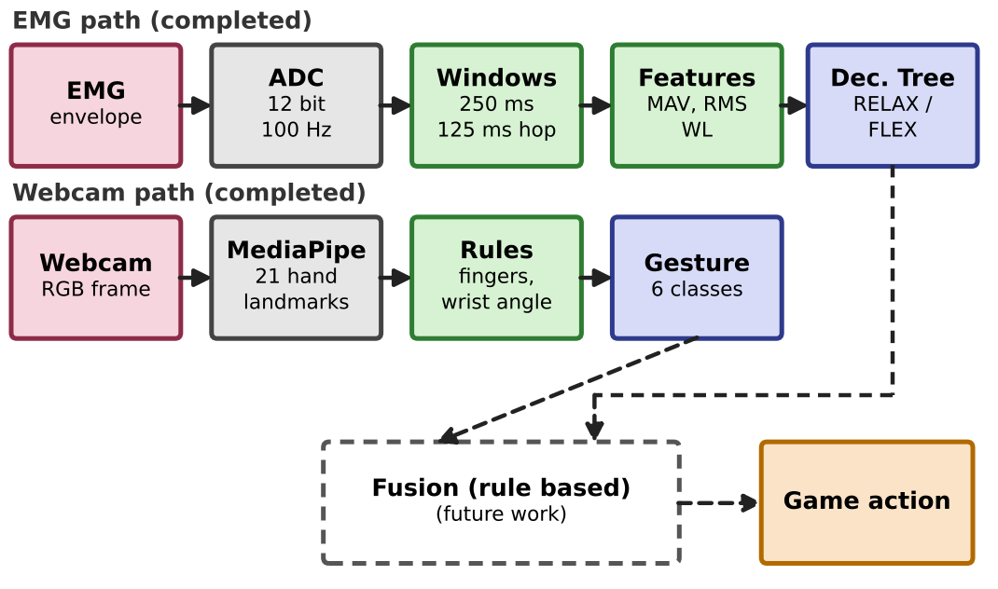
Fig. 3. EMG and webcam processing pipelines (dashed: future work).

Gesture Classification
Completed: binary EMG classifier (RELAX vs. FLEX) using a Decision Tree.
Future work: seven class gesture recognition using EMG and webcam data together, and selection of the final classifier.
At the current stage, the EMG classifier separates two classes: RELAX (no active muscle contraction) and FLEX (active forearm contraction, such as gripping). A Decision Tree was chosen for this first stage because it is simple to train and interpret and needs very little computing power. The tree is built with the CART algorithm (DecisionTreeClassifier in the scikit-learn Python library) as follows:
1) Start with all labeled training feature vectors at the root node.
2) For each feature (MAV, RMS, WL) and each candidate threshold, split the node into two groups and measure how mixed each group is using the Gini impurity (0 for a group with only one class, higher when the classes are mixed).
3) Choose the feature and threshold that give the lowest weighted Gini impurity of the two child nodes.
4) Repeat steps 2–3 for each child node until a node contains only one class or no split reduces the impurity.
5) To classify a new window, follow the tree from the root by comparing the window's features with the learned thresholds until a leaf is reached; the class of that leaf is the output.
In the final system, the target gesture set has seven classes, listed in Table 5. The webcam identifies the movement, and the EMG shows whether the muscle is at rest or actively contracting, and at what level. Rest and Hand Open look similar to the camera but differ in EMG activity, which is why both signals are needed. A single EMG channel alone cannot reliably separate the four wrist directions, because they use muscles on different sides of the forearm. The two signals will be combined by a rule based state machine (IDLE, HAND_ONLY, EMG_ONLY, HOLD, FIRE), which fires a game action only after both agree for a minimum hold time.
Table 5. Target gesture classes (future work)
Class | Detected by webcam | Expected EMG
Rest | Hand still, fingers relaxed | RELAX (baseline)
Hand Open | All fingers extended | FLEX (extensors)
Hand Close | Fist | FLEX (flexors)
Wrist Left | Wrist turned left | FLEX
Wrist Right | Wrist turned right | FLEX
Wrist Up | Wrist bent up | FLEX
Wrist Down | Wrist bent down | FLEX

Data Collection, Model Training, and Evaluation Metrics
Completed: per-session calibration, a preliminary dataset, and a binary Decision Tree model.
Future work: recording more sessions, tuned comparison of the candidate models, and a learned hand gesture model.
Data are collected from the authors and healthy adult volunteers who gave informed consent. After the session calibration (Section VII of the Methodology), each participant, with the forearm resting on a table, repeats each gesture with rest in between, and every 250 ms window is labeled from the on-screen cue. Four to five sessions (a few thousand windows) have been recorded so far. The preliminary Decision Tree was tested on 31 held-out trials (14 RELAX, 17 FLEX); this dataset is small and has no stroke patients, so collection continues.
The EMG model classifies each window as REST or FLEX from MAV, RMS, and WL. The candidates are an RMS threshold from calibration (baseline), LDA, SVM with an RBF kernel, and Random Forest, with the Decision Tree kept for comparison. A future hand model will classify OPEN, CLOSED, or NONE from the 63 normalised MediaPipe landmark values, with the current rules as its baseline.
Because overlapping windows are near-duplicates, data are split by session, never by window, and scaling is fitted on the training sessions only. Models are tested leave-one-session-out; when tuned, an inner cross-validation on the training sessions picks settings from small ranges (LDA shrinkage, SVM C and gamma, Random Forest size and depth), and tuned settings are kept only if they clearly beat the defaults. Since a false FLEX at rest is worse than a missed one, the decision threshold is set to keep false FLEX at rest below 1%.
Accuracy, precision, recall, and F1-score are calculated from the confusion matrix, per class and as macro averages, together with per-session accuracy, inference time per window, and the false FLEX rate at rest. The model with the best macro F1-score is chosen, preferring the simpler model when results are close. For Objective 3, an attempt is successful when the gesture matches the target and the EMG reaches the required level, and movement accuracy (MA) is calculated using (4), where S is the number of successful attempts and T the total number of attempts.
MA = (S / T) × 100% (4)

Game Development
Completed: Balloon Pop and Car Control games, each at a single difficulty level.
Future work: Shape Placement game, three difficulty levels based on the calibration values, rewards, and control using combined EMG and webcam input.
The games are built in a game engine. Their design follows the motor learning principles described in Section II of the Literature Review: gestures should match game actions naturally, feedback (sound and visuals) should be immediate, and difficulty should increase gradually. Table 6 summarizes the games.
• Balloon Pop (hand opening and closing, completed): the patient closes the fist to pop balloons on the screen. In the final design, a balloon pops only when both the hand position (webcam) and the muscle activation (EMG) are correct. This targets grip and the control of hand opening and closing, which are needed for holding and releasing objects.
• Car Control (wrist movement and fist control, completed): the patient moves the wrist right or left to steer a car along a road and closes the fist to brake. This targets wrist control and the coordination of wrist and hand movements.
• Shape Placement (thumb to finger touching, future work): the patient picks up shapes and places them in the correct positions. Each shape is linked to a finger movement, for example thumb to index finger for a triangle and thumb to middle finger for a square. Because a single EMG channel cannot tell which finger is used, the finger will be identified from the webcam landmarks and the EMG will confirm the effort. This targets fine finger movements needed for holding a pen or spoon and buttoning clothes.
Calibration (completed) and levels (future work): at the start of each session, the system records EMG at rest and at maximum effort (about 10 s) and calculates a personal threshold and rest noise level. In future, the required muscle activation will be set low at Level 1, medium at Level 2, and high at Level 3, relative to this calibration, and a reward will be given after each level. Here, a higher level means higher muscle activation measured by EMG, which is related to, but not the same as, muscle force.
Table 6. Games, gestures, and planned levels
Game | Gesture → goal | Planned levels 1–3 | Status
Balloon Pop | Hand open/close → grip and release | Higher activation needed, longer time allowed | Done (1 level)
Car Control | Wrist left/right, fist → wrist control | Faster car, more complex road | Done (1 level)
Shape Placement | Thumb to finger → fine finger control | More shapes and fingers, higher activation | Future

Web Application
Completed: web application with login, patient and physiotherapist roles, voice and text messaging, and a progress dashboard.
Future work: storing calibration results and EMG–webcam session data, and evaluation with users.
The web application is built with React.js for the frontend and Node.js for the backend, and it is used by both patients and physiotherapists. After logging in, the user has three main options. Games: the patient selects and plays an exercise game. Communication: the patient and physiotherapist exchange text and voice messages. Dashboard: the physiotherapist can see which game the patient played, for how long, how accurately, whether the daily exercise was completed, and progress graphs over time.

Security and Data Privacy
Completed: login based access with separate patient and physiotherapist roles.
Future work: full security hardening and review before any clinical use.
Because the platform stores personal health information, access is controlled by login, and patient and physiotherapist accounts see different views. Before clinical use, data sent between the device, the games, and the web application will be encrypted, stored data will be protected, access will be restricted so that physiotherapists see only their assigned patients, and the design will be reviewed against local health data laws.

Evaluation Plan
Future work: all stages below.
The complete platform will be evaluated in three stages. In the first stage, five to ten healthy volunteers will use the system to measure webcam gesture detection accuracy, classification performance with the metrics in Section VI of the Methodology, game control accuracy using (4), and end to end latency from muscle activation to on screen response. EMG only, webcam only, and combined control will be compared. In the second stage, a short usability study with physiotherapists and patients will combine a standard usability questionnaire with structured interviews. In the third stage, subject to ethics approval, a small pilot with stroke patients will assess whether the games are well tolerated, whether adherence improves compared with unsupervised home exercise, and whether the dashboard gives clinically useful information.

RESULTS AND DISCUSSION
Completed: preliminary EMG classification results (Section I of the Results and Discussion) and implementation of the hardware, webcam detection, two games, and web application (Section II of the Results and Discussion).
Future work: quantitative evaluation of the combined system, latency, and usability (Section X of the Methodology).

Preliminary Classification Performance
The binary Decision Tree classifier was tested on 31 trials (14 RELAX, 17 FLEX) and classified 26 of them correctly, giving an overall accuracy of 83.9% (95% Wilson confidence interval: 67.4%–92.9%) and a Cohen's kappa of 0.67. Table 7 shows the per class precision, recall, and F1-score, and Fig. 4 shows the confusion matrix. FLEX trials were recognized well (recall 94.1%, 16 of 17), while 4 of the 14 RELAX trials were wrongly classified as FLEX (recall 71.4%). This suggests that some rest windows still contained enough muscle activity or noise to cross the learned threshold, and using the per-session rest calibration in the classifier is expected to reduce these errors. The wide confidence interval shows that 31 trials are not enough for a precise estimate, so this result should be read as a first feasibility check only.
Table 7. Classification performance (RELAX vs. FLEX, Decision Tree, 31 test trials)
Class | Precision | Recall | F1-score
RELAX (n = 14) | 90.9% | 71.4% | 80.0%
FLEX (n = 17) | 80.0% | 94.1% | 86.5%
Macro average | 85.5% | 82.8% | 83.2%

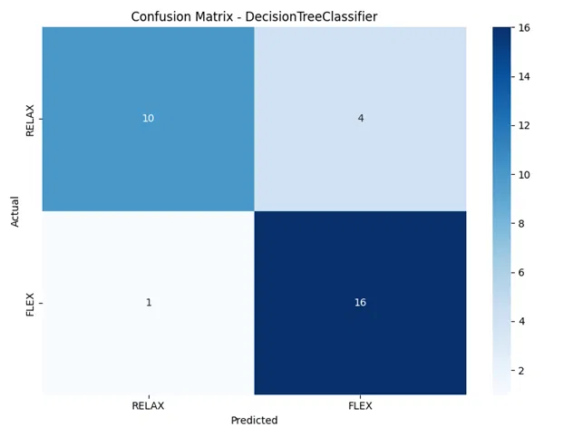
Fig. 4. Confusion matrix for the RELAX vs. FLEX Decision Tree classifier.

Implemented System Components
The following parts have been implemented and checked by the authors to work individually: the battery powered EMG sensor and the ESP32 stream timestamped EMG samples to the laptop over USB at 100 Hz; the webcam module detects the six hand and wrist gestures in real time; the Balloon Pop and Car Control games run at a single difficulty level; and the web application supports login, voice and text messaging, and the physiotherapist dashboard. These were functional checks only. Quantitative evaluation of webcam detection accuracy, game performance, and usability has not yet been carried out and is future work.

System Responsiveness
End to end latency, from muscle activation to the in game response, has not yet been measured and is future work. By design, the EMG path samples every 10 ms and produces a new classification about every 125 ms from the most recent 250 ms of data.

Discussion
An important design choice in this project is to use one EMG channel for muscle activation and a webcam for hand position, instead of combined IMU and multi channel EMG sensing. This keeps the hardware low cost (estimated at around LKR 14,000 in the project proposal), makes the device easier to wear, and removes the extra calibration needed for inertial sensors, which matters for home use in low resource settings. The trade off is that the 100 Hz envelope from a single channel carries only amplitude information, so EMG alone can show how strongly the muscle works but not which movement is made; this is why the webcam is used to identify the movement. The webcam, in turn, depends on lighting and camera angle, and these effects still need to be measured.

Comparison with Related Work
Multi channel EMG pattern recognition systems have reported high accuracy for several hand and wrist motions under controlled conditions [11]. The present 83.9% is lower even though only two classes are separated, but it was obtained with a single low cost channel, a 100 Hz envelope signal, and a small dataset, so a direct comparison is not fair. Systems that combine camera tracking with EMG, such as [16], also use EMG mainly to monitor muscle activity rather than to identify the gesture, which is the same role EMG plays in the proposed design. A fair comparison with these systems will be possible only after the combined system has been evaluated on a larger dataset.

Limitations
Small dataset: the most important limitation is that the classifier was tested on only 31 trials from the authors and a small number of healthy volunteers. The wide confidence interval (67.4%–92.9%) shows that the accuracy is uncertain, and the result may not generalize to other users or to stroke patients, none of whom have yet been tested. Data collection is continuing, and future work will increase the number of participants and repetitions, use leave-one-subject-out testing, and include stroke patients after ethics approval.
Other limitations: the EMG classifier currently separates only two classes; the EMG and webcam data are not yet combined; the games run at a single level and do not yet use the calibration values; the accuracy of webcam gesture detection has not yet been measured; and the data link of the current prototype is still a USB cable, because Wi-Fi transmission is not yet implemented.

CONCLUSION
This paper presented a low cost, gamified upper limb stroke rehabilitation system that combines a single channel EMG sensor with webcam based hand tracking, rehabilitation games, and a web application for remote physiotherapist support.
Completed: EMG acquisition hardware with a battery powered ±9 V supply (MD0437 sensor and ESP32 at 100 Hz); webcam detection of six hand and wrist gestures; per-session EMG calibration; a binary RELAX/FLEX Decision Tree classifier with 83.9% accuracy on a small preliminary test set of 31 trials; the Balloon Pop and Car Control games at a single level; and the web application with messaging and a progress dashboard.
Future work: Wi-Fi (UDP) wireless data transmission from the ESP32, combining EMG and webcam data for game control, three activation levels based on the calibration, the Shape Placement game, and evaluation on a larger dataset and with stroke patients.
These results show that the main parts of the system can be built with low cost hardware, but they do not yet show clinical benefit. The modular design allows each remaining part to be developed and tested separately before integration into the final platform.

Future Work
• Collect a larger dataset with more participants and repetitions, and compare an RMS threshold, LDA, SVM, Random Forest, and Decision Tree using leave-one-session-out testing with nested tuning, and test the model on stroke patients after ethics approval.
• Synchronize the EMG and webcam data using timestamps, and combine them to recognize the seven gesture classes in Table 5.
• Use the calibration values to set three activation levels, add rewards to the games, and complete the Shape Placement game.
• Add Wi-Fi (UDP) wireless data transmission from the ESP32 to the laptop, building on the battery powered hardware, and strengthen the security of the web application.
• Carry out the three stage evaluation in Section X of the Methodology, including a pilot study with stroke patients after ethics approval.
Ethical Approval
Data for this study were collected from the authors and healthy adult volunteers, who took part voluntarily and gave informed consent before data collection. No stroke patient data are used in this paper. Formal ethics committee approval has not yet been obtained, and data collection from stroke patients is future work that will start only after approval.
Conflict of Interest
The authors declare no conflict of interest.

REFERENCES
[1] GBD 2021 Stroke Risk Factor Collaborators, “Global, regional, and national burden of stroke and its risk factors, 1990–2021: A systematic analysis for the Global Burden of Disease Study 2021,” Lancet Neurol., vol. 23, no. 10, pp. 973–1003, 2024.
[2] C. Winstein and R. Varghese, “Been there, done that, so what’s next for arm and hand rehabilitation in stroke?” NeuroRehabilitation, vol. 43, no. 1, pp. 3–18, 2018.
[3] I. Doumas, G. Everard, S. Dehem, and T. Lejeune, “Serious games for upper limb rehabilitation after stroke: A meta-analysis,” J. NeuroEng. Rehabil., vol. 18, no. 1, Art. no. 100, 2021.
[4] M. Munoz-Novoa, M. B. Kristoffersen, K. S. Sunnerhagen, A. Naber, M. Alt Murphy, and M. Ortiz-Catalan, “Upper limb stroke rehabilitation using surface electromyography: A systematic review and meta-analysis,” Front. Hum. Neurosci., vol. 16, Art. no. 897870, 2022.
[5] F. Zhang, V. Bazarevsky, A. Vakunov, A. Tkachenka, G. Sung, C.-L. Chang, and M. Grundmann, “MediaPipe Hands: On-device real-time hand tracking,” arXiv preprint arXiv:2006.10214, 2020.
[6] O. Marin-Pardo, C. Phanord, M. R. Donnelly, C. M. Laine, and S.-L. Liew, “Development of a low-cost, modular muscle–computer interface for at-home telerehabilitation for chronic stroke,” Sensors, vol. 21, no. 5, Art. no. 1806, 2021.
[7] S. I. Lee et al., “Enabling stroke rehabilitation in home and community settings: A wearable sensor-based approach for upper-limb motor training,” IEEE J. Transl. Eng. Health Med., vol. 6, pp. 1–11, 2018.
[8] D. K. Zondervan et al., “Home-based hand rehabilitation after chronic stroke: Randomized, controlled single-blind trial comparing the MusicGlove with a conventional exercise program,” J. Rehabil. Res. Dev., vol. 53, no. 4, pp. 457–472, 2016.
[9] X. Song, L. Ding, J. Zhao, J. Jia, and P. B. Shull, “Cellphone augmented reality game-based rehabilitation for improving motor function and mental state after stroke,” in Proc. IEEE 16th Int. Conf. Wearable Implant. Body Sensor Netw. (BSN), 2019, pp. 1–4.
[10] Z.-X. Yin and H.-M. Xu, “A wearable rehabilitation game controller using IMU sensor,” in Proc. IEEE Int. Conf. Appl. Syst. Invention (ICASI), 2018, pp. 1060–1062.
[11] S. Jiang et al., “Feasibility of wrist-worn, real-time hand, and surface gesture recognition via sEMG and IMU sensing,” IEEE Trans. Ind. Informat., vol. 14, no. 8, pp. 3376–3385, 2018.
[12] O. Marin-Pardo, M. R. Donnelly, C. S. Phanord, K. Wong, J. Pan, and S.-L. Liew, “Functional and neuromuscular changes induced via a low-cost, muscle–computer interface for telerehabilitation: A feasibility study in chronic stroke,” Front. Neuroergon., vol. 3, Art. no. 1046695, 2022.
[13] H.-P. Lin et al., “A usability study on mobile EMG-guided wrist extension training in subacute stroke patients—MyoGuide,” J. NeuroEng. Rehabil., vol. 21, no. 1, Art. no. 39, 2024.
[14] S. Heins et al., “Robotic-assisted serious game for motor and cognitive post-stroke rehabilitation,” in Proc. IEEE 5th Int. Conf. Serious Games Appl. Health (SeGAH), 2017, pp. 1–8.
[15] X. Song, S. S. van de Ven, L. Liu, F. J. Wouda, H. Wang, and P. B. Shull, “Activities of daily living-based rehabilitation system for arm and hand motor function retraining after stroke,” IEEE Trans. Neural Syst. Rehabil. Eng., vol. 30, pp. 621–631, 2022.
[16] Z. Ibrahim, B. N. Cahyadi, A. Aziz, and A. Shamil, “Enhancing upper limb stroke rehabilitation with electromyography-monitored virtual reality-based games,” J. Robot., vol. 2024, Art. no. 8945325, 2024.
[17] N. H. Mohd Dhuzuki et al., “Design and implementation of a deep learning-based hand gesture recognition system for rehabilitation Internet-of-Things (RIoT) environments using MediaPipe,” IIUM Eng. J., vol. 26, no. 1, pp. 353–372, 2025.
[18] Y. Geng, O. W. Samuel, Y. Wei, and G. Li, “Improving the robustness of real-time myoelectric pattern recognition against arm position changes in transradial amputees,” BioMed Res. Int., vol. 2017, pp. 1–10, 2017.
[19] M. Panwar et al., “Rehab-Net: Deep learning framework for arm movement classification using wearable sensors for stroke rehabilitation,” IEEE Trans. Biomed. Eng., vol. 66, no. 11, pp. 3026–3037, 2019.

