A Gamified Upper Limb Stroke Rehabilitation System with Remote Monitoring and Communication Features
M. Imzan¹*, M. Atheeq¹, D. Karunakalage², V. Herath¹
¹Department of Electronics & Telecommunication, Faculty of Engineering, Sri Lanka Technology Campus, Padukka 10500, Sri Lanka
²Department of Electrical Engineering, Faculty of Engineering, Sri Lanka Technology Campus, Padukka 10500, Sri Lanka
¹22ug2-0072@sltc.ac.lk*, ¹22ug2-0237@sltc.ac.lk, ²dulashik@sltc.ac.lk, ¹vihanga.h@sltc.ac.lk

Abstract - After a stroke, many people are left with lasting weakness in the arm and hand. Recovery needs a great deal of repeated practice, which is hard to keep up at home. This paper presents a low cost, game based upper limb rehabilitation system that combines hand tracking from an ordinary webcam with a single channel forearm electromyography sensor read by an ESP32 microcontroller. MediaPipe hand landmarks are turned into seven hand and wrist movements, which control four games that give rewards and adjust their difficulty to the patient. The muscle activity measured by electromyography is attached to every game command. All sessions are saved on the computer and can be reviewed by a physiotherapist in a web application. Movement recognition from electromyography alone was also tested offline on nine healthy volunteers, with each volunteer left out of training in turn. With seven movements, the chance level is 14.3%. A support vector machine on 200 millisecond windows reached 37.2% accuracy, longer 5.12 second windows raised this to 47.3%, and features from the frozen MOMENT-1 time-series foundation model with a random forest gave the best result of 48.1%. Rest, hand opening and hand closing were recognized much better than wrist directions. This supports a design in which the camera decides each movement and electromyography gives feedback on muscle activity.
Keywords - Electromyography, hand tracking, serious games, time-series foundation models

I. Introduction
Stroke is one of the leading causes of long term disability in adults around the world [1]. Many survivors live with lasting problems in arm and hand movement, which make everyday activities such as eating, dressing and washing more difficult. Recovery depends on frequent, repeated practice of specific tasks, and this is hard to achieve through regular therapy sessions alone [2]. Rehabilitation that uses sensors and games can make therapy more engaging, easier to access and easier to measure [3]. Electromyography (EMG) sensors pick up muscle activity even when the visible movement is very small [4], while webcam based hand tracking can locate the hand and fingers without any wearable device [5].
Current rehabilitation practice faces several problems. Patients get bored when they repeat the same exercises, so many stop practicing once supervision ends [2]. People who live far from cities often cannot reach a trained therapist [6]. Many technical solutions also cover only one part of the problem, such as tracking hand gestures, and do not link game based exercise with monitoring by a clinician [7], [8]. In addition, regular therapy rarely produces numerical progress data that a clinician can follow between visits. Tele rehabilitation platforms do exist [6], [9], but few of them bring a real time game interface, muscle activity sensing and clinical monitoring together in one low cost system.
This work aims to build a low cost rehabilitation game platform that recognizes therapeutic hand and wrist movements from webcam and EMG data, uses these movements to control interactive games, and allows physiotherapists to monitor their patients. The objectives are as follows:
- To build hardware that captures hand movement and muscle activity at the same time.
- To design feature extraction and classification methods that identify hand movements from the sensor data.
- To develop interactive rehabilitation games and measure how accurately patients perform the movements.
- To develop a web platform through which physiotherapists can monitor progress and communicate with patients.
Table 1 shows which parts of the work are complete and which remain as future work. The rest of the paper is organized as follows. Section II reviews related work, Section III describes the system and the experiments, Section IV presents and discusses the results, and Section V concludes the paper.

II. Literature Review

A. Wearable Sensing and Serious Games
Inertial measurement units (IMUs) capture large arm movements well [6], [10], while surface EMG records muscle activity and can reveal an intention to move even when voluntary movement is very limited [11]. A meta analysis found that EMG based interventions can improve upper limb function after stroke, although there is limited evidence that they work better than the same amount of conventional therapy [4]. Low cost EMG systems have also been used at home. Tele-REINVENT rewarded wrist extension in games, with a therapist guiding the patient over video calls [9], [12], and MyoGuide evaluated mobile, EMG guided wrist training in subacute stroke [13]. Adding IMUs to EMG improves gesture recognition [11], but it also adds cost and calibration effort. A meta analysis of randomized trials showed that serious games improved upper limb function more than conventional therapy [3]. Robotic games have combined motor and cognitive training [14], and well designed games follow the motor learning principles of task specific repetition, feedback and gradually increasing difficulty [15]. Ibrahim et al. combined Kinect tracking, games and EMG monitoring, but tested their system only on healthy participants [16].
Table 1. Status of the work
Status | Components
Completed | Battery powered EMG hardware and ESP32 firmware with a USB serial link; webcam detection of seven movements; fusion of camera labels with EMG features; four games with rewards and adaptive difficulty; local server, database and offline queue; physiotherapist web application; EMG dataset from nine healthy volunteers; offline comparison of classical and foundation model classifiers; 47 automated tests
Future work | Enclosure and Wi-Fi transmission; patient login, text and voice messaging between patients and physiotherapists, and remote access; use of EMG activity levels in game control; measurement of webcam accuracy, latency and usability; stroke patient data after ethics approval

B. Hand Tracking and Movement Recognition
MediaPipe Hands finds 21 hand landmarks in real time using a single RGB camera [5], and it has been used in remote hand rehabilitation together with deep learning feedback [17]. However, a camera cannot measure how strongly a muscle is working. For EMG, real time control usually relies on time domain features, such as mean absolute value and waveform length, combined with Linear Discriminant Analysis (LDA) or Support Vector Machines (SVM) [18]. Random forests cope well with features on different scales [19], while deep networks need more data and more computing power [20]. Classifiers also tend to fail when the electrode position, the arm position or the user changes [18].

C. Time-Series Foundation Models
MOMENT is a family of open transformer models that were pre-trained on a large collection of public time series, and it classifies inputs with a fixed length of 512 steps [21]. The model can be used frozen, with a separate classifier trained on its embeddings, or it can be fine-tuned with low-rank adaptation (LoRA), which trains small matrices added to the attention layers [22]. MOMENT normalizes each window with reversible instance normalization (RevIN) [23], which removes the mean and scale of the window. For an EMG envelope, where the activity level is what separates the movements, this step may throw away useful information. Public EMG datasets such as UCI EMG Data for Gestures [24] could provide extra training data, but they were recorded with different sensors.

D. Tele Rehabilitation and Research Gap
Tele rehabilitation systems combine a sensor, a data link and a remote monitoring platform [6], [9]. However, few of them bring together games, muscle sensing and two way communication with the therapist (Table 2). Systems with several sensors [10], [11] cost more and are harder to set up at home, and many game based systems [14], [16] provide no clinical monitoring. There is also little evidence on how much movement information a single low cost EMG envelope channel carries, or on whether foundation models help with datasets this small. This work addresses both of these questions.
Table 2. Comparison of related rehabilitation systems
Study | Sensing | Game | Monitoring
Yin & Xu [10] | IMU | Yes | No
Jiang et al. [11] | EMG + IMU | No | No
Heins et al. [14] | Robotic device | Yes | Not reported
Lee et al. [6] | Wearable IMU | No | Yes
Marin-Pardo et al. [9] | EMG | Yes | Video calls
Ibrahim et al. [16] | Kinect + EMG | Yes | No
Dhuzuki et al. [17] | Camera | No | Yes
Proposed | Webcam + EMG | Yes | Clinic dashboard

III. Methodology

A. System Architecture
The system is organized in four layers (Fig. 1). The sensing layer contains the EMG sensor with its ESP32 and the webcam. The processing layer holds the EMG and vision pipelines and a fusion engine. The application layer runs the four games, and the data and monitoring layer contains a local application programming interface (API), a database and the web application. All parts run on one laptop. The game process uses three threads. The EMG thread reads the serial port, the vision thread processes every camera frame, and the fusion thread combines the latest camera label and EMG features into one command every 50 ms. These commands go to the game loop, which runs at 30 frames per second. A FastAPI server with an SQLite database stores patients, sessions and attempts. It also serves the web application, from which the games are started and stopped. If a session ends while the server is not running, it is kept in an offline queue and uploaded later.
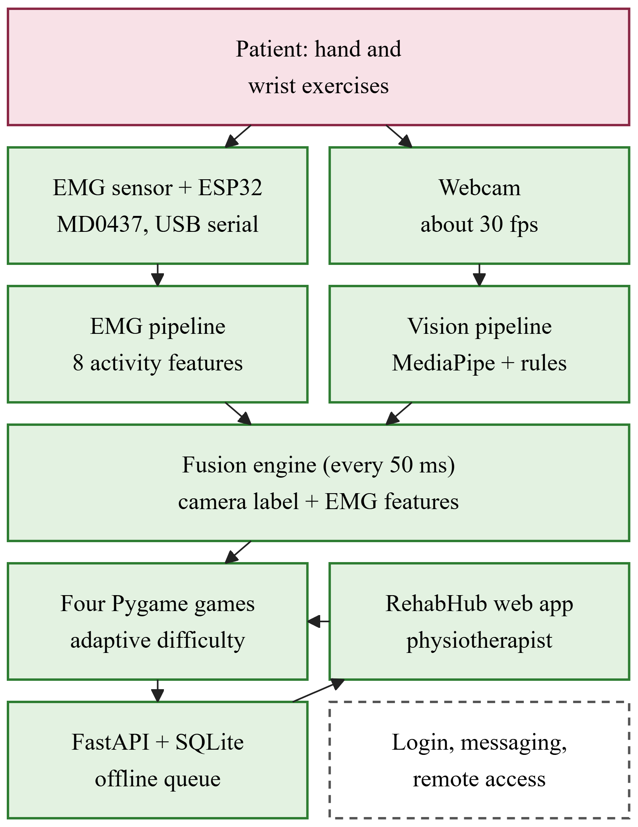
Fig. 1. System architecture (green: completed; dashed: future work)

B. Hardware
Fig. 2 shows the data acquisition hardware. The MD0437 is a single channel surface EMG module that amplifies, rectifies and smooths the muscle signal on the board itself, so its output is an activity envelope rather than raw EMG. The module runs on a split ±9 V battery supply and is never connected to mains power while it is worn. Three disposable Ag/AgCl electrodes are used. The positive signal electrode sits on the upper forearm muscle, the negative electrode sits 3–4 cm closer to the wrist, and the reference electrode is placed on the bony area near the elbow. A 30-pin ESP32 reads the module output on GPIO34 (ADC1) with 12-bit resolution (0–4095) and 11 dB attenuation. Each sample is sent to the laptop over USB serial at 921600 baud as a line of the form “timestamp (ms), ADC value”. The dataset described in Section III-F was recorded at 100 Hz, while the current firmware samples at 1 kHz using a microsecond timer. Lines that are badly formed or outside the 0–4095 range are discarded, and any game that uses EMG pauses if no valid sample arrives for 2.5 s.
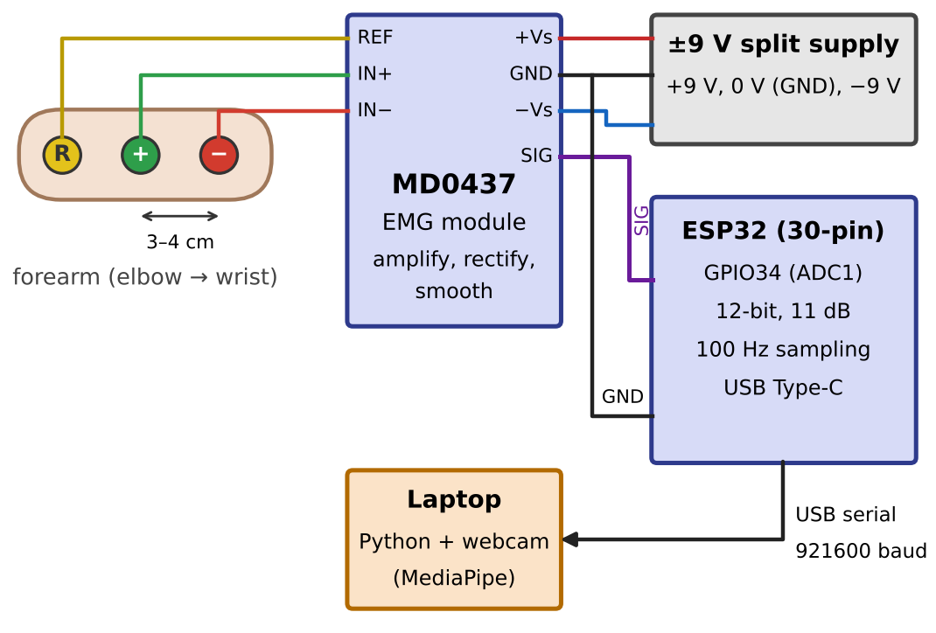
Fig. 2. Wiring of the EMG acquisition hardware, as used to record the dataset at 100 Hz

C. Visual Hand Detection
Every webcam frame is passed to the MediaPipe hand landmarker [5], which returns 21 landmarks. From these landmarks the system calculates the curl angle of each finger, the fingertip reach divided by the palm size (so that the rules work at any distance from the camera), the pinch ratio between the thumb and index finger, and a strict full fist flag. The hand is labeled Hand Close when the pinch ratio is below 0.34 or when one or no finger is extended. It is labeled Hand Open when three or more fingers are extended, and Rest in all other cases. A label is accepted only when 3 of the last 5 frames agree. Left, Right, Up and Down are detected from the movement of the palm center relative to an anchor point, once the palm moves more than 2.5% of the frame width or 4% of the frame height. A detected direction is held for 350 ms, and closing the hand resets the anchor. A smoothed pointer placed on the middle finger is used for aiming and steering in the games.

D. EMG Processing and Features
Since the MD0437 already outputs an envelope, the 20–450 Hz band pass filter and 50 Hz notch filter that raw EMG would need are not used. The signal is divided into 200 ms windows, with a new window every 100 ms (N = 20 samples at 100 Hz, or 200 samples at 1 kHz). Eight features are computed for each window: root mean square (RMS), mean absolute value (MAV), variance, standard deviation, peak, waveform length (WL), zero crossings and slope sign changes. The three main features are
$$MAV=\frac{1}{N}\sum_{i=1}^{N}{\left|x_{i}\right|},$$ | (1)

$$RMS=\sqrt{\frac{1}{N}\sum_{i=1}^{N}{x_{i}^{2}}},$$ | (2)

$$WL=\sum_{i=2}^{N}{\left|x_{i}−x_{i−1}\right|},$$ | (3)

where x_{i} is the i-th envelope sample (ADC value) in a window of N samples. These values describe electrical activity in ADC units. They increase with muscle contraction, but they are not a calibrated measure of muscle force. The live system and the offline experiments use the same code (Fig. 3).
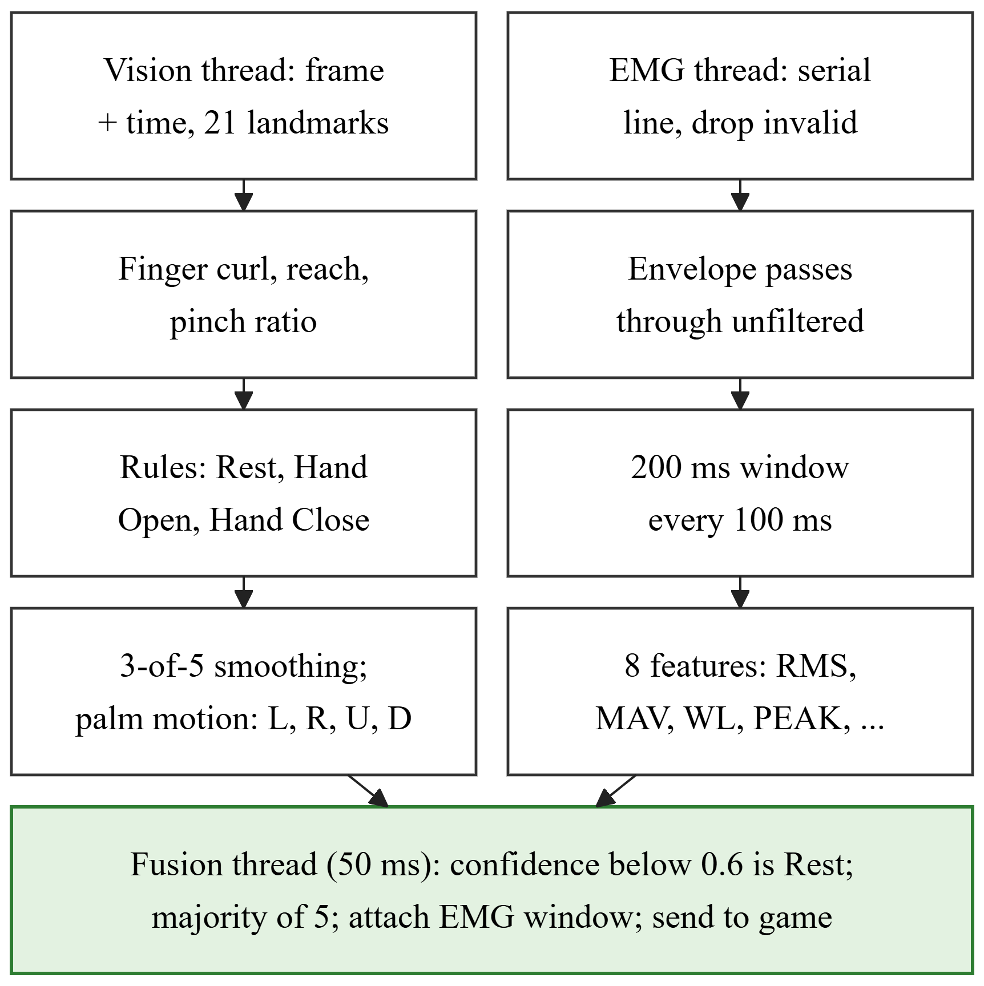
Fig. 3. Vision, EMG and fusion pipelines; each runs in its own thread

E. Fusion of Camera and EMG
Every 50 ms, the fusion thread takes the most recent camera label and replaces it with Rest if its confidence is below 0.6. It then takes a majority vote over the last five labels and attaches the most recent EMG window and the capture time of the camera frame. In the earlier design, a game action was triggered only when both signals agreed. This was changed because a single forearm channel separates activity levels well but says little about the direction of a movement (Section IV-B). As a result, EMG never overrides a camera label. Instead, it is shown to the patient as live activity feedback and stored with every attempt, and in Webcam + EMG mode the games wait until fresh EMG data arrive. Because the capture time is stored, the delay from camera to game can be measured for every command.

F. Dataset
Nine healthy adult volunteers (S01–S09) took part voluntarily and gave informed consent. Each volunteer performed each of the seven movements for about 60 s with the forearm resting on a table, and the signals were recorded at 100 Hz. The dataset contains 61 files with 369,435 labeled samples. Files that held several recordings, or that had gaps longer than 1 s, were split into 66 segments so that no window crosses from one recording into another. Two volunteers are each missing one movement (Rest for S01 and Down for S04), and S01 lost 26–50% of its samples because of an unreliable recording link. Cutting the data into 200 ms windows gives 36,873 examples.

G. EMG Movement Classification
The classifiers were studied offline to decide what role EMG should play in the system; none of them is used to control the games. Each classifier assigns a window to one of the seven movements (Fig. 4). In the first group, LDA, an SVM with a radial basis function kernel (C = 10) and a random forest with 200 trees were trained on the eight features of the 200 ms windows.
Second, MOMENT-1 needs 512 evenly spaced samples as input. Each segment was therefore resampled to a 10 ms grid, and missing samples were filled in by linear interpolation. S01 was left out because 39% of its samples would have been interpolated. Every sample x from subject s was then transformed and calibrated as
$$z=\operatorname{clip}\left(\frac{\ln\left(1+x\right)−μ_{s}}{σ_{s}}, −6, 6\right),$$ | (4)

where μ_{s} and σ_{s} are the mean and standard deviation of ln(1 + x) over all recordings of that subject, calculated without using the labels. The logarithm keeps the quiet Rest movement and the strong Hand Close movement on a similar scale, and the calibration removes differences in signal gain between people. Windows of 512 samples (5.12 s) were taken every 128 samples, which gave 2,494 windows from eight volunteers. The same eight features were also computed on these windows.
Third, MOMENT-1-small (35.3 million parameters) [21] was used frozen, either with its untrained classification head or with LDA, SVM or a random forest trained on its 512 value embedding. In these tests the calibration in (4) replaced RevIN [23], and RevIN itself was also tested for comparison. Fourth, the model was fine-tuned in two ways: as a linear probe, in which only the 3,591 parameter head is trained, and with rank 8 LoRA [22] adapters on the attention query and value projections (118,279 parameters). Each was trained for up to 15 epochs with early stopping. Finally, the UCI dataset [24] (36 people, eight channel armband) was converted into envelope-like windows. These were used either as extra training windows for the three movements it shares with our dataset, or to pre-train the LoRA adapters.
The data were always split by subject, because overlapping windows are almost identical. The main test is leave-one-subject-out (LOSO) over S02–S09. In each fold, one volunteer is used for testing, six for training and the remaining one for early stopping. A holdout split (training on S02–S05, validation on S06 and testing on S07–S09) gives a second view of performance. Accuracy and the macro F1-score are reported, and the chance level is 1/7 = 14.3%:
$${F1}_{macro}=\frac{1}{K}\sum_{k=1}^{K}{\frac{2P_{k}R_{k}}{P_{k}+R_{k}}},$$ | (5)

where P_{k} and R_{k} are the precision and recall of class k, and K = 7.

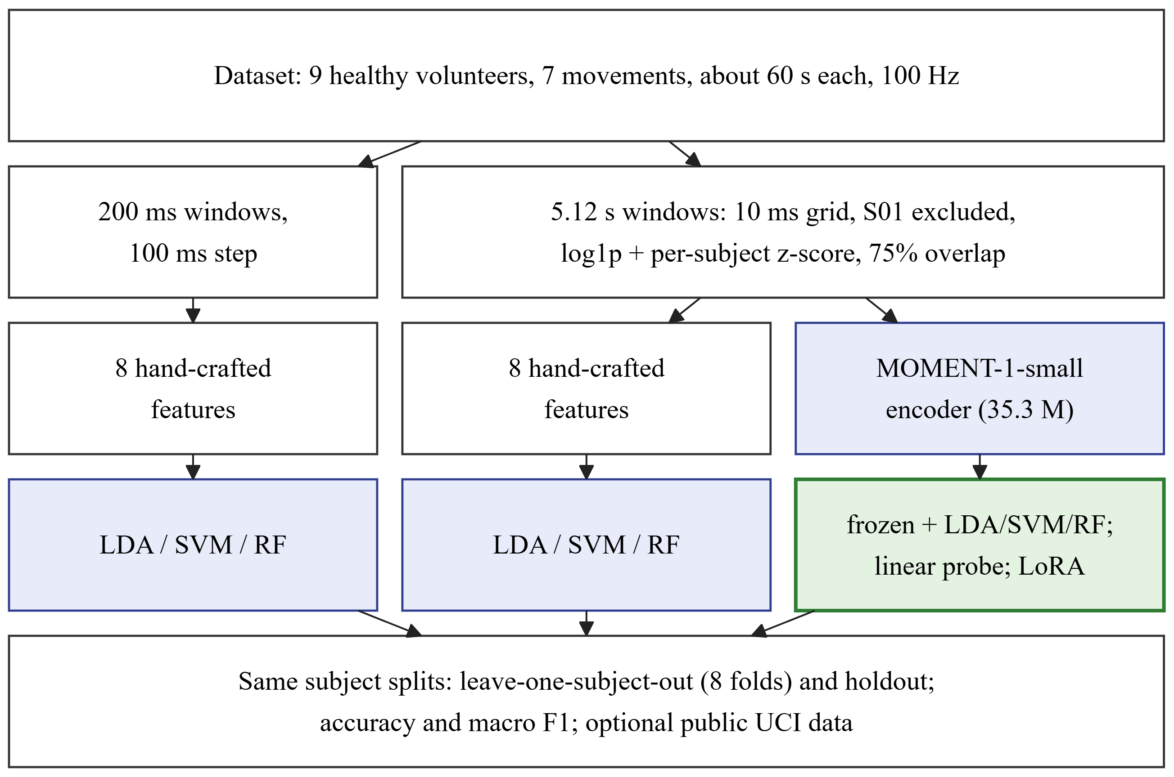
Fig. 4. Offline EMG classification pipelines compared on the same subject splits (green: classifiers built on MOMENT-1; frozen MOMENT-1 features with a random forest gave the best result)

H. Games and Adaptive Difficulty
Four games were written in Python with Pygame, and they are launched from the web application (Table 3). In line with motor learning principles [15], each movement maps naturally to a game action, sound and visual feedback is given immediately, and the difficulty rises gradually. Each game asks for one target movement at a time and records the target, the detected movement, whether it was correct, the reaction time, the EMG RMS and MAV, and the confidence. All games can also be played with a keyboard or a simulator.
Table 3. Games and webcam controls
Game | Webcam control | Trains
Balloon Pop | Aim with the hand; a full fist on a balloon pops it | Reaching, hand closing and opening
Car Driving | Holding the hand left, center or right selects one of three lanes; a fist brakes | Side to side reaching, hand closing
Treasure Hunt | Push the hand like a joystick to walk; open and then close the hand at each chest | Four directions, hand opening and closing
Shape Matching | Make a fist to grasp a shape, carry it, then open the hand to drop it into its hole | Grasping, releasing, precise reaching

A correct movement earns 10 points, with 5 extra points while the patient has three or more correct movements in a row, plus bonuses that are specific to each game. By default a session lasts 180 s, and it ends with a results screen that shows the score, accuracy, best streak, reaction time and a rating of one to three stars. Movement accuracy is calculated as
$$MA=\frac{S}{T}×100\%,$$ | (6)

where S is the number of correct attempts and T is the total number of attempts. The EMG envelope is not a calibrated force and is only weakly related to the movement, so the difficulty adapts to accuracy rather than to an EMG calibration. This approach also works in every input mode. The level changes continuously between 1.0 and 5.0. In automatic mode (Fig. 5), once at least four attempts have been made since the last change, the level ℓ is updated from the accuracy a₆ of the last six attempts:
$$ℓ←\left\{\begin{aligned}\min\left(ℓ+0.5, 5\right), a_{6}≥ 80\%, \\ \max\left(ℓ−0.5, 1\right), a_{6}≤ 40\%, \\ ℓ, otherwise.\end{aligned}\right.$$ | (7)

Each game interpolates its settings between level 1 and level 5. For example, a new balloon appears every 1,700 ms at level 1 and every 800 ms at level 5, and the number of shapes per round rises from three to six. The level is saved for each patient and game.
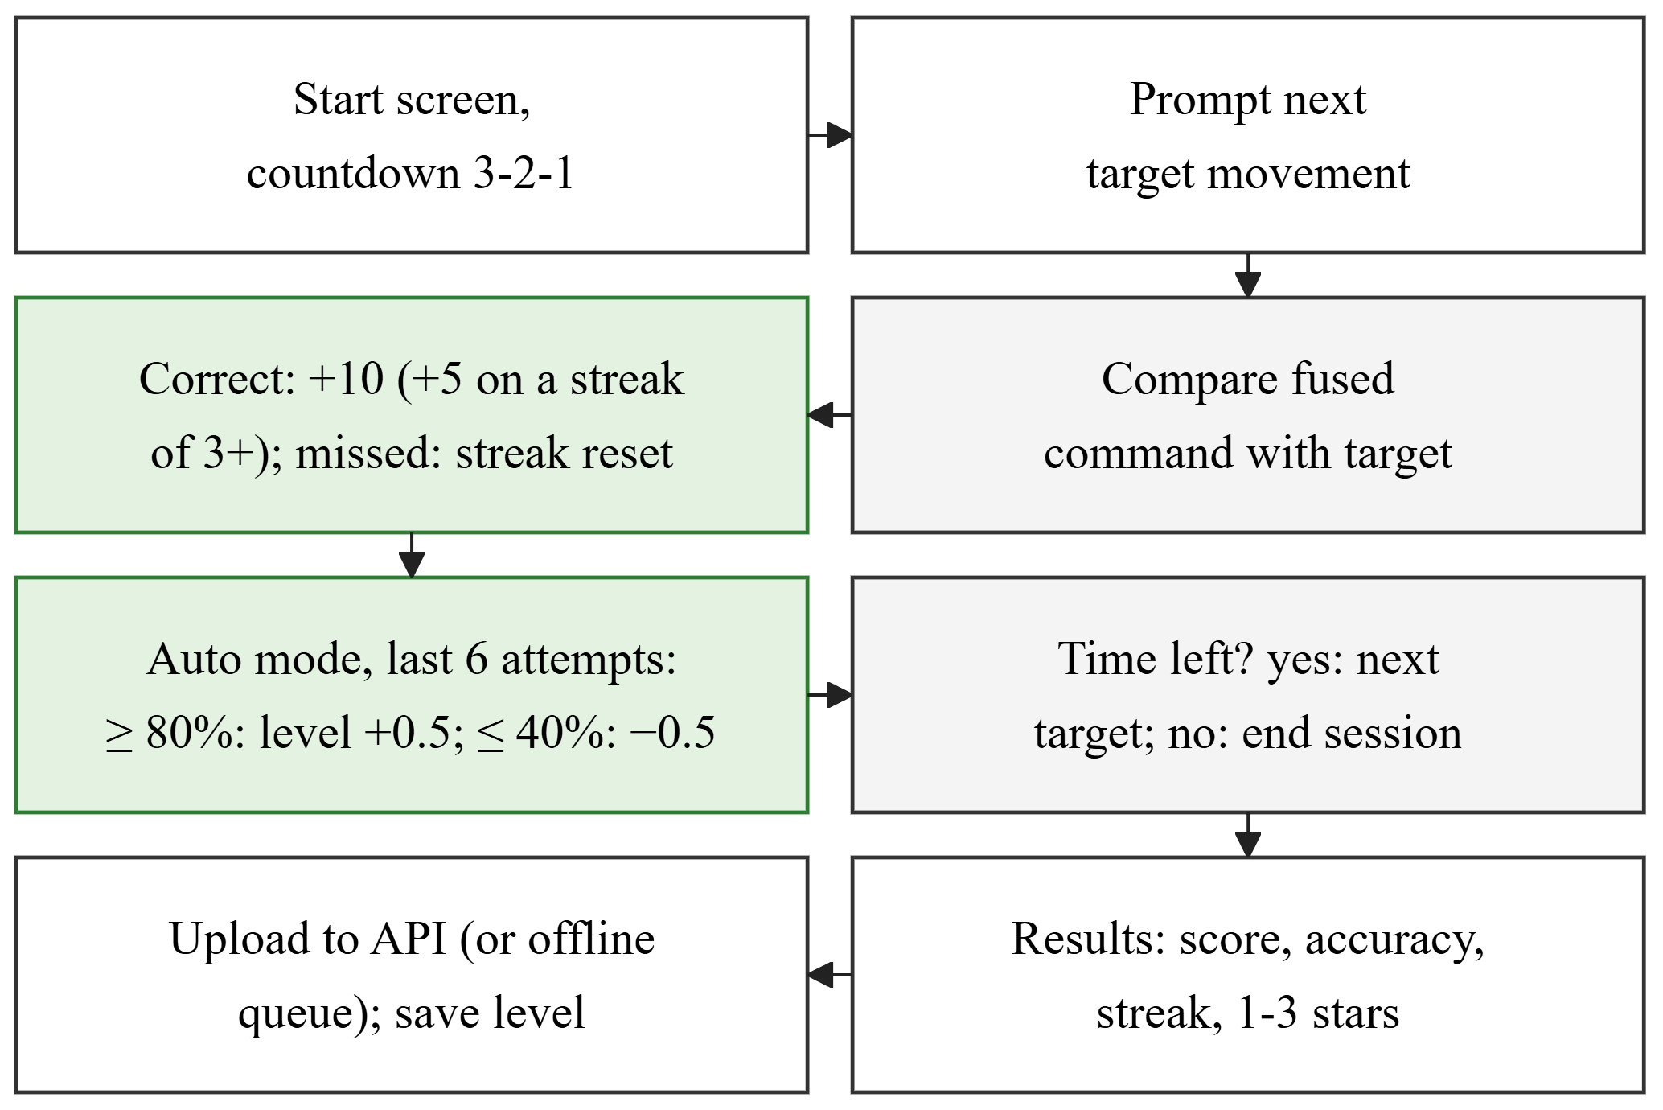
Fig. 5. Game session flow with automatic difficulty adaptation

I. Web Application and Data Privacy
The web application, called RehabHub, is built with React and TypeScript and uses the FastAPI server and SQLite database (32 endpoints). Its pages show overview statistics and the patients who need attention; coded patient records with clinical notes, progress, accuracy by movement, EMG activity by movement, session history and CSV export; every session and attempt; a game launcher for choosing the patient, game, input mode, difficulty and duration, together with a live log; an EMG data viewer; and the settings. To protect health data, all components run on one computer and the server only listens on the local address. Patients are identified by coded IDs only, and no camera video is stored. Login with separate user roles, encryption and a security review will be needed before any remote or clinical use.

J. Testing and Evaluation Plan
Forty-seven automated tests cover the features and filtering, fusion, the server, the offline queue, difficulty adjustment, dataset loading, EMG replay and all four games, which are played with scripted input on a hidden display. Recorded EMG can also be replayed into the live pipeline, so the whole system can be tested without the sensor. The planned evaluation has three stages. In the first, five to ten healthy volunteers will take part to measure webcam detection accuracy, movement accuracy using (6) and the delay from camera to game (target median below 300 ms). The second is a usability study with the System Usability Scale [25] (target score above 68). The third, after ethics approval, is a small pilot study with stroke patients.

IV. Results and Discussion

A. EMG Activity per Movement
Table 4 shows the mean window RMS for each movement across the nine volunteers. Hand Close produces by far the most activity and Rest the least. The four directions have similar values, and Hand Open is only about twice as active as Rest. Compared with each volunteer’s own Rest level, Hand Close ranged from 7.3 times (S03) to 117 times (S02), which shows large differences in signal gain and electrode contact between people.
Table 4. Mean EMG activity per movement (9 volunteers)
Movement | Mean RMS (ADC units) | Ratio to Rest
Hand Close | 884.6 | 23.0
Up / Down | 413.8 / 413.5 | 10.7 / 10.7
Right / Left | 387.9 / 301.4 | 10.1 / 7.8
Hand Open | 92.0 | 2.4
Rest | 38.5 | 1.0

B. Classification Performance
Table 5 compares all methods on the same splits. With 200 ms windows, the best classical model was the SVM at 37.2% LOSO accuracy. This is well above chance but still far from good enough for game control. Using the same features on 5.12 s windows raised the SVM to 47.3%. The MOMENT-1 model without any training performed at chance level, but its frozen embeddings combined with a random forest gave the best LOSO result of 48.1% (macro F1 0.443). Fine-tuning did not improve on the frozen features: the linear probe reached 43.0% and LoRA 43.2%. When RevIN was used instead of the per-subject calibration, the frozen models lost 11–13 points.
Table 5. Accuracy over 7 movements (chance 14.3%)
Method | LOSO | LOSO F1 | Holdout
LDA, 200 ms | 34.7% | 0.297 | 36.0%
SVM, 200 ms | 37.2% | 0.321 | 40.5%
Random forest, 200 ms | 34.0% | 0.307 | 37.5%
LDA, 5.12 s | 43.8% | 0.381 | 40.3%
SVM, 5.12 s | 47.3% | 0.425 | 50.2%
Random forest, 5.12 s | 40.3% | 0.368 | 45.0%
MOMENT, untrained head | 14.2% | 0.059 | 17.4%
Frozen MOMENT + LDA | 41.9% | 0.392 | 45.2%
Frozen MOMENT + SVM | 46.4% | 0.425 | 48.3%
Frozen MOMENT + RF | 48.1% | 0.443 | 49.3%
Frozen MOMENT + RF, RevIN | 35.3% | 0.304 | 29.2%
MOMENT linear probe | 43.0% | 0.369 | 45.5%
MOMENT LoRA | 43.2% | 0.369 | 45.5%

C. Per-Movement Results and Public Data
All methods recognized Rest, Hand Open and Hand Close much better than the four directions (Table 6). Longer windows and MOMENT features mainly improved Hand Open (from 46% to 74%) and Hand Close, while Up and Down stayed close to chance. Accuracy also differed greatly between volunteers. S03 was the hardest for every method (16–31%), and S05 and S06 were the easiest (up to 58.5%), so differences of one or two points between the best methods fall within this spread. The public UCI data did not improve the best accuracy. When added as extra windows, it lowered the SVM by 4.2 points and LoRA by 4.1 points, because it covers only three of our movements. Pre-training LoRA on it added 1.2 points on average (44.4%), and most of this gain came from one volunteer. The armband sensor and short gestures in the UCI data are too different from our recordings to replace data from our own sensor.
Table 6. LOSO recall per movement (Frozen + RF: frozen MOMENT-1 features with a random forest)
Movement | SVM 200 ms | SVM 5.12 s | Frozen + RF | LoRA
Rest | 81% | 74% | 78% | 72%
Hand Open | 46% | 59% | 74% | 74%
Hand Close | 66% | 79% | 75% | 76%
Left | 23% | 47% | 40% | 32%
Right | 9% | 40% | 31% | 18%
Up | 19% | 23% | 9% | 19%
Down | 11% | 5% | 27% | 3%

D. Implemented System
The authors checked that all parts work together. The battery powered sensor and the ESP32 stream timestamped samples over USB, the webcam module detects the seven movements and the pointer in real time, and the fusion engine attaches EMG features to every command. The four games run with rewards and automatic difficulty, sessions are either stored directly or queued and uploaded later, and the physiotherapist can launch games and review patients, sessions and EMG activity. All 47 tests pass. These were functional checks only. Each command carries the capture time of its frame and the games log the delay from camera to game, but this delay, the webcam detection accuracy and the usability have not yet been measured. By design, a new command is produced every 50 ms and a new EMG window every 100 ms.

E. Discussion
Using one EMG channel for muscle activity and a webcam for hand position keeps the hardware cheap (about LKR 14,000) and easy to wear, and it avoids the calibration that inertial sensors need. This matters for use at home. The results show the trade-off clearly. A single envelope channel separates activity levels well but carries little information about direction, so the camera decides every game movement, and EMG is used for activity feedback and as a record of effort. Three further findings point the way for future work. First, window length mattered more than the choice of model: the same SVM gained 10.1 points when the window grew from 200 ms to 5.12 s. Such long windows are too slow for game control, but they suit measures of effort over a whole session. Second, frozen MOMENT-1 features gave the best results overall, while LoRA, trained on about 1,900 windows from six people in each fold, had too little data to improve on them. Third, the activity level must be kept. RevIN removes it and cost 11–13 points, so a short calibration recording for each patient is a sensible next step. Multi channel systems report higher accuracy under controlled conditions [11], but our results come from a single low cost channel at 100 Hz with strict testing on unseen people, so a direct comparison would not be fair. Our findings do agree with how similar systems use EMG, namely to reward or monitor muscle activity rather than to recognize several different gestures [9], [16].

F. Limitations
The classifiers were trained and tested on nine healthy volunteers, two of whom have a missing movement, so the results may not carry over to other users or to stroke patients. No stroke patient data are used in this paper. The dataset was recorded at 100 Hz, but the live firmware samples at 1 kHz, so the offline models must be resampled before they can be used live. The webcam rules were tuned by hand, and their accuracy, the latency and the usability have not yet been measured. The prototype runs on a single computer without login or messaging, so remote monitoring is not yet possible, and the data link is still a USB cable.

V. Conclusion
This paper presented a low cost, game based system for upper limb stroke rehabilitation. It combines webcam hand tracking with a single channel EMG sensor, four rehabilitation games with adaptive difficulty, and a web application for physiotherapists. The hardware, movement detection, fusion, games, data storage and web application all work together. An offline comparison showed that frozen MOMENT-1 features with a random forest reach 48.1% LOSO accuracy over seven movements, and that rest, hand opening and hand closing are recognized much better than wrist directions. A single EMG channel is therefore best used for activity feedback, while the camera recognizes the movement. The results do not yet show any clinical benefit. Future work will add patient login, messaging between patients and physiotherapists, Wi-Fi transmission and an enclosure. It will also record more volunteers with a calibration for each patient, test a second EMG channel for detecting directions, use EMG activity levels in the games, and carry out the three stage evaluation, including a pilot study with stroke patients after ethics approval.

VI. Acknowledgements
The authors thank the volunteers who took part in data collection. All participants were healthy adults who joined voluntarily and gave informed consent. Formal ethics committee approval has not yet been obtained, and data collection from stroke patients will begin only after approval. The system is a research prototype and not a certified medical device. The authors declare no conflict of interest. AI-assisted tools were used for language editing and formatting, and to help prepare the manuscript text from the authors’ project documentation. The system design, implementation, data collection, experiments and analyses were carried out by the authors, who reviewed the final text and take full responsibility for it.

VII. References
[1] GBD 2021 Stroke Risk Factor Collaborators, “Global, regional, and national burden of stroke and its risk factors, 1990–2021: A systematic analysis for the Global Burden of Disease Study 2021,” Lancet Neurol., vol. 23, no. 10, pp. 973–1003, 2024, doi: 10.1016/S1474-4422(24)00369-7.
[2] C. Winstein and R. Varghese, “Been there, done that, so what’s next for arm and hand rehabilitation in stroke?” NeuroRehabilitation, vol. 43, no. 1, pp. 3–18, 2018, doi: 10.3233/NRE-172412.
[3] I. Doumas et al., “Serious games for upper limb rehabilitation after stroke: A meta-analysis,” J. NeuroEng. Rehabil., vol. 18, no. 1, Art. no. 100, 2021, doi: 10.1186/s12984-021-00889-1.
[4] M. Munoz-Novoa et al., “Upper limb stroke rehabilitation using surface electromyography: A systematic review and meta-analysis,” Front. Hum. Neurosci., vol. 16, Art. no. 897870, 2022, doi: 10.3389/fnhum.2022.897870.
[5] F. Zhang et al., “MediaPipe Hands: On-device real-time hand tracking,” 2020, arXiv:2006.10214.
[6] S. I. Lee et al., “Enabling stroke rehabilitation in home and community settings: A wearable sensor-based approach for upper-limb motor training,” IEEE J. Transl. Eng. Health Med., vol. 6, pp. 1–11, 2018, doi: 10.1109/JTEHM.2018.2829208.
[7] D. K. Zondervan et al., “Home-based hand rehabilitation after chronic stroke: Randomized, controlled single-blind trial comparing the MusicGlove with a conventional exercise program,” J. Rehabil. Res. Dev., vol. 53, no. 4, pp. 457–472, 2016.
[8] X. Song et al., “Cellphone augmented reality game-based rehabilitation for improving motor function and mental state after stroke,” in Proc. IEEE 16th Int. Conf. Wearable Implant. Body Sensor Netw. (BSN), 2019, pp. 1–4, doi: 10.1109/BSN.2019.8771093.
[9] O. Marin-Pardo et al., “Development of a low-cost, modular muscle–computer interface for at-home telerehabilitation for chronic stroke,” Sensors, vol. 21, no. 5, Art. no. 1806, 2021, doi: 10.3390/s21051806.
[10] Z.-X. Yin and H.-M. Xu, “A wearable rehabilitation game controller using IMU sensor,” in Proc. IEEE Int. Conf. Appl. Syst. Invention (ICASI), 2018, pp. 1060–1062, doi: 10.1109/ICASI.2018.8394459.
[11] S. Jiang et al., “Feasibility of wrist-worn, real-time hand, and surface gesture recognition via sEMG and IMU sensing,” IEEE Trans. Ind. Informat., vol. 14, no. 8, pp. 3376–3385, 2018, doi: 10.1109/TII.2017.2779814.
[12] O. Marin-Pardo et al., “Functional and neuromuscular changes induced via a low-cost, muscle–computer interface for telerehabilitation: A feasibility study in chronic stroke,” Front. Neuroergon., vol. 3, Art. no. 1046695, 2022, doi: 10.3389/fnrgo.2022.1046695.
[13] H.-P. Lin et al., “A usability study on mobile EMG-guided wrist extension training in subacute stroke patients—MyoGuide,” J. NeuroEng. Rehabil., vol. 21, no. 1, Art. no. 39, 2024, doi: 10.1186/s12984-024-01334-9.
[14] S. Heins et al., “Robotic-assisted serious game for motor and cognitive post-stroke rehabilitation,” in Proc. IEEE 5th Int. Conf. Serious Games Appl. Health (SeGAH), 2017, pp. 1–8.
[15] X. Song et al., “Activities of daily living-based rehabilitation system for arm and hand motor function retraining after stroke,” IEEE Trans. Neural Syst. Rehabil. Eng., vol. 30, pp. 621–631, 2022, doi: 10.1109/TNSRE.2022.3156387.
[16] Z. Ibrahim et al., “Enhancing upper limb stroke rehabilitation with electromyography-monitored virtual reality-based games,” J. Robot., vol. 2024, Art. no. 8945325, 2024, doi: 10.1155/2024/8945325.
[17] N. H. Mohd Dhuzuki et al., “Design and implementation of a deep learning-based hand gesture recognition system for rehabilitation Internet-of-Things (RIoT) environments using MediaPipe,” IIUM Eng. J., vol. 26, no. 1, pp. 353–372, 2025.
[18] Y. Geng et al., “Improving the robustness of real-time myoelectric pattern recognition against arm position changes in transradial amputees,” BioMed Res. Int., vol. 2017, pp. 1–10, 2017, doi: 10.1155/2017/5090454.
[19] L. Breiman, “Random forests,” Mach. Learn., vol. 45, no. 1, pp. 5–32, 2001, doi: 10.1023/A:1010933404324.
[20] M. Panwar et al., “Rehab-Net: Deep learning framework for arm movement classification using wearable sensors for stroke rehabilitation,” IEEE Trans. Biomed. Eng., vol. 66, no. 11, pp. 3026–3037, 2019, doi: 10.1109/TBME.2019.2899927.
[21] M. Goswami et al., “MOMENT: A family of open time-series foundation models,” in Proc. 41st Int. Conf. Mach. Learn. (ICML), 2024, pp. 16115–16152.
[22] E. J. Hu et al., “LoRA: Low-rank adaptation of large language models,” in Proc. Int. Conf. Learn. Represent. (ICLR), 2022.
[23] T. Kim et al., “Reversible instance normalization for accurate time-series forecasting against distribution shift,” in Proc. Int. Conf. Learn. Represent. (ICLR), 2022.
[24] S. Lobov et al., “Latent factors limiting the performance of sEMG-interfaces,” Sensors, vol. 18, no. 4, Art. no. 1122, 2018, doi: 10.3390/s18041122.
[25] J. Brooke, “SUS: A ‘quick and dirty’ usability scale,” in Usability Evaluation in Industry, P. W. Jordan, B. Thomas, B. A. Weerdmeester, and I. L. McClelland, Eds. London, U.K.: Taylor & Francis, 1996, pp. 189–194.

