|  |  |  |
| --- | --- | --- |
| jkhjkhjk | College of Computer and Information Sciences  Information Technology Department  3rd Semester 1444  IT 474 – Network Security  **Lab 1 Evaluation Sheet** |  |

|  |  |  |  |  |
| --- | --- | --- | --- | --- |
| **Team Number** | Names | | | **Serial Number** |
| **12** | **Deema ALfuaim**  **May Alsalama** | | | **8**  **6** |
| **Lab Component** | **VMs** | **Part 1** | **Part2** | **Total** |
| **Practical** | **2 screen shoots** |  |  |  |
| **Review Question** |  |  |  |  |

**VMs installations:**

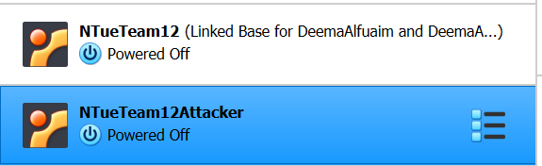

**Vm1 IP:**

**Vm2 IP:**

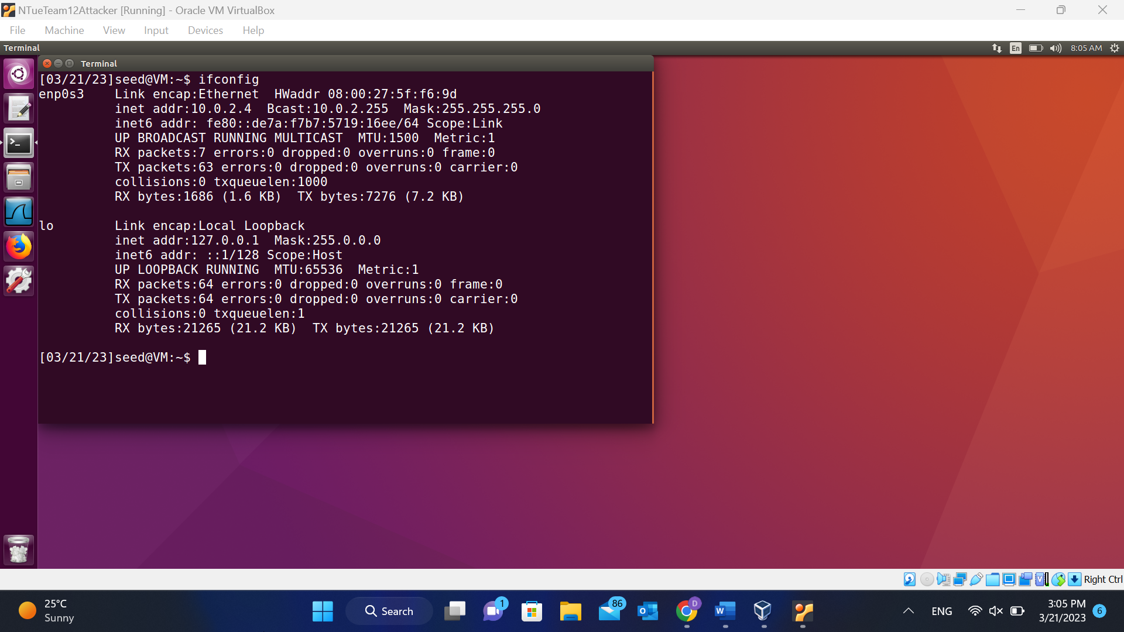

**Part1:**

* 1. What is the IP address of gaia.cs.umass.edu? On what port number is it sending and receiving TCP segments for this connection?

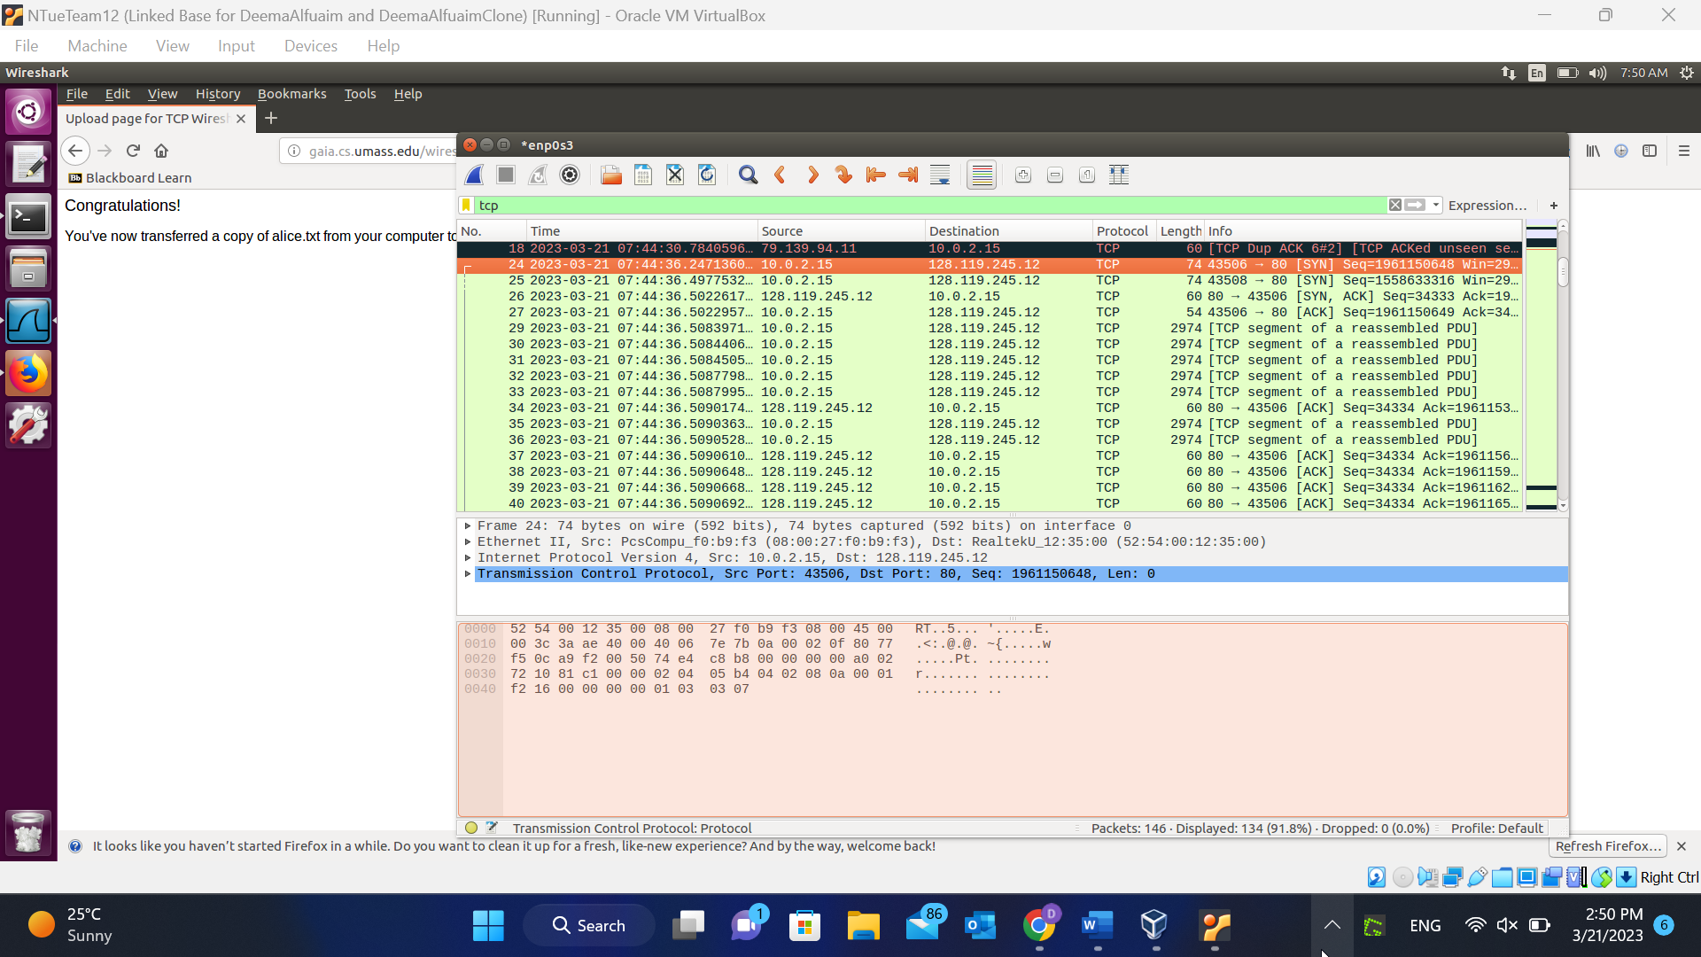

128.119.245.12

Sending port : 43506

Receiving port : 80

**Part2:**

* 1. What type of ICMP messages sent by ping? What type used for the responses?

8 echo ping request

0 echo ping reply

* 1. What are the parts contained in the ICMP requests and responses packets, which be used to match them with each other?

the checksum with the sequence and the identifier