Procedure and project description

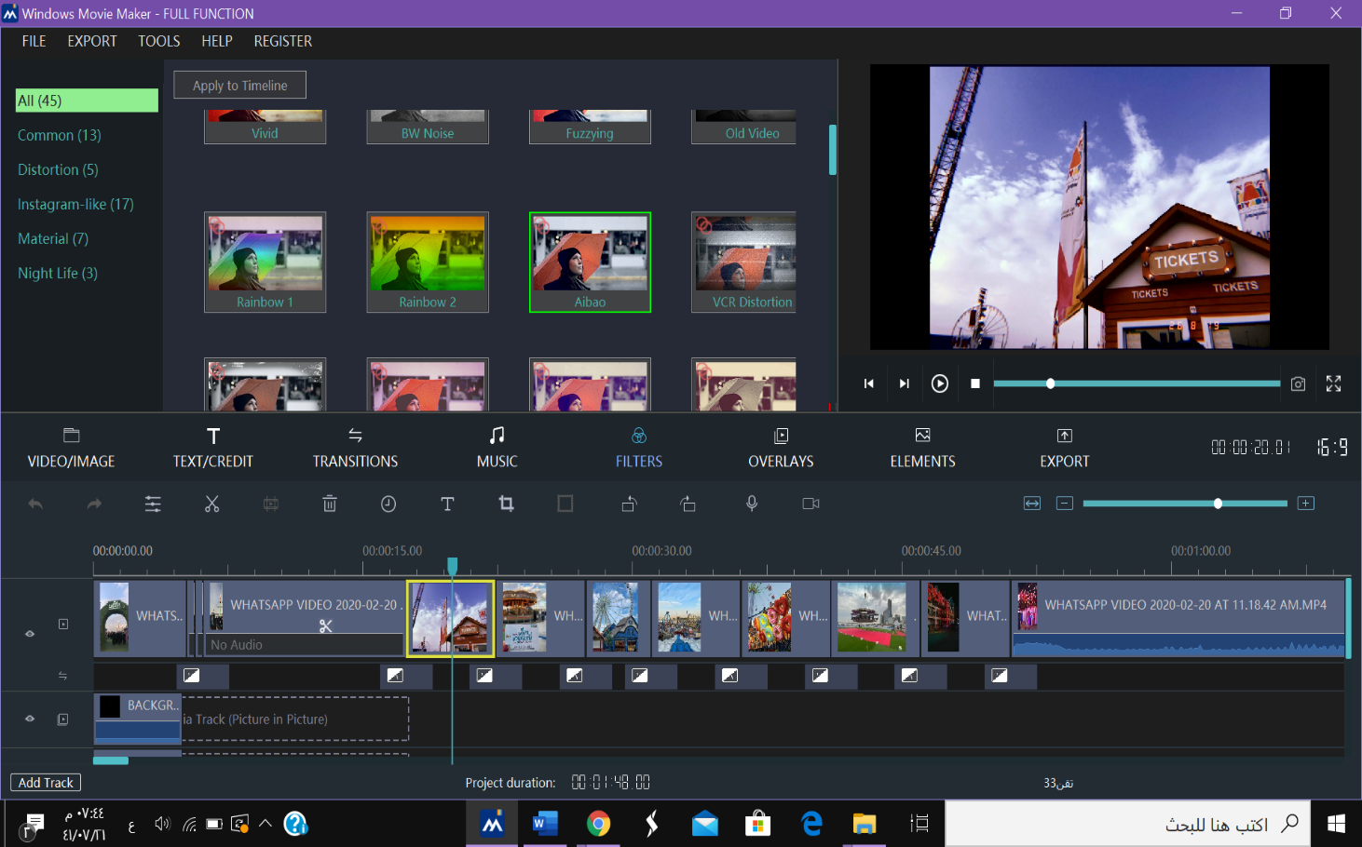**Special fx - Video Effects**.

Step 1: click on the image

Step 2: choose filters

Step 3: choose the filter that you want

Step 4: tap on apply to timeline

**Transition**

Step 1: click on the image/video

Step 2: choose transitions

Step 3: choose the transition

Step 4: drag it and place it between the image/video and the one after it

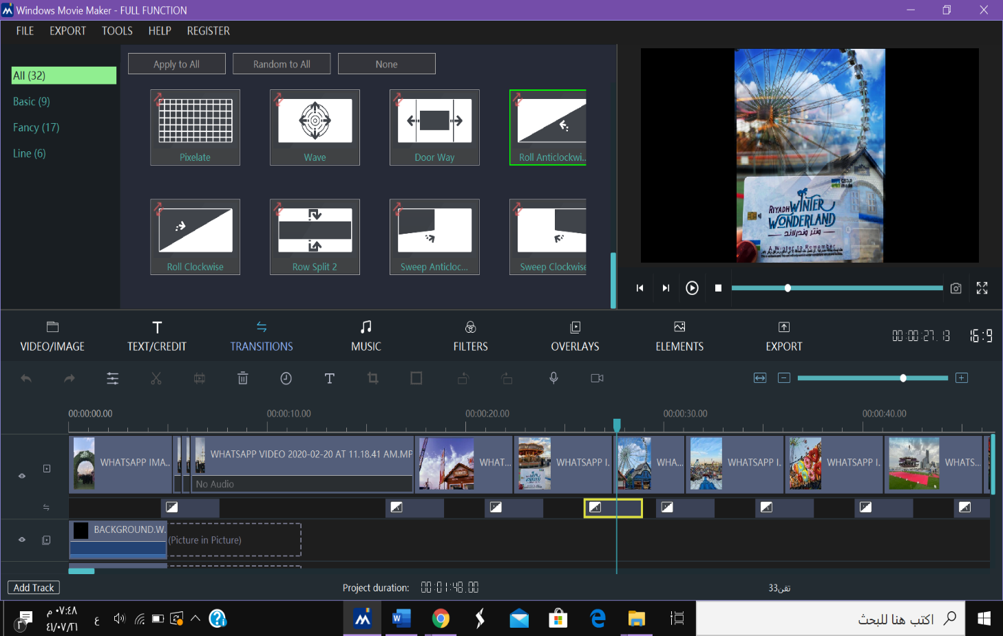

**Cutting**

Step one: click on the video

Step two: zoom out the video

Step three: put the cursor after the part you want to cut

Step four: click split icon

Step five: click remove icon

