National Chengchi University, Department of Management Information Systems

2023 Project Presentation

Team 8A Project Report

Project Title: Swap – AI-Powered Second-Hand Goods Exchange Platform

Team Members:

109306045 MIS Huang Yun-Chien

109306044 MIS Yang Juan-Tzu

109306083 MIS Huang Hui-Ju

109306087 MIS Hua Chiao-Chen

109306088 MIS Huang Jen-Chien

Date: December 2023

Swap
Abstract
This platform is a secondhand goods exchange system that integrates object recognition technology, aiming to provide users with a fast, convenient, and engaging experience. Users upload photos of items they wish to exchange, and the platform utilizes YOLO object detection, K-Means color clustering, and AILOGO recognition technologies to identify the item’s category, name, color, brand, and more. The information is then automatically filled in the upload form, eliminating the need for manual input. The platform’s interface adopts a youthful and interactive card-based design, distinguishing it from conventional secondhand trading platforms with their typically dull layouts. Primarily targeting students, the platform leverages student account reliability to reduce fake accounts and fraudulent activities. By promoting the fun of item exchanges, it aligns with sustainability goals. Future plans include optimizing the platform to enhance matching success rates, expanding the user base, and increasing the reuse value of campus resources.

。

1、Project Overview

1.1 Motivation

The rise of fast fashion in recent years has reignited global discussions about resource waste. The United Nations' 2030 SDGs Target 12.5, which focuses on significantly reducing waste through prevention, reduction, recycling, and reuse, highlights the severity of resource waste. While existing secondhand trading platforms (e.g., Facebook groups, Carousell) have large user bases, they also face the following issues:

- Poor User Experience: Non-intuitive interfaces lower user willingness to use the platform, leading to gradual decline.

- Limited User Base: International students on campuses often face challenges with surplus items but find current platforms with complex interfaces and Chinese descriptions difficult to use.

- Lengthy Transaction Process: Traditional platforms require multiple steps, from taking photos to manually inputting item details, creating high transaction costs.

- Security Concerns: Lack of transparency between buyers and sellers leads to trust issues, with fake accounts and scams prevalent.

To address these issues, our team developed an AI-powered secondhand exchange platform that combines convenience and safety, contributing to sustainability goals by reducing irresponsible consumption and promoting green economies.

1.2 Objectives and Content

Our team is dedicated to creating a simple, low-cost, and life-integrated secondhand exchange platform. By fostering a culture of daily exchanges, we aim to increase the reuse of idle items and improve users' quality of life through the following goals:

1. Enhancing User Experience: Simplifying item uploads and searches using AI for item recognition and tagging, paired with a fun and interactive design.

2. Expanding the User Base: Providing an English interface to break language barriers, making the platform accessible to global users.

3. Improving Security: Utilizing verified school accounts to reduce fraud and enhance trust in secondhand item sources.

In summary, the purpose of this platform's development is to seamlessly integrate information services with daily life, providing users with a fresh and convenient experience while simultaneously reducing resource waste and promoting the concept of sustainable green economy.

2、Requirements Analysis and Work Division

2.1 Analysis Method
We conducted interviews with university students from diverse backgrounds to gather qualitative data on their experiences and needs in secondhand exchanges. A semi-structured guide covered personal backgrounds, past experiences, and expectations for platform functionality. These insights informed the design and improvement of Swap.

2.2 Interview Subjects
Our team selected three interviewees with diverse backgrounds to gain a more comprehensive understanding of their needs and perspectives regarding the secondhand exchange platform:

- Sophia: A 21-year-old MIS student passionate about secondhand exchanges, concerned about privacy and transaction security.

- Jeffrey: A 22-year-old psychology student interested in simplifying exchange processes and increasing transparency.

- Ahmed: A 24-year-old international relations master’s student who values intuitive and secure platforms.

2.3 Interview Content Summary
(1) Personal Background
- The interviewees' names and ages.
- Whether they are studying or working at National Chengchi University, along with details of their relevant departments or faculties.
(2) User Needs
- The level of interest in secondhand exchange.
- Whether they have prior experience with secondhand transactions, and a description of their past experiences.
- Whether they encountered any problems or inconveniences while conducting secondhand transactions on existing platforms.
- Specific expectations they have for a secondhand exchange platform.

2.4 Analysis Results
During the interview process, our team discovered that all three interviewees showed a high level of interest in the secondhand exchange model, and they expressed a willingness to try related platforms in the future. Furthermore, our team explored the interviewees' past experiences with secondhand transactions, delving into the reasons behind their experiences to identify pain points. Finally, by understanding their expectations for a secondhand exchange platform, we were able to more directly and specifically outline the real needs of the users for the platform. After summarizing the interview results, we categorized the user needs into functional and non-functional requirements:
(1) Functional Requirements
- Simplified Listing Process:
Existing secondhand trading platforms have a cumbersome listing process, requiring users to fill in extensive details, which significantly reduces their willingness to list items. Therefore, to increase user participation, the platform's listing process needs to be simplified to help users quickly list their items.

- Intuitive Functional Operation:
All three interviewees agreed that the platform's interface should be intuitive and user-friendly, helping new users get started quickly. Overly complex functionality can lead to users wasting time exploring during the initial stages and potentially losing patience before they become familiar with the system.

- Easy-to-Read Interface:
Current secondhand trading platforms often have disorganized interfaces, with excessive text and confusing item layouts, making it difficult for users to read and easily distracted. To enhance browsing comfort, the interviewees hope the platform will provide an image-centric and clear interface.
(2) Non-Functional Requirements
- Secure Exchange Process:
With the rise of online scams, interviewees want the platform to ensure transaction safety by providing reliable identity verification and encryption mechanisms to increase users' trust and security while using the platform.

- English Interface:
Given that the platform serves international students, the primary language must be English to ensure that users from different language backgrounds can use the platform smoothly.
2.5 Division of Responsibilities
(1) Image Recognition (Huang Jun-Qian, Hua Qiao-Zhen)
- Responsible for developing and training the image recognition model.
- Collecting and organizing datasets for model training, selecting appropriate algorithms and model structures.
- Using Python for image recognition, ensuring model accuracy and performance.
- Integrating YOLO object detection technology, K-Means algorithm, and AILOGO recognition technology to simplify the item listing process by automatically filling in product name, color, and brand.
(2) App Frontend and Backend Programming (Huang Hui-Ru, Huang Ren-Qian, Yang Juan-Ci)
- Responsible for developing the app's frontend and backend.
- Frontend development uses the Flutter framework to design and implement user interfaces, including exchange pages, personal pages, and notification pages.
- Backend development focuses on constructing servers and application logic, handling user registration, item listing, exchange requests, notifications, etc.
- Ensuring smooth operation and consistent user experience across the app.
(3) Database Management (Yang Juan-Ci, Huang Ren-Qian, Hua Qiao-Zhen)
- Responsible for creating and managing the application's database.
- Designing the database structure, including user information, item details, and exchange records.
- Ensuring the stability, availability, and security of the database while handling data storage and retrieval.
- Supporting unstructured data adjustments.

- System Architecture and Explanation
3.1 Development Environment
In the initial phase, our team focused on selecting efficient tools to ensure a smooth development process. For image recognition model training and testing, we used Jupyter Notebook and Google Colab. For frontend and backend app development, Visual Studio Code was chosen to quickly build iOS and Android applications.
3.2 Programming Languages and Frontend-Backend Strategy
- Image Recognition: Python was selected due to its computational performance, rich image processing libraries, simple syntax, and extensive community support, which facilitate rapid development and maintenance.
- App Frontend and Backend Development: Flutter framework and Dart language were used for cross-platform consistency, speeding up development and reducing maintenance costs.
- Database Management: MongoDB was chosen as the primary database management system due to its flexibility and performance, especially suitable for storing user information and item exchange records. It also supports unstructured data adjustments to meet future needs.

3.3 System Architecture

（1）Log in

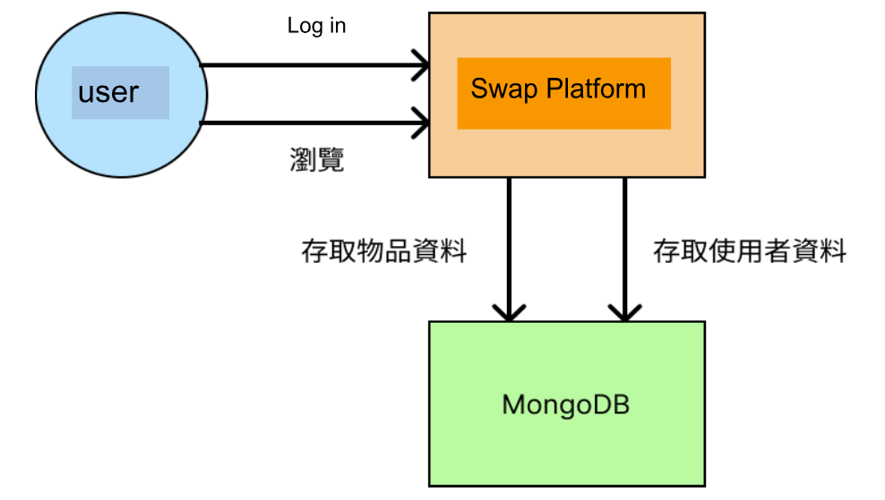
Browse
Store Items Records
Store
Users Records
Figure 2-Log in
When users register or log in through the Swap platform, MongoDB is used to verify that the account and password are correct and meet the required standards. During browsing of the main pages, the platform retrieves existing item data from MongoDB and displays it on the user's page.。

（2）List
In the listing process, after users confirm their photo, Swap will first store the photo in MongoDB. At this point, the backend detects the new entry in the database, triggering the recognition process. Once the image is recognized, the backend updates the database with the recognized image and its corresponding results. On the user side, they will be redirected to the listing page, where the recognition results are displayed as the default values on the screen. When the user proceeds with the listing, Swap will then store the item information in MongoDB.

（3）Exchange

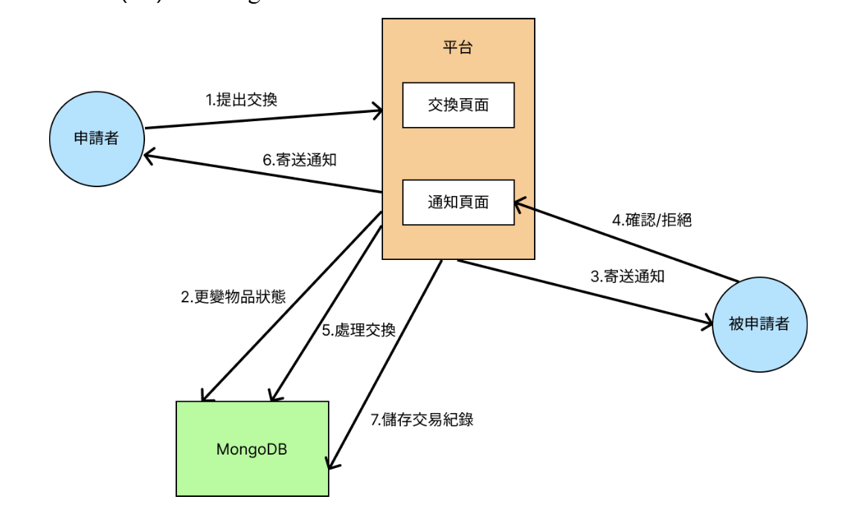
Applicant
Recipient
Notification Page
Exchange
Page
Swap Platform
6.Notification
1.Exchange Request
2.Item Status Change
4.Accept/Deny
3.Notification
7.Store Exchange Record
5.Exchange Process
Figure 4-Exchange
In this diagram, the applicant is the user who wants to initiate an exchange request, while the recipient is the user who receives the exchange request. When the applicant submits an exchange request on the platform, Swap sends a notification to the recipient, allowing them to decide whether to accept the exchange. At this point, the item status in MongoDB is updated to "exchange in progress." After the recipient either accepts or rejects the exchange, Swap processes the item transaction steps in the database and sends a notification to the applicant, informing them of the transaction result. Once the transaction steps are completed, the transaction record is stored in MongoDB for future reference.

3.4 Image Recognition Logic
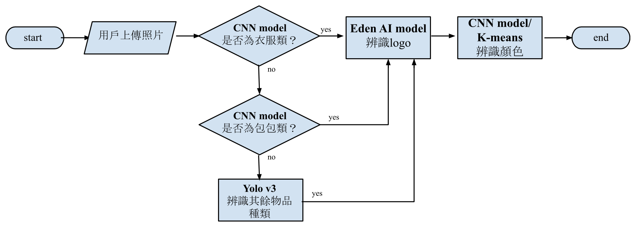
Figure 5-Image Recognize Process
When users take a photo of an item or select an existing image in Flutter and click to confirm the image, the photo is stored in MongoDB and triggers the Python image recognizer. After reviewing existing secondhand exchange platforms, our team focused on clothing and bags, so the image is first processed for recognition of these two categories. We used a CNN-trained model to recognize clothing and bags, and if the recognition results are negative for both categories, the recognition continues for other item types using Yolov3 object detection technology.
After completing the item recognition, the system proceeds with logo recognition, which integrates with external EdenAI for processing. Finally, K-means clustering for color grouping and CNN-based color recognition are applied. After completing all the recognition steps, the results are sent back to MongoDB for storage and displayed on the Flutter user listing page, allowing users to edit or directly list the item. When users click the "List" button, the system automatically updates the modified item information in MongoDB.

3.5 Testing and Maintenance
At the end of the development phase, the team focused on testing and maintenance. We used GitHub as a version control tool to help the team collaborate, ensuring code changes and information synchronization. The team implemented a multi-layered testing strategy to ensure application quality and stable operation across different platforms. For Android, testing was done using Android Studio’s emulator, while for iOS, the Simulator was used. Additionally, actual iOS and Android devices were tested to verify system performance and ensure effective long-term maintenance.

3.6 System Function Introduction
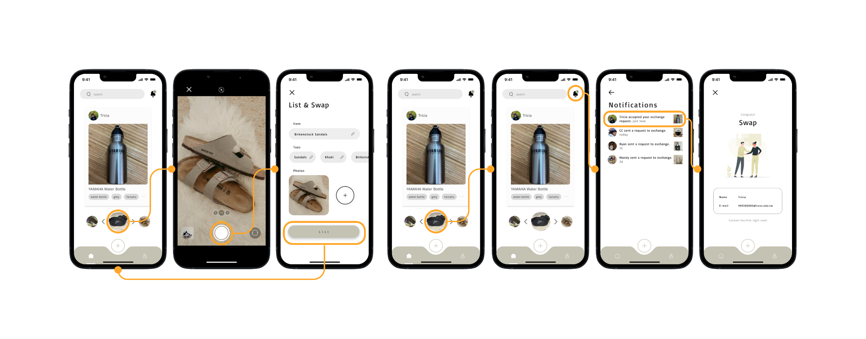
Figure 6 - Listing Figure 7-apply

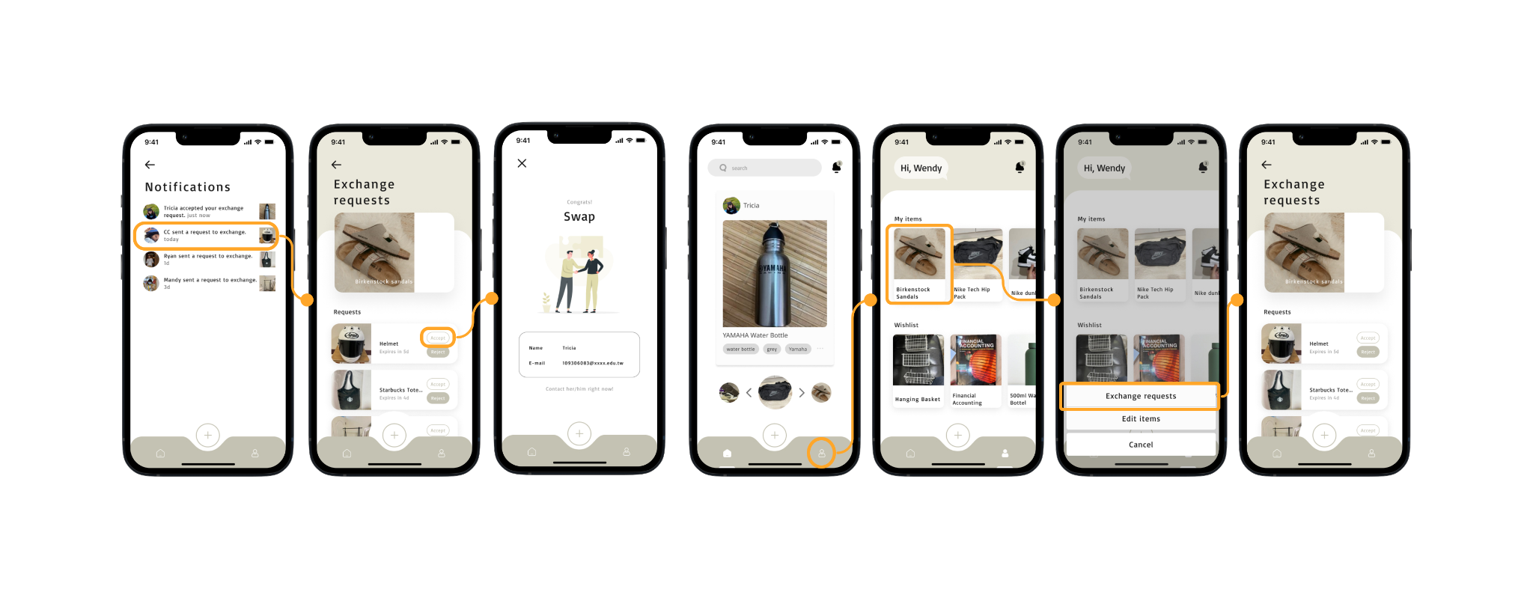
Figure 8-verified Figure 9-Personal Page

(1) Instant Recognition for Quick Listing
Users click the "+" button on the exchange homepage to open the camera and capture an image of the item they wish to list. After confirming the photo, the system backend triggers the image recognizer to identify the item. Once the recognition is complete, the screen transitions to the listing page, where the recognized item information (e.g., item name, item tags) is displayed as default. Users can list the item with a single click, saving the manual input steps, but they still have the option to freely edit the item information, including changing the name or tags.
(2) Swipe Up to Submit Exchange Request
After listing the item, users are directed to the exchange homepage to browse other users' listed items by swiping left and right. Once a desired item is selected, users simply swipe their item card upwards to the other party's item card to submit an exchange request. Once submitted, the item is temporarily gray and cannot be swiped again until the request is rejected or the five-day validity period expires.
(3) Real-time Notifications for Requests and Replies
After submitting the request, if the other party does not respond within five days, the system will automatically cancel the request. If the other party rejects or accepts the request, users will receive an immediate notification and can proceed accordingly. Once the request is confirmed, users can view the other party’s email address and contact them via email to arrange the physical exchange of items.
(4) Personal Page Management
Users can enter their personal page by clicking the "avatar" icon in the app's navigation bar to manage their listed items and exchange requests. In the "My items" section, users can view and edit their listed items, while in the "Wishlist" section, users can check the items they have requested to exchange. They can cancel the request or edit the item from this page.

4. Conclusion and Future Development Directions
The development of the Swap platform aims to address the issues existing in current second-hand exchange platforms and provide users with a convenient, secure, and enjoyable item exchange experience. By leveraging image recognition technology, Swap enables the "instant recognition" feature, allowing users to quickly list items by simply taking a photo, eliminating the need for tedious manual input. Additionally, the platform emphasizes a simple and intuitive interface, specially designed for student groups, improving security and reducing the issue of fake accounts.
The platform not only focuses on creating a convenient second-hand item exchange experience but also adheres to the principles of sustainability by reducing resource waste and promoting greener consumption patterns. In the future, our team will continue to optimize the platform and introduce more personalized features, such as a recommendation system based on user behavior and preferences, to enhance the chances of successful exchanges. Moreover, we plan to expand the user base, encourage the sustainable reuse of campus resources, and support the concepts of sustainable development and the sharing economy.
We hope that the Swap platform will change consumption habits, promote sustainable development, and become an important driver for resource protection and environmental sustainability.

5、Reference
Liao, J. (2018, December 4). 淺談爬蟲和爬蟲倫理 [A brief discussion of web scraping and web scraping ethics]. iThome.
https://ithelp.ithome.com.tw/articles/10253100

Cinnamon AI. (2019, Jun 5). 深度學習：CNN原理和Keras實現 [Deep Learning: CNN Principles and Keras Implementation]. Medium.
https://cinnamonaitaiwan.medium.com/%E6%B7%B1%E5%BA%A6%E5%AD%B8%E7%BF%92-cnn%E5%8E%9F%E7%90%86-keras%E5%AF%A6%E7%8F%BE-432fd9ea4935

陳芳毓、許鈺屏、李鈺淇 數位營運暨社群．高偉倫、阮怡婷. (2023, April 1). 新興科技對城市發展的影響 [The Impact of Emerging Technologies on Urban Development]. Future City.
https://futurecity.cw.com.tw/article/1867

TD (2020, May 4). 是否該用MongoDB？選擇資料庫前你該了解的事。ALPHA Camp.
https://tw.alphacamp.co/blog/mysql-and-mongodb-comparison

David Cochard (2020, Dec 8) YOLOv3 : A Machine Learning Model to Detect the Position and Type of an Object
https://medium.com/axinc-ai/yolov3-a-machine-learning-model-to-detect-the-position-and-type-of-an-object-60f1c18f8107

Harshvardhan Shinde (2021, Jul 13). MongoDB with Flutter. Level Up Coding.
https://levelup.gitconnected.com/mongodb-with-flutter-407de79f84e4

Flutter & Dart - The Complete Guide [2023 Edition]
https://www.udemy.com/course/learn-flutter-dart-to-build-ios-android-apps/learn/lecture/37266944?start=0#overview

MarsW (2013, Aug 16) Git 筆記 – Git 初始設定 & Github 入門
http://tech-marsw.logdown.com/blog/2013/08/16/git-notes-github

Flutter documentation

https://docs.flutter.dev/

