Analytics mindset
P-card
Part I solutions:
Some suggested responses might include, but are not limited to, the following:
- Do all employees receive a copy of the P-card policies and procedures upon receiving the P-card?
- Do employees sign a statement proving that they have read the P-card policies and procedures?
- How would the university learn that goods or items were shipped to an employee’s home, or any address other than a university address?
- What controls are in place to prevent an employee from purchasing an approved item and then returning it and receiving the refund in cash or a payment type that does not credit the P-card for the return?
- How do approvers and accountants verify the goods or items were received and are to be used for business purposes?
- Who are the approvers? Can individuals of the same organizational status be cardholders and approvers? Could two employees review each other’s transactions?
- Is there a control to prevent purchases of goods or items that exceed $5,000 from being be split into multiple payments to circumvent the single transaction limit?
- Do some sellers within an approved merchant category code (MCC) sell non-approved goods or items (e.g., gift cards, items for personal use)?
- How does the university determine whether purchases are made from companies owned by friends or family?
- What happens if a receipt is not submitted with the cardholder’s statement?

Analytics mindset
P-card
Part II solutions:
- Variety – different forms and formats of the data
  - Are all of the data set formats the same? Do they need to be the same for your analysis?
    - Yes. They are all .csv files.
    - No. Analysts can use data sets in various formats and transform them into the appropriate format for analysis.
  - Do all fields contain the same labels? Does the data with similarly titled labels contain the same type of data?
    - No. Most titles were different in 2010.
    - CardholderLastName and CardholderFirstInitial look to be the same before you expand the column. The data is similar (text), but CardholderFirstInitial is only one character and the last name field is longer.
  - Are all of the data formats the same? Do they need to be the same for your analysis?
    - No. Most notably, Amount is formatted as currency in some data files and as general in other files.
    - For 2011, the MCC does not contain any data.
    - The TransactionDate and PostedDate fields contain different formats in the 2013 file and the 2011 file. For some of the transactions, the format is different than other transactions.
  - How are the files delimited? Are there any extra delimiters that may cause problems when importing? What strategies can you take to deal with any of these challenges?
    - Commas are used as delimiters (it’s a .csv file).
    - The MCC field and description contain some commas, which will cause problems when converting the file.
  - Are formats consistent for all entries in a field?
    - No. In the 2013 and 2011 files, the TransactionDate and PostedDate have two different formats within the same column of information.
  - Is the data structured or unstructured? What transformation would need to happen to any unstructured data to make it possible to analyze?
    - For the most part, the data is structured. However, the Description field contains a text description of the purchase that is entered by the cardholder and cannot be meaningfully analyzed as it is. Before analyzing this text data, we would need to do different transformations and searches for key terms. There are several ways this could be performed. For example, you could perform a text search for specific search terms using the conditional formatting functions and then code data that meets those conditions in a separate field. Task 6 creates one possible way to analyze data in the Description field.
- Velocity – frequency of incoming data that needs processing
  - Is the analysis performed on “live” data or only on historical data?
    - It is performed on historical data.
  - How often will you be updating this analysis? How automated should the analysis be?
    - It is updated annually. Because the analysis is infrequent, it is not necessary for it to be automated, but it still needs to be replicable. Therefore, detailed notes about how the data cleansing and analysis processes are performed are critical.
- Veracity – trustworthiness of the data
  - Is the data you have complete? Do the data files you received contain all transactions? Are all of the data fields complete for each year and do the files contain all of the same data for each year?
    - This data does not have unique identifiers, so it is difficult to determine if there are any missing transactions. We can perform some reasonableness checks to determine whether a similar amount of data was received for each year. Any major differences during the years may need to be investigated. In addition, we need to ensure that we have a good understanding of how the data was captured and provided to us. If we can trust that process, it gives us some confidence that we have all of the transactions.
    - The data fields are not complete for each year. There is no data for the MCC field for 2011.
  - Does the data contained in the data files accurately represent the economic transactions?
    - Yes.
  - What human judgment went into establishing the data?
    - Individual cardholders enter the description data into the WORKS system. There is some risk here because it is the cardholder who would be the most interested in falsifying the details of the purchase and they also are responsible for reporting the details. Also, it is notable that many of the descriptions merely indicate a general transaction, which provides no information about what was purchased.
- Volume – the amount or scale of data
  - Should you include data for all years?
    - This depends on the scope of the audit and the tools available to your audit department. Using Excel, data cannot be included for all years because it is too much data for a single sheet. Using a tool like Access allows you to include data from all years.
  - Should you include data from all entities in Oklahoma or only for OSU?
    - This depends on the scope of the audit. If we are only interested in OSU data, then we could filter out non-OSU transactions. However, it may be useful to keep them in for comparison purposes.
  - Are all fields relevant to your analysis?
    - Some fields may be redundant. For example, AgencyName and AgencyNumber both describe the same data.
  - How many rows will you need to import? What tools can handle this quantity of data?
    - There are approximately 2.2 million records, which is more data than Excel can store. We can conduct this analysis in Access, Tableau or other tools that can accommodate this volume of data.
Analytics mindset
P-card
Part III solutions:
Here are the changes that need to be made in Excel for each file before it is imported into Access.
File: Analytics_mindset_case_study_solutions_PCard_FY2015.csv
- In row 1, rename all of the columns using the names from Task 2, but remove the spaces. The names should appear like this screenshot below.
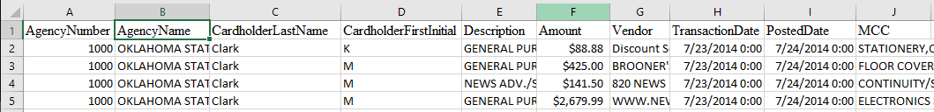
- Column A (AgencyNumber): No changes are necessary.
- Column B (AgencyName): No changes are necessary.
- Column C (CardholderLastName): No changes are necessary.
- Column D (CardholderFirstInitial): No changes are necessary.
- Column E (Description): No changes are necessary.
- Column F (Amount): Remove the dollar sign symbol from the currency amounts. To do this, select the entire column by clicking on the column heading. Then, under the home tab in the Number group, select the box to open up more options. In the Category box, select number and make sure the Use 1000 Separator (,) box is not selected and negative numbers are displayed with a dash symbol. This is a screenshot of the dialog box.
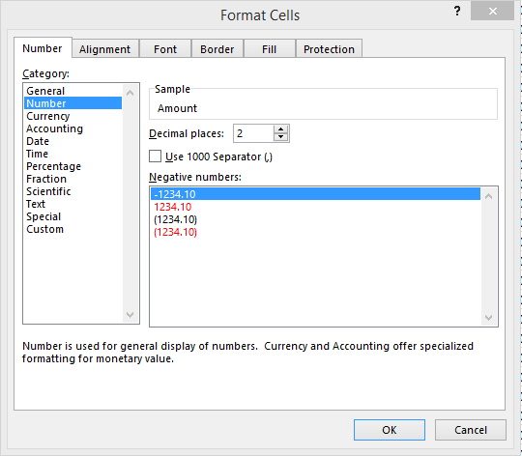
- Column G (Vendor): No changes are necessary.
- Column H and Column I (TransactionDate and PostedDate, respectively): Change the format of the transaction date to match the MM/DD/YYYY format. To do this, select the entirety of both columns by
clicking on the column headings. Then, right-click and select Format cells. Select Date in the Category field and scroll down to select the date option 3/14/2012. The dialog box should look like this:
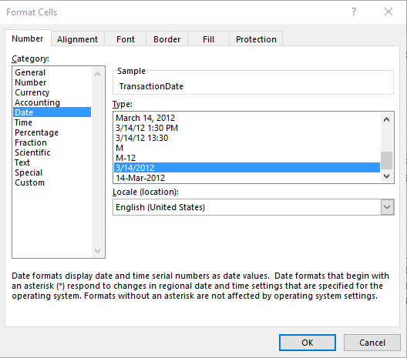
- Column J (MCC): No changes are necessary.
File: Analytics_mindset_case_study_solutions_PCard_FY2014.csv
- All changes are the same as in the 2015 file.
File: Analytics_mindset_case_study_solutions_PCard_FY2013.csv
- All changes are the same as in the 2015 file, except the following:
  - Changing the formatting of the TransactionDate (Column H) and PostedDate (Column I) doesn’t work correctly for the first 215,328 rows. Instead, for these rows, you will need to extract the data manually to format it correctly. To do this, insert two columns to the right of Column I. Then use the formula =MID(H2,4,2)&“/”&LEFT(H2,2)&“/”&MID(H2,7,4) in the new Column J and =MID(I2,4,2)&“/”&LEFT(I2,2)&“/”&MID(I2,7,4) in the new Column K. Copy and paste these formulas down to row 215,328. Copy the formula and paste the values into the TransactionDate and PostedDate columns. Then, delete the two new columns you added. Make sure to format the columns using the same formatting as you did in the 2015 file.
File: Analytics_mindset_case_study_solutions_PCard_FY2012.csv
- All changes are the same as in the 2015 file.
File: Analytics_mindset_case_study_solutions_PCard_FY2011.csv
- All changes are the same as in the 2015 file, except the following:
  - Starting with line 289,822 until line 332,689, you have the same date problem as in the 2013 file. You will need to use the same date extraction procedure as described above.
File: Analytics_mindset_case_study_solutions_PCard_FY2010.csv
- All changes are the same as the 2015 file except the following:
  - Note that the titles are different in this file than in the other files. They are still in the same order, but they have different titles. They should be renamed the same as the other files.
  - The file also is missing all MCC descriptions and some dates in the TransactionDate field and PostedDate field. No changes should be made for these missing values.

Here are the important steps you should have taken to ensure proper importing into Access.
- On the screen below, you need to make sure to click the First Row Contains Field Names box, and select the Text Qualifier box. Since some fields contain extra commas, like the MCC field, Access would import these into different fields, unless this box specifies that the quotes specify what is text. This would not be an issue if you were using a delimiter that was not repeated somewhere else in the file, but it can be problematic with commonly used delimiters like commas. The screen should look like this before continuing.
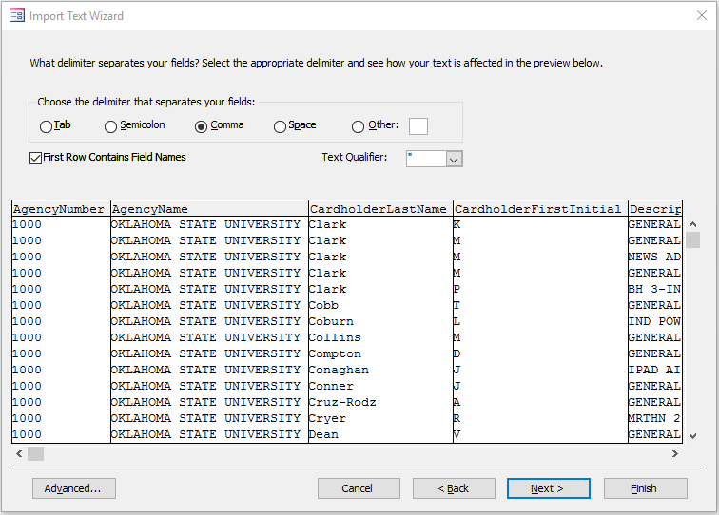
- You do not need a primary key for this database because only a single table will be used; however, go ahead and let Access assign a primary key.
- Make sure all files are appended to the first imported file so that all data is in a single table.
You should have no errors when importing data if it’s done correctly. Your final file should provide the following responses to the data questions:
File: Analytics_mindset_case_study_solutions_PCard_P3.accdb
- How many rows of data are contained in your final file?
  - 2,281,562
- What it the total sum in the Amount column?
  - 977,812,139.06

Analytics mindset
P-card
Part IV solutions:
File: Analytics_mindset_case_study_solutions_PCard_P4.accdb
The following are screenshots of how the master query, including only OSU, should look like.
Query design view | Results table
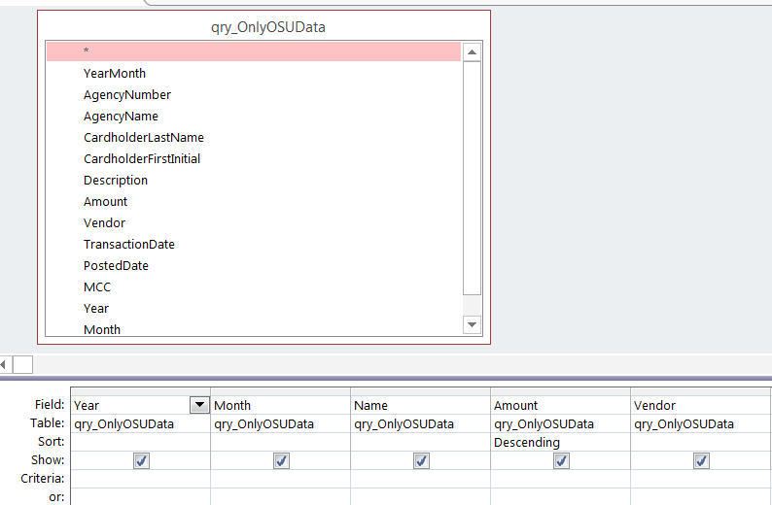 | 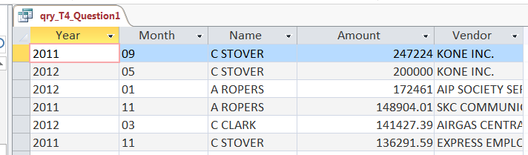
Results and conclusions
Check numbers from results table:
- Total # of records: 489,178
- Sum of Amount: $16,441,272

Queries
- Show all transactions sorted by the amount (smallest to largest), with the most expensive transactions listed first. Display the year, month, cardholder name, the amount of the transaction and the vendor.
Query design view | Results table
Results and conclusions
Check numbers from results table:
- Total # of records: 489,178
- Sum of Amount: $16,441,272
- Show all transactions that occurred in the 2014 calendar year sorted by month and then, within each month, list the most expensive transactions first and then alphabetize them by the name of the employee. Display the year, month, cardholder name, the amount of the transaction and the vendor.
Query design view | Results table
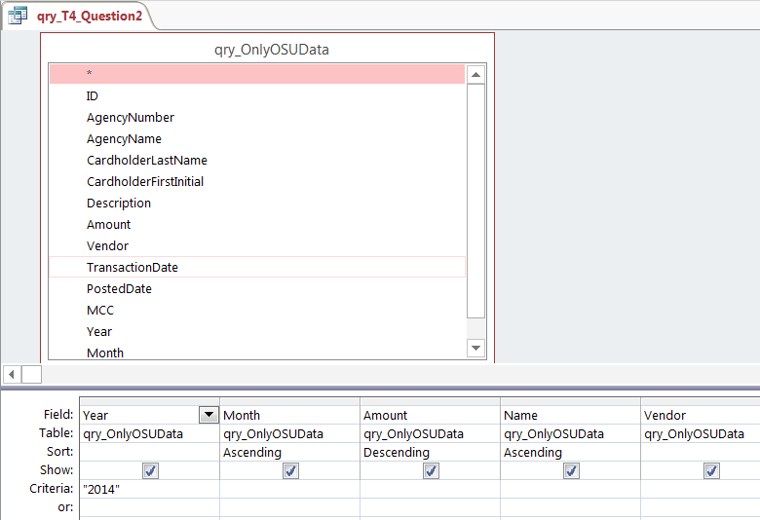 | 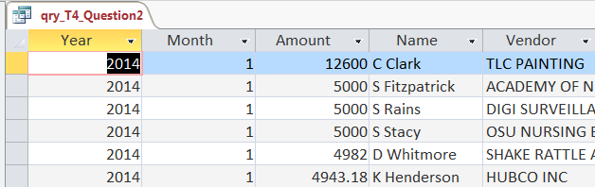
Results and conclusions
Check numbers from results table:
- Total # of records: 116,031
- Sum of Amount: $33,504,148

- Show all transactions that occurred in the 2014 calendar year more than $3,000. Sort by month and then, within each month, list the most expensive transactions first and then alphabetize them by the name of the employee. Display the year, month, cardholder name, the amount of the transaction and the vendor.
Query design view | Results table
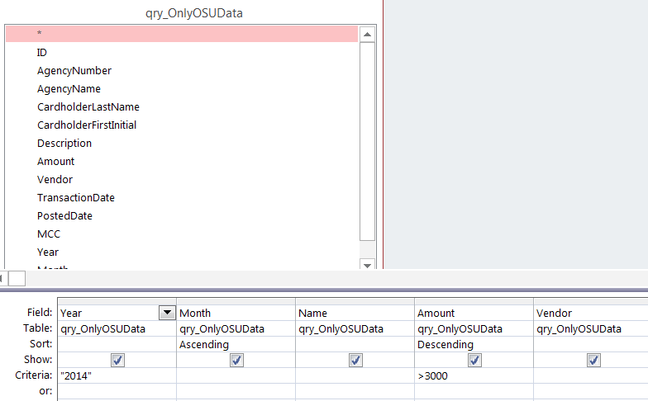 | 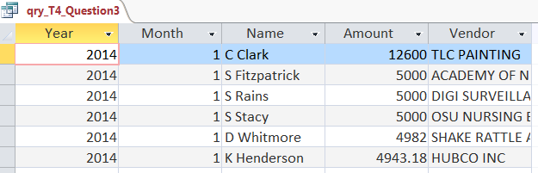
Results and conclusions
Check numbers from results table:
- Total # of records: 1,197
- Sum of Amount: $4,956,475.56
- Show all transactions that came from a vendor with Amazon somewhere in the name that occurred in the 2014 calendar year that are more than $3,000. Display the vendor name, employee name, amount, year and month. Sort by amount so the smallest amount is listed first.
Query design view | Results table
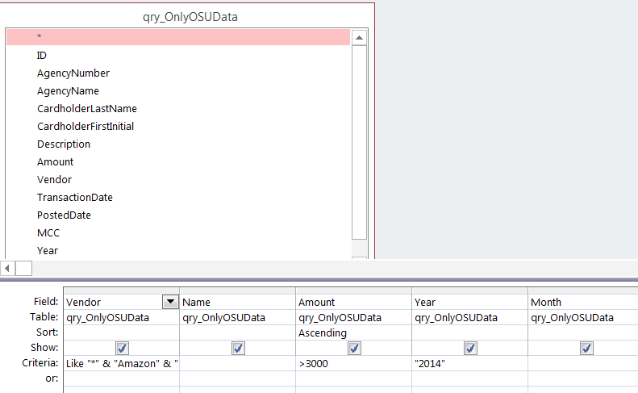 | 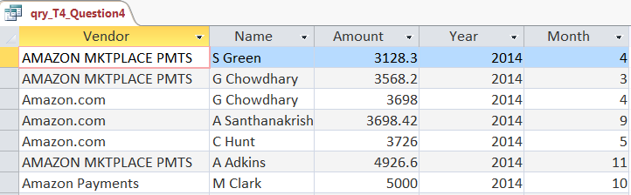
Results and conclusions
Check numbers from results table:
- Total # of records: 7
- Sum of Amount: $27,745.52
- What is the total number of P-card transactions in the database? Label the column TotalTrans.
Results table
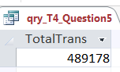
- What is the total number of P-card transactions in the database with amounts more than or equal to $5,000? Label the column TotalTransGT5k.
Results table
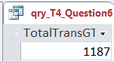
- What is the total dollar amount of transactions returned from January to March, inclusive, in 2014? Label the column TotalReturns2014Q1.
Results table
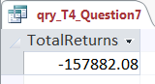

- What is the total number of P-card transactions in the database for each year? Sort the data by year so the most recent date is listed first. Label the column with the counts TotalTrans.
Query design view | Results table
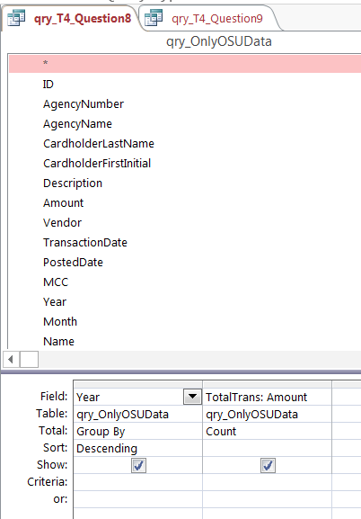 | 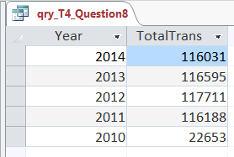
- List the names of all cardholders sorted by the most transactions in the 2014 calendar year. Display the name and number of transactions (labeled NumTrans).
Query design view | Results table
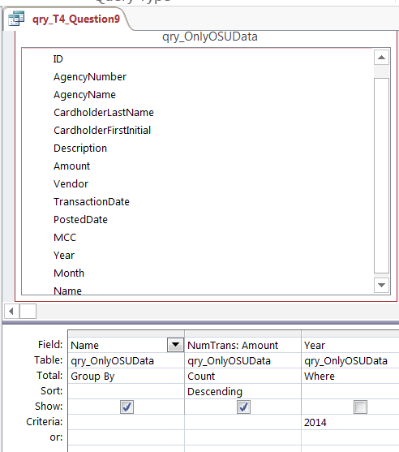 | 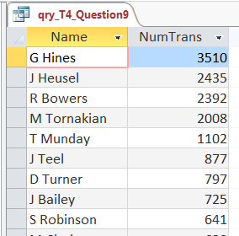
Results and conclusions
Check numbers from results table:
- Total # of records: 2,009
- Sum of NumTrans: 116,031
- List the names of all people sorted by the largest dollar amount of goods in the 2014 calendar year. Display the name, total amount of returned goods (labeled ReturnedGoodsValue) and total number of returned transactions (labeled ReturnedGoodsCount).
Query design view | Results table
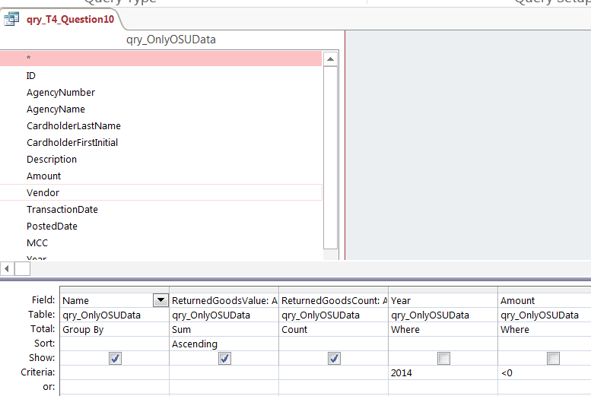 | 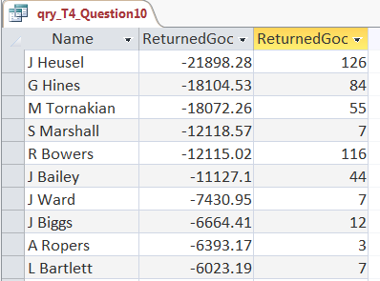

Results and conclusions
Check numbers from results table:
- Total # of records: 1,050
- Sum of ReturnedGoods: ($629,445.26)
- Compute the amount of sales tax for each transaction that would have been paid if OSU was required to pay sales tax in December 2014. The state sales tax rate is 4.5%. Display the month, year, cardholder name, description, vendor name, amount and computed sales tax amount (labeled SalesTax). Sort by the sales tax amount so the largest items appear at the top.
Query design view | Results table
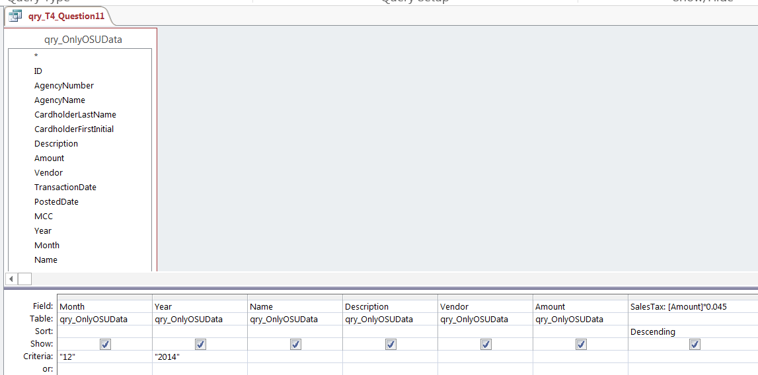 | 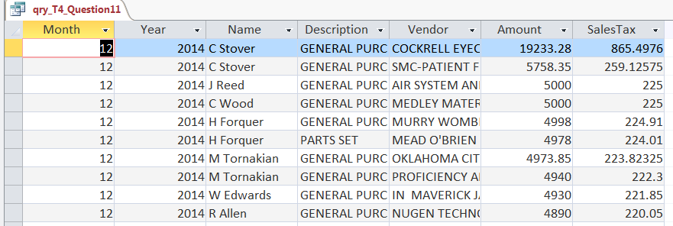
Results and conclusions
Check numbers from results table:
- Total # of records: 6,907
- Sum of Amount: $218,826.45
- Sum of SalesTax: $98,497.19
- The university would like to know how much money it saves because it does not pay state sales tax. The state sales tax rate is 4.5%. If you assume all sales are made net of the state sales tax, how much money in sales tax did OSU avoid paying to the government via P-card transactions each calendar year? Show the year, total amount spent and total sales tax amount saved (labeled SalesTaxSaved). Make sure to round dollar figures to the nearest cent using the Property Sheet, and use the Format field (use the currency format) rather than a formula. Sort the data by year with the most recent year listed first.
Query design view | Results table
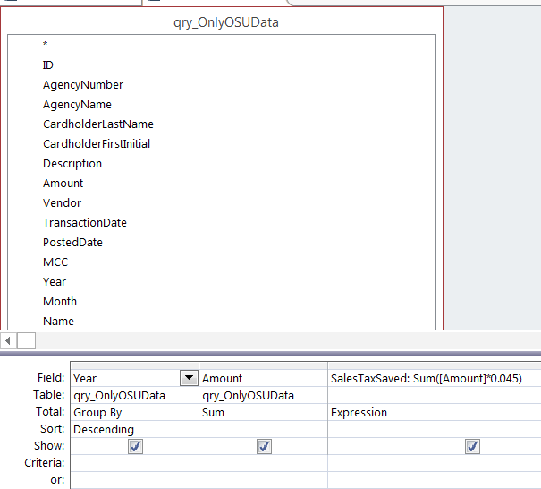 | 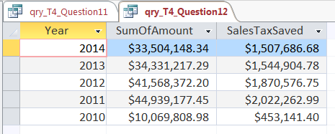

Results and conclusions
Check numbers from results table:
- Total # of records: 5 (1 per year)
- SumOfAmount: $164,412,724.26
- Sum of SalesTaxSaved: $7,398,572.59
- Related to problem 12., the university estimates it had to pay sales tax in other states 30% of the time. Reperform problem 12., but only compute the savings as 70% of the transaction total instead of 100%. Make sure to round dollar figures to the nearest cent using the Property Sheet, and use the Format field (use the currency format) rather than a formula.
Query design view | Results table
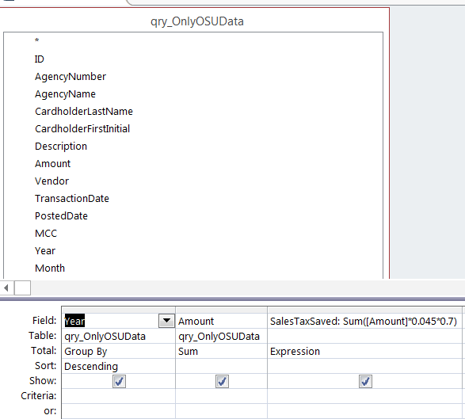 | 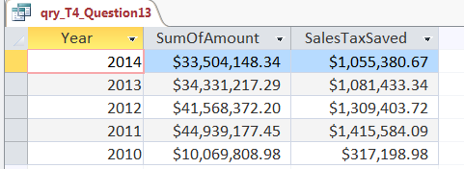
Results and conclusions
Check numbers from results table:
- Total # of records: 5 (1 per year)
- SumOfAmount: $164,412,724.26
- Sum of SalesTaxSaved: $5,179,000.81
- Compute the number of days between the transaction date and the posted date for all transactions in November 2014. Display the month, year, cardholder name, description, vendor name, amount and amount of time (labeled TimeDif). Numbers should be positive if the posted date was after the transaction date. Sort by the TimeDif and then the name of the employee so items that took the most days appear on the top.
Query design view
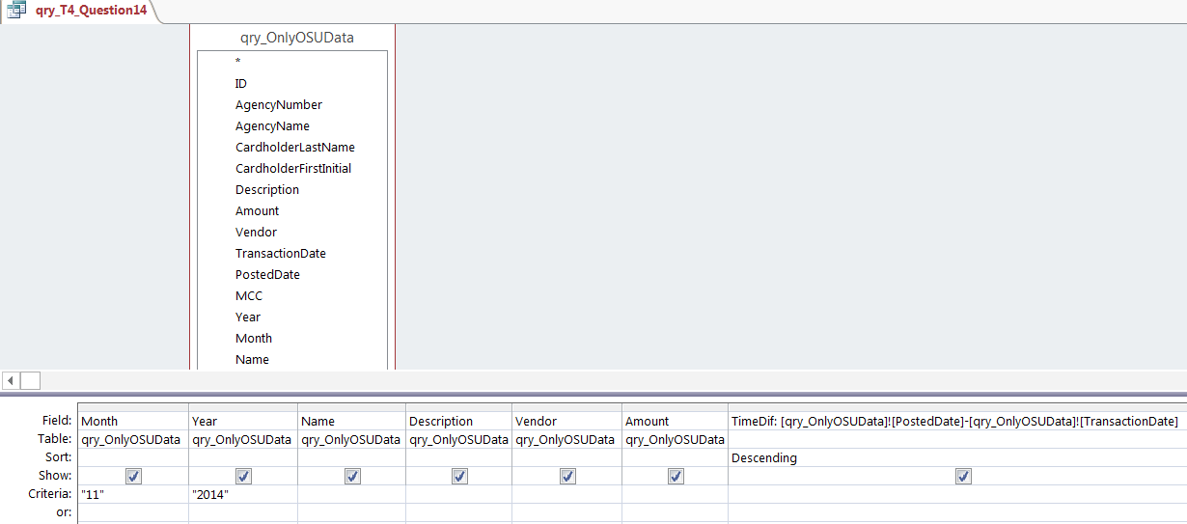

Results table
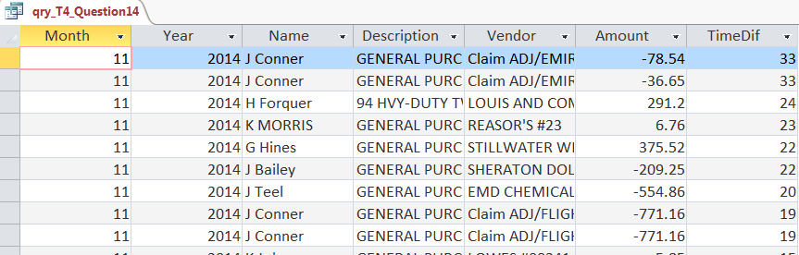
Results and conclusions
Check numbers from results table:
- Total # of records: 8727
- Sum of Amount: $2,298,796.83
- Sum of TimeDif: 15,853
- Create a risk ranking of returned items in 2014. Create a new column of data that shows whether something is high risk, medium risk or low risk based on the following criteria. If the return was equal to or more than $1,000, it is high risk; if the return is equal to or more than $500 and less than $1,000, it is medium risk; and if the return is less than $500, it is low risk. Display the year, name of the cardholder, description, vendor, amount of return and the new column (labeled RiskRanking). Sort the data so that the largest returns are listed first, and do not list any data that is not a return. As a hint, remember returns are listed as negative numbers — make sure to think about this carefully.
Query design view
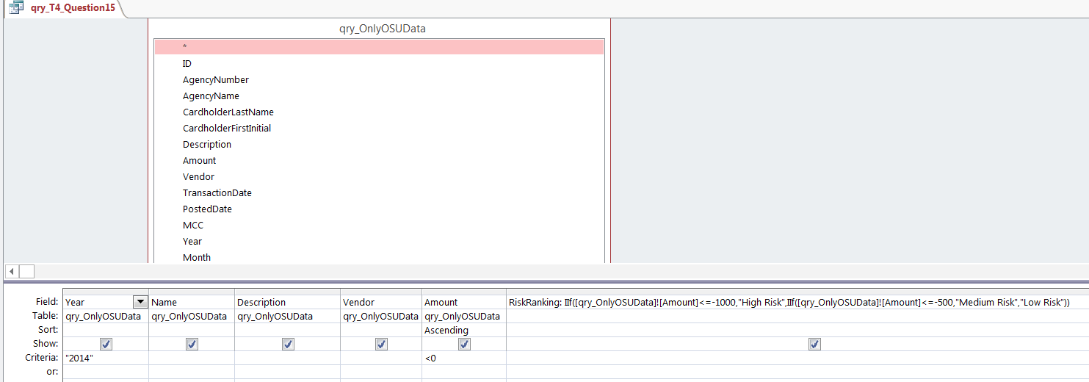
Results table
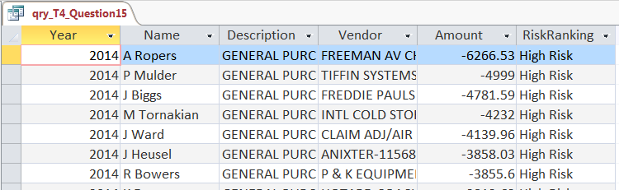
Results and conclusions
Check numbers from results table:
- Total # of records: 3791
- Sum of Amount: ($629,445.26)
- OSU potentially can earn money from Amazon.com if employees make their purchases at smile.amazon.com and direct the earnings to OSU. Assume that for all transactions at the vendor Amazon.com, OSU would earn 0.75% for transactions $500 and more and 0.50% for transactions less than $500. What is the total amount that OSU would earn for 2014 based on these figures? Label the column AmazonEarnings in your output.
Query design view | Results table
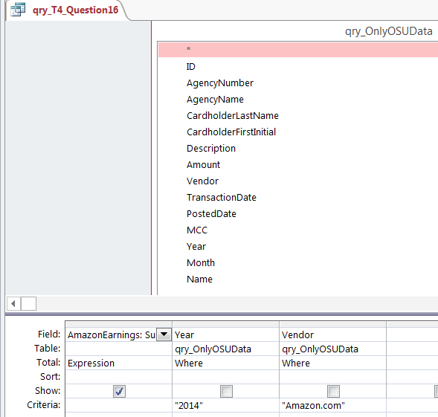 | 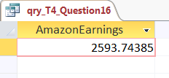

- Use a cross-tab query to display the total amount spent per MCC each year. List years across the top of the query. Sort in alphabetical order by MCC.
Query design view | Results table
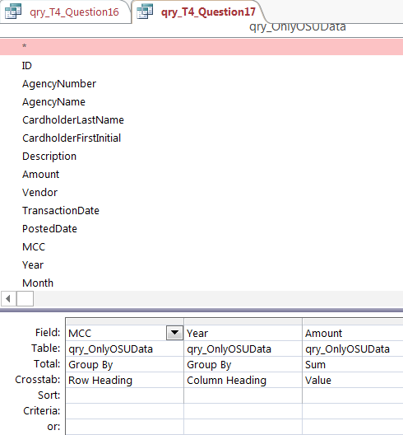 | 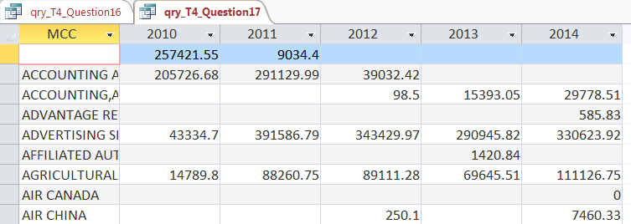
Results and conclusions
Check numbers from results table:
- Total # of records: 501
- Sum of 2010: $10,069,808.98
- Sum of 2014: $33,504,148.34
- Use a cross-tab query to display the total number of transactions for each month of each year. Display each year across the top of the query and each month in the rows. Sort so January is first, then February, etc.
Query design view | Results table
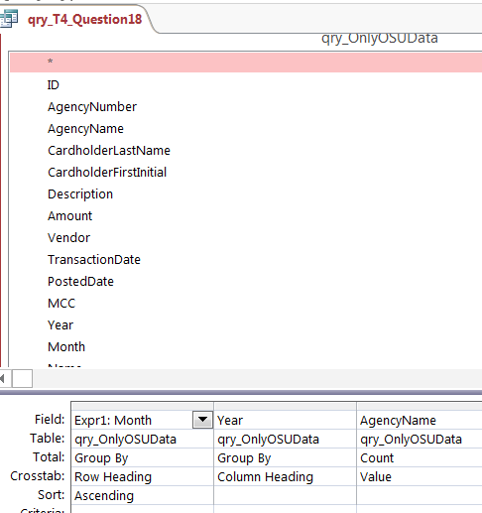 | 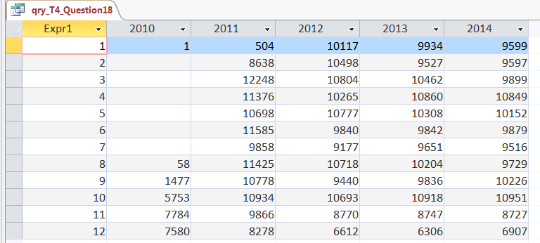
Results and conclusions
Check numbers from results table:
- Total # of records: 12
- Sum of 2010: $22,653
- Sum of 2014: $116,031
- Show all transactions that occurred in the year specified by users. Sort the output by month and then, within each month, list the most expensive transactions first and then alphabetize them by the name of the employee. Display the year, month, cardholder name, the amount of the transaction and the vendor.
Query design view | Results table
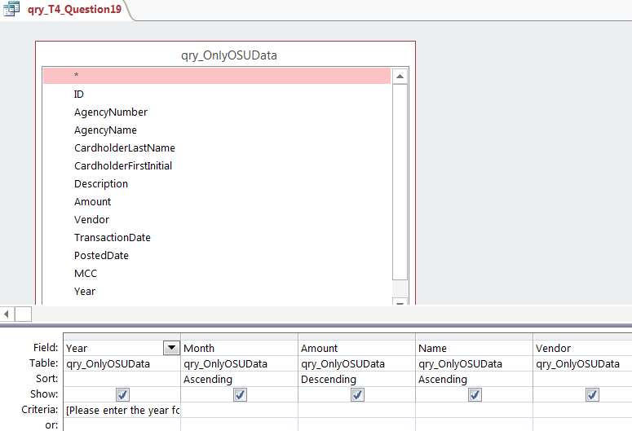 | 2014 example  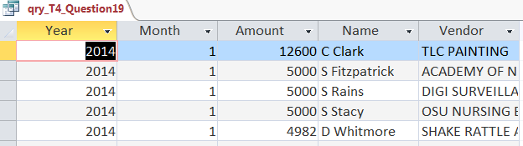
Results and conclusions
Check numbers from results table (2014 example):
- Total # of records: 116,031
- Sum of Amount: $33,504,148
- Show all transactions that occurred that match whichever part of the name the user entered for the vendor. For example, if the user entered Amz, then all transactions that have those letters, anywhere in the vendor name, should be returned. Display the names of the vendors and the total of all transactions (labeled TotalPurchases) with that vendor in the database. Sort the results alphabetically by the name of the vendor.
Query design view | Results table
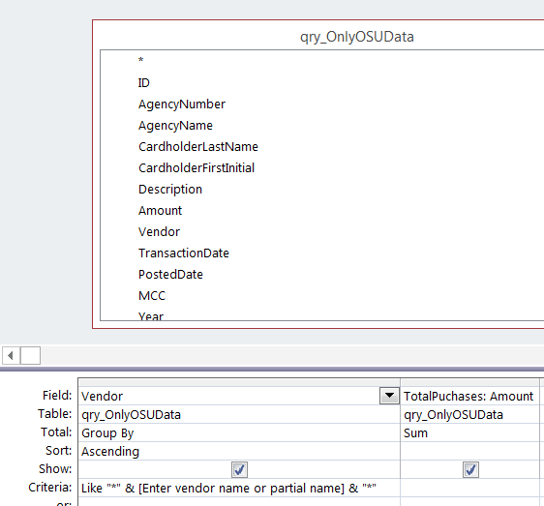 | (Example: Walmart)  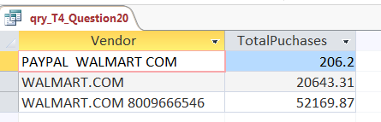
Results and conclusions
Check numbers from results table:
- Total # of records: 3
- Sum of TotalPurchases: $73,019.38
- Show all 2014 transactions sorted by amount (with the most expensive transactions listed first) that are more than the average transaction amount for 2014. Display the year, month, cardholder name, the amount of the transaction and the vendor.
Query design view (for final query)
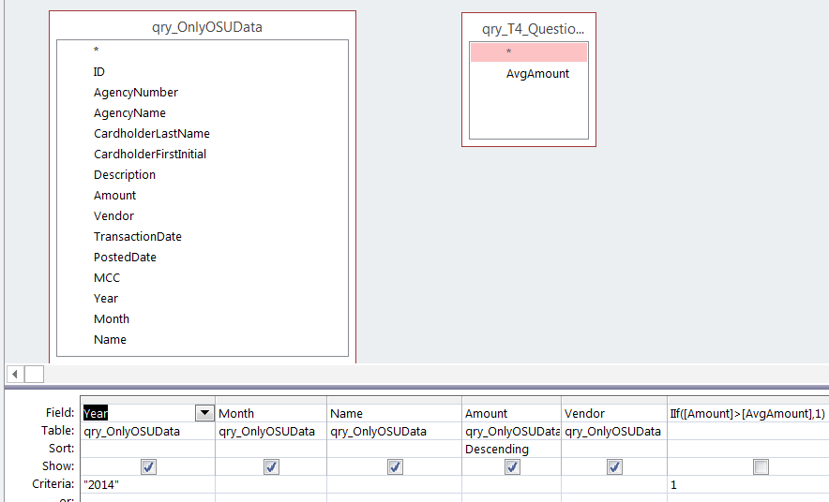
Results table
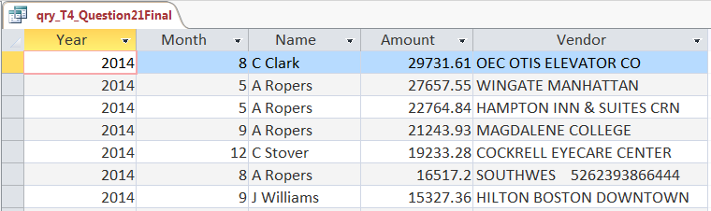
Results and conclusions
Check numbers from results table:
- Total # of records: 29,640
- Sum of Amount: $26,930,594

- List how much more or less was spent at each vendor in 2014 than in 2013. Only include companies for which there was a purchase in both 2013 and 2014. Display the vendor name and the difference between the amounts spent in 2014 and 2013 (labeled DiffSpending) with positive numbers indicating more was spent in 2014 than in 2013 (and sort the results so the largest increases in spending are listed at the top).
Query design view | Results table
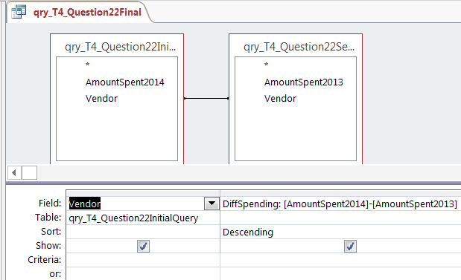 | 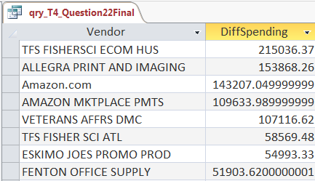
Results and conclusions
Check numbers from results table:
- Total # of records: 6,198
- Sum of DiffSpending: ($249,257.73)
- Show all 2014 vendors from which employees purchased more during the year than the total amount spent at the top vendor in 2013. Display the total amount of the transactions (labeled TotalSpent) and the vendor. Sort the results by the total amount of the transactions, with greater totals listed first.
  - It is likely that this question will take four queries.
Query design view (for final query) | Results table
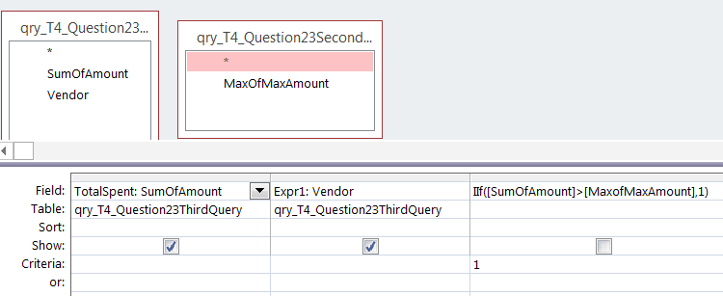 | 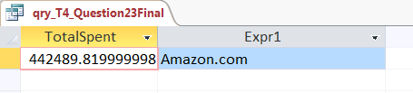

- Create a query that calculates the percentage increase or decrease in the number of transactions for 2012, 2013 and 2014 relative to 2011. That is, the query should include two output columns, with the first being the year (using 2012, 2013 and 2014 as rows) and the second column should be labeled PercDiffFrom2010. Calculate the percentage increase or decrease in transactions since 2011 as follows: (# of transactions in 201X – # of transactions in 2011) / (# of transactions in 2011)*100 and round to two decimal spaces using the Round formula. As a hint, do not count a field that has some null values, like the Description field, because this will give you the wrong answer.
  - It is likely that this question will take three queries.
Query design view (for final query) | Results table
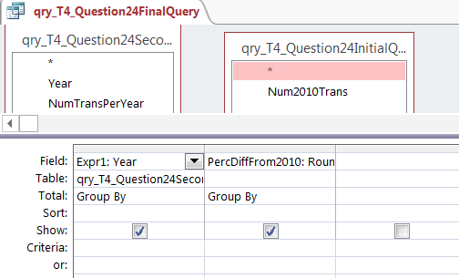 | 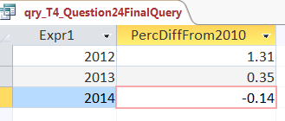
Results and conclusions
Check numbers from results table:
- Total # of records: 3
- Sum of PercentDiffFrom2010: 1.52

Analytics mindset
P-card
Part V solutions:
Task 5
File: Analytics_mindset_case_study_solutions_PCard_P5.accdb
1. The user shall not spend more than $50,000 per year.
Query design table | Results table | Results and conclusions
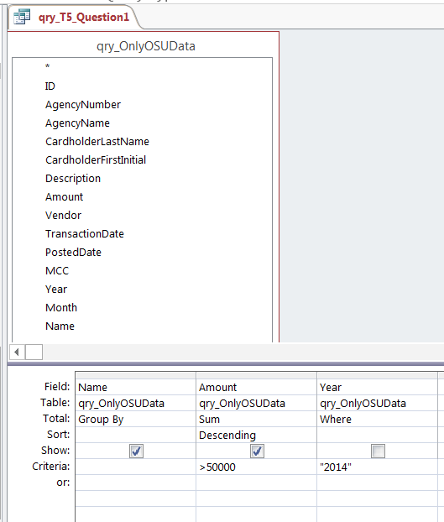 | 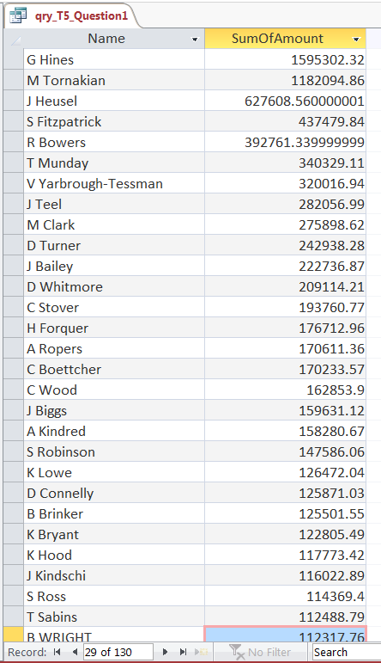 | The results show 130 employees spent more than $50,000 per year.  *Internal audit needs to follow up to determine whether these exceptions were approved properly.

2. The user shall not spend more than $10,000 per month without approval.
Query design table | Results table | Results and conclusions
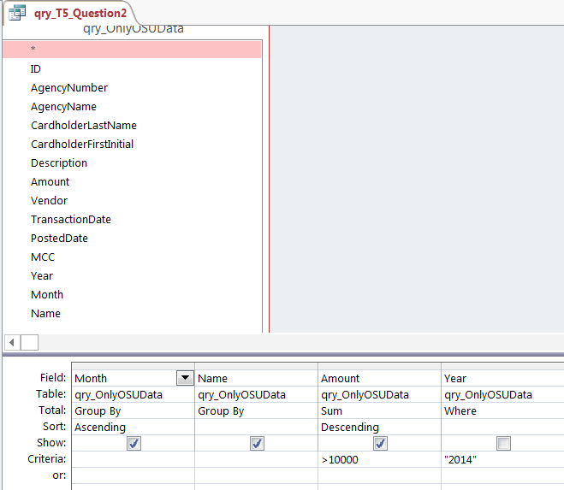 | 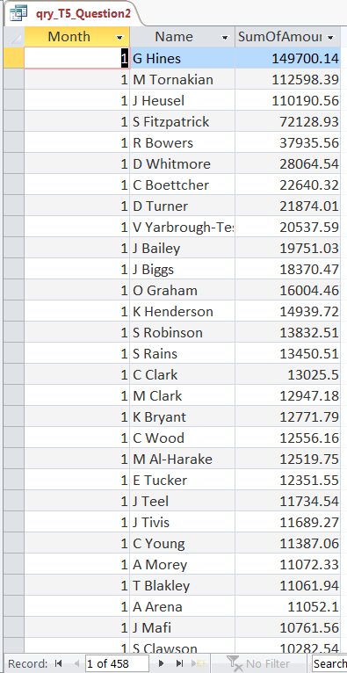 | There were 458 instances of employees spending more than $10,000 per month.  *Internal audit needs to follow up to determine whether these exceptions were approved properly.

3. The user shall not spend more than $5,000 per transaction.
Query design view
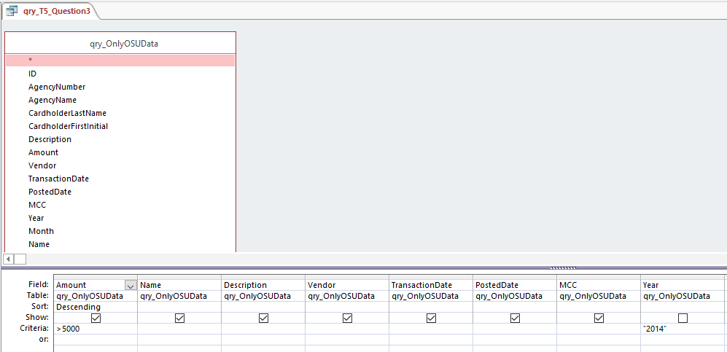
Results table
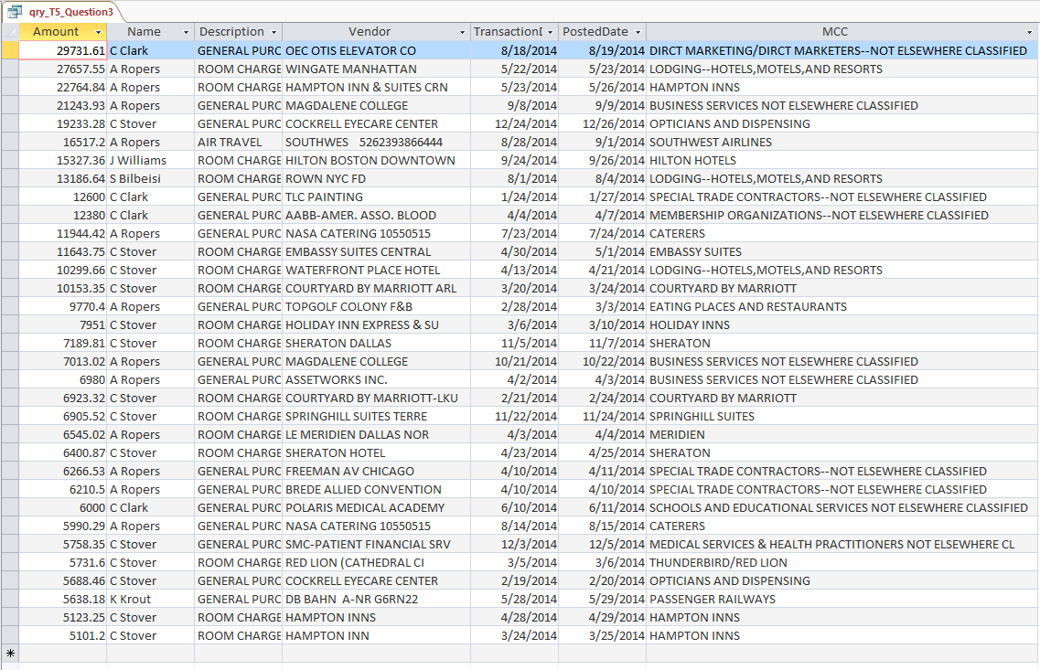
Results and conclusions
There were 33 transactions that exceeded the $5,000 limit.
*Internal audit needs to follow up to determine whether these exceptions were approved properly.

- Employees cannot split an amount that is more than $5,000 between two or more swipes of the P-card.
Query design table | Results table
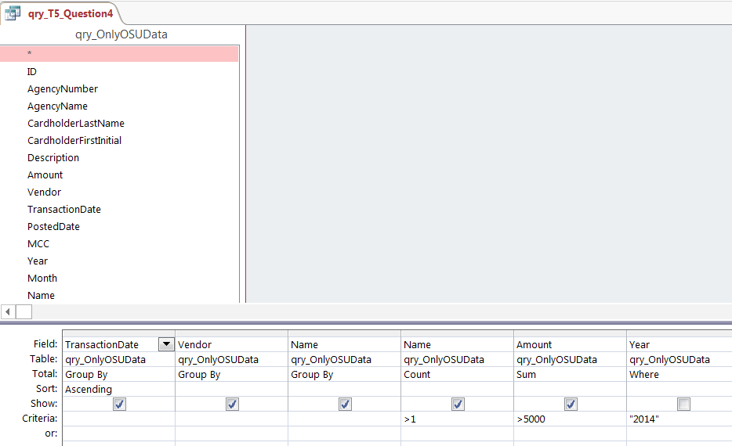 | 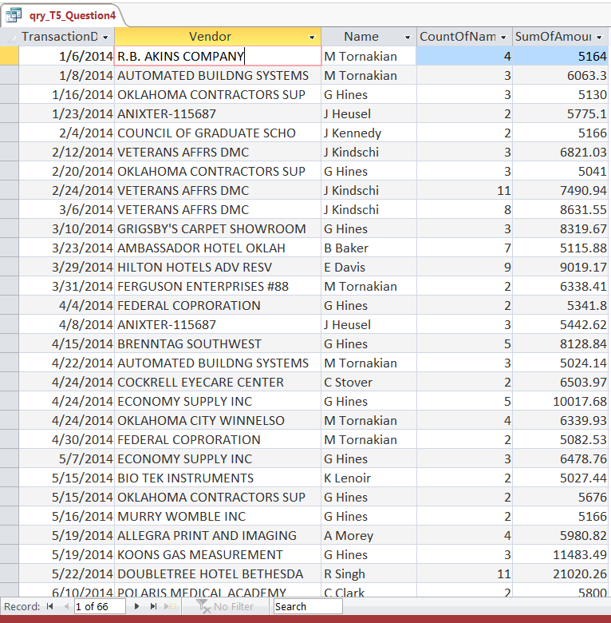
Results and conclusions
There are 66 sets of combined transactions in which each part of combined transaction was made by the same employee with the same vendor on the same day and exceeded $5,000. This pattern of activity suggests that employees were trying to avoid exceeding the $5,000 limit so that their transactions would not be flagged.
*Internal audit needs to follow up to determine whether these exceptions were approved properly.

- Employees cannot split a purchase between two or more cardholders.
Query design table | Results table
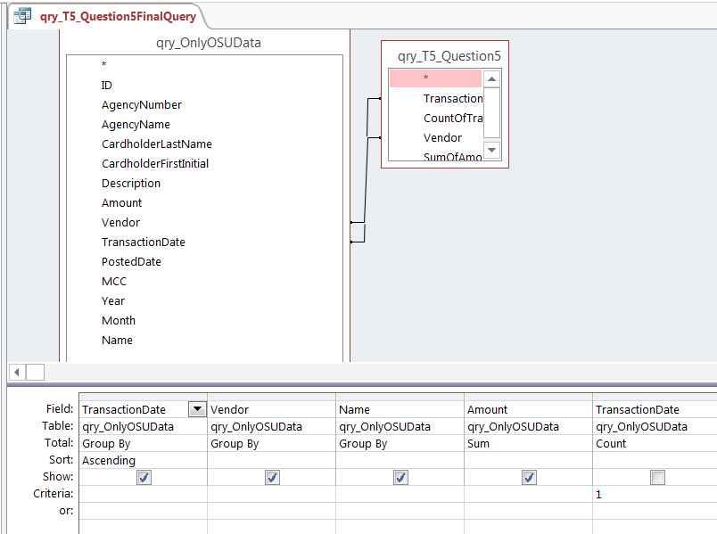 | 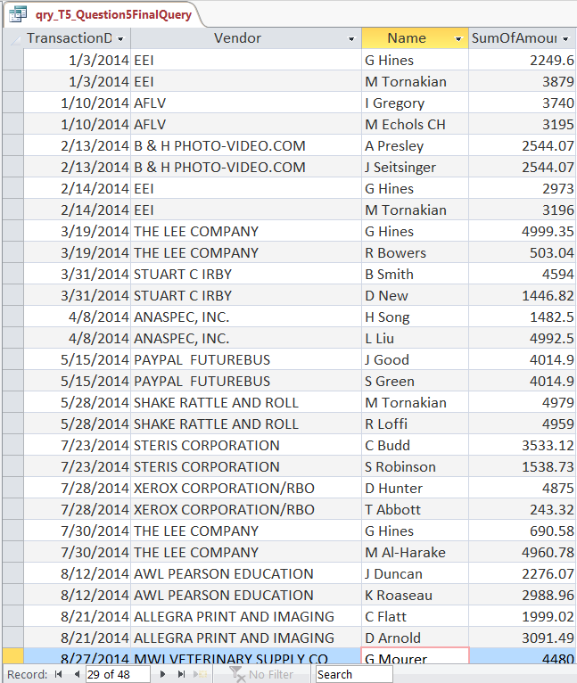
Results and conclusions
There are 24 separate instances in which two employees made a purchase from the same vendor on the same day as part of the same transaction in which the total exceeded the $5,000 limit. These employees may have been colluding to circumvent the $5,000 purchase limit.
*Internal audit needs to follow up to determine whether these exceptions were approved properly.

- Employees cannot split a purchase between two or more vendors.
Query design table | Results table
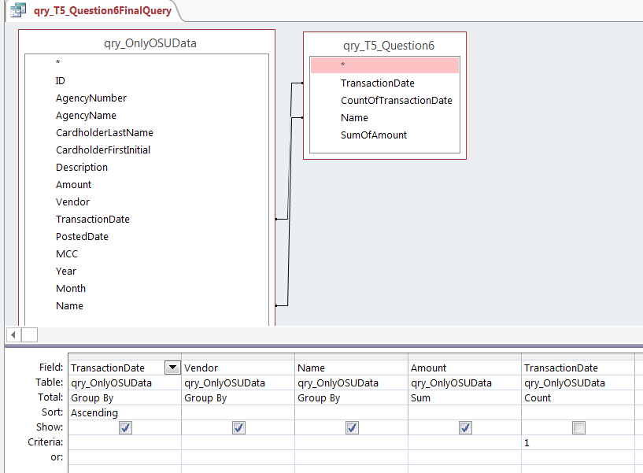 | 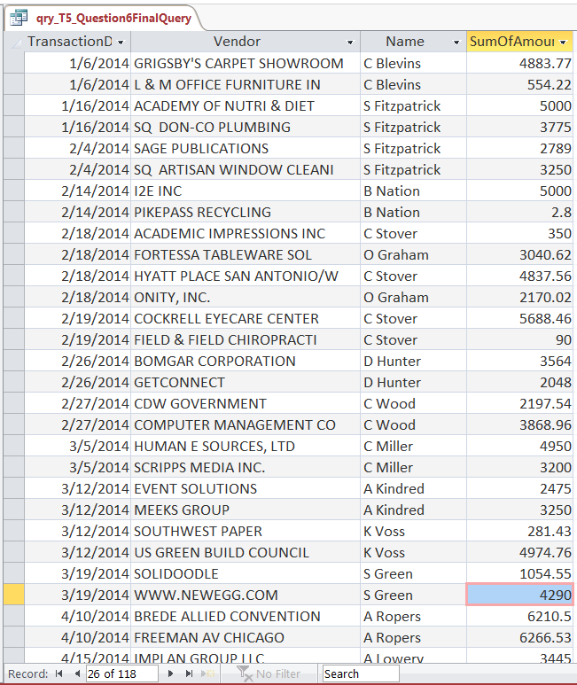
Results and conclusions
There are 59 instances of individual employees making multiple purchases in a single day at 118 vendors that collectively exceed $5,000 combined. These transactions should be further analyzed. These transactions may indicate that employees are trying to avoid meeting the $5,000 limit. However, a quick perusal of some of the vendors shows that, at least in some instances, these are two very different vendors (e.g., Sage publications and Artisan Window Cleaning), suggesting that they are not related transactions.

- Transactions are prohibited for food and mileage expenses while in traveling. A per diem for food expenses and mileage may be claimed using a travel voucher.
Query design table
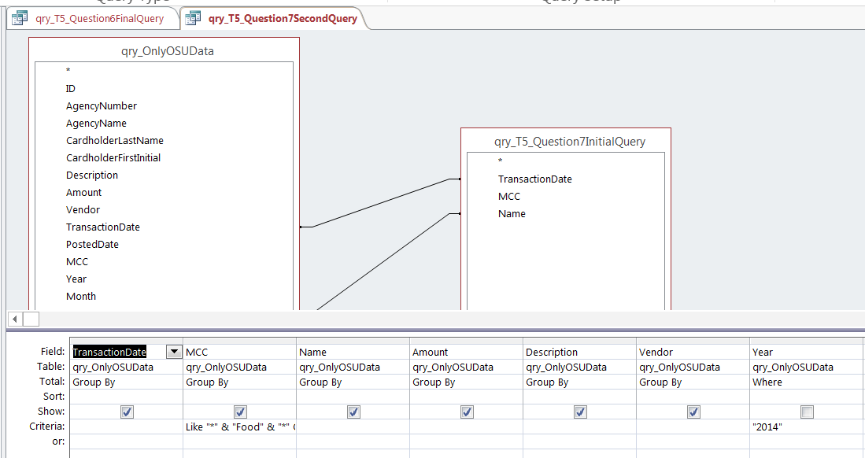
Results table
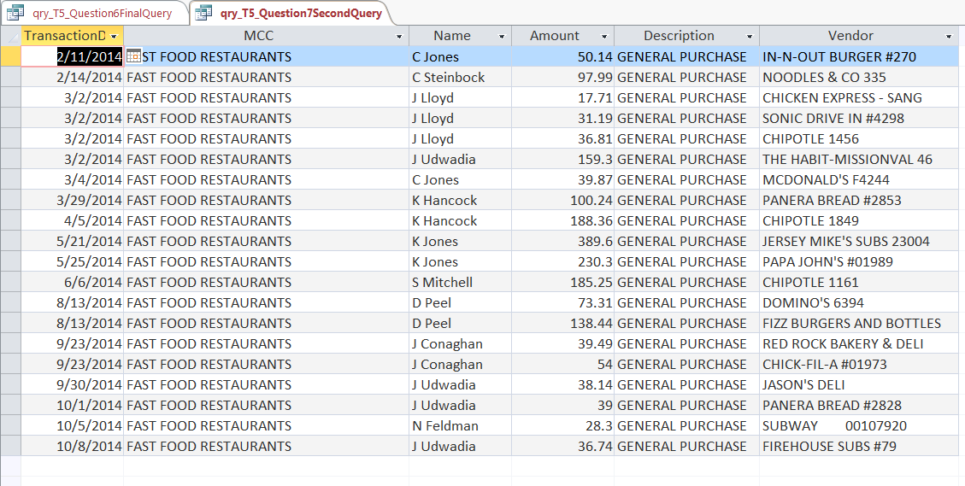
Results and conclusions
There are 100 transactions for food purchases on the same dates that employees were traveling.
*Internal audit needs to follow up to determine whether these exceptions were approved properly.

Analytics mindset
P-card
Part VI solutions:
Task 6
File: Analytics_mindset_case_study_solutions_PCard_P6.accdb
Video: Analytics_mindset_case_study_solutions_PCard_P6.mp4
A possible format of the form is presented below.
Design view | Form view
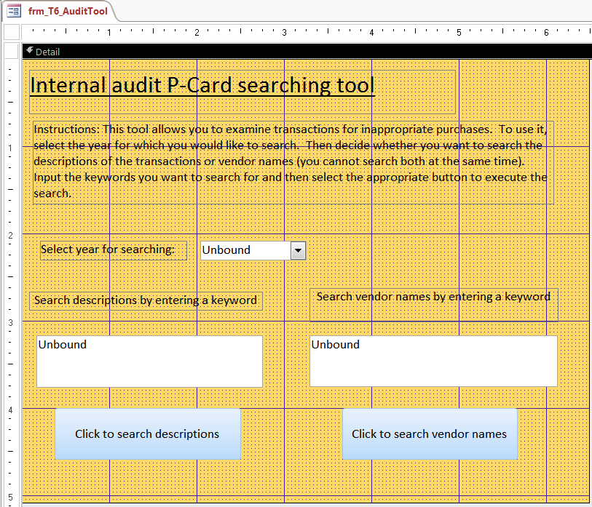 | 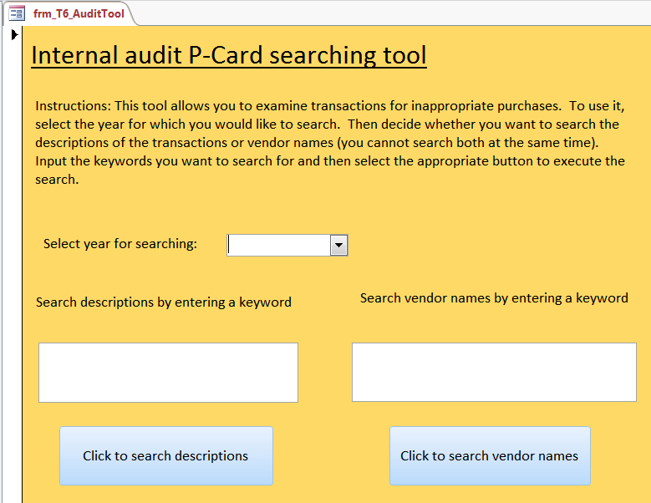
To make the form useful, the form must launch a query. The queries will use parameters so that the criteria entered into the form are passed to the query as criteria. See the video file referenced above for a step-by-step approach to building this functionality. Below, we summarize some of the key steps and details.
- You must first create a query. Here is what the query looks like when querying the Description field.
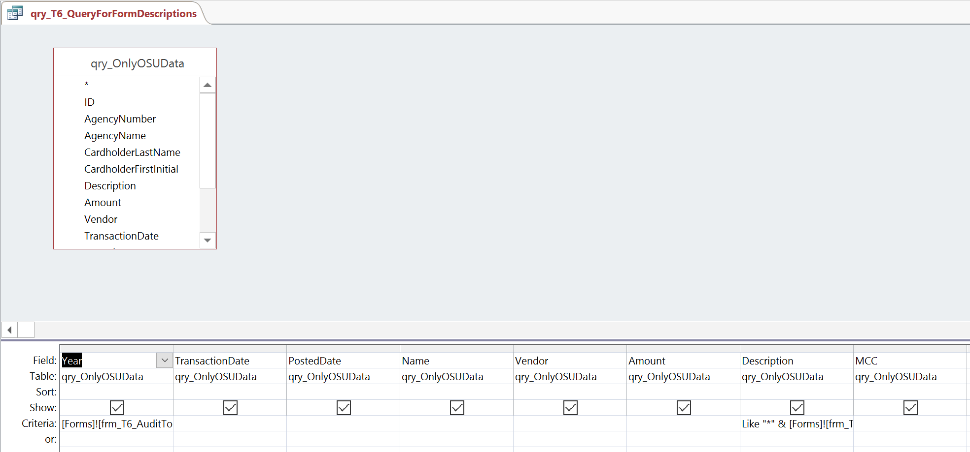
  - The text listed in the Criteria line is as follows:
    - In the Year column: [Forms]![frm_T6_AuditTool]![txt_T6_AuditTool_Year]
    - In the Description column: Like “*” & [Forms]![frm_T6_AuditTool]![txt_T6_AuditTool_Description] & “*”
  - To build these criteria, you can use the Builder function on the Design tab in the Query setup grouping. Select the appropriate form in the Expression Elements field. Then, you need to find the name of your text box using the year and the description in the Expression Categories box.
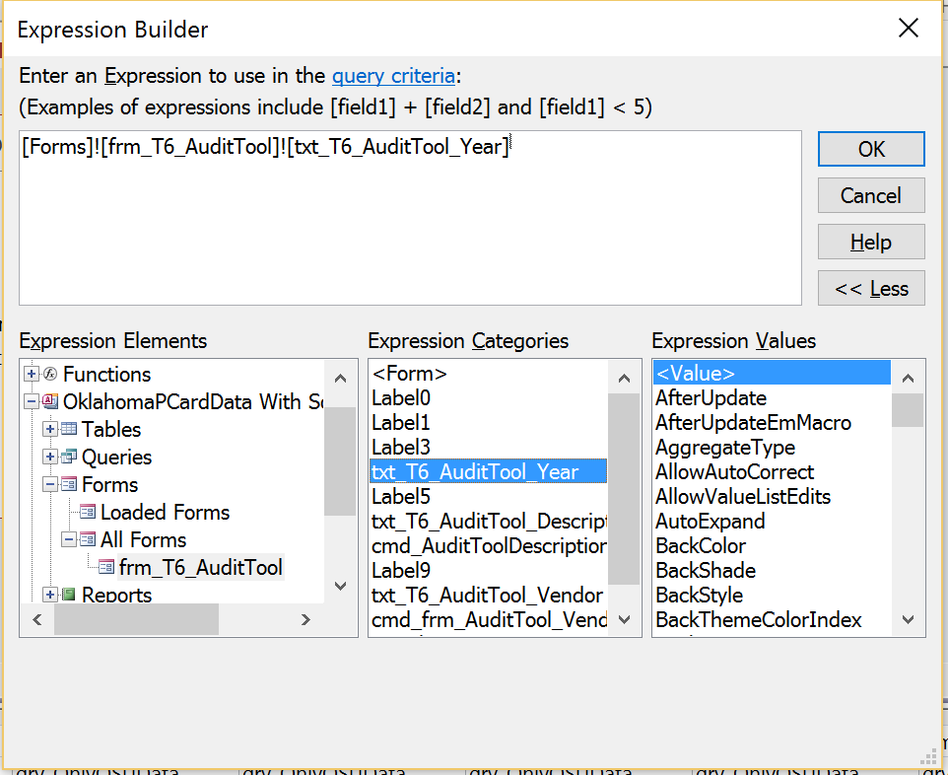

  - Here is an explanation of the text entered in the Descriptions field (i.e., Like “*” & [Forms]![frm_T6_AuditTool]![txt_T6_AuditTool_Description] & “*”):
    - The LIKE command tells Access to search for information that is similar to the string that follows. The asterisk allows any characters, and any number of characters, to be present. The ampersand concatenates the Like and asterisk function, to the text that it pulls from the field on the form. Then the ampersand and asterisk at the end of the formula say that any text can appear after the description.
    - This particular formula allows the auditor to do a more general search, rather than an exact text search of the Description field. Without the concatenated asterisk, the search would look for the exact text entered into the form. This is less useful than being able to search for only a key word or two in the entire Description field.
The form for vendors uses the same logic. Here is a screenshot showing the text entered into the Criteria field.
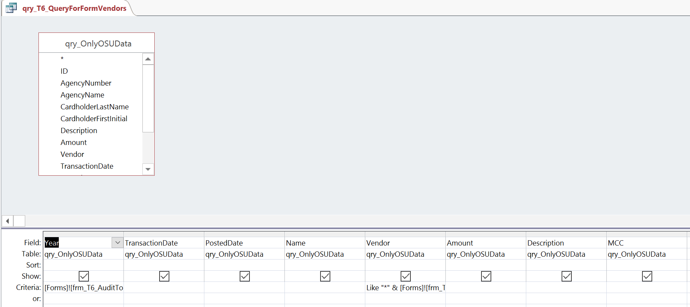
- The text listed in the Criteria line is as follows:
  - In the Year column: [Forms]![frm_T6_AuditTool]![txt_T6_AuditTool_Year]
  - In the Description column: Like “*” & [Forms]![frm_T6_AuditTool]![txt_T6_AuditTool_Vendor] & “*”

Analytics mindset
P-card
Part VII solutions:
Task 7
File: Analytics_mindset_case_study_solutions_PCard_P7.accdb
Internal auditors can help perform forensic audits to determine if fraud is taking place in the organization or by the credit card company.
Required
Using the OSU 2014 calendar year data, perform several tests for fraudulent transactions as follows, and report your results. Some of these tests are more global and function like a risk assessment to provide high-level evidence suggesting fraud, and other tests are more granular to find specific fraudulent transactions.
Label each of your solutions using the following convention: qry_T7_Question#, where # should be the question number. For example, the answer to question 3. should be labeled qry_T7_Question3. If you use multiple queries, then label the final query (i.e., the query with the solution) qry_T7_Question3Final, making sure to replace the three in the example with the question number. Some queries will require multiple queries to get the final answer. Note that just because these tests might suggest fraud or a higher likelihood of fraud, they are not definitive in nature. More work would need to be done to determine that fraud had in fact taken place.
- Write queries to conduct a Benford’s Law analysis of the first digit of all transactions from OSU in 2014.
  - The final output should be a single query that shows the percentage of transactions that begin with each of the digits one through nine.
  - From this analysis, suggest whether there is a low or high likelihood of fraud occurring.
  - Exclude all numbers less than 1.00 for this analysis and round your percentages to three decimal places.
A Benford’s Law-based test signals abnormalities. Benford’s Law indicates the expected frequencies of the specific digits in naturally occurring data. According to Benford’s Law, one will occur as the first digit in approximately 30% of data points. The following table is reproduced from Mark J. Nigrini, “A taxpayer compliance application of Benford’s Law,” The Journal of the American Taxation Association, 18 (Spring): 72-91, 1996.
 | Position in number
Digit | 1st | 2nd | 3rd | 4th
0 |  | .11968 | .10178 | .10018
1 | .30103 | .11389 | .10138 | .10014
2 | .17609 | .10882 | .10097 | .10010
3 | .12494 | .10433 | .10057 | .10006
4 | .09691 | .10031 | .10018 | .10002
5 | .07918 | .09668 | .09979 | .09998
6 | .06695 | .09337 | .09940 | .09994
7 | .05799 | .09035 | .09902 | .09990
8 | .05115 | .08757 | .09864 | .09986
9 | .04576 | .08500 | .09827 | .09982

Query design table | Results table
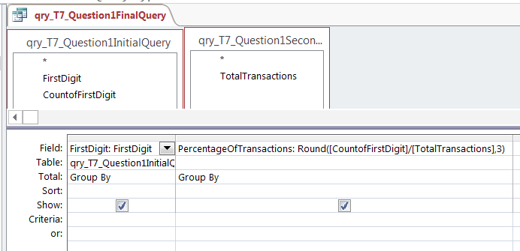 | 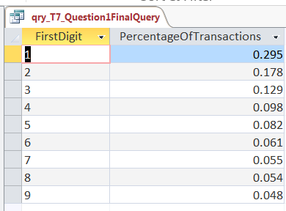
Results
The results from the first query suggest there is little likelihood of fraud based on the Benford’s Law analysis. That is, the data conforms well to the expectations from the Benford’s Law analysis.
- Transactions should only be processed once. However, it is possible that the credit card company made a mistake or a vendor submitted a payment twice. Check for duplicate payments.
  - Assume that charges made on the same day to the same vendor by a cardholder with the same first initial and last name and for the same amount are duplicates (if there are more than two charges, consider that all are possible duplicate payments).
  - Make sure to exclude all returns from your results and sort in ascending order by the transaction date and then by the vendor name.
  - Return the date of the transaction, the vendor, the cardholder name and the amount for additional testing.
Query design table
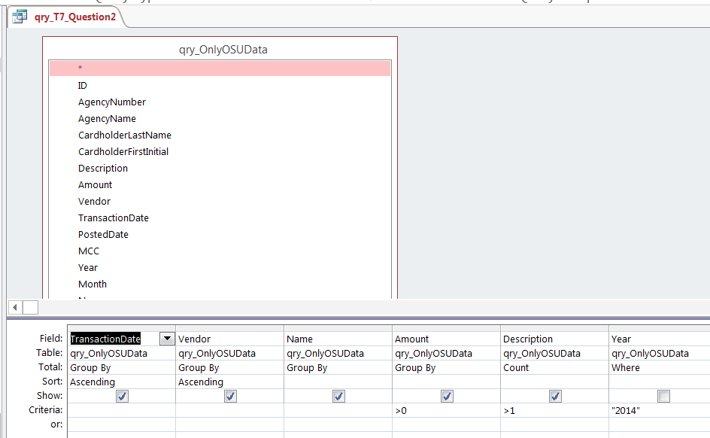
Results table
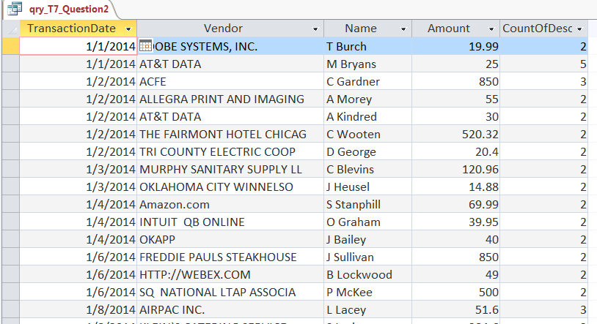
Results and conclusions
Check numbers from results table:
- Total # of records: 1,732
- Sum of Amount: $417,136.40
The results suggest there likely are several duplicate payments, which should be investigated further.
- The number of transactions to examine from the previous requirement is unwieldy. List the names of the individuals and how many times they have a possible duplicate transaction (not the number of duplicate transactions). This way, you can investigate those appearing most often on the list for infractions.
Query design table | Results table
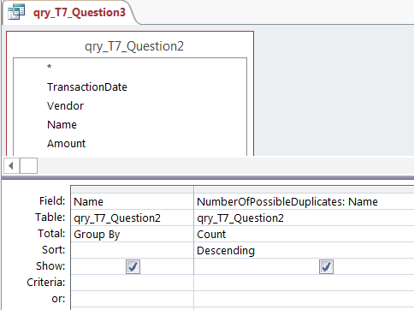 | 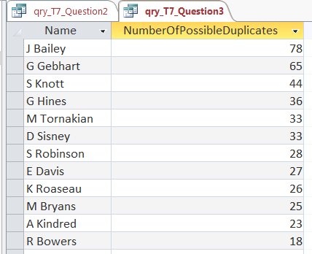
Results and conclusions
Check numbers from results table:
- Total # of records: 577
- Sum of NumberOfPossibleDuplicates: 1,732
The results suggest that these individuals should be interviewed and the transactions should be examined in more depth because of the frequency of potential violations. Additional training also may be needed for all employees, given the large number of possible problems.
- Round number transactions may indicate fraud. Return all transactions in 2014 that have four digits in the Amount field and end in 000 (ignore transactions with values of only cents).
  - Include the amount, vendor, description and name of the individual in the output.
  - Sort by ascending order and vendor name and then employee name to search for any patterns.
Query design table | Results table
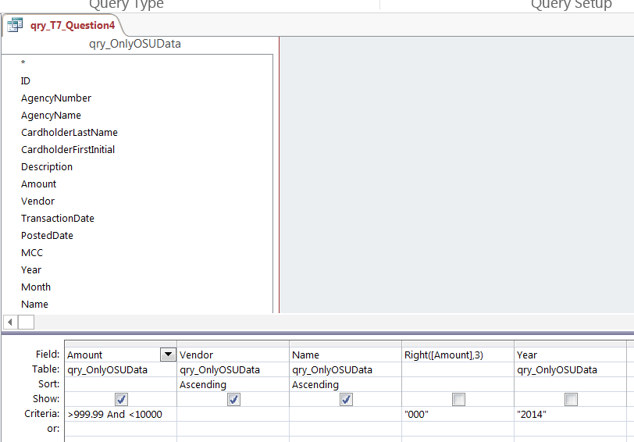 | 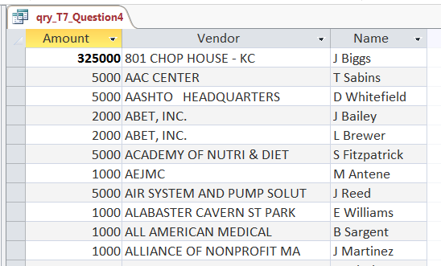
Results and conclusions
Check numbers from results table:
- Total # of records: 149
- Sum of Amount: $325,000
The results suggest a number of transactions should be investigated further. This is a weak test for fraud, but still hints at possible problems.

To learn more about Benford’s Law, see Mark J. Nigrini, “I’ve Got Your Number,” Journal of Accountancy, (http://www.journalofaccountancy.com/issues/1999/may/nigrini.html), December 1, 2016.

