**Operating System**

Information about the operating system exists outside of the /proc directory, in the /etc/os-release file.

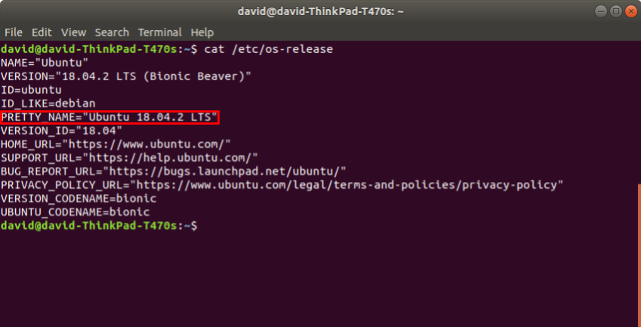

There are several strings from which to choose here, but the most obvious is the value specified by "PRETTY\_NAME".

**Kernel**

Information about the kernel exists /proc/version file.

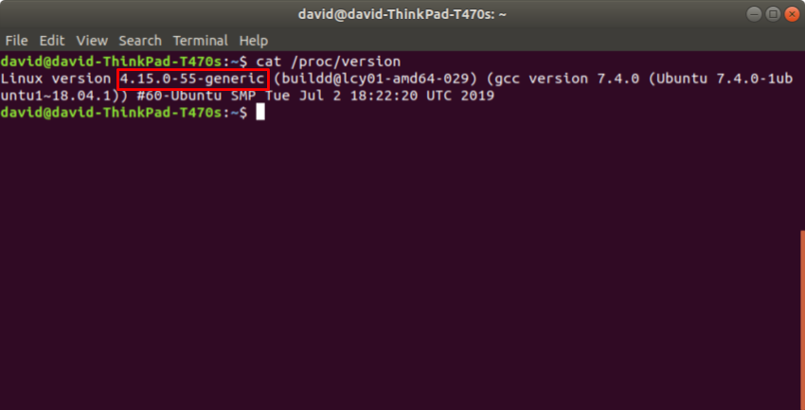

**Memory Utilization**

Information about memory utilization exists in the /proc/meminfo file.

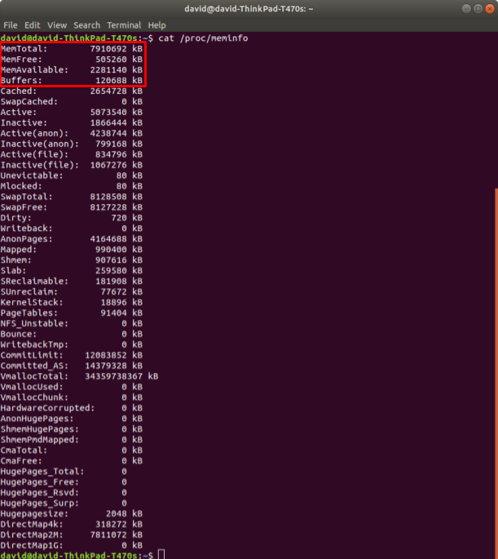

There are a [variety](https://www.thegeekdiary.com/understanding-proc-meminfo-file-analyzing-memory-utilization-in-linux/) of [ways](https://access.redhat.com/solutions/406773) to use this data to calculate memory utilization.

[Hisham H. Muhammad](http://hisham.hm/about), the author of [htop](http://hisham.hm/htop/index.php" \t "_blank), wrote a [Stack Overflow answer](https://stackoverflow.com/a/41251290) about how htop calculates memory utilization from the data in /proc/meminfo.

Use the formula that makes the most sense to you!

**Total Processes**

Information about the total number of processes on the system exists in the /proc/meminfo file.

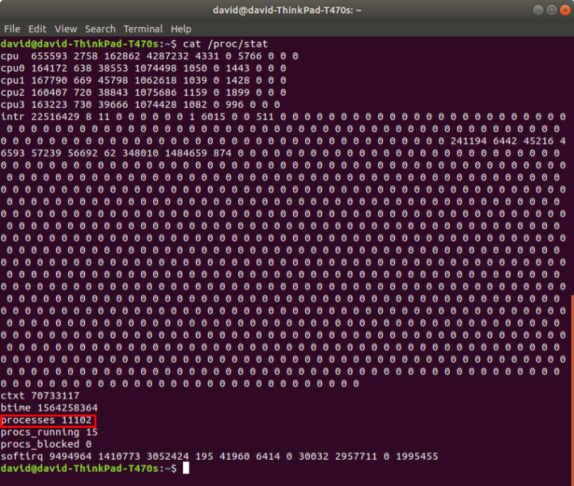

**Running Processes**

Information about the number of processes on the system that are currently running exists in the /proc/meminfo file.

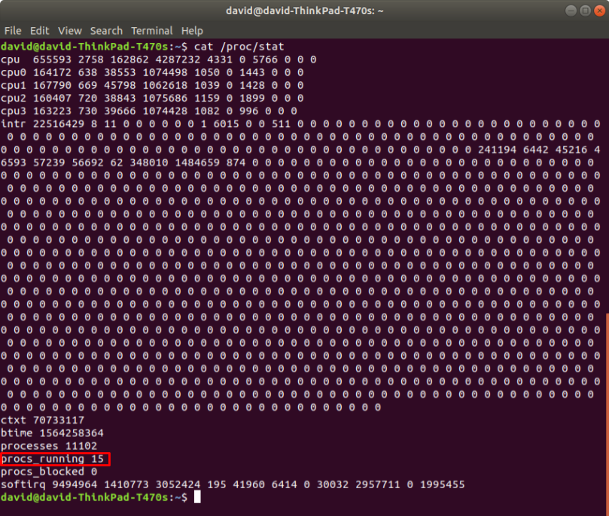

**Up Time**

Information about system up time exists in the /proc/uptime file.

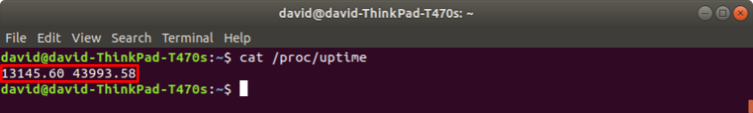

*This file contains two numbers (values in seconds): the uptime of the system (including time spent in suspend) and the amount of time spent in the idle process.*

From the [*man* page for proc](http://man7.org/linux/man-pages/man5/proc.5.html)