Online Appointment Scheduling workflow:

Summary:

The overall documentation is good, but the info is not updated. I encountered errors executing the following tasks,

1. Creating a few appointments slots. ( see error and details below)

Used Practice id 1128700

## Step 1: Get a list of departments

Required fields: practice id (1128700)

[GET](https://docs.athenahealth.com/api/api-ref/departments-reference#Get-list-of-all-departments) [/v1/{practiceid}/departments](https://docs.athenahealth.com/api/api-ref/departments-reference#Get-list-of-all-departments)

Executed successfully on sandbox

## Step 2: Get a list of providers

Required fields: practice id (1128700)

GET /v1/{practiceid}/providers

Executed successfully on sandbox

## Step 3: Get specific appointment reason

Required fields: Practiceid, departmentid and providerid (1128700, 1, 11)

[GET](https://docs.athenahealth.com/api/api-ref/appointment-reasons#Get-list-of-appointment-reasons) [/v1/{practiceid}/patientappointmentreasons](https://docs.athenahealth.com/api/api-ref/appointment-reasons#Get-list-of-appointment-reasons)

Executed successfully on sandbox

## Step 4: Create new appointment slots

Creating some slots for provider id 40 for 02/17/2022 , 3 30 mins slots for 10am, 11am and 200pm

Documentation for appointment type of format hh24:30 Is not clear. I tried the following formats for an 3 slots, 10:30, 11:30, 14:30 for 1000am, 11am and 200pm slots

ERROR:

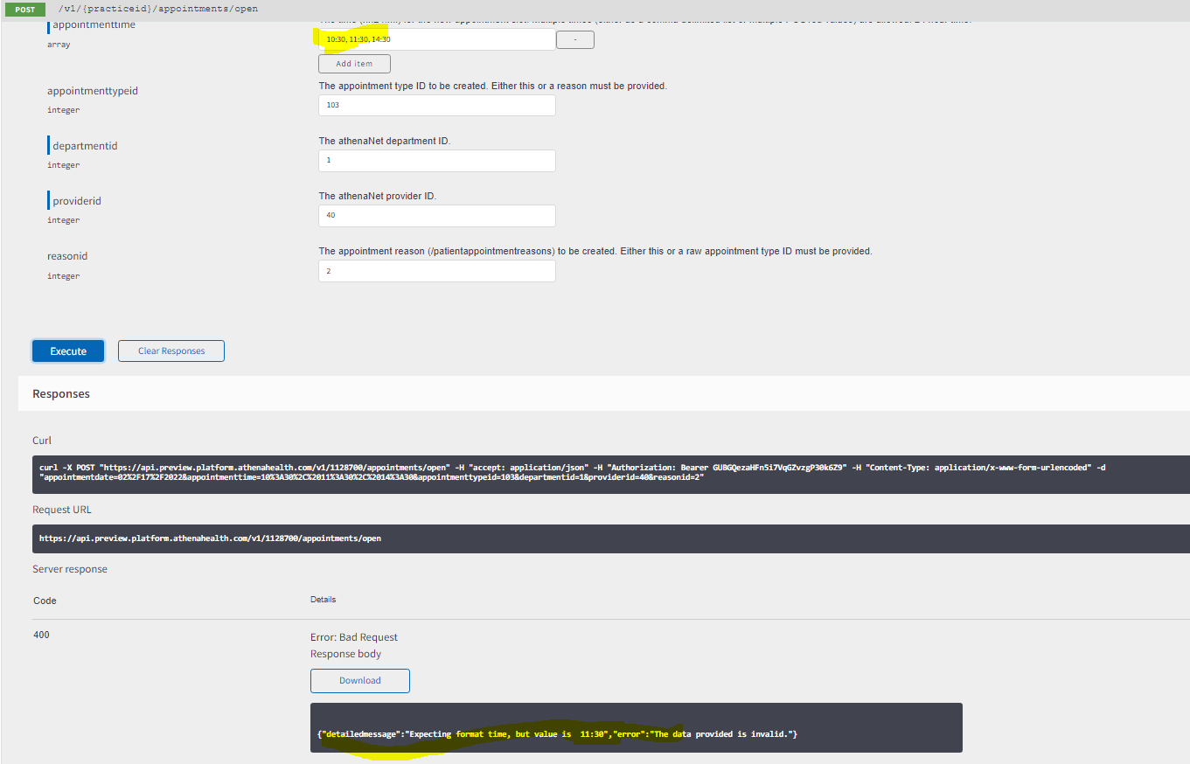

ERROR:

After putting info for only one slot, it complained about the reason id, but there is only one reason id in the data and it does not seem to work

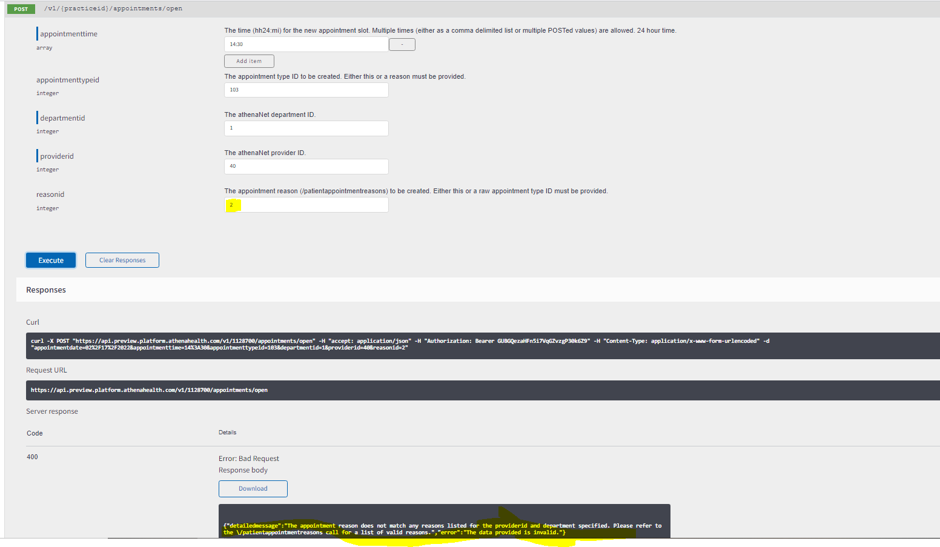

From the description of the fields it states that either reason id or appointment id is needed but the error indicates both are needed.

ERROR:

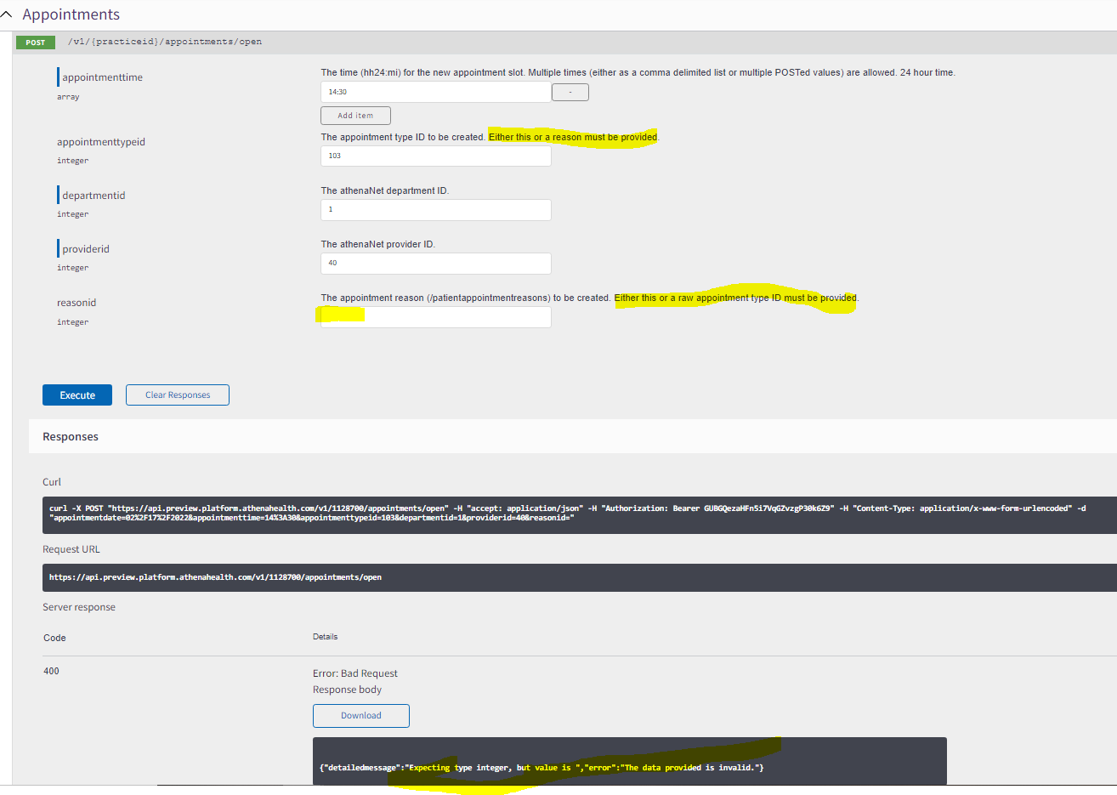

[GET](https://docs.athenahealth.com/api/api-ref/appointment-slot#Get-list-of-open-appointment-slots) [/v1/{practiceid}/appointments/open](https://docs.athenahealth.com/api/api-ref/appointment-slot#Get-list-of-open-appointment-slots)

Step 5: Create new patient

POST /v1/{practiceid}/patients

After providing all the required fields, I am unable to create a new patient

