University of Alberta Faculty of Engineering Research Output

Alison Henry

September 29, 2017

Define the question Define the ideal data set Determine what data you can access Obtain the data Clean the data

A report to examine the publication output of the Univeristy of Alberta Faculty of Engineering. Searches were conducted using Web of Science, and limited to the five publications years from 2012-2016.

Initial processing of the data was accomplished with the Bibliometrix package written by Massimo Aria and Corrado Cuccurullo. This allowed easy conversion of records into a data frame to facilitate further processing.

Data was kept for unique artilce identifiers, addresses, document type, publication year and number of citations.

Whole counting is used, so that each publication is counted only once for the institution, but articles with authors from different departments will count toward to totals for each of those departments.

Testing how this looks once knit. 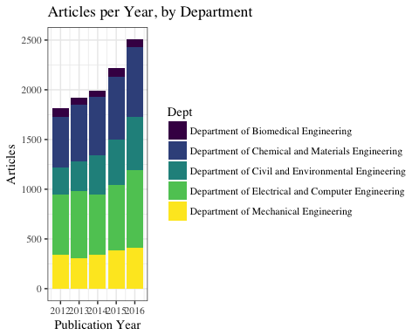

|  |  |
| --- | --- |
| Dept | TimesCited |
| Department of Biomedical Engineering | 11.293367 |
| Department of Chemical and Materials Engineering | 8.219366 |
| Department of Civil and Environmental Engineering | 5.217771 |
| Department of Electrical and Computer Engineering | 7.463268 |
| Department of Mechanical Engineering | 6.504479 |