University of Alberta Faculty of Engineering Research Output

Alison Henry

20 October 2017

A report to examine the publication output of the Univeristy of Alberta Faculty of Engineering. Searches were conducted using Web of Science, and limited to the five publication years from 2012-2016.

Initial processing of the data was accomplished with the Bibliometrix package written by Massimo Aria and Corrado Cuccurullo[1]. This allowed easy conversion of records into a data frame to facilitate further processing.

Data was kept for article identifiers, addresses, document type, publication year and number of citations. The address field is first split to separate co-author addresses.

Confirm no addresses were lost in the split:

## [1] "No drops"

Non-UofA addresses are then removed and departmental affiliations assigned. This was done by comparing the abbreviations in the address field to a list of potential abbreviations with associated department names. Addresses without a match were assigned "Other" and removed. For a more detailed analysis, the "Other"s should be examined to identify potential Faculty of Engineering affiliation. A quick skim of the list shows that most were from other U of A departments (e.g. Physics, Earth and Atmospheric Sciences), but some listed only Univ Alberta, so would need to be compared to a list of faculty members to be properly assigned.

Whole counting is used, such that each publication is counted only once for the institution, but articles with authors from different departments will count toward the totals for each of those departments.

## Results

Number of articles per year

With BioMed:

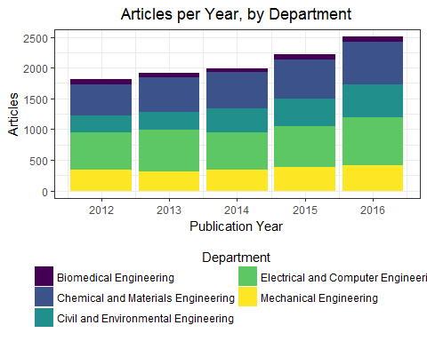

Without BioMed:

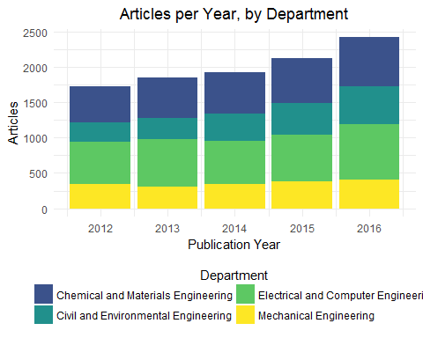

|  |  |  |  |  |  |
| --- | --- | --- | --- | --- | --- |
|  | 2012 | 2013 | 2014 | 2015 | 2016 |
| Biomedical Engineering | 89 | 73 | 66 | 85 | 79 |
| Chemical and Materials Engineering | 506 | 567 | 589 | 637 | 696 |
| Civil and Environmental Engineering | 273 | 298 | 389 | 451 | 536 |
| Electrical and Computer Engineering | 605 | 680 | 608 | 660 | 782 |
| Mechanical Engineering | 343 | 305 | 342 | 384 | 412 |

The initial data load contained three types of publications: Articles, Book Chapters, and Conference Proceedings.

Mean number of citations per publication

|  |  |
| --- | --- |
| Department | Times Cited |
| Biomedical Engineering | 11.29 |
| Chemical and Materials Engineering | 8.22 |
| Civil and Environmental Engineering | 5.22 |
| Electrical and Computer Engineering | 7.46 |
| Mechanical Engineering | 6.50 |

Mean citations per article using only document type "article"

|  |  |
| --- | --- |
| Department | Times Cited |
| Biomedical Engineering | 12.07 |
| Chemical and Materials Engineering | 8.94 |
| Civil and Environmental Engineering | 5.76 |
| Electrical and Computer Engineering | 11.12 |
| Mechanical Engineering | 7.57 |

# References

[1] M. Aria, C. Cuccurullo, &Nbsp;bibliometrix: An r-tool for comprehensive science mapping analysis, Journal of Informetrics. 11 (2017) 959–975. <https://doi.org/10.1016/j.joi.2017.08.007>.