Week 10: Simulating Data

Distributions
- How does a Uniform distribution look?
  - What values define a Uniform distribution?
- How does a Normal distribution look?
  - What values define a Normal distribution?
- How does a t-distribution look?
  - What is the relationship between a t-distribution and a Normal distribution?
- How does a Chi-square distribution look?
  - What values define a Chi-square distribution?
- How is a Binomial distribution different from the other four distributions?
  - What values define a Binomial distribution?

Distribution Functions in R
- r stands for:
  - What are the inputs to the rnorm() function?
  - What does the rnorm() function return?
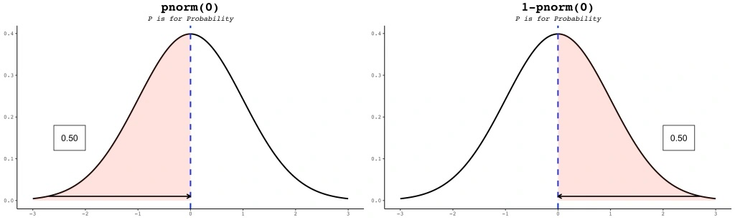
- p stands for:
  - What are the required inputs to the pchisq() function?
  - What is the optional input to the pchisq() function?
  - What does the pchisq() function return?
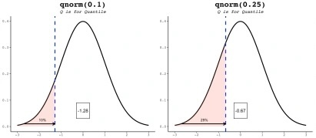
- q stands for:
  - What are the inputs to the qt() function?
  - What does the qt() function return?
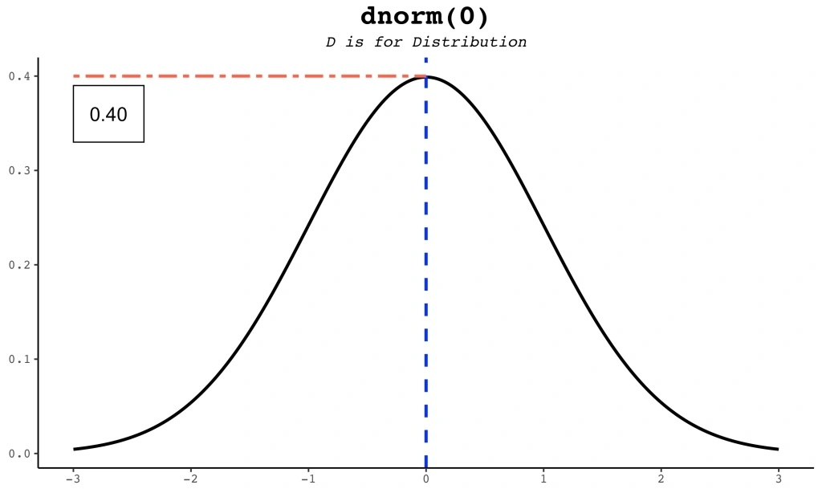
- d stands for:
  - What are the inputs to the dbinom() function?
  - What does the dbinom() function return?

