Week 4 Day 1: PA Warm-up

## read_xlsx()

1. What’s wrong with the top of the gov_spending_per_capita.xlsx spreadsheet?
2. Fill in the code you would need to read in the cleanest version of these data.

military <- read_xlsx("gov_spending_per_capita.xlsx",   
 sheet =   
 skip =   
 n_max =   
 )

1. What are the three ways NA values were coded in these data?
2. What would you input into the na = argument of read_xlsx() to recode these values as NAs?

## pivot_longer()

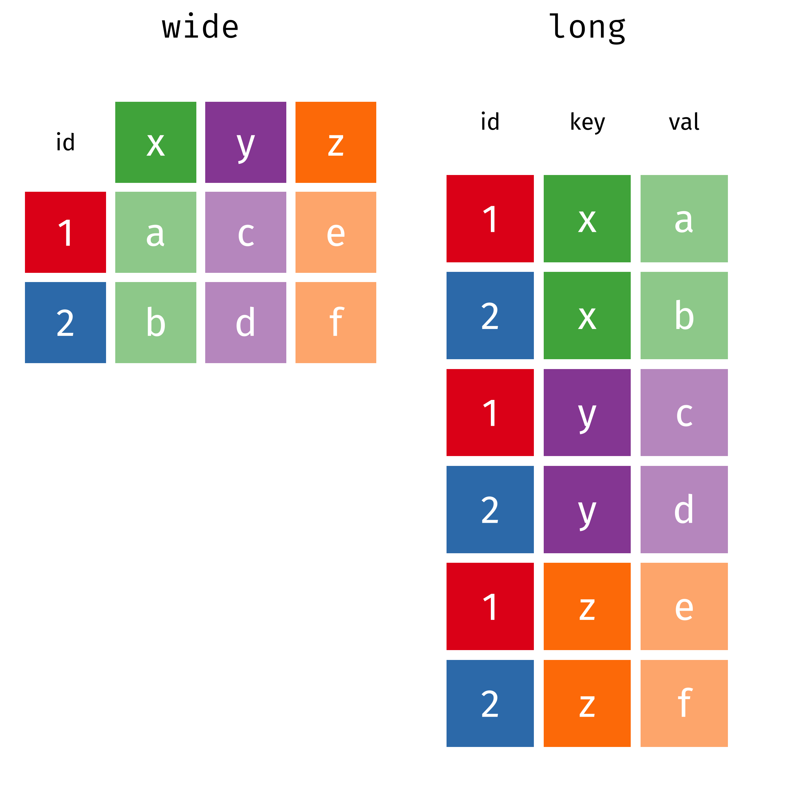

1. Why don’t we want to pivot our data manually?
2. Fill in the code below to pivot the military data from wide to long:

military |>   
 pivot_longer(cols =   
 names_to =   
 values_to =   
 )

1. What do you notice is weird about some of the values of Country?

## if_any() & if_all()

These functions are used with filter() to select rows based on a logical statement applied to multiple columns

* if_any() – returns a logical vector (one element for each row) that is TRUE if the logical statement is true for **any** column in the supplied columns
* if_all() – returns a logical vector (one element for each row) that is TRUE if the logical statement is true for **all** columns in the supplied columns

1. Fill in the code to filter() the military data to only include observations that have **at least one** missing value for the military spending:

military |>   
 filter(  
 if_any(  
 .cols =   
 .fns =   
 )  
 )