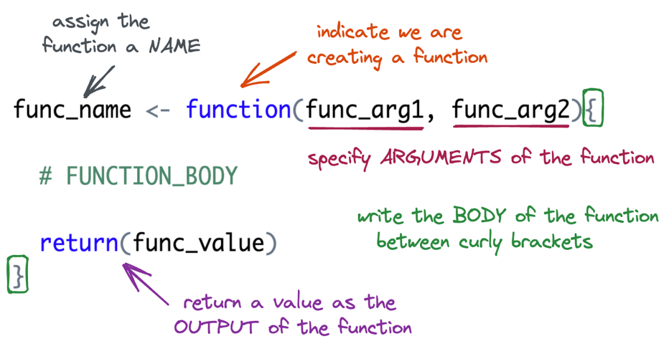Week 7: Writing Your Own (Vector) Functions

# Writing Functions in R

1. Write a function named add_two() that will add 2 to whatever number is input.
2. In your function what is the:

* Function Name:
* Function Argument(s):
* Function Body:
* Function Return:

1. What if we wanted to write a more general function, named add_something(). The function would take **two** inputs:

* x the vector to add to
* something the value to add to x

**How would your function (from Question 1) change?**

1. Are your arguments ***optional*** or ***required***?
2. What is the difference?
3. What are the two ways you can return a value in a function?
4. Which method for returning a value makes more sense to you?

## Function Practice

1. Fill in the code below to create a function named above_average(). The function should keep only the elements of x greater than the mean.

above_average <- function(x) {

}

1. Write down the steps you would need to create a function named every_third() that takes in a vector and returns every third element from that vector (i.e., indices 1, 4, 7, 10, etc.).

**Think about:**

* What inputs the function should take.
* How to identify which positions in the vector are “every third.”
* How to select those elements from the vector.