Practice Activity 2 Warm-up

# Data Context

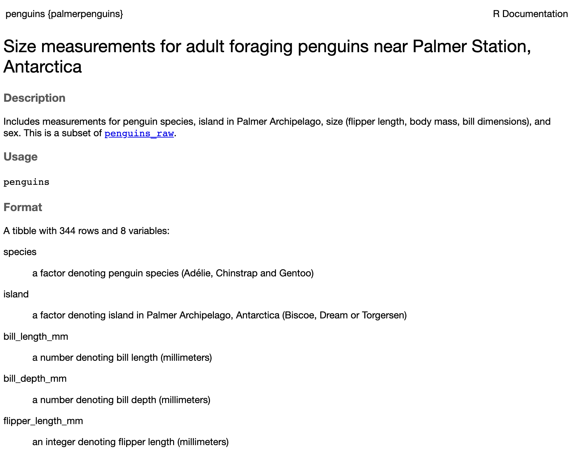 **What variables are included in these data? What units are the variables measured in? What do you think each row in the data represents?**

# Grammar of Graphics

Think of a graph or a data visualization as a mapping…

…**FROM variables** in the data set (or statistics computed from the data)…

…**TO visual attributes** (or “aesthetics”) **of marks** (or “geometric elements”) on the page/screen.

## How to Build a Graphic with ggplot2

ggplot(data = penguins)

**What do you expect to see after running this code?**

ggplot(data = penguins,   
 mapping = aes(x = species, y = bill_length_mm)  
 )

**What do you expect to see after running this code?**

ggplot(data = penguins,   
 mapping = aes(x = species, y = bill_length_mm)  
 ) +  
 geom_jitter() +  
 geom_boxplot()

**What do you expect to see after running this code?**

## aesthetics & geometries

**Common aesthetics**

* x, y
* color, fill
* linetype
* shape
* size

**Common geometries**

* geom_density()
* geom_bar()
* geom_histogram()
* geom_boxplot()
* geom_point()
* geom_line()

## How many penguins were captured on each island?

1. What type of variable is island?
2. What type of plot would you make for this type of variable?
3. What geom would you use to get this plot?

## What are the most common bill lengths for the penguins included in these data?

1. What type of variable is island?
2. What type of plot would you make for this type of variable?
3. What geom would you use to get this plot?

## What is the relationship between a penguin’s bill length and body mass?

1. What type of variable is island?
2. What type of plot would you make for this type of variable?
3. What geom would you use to get this plot?

## How would you recreate this plot?

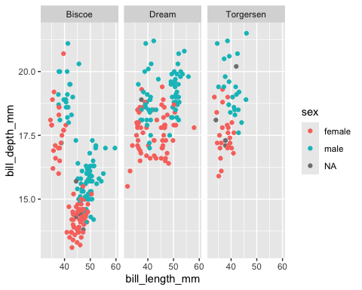

1. What variables are included?
2. What aesthetics are being used?
3. What geometries are being used?
4. What functions would you need?

Are there any additions that would make the plot more clear?