- Introduction
Trivia Fiesta is a web-based quiz application developed as part of the COMP1004 module. The aim of the project is to design and implement an interactive quiz system that allows users to test their knowledge across different categories and difficulty levels. The application is implemented as a Single Page Application (SPA) using HTML, CSS and JavaScript, meaning all functionality operates entirely on the client side without requiring a backend server.

The system allows users to select a preferred language between English and Greek before starting the quiz. Questions are organised into categories and difficulty levels, allowing the user to customise quiz experience. Each question is presented with multiple-choice answers and includes a countdown timer to increase engagement. At the end of the quiz, the system calculates the user’s score and displays the results along with a leaderboard that stores the highest scores locally in the browser.

The application also allows users to upload their own quizzes using JSON files, enabling the creation of custom question sets. In addition, quiz results can be exported as a JSON file, demonstrating the use of both JSON input and output as required by the module.

The development of Trivia Fiesta followed an Agile development approach using Scrum, allowing the system to be built iteratively through multiple development sprints.

- Background and Existing Systems
Quiz-based learning and entertainment applications have become increasingly popular in recent years, particularly through web and mobile platforms. Applications such as Kahoot, Who Wants to be a Millionaire, Sporcle, and many others provide interactive quiz experiences where users can test their knowledge across a variety of topics. These systems typically include features such as multiple-choice questions, scoring systems, and competitive leaderboards.

Many existing quiz platforms are designed primarily for classroom environments or large-scale multiplayer participation. For example, Kahoot focuses on real-time group quizzes where participants join using a shared game code, while Quizizz provides structures quizzes commonly used in educational settings. Although these platforms offer rich functionality, they often rely on server-based infrastructures and require user accounts, internet connectivity or instructor control.

In contrast, the objective of the Trivia Fiesta project is to create a lightweight quiz application that operates entirely on the client side using standard web technologies. By implementing the system as a Single Page Application (SPA), the application can run directly in the browser without requiring a backend server or database.

A distinguishing feature of the system is its bilingual support, allowing users to complete quizzes in either English or Greek. Additionally, the application allows users to upload custom quiz files using a predefined JSON structure. This enables users to generate their own quizzes without modifying the underlying code.

Another distinguishing aspect is the ability to export quiz results as JSON, fulfilling the project requirement to demonstrate both JSON input and output. These design choices allow the system to remail simple, flexible and easily extendable while still delivering an engaging quiz experience.
sdlc
- Requirement Analysis – all of them
The requirements analysis phase was used to identify the key functionality and system constraints necessary for the development of the Trivia Fiest application. Requirements were gathered during the early planning stages of the project and were used to guide the design and the implementation of the system. The requirements were divided into functional requirements which describe the behaviour of the system, and non-functional requirements which define the quality attributes and operational constraints of the application.

  - Functional Requirements
Functional requirements describe the core features that the system provide in order to fulfil its purpose as a quiz application. The primary functional requirements identified for the system are listed below:

- The system must allow users to select a preferred language (English or Greek).
- The system must allow users to select a quiz category.
- The system must allow users to select a difficulty level.
- The system must display quiz questions with four multiple-choice answers.
- The system must record and evaluate user answers.
- The system must calculate and display final score quiz.
- The system must include a countdown timer for each question.
- The system must allow users to upload custom quizzes using a JSON file.
- The system must validate uploaded JSON quiz files to ensure the correct structure.
- The system must store top scores locally and display them in a leaderboard.
- The system must allow quiz results to be exported as a JSON file.
These requirements form the core functionality of the application and correspond directly to the features implemented during development.
  - Non-functional Requirements
Non-functional requirements define the quality characteristics and constraints of the system. These requirements ensure that the application performs reliably and provides a positive user experience.

Key non-functional requirements include:
- Usability: The interface must be clear, simple and easy to navigate for users.
- Performance: The application should respond quickly to user input without noticeably delays.
- Accessibility: The interface should remain readable and usable across different screen sizes and devices.
- Reliability: The system must handle invalid inputs, such as incorrectly structured JSON files, without crashing.
- Maintainability: The code should be organised and commented to allow future modifications or extensions.
Together, these requirements guided the design and development of the Trivia Fiest application.

- Agile Development Using Scrum
The development of Trivia Fiesta followed an Agile methodology using Scrum principles. Scrum was chosen because it supports iterative development through small development cycles known as sprints. Each sprint focuses on implementing specific tasks and results in a functional increment of the system.
The project was divided into nine sprints, beginning with project initiation and requirements analysis and ending with testing, refinement, and final submission. A task tracker was used to record sprint goals, tasks, progress, and completion status throughout development. This approach ensured that development progressed in manageable stages and allowed improvements to be made iteratively.
4.1 Product backlog
The product backlog represents the list of all features and functionality required for the system. These items were identified during the planning stage and prioritised based on their importance to the core functionality of the quiz application.
ID | Feature | Description | Priority
PB1 | Language selection | Allow users to choose between English and Greek | High
PB2 | Quiz categories | Allow users to select quiz categories | High
PB3 | Question system | Display multiple choice quiz questions | High
PB4 | Score tracking | Track user answers and calculate final score | High
PB5 | Difficulty filtering | Allow users to select difficulty levels | Medium
PB6 | Countdown timer | Add time pressure for answering questions | Medium
PB7 | Sound effects | Provide audio feedback for answers | Low
PB8 | Theme toggle | Allow users to switch between dark and light mode | Low
PB9 | Custom quiz upload | Allow users to upload their own quiz JSON file | High
PB10 | JSON score export | Allow users to export leaderboard scores | High
PB11 | Leaderboard | Store and display top scores locally | Medium

4.2 User Stories – all of them
User stories were created to describe system functionality from both the user and the developer perspectives.
Examples of key user stories include:
- As a user, I want to select a language so that I can use the quiz application in either English or Greek.
- As a user, I want to choose a quiz category so that I can answer questions related to topics that interest me.
- As a user, I want to answer multiple-choice questions so that I can test my knowledge and receive feedback on my answers.
- As a user, I want to select a difficulty level so that the quiz matches my knowledge levels and provides an appropriate challenge.
- As a user, I want a countdown timer for each question so that the quiz becomes more engaging and challenging.
- As a user, I want to upload my own quiz file so that I can create custom quizzes using my own questions.
- As a user, I want to export quiz scores as a JSON file so that the results can be stored or analysed externally.

Developer stories were also included to address technical requirements:
- As a developer, I want the application to function as a Single Page Application so that the interface can update dynamically without page reloads.
- As a developer, I want uploaded quiz files to be validated so that incorrectly structured JSON files do not cause application errors.
- As a developer, I want leaderboard data to be stored in local storage so that scores persist between browser sessions.

4.3 Sprint Planning
Sprint planning was used to organise development tasks across the nine sprints. Product backlog items and user stories were prioritised and assigned to specific sprints based on development goals. Each sprint focused on implementing a set of features while maintaining a functional version of the application.
A task tracker was used to document sprint tasks, progress, and completion status. This provided a clear overview of the development timeline and ensured that tasks were completed systematically.
The full sprint schedule and task tracker used to manage development are provided in Appendix A.

4.4 Sprint Implementation
The development of Trivia Fiesta progressed through nine sprints, each focusing on a specific stage of development.
Sprint 1 – Project Initiation
Defined the project idea, scope and development approach, and produced the project initiation document.

Sprint 2 – Requirements and Planning
Defined the core quiz features, designed the data structure, collected bilingual question examples, and planned the user interface.

Sprint 3 – Initial Implementation
Created the project repository and initial application structure, including HTML layout, SPA container setup, and helper function.

Sprint 4 – Core Quiz Functionality
Implemented category selection, question rendering, answer validation, and score tracking.

Sprint 5 – Mid-Project Submission
Prepared the mid-project review materials, including the presentation and video demonstration.

Sprint 6 – Advanced Features
Added interactive functionality including the countdown timer, sound effects, theme toggle, and difficulty filtering.

Sprint 7 – Custom Quiz Feature
Implemented the custom quiz system allowing users to download a JSON template and upload validated quiz files.

Sprint 8 – Testing and Refinement
Conducted system testing, fixed bugs, improved the interface, and implemented leaderboard functionality.

Sprint 9 – Finalisation
Finalised the application by implementing JSON score export, polishing the interface, completing documentation, and preparing the final submission.

- System Design
The system design phase focused on defining the overall structure of the application, including the system architecture, data organisation, and user interface design. The design decisions were guided by the project requirements and aimed to ensure that the application remained modular, maintainable and easy to use.

  - System Architecture
Trivia Fiesta was implemented as a Single Page Application (SPA). In this architecture, the entire application operates within a single web page, with different views dynamically rendered using JavaScript. This approach eliminates the need for page reloads and allows the interface to update instantly in response to user actions.

All application logic is handled on the client side using JavaScript. The system manages application state through a state object that stores information such as the selected language, quiz category, current question index, and user answers. Different views of the application are dynamically generated and inserted into the main application container.

The application also makes use of the browser’s local storage to store leaderboard data. This allows quiz scores to persist between sessions without requiring a database or backend server.
  - Data Design
Quiz data within the application is structured using JSON (JavaScript Object Notation). JSON was chosen because it’s lightweight, human-readable, and easily processed by JavaScript. The use of JSON also satisfies the module requirement to demonstrate both input and output.

Each quiz file contains a list of categories, and each category contains a collection of questions. Each question includes the question text, four possible answer options, the index of the correct answer, and the associated difficulty level. Shown in figure 1

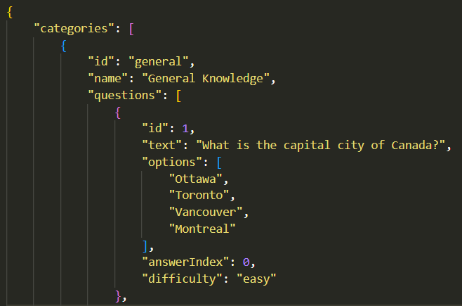
A simplified representation of the quiz questions data structure is shown in the figure below:
Figure 1 Quiz questions sample structure
This structure allows quiz questions to be easily organised and extended with additional categories or difficulty levels. The same structure is also used when users upload their own custom quiz files.

  - User interface design
The user interface was designed to be simple, and easy to navigate, following common web usability principles. Clear visual hierarchy, consistent button placement, and step-by-step navigation were used to guide the user through the quiz process. Each screen focuses on a single task, reducing cognitive load and helping users understand what action to take next.
The main interface screens include:
- Language selection screen, allowing users to choose between English and Greek.
- Category selection screen, where users select a quiz topic.
- Difficulty selection screen, allowing users to choose the level of challenge.
- Quiz questions screen, which displays the question, answer options and countdown times.
- Results screen, showing the final score and leaderboard.

Visual feedback is provided to improve user experience. Correct answers are highlighted in green and incorrect answers in red, allowing users to immediately see the outcome of their selection. A countdown timer is also displayed for each question to increase engagement and provide an element of challenge.

Additional interface features include a light/dark theme toggle and sound effects that provide auditory feedback for correct and incorrect answers. These design decisions aim to create a more engaging and accessible quiz experience for users.

- Implementation
The implementation phase involved translating the system design into a working web application using HTML, CSS and JavaScript. The application was developed as a client-side Single Page Application, meaning that all functionality operates within the browser without requiring a backend server. The system logic is implemented primarily in JavaScript, while HTML defines the structure of the interface and CSS provides the visual styling.

  - Application Structure
The application is organised around a central JavaScript file that manages the main functionality of the quiz game. A central state object is used to track the current state of the application, including the selected language, current category, difficulty level, question index, user answers, and timer status. This approach allows the system to maintain consistent data across different views of the application.

Different screens of the application, such as language selection, category selection, quiz questions, and results, are generated dynamically using JavaScript functions. Each function is responsible for rendering a specific view and inserting the corresponding elements into the main application container, allowing the interface to update without reloading the page.

  - DOM Helper Utility
To simplify the creation and rendering of user interface elements, a helper module was implemented to manage dynamic DOM generation. The application frequently creates interface components programmatically due to the SPA architecture, where views are generated and replaced dynamically rather than being statically defined in HTML.

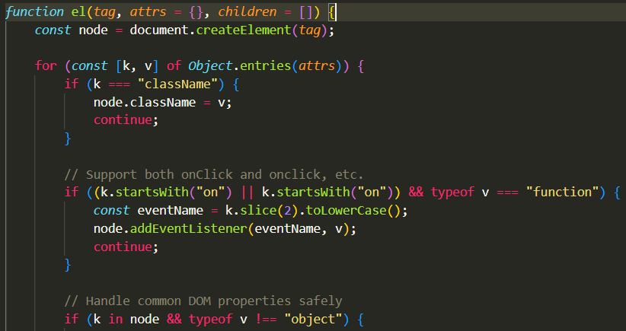
The helper module provides to key functions: el() and setView(). The el() function is responsible for creating HTML elements with attributes, event listeners, and child nodes in a structured and consistent way. This approach avoids the use of innerHTML, which can introduce security risks and make the code harder to maintain.

Figure 2 Part of the helper function code
This function allows interface components

  - Quiz Engine
The quiz engine is responsible for loading quiz questions, presenting answer options, and evaluating user responses. When a user selects a category (after selecting the language), and difficulty level, the system retrieves the relevant set of questions from the quiz data. Questions are filtered based on difficulty and then randomly shuffled to ensure that quizzes vary between attempts.

Each question is displayed with four possible answer options. When the user selects an answer, the system records the selected option and compares it with the correct answer index stored in the JSON data. The interface then provides visual and auditory feedback.

  - Countdown Timer
A countdown timer is implemented for each question to increase engagement and introduce a time constraint. The timer begins when a question is displayed and counts down from a predefined value. If the time reaches zero before an answer is selected, the question is marked as wrong. The timer is visually represented through a progress bar and a numeric time indicator.

  - Custom Quiz Upload and JSON Validation

Sdlc in introduction -planning

