
Trivia Fiesta

Student Number: 10911878
Module Code: COMP1004
Deadline: 30 Apr 2026
Module Leader: Dr Vasilios Kelefouras
Dr Lauren Ansell

Contents
1. Introduction 2
2. Background and Existing Systems 2
3. Methodology 3
4. Analysis 3
4.1 Functional Requirements 4
4.2 Non- Functional Requirements 4
4.3 User Stories 5
4.4 Legal, Social, Ethical and Professional Considerations 6
4.5 Sprint Reflection 7
5. System Design 8
5.1 Overview 8
5.2 Architecture Design 8
5.3 Data Design (JSON Structure) 8
5.4 User Interface Design 9
5.5 Interaction and Navigation Design 9
5.6 Design Decisions and Justification 9
6. Implementation 10
6.1 Overview 10
6.2 Application State Management 10
6.3 DOM Helper Utility 11
6.4 Question Handling and Logic 12
6.5 Custom Quiz Upload and Validation 13
6.6 Local Storage Leaderboard 14
6.7 JSON Score Export 15
7. Testing 15
8. Evaluation and Conclusion 16
9. References 17
APPENDIX A – Sprint Plan and Task Tracker 19
APPENDIX B – Data Design 22
APPENDIX C – Test Plan 24
APPENDIX D – UML Diagrams 30
APPENDIX E - User Interface and Validation Feedback 34
APPENDIX F – AI Declaration Form 35

Introduction
Trivia Fiesta is a web-based quiz application developed as part of the COMP1004 module, designed to allow users to test their knowledge across multiple categories and difficulty levels. The application is implemented as a Single Page Application (SPA) using HTML, CSS, and JavaScript, with all functionality executed client-side in accordance with module requirements prohibiting backend technologies.

Development followed the Software Development Life Cycle (SDLC), providing a structured approach to planning, design, implementation, and evaluation. An Agile methodology using Scrum principles was adopted, dividing the project into iterative sprints to enable continuous feedback and refinement (Pressman, 2014; Schwaber and Sutherland, 2020).

The system provides a customisable quiz experience in which users can select their preferred language (English or Greek), category, and difficulty level. Questions are dynamically loaded from structured JSON data, fulfilling the module requirement for JSON input. Additional features include a countdown timer, immediate answer feedback, a locally stored leaderboard, custom quiz upload via JSON, and score export — demonstrating both data input and output capabilities.

Key design decisions include varying question count by difficulty level and implementing a centralised state object to manage application data consistently across views, contributing to a responsive and reliable user experience within a fully client-side architecture.

Background and Existing Systems
Quiz-based applications are widely used in both educational and entertainment contexts. Platforms such as Kahoot, Quizizz, and Sporcle offer structured quiz environments with multiple choice questions, scoring systems, and leaderboards, to enhance engagement.

Many existing platforms rely on server-based architectures requiring internet connectivity, user accounts, or instructor-led sessions. Kahoot is primarily designed for classroom use, while Quizizz focuses on structured assessment, limiting flexibility for independent use.

In contrast, Trivia Fiesta operates entirely as a client-side SPA using HTML, CSS, and JavaScript, with no backend technologies. All processing occurs within the browser, removing the need for network connectivity or server infrastructure. LocalStorage is used to persist leaderboard data, enabling score tracking without a database.

The application also extends beyond basic functionality through bilingual support (English and Greek), custom quiz upload via JSON, and JSON score export, allowing users to create, load, and reuse quiz data externally.

Methodology
The development of Trivia Fiesta followed a structured Software Development Life Cycle (SDLC), providing a systematic approach to planning, design, implementation, testing, and evaluation. An Agile methodology using Scrum principles was adopted to support iterative development, dividing the project into a series of manageable sprints, each focused on implementing specific functionality derived from the product backlog (Pressman, 2014; Schwaber and Sutherland, 2020).

The project was organised into nine sprints, progressing from project initiation and requirements analysis through core implementation, feature enhancement, testing, and finalisation. At the start of each sprint, tasks were prioritised based on their importance to core functionality, forming the sprint backlog and guiding development during each iteration. A task tracker was maintained to document sprint goals, individual tasks, progress, and completion status, reflecting key Scrum practices of backlog management and task prioritisation. The full sprint plan and task tracker are provided in Appendix B.

Regular stand-up meetings were conducted approximately every two weeks with a supervising lecturer, providing opportunities to review progress, discuss challenges, and receive feedback. This aligns with Agile principles of continuous improvement, enabling issues to be identified and addressed early rather than accumulating across sprints.

Analysis
While the core functional requirements remained stable throughout development, several features were refined during implementation. The custom quiz upload functionality, for example, evolved from a simple file input into a fully validated feature with structured user feedback. The leaderboard was similarly extended to support JSON export to meet module requirements. Non-functional requirements such as usability and reliability also became more prominent during later stages of development.

Functional Requirements
Functional requirements define the core features and behaviour of the system. These were identified during the planning phase and form the basis of the application's functionality. Table 1 presents all functional requirements with their assigned priority.

Table 1: Functional Requirements
ID | Requirement | Description | Priority
FR1 | Language Selection | The system must allow users to select between English and Greek | High
FR2 | Category Selection | The system must allow users to choose a quiz category | High
FR3 | Difficulty Selection | The system must allow users to select a difficulty level | Medium
FR4 | Question Display | The system must display multiple choice questions | High
FR5 | Answer Selection | The system must allow users to select an answer | High
FR6 | Answer Feedback | The system must provide immediate feedback on answers | Medium
FR7 | Score Calculation | The system must calculate user’s final score | High
FR8 | Score Display | The system must display the final score at the end of the quiz | High
FR9 | Name Input | The system must allow users to enter their name for score recording | Medium
FR10 | Leaderboard Storage | The system must store scores using localStorage | Medium
FR11 | Leaderboard Display | The system must display top scores in a leaderboard | Medium
FR12 | JSON Score Export | The system must allow users to export scores as a JSON file | High
FR13 | Custom Quiz Upload | The system must allow users to upload quiz files in JSON format | High
FR14 | JSON Validation | The system must validate uploaded quiz files before use | High
FR15 | Navigation Controls | The system must provide navigation (next,back,play again) | High
FR16 | Countdown Timer | The system must include a timer for each question | Medium
FR17 | Audio Feedback | The system must provide sound feedback for answers | Low
FR18 | Theme Toggle | The system must allow switching between light and dark mode | Low

Non- Functional Requirements
Non-functional requirements define the quality attributes and constraints of the system. Table 2 presents all non-functional requirements with their assigned priority.

Table 2: Non-Functional Requirements
ID | Requirement | Description | Priority
NFR1 | Technology Constraint | The system must be built using HTML, CSS and JavaScript only | High
NFR2 | SPA Architecture | The system must function as a Single Page Application | High
NFR3 | Browser Compatibility | The system must run on modern browsers (Chrome, Edge, Firefox) | High
NFR4 | Performance | The system should respond quickly to user interactions | Medium
NFR5 | Usability | The interface should be clear, structured, and easy to navigate | High
NFR6 | Accessibility | The system should support bilingual interaction (English and Greek) | Medium
NFR7 | Data Persistence | The system should store data locally using localStorage | Medium
NFR8 | Error Handling | The system should handle invalid inputs gracefully | High
NFR9 | Maintainability | The code should be modular and well-structured | Medium
NFR10 | Consistency | The UI should remain consistent across all views | Medium

User Stories
User stories were used to define system behaviour from both user and developer perspectives. Each story follows the format:
“As a [user], I want [feature], so that [benefit]”

User-Focused Stories
- As a user, I want to select a language so that I can use the application in English or Greek.
- As a user, I want to choose a quiz category so that I can answer questions related to my interests.
- As a user, I want to answer multiple choice questions so that I can test my knowledge.
- As a user, I want to select a difficulty level so that the quiz matches my ability.
- As a user, I want a countdown timer so that the quiz is more engaging and challenging.
- As a user, I want immediate feedback on my answers to that I understand my performance.
- As a user, I want to see my final score so that I can evaluate my results.
- As a user, I want to save my score so that it appears on the leaderboard.
- As a user, I want to export scores as a JSON file so that I can store or reuse results externally.
- As a user, I want to upload my own quiz file so that I can create custom quizzes.

Developer-Focused Stories
- As a developer, I want the application to function as a Single Page Application so that views update dynamically without page reloads.
- As a developer, I want quiz data to be stored in JSON format so that it is structured and easy to manage.
- As a developer, I want uploaded quiz files to be validated so that invalid data does not break the system.
- As a developer, I want leaderboard data to be stored in localStorage so that scores persist between sessions.
- As a developer, I want reusable helper functions so that UI rendering remains consistent and secure.

Legal, Social, Ethical and Professional Considerations
The development of Trivia Fiesta involved consideration of several legal, social, ethical, and professional factors. From a legal perspective, the application does not collect or transmit personal data, as all user information is stored locally using browser localStorage, avoiding data protection concerns under GDPR.

Social considerations were addressed through bilingual support (English and Greek), improving accessibility for a wider range of users. The interface was designed to be clear and readable, supporting users with varying levels of technical experience.

Ethically, the application was designed to ensure a fair and transparent user experience. Clear feedback is provided when answering questions or uploading invalid quiz files, and neutral, non-judgemental language was used throughout to support a positive experience.

From a professional perspective, the project followed structured development practices including version control, Agile methodology, and regular supervisor reviews, reflecting industry standards for software development.

Sprint Reflection
The nine sprints were structured to progress from project initiation and requirements analysis through to core implementation, feature enhancement, testing, and finalisation. Sprints 1 and 2 covered project scoping, requirements definition, and JSON data structure planning. Sprints 3 and 4 established the core application structure, including SPA navigation, question rendering, and basic scoring, ensuring a functional foundation before more complex features were introduced. Sprint 5 addressed mid-project deliverables, while Sprints 6 and 7 introduced advanced features including the countdown timer, sound effects, theme toggle, and custom quiz upload with validation. Sprints 8 and 9 focused on testing, bug fixing, refinement, and finalisation. A full breakdown of tasks, dates, and completion status for each sprint is provided in Appendix B.

Later sprints introduced and refined advanced functionality. The custom quiz upload feature, initially planned as a simple file input, evolved to include structured validation and user feedback after it became clear that unvalidated input could compromise system stability. Similarly, the leaderboard was extended to support JSON score export to meet module data output requirements, and bilingual support introduced additional complexity in maintaining consistent translations across all interface elements and validation messages.

A notable challenge arose during sprint-based usability testing, where navigating backwards multiple times allowed previously answered questions to be reattempted. This was traced to inconsistent state management and resolved by ensuring answers were persistently stored and validated prior to any interaction. This experience highlighted the value of iterative testing, as the issue only surfaced through real user interaction rather than developer testing alone.
Overall, the sprint-based approach enabled continuous refinement, with each iteration building meaningfully on the last and allowing both technical and usability issues to be identified and addressed progressively.

System Design

Overview
The application follows a Single Page Application (SPA) architecture, where content is dynamically rendered without full page reloads, improving responsiveness and user experience. (Flanagan, 2020)

The design follows a modular structure, separating concerns between data handling, application logic, and user interface rendering. This improves maintainability and allows features to be developed and tested independently.

UML diagrams illustrating system architecture and behaviour are provided in Appendix D.

Architecture Design
The application follows a fully client-side architecture, as required by the module brief, with all functionality executed in the browser using JavaScript and no backend services. A centralised state object was implemented to manage application data, including current language, selected category and difficulty, questions index, user answers, and timer state, ensuring all components remain synchronised and simplifying state updates across views.

Data Design (JSON Structure)
Quiz data is structured using JSON, a lightweight data-interchange format widely used in web applications (MDN Web Docs, 2024a).

Each quiz consists of:
- categories
- questions
- answer options
- correct answer index
- difficulty level
This structure was chosen because JSON is lightweight, human-readable, and aligns with the module requirement for JSON input/output. It also enables the custom quiz upload feature, allowing users to create and load their own quizzes without modifying the application code.
Validation rules were implemented to enforce structural integrity, ensuring every question contains exactly four options, answer indices are valid, and difficulty values are consistent. This prevents malformed data from compromising system stability.

User Interface Design
The user interface was designed to be clear, structured, and predictable. Key decisions included maintaining a consistent layout across all views so users can anticipate control placement, providing visual feedback to communicate outcomes immediately, and ensuring timer visibility to support user awareness. Readable typography and spacing improve clarity across screen sizes, while a light/dark theme toggle and sound feedback were included to improve comfort and interactivity.

Interaction and Navigation Design
The application follows a linear navigation model, guiding the user through the following stages:
- Language selection
- Category selection
- Difficulty selection
- Quiz questions
- Results and leaderboard
This structured flow ensures that users cannot skip essential steps, reducing the likelihood of errors.
A back navigation feature allows users to revisit previous questions, with safeguards implemented to preserve previously selected answers and prevent unintended state resets.

Design Decisions and Justification
Two key design decisions were made to balance usability and challenge. First, question quantity varies by difficulty with easier quizzes containing more questions while harder quizzes fewer. This is intended to manage cognitive load and prevent user fatigue without reducing the sense of challenge. Second, a fixed countdown timer was introduced per question to encourage consistent pacing and ensure fairness, as all users are given identical conditions. The visual timer display further supports user awareness and interaction.

Implementation

Overview
Trivia Fiesta was implemented using HTML, CSS and JavaScript in accordance with module requirements, following a Single Page Application model where views are dynamically rendered without page reloads. The system was developed in a modular manner, separating state management, UI rendering and data handling into distinct components to improve readability, maintainability, and scalability. Key code snippets are included here, and the full source code is available in the GitHub repository: https://github.com/atheodorou13/COMP1004-Aspa-Theodorou

Detailed data structures are provided in Appendix B.

Application State Management
A centralised state object was implemented to manage the application’s data and control flow. As shown in Figure 1, this ensures consistency across different views and simplifies updates during user interaction.

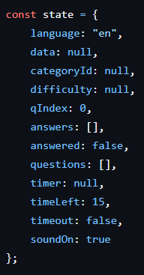
Figure 1: Centralised state object used for managing quiz state

This structure tracks quiz progress, user choices and UI state in a single location, reducing complexity and avoiding inconsistencies between different parts of the application.

DOM Helper Utility
A reusable helper function was implemented to dynamically create DOM elements, avoiding the use of innerHTML. Unlike innerHTML, which inserts raw HTML strings directly into the DOM and risks Cross-Site Scripting (XSS) vulnerabilities, the helper function shown in Figure 2 constructs elements using the standard DOM API. This is particularly important when handling user-generated content such as custom quiz data, as it safely attaches event listeners, ensures consistent element creation, and avoids unintended side effects such as overwriting existing listeners or introducing parsing errors.

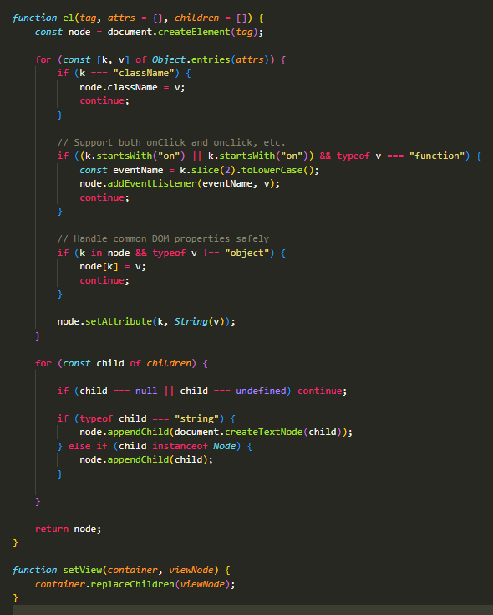
Figure 2: DOM helper function used to safely create and manage dynamic UI element
The setView() function complements the helper by enabling SPA navigation, replacing the current view entirely using replaceChildren() without triggering a page reload, which is central to the application’s single page architecture.

Question Handling and Logic
The renderQuestionView() function forms the core of the application, dynamically rendering each question and its answer options based on the current state. As shown in Figure 3, labels are generated bilingually, switching between Latin characters (A-D) and Greek characters (Α-Δ) based on the selected language, ensuring consistency across both supported languages.
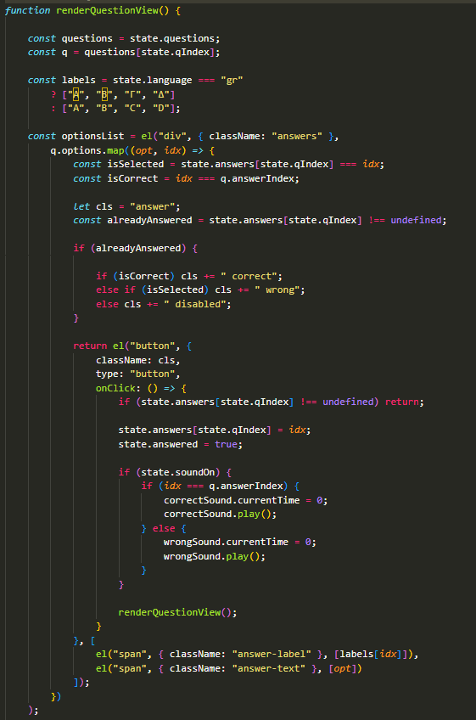
Figure 3: Question rendering logic showing dynamic UI updates, answer handling, and feedback mechanisms

Answer buttons are styled conditionally upon selection — correct answers are highlighted green, incorrect selections red, and remaining options disabled — providing immediate visual feedback. A guard condition (if state.answers[state.qIndex] !== undefined return) prevents multiple selections per question, maintaining data integrity and ensuring fair scoring. Audio feedback is triggered on answer selection, playing a correct or incorrect sound based on the user's choice, provided sound is enabled in state. User selections are stored in the state.answers array, allowing previously answered questions to be revisited without data loss, with the timer started or stopped depending on whether the current question has already been answered.

Custom Quiz Upload and Validation
A custom quiz upload feature was implemented to allow users to load their own quiz data in JSON format, enabling user-generated content without requiring modifications to the application code. As shown in Figure 4, the upload process reads and validates external data before integrating it into the application state.
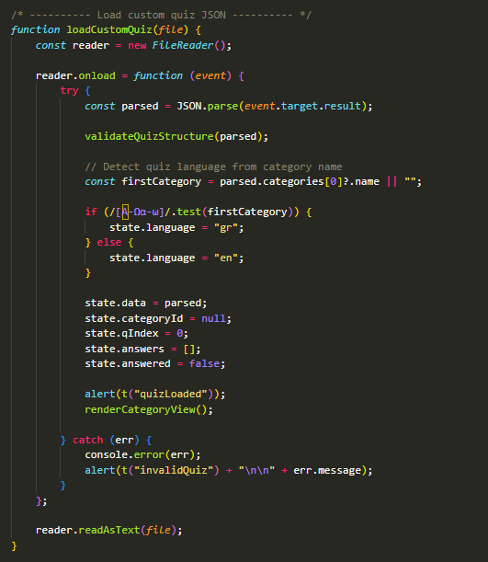

Figure 4: Custom quiz upload and validation process showing JSON parsing, structure validation, and automatic language detection

The FileReader API reads the uploaded file asynchronously, keeping the application responsive during processing. Once parsed, the data is passed to validateQuizStructure(), which enforces structural integrity, checking for valid categories, question format, exactly four answer options, valid answer indices (0–3), and recognised difficulty values. Error handling via try-catch ensures users receive clear, descriptive feedback for invalid files without causing the application to crash.

A notable addition is automatic language detection — the first category name is tested against a Greek character regex (/[Α-Ωα-ω]/), and the application language is set accordingly. This means uploaded quizzes automatically switch the UI to the correct language without requiring manual selection, improving usability and extending the bilingual functionality beyond the default quiz data.

Local Storage Leaderboard
The browser’s Web Storage API is used to persist leaderboard data locally across sessions, without requiring a backend or database (MDN Web Docs, 2024b). As shown in Figure 5, scores are stored and managed within localStorage to maintain user progress between sessions.

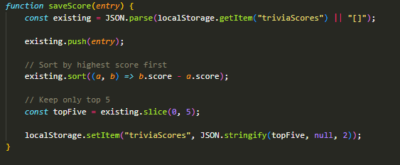
Figure 5: Local storage leaderboard implementation showing score persistence, sorting, and top-five filtering

Each score entry stores the user's name, score, category, and timestamp. Scores are sorted in descending order and capped at five entries to maintain a concise leaderboard. While localStorage restricts data to a single browser and device, it was an appropriate choice given the requirement to avoid backend technologies.

JSON Score Export
The export feature allows users to download leaderboard data as a JSON file for external storage or further analysis. As shown in Figure 6, leaderboard data is converted into a downloadable file using client-side processing.
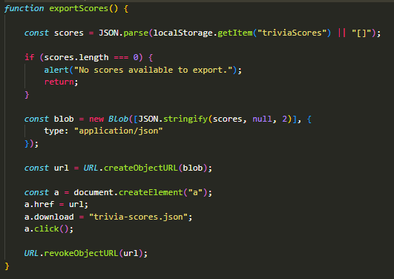
Figure 6: JSON score export process showing conversion of leaderboard data into a downloadable file using the Blob API

The Blob API converts leaderboard data into a downloadable file, with a temporary object URL triggering the download client-side without server-side processing. This complements the custom quiz upload feature, demonstrating that the system supports structured JSON data for both input and output.

Testing
Testing was conducted throughout development across three approaches: functional, validation, and usability testing. Functional testing was carried out manually against the requirements defined In Section 4.1, covering navigation, timer behaviour, score calculation, and leaderboard storage, with all high-priority requirements confirmed as passing.

Validation testing targeted the custom JSON upload feature, verifying that validateQuizStructure() correctly rejected malformed files, including missing categories, invalid answer indices, and incorrect option counts, producing appropriate error messages without crashing the application.

Usability testing conducted during a university-organised session identified an edge case where navigating backwards multiple times allows previously answered questions to be reattempted. This was resolved by refining state persistence logic, demonstrating the value of real-user testing in surfacing issues that developer testing had not identified. A full test plan and results are provided in Appendix C.

Evaluation and Conclusion
Trivia Fiesta successfully meets the objectives defined at the outset of the project, delivering a fully functional browser-based quiz system within the constraints of a client-side architecture. The SPA approach enables seamless navigation without page reloads, while the centralised state object ensures consistent data management across all views.
The custom quiz upload feature represents a significant achievement, allowing users to load their own content without modifying the application code. Structured validation ensures system stability when handling user-generated data, and automatic language detection from uploaded files extends bilingual support beyond the default quiz content. JSON score export satisfies the module requirement for data output and complements the upload functionality, demonstrating consistent handling of structured data in both directions.
Usability testing proved valuable in identifying a state management edge case that developer testing had not surfaced, reinforcing the importance of real-user feedback in the development process. The bilingual implementation, while improving accessibility, introduced complexity in maintaining consistent translations across all interface elements and validation messages.
Key limitations include localStorage restricting leaderboard data to a single browser and device, and the absence of a backend preventing features such as shared leaderboards or user accounts. Future development could address these through the introduction of a backend service, alongside enhanced accessibility features and expanded question formats.
Overall, the project demonstrates a strong application of front-end development principles, structured data handling, and Agile methodology, providing a solid foundation for future expansion.

References

Pressman, R. (2014) *Software Engineering: A Practitioner’s Approach*. 8th edn. New York: McGraw-Hill.

Schwaber, K. and Sutherland, J. (2020) *The Scrum Guide*. Available at: https://scrumguides.org (Accessed: 23 March 2026).

Flanagan, D. (2020) *JavaScript: The Definitive Guide*. 7th edn. Sebastopol: O’Reilly Media.

MDN Web Docs (2024a) *JSON*. Available at: https://developer.mozilla.org/en-US/docs/Web/JavaScript/Reference/Global_Objects/JSON (Accessed: 23 March 2026).

MDN Web Docs (2024b) *Web Storage API*. Available at: https://developer.mozilla.org/en-US/docs/Web/API/Web_Storage_API (Accessed: 23 March 2026).

APPENDIX A – Sprint Plan and Task Tracker
This appendix presents the sprint plan used during development. The project followed an iterative approach, with tasks organised into nine sprints covering planning, implementation, testing, and finalisation.
Task | Description | Status | Start Date | End Date
COMP1004 - Trivia Fiesta | Trivia Fiesta is a browser-based Single Page Application (SPA) quiz system developed using vanilla HTML, CSS and JavaScript. | Complete | 07/10/2025 | 30/04/2026
SPRINT 1 - Initiation | Project idea definition, project scope planning, and creation of the project initiation document outlining objectives, risks, and development approach. | Complete | 07/10/2025 | 21/10/2025
Define project idea and scope |  | Complete | 07/10/2025 | 21/10/2025
Identify functional and non-functional requirements |  | Complete | 07/10/2025 | 21/10/2025
Plan development approach using Scrum and Waterfall |  | Complete | 07/10/2025 | 21/10/2025
Write project initiation document |  | Complete | 07/10/2025 | 21/10/2025
SPRINT 2 - Requirements & Planning | Definition of quiz features, creation of the JSON structure for quiz data, collection of bilingual question examples, and initial planning of the user interface. | Complete | 22/10/2025 | 04/11/2025
Define quiz features (categories, scoring, bilingual support) |  | Complete | 22/10/2025 | 04/11/2025
Design JSON structure for quiz data |  | Complete | 22/10/2025 | 04/11/2025
Gather example questions in English and Greek |  | Complete | 22/10/2025 | 04/11/2025
Plan UI layout |  | Complete | 22/10/2025 | 04/11/2025
SPRINT 3 - Initial Implementation | Creation of the project repository and initial application structure, including HTML layout, SPA container setup, helper functions, and project documentation. | Complete | 05/11/2025 | 19/11/2025
Set up project repository |  | Complete | 05/11/2025 | 19/11/2025
Build HTML layout |  | Complete | 05/11/2025 | 19/11/2025
Implement SPA containers |  | Complete | 05/11/2025 | 19/11/2025
Add helper function |  | Complete | 05/11/2025 | 19/11/2025
Write READ.ME |  | Complete | 05/11/2025 | 19/11/2025
SPRINT 4 - Core Quiz Functionality | Implementation of the main quiz logic including category selection, question rendering, answer validation, and score tracking. | Complete | 20/11/2025 | 11/12/2025
Category selection system |  | Complete | 20/11/2025 | 11/12/2025
Question rendering |  | Complete | 20/11/2025 | 11/12/2025
Answer selection logic |  | Complete | 20/11/2025 | 11/12/2025
Score tracking |  | Complete | 20/11/2025 | 11/12/2025
SPRINT 5 - Mid Project Submission | Preparation of mid-project deliverables including the personal development paragraph, presentation, and submission of the mid-project video demonstration. | Complete | 12/12/2025 | 09/01/2026
Personal development paragraph |  | Complete | 12/12/2025 | 19/12/2025
Powerpoint |  | Complete | 12/12/2025 | 19/12/2025
Christmas Break |  | Complete | 20/12/2025 | 03/01/2026
Mid project video submission |  | Complete | 04/01/2026 | 09/01/2026
SPRINT 6 - Advanced Features | Development of additional interactive features including the countdown timer, sound effects, theme toggle (light/dark mode), and difficulty filtering. | Complete | 10/01/2026 | 31/01/2026
Timer system |  | Complete | 10/01/2026 | 31/01/2026
Sound effects |  | Complete | 10/01/2026 | 31/01/2026
Light / Dark mode |  | Complete | 10/01/2026 | 31/01/2026
Difficulty filtering |  | Complete | 10/01/2026 | 31/01/2026
SPRINT 7 - Custom Quiz Feature | Implementation of custom quiz functionality allowing users to download a JSON template and upload their own quizzes with validation checks. | Complete | 01/02/2026 | 15/02/2026
JSON template download |  | Complete | 01/02/2026 | 15/02/2026
Custom quiz upload |  | Complete | 01/02/2026 | 15/02/2026
Error messages |  | Complete | 01/02/2026 | 15/02/2026
JSON structure validation |  | Complete | 01/02/2026 | 15/02/2026
SPRINT 8 - Testing & Refinement | System testing and interface improvements including bug fixes, UI adjustments, validation testing, leaderboard functionality, and navigation corrections. | Complete | 16/02/2026 | 02/03/2026
Bug fixes |  | Complete | 16/02/2026 | 02/03/2026
UI improvements |  | Complete | 16/02/2026 | 02/03/2026
Validation testing |  | Complete | 16/02/2026 | 02/03/2026
Leaderboard functionality |  | Complete | 16/02/2026 | 02/03/2026
Navigation fixes (back button / timer reset) |  | Complete | 16/02/2026 | 02/03/2026
SPRINT 9 - Finalisation | Final project refinement including JSON score export, code commenting, poster creation, report writing, final testing, and submission preparation. | Complete | 03/03/2026 | 30/04/2026
JSON score export |  | Complete | 03/03/2026 | 17/03/2026
Final code comments |  | Complete | 03/03/2026 | 17/03/2026
Final UI polishing |  | Complete | 03/03/2026 | 17/03/2026
Create poster |  | Complete | 18/03/2026 | 29/03/2026
Write report |  | Complete | 18/03/2026 | 29/03/2026
Final application test |  | Complete | 18/03/2026 | 29/03/2026
Spring/Easter break |  | Complete | 30/03/2026 | 17/04/2026
Submission checklist |  | Complete | 18/04/2026 | 30/04/2026

APPENDIX B – Data Design
This appendix presents the data structures used within the Trivia Fiesta application. The system relies on structured JSON data and a centralised state object to manage quiz content, user interaction, and application state.

JSON STRUCTURE

{
"categories": [
{
"id": "general",
"name": "General Knowledge",
"questions": [
{
"id": 1,
"text": "What is the capital city of Canada?",
"options": [
"Ottawa",
"Toronto",
"Vancouver",
"Montreal"
],
"answerIndex": 0,
"difficulty": "easy"
}
]
}
]
}

This structure represents quiz data stored in JSON format. Each category contains multiple questions, with each question including a text prompt, four answer options, the correct answer index, and a difficulty level. The application supports both English and Greek quiz datasets, which follow the same JSON structure.

APPLICATION STATE OBJECT
const state = {
language: "en",
data: null,
categoryId: null,
difficulty: null,
qIndex: 0,
answers: [],
answered: false,
questions: [],
timer: null,
timeLeft: 15,
timeout: false,
soundOn: true
};

The state object stores key application data, including user selections, quiz progress and timer state, ensuring consistency across all views of the application.

LOCAL STORAGE STRUCTURE
[
{
"name": "User",
"score": 5,
"category": "General Knowledge",
"date": "2026-03-20"
}
]

Leaderboard data is stored in localStorage as an array of objects, each containing the user’s name, score, category and timestamp. This enables data persistence across sessions without requiring a backend.

All data processing is performed client-side using JavaScript. Quiz data is loaded dynamically from JSON, user interactions are managed through the state object, and leaderboard data is stored using localStorage.

APPENDIX C – Test Plan

Testing Overview
A comprehensive testing strategy was implemented to ensure the reliability, functionality, and usability of the Trivia Fiesta application. Testing was conducted iteratively throughout development, allowing issues to be identified and resolved early. The approach combined verification and validation techniques, ensuring that the system was developed according to its specifications (verification) and met the needs of its intended users (validation). Emphasis was placed on testing core interactive features such as quiz navigation, answer selection, timer behaviour, and score calculation, as these are central to the user experience. In addition, validation testing ensured that invalid inputs, particularly within the custom quiz upload feature, were handled safely without causing system failures.
Test Plan
The test plan was designed to cover multiple levels of testing, including functional, usability, validation, and cross-browser testing. Functional testing verified that all major features operated as expected under normal conditions, while validation testing ensured that incorrect or incomplete inputs were handled appropriately. Testing also ensured that key components, including the application state, user interface, and localStorage, interacted correctly and maintained consistency across the application. Usability testing was conducted informally to assess the clarity and responsiveness of the interface, particularly in relation to bilingual support and user feedback. Cross-browser and device testing confirmed consistent performance across modern browsers and mobile devices. The detailed test cases presented in this appendix demonstrate a structured approach, with clearly defined scenarios, expected outcomes, and results, ensuring coverage of both typical and edge-case behaviours.

Testing Reflection
Several test cases initially resulted in failures, particularly in relation to navigation logic and edge-case conditions. These issues were identified during testing and subsequently resolved, improving overall system reliability.

Quiz Flow and Setup
Test Case ID | Page | Testing Type | Test Scenario | Test Description | Expected Outcome | Result
TC1 | SPA | Functional | Select English Language | User clicks English button | UI updates to English (default language applied) | Pass
TC2 | SPA | Functional | Select Greek Language | User clicks Greek button | UI updates to Greek | Pass
TC3 | SPA | Functional | Select Category | User selects a category | Category stored in state | Pass
TC4 | SPA | Functional | Select Difficulty | User selects difficulty | Difficulty stored in state | Pass
TC5 | SPA | Functional | Start Quiz | User completes setup | First question displayed | Pass
Question Handling and Logic
Test Case ID | Page | Testing Type | Test Scenario | Test Description | Expected Outcome | Result
TC6 | SPA | Functional | Display Question | Question loads from dataset | Question text and options show | Pass
TC7 | SPA | Functional | Select answer | User selects an option | Answer stored in state.answers | Pass
TC8 | SPA | Functional | Prevent multiple answers | User selects an answer and attempts to select another | Second selection is ignored and original answer remains | Pass
TC9 | SPA | Functional | Correct answer feedback | Select correct answer | Option highlighted green | Pass
TC10 | SPA | Functional | Incorrect answer feedback | Select incorrect answer | Option highlighted red | Pass
TC11 | SPA | Functional | Disable other options | Answer selected | Other options disabled | Pass
TC12 | SPA | Functional | Next question | Click “Next” button | Next question loads | Pass
TC13 | SPA | Functional | Last question | Reach final question | Results screen displayed | Pass
TC14 | SPA | Functional | Back navigation issue | User navigates back | Answer can be changed | Fail
TC15 | SPA | Functional | Back navigation fixed | User navigates back | Answer cannot be changed | Pass

Timer Functionality
Test Case ID | Page | Testing Type | Test Scenario | Test Description | Expected Outcome | Result
TC16 | SPA | Functional | Timer starts | Question loads | Timer begins countdown | Pass
TC17 | SPA | Functional | Timer countdown | Timer running | Timer decreases correctly | Pass
TC18 | SPA | Functional | Timer expires | Timer reaches 0 before user answers | Question is marked incorrect | Pass
TC19 | SPA | Functional | Timer stops after answer | User selects an answer before timer ends | Timer stops immediately after selection | Pass
TC20 | SPA | Functional | Timer edge condition issue | Answer selected at exact timeout | Inconsistent behaviour occurs | Fail
TC21 | SPA | Functional | Timer edge condition fixed | Answer selected at exact timeout | Correct behaviour enforced consistently | Pass
Score and Results
Test Case ID | Page | Testing Type | Test Scenario | Test Description | Expected Outcome | Result
TC22 | SPA | Functional | Calculate Score | Quiz completed | Score calculated correctly | Pass
TC23 | SPA | Functional | Display results | Quiz ends | Score shown to user | Pass
TC24 | SPA | Functional | Score accuracy | Multiple correct answers | Score matches correct answers | Pass

Custom Quiz Upload
Test Case ID | Page | Testing Type | Test Scenario | Test Description | Expected Outcome | Result
TC25 | SPA | Functional | Upload valid JSON | Upload correctly structured file | Quiz loads successfully | Pass
TC26 | SPA | Validation | Invalid JSON format | Upload malformed JSON file | Error message displayed | Pass
TC27 | SPA | Validation | Missing options | Upload JSON with <4 options | Error shown | Pass
TC28 | SPA | Validation | Invalid answerIndex | answerIndex outside 0-3 | Error shown | Pass
TC29 | SPA | Validation | Missing category | JSON missing category field | Error shown | Pass
TC30 | SPA | Validation | Partial JSON issue | Missing questions array | Application fails to load | Fail
TC31 | SPA | Validation | Partial JSON fixed | Missing questions handled | Error handled gracefully with message | Pass
TC32 | SPA | Functional | Greek detection | Upload Greek quiz | Language switches to Greek | Pass
TC33 | SPA | Functional | English detection | Upload English quiz | Language remains English | Pass
Export Functionality
Test Case ID | Page | Testing Type | Test Scenario | Test Description | Expected Outcome | Result
TC34 | SPA | Functional | Export scores JSON | Click export button | JSON file downloaded | Pass
TC35 | SPA | Functional | File content check | Open exported file | Data correctly formatted | Pass

UI and Usability
Test Case ID | Page | Testing Type | Test Scenario | Test Description | Expected Outcome | Result
TC36 | SPA | Usability | Button feedback | Hover/click buttons | Visual feedback displayed | Pass
TC37 | SPA | Usability | Navigation clarity | Move through quiz | UI is user-friendly and easy to navigate | Pass
TC38 | SPA | Usability | Language switching UI | Switch languages | UI updates consistently | Pass

Local Storage and Leaderboard
Test Case ID | Page | Testing Type | Test Scenario | Test Description | Expected Outcome | Result
TC39 | SPA | Functional | Save score | User enters name and saves | Score stored in localStorage | Pass
TC40 | SPA | Functional | Retrieve leaderboard | Reload app | Stored scores displayed | Pass
TC41 | SPA | Functional | Score sorting | Multiple scores saved | Sorted in descending order | Pass
TC42 | SPA | Functional | Limit entries | More than 5 scores saved | Only top 5 retained | Pass

Theme and Sound Controls
Test Case ID | Page | Testing Type | Test Scenario | Test Description | Expected Outcome | Result
TC43 | SPA | Functional | Toggle theme | User clicks theme toggle button | UI switches between light/dark mode | Pass
TC44 | SPA | Functional | Theme persistence | User toggles theme and reloads page | Selected theme remains applied | Pass
TC45 | SPA | Functional | Toggle sound on | User enables sound | Audio feedback plays on answer selection | Pass
TC46 | SPA | Functional | Toggle sound off | User disables sound | No audio plays on answer selection | Pass
TC47 | SPA | Functional | Sound toggle during quiz | User toggles sound mid-quiz | Change applies immediately | Pass
TC48 | SPA | Validation | Sound disabled state | Sound is off and answer selected | No audio triggered under any condition | Pass

Cross-browser and Device Testing
Test Case ID | Page | Testing Type | Test Scenario | Test Description | Expected Outcome | Result
TC49 | SPA | Cross-browser | Chrome | Run app in Chrome | Works correctly | Pass
TC50 | SPA | Cross-browser | Firefox | Run app in Firefox | Works correctly | Pass
TC51 | SPA | Cross-browser | Edge | Run app in Edge | Works correctly | Pass
TC52 | SPA | Cross-browser | Mobile | Test on smartphone | Layout responsive | Pass

APPENDIX D – UML Diagrams
This appendix presents the UML diagrams used to model the structure and behaviour of the Trivia Fiesta application. These diagrams illustrate user interaction, system flow, data structure, and component interaction within the system.

Figure D1: Use Case Diagram illustrating user interactions with the system

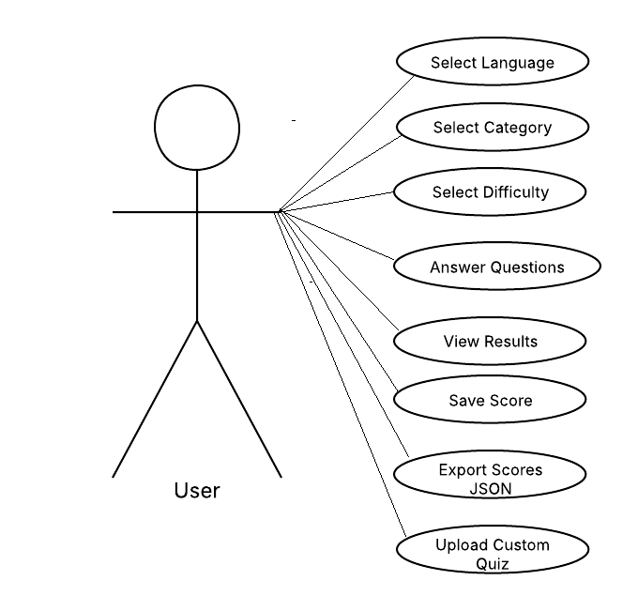
This diagram shows how users interact with the application, including selecting quiz options, answering questions, and viewing results. Additional features such as saving scores, exporting results, and uploading custom quizzes are also represented.
Figure D1: Use Case Diagram

FIGURE D2: Activity Diagram showing the overall quiz flow
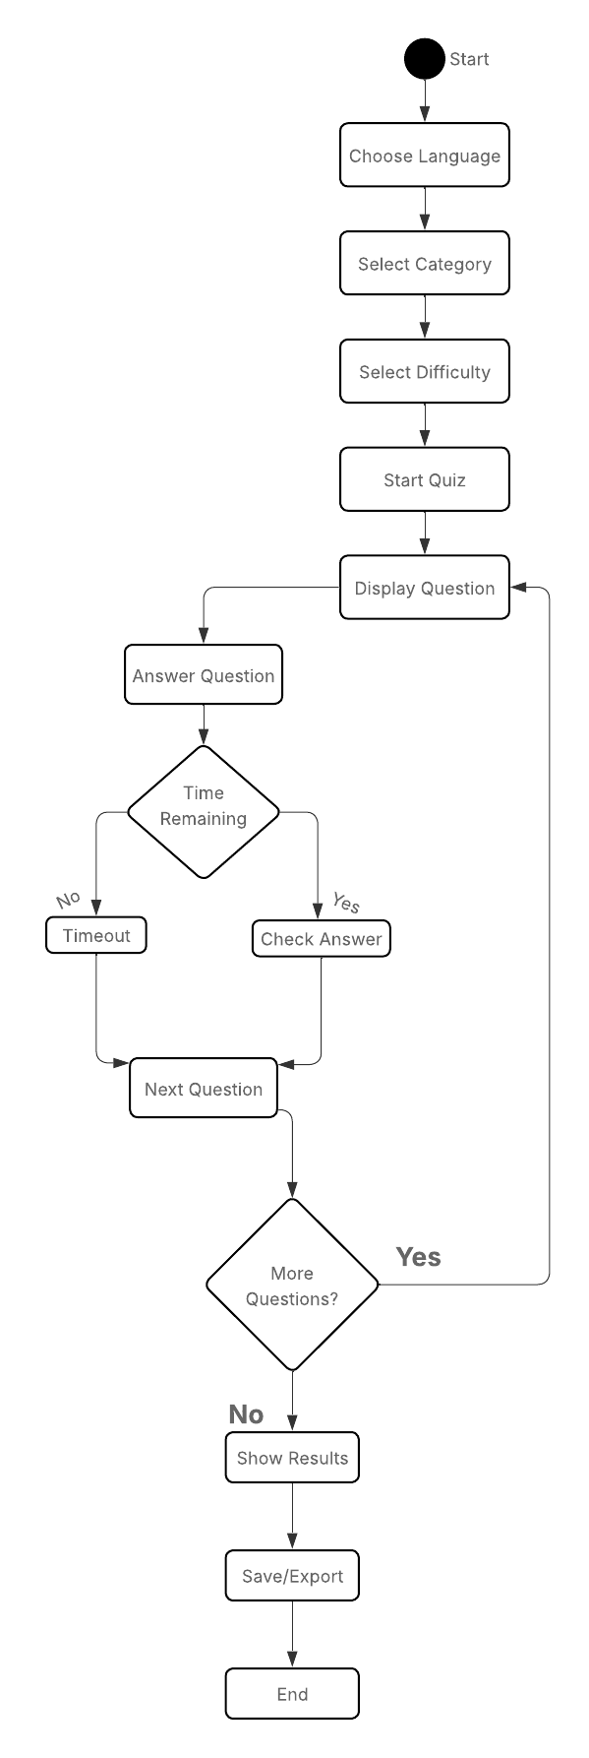
This diagram illustrates the sequence of actions within the quiz, from initial setup to question answering and final results. It includes decision points such as timer expiration and question progression.

Figure D2: Activity Diagram
FIGURE D3: Sequence Diagram

This diagram demonstrates how user input is processed by the system, showing the interaction between the user interface, application state, and DOM updates during question answering.
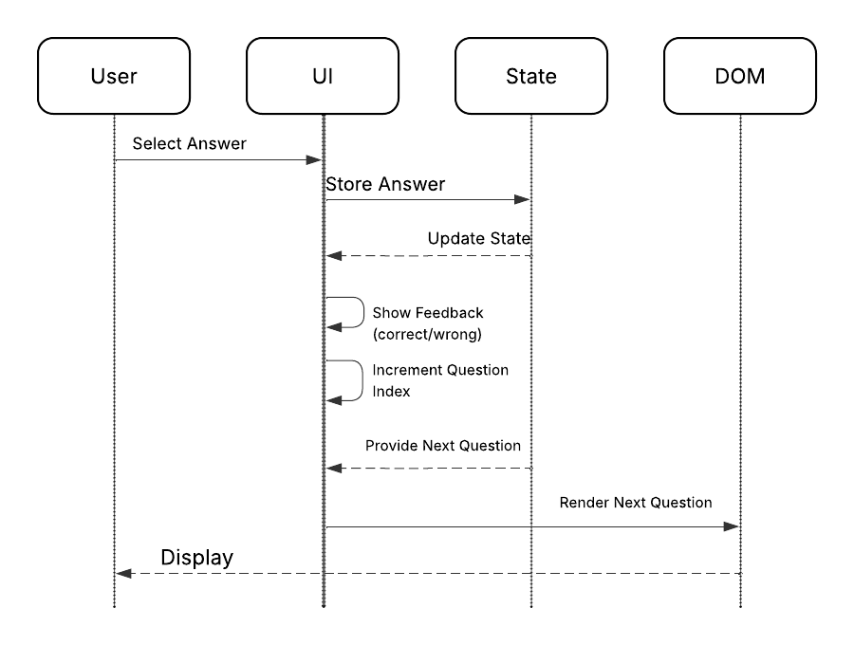
Figure D3: Sequence Diagram

FIGURE D4: Class Diagram

This diagram represents the structure of the application’s data model, highlighting the centralised state object and its relationship with question data.

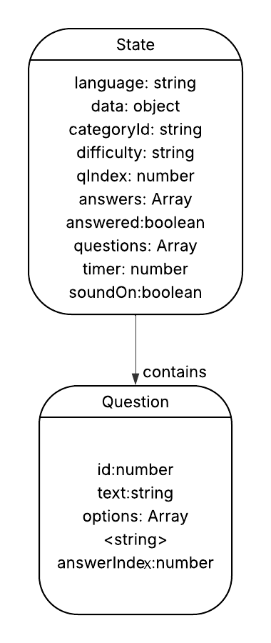

Figure D4: Class Diagram

APPENDIX E - User Interface and Validation Feedback

This appendix presents screenshots demonstrating user interface feedback and validation handling within the Trivia Fiesta application. These examples highlight successful data processing, error handling, and bilingual support across both English and Greek interfaces. These screenshots support the validation testing discussed in Appendix C.

Figure E1: Successful custom quiz upload (English)

Displays confirmation message after a valid JSON quiz file is uploaded successfully.

Figure E1 Confirmation message displayed after a valid JSON quiz file is successfully uploaded and processed.

Figure E2: JSON validation error (English)
Shows error handling when a question does not contain exactly four options, preventing invalid data from being loaded.
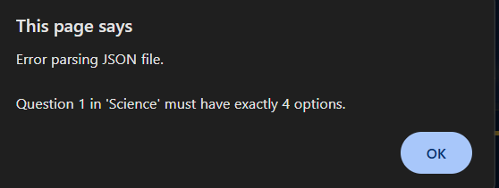
Figure E2: Error message displayed when uploaded quiz data does not meet structural requirements, preventing invalid input from being processed.

Figure E3: Successful custom quiz upload (Greek)
Demonstrates bilingual support, with confirmation messages displayed in Greek when a Greek quiz file is uploaded.
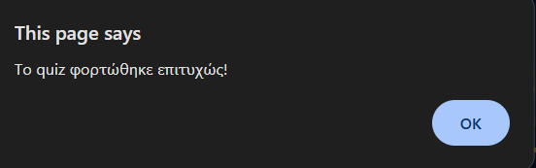
Figure E3: Confirmation message displayed in Greek following successful upload and processing of a valid quiz file.

Figure E4: JSON validation error (Greek)
Shows validation feedback in Greek, ensuring consistent user experience across both supported languages.
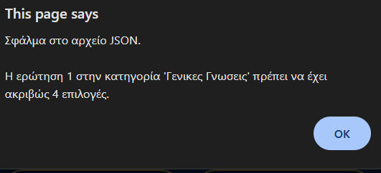
Figure E4: Validation error message displayed in Greek when uploaded quiz data contains structural issues, ensuring consistent bilingual feedback.

APPENDIX F – AI Declaration Form
Student Declaration of AI Tool use in this Assessment
Please indicate your level of usage of generative AI for this assessment - please tick the appropriate category(s).
If the “Assisted Work” or “Partnered Work” category is selected, please expand on the usage and in which elements of the assignment the usage refers to.

Solo Work | S1 - Generative AI tools have not been used for this assessment. | ☐
Assisted Work | A1 – Idea Generation and Problem Exploration  Used to generate project ideas, explore different approaches to solving a problem, or suggest features for software or systems. Students must critically assess AI-generated suggestions and ensure their own intellectual contributions are central. | ☐
 | A2 - Planning & Structuring Projects  AI may help outline the structure of reports, documentation and projects. The final structure and implementation must be the student’s own work. | ☐
 | A3 – Code Architecture  AI tools maybe used to help outline code architecture (e.g. suggesting class hierarchies or module breakdowns). The final code structure must be the student’s own work. | ☐
 | A4 – Research Assistance  Used to locate and summarise relevant articles, academic papers, technical documentation, or online resources (e.g. Stack Overflow, GitHub discussions. The interpretation and integration of research into the assignment remain the student’s responsibility. | ☒
 | A5 - Language Refinement  Used to check grammar, refine language, improve sentence structure in documentation not code. AI should be used only to provide suggestions for improvement. Students must ensure that the documentation accurately reflects the code and is technically correct. | ☒
 | A6 – Code Review  AI tools can be used to check comments within the code and to suggest improvements to code readability, structure or syntax. AI should be used only to provide suggestions for improvement. Students must ensure that the code accurately reflects their knowledge and is technically correct. | ☐
 | A7 - Code Generation for Learning Purposes  Used to generate example code snippets to understand syntax, explore alternative implementations, or learn new programming paradigms. Students must not submit AI-generated code as their own and must be able to explain how it works. | ☐
 | A8 - Technical Guidance & Debugging Support  AI tools can be used to explain algorithms, programming concepts, or debugging strategies. Students may also help interpret error messages or suggest possible fixes. However, students must write, test, and debug their own code independently and understand all solutions submitted. | ☐
 | A9 - Testing and Validation Support  AI may assist in generating test cases, validating outputs, or suggesting edge cases for software testing. Students are responsible for designing comprehensive test plans and interpreting test results. | ☐
 | A10 - Data Analysis and Visualization Guidance  AI tools can help suggest ways to analyse datasets or visualize results (e.g. recommending chart types or statistical methods). Students must perform the analysis themselves and understand the implications of the results. | ☐
 | A11 - Other uses not listed above  Please specify: | ☐
Partnered Work | P1 - Generative AI tool usage has been used integrally for this assessment  Students can adopt approaches that are compliant with instructions in the assessment brief.  Please Specify: | ☐

Please provide details of AI usage and which elements of the coursework this relates to:

Language refinement – used to assist with the word limit and grammar check.
Research assistant – used to research questions and learn about scrum.

I understand that the ownership and responsibility for the academic integrity of this submitted assessment falls with me, the student. | ☒
I confirm that all details provide above are an accurate description of how AI was used for this assessment. | ☒

