**LED_BLINK**

In this demo, I have used an interrupt to toggle an LED on and off using interrupt and counter debouncing.

As we all know, key bouncing is a major issue for buttons, and just pulling up or pulling down a button won't be enough to counter it. So, in my approach, I used an interrupt to tackle it.

1. First Approach - Using SysTick Timer

The plan was to tackle debouncing by first observing when the false triggering took place using a Salea Logic Analyzer. It was around 40ms. So, I used the built-in function:

**Hal_Delay(100); //100 ms delay**

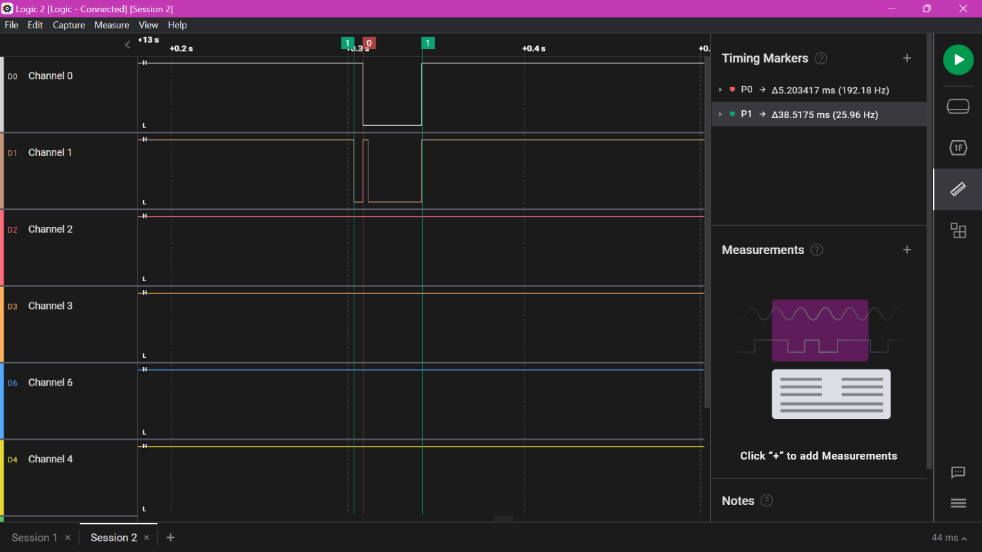

Key bouncing(a)

Key bouncing(b)

However, after pressing the button once, it went into an infinite loop. After debugging, I found that the priority of NVIC_Systick_Timer was lower than NVIC_EXT_13 (my pin). But even after changing the priority, it was not running. After hours of troubleshooting, I decided to use a timer for this purpose instead.

1. First Approach- Using TIM3-

Instead of using the Systick Timer, we can use any timer to generate a delay.

For this, I set the APB1Tim clock to 20MHz and the clock source to be the internal clock. Do not change any other settings. Now set the Clock Prescaler to 2000-1.

20MHz / 2000 = 10kHz

Now set ARR to 1600-1.

10kHz / 1600 = 6.25Hz

After running this (without changing the NVIC priority), it worked perfectly.

Correct LED Blink using Interrupt

**Notes**

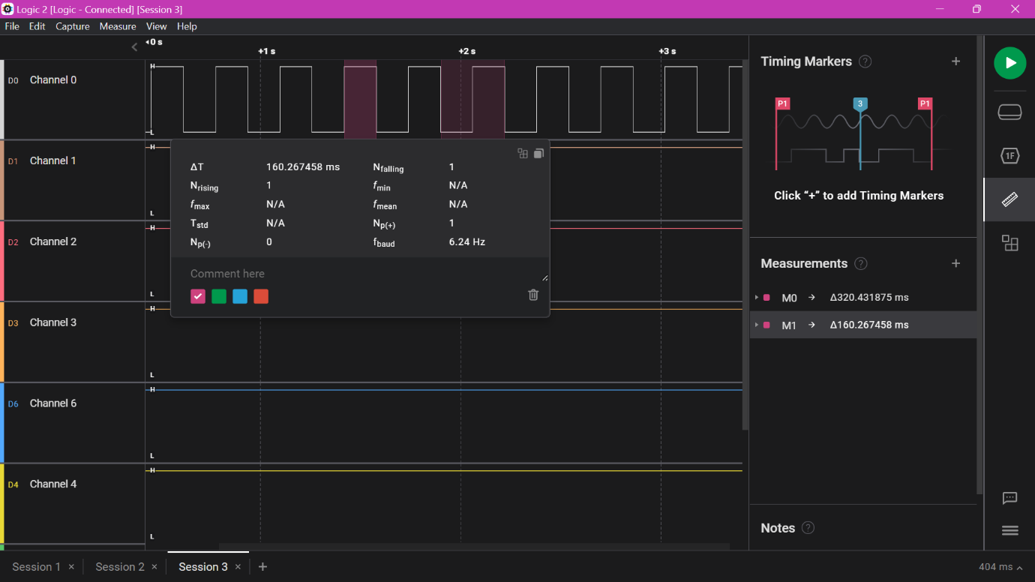

Demo Link

160ms PWM 50% pulse