## Step 1:

Go to <https://www.luis.ai/user/settings> and copy “Authoring Key” and paste it in index.js

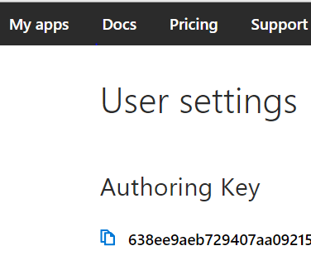

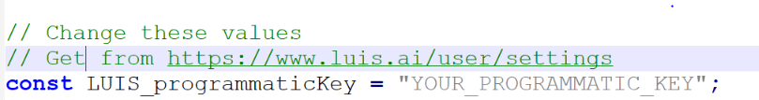

## Step 2:

Csv named IoT.csv (Sample file is already there, change to add your intents/entities)

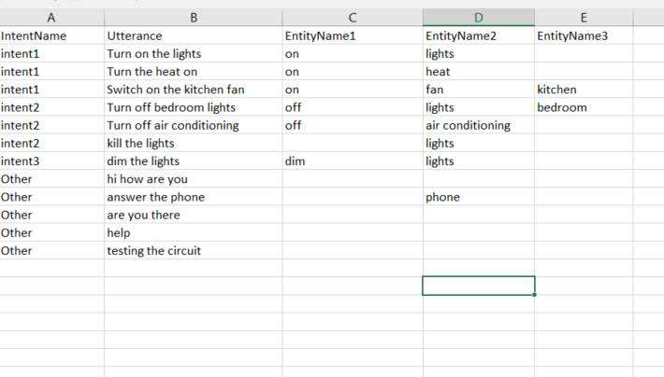

## Step 3:

Run “npm install” then

“node index.js”

Note: You need Node to run this command. <https://nodejs.org/en/>

After that, go to <https://www.luis.ai/applications> and Select your app.

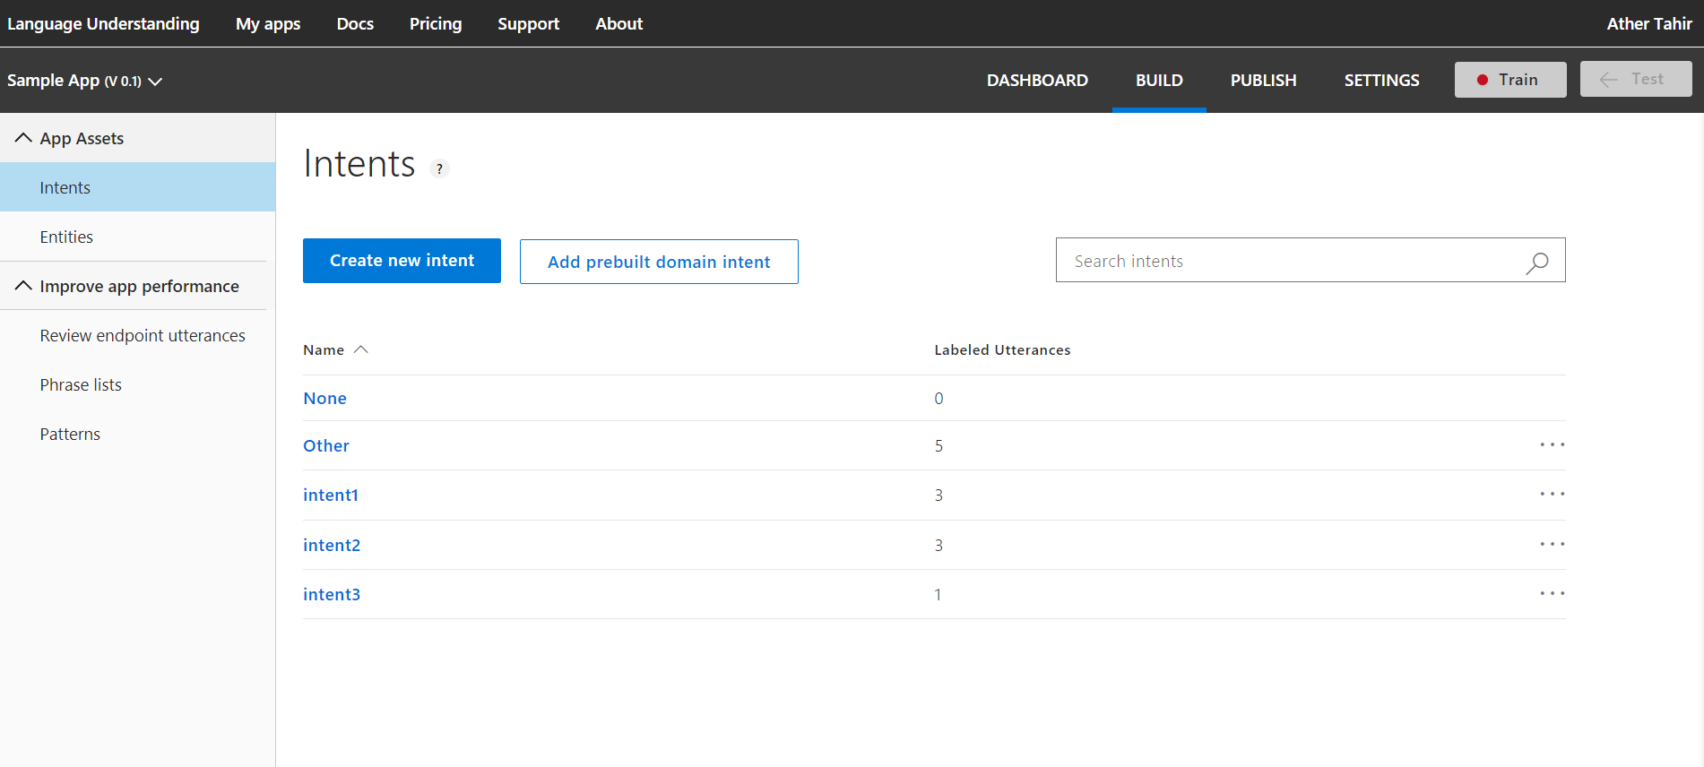

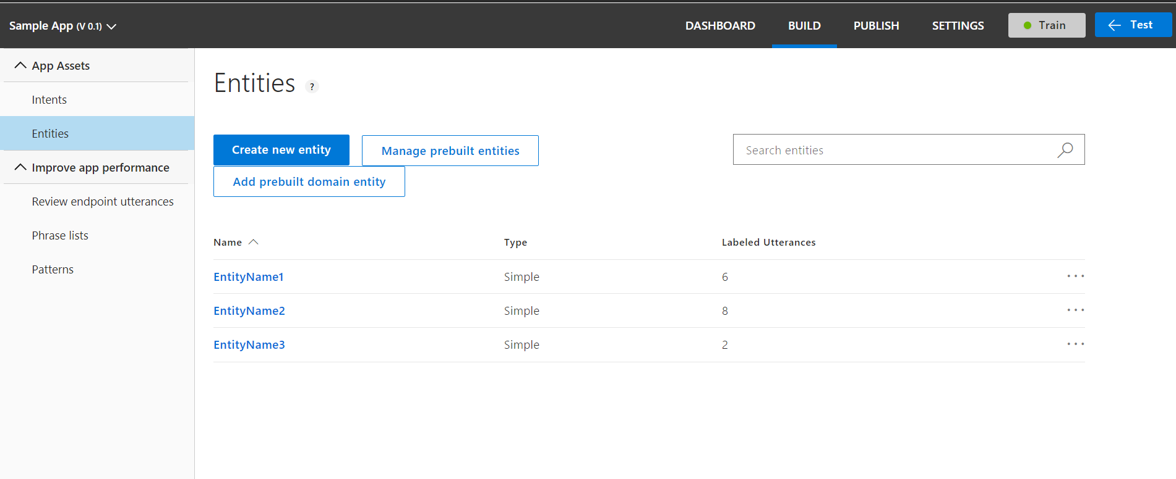

Now, your luis model has been created but you need to train and publish your model from website

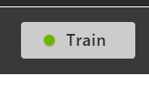

Then Publish it.

