Lab#2: Data Definition and Addressing Modes.

Data Definition:

Assignment #1: Show the memory after defining the following variables:

ORG 100H X1 DB ?
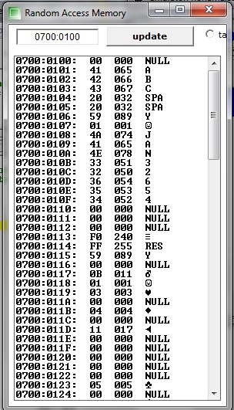
X2 DB 'ABC' X3 DB 32
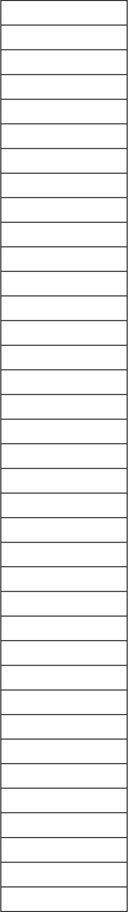X4 DB 20H X1
00
41
42
43
20
20
59
01
4A
41
4E
33
32
36
35
34
00
00
00
F0 FF 59
00
0B
01
03
00
04
00
11
00
00
00
00
00
05
00
X5 DB 01011001B X2
X6 DB 01, 'JAN'
X7 DB '32654'
X8 DB 3 DUP(0) X3
X4
Y1 DW 0FFF0H X5
Y2 DW 01011001B X6
Y3 DW X7
Y4 DW 3, 4, 17 Y5 DW 2 DUP(0)
Y6 DW X8-X7 X7
HLT

X8

Y1 Y2 Y3 Y4

Y5

Y6

Addressing Modes:
Assignment #2: Initializing the internal registers of the 80x86 as follows:
(AX) = 0000H (BX) = 0001H (CX) = 0002H (DX) = 0003H (SI) = 0010H (DI) = 0020H (BP) = 0030H (DS) = 0B60H

Fill all memory locations in the range DS:00 through DS:1F with 00H and then initialize the following storage locations:
(DS:0001H) = BBBBH (DS:0004H) = CCCCH (DS:0011H) = DDDDH (DS:0014H) = EEEEH (DS:0016H) = FFFFH

Using emu8086 to assemble the instructions
- MOV AX, BX
- MOV AX, 0AAAAh
- MOV AX, [BX]
- MOV AX, [4]
- MOV AX, [BX+SI]
- MOV AX, [SI+4]
- MOV AX, [BX+SI+4]

Trace the execution of the instructions (a) through (g). Explain the execution of each instruction, including addressing mode, physical address for memory addressing mode, value in AX. Fill the table below.

Instruction | Addressing Mode | Physical Address | AX
a | Register A. M.
b | Immediate A. M.
c | Indirect A. M.
d | Direct A. M.
e | Based Indexed A. M.
f | Indexed A. M.
g | Based Indexed A. M.

Solution:

ORG 100H
;;;;;;;;;;;;;;;;;;;;;;;;;;;;;;;;;;;;;;;;;;;;;;;;;;;;;;;;;;;;;;;;; Initializing Registers

;;;;;;;;;;;;;;;;;;;;;;;;;;;;;;;;;;;;;;;;;;;;;;;;;;;;;;;;;;;;;;;;;; Fill the specified memory locations

;;;;;;;;;;;;;;;;;;;;;;;;;;;;;;;;;;;;;;;;;;;;;;;;;;;;;;;;;;;;;;;;;;; Instructions

HLT

Writing program

Given memory locations defined as below:

X DB 10,11,19,20,30,40,100,1,2,3,4,5,6

Write an assembler codes to replace values that are greater than 10 with zero values.

