OASIS Health Check User Guide



Table of Contents

1. Contents

1 Summary 2

1.1 Intended Audience 2

2 Installation / Uninstallation 2

2.1 Assumptions / Requirements 2

2.2 Installation 2

2.3 Uninstallation 4

3 Tool Usage 5

3.1 Command Line Help 5

3.2 Run OASIS Health Check from the Command Line 6

3.3 Run OASIS Health Check for Multiple Environments 8

3.3.1 Run Oasis Health Check Using Config File 8

3.3.2 Create Database Config Table Data 9

3.3.3 Run OASIS Health Check Using DB Config Table 9

3.3.4 Encrypted Password 10

4 Test Reports 10

4.1 Last Run Report 10

4.2 List of all tests run with dates and run sequence for the day 11

4.3 Report of a Test Run for a Particular date and run 11

4.4 All Reports 12

5 Test Interpretations & Validations - Advanced Users 13

5.1 Health Check Results 13

5.2 Health Check Interpretations 14

5.2.1 Test Status – OK and REVIEW 14

5.2.2 Missing Parameter Configuration 15

5.2.3 Invalid Parameter Value 15

5.2.4 Parameter Validation Failure 16

5.2.5 Incorrect Parameter Value 16

6 Self-Service 16

6.1 Self-Service Steps 17

6.2 An Example of a Self-Service Procedure Performed in odev20181se 17

7 Troubleshooting 19

7.1 Possible Errors 19

7.2 OHC Test Matrix 20

7.2.1 TEST ID: CIS_001 20

7.2.2 TEST ID: CIS_002 20

7.2.3 TEST ID: OUTPUT_001 20

7.2.4 TEST ID: OUTPUT_002 20

7.2.5 TEST ID: OUTPUT_003 21

7.2.6 TEST ID: OUTPUT_004 21

7.2.7 TEST ID: OUTPUT_005 21

7.2.8 TEST ID: OUTPUT_006 21

7.2.9 TEST ID: OUTPUT_007 22

7.2.10 TEST ID: OUTPUT_008 22

7.2.11 TEST ID: OUTPUT_ODS_INSTALLED 22

7.2.12 TEST ID: OUTPUT_ODS_VERSION 23

7.2.13 TEST ID: OUTPUT_OS_APP_DATE_TO_DIR 23

7.2.14 TEST ID: OUTPUT_DOC_GEN_PRD_NAME 23

7.2.15 TEST ID: OUTPUT_OS_BASE_VERSION 23

7.2.16 TEST ID: OUTPUT_OS_DIRECTORY_SIZE 24

7.2.17 TEST ID: OUTPUT_OS_DOC_DIRECTORY 24

7.2.18 TEST ID: OUTPUT_OS_SORT_FORM 24

7.2.19 TEST ID: OUTPUT_OS_XML_DIRECTORY 24

7.2.20 TEST ID: POLICY_PM_CHECK_NOTICE 25

7.2.21 TEST ID: PM_001 25

7.2.22 TEST ID: PM_002 25

7.2.23 TEST ID: PM_003 25

7.2.24 TEST ID: PM_004 26

7.2.25 TEST ID: PM_005 26

7.2.26 TEST ID: PM_006 26

7.2.27 TEST ID: PM_007 26

7.2.28 TEST ID: PM_008 27

7.2.29 TEST ID: PM_009 27

7.2.30 TEST ID: PM_010 27

7.2.31 TEST ID: PM_011 27

7.2.32 TEST ID: PM_012 28

7.2.33 TEST ID: PM_013 28

7.2.34 TEST ID: PM_014 28

7.2.35 TEST ID: PM_015 28

7.2.36 TEST ID: PM_016 29

7.2.37 TEST ID: PM_017 29

7.2.38 TEST ID: PM_018 29

7.2.39 TEST ID: PM_019 29

7.2.40 TEST ID: PM_020 30

7.2.41 TEST ID: PM_021 30

7.2.42 TEST ID: PM_022 30

7.2.43 TEST ID: PM_023 30

7.2.44 TEST ID: PM_024 31

7.2.45 TEST ID: PM_025 31

7.2.46 TEST ID: PM_026 31

7.2.47 TEST ID: PM_027 31

7.2.48 TEST ID: PM_028 32

7.2.49 TEST ID: PM_029 32

7.2.50 TEST ID: PM_030 32

7.2.51 TEST ID: PM_031 32

7.2.52 TEST ID: PM_032 33

7.2.53 TEST ID: FM_001 33

7.2.54 TEST ID: FM_002 33

7.2.55 TEST ID: FM_003 33

7.2.56 TEST ID: FM_004 34

7.2.57 TEST ID: FM_005 34

7.2.58 TEST ID: FM_006 34

7.2.59 TEST ID: FM_007 34

7.2.60 TEST ID: FM_008 35

7.2.61 TEST ID: FM_009 35

7.2.62 TEST ID: FM_010 35

7.2.63 TEST ID: FM_011 35

7.2.64 TEST ID: FM_012 36

7.2.65 TEST ID: FM_013 36

7.2.66 TEST ID: CM_001 36

7.2.67 TEST ID: CM_002 36

7.2.68 TEST ID: CM_003 37

7.2.69 TEST ID: CM_004 37

7.2.70 TEST ID: CM_005 37

7.2.71 TEST ID: CM_006 37

7.2.72 TEST ID: CM_007 38

7.2.73 TEST ID: CM_008 38

7.2.74 TEST ID: CM_009 38

7.2.75 TEST ID: CM_010 38

7.2.76 TEST ID: CM_011 39

7.2.77 TEST ID: CM_012 39

7.2.78 TEST ID: CM_013 39

7.2.79 TEST ID: CM_014 39

7.2.80 TEST ID: CM_015 40

7.2.81 TEST ID: CM_016 40

7.2.82 TEST ID: CM_017 40

7.2.83 TEST ID: CM_018 40

7.2.84 TEST ID: CM_019 41

7.2.85 TEST ID: CM_020 41

7.2.86 TEST ID: CM_021 41

7.2.87 TEST ID: CM_022 41

7.2.88 TEST ID: CM_023 42

7.2.89 TEST ID: CM_024 42

7.2.90 TEST ID: CM_025 42

7.2.91 TEST ID: CM_026 42

7.2.92 TEST ID: CM_027 43

7.2.93 TEST ID: CM_028 43

7.2.94 TEST ID: CM_029 43

7.2.95 TEST ID: CM_030 43

7.2.96 TEST ID: CM_031 44

7.2.97 TEST ID: CM_032 44

7.2.98 TEST ID: CM_033 44

7.2.99 TEST ID: CM_034 44

7.2.100 TEST ID: CM_035 45

7.2.101 TEST ID: CM_036 45

7.2.102 TEST ID: CM_037 45

7.2.103 TEST ID: CM_038 45

7.2.104 TEST ID: CM_039 46

7.2.105 TEST ID: CM_040 46

7.2.106 TEST ID: CM_041 46

7.2.107 TEST ID: CM_042 46

7.2.108 TEST ID: CM_043 47

7.2.109 TEST ID: CM_044 47

7.2.110 TEST ID: CM_045 47

7.2.111 TEST ID: CM_046 47

7.2.112 TEST ID: CM_047 48

7.2.113 TEST ID: CM_048 48

7.2.114 TEST ID: CM_049 48

7.2.115 TEST ID: CM_050 48

7.2.116 TEST ID: CM_051 49

7.2.117 TEST ID: CM_052 49

7.2.118 TEST ID: CM_053 49

7.2.119 TEST ID: CLAIMS_CM_AUTO_INS_CLMNTCOV 49

8 Future Enhancements 51

# Summary

OASIS Health Check tool (OHC) is used to monitor OASIS database environments for inconsistencies in configuration and data. Every time the tool is run, routine checks for validity of the OASIS configuration and data are conducted.

*This tool does not monitor OASIS web applications.*

While this tool can be run multiple times a day, daily health check runs are recommended. The tool creates a report of every run in a table; the report can be downloaded as a comma-separated file.

OASIS Health Check tool can be downloaded [from Delphi FTP site](http://ftp.delphi-tech.com/pub/OASIS/Utilities/Oasis_Health_Check)

The latest version of this document can be retrieved from the [techpub](http://techpubs.delphi-tech.com/) section of Delphi website.

## Intended Audience

This document is intended to help orient database and system administrators to several database and system maintenance-related tasks and the tools at their disposal.

# Installation / Uninstallation

## Assumptions / Requirements

1. Users must be able to log into the target database from the host machine where OHC Tool is run.
2. TNS alias names must be set up on the host machine where OHC is run.

## Installation

1. Download [the zip file](http://ftp.delphi-tech.com/pub/OASIS/Utilities/Oasis_Health_Check) to a preferred directory.
2. Unzip the file. **Oasis_Health_Check** folder is created automatically; its contents are shown below: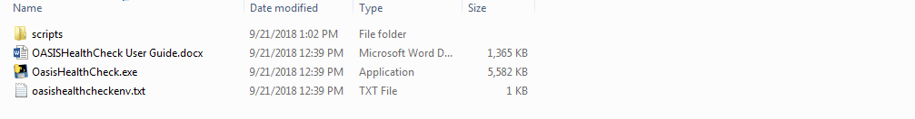
3. Open the Command Prompt and use the CD command to open the downloaded OASIS Health Check executable directory.
4. Connection string to the database is a required parameter that must be provided with the **-c** command line option and the action as **install**:

* **OasisHealthCheck.exe -c user/passwd@dbhost_dbschema –-install**

See below for sample installation screenshots:

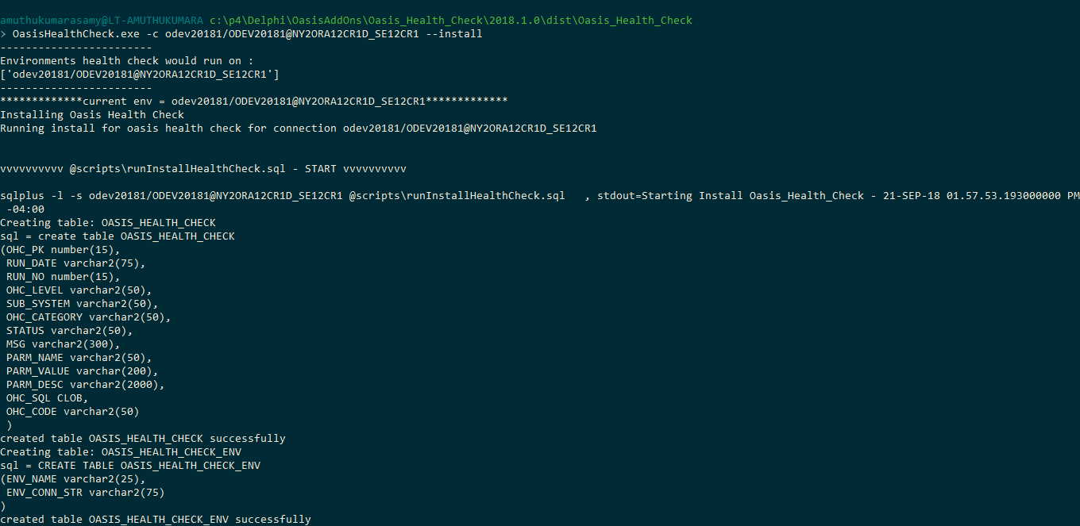

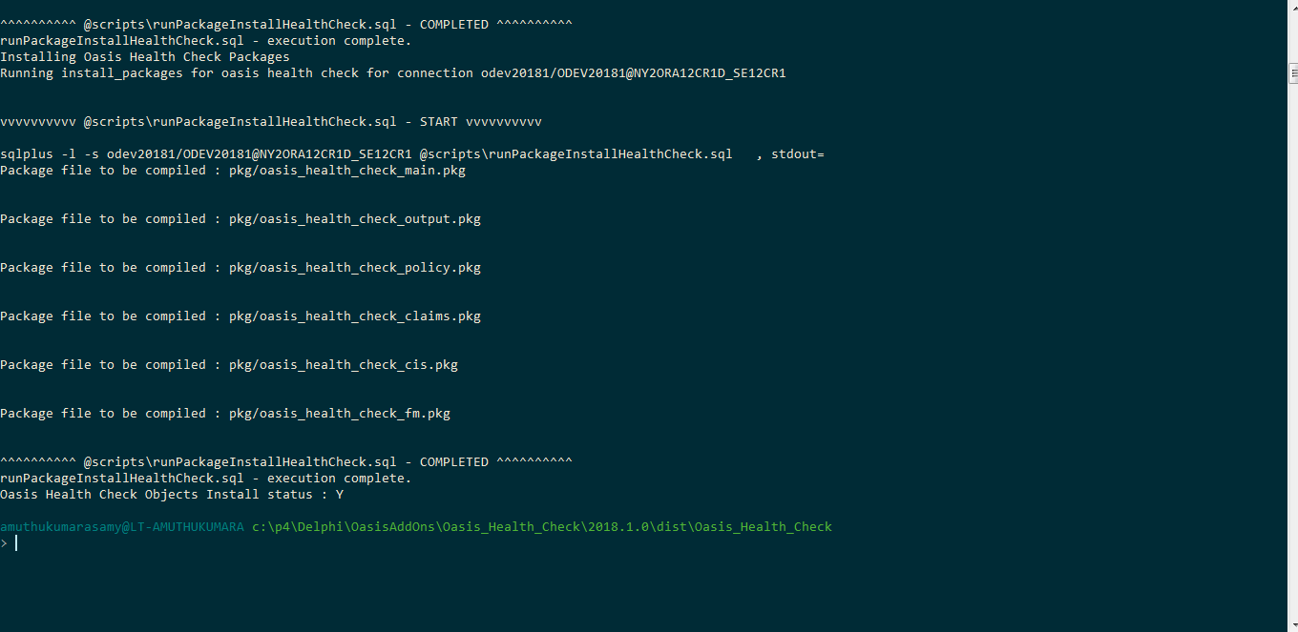

An installation log is created in the installation directory. New oracle objects such as tables, sequences and packages are installed to the database. Existing objects in the database are not modified due to the tool installation.

To ensure the installation was successful:

* Check for any errors listed in the output or in the log file.
* Make sure that the **Install status** at the end of the output is set to **‘Y**’.
* If errors had been found and installation was partially completed, follow directions to uninstall OHC in the next section, fix the issues, and try installing again.

## Uninstallation

Run the following command in the command line window to uninstall the OHC tool, as shown below:

* OasisHealthCheck.exe -c user/passwd@dbhost_dbschema –-uninstall

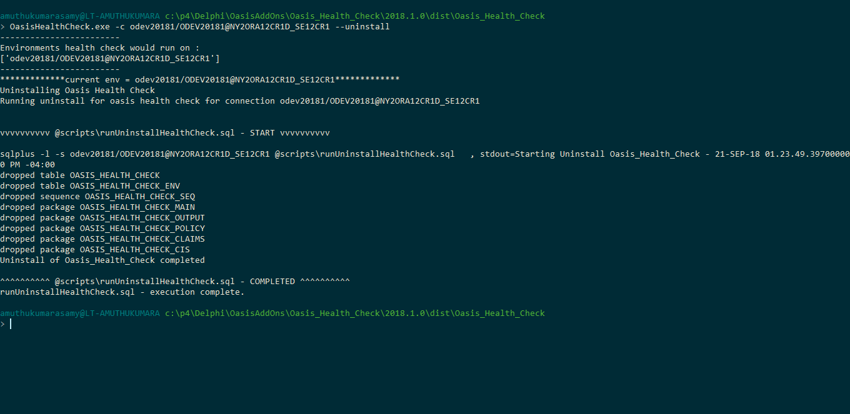

An uninstall log is created in the root directory. All the new objects such as tables, sequences and packages that were installed during installation is uninstalled. No modifications are done to existing oracle objects.

# Tool Usage

This section describes the three methods of using the OHC tool:

* Using a command line parameter to provide the connection string to the database.
* Provisioning the file with environments to be monitored with OHC.
* Provisioning the database with environments to be monitored with OHC.

At present, provisioning to the file or database uses plain text username and passwords. Next release will include making them more obscure for end users. Until then, access to this file or table (used exclusively to automate the testing) should be limited to personnel with administrative permissions only.

## Command Line Help

To use the basic command line options to run the tool, enter the following command:

* OasisHealthCheck.exe

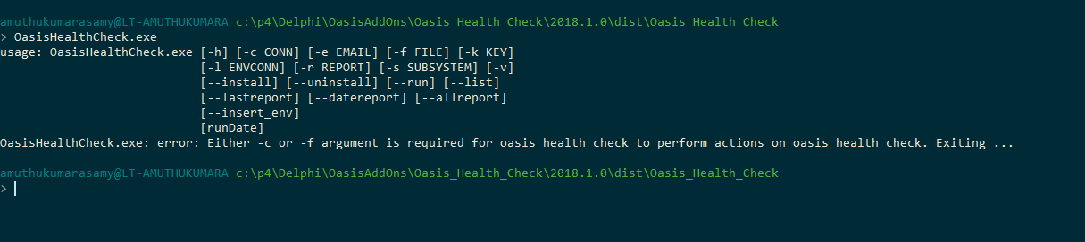

To get the version of the tool that installed,

* OasisHealthCheck.exe -v



To get detailed help messages such as usage and details on each option, enter the following command:

* OasisHealthCheck.exe -h (detailed help messages).

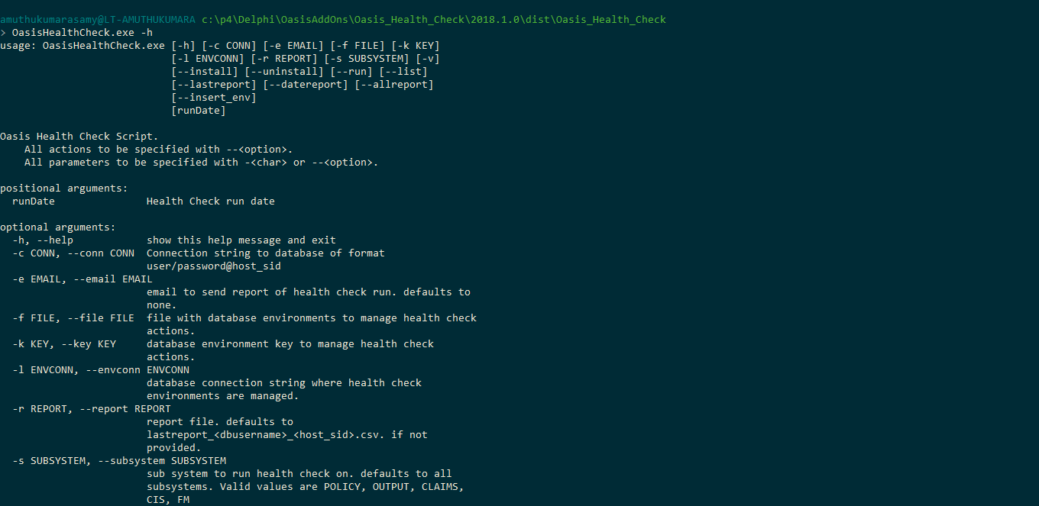

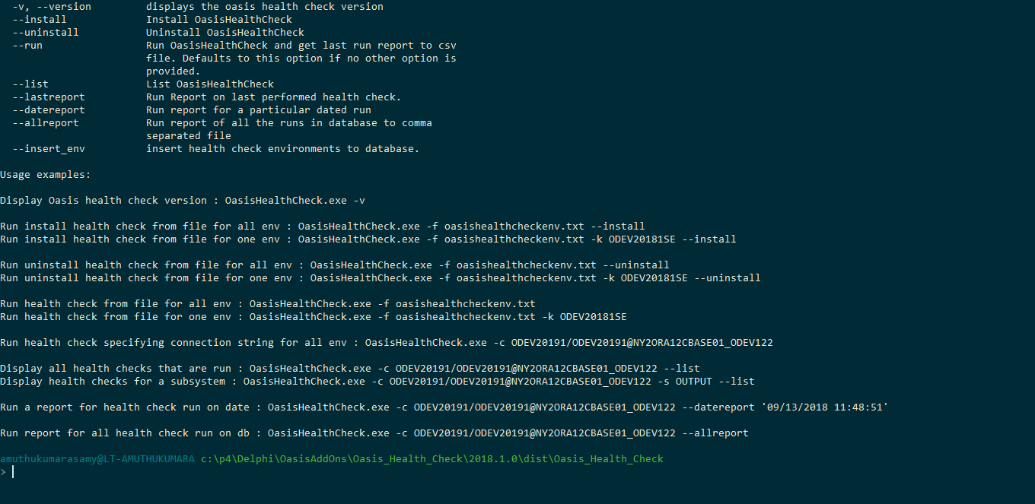

## Run OASIS Health Check from the Command Line

Once OASIS Health Check tool is installed, type in the following command,

* OasisHealthCheck.exe -c user/passwd@dbhost_dbschema (*defaults to –-run action*)

Or

* OasisHealthCheck.exe -c user/passwd@dbhost_dbschema –-run

OHC defaults to Run action if no action is specified.

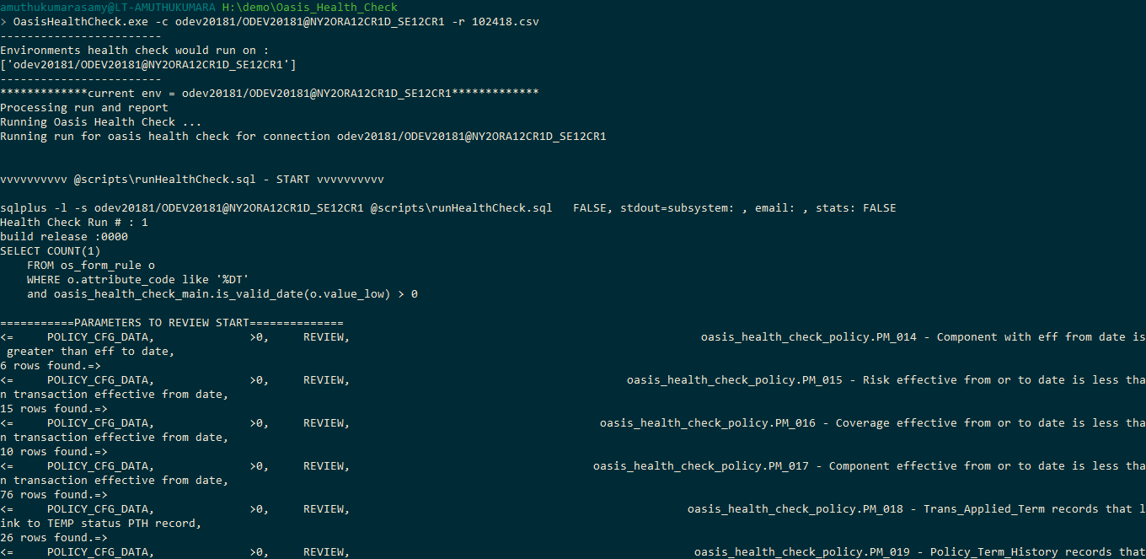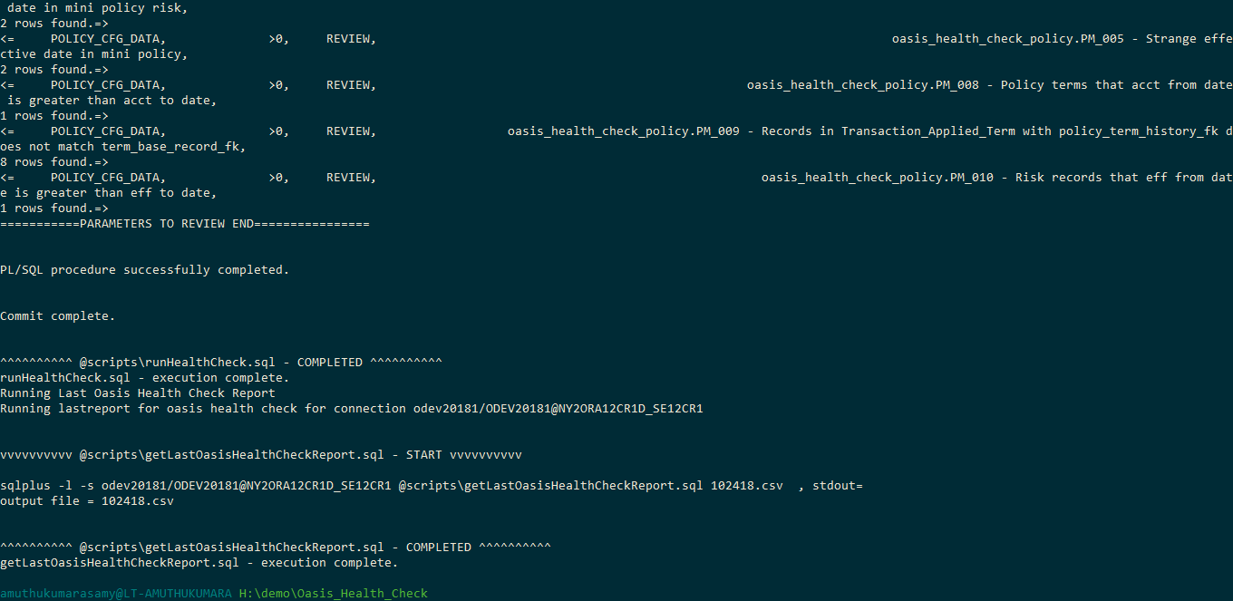

A test file included in the **scripts/oasis_health_check.tst** directory can be used to run OASIS Health Check tool manually using PL/SQL Developer environment. This method of running a test provides control over the commit of the health check test results. Test runs are not committed to the “OASIS_HEALTH_CHECK” table by default unlike when the tool is run using the OHC executable where commit of results is done immediately after execution of tests.

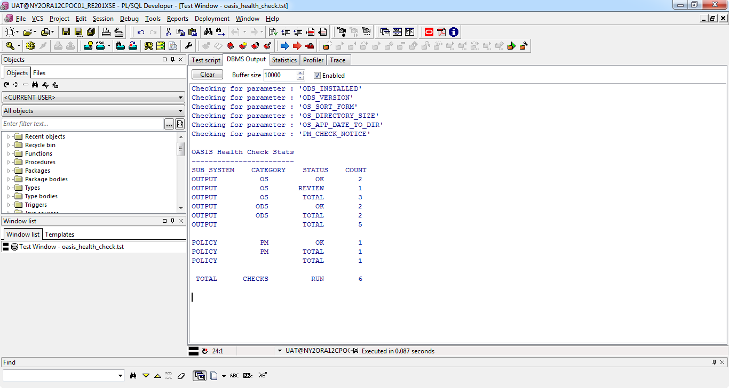

## Run OASIS Health Check for Multiple Environments

OASIS Health Check tool could be run against multiple environments using command line, saving all environments in a file or database.

Setup is required for the initial setup described below,

1. To create the file that the tool would use to get the environment information, if it is a file option.
2. To create the database table if the tool is going to be used with the database option.
3. To add encrypted password, if plain text password is not to be used during setup of the above options.

### Run Oasis Health Check Using Config File

OASIS Health Check can be run in the environments listed in the following format:

<Key> <Connection String in the format user/password@host_sid>

Refer to sample “**oasishealthcheckenv.txt”** in the OASIS Health Check tool directory. This setup file supports commenting a line by adding “#” as the first character. If a line is commented, that environment is not considered while performing any actions.

After creating the environment file, the following command runs the health check in the environment pointed to by the key:

* OASISHealthCheck.exe -f <filename> -k <key>

If no key is provided, health check runs for all the environments specified in the health check environments file for the command shown below:

* OASISHealthCheck.exe -f <filename>

### Create Database Config Table Data

OASIS Health Check environments can be provisioned in a database table created during installation (OASIS_HEALTH_CHECK_ENV) using a sample script provided in the **scripts** directory:

**scripts/ insertHealthCheckEnv.sql**

To provision the database environments through the OasisHealthCheck.py script, update the SQL in the script shown above for all the environments that OASIS Health Check has to run on, and run the following command:

* OasisHealthCheck.exe -c <connection string of the db where env has to be installed> --insert_env

### Run OASIS Health Check Using DB Config Table

OASIS Health Check can be run with the environments provisioned in a database table created during installation (**OASIS_HEALTH_CHECK_ENV**) once the step in the previous section is completed.

The following command runs the health check on the environment specified by the key:

* OASISHealthCheck.exe -d <connection string where the environments are maintained> -k <key>

If no key is provided, the health check runs for all the environments specified in the health check environments’ file for the command shown below:

* OASISHealthCheck.exe -d <connection string where the environments are maintained>

### Encrypted Password

OHC Tool will work with plain text or encrypted passwords provisioned in the file or database. To create an encrypted text password, use the following command to get the encrypted text for the connection string that needs to be saved in a file on database. This command would show the cipher text password (binary text password) that needs to be added instead of plain text password to the file or database.

To get encrypted password from the tool, use the following command,

* OASISHealthCheck.exe –encrypt_passwd <connection string in the format user/password@host_sid>

A sample run is shown below,



Replace the password field in the file or database with the whole encrypted string (**default format is b’encrypted_text’**)

# Test Reports

After oasis health check has run successful, OHC tool could be used to download various reports in a comma separated file format that could be opened through Microsoft Excel. Every run will capture that latest run results to a default file or report file specified through -r option.

The various reports that could be run using the tool are described in the sections below.

## Last Run Report

To get the last run report in a comma-separated file, type in the following command:

* OasisHealthCheck.exe -c user/passwd@dbhost_dbschema --lastreport

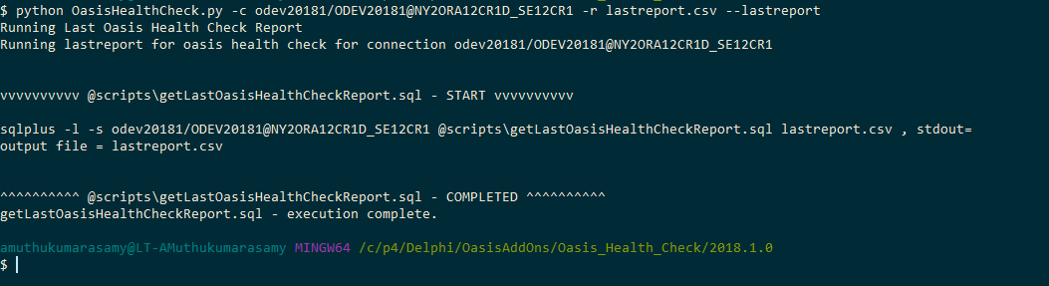

Example of a report:

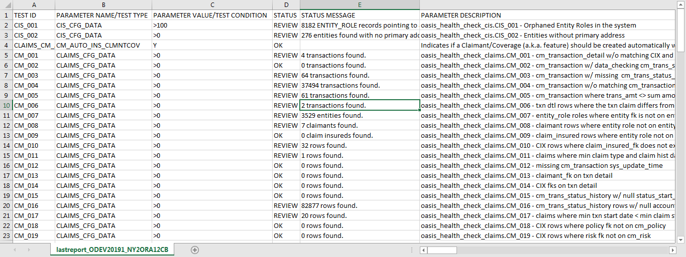

## List of all tests run with dates and run sequence for the day

To get a report for a timestamp in a comma-separated file, type in the following command:

* OasisHealthCheck.exe -c user/passwd@dbhost_dbschema -r listreport.csv –listreport

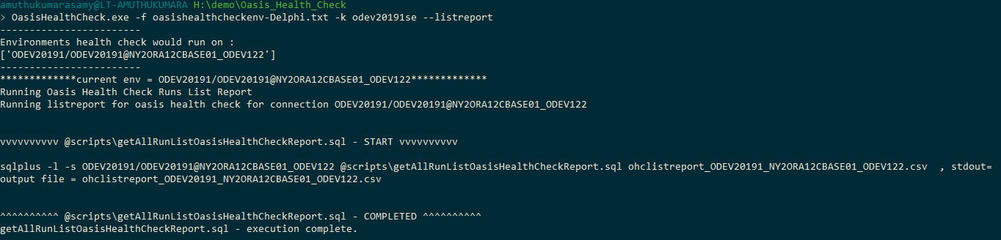This report would produce a comma separated file as given below,



## Report of a Test Run for a Particular date and run

To get a report for a timestamp in a comma-separated file, type in the following command:

* OasisHealthCheck.exe -c user/passwd@dbhost_dbschema -r daterunreport.csv --daterunreport “10/24/2018” 29

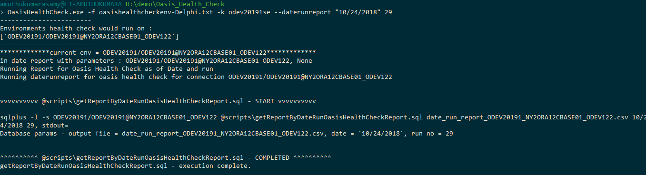A sample of all report is given below,

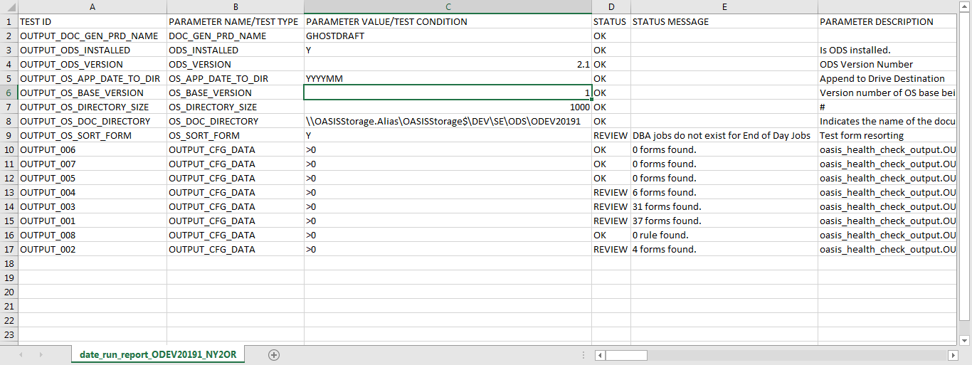

## All Reports

To get all health check reports in the database in a comma-separated file, type in the following command:

* OasisHealthCheck.exe -c user/passwd@dbhost_dbschema -r allreport.csv –allreport

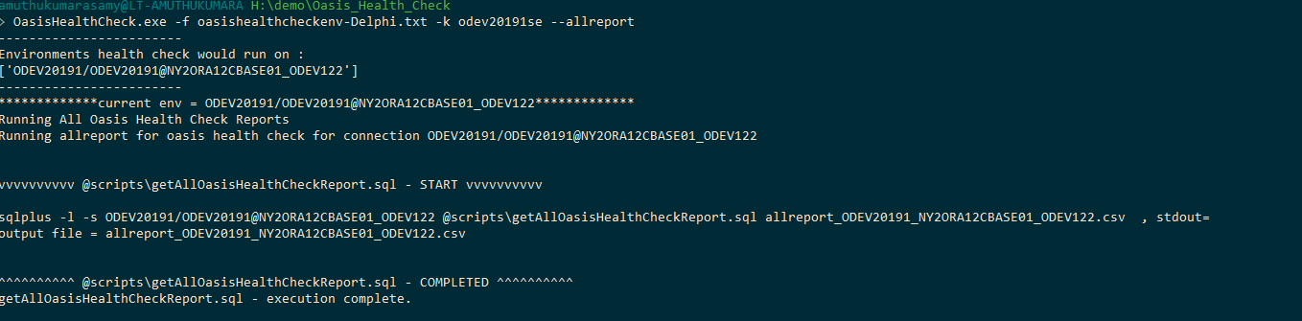A sample of all report is given below,

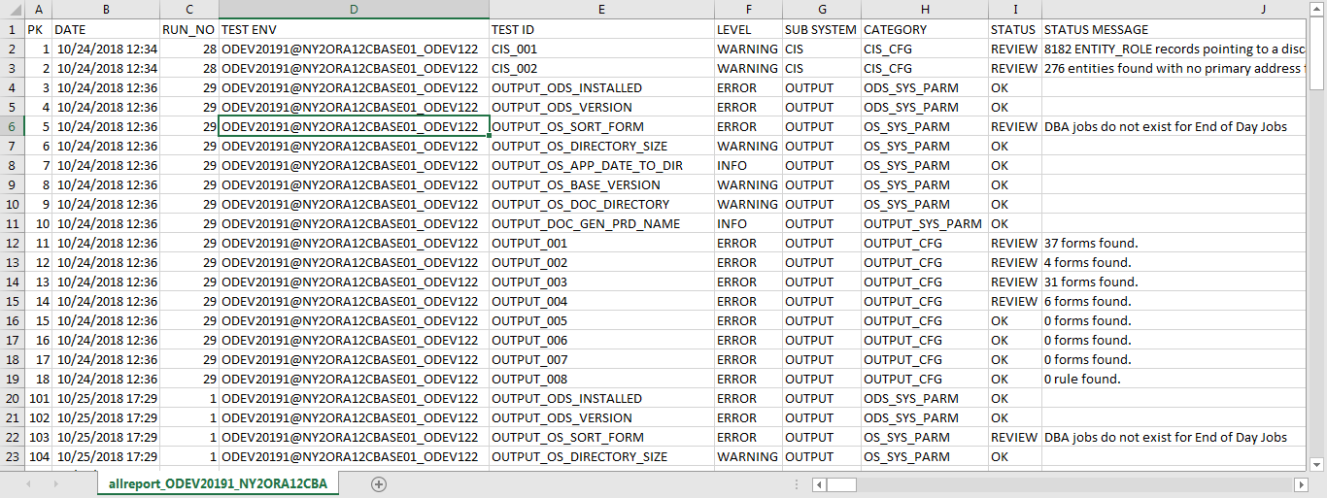

# Test Interpretations & Validations - Advanced Users

This section introduces the location where the health check results are stored, as well as the type of validations performed and how they can be interpreted from the results saved to a table or a comma-separated file.

## Health Check Results

The OHC tool captures the results of the test to the **OASIS_HEALTH_CHECK** table. The following information is stored for some of the columns in that table:

1. **STATUS** column reports the test status with three status codes:
   * OK – Validation was completed and was found to be the expected value.
   * REVIEW – Validation was completed; a configuration issue was found. A status message field specifies the problem for the parameter.
   * PENDING – Validation was not completed when a test case was added without the validation option.
2. Presently, the following subsystems supported by OASIS Health Check tool are shown in the **SUB_SYSTEM** column:
   * CIS
   * Claims
   * FM
   * Output
   * Policy
3. Two categories of validations are supported as shown in the **OHC_CATEGORY** column:
   * Configuration - Invalid configuration in the **SYSTEM_PARAMETER_UTIL** table for every subsystem. This category is stored in the following format: <SUBSYSTEM>_SYS_PARAM.
   * Data inconsistencies – Data inconsistencies found for the subsystem. This category is stored in the following format: <SUBSYSTEM>_CFG.
4. Validation level is shown using column **OHC_LEVEL** and is used to assign severity level to the validation. Some of the validation levels are:
   * INFO – Informational. This fix should be applied for OASIS to work efficiently.
   * WARNING – Problem exists, but OASIS is operational.
   * ERROR – The issue must be fixed.

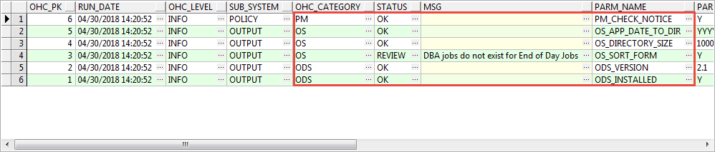

## Health Check Interpretations

This section provides examples of interpreting the OHC tool results. Screenshots below show different test statuses and an explanation of what is expected in that test scenario.

### Test Status – OK and REVIEW

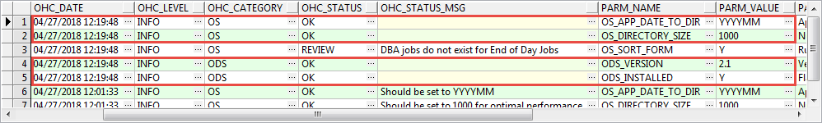

All expected parameter values are displayed with a status of OK and blank status message.

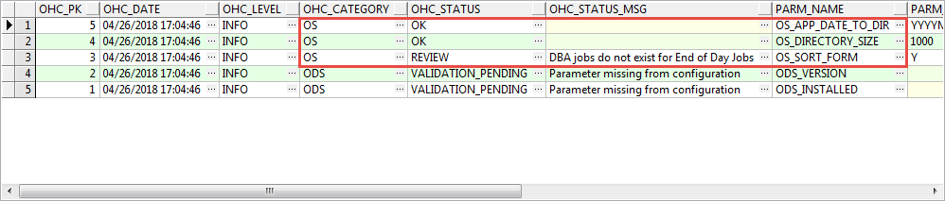

These examples show two types of validations:

* **OK** status for OS_APP_DATE_TO_DIR and OS_DIRECTORY_SIZE includes a blank status message field.
* **REVIEW** status includes an explanation of which validation failed in the status message field.

### Missing Parameter Configuration

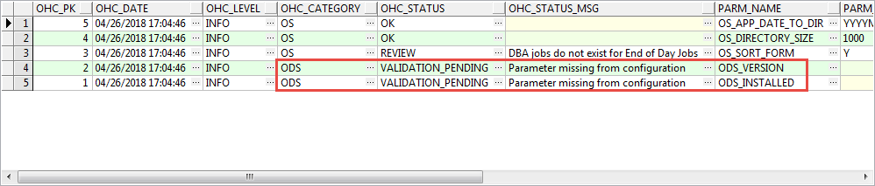

**ODS_INSTALLED** and **ODS_VERSION** parameters are not set. Status is set to **Validation_Pending** since validation was not completed for the missing parameters.

### Invalid Parameter Value

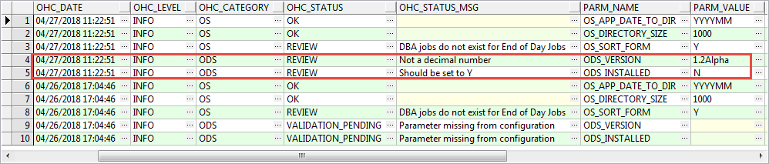

**ODS_VERSION** is a floating number.

**ODS_INSTALLED** is expected to be Y.

### Parameter Validation Failure

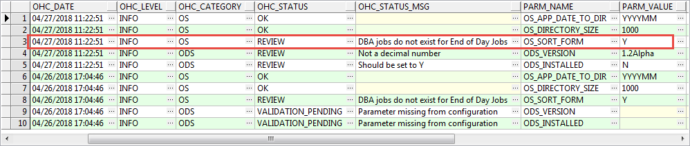

If **OS_SORT_FORM** is set to **‘Y’**, jobs must be present to handle EOD for a form that is configured to be **End Of Day**. Since it did not find that job, this is set to **REVIEW**.

### Incorrect Parameter Value

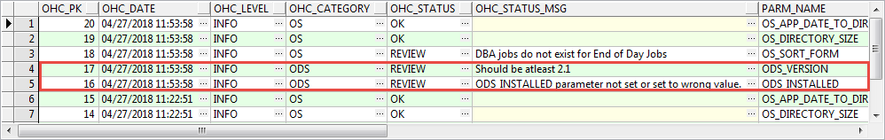

**ODS_Version** should equal 2.1.

**ODS_INSTALLED** is expected to be set to **‘Y’.**

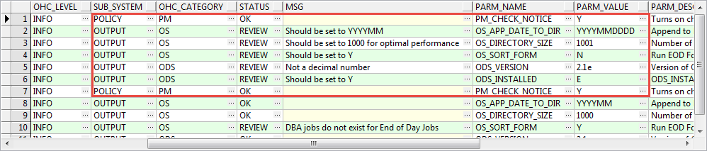

**OS_APP_DATE_TO_DIR** is expected to be set as **‘YYYYMM’.**

**OS_DIRECTORY_SIZE** is expected to be set to **1000**.

**OS_SORT_FORM** is expected to be set to ‘**Y’.**

**ODS_VERSION** is expected to be **2.1**.

# Self-Service

Customers may resolve the issues on their own using OHC tool. Below is an example of self-service using one of Delphi environments.

## Self-Service Steps

The following steps are required to successfully resolve an issue found during OASIS health check process:

1. Run health check for a small subset (one subsystem).
2. Check for any errors (review the ohc_sql used to trigger the error).
3. Fix any found errors.
4. Run the same health check for that small subset (one subsystem).
5. Check to see if the errors have been resolved.

## An Example of a Self-Service Procedure Performed in odev20181se

1. Run health check for a small subset (one subsystem, in this case CIS).

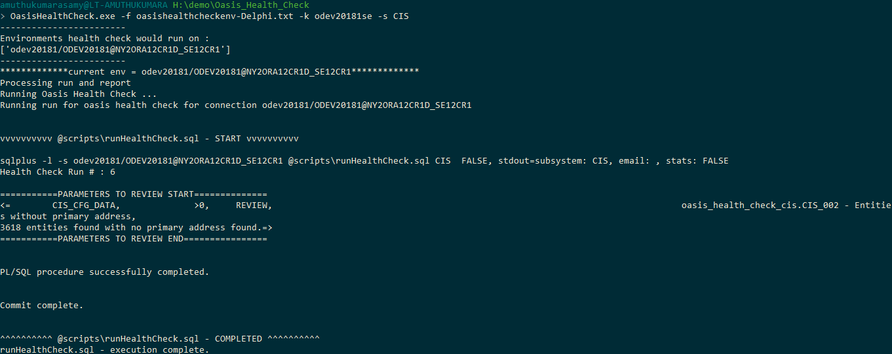

1. Check for any errors (look at the ohc_sql used to trigger the error).

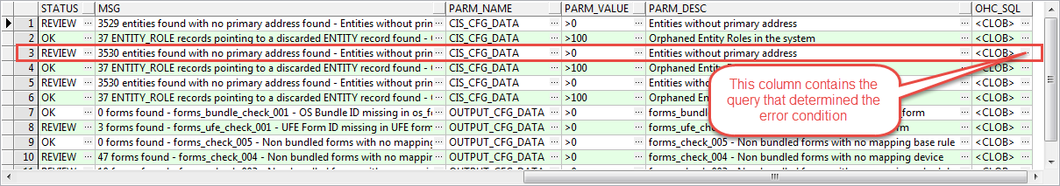

1. Click on the “…” to get the SQL and run the SQL with minor updates as shown below,

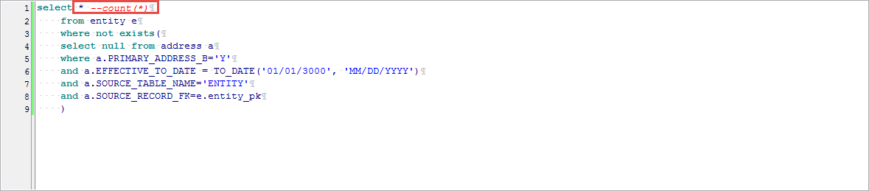

1. The error rows will be displayed

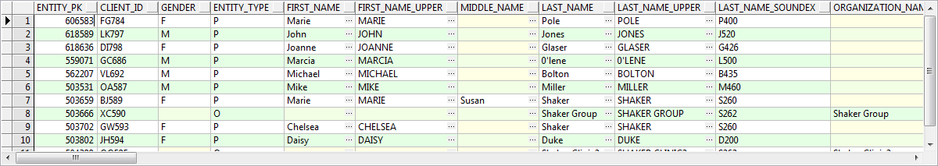

1. Fix the error. In this case, the primary address for the first entity on the query was added.

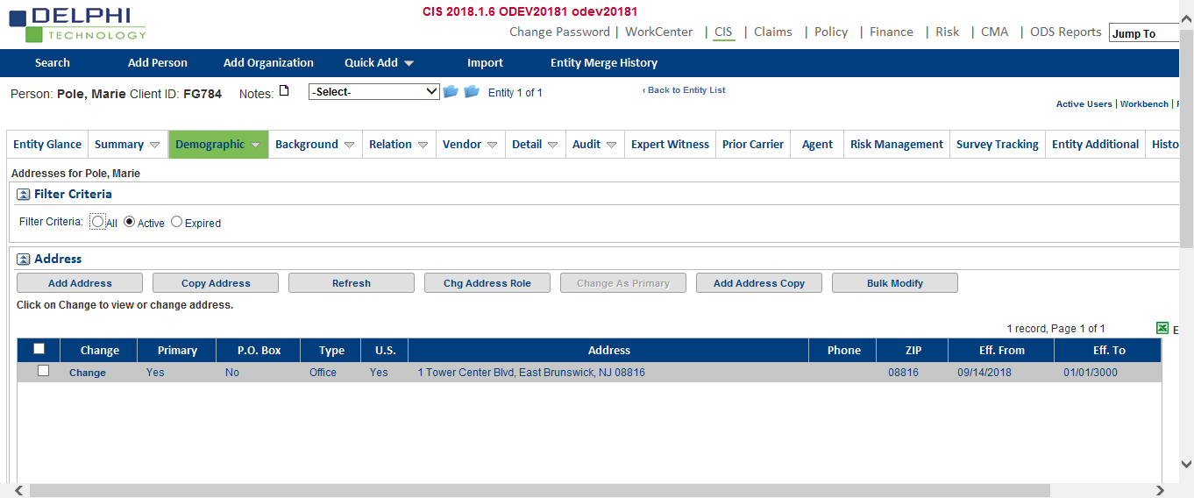

1. Run the same health check for that small subset (one subsystem, in this case CIS).

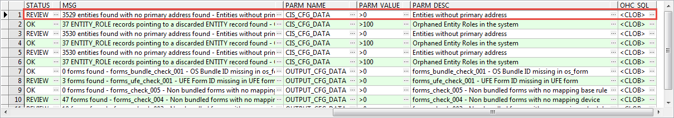

1. Check to make sure the error was resolved.

The number of rows of the health check went down by one from 3530 rows on the previous run to 3529 rows on the present run.

# Troubleshooting

This section lists examples of errors that may be encountered during OASIS health check process and suggested fixes.

## Possible Errors

1. 32-bit Oracle Client Library is not installed.

(To be revisited in a later release.)

OHC tool only works with the Oracle 32-bit client library installed in the host machine. In this case, the host machine had only 64-bit client library installed in the host machine.

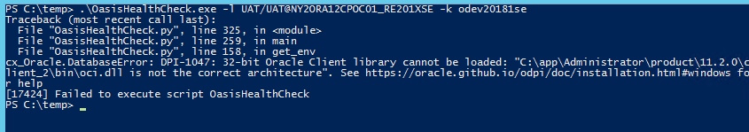

1. Excessive number of invalid rows shows up in the health check runs.

If there is an excessive number of records in the OASIS health check test run that show up in REVIEW status **(STATUS** column in **OHC_HEALTH CHECK** table), customers can refer these results to Delphi by creating a comma separated file of the last report. If a fix is required, Delphi can assist with this effort by creating additional scripts to fix the issue.

## OHC Test Matrix

Tests run with OHC tool are listed in this section with a description and instructions on fixing the issues. This section will be updated as fixes are found for each of the issues. Since this section is bound to evolve, Delphi recommends reviewing this section with each new release.

### TEST ID: CIS_001

|  |  |
| --- | --- |
| Summary | Check for orphaned Entity Roles in the system. |
| Description | Orphaned ENTITY_ROLE records pointing to a discarded ENTITY record. |
| Type | Data Inconsistency |
| Fix | To be added. |

### TEST ID: CIS_002

|  |  |
| --- | --- |
| Summary | Entities without primary address. |
| Description | Historical Entities that do not have a primary address |
| Type | Data Inconsistency |
| Fix | To be added. |

### TEST ID: OUTPUT_001

|  |  |
| --- | --- |
| Summary | Non-bundled forms with no mapping transaction. |
| Description |  |
| Type | Data Inconsistency |
| Fix | To be added. |

### TEST ID: OUTPUT_002

|  |  |
| --- | --- |
| Summary | Non-bundled forms with no mapping copy type. |
| Description |  |
| Type | Data Inconsistency |
| Fix | To be added. |

### TEST ID: OUTPUT_003

|  |  |
| --- | --- |
| Summary | Non-bundled forms with no mapping schedule. |
| Description |  |
| Type | Data Inconsistency |
| Fix | To be added. |

### TEST ID: OUTPUT_004

|  |  |
| --- | --- |
| Summary | Non-bundled forms with no mapping device. |
| Description |  |
| Type | Data Inconsistency |
| Fix | To be added. |

### TEST ID: OUTPUT_005

|  |  |
| --- | --- |
| Summary | Non-bundled forms with no mapping base rule. |
| Description |  |
| Type | Data Inconsistency |
| Fix | To be added. |
|  |  |

### TEST ID: OUTPUT_006

|  |  |
| --- | --- |
| Summary | OS_Bundle_ID missing in OS_FORM table. |
| Description |  |
| Type | Data Inconsistency |
| Fix | To be added. |

### TEST ID: OUTPUT_007

|  |  |
| --- | --- |
| Summary | UFE Form ID missing in UFE form. |
| Description |  |
| Type | Data Inconsistency |
| Fix | To be added. |

### TEST ID: OUTPUT_008

|  |  |
| --- | --- |
| Summary | Invalid data format in OS_FORM_RULE Table – VALUE_LOW column. |
| Description | This test would capture any invalid configuration in VALUE_LOW column of OS_FORM_RULE table, if the parameter is a date and is configured with double slashes (10//01/2018) |
| Type | Data Configuration |
| Fix | This script will get any invalid rows configured in the table for the value_low column.  SELECT *  FROM os_form_rule o  WHERE o.attribute_code like '%DT'  and oasis_health_check_main.is_valid_date(o.value_low) > 0  ; |

### TEST ID: OUTPUT_ODS_INSTALLED

|  |  |
| --- | --- |
| Parameter | ODS_INSTALLED |
| Description | This parameter should be set to Y if ODS is in the solution architecture. |
| Type | SYSTEM_PARAMETER_UTIL Table Configuration |
| Value | Y or N |

### TEST ID: OUTPUT_ODS_VERSION

|  |  |
| --- | --- |
| Parameter | ODS_VERSION |
| Description | ODS Version number. This can be set to 1 or 2 or any value beyond 2 |
| Type | SYSTEM_PARAMETER_UTIL Table Configuration |
| Value | 2.1 |

### TEST ID: OUTPUT_OS_APP_DATE_TO_DIR

|  |  |
| --- | --- |
| Parameter | OS_APP_DATE_TO_DIR |
| Description | Append to Drive Destination. This has to be set to YYYYMM for optimal performance. It can also be set to YYYYMMDD, but there maybe too many folders to handle. |
| Type | SYSTEM_PARAMETER_UTIL Table Configuration |
| Value | YYYYMM |

### TEST ID: OUTPUT_DOC_GEN_PRD_NAME

|  |  |
| --- | --- |
| Parameter | DOC_GEN_PRD_NAME |
| Description | This must be set to the third-party forms engine that is a part of the solution architecture. |
| Type | SYSTEM_PARAMETER_UTIL Table Configuration |
| Value | GHOSTDRAFT/ELOQUENCE |

### TEST ID: OUTPUT_OS_BASE_VERSION

|  |  |
| --- | --- |
| Parameter | OS_BASE_VERSION |
| Description | Version number of OS base being used |
| Type | SYSTEM_PARAMETER_UTIL Table Configuration |
| Value | 0 for OLD, 1 for NEW, and 2 for both OLD and NEW |

### TEST ID: OUTPUT_OS_DIRECTORY_SIZE

|  |  |
| --- | --- |
| Parameter | OS_DIRECTORY_SIZE |
| Description | Number of PDFs that ODS will put into a single folder |
| Type | SYSTEM_PARAMETER_UTIL Table Configuration |
| Value | 1000 |

### TEST ID: OUTPUT_OS_DOC_DIRECTORY

|  |  |
| --- | --- |
| Parameter | OS_DOC_DIRECTORY |
| Description | Indicates the name of the document directory. |
| Type | SYSTEM_PARAMETER_UTIL Table Configuration |
| Value | \\OASISStorage.Alias\OASISStorage$\Dev\SE\ODS\ODEV20181 (Sample) |

### TEST ID: OUTPUT_OS_SORT_FORM

|  |  |
| --- | --- |
| Parameter | OS_SORT_FORM |
| Description | Test form resorting |
| Type | SYSTEM_PARAMETER_UTIL Table Configuration |
| Value | Y or N |

### TEST ID: OUTPUT_OS_XML_DIRECTORY

|  |  |
| --- | --- |
| Parameter | OS_XML_DIRECTORY |
| Description | The network location to save XML file used by 3rd party ODS form generation product. |
| Type | SYSTEM_PARAMETER_UTIL Table Configuration |
| Value | \\OASISStorage.Alias\OASISStorage$\Dev\SE\ODS\ODEV20181\XMLDATA  (Sample) |

### TEST ID: POLICY_PM_CHECK_NOTICE

|  |  |
| --- | --- |
| Parameter | PM_CHECK_NOTICE |
| Description | Turns on check for notices that are stored in PM_ATTRIBUTE table |
| Type | SYSTEM_PARAMETER_UTIL Table Configuration |
| Value | Y or N |

### TEST ID: PM_001

|  |  |
| --- | --- |
| Summary | Policy term records that have incorrect CLOSING_TRANS_LOG_FK. |
| Description |  |
| Type | Data Inconsistency |
| Fix | To be added. |

### TEST ID: PM_002

|  |  |
| --- | --- |
| Summary | TRANSACTION_APPLIED_TERM table that has more than one term affected by a transaction but has same POLICY_TERM_HISTORY_FK in TRANSACTION_APPLIED_TERM table |
| Description |  |
| Type | Data Inconsistency |
| Fix | To be added. |

### TEST ID: PM_003

|  |  |
| --- | --- |
| Summary | Invalid effective date in mini policy coverage |
| Description |  |
| Type | Data Inconsistency |
| Fix | To be added. |

### TEST ID: PM_004

|  |  |
| --- | --- |
| Summary | Invalid effective date in mini policy risk |
| Description |  |
| Type | Data Inconsistency |
| Fix | To be added. |

### TEST ID: PM_005

|  |  |
| --- | --- |
| Summary | Invalid effective date in mini policy |
| Description |  |
| Type | Data Inconsistency |
| Fix | To be added. |

### TEST ID: PM_006

|  |  |
| --- | --- |
| Summary | Transactions that have timestamp info in ACCOUNTING_DATE |
| Description |  |
| Type | Data Inconsistency |
| Fix | To be added. |

### TEST ID: PM_007

|  |  |
| --- | --- |
| Summary | Policies with more than one primary risk |
| Description |  |
| Type | Data Inconsistency |
| Fix | To be added. |

### TEST ID: PM_008

|  |  |
| --- | --- |
| Summary | Policy terms with ACCT_FROM_DATE greater than ACCT_TO_DATE |
| Description |  |
| Type | Data Inconsistency |
| Fix | To be added. |

### TEST ID: PM_009

|  |  |
| --- | --- |
| Summary | Records in TRANSACTION_APPLIED_TERM table with POLICY_TERM_HISTORY_FK does not match TERM_BASE_RECORD_FK |
| Description |  |
| Type | Data Inconsistency |
| Fix | To be added. |

### TEST ID: PM_010

|  |  |
| --- | --- |
| Summary | Risks with EFFECTIVE_FROM_DATE is greater than EFFECTIVE_TO_DATE |
| Description |  |
| Type | Data Inconsistency |
| Fix | To be added. |

### TEST ID: PM_011

|  |  |
| --- | --- |
| Summary | Risks with ACCT_FROM_DATE is greater than ACCT_TO_DATE |
| Description |  |
| Type | Data Inconsistency |
| Fix | To be added. |

### TEST ID: PM_012

|  |  |
| --- | --- |
| Summary | Coverage with EFFECTIVE_FROM_DATE greater than EFFECTIVE_TO_DATE |
| Description |  |
| Type | Data Inconsistency |
| Fix | To be added. |

### TEST ID: PM_013

|  |  |
| --- | --- |
| Summary | Coverage with ACCT_FROM_DATE is greater than ACCT_TO_DATE |
| Description |  |
| Type | Data Inconsistency |
| Fix | To be added. |

### TEST ID: PM_014

|  |  |
| --- | --- |
| Summary | Component with EFFECTIVE_FROM_DATE greater than EFFECTIVE_TO_DATE |
| Description |  |
| Type | Data Inconsistency |
| Fix | To be added. |

### TEST ID: PM_015

|  |  |
| --- | --- |
| Summary | Risk effective from or to date is less than transaction EFFECTIVE_FROM_DATE |
| Description |  |
| Type | Data Inconsistency |
| Fix | To be added. |

### TEST ID: PM_016

|  |  |
| --- | --- |
| Summary | Coverage effective from or to date is less than transaction effective from date |
| Description |  |
| Type | Data Inconsistency |
| Fix | To be added. |

### TEST ID: PM_017

|  |  |
| --- | --- |
| Summary | Component effective from or to date is less than transaction effective from date |
| Description |  |
| Type | Data Inconsistency |
| Fix | To be added. |

### TEST ID: PM_018

|  |  |
| --- | --- |
| Summary | TRANSACTION_APPLIED_TERM table records that link to TEMP status POLICY_TERM_HISTORY table record |
| Description |  |
| Type | Data Inconsistency |
| Fix | To be added. |

### TEST ID: PM_019

|  |  |
| --- | --- |
| Summary | POLICY_TERM_HISTORY table records that have gap in accounting dates |
| Description |  |
| Type | Data Inconsistency |
| Fix | To be added. |

### TEST ID: PM_020

|  |  |
| --- | --- |
| Summary | Policy with incorrect transaction accounting date |
| Description |  |
| Type | Data Inconsistency |
| Fix | To be added. |

### TEST ID: PM_021

|  |  |
| --- | --- |
| Summary | Agent without row in ENTITY_ROLE table |
| Description |  |
| Type | Data Inconsistency |
| Fix | To be added. |

### TEST ID: PM_022

|  |  |
| --- | --- |
| Summary | Policy term with EFFECTIVE_FROM_DATE greater EFFECTIVE_TO_DATE |
| Description |  |
| Type | Data Inconsistency |
| Fix | To be added. |

### TEST ID: PM_023

|  |  |
| --- | --- |
| Summary | Policy term that ACCT_FROM_DATE greater than ACCT_TO_DATE |
| Description |  |
| Type | Data Inconsistency |
| Fix | To be added. |

### TEST ID: PM_024

|  |  |
| --- | --- |
| Summary | Policy premium with rate from date is greater than rate to date |
| Description |  |
| Type | Data Inconsistency |
| Fix | To be added. |

### TEST ID: PM_025

|  |  |
| --- | --- |
| Summary | Policy premium that acct from date is greater than acct to date |
| Description |  |
| Type | Data Inconsistency |
| Fix | To be added. |

### TEST ID: PM_026

|  |  |
| --- | --- |
| Summary | PM trans that Gross premium plus Comp do not equal to Net premium |
| Description |  |
| Type | Data Inconsistency |
| Fix | To be added. |

### TEST ID: PM_027

|  |  |
| --- | --- |
| Summary | Records with invalid TRANSACTION_FK in COVERAGE table |
| Description |  |
| Type | Data Inconsistency |
| Fix | To be added. |

### TEST ID: PM_028

|  |  |
| --- | --- |
| Summary | Records with invalid TRANSACTION_FK in RISK table |
| Description |  |
| Type | Data Inconsistency |
| Fix | To be added. |

### TEST ID: PM_029

|  |  |
| --- | --- |
| Summary | Records with invalid TRANSACTION_FK in POLICY_TERM_HISTORY table |
| Description |  |
| Type | Data Inconsistency |
| Fix | To be added. |

### TEST ID: PM_030

|  |  |
| --- | --- |
| Summary | Records with invalid TRANSACTION_FK in POLICY_COVERAGE_COMPONENT table |
| Description |  |
| Type | Data Inconsistency |
| Fix | To be added. |

### TEST ID: PM_031

|  |  |
| --- | --- |
| Summary | Records with incorrect TRANSACTION_FK in POLICY_COVERAGE_COMPONENT table |
| Description |  |
| Type | Data Inconsistency |
| Fix | To be added. |
| Fix | To be added. |

### TEST ID: PM_032

|  |  |
| --- | --- |
| Summary | Records with incorrect TRANSACTION_FK in COVERAGE table |
| Description |  |
| Type | Data Inconsistency |
| Fix | To be added. |

### TEST ID: FM_001

|  |  |
| --- | --- |
| Summary | Invoices that exist in FM_BILL but not in FM_BILL_ACCOUNT table |
| Description |  |
| Type | Data Inconsistency |
| Fix | To be added. |

### TEST ID: FM_002

|  |  |
| --- | --- |
| Summary | Identify FM_Master records that transaction accounting date is less than minimum accounting date of RISK table |
| Description |  |
| Type | Data Inconsistency |
| Fix | To be added. |

### TEST ID: FM_003

|  |  |
| --- | --- |
| Summary | Identify FM_Master records that transaction accounting date is less than minimum accounting date of COVERAGE table |
| Description |  |
| Type | Data Inconsistency |
| Fix | To be added. |

### TEST ID: FM_004

|  |  |
| --- | --- |
| Summary | Transaction amount different between FM_MASTER and FM_OPEN_ITEM_CHANGE |
| Description |  |
| Type | Data Inconsistency |
| Fix | To be added. |

### TEST ID: FM_005

|  |  |
| --- | --- |
| Summary | Transactions with accounting date is unreasonably high |
| Description |  |
| Type | Data Inconsistency |
| Fix | To be added. |

### TEST ID: FM_006

|  |  |
| --- | --- |
| Summary | Transactions with accounting date is unreasonably low |
| Description |  |
| Type | Data Inconsistency |
| Fix | To be added. |

### TEST ID: FM_007

|  |  |
| --- | --- |
| Summary | Transactions with effective from date is unreasonably high |
| Description |  |
| Type | Data Inconsistency |
| Fix | To be added. |

### TEST ID: FM_008

|  |  |
| --- | --- |
| Summary | Transactions with effective from date is unreasonably low |
| Description |  |
| Type | Data Inconsistency |
| Fix | To be added. |

### TEST ID: FM_009

|  |  |
| --- | --- |
| Summary | Transactions with transaction date is unreasonably high |
| Description |  |
| Type | Data Inconsistency |
| Fix | To be added. |

### TEST ID: FM_010

|  |  |
| --- | --- |
| Summary | Transactions with transaction date is unreasonably low |
| Description |  |
| Type | Data Inconsistency |
| Fix | To be added. |

### TEST ID: FM_011

|  |  |
| --- | --- |
| Summary | Accounts that balance do not match between FM_OPEN_ITEM and FM_OPEN_ITEM_CHANGE |
| Description |  |
| Type | Data Inconsistency |
| Fix | To be added. |

### TEST ID: FM_012

|  |  |
| --- | --- |
| Summary | Records in FM_OPEN_ITEM table that OPEN_BALANCE is null |
| Description |  |
| Type | Data Inconsistency |
| Fix | To be added. |

### TEST ID: FM_013

|  |  |
| --- | --- |
| Summary | Records in FM_OPEN_ITEM_CHANGE table that OPEN_BALANCE is null |
| Description |  |
| Type | Data Inconsistency |
| Fix | To be added. |

### TEST ID: CM_001

|  |  |
| --- | --- |
| Summary | CM_TRANSACTION_DETAIL w/o matching CIX and claimant on CCX |
| Description |  |
| Type | Data Inconsistency |
| Fix | To be added. |

### TEST ID: CM_002

|  |  |
| --- | --- |
| Summary | cm_transaction w/ data_checking cm_trans_status_history row |
| Description |  |
| Type | Data Inconsistency |
| Fix | To be added. |

### TEST ID: CM_003

|  |  |
| --- | --- |
| Summary | cm_transaction w/ missing cm_trans_status_history row |
| Description |  |
| Type | Data Inconsistency |
| Fix | To be added. |

### TEST ID: CM_004

|  |  |
| --- | --- |
| Summary | cm_transaction w/o matching CM_TRANSACTION_DETAIL row |
| Description |  |
| Type | Data Inconsistency |
| Fix | To be added. |

### TEST ID: CM_005

|  |  |
| --- | --- |
| Summary | cm_transaction where trans_amt <> sum amount on det row |
| Description |  |
| Type | Data Inconsistency |
| Fix | To be added. |

### TEST ID: CM_006

|  |  |
| --- | --- |
| Summary | txn dtl rows where the txn claim differs from CIX claim |
| Description |  |
| Type | Data Inconsistency |
| Fix | To be added. |

### TEST ID: CM_007

|  |  |
| --- | --- |
| Summary | entity_role roles where entity fk is not on entity table |
| Description |  |
| Type | Data Inconsistency |
| Fix | To be added. |

### TEST ID: CM_008

|  |  |
| --- | --- |
| Summary | claimant rows where entity role not on entity role table |
| Description |  |
| Type | Data Inconsistency |
| Fix | To be added. |

### TEST ID: CM_009

|  |  |
| --- | --- |
| Summary | claim_insured rows where entity role not on entity role table |
| Description |  |
| Type | Data Inconsistency |
| Fix | To be added. |

### TEST ID: CM_010

|  |  |
| --- | --- |
| Summary | CIX rows where claim_insured_fk does not exist |
| Description |  |
| Type | Data Inconsistency |
| Fix | To be added. |

### TEST ID: CM_011

|  |  |
| --- | --- |
| Summary | claims with min claim type and claim history dates are not equal |
| Description |  |
| Type | Data Inconsistency |
| Fix | To be added. |

### TEST ID: CM_012

|  |  |
| --- | --- |
| Summary | missing cm_transaction SYS_UPDATE_TIME |
| Description |  |
| Type | Data Inconsistency |
| Fix | To be added. |

### TEST ID: CM_013

|  |  |
| --- | --- |
| Summary | claimant_fk on txn detail, not on claimant table |
| Description |  |
| Type | Data Inconsistency |
| Fix | To be added. |

### TEST ID: CM_014

|  |  |
| --- | --- |
| Summary | CIX fks on txn detail, not on CIX table |
| Description |  |
| Type | Data Inconsistency |
| Fix | To be added. |

### TEST ID: CM_015

|  |  |
| --- | --- |
| Summary | cm_trans_status_history w/ null status_start_date |
| Description |  |
| Type | Data Inconsistency |
| Fix | To be added. |

### TEST ID: CM_016

|  |  |
| --- | --- |
| Summary | cm_trans_status_history rows w/ null accounting_date |
| Description |  |
| Type | Data Inconsistency |
| Fix | To be added. |

### TEST ID: CM_017

|  |  |
| --- | --- |
| Summary | claims where min txn start date < min claim start date |
| Description |  |
| Type | Data Inconsistency |
| Fix | To be added. |

### TEST ID: CM_018

|  |  |
| --- | --- |
| Summary | CIX rows where POLICY_FK not on cm_policy |
| Description |  |
| Type | Data Inconsistency |
| Fix | To be added. |

### TEST ID: CM_019

|  |  |
| --- | --- |
| Summary | CIX rows where RISK_FK not on cm_risk |
| Description |  |
| Type | Data Inconsistency |
| Fix | To be added. |

### TEST ID: CM_020

|  |  |
| --- | --- |
| Summary | CIX rows where COVG_FK not on cm_coverage |
| Description |  |
| Type | Data Inconsistency |
| Fix | To be added. |

### TEST ID: CM_021

|  |  |
| --- | --- |
| Summary | CIX rows where POLICY_FK not on policy |
| Description |  |
| Type | Data Inconsistency |
| Fix | To be added. |

### TEST ID: CM_022

|  |  |
| --- | --- |
| Summary | CIX rows where POLICY_TERM_FK not on POLICY_TERM_HISTORY table |
| Description |  |
| Type | Data Inconsistency |
| Fix | To be added. |

### TEST ID: CM_023

|  |  |
| --- | --- |
| Summary | CIX rows where RISK_FK not on RISK table |
| Description |  |
| Type | Data Inconsistency |
| Fix | To be added. |

### TEST ID: CM_024

|  |  |
| --- | --- |
| Summary | CIX rows where COVG_FK not on COVERAGE table |
| Description |  |
| Type | Data Inconsistency |
| Fix | To be added. |

### TEST ID: CM_025

|  |  |
| --- | --- |
| Summary | CM_TRANSACTION_DETAIL rows where CIX fk is null |
| Description |  |
| Type | Data Inconsistency |
| Fix | To be added. |

### TEST ID: CM_026

|  |  |
| --- | --- |
| Summary | CM_TRANSACTION_DETAIL rows where claimant fk is null |
| Description |  |
| Type | Data Inconsistency |
| Fix | To be added. |

### TEST ID: CM_027

|  |  |
| --- | --- |
| Summary | CM_TRANSACTION accounting dates not in yyyy/mm/dd format |
| Description |  |
| Type | Data Inconsistency |
| Fix | To be added. |

### TEST ID: CM_028

|  |  |
| --- | --- |
| Summary | Checking for cm_trans_status_history rows where latest status record does not have the max Trans PK of transaction |
| Description |  |
| Type | Data Inconsistency |
| Fix | To be added. |

### TEST ID: CM_029

|  |  |
| --- | --- |
| Summary | CM Coverage records with SYS_UPDATE_TIME is null |
| Description |  |
| Type | Data Inconsistency |
| Fix | To be added. |

### TEST ID: CM_030

|  |  |
| --- | --- |
| Summary | CM Risk records with SYS_UPDATE_TIME is null |
| Description |  |
| Type | Data Inconsistency |
| Fix | To be added. |

### TEST ID: CM_031

|  |  |
| --- | --- |
| Summary | CM Policy records with s SYS_UPDATE_TIME is null |
| Description |  |
| Type | Data Inconsistency |
| Fix | To be added. |

### TEST ID: CM_032

|  |  |
| --- | --- |
| Summary | CM Coverage records where EFFECTIVE_FROM_DATE is null |
| Description |  |
| Type | Data Inconsistency |
| Fix | To be added. |

### TEST ID: CM_033

|  |  |
| --- | --- |
| Summary | CM Risk records where EFFECTIVE_FROM_DATE is null |
| Description |  |
| Type | Data Inconsistency |
| Fix | To be added. |

### TEST ID: CM_034

|  |  |
| --- | --- |
| Summary | CM Policy records where EFFECTIVE_FROM_DATE is null |
| Description |  |
| Type | Data Inconsistency |
| Fix | To be added. |

### TEST ID: CM_035

|  |  |
| --- | --- |
| Summary | CM Trans History records where SYS_CREATE_TIME is null |
| Description |  |
| Type | Data Inconsistency |
| Fix | To be added. |

### TEST ID: CM_036

|  |  |
| --- | --- |
| Summary | CM Trans records whose trans date is less than claim report date |
| Description |  |
| Type | Data Inconsistency |
| Fix | To be added. |

### TEST ID: CM_037

|  |  |
| --- | --- |
| Summary | Invalid claim final disposition date |
| Description |  |
| Type | Data Inconsistency |
| Fix | To be added. |

### TEST ID: CM_038

|  |  |
| --- | --- |
| Summary | Invalid claim type start date |
| Description |  |
| Type | Data Inconsistency |
| Fix | To be added. |

### TEST ID: CM_039

|  |  |
| --- | --- |
| Summary | Invalid claim status start date |
| Description |  |
| Type | Data Inconsistency |
| Fix | To be added. |

### TEST ID: CM_040

|  |  |
| --- | --- |
| Summary | Invalid cm_policy start date |
| Description |  |
| Type | Data Inconsistency |
| Fix | To be added. |

### TEST ID: CM_041

|  |  |
| --- | --- |
| Summary | Claims that status start date is greater than end date |
| Description |  |
| Type | Data Inconsistency |
| Fix | To be added. |

### TEST ID: CM_042

|  |  |
| --- | --- |
| Summary | Claims that type start date is greater than end date |
| Description |  |
| Type | Data Inconsistency |
| Fix | To be added. |

### TEST ID: CM_043

|  |  |
| --- | --- |
| Summary | Claims that has trans acct date less than policy acct date |
| Description |  |
| Type | Data Inconsistency |
| Fix | To be added. |

### TEST ID: CM_044

|  |  |
| --- | --- |
| Summary | Trans that status start date is greater than status end date |
| Description |  |
| Type | Data Inconsistency |
| Fix | To be added. |

### TEST ID: CM_045

|  |  |
| --- | --- |
| Summary | Mini policies with overlapping terms |
| Description |  |
| Type | Data Inconsistency |
| Fix | To be added. |

### TEST ID: CM_046

|  |  |
| --- | --- |
| Summary | Trans with transaction accounting date is null |
| Description |  |
| Type | Data Inconsistency |
| Fix | To be added. |

### TEST ID: CM_047

|  |  |
| --- | --- |
| Summary | CIX records that do not have correspond records in CCX |
| Description |  |
| Type | Data Inconsistency |
| Fix | To be added. |

### TEST ID: CM_048

|  |  |
| --- | --- |
| Summary | Claim transaction detail records where SYS_UPDATE_TIME is null |
| Description |  |
| Type | Data Inconsistency |
| Fix | To be added. |

### TEST ID: CM_049

|  |  |
| --- | --- |
| Summary | Claim transaction detail records where trans type code is null |
| Description |  |
| Type | Data Inconsistency |
| Fix | To be added. |

### TEST ID: CM_050

|  |  |
| --- | --- |
| Summary | Claim transaction detail records where trans status code is null |
| Description |  |
| Type | Data Inconsistency |
| Fix | To be added. |

### TEST ID: CM_051

|  |  |
| --- | --- |
| Summary | Claim transaction detail records where trans source fk is null |
| Description |  |
| Type | Data Inconsistency |
| Fix | To be added. |

### TEST ID: CM_052

|  |  |
| --- | --- |
| Summary | Claim records that CLAIMANT_COVERAGE_XREF link to different claim |
| Description |  |
| Type | Data Inconsistency |
| Fix | To be added. |

### TEST ID: CM_053

|  |  |
| --- | --- |
| Summary | ENTITY records that CLIENT_ID is null |
| Description |  |
| Type | Data Inconsistency |
| Fix | To be added. |

### TEST ID: CLAIMS_CM_AUTO_INS_CLMNTCOV

|  |  |
| --- | --- |
| Parameter | CM_AUTO_INS_CLMNTCOV |
| Description | Indicates if a Claimant/Coverage (a.k.a. feature) should be created automatically when a coverage is added and there is only one claimant on the claim or if a claimant is added and there is only one coverage |
| Type | SYSTEM_PARAMETER_UTIL Table Configuration |
| Value | Y or N |

# Future Enhancements

The following enhancements are expected in the future releases:

1. Manage OASIS health check environments through Properties file that will contain the database connection string for environments without passwords.
2. Presently the tool requires the host machine to have a 32-bit oracle client library installed. Ability to work with a 64-bit oracle client library will be addressed.