# OASIS Health Check

Oasis Health Check is a health check tool for OASIS environment. Every run of this tool goes through routine checks on configuration to check for validity of the configuration. It creates a report of every run in a table, a report of which can be downloaded to a comma separated file.

## AVAILABILITY

Oasis Health Check is available through a web download at this link: <link>

## COMMAND LINE HELP

To get command line options to run the tool, type in this command: **OasisHealthCheck.bat**



## INSTALLATION

1. Download the zip file.
2. Unzip to a local directory. Contents of the directory would look like snapshot below:

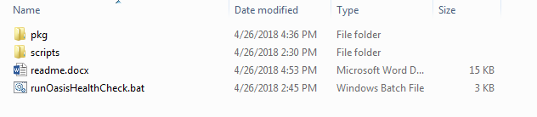

1. Update the runOasisHealthCheck.bat for lines between “CONFIG START” and “CONFIG END” to suit the script to against one environment

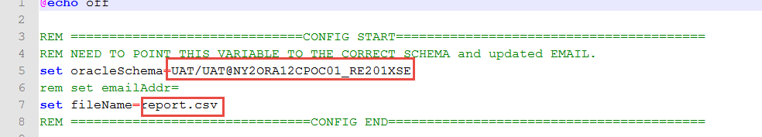

1. Open command line window and cd to the oasis health check tool directory.
2. Run this command : **OasisHealthCheck.bat install**

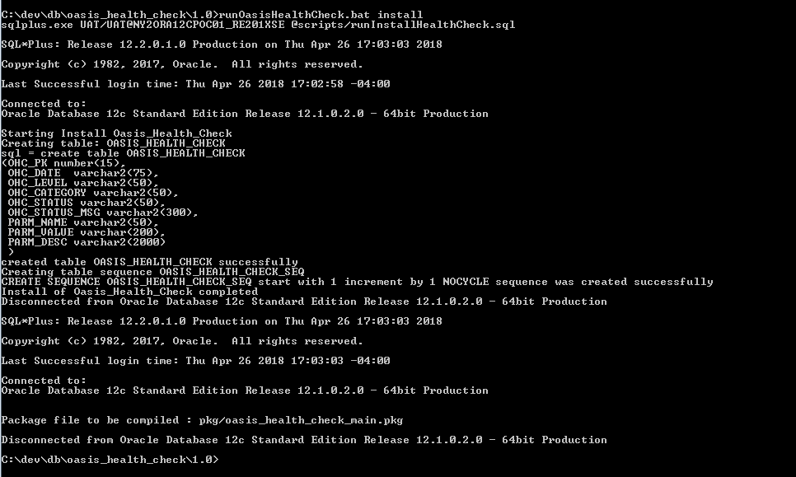

An install log is created in the root directory.

## UNINSTALL

Run this command in the command line window : **OasisHealthCheck.bat uninstall**

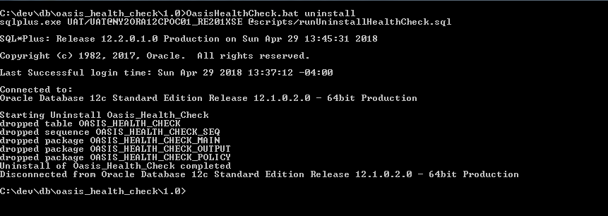

An uninstall log is created in the root directory.

## RUN

After successful installation, to run the oasis check tool,

type in this command: **OasisHealthCheck.bat run**

## Validations

At present, oasis health check tool checks for 2 ODS parameters and 3 OS parameters. The table would have all the details of the validation.

1. There tool reports with 3 status codes, namely
   1. OK – Validation was completed and was found to be the expected value.
   2. REVIEW – Validation was completed and it found an issue with the configuration. There is a status message field that gives some information on what the problem is for that parameter.
   3. PENDING – Validation was not done due to an issue with the configuration
2. There are two categories of validations as of now.
   1. ODS
   2. OS
3. Validation level could be used later to give priority to a validation. Right now all are in INFO level.

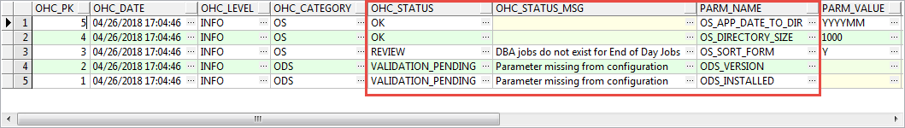

## Health Check Interpretation

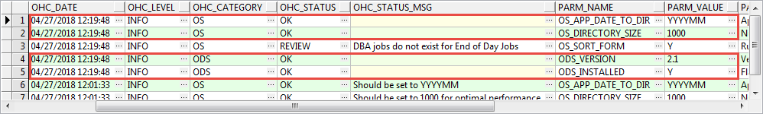

All expected parameter values would show up with a status of OK with no status msg.

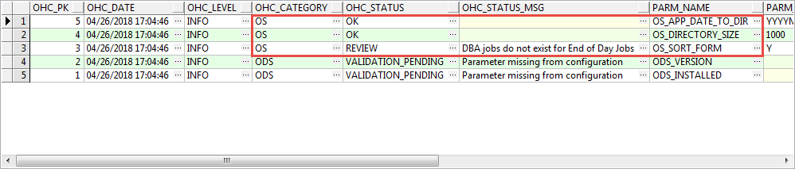

Samples shows two types of validations.

* OS_APP_DATE_TO_DIR and OS_DIRECTORY_SIZE are OK status with no status message.
* A ‘REVIEW’ status would accompany with a message with an explanation what validation failed.

## Health Check Results

### Parameter configuration missing

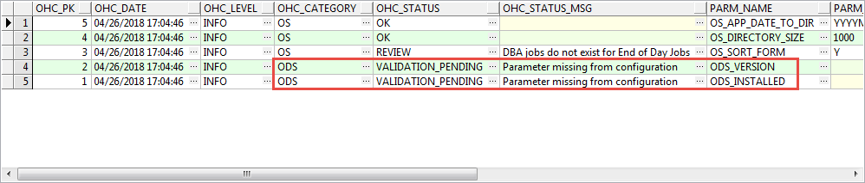

ODS_INSTALLED and ODS_VERSION parameters are not set. Status is set to ‘Validation_Pending’ since validation was not completed for the missing parameters.

### Wrong Parameter Value

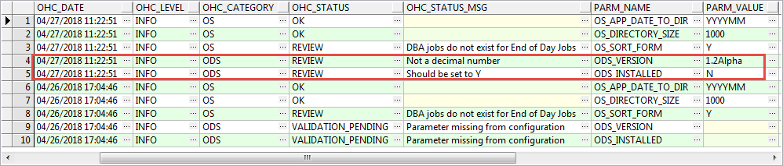

* ODS version should be a float number
* ODS_INSTALLED is expected to be Y

### Subsequent Validation failure

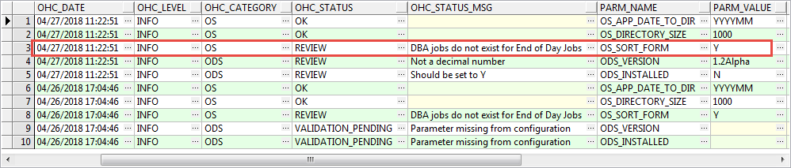

If OS_FORM is set to ‘Y’, then there should be some jobs present to handle EOD jobs, for a form that is configured to be End Of Day. Since it did not find that jobs, this is on REVIEW.

### Parameter values incorrect

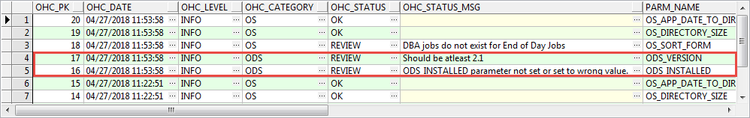

* ODS_Version should be equal to 2.1
* ODS_INSTALLED is expected to be set to ‘Y’

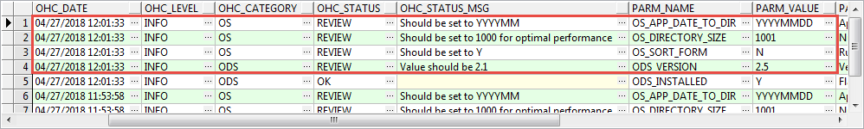

* OS_APP_DATE_TO_DIR is expected to be set as ‘YYYYMM’
* OS_DIRECTORY_SIZE is expected to be set to 1000
* OS_SORT_FORM is expected to be set to Y
* ODS_VERSION is expected to be 2.1

## REPORTS

### Last Report

To get a last run report in a comma separated file, type in the command : **OasisHealthCheck.bat lastreport**

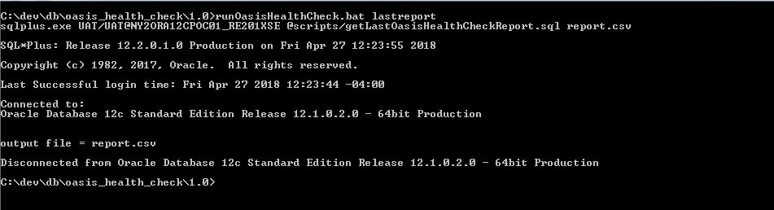

The report looks like screen shot below:

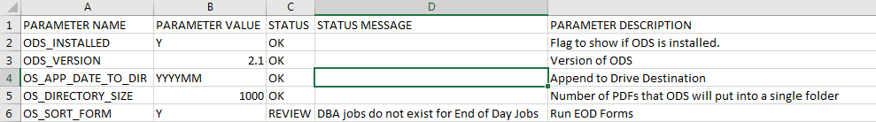

### Report of a particular date

To get a report for a date in a comma separated file, type in the command:  **OasisHealthCheck.bat reportfordate “04/26/2018 14:39:28”**

### All Reports

To get a all reports in a comma separated file, type in the command :   
**OasisHealthCheck.bat allreport**